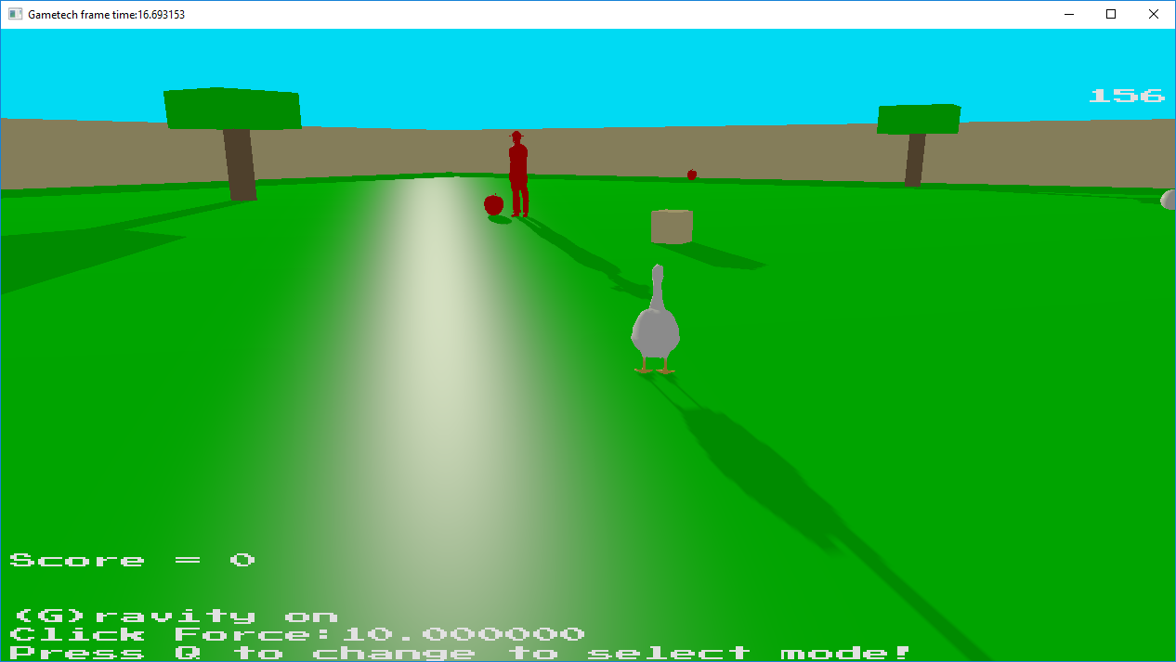

Spawn Location for the game. Keeper being passive as no items have been stolen (yet). If the keeper touches you he will take your current held item and kick you away towards your nest. Removing points.

W and S to move forward and backwards based on the camera direction.

A and D to rotate the camera and the goose.

Q to change between play and select mode. Select mode required to press main menu options so pressing Q is required on launch to change to select mode. Clicking an item will reveal its name and location info.

Timer on the top right starts at 3 minutes and upon reaching 0 is game over.

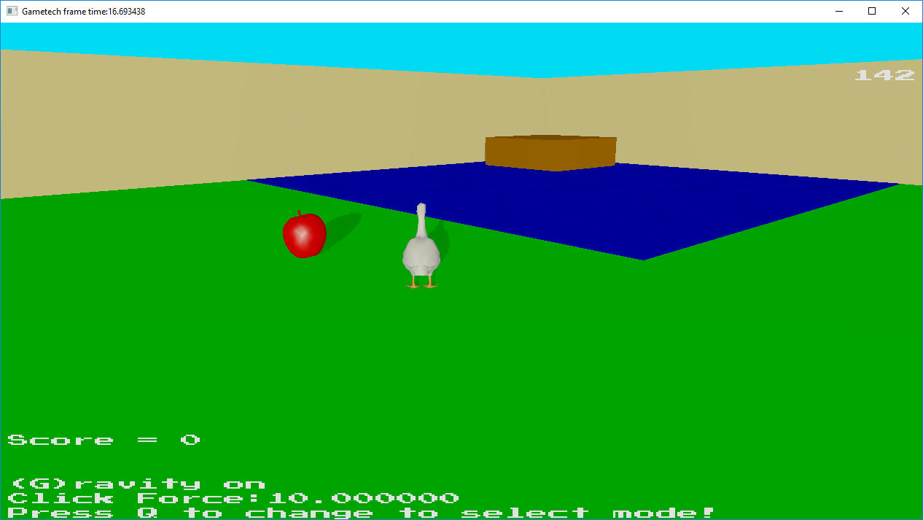

Pond with nest on it. If you enter it the keeper will begrudgingly return to his earliest position since he does not want to get wet. Touching the test will save the items inside increasing your score.

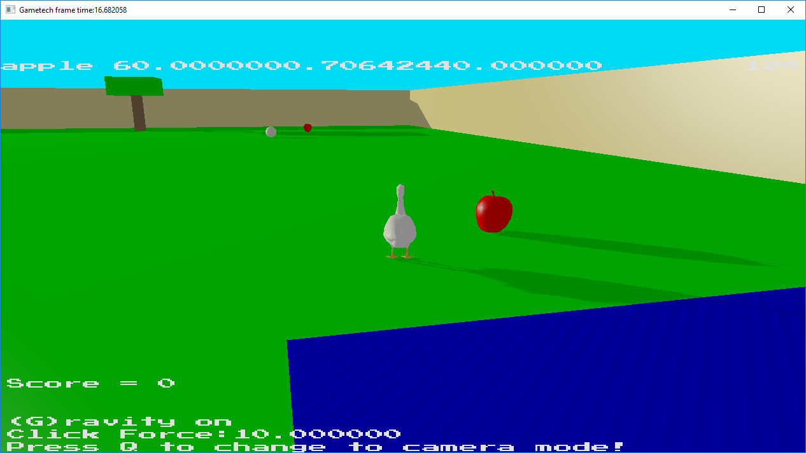

Goose next to an apple and pond, with bonus point sphere in the distance and a tree.

Spheres give more points than apples.

Not carrying anything will not get the keeper to chase you.

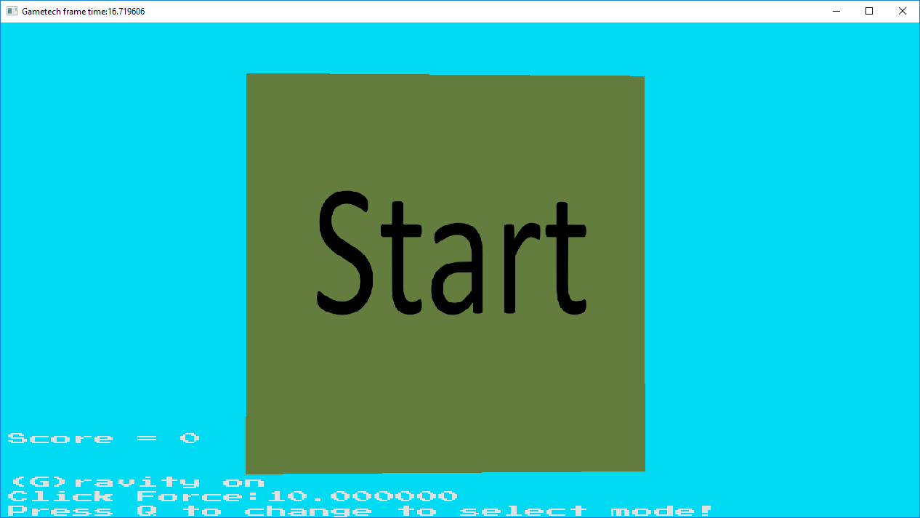

One of the options on the 3d main menu. Click to start game.

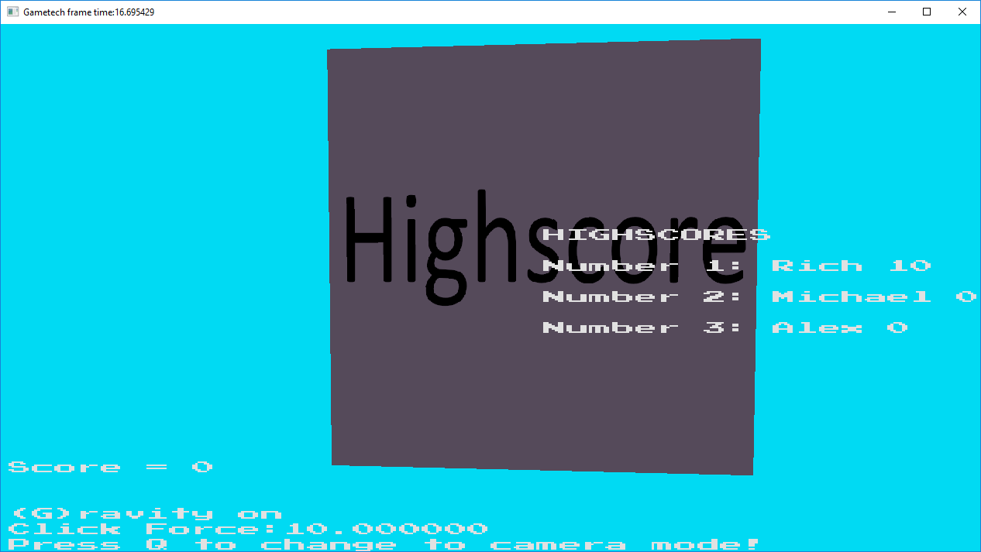

Clicking on the highscore option will show the highscores being red from a file.

Server broadcasts the highscores (if exist) to all the clients on launch.

Rui Antunes

B9059301