**Local DNS Attack Lab**

2.1 Task1: Configure the User Machine

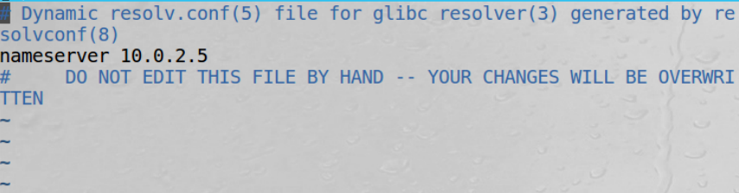



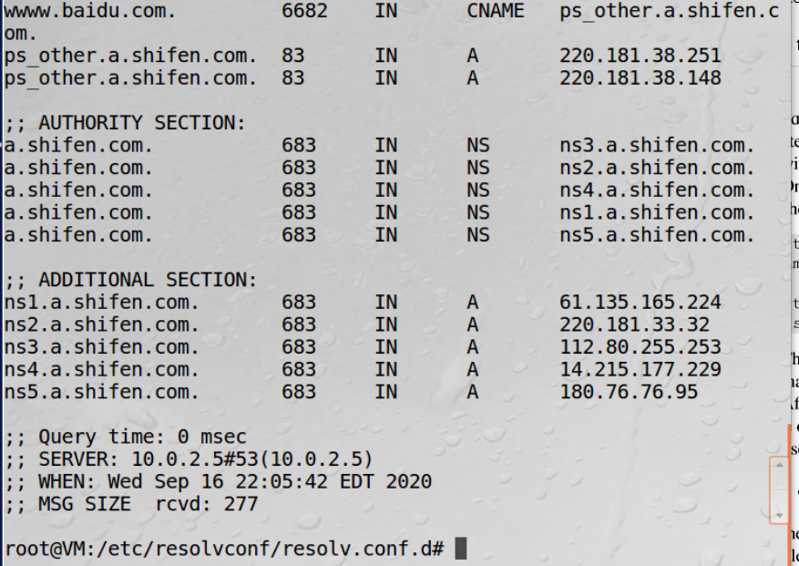

Task2: SetupaLocalDNSServer

Step 1: Configure the BIND 9 server

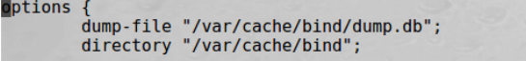



Step 2: Turn off DNSSEC.



Step 3: Start DNS server



Step 4: Use the DNS server





2.3 Task3: Host a Zone in the Local DNS Server

Step 1: Create zones

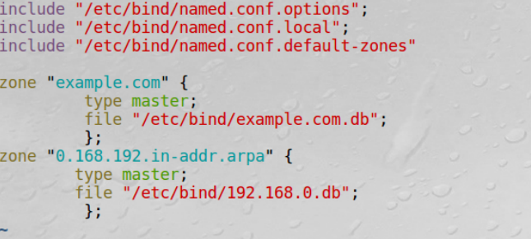

Step 2: Setup the forward lookup zone file

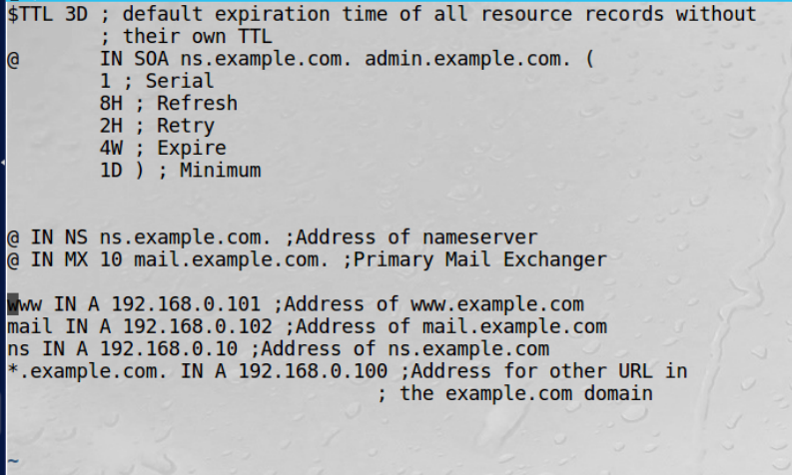

Step 3: Set up the reverse lookup zone file

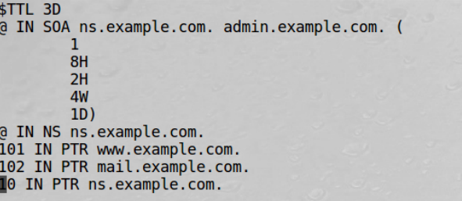

Step 4: Restart the BIND server and test



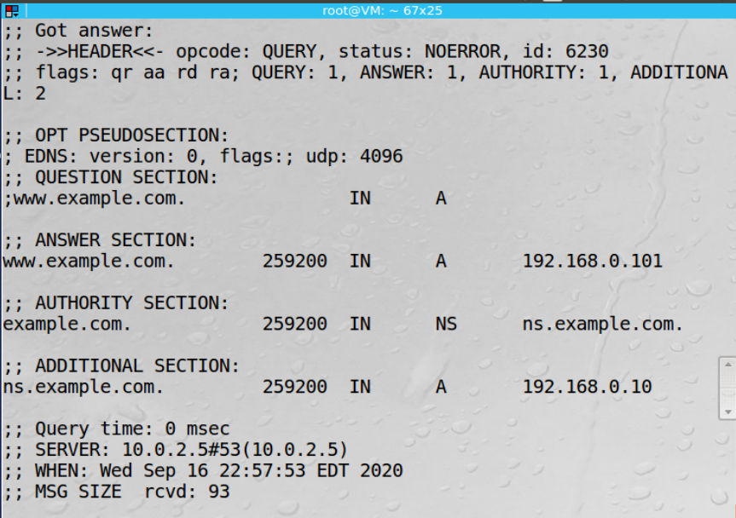

3.1 Task4: Modifying the Host File

攻击前：

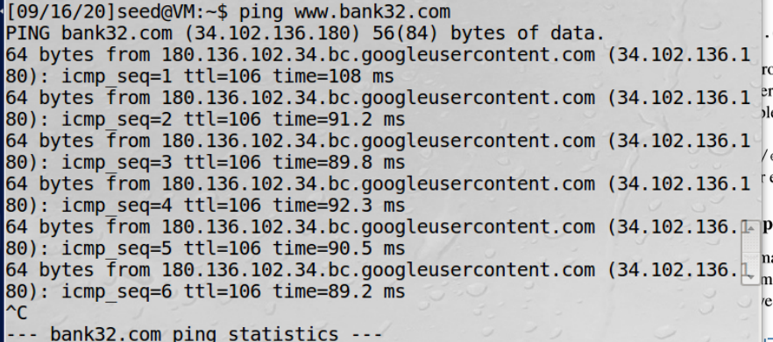

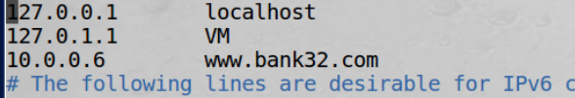

攻击后



Task5: Directly Spoofing Response to User

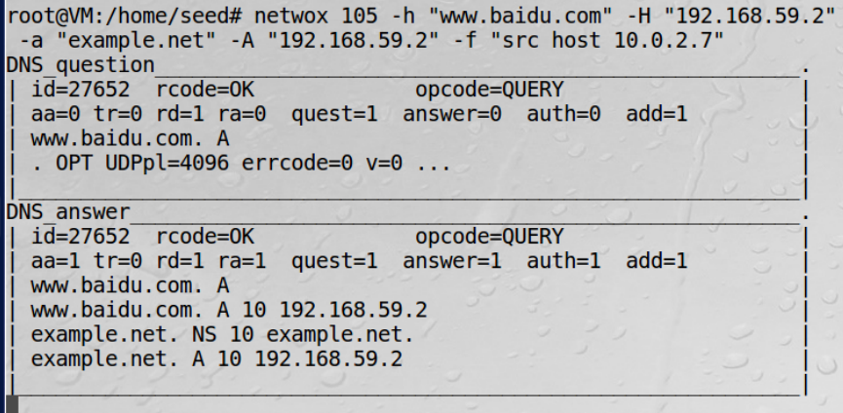

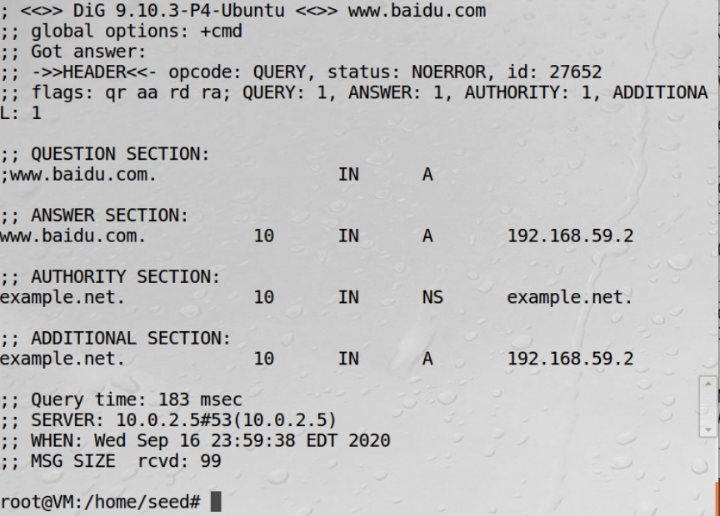

3.3 Task6: DNS Cache Poisoning Attack

3.4 Task7: DNS Cache Poisoning: Targeting the Authority Section