# Conflict Scenario

## **Review**

### Interpersonal Conflict Management Styles

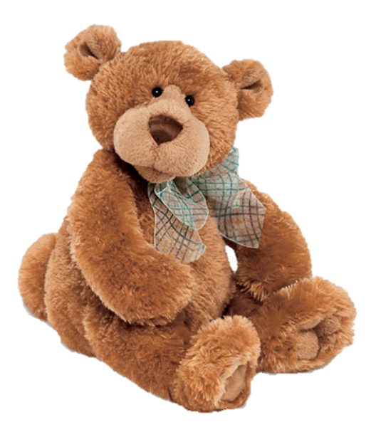

[CC 2.0 BY Matthew](https://www.flickr.com/photos/falcon1961/3304306800/)



[CC SA 3.0 Unported BY Jonathan Zander](https://en.wikipedia.org/wiki/File:Florida_Box_Turtle_Digon3.jpg)



[CC 3.0 BY Superawesomevectors](https://superawesomevectors.deviantart.com/art/Shark-Cartoon-Free-Vector-Illustration-643399222)



[CC0](https://pixabay.com/en/urban-lost-hiding-afraid-1002149/)

Low to High Concern for Other

Concern for Self



CC SA 2.0 Generic BY [Carine06 from UK](https://commons.wikimedia.org/wiki/File:Flickr_-_Carine06_-_%22I_give_up.%22.jpg)



CC 2.0 BY [Zabara Alexander](https://www.flickr.com/photos/zabara_tango/6955720271)



[CC0](https://commons.wikimedia.org/wiki/File:US_Army_53525_Soldiers_compete_in_Tae_Kwon_Do_tournament_for_Warrior_Country_level.jpg)

### **Interpersonal Conflict Resolution**

The following diagram shows a process that can be followed when trying to resolve interpersonal conflict.

### Listening

A considerable proportion of our communication involves listening, yet little attention is devoted to improving listening. HURIER is an acronym for tips that can be used to improve listening.

### “I” Phrases for Conflict Resolution

The “I” phrase is used during conflict resolutions to avoid attacking others. Open the conversation with a statement in first person, passive voice: “I feel … when … because … I would like …”

Adapted from (Dwyer 2012, p. 40)

## **Student Name and ID:** Therisa Mews -12190349

## **Student Name and ID:** Joseph Hunt - 12196064

## **Scenario**

Find a partner. Read the scenario below. Choose one partner to be Joe Bloggs, and the other to be Jane Doe. Together, answer the following to help prepare you for the role play.

## **Scenario: Joe did not complete a task by the deadline**

Joe and Jane are working on a report that is due today. Joe was assigned the task of writing the executive summary. Unfortunately, Joe has not completed the task.

What is the most appropriate conflict management strategy for Jane to use in this situation? (Choose one)

Compete/Force

Compromise

Avoid/Withdraw

Collaborate/Confront

Accommodate/Smooth

Why did you choose the above conflict management strategy?

This was selected because sometimes there are things in our lives that prevent deadlines being met and sometimes compromise (via an extension or the like) is required.

### **Listen and Understand**

How could Jane start the conversation?

Hi Joe, the Executive summary is due today and you haven’t completed it.

Describe the purpose of the discussion. Describe the conflict. What questions could Jane ask to determine Joe’s perspective of the situation?

I wonder if you could tell me where this task is up to and why it hasn’t been completed.

Was there something preventing you from completing the task?

Is there anything I can do to assist with the completion?

Write sentences that features the “I” phrase, such as in the example below:

“I feel *[your feeling]* when *[their behaviour]* because *[effects on you]*. I would like *[alternative behaviour]*”.

I feel frustrated that you haven’t complete the tasks because it impacts the entire team and the whole report.

I would like you to complete the task or approach me in the future for assistance if you require it or have any difficulty in completing the task.

Invent a reason why Joe did not complete the executive summary by the deadline.

Joe got covid and has been unwell.

How could Jane paraphrase Joe’s reason for missing the deadline to ensure that she understands Joe’s perspective?

That’s terrible to hear that you are sick.

### **Empathise**

Now that Jane understands Joe’s perspective, how could Jane empathise with Joe? Write a response that shows that Jane identifies with Joe’s emotions.

I understand what it is like to have deadlines looming and be unwell. How are you feeling today?

### **Apologise**

Include an apology if it is appropriate.

N/A

### **Offer Solution**

What question could Jane ask to help build Joe’s involvement with potential solutions?

Do you feel well enough today to work on the executive summary? Can I assist in any way to finalise it today or do you need us to request an extension?

Come up with a way for Jane and Joe to settle on a solution.

Joe is feeling well today and will get started on the executive summary, but may not get it finished so thinks we should request an extension until tomorrow.

### **Resolution**

How could Jane resolve the conflict? Jane needs to ensure that Joe agrees. Write a response that outlines appreciation for the solution.

Jane says Great, lets make that the plan and confirms that she will request an extension for one day and reminds Joe that she is available to assist if required.

Joe confirms he agrees and starts working on the Executive Summary.

Jane reminds Joe that if this were to happen again to reach out earlier for assistance prior to the due date.

### **Reconciliation**

How could Joe reconcile the relationship and let Jane know that she is important to him?

Hi Jane I appreciate that you were looking out for me while I was sick and checking up on my wellbeing. You are a really great team mate to have. I’m sorry for limiting the task by not communicating it to you.

Can I take you out for coffee once we get this task complete to debrief?

How can Jane let Joe know she is listening while Joe is talking?

Eye contact, move her body to face his direction, use of appropriate speech tone.

What could Jane do if Joe started to withdraw from the conflict at any stage?

Jane could remind Joe that we are all working as a team to get the task completed, and Joe is an important part of the team.