**# Thermal-conductivity-calculation**

Calculation of effective thermal conductivity of filler filled composites. The **Thermal Conductivity Calculation** method provides a numerical approach to accurately predict the effective thermal conductivity of polymer composites. This method considers various parameters, including the properties of the filler (thermal conductivity and particle radius), the properties of the polymer (thermal conductivity), and the properties of the composite material (volume fraction of the filler and interfacial thermal resistance between the filler and the polymer).

**System requirements**

**Installation guide**

**Demos and user instructions**

**Example 1: Calculating the Effective Thermal Conductivity for a Single Set of Data.**

**Example 2: Calculating Effective Thermal Conductivity for Multiple Data Sets**

**Example 3: Calculating Interfacial Thermal Resistance Using EMT and BCC Models**

**Additional Features**

# System requirements

server.py requires packages from the python library. The versions currently used in our lab are listed below:

* **Python**: 3.12.3
* **Minimum Requirement:** Python 3.9 or later

This program relies on the following Python libraries, please follow the steps to install:

Run the following commands one by one in the terminal (Command Prompt/PowerShell/Terminal):

# pip install flask sympy joblib scipy numpy matplotlib pandas #

# Installation guide

Installation time: < 5 min

* Visit our GitHub repository at: <https://github.com/ThermalCalc/Thermal-conductivity-calculation>
* Locate and click the green **"Code"** button
* Select **"Download ZIP"** from the dropdown menu
* Save the file: **Thermal-conductivity-calculation-main.zip**

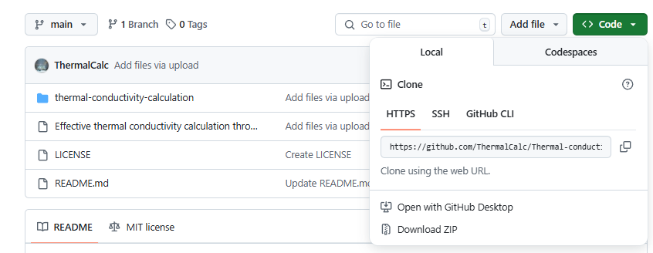

* Make sure you have installed the Python versions listed above.

# Demos and user instructions

Open the “server.py” file in the “thermal-conductivity-calculation” folder. Click “Run module”.

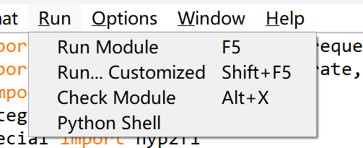

Then, following the pop-up instruction "Running on <http://127.0.0.1:5000>," open this URL in your computer’s browser. A simple calculation webpage will appear, where you can directly enter the required parameters into the designated fields and click the button to calculate the effective thermal conductivity.

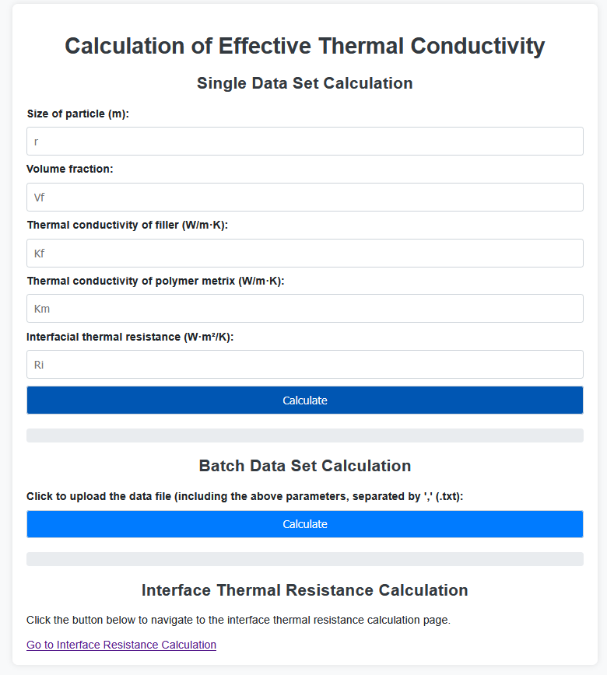

## Example 1: Calculating the Effective Thermal Conductivity for a Single Set of Data.

Enter the respective parameters of the filler, polymer, and composite material in the "Single Data Set Calculation" module and click "Calculate" to perform the single-data-set computation.

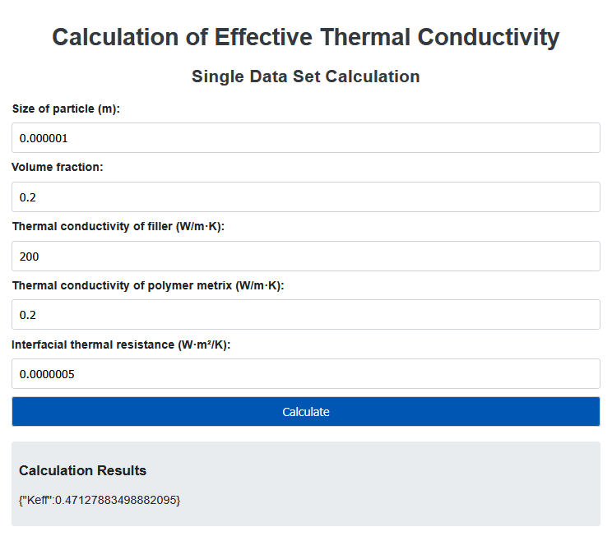

## Example 2: Calculating Effective Thermal Conductivity for Multiple Data Sets

In the "Batch Data Set Calculation" section, click the text "Click to upload the data file (including the above parameters, separated by ',' (.txt))" to import a .txt file.

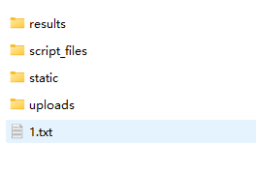

- For calculating multiple sets of data, create a `.txt` file with the following format:

- **First Column**: Volume fraction of the filler

- **Second Column**: Particle size of the filler

- **Third Column**: Thermal conductivity of the polymer

- **Fourth Column**: Thermal conductivity of the filler

- **Fifth Column**: Interfacial thermal resistance between the filler and the polymer

Then click the "Calculate" button to process the batch data. A "Calculation Results" dialog will appear, and the computed results can be accessed in the "results" folder.

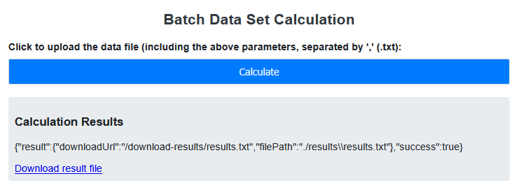

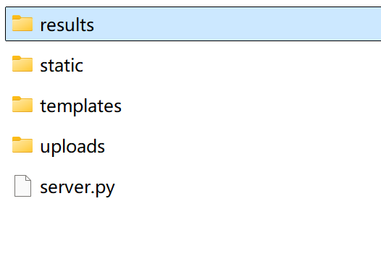

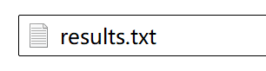

## Example 3: Calculating Interfacial Thermal Resistance Using EMT and BCC Models

At the bottom of the page, click "Go to Interface Resistance Calculation" to navigate to the interfacial thermal resistance computation page.



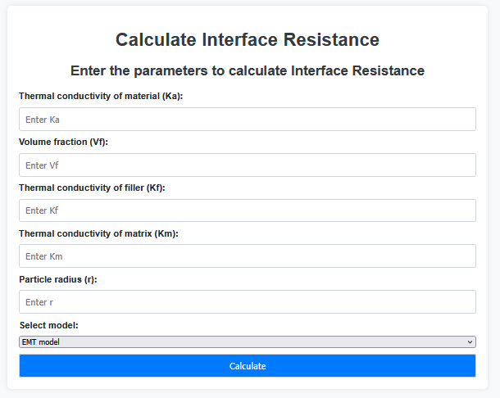

In the final row, select the desired calculation model ("EMT Model" or "BCC Model"), then input the required parameters: thermal conductivity of composite, filler and polymer, filler volume fraction, and filler size. The interfacial thermal resistance will be computed automatically upon parameter entry.

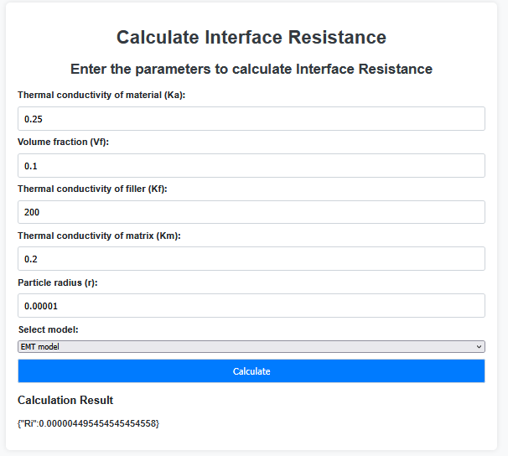

## Additional Features

The file also includes an "Effective Thermal Conductivity Calculation through MATLAB.m" script, which can be directly opened and executed in MATLAB. Separate calculation codes are provided for low-fill (Vf ≤ 13%) and high-fill (13% < Vf ≤ 68%) systems.

**For Low-Fill Systems (Vf ≤ 13%)**

**Code Lines**: 0–109

**Input Requirements**: Prepare a "xx.data" text file containing material parameters, formatted according to Lines 5–13. Alternatively, manually input specific values in Lines 5–13.

**Output**: Calculates the effective thermal resistance predicted by the BCC model. If experimental thermal conductivity data is available, the prediction error of the BCC model can be validated.

**For High-Fill Systems (13% < Vf ≤ 68%)**

**Code Lines**: 112–232

**Procedure**: Identical to the low-fill method.