选做题 习题三 1

归并排序：

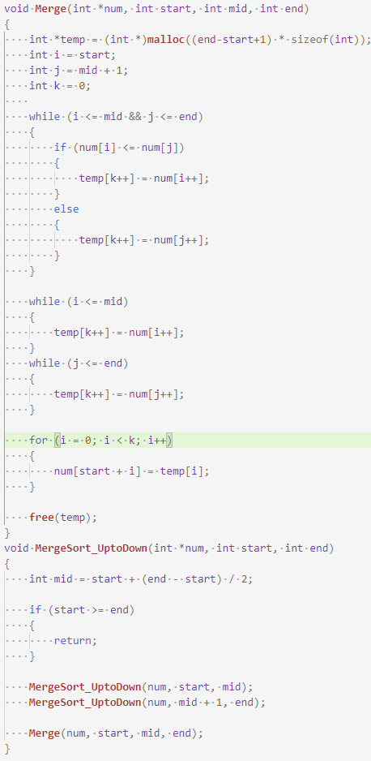

快速排序：

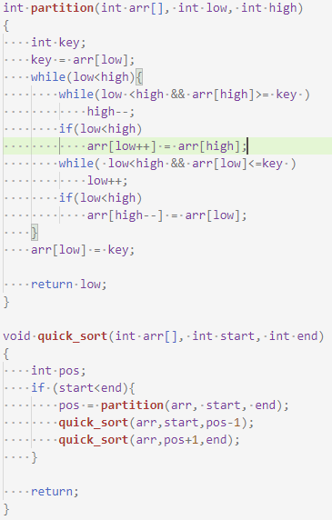

2.

|  |  |  |
| --- | --- | --- |
| 长度 | 归并排序 | 快速排序 |
| 100 | 142.9us | 6.8us |
| 200 | 307.6us | 14.6us |
| 300 | 421.9us | 22us |
| 400 | 541.3us | 29.8us |
| 500 | 677.4us | 37.6us |
| 600 | 813.6us | 46.6us |
| 700 | 988.0us | 55.3us |
| 800 | 982.5us | 59.0us |
| 900 | 1130.4us | 70.3us |
| 1000 | 1496.1us | 196.8us |