7.1：

（1）

|  |  |  |
| --- | --- | --- |
| 顶点 | 入度 | 出度 |
| 1 | 3 | 0 |
| 2 | 2 | 2 |
| 3 | 1 | 2 |
| 4 | 1 | 3 |
| 5 | 2 | 1 |
| 6 | 2 | 3 |

（2）

|  |  |  |  |  |  |
| --- | --- | --- | --- | --- | --- |
| 0 | 0 | 0 | 0 | 0 | 0 |
| 1 | 0 | 0 | 1 | 0 | 0 |
| 0 | 1 | 0 | 0 | 0 | 1 |
| 0 | 0 | 1 | 0 | 1 | 1 |
| 1 | 0 | 0 | 0 | 0 | 0 |
| 1 | 1 | 0 | 0 | 1 | 0 |

（3）

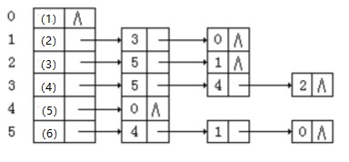

（4）

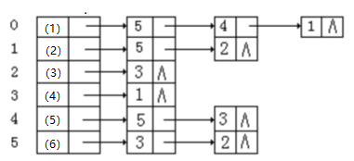

（5）

强连通分量：1；2346

7.3：

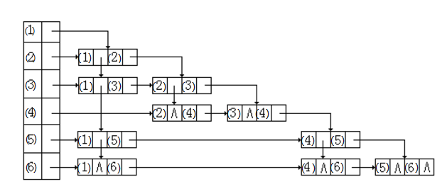

深度优先搜索：1 5 6 4 3 2

广度优先搜

索：1 5 6 3 2 4

7.10：

|  |  |  |  |  |  |  |  |  |  |  |  |  |  |
| --- | --- | --- | --- | --- | --- | --- | --- | --- | --- | --- | --- | --- | --- |
|  | a | A | B | C | D | E | F | G | H | I | J | K | w |
| ve | 0 | 1 | 6 | 17 | 3 | 34 | 4 | 3 | 13 | 1 | 31 | 22 | 44 |
| vl | 0 | 20 | 24 | 26 | 19 | 34 | 8 | 3 | 13 | 7 | 31 | 22 | 44 |

|  |  |  |  |  |  |  |  |  |
| --- | --- | --- | --- | --- | --- | --- | --- | --- |
|  | a,A | a,B | a,D | a,F | a,G | a,I | A,C | B,C |
| e | 0 | 0 | 0 | 0 | 0 | 0 | 1 | 6 |
| l | 19 | 18 | 16 | 4 | 0 | 6 | 20 | 24 |
|  | D,C | D,E | D,J | F,E | F,H | G,w | G,H | I,H |
| e | 3 | 3 | 3 | 4 | 4 | 3 | 3 | 1 |
| l | 19 | 26 | 25 | 23 | 8 | 23 | 3 | 7 |
|  | C,E | H,C | H,J | H,K | K,J | J,E | J,w | E,w |
| e | 17 | 13 | 13 | 13 | 22 | 31 | 31 | 34 |
| l | 26 | 22 | 27 | 13 | 22 | 31 | 32 | 34 |

关键路径：a-G-H-K-J-E-w

7.11

|  |  |  |  |  |  |  |  |
| --- | --- | --- | --- | --- | --- | --- | --- |
|  | b | c | d | e | f | g | S |
| 1 | 15 | 2 | 12 |  |  |  | a |
| 2 | 15 | 2 | 12 | 10 | 6 |  | a,c |
| 3 | 15 | 2 | 11 | 10 | 6 | 16 | a,c,f |
| 4 | 15 | 2 | 11 | 10 | 6 | 16 | a,c,f,e |
| 5 | 15 | 2 | 11 | 10 | 6 | 14 | a,c,f,e,d |
| 6 | 15 | 2 | 11 | 10 | 6 | 14 | a,c,f,e,d,g |
| 7 | 15 | 2 | 11 | 10 | 6 | 14 | a,c,f,e,d,g,b |