编译原理第八章第三次作业

李昊宸 2017K8009929044

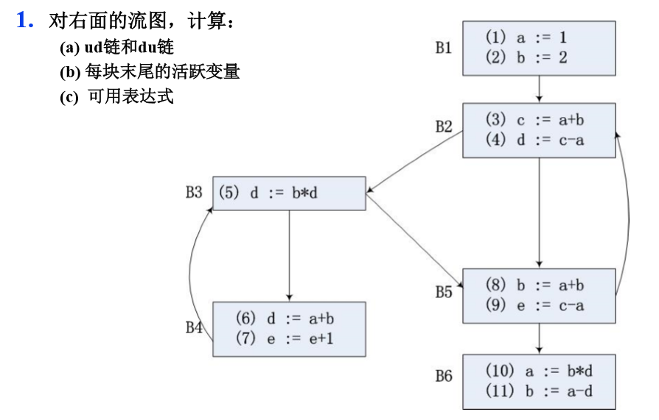

答：

a）

gen[B1] = {(1) , (2)}

kill[B1] = {(10) , (8) , (11)}

gen[B2] = {(3) , (4)}

kill[B2] = {(5) , (6)}

gen[B3] = {(5)}

kill[B3] = {(4) , (6)}

gen[B4] = {(6) , (7)}

kill[B4] = {(4) , (5) , (9)}

gen[B5] = {(8) , (9)}

kill[B5] = {(2) , (7) , (11)}

gen[B6] = {(10) , (11)}

kill[B6] = {(1) , (2) , (8)}

计算IN 和 OUT：

|  |  |  |  |  |
| --- | --- | --- | --- | --- |
| 块B | 初始 | | 第一次扫描 | |
| in | out | in | out |
| B1 | 0 00000 00000 | 1 10000 00000 | 0 00000 00000 | 1 10000 00000 |
| B2 | 0 00000 00000 | 0 01100 00000 | 1 10000 01100 | 1 11100 01100 |
| B3 | 0 00000 00000 | 0 00010 00000 | 1 11101 11100 | 1 11010 11100 |
| B4 | 0 00000 00000 | 0 00001 10000 | 1 11010 11100 | 1 11001 11000 |
| B5 | 0 00000 00000 | 0 00000 01100 | 1 11110 11100 | 1 01110 01100 |
| B6 | 0 00000 00000 | 0 00000 00011 | 1 01110 01100 | 0 01110 00111 |
| 块B | 第二次扫描 | | 第三次扫描 | |
| in | out | in | out |
| B1 | 0 00000 00000 | 1 10000 00000 | 0 00000 00000 | 1 10000 00000 |
| B2 | 1 11110 01100 | 1 11110 01100 | 1 11110 01100 | 1 11110 01100 |
| B3 | 1 11101 11100 | 1 11010 11100 | 1 11101 11100 | 1 11010 11100 |
| B4 | 1 11010 11100 | 1 11001 11000 | 1 11010 11100 | 1 11001 11000 |
| B5 | 1 11110 11100 | 1 01110 01100 | 1 11110 11100 | 1 01110 01100 |
| B6 | 1 01110 01100 | 0 01110 00111 | 1 01110 01100 | 0 01110 00111 |

第二次扫描结果与第三次扫描结果相同，扫描结束。

|  |  |  |
| --- | --- | --- |
| 变量 | 引用位置 | ud链 |
| a | B2: (3) | {(1)} |
| B2: (4) | {(1)} |
| B4: (6) | {(1)} |
| B5: (8) | {(1)} |
| B5: (9) | {(1)} |
| B6: (11) | {(10)} |
| b | B2: (3) | {(2) , (8)} |
| B3: (5) | {(2) , (8)} |
| B4: (6) | {(2) , (8)} |
| B5: (8) | {(2) , (8)} |
| B6: (10) | {(8)} |
| c | B2: (4) | {(3)} |
| B5: (9) | {(3)} |
| d | B3: (5) | {(4) , (6)} |
| B6: (10) | {(4) , (5)} |
| B6: (11) | {(4) , (5)} |
| e | B4: (7) | {(7) , (9)} |

|  |  |  |
| --- | --- | --- |
| 变量 | 定值位置 | du链 |
| a | B1: (1) | {(3) , (4) , (6) , (8) , (9)} |
| B6: (10) | {(11)} |
| b | B1: (2) | {(3) , (5) , (6) , (8)} |
| B5: (8) | {(3) , (5) , (6) , (8) , (10)} |
| B6: (11) | {} |
| c | B2: (3) | {(4) , (9)} |
| d | B2: (4) | {(5) , (10) , (11)} |
| B3: (5) | {(10) , (11)} |
| B4: (6) | {(5)} |
| e | B4: (7) | {(7)} |
| B5: (9) | {(7)} |

b)

def[B1] = {a , b}

use[B1] = {}

def[B2] = {c , d}

use[B2] = {a , b}

def[B3] = {}

use[B3] = {d}

def[B4] = {d}

use[B4] = {a , b , e}

def[B5] = {e}

use[B5] = {a , b , c}

def[B6] = {a}

use[B6] = {b , d}

|  |  |  |  |  |
| --- | --- | --- | --- | --- |
| 块B | 初始 | | 第一次扫描 | |
| in | out | in | out |
| B1 | {} | {} | {} | {a , b} |
| B2 | {} | {} | {a , b} | {a , b , c , d} |
| B3 | {} | {} | {a , b , c , d} | {a , b , c , d} |
| B4 | {} | {} | {a , b , c , e} | {a , b , c , d} |
| B5 | {} | {} | {a , b , c , d} | {b , d} |
| B6 | {} | {} | {b , d} | {} |
| 块B | 第二次扫描 | | 第三次扫描 | |
| in | out | in | out |
| B1 | {e} | {a , b , e} | {e} | {a , b , e} |
| B2 | {a , b , e} | {a , b , c , d , e} | {a , b , e} | {a , b , c , d , e} |
| B3 | {a , b , c , d , e} | {a , b , c , d , e} | {a , b , c , d , e} | {a , b , c , d , e} |
| B4 | {a , b , c , e} | {a , b , c , d} | {a , b , c , e} | {a , b , c , d} |
| B5 | {a , b , c , d} | {a , b , d} | {a , b , c , d} | {a , b , d} |
| B6 | {b , d} | {} | {b , d} | {} |

第二次扫描与第三次扫描结果相同，扫描结束。

活跃变量见表格的第三次扫描内容，in表示块入口活跃变量，out表示块出口活跃变量。

3）

为方便起见，e_kill设置为在该流图中所有能注销掉的表达式，未必该表达式真的流经该块。

U = {a+b , c-a , b*d , e+1 , a-d}

e_gen[B1] = {}

e_kill[B1] = {a+b , c-a , a-d}

e_gen[B2] = {a+b , c-a}

e_kill[B2] = { b*d , a-d}

e_gen[B3] = {}

e_kill[B3] = {b*d , a-d}

e_gen[B4] = {a+b , e+1}

e_kill[B4] = {b*d , a-d}

e_gen[B5] = {c-a}

e_kill[B5] = {b*d , a+b , e+1}

e_gen[B6] = {a-d}

e_kill[B6] = {b*d , a+b , c-a }

|  |  |  |  |  |
| --- | --- | --- | --- | --- |
| 块B | 初始 | | 第一次扫描 | |
| in | out | in | out |
| B1 | {} | {} | {} | {} |
| B2 | {} | {c-a ,a+b , e+1} | {} | {a+b , c-a} |
| B3 | {} | {a+b, c-a , e+1} | {} | {} |
| B4 | {} | {a+b, c-a , e+1} | {} | {a+b , e+1} |
| B5 | {} | {c-a , a-d} | {} | {c-a} |
| B6 | {} | {a-d , e+1} | {c-a} | {a-d} |
| 块B | 第二次扫描 | | 第三次扫描 | |
| in | out | in | out |
| B1 | {} | {} | {} | {} |
| B2 | {c-a} | {a+b , c-a} | {c-a} | {a+b , c-a} |
| B3 | {a+b} | {a+b} | {a+b} | {a+b} |
| B4 | {a+b} | {a+b , e+1} | {a+b} | {a+b , e+1} |
| B5 | {a+b} | {c-a} | {a+b} | {c-a} |
| B6 | {c-a} | {a-d} | {c-a} | {a-d} |

第二次扫描与第三次扫描结果相同，扫描结束。

可用表达式见表格的第三次扫描内容，in表示块入口可用表达式，out表示块出口可用表达式。