编译原理第六章第二次作业

李昊宸2017K8009929044

6.3.1确定下列声明序列中各个标识符的类型和相对地址。

float x;

record {float x; float y;} p;

record {int tag; float x; float y;} q;

答：

|  |  |  |
| --- | --- | --- |
| id | type | offset |
| x | float | 0 |
| x | float | 0 |
| y | float | 8 |
| p | record | 8 |
| tag | int | 0 |
| x | float | 4 |
| y | float | 12 |
| q | record | 24 |

6.4.3使用图 6-22 的翻译方案来翻译下列赋值语句：

1) x = a[i] + b[j]

2) x = a[i][j] + b[i][j]

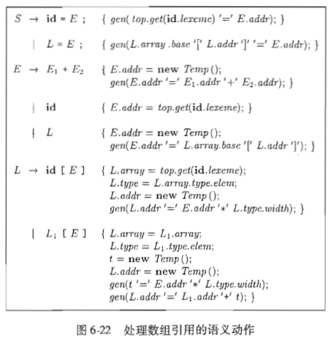

答：

1）x = a[i] + b[j]

S

x = E.addr = t5

E.addr = t2 + E.addr = t4

L.array = a L.array = b

L.type = a_type L.type = b_type

L.addr = t1 L.addr = t3

a.type [ E.addr = i ] b.type [ E.addr = j ]

=array(a_length, a_type) =array(b_length, b_type)

i j

t1 = i * a_type.width

t2 = a [ t1 ]

t3 = j * b_type.width

t4 = b [ t3 ]

t5 = t2 + t4

x = t5

2) x = a[i][j] + b[i][j]

S

x = E.addr = t9

E.addr = t4 + E.addr = t8

L.array = a L.array = b

L.type = a_type L.type = b_type

L.addr = t3 L.addr = t7

L.array = a L.array = b

L.type = array(aj_length, a_type) [ E.addr = j ] L.type = array(bj_length, b_type) [ E.addr = j ]

L.addr = t1 L.addr = t5

j j

a.type [ E.addr = i ] b.type [ E.addr = i ]

=array(ai_length, array(aj_length, a_type)) =array(bi_length, array(bj_length, b_type))

i i

t1 = i * array(aj_length, a_type).width

t2 = j * a_type

t3 = t1 + t2

t4 = a [ t3 ]

t5 = i * array(bj_length, b_type).width

t6 = j * b_type

t7 = t5 + t6

t8 = b [ t7 ]

t9 = t4 + t8

x = t9

6.5.1假定图 6-26 中的函数 widen 可以处理图 6-25a 的层次结构中的所有类型，翻译下列表达式。假定 c 和 d 是字符类型，s 和 t 是短整型， i 和 j 为整型， x 是浮点型。

1）x = s + c

2）i = s + c

3）x = (s + c) * (t + d)

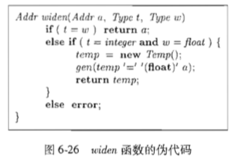 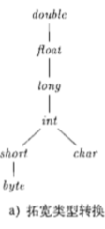

答：widen函数原本只能将integer转换为float，现假设该函数可以在所有类型间自下而上的转换

1）x = s + c

t1 = ( int ) s

t2 = ( int ) c

t3 = t1 + t2

x = ( float ) t3

2) i = s + c

t1 = ( int ) s

t2 = ( int ) c

i = t1 + t2

3) x = (s + c) * (t + d)

t1 = ( int ) s

t2 = ( int ) c

t3 = t1 + t2

t4 = ( int ) t

t5 = ( int ) d

t6 = t4 + t5

t7 = t3 * t6

x = ( float ) t7