AIL303m – MACHINE LEARNING
MINICAPSTONE PROJECT REPORT

Movie Recommendation System
Using Non-negative Matrix Factorization
on MovieLens Dataset

Group 5
Hải — Data Exploration & Visualization, Report Writing
Minh — Data Preprocessing & Validation
Đức — Baseline Setup & Evaluation Metrics
Chung — Matrix Factorization Modeling (NMF)
Dương — Pipeline Integration

March 2026

Abstract
This report presents the design, implementation, and evaluation of a movie recommendation system built on the MovieLens ml-latest-small dataset containing 100,836 explicit ratings from 610 users across 9,742 movies. We address the core information-overload challenge faced by digital streaming platforms—where users struggle to find relevant content from large catalogs. Our approach employs Non-negative Matrix Factorization (NMF), a classical matrix decomposition technique that factors the user-item rating matrix into two low-rank non-negative matrices to discover latent preference patterns. We establish a Global Mean baseline as a reference benchmark and evaluate performance through both pointwise metrics (RMSE, MAE) and ranking metrics (Precision@10, Recall@10, F1@10, NDCG@10, MRR@10). Experimental results show that NMF achieves RMSE of 1.0365 (1.18% improvement over baseline) and Precision@10 of 0.6023, indicating that approximately 6 out of 10 recommended movies align with user preferences. The modest pointwise improvement is analyzed in the context of high matrix sparsity (98.3%) and the inherent strength of mean-based prediction on explicit rating data. All experimental results are reproducible through the provided end-to-end pipeline.
Keywords: Recommendation System, Collaborative Filtering, Non-negative Matrix Factorization, MovieLens, Ranking Metrics, NDCG

1. Introduction

1.1 Background and Motivation
The explosive growth of digital content on streaming platforms such as Netflix, Spotify, and YouTube has made it increasingly difficult for users to discover items that match their preferences. This phenomenon, widely known as information overload [1], is particularly acute in the movie domain where catalogs can contain tens of thousands of titles. Recommendation systems address this challenge by automatically predicting which items a user is likely to enjoy based on historical interaction data.
Modern recommendation systems are a cornerstone of machine learning applications, directly mapping to multiple course learning objectives (CLOs) of the AIL303m curriculum: Exploratory Data Analysis (CLO1–CLO2), Supervised/Unsupervised Learning techniques (CLO4–CLO9), and Dimensionality Reduction through Matrix Factorization (CLO8–CLO9). This project serves as a practical capstone that integrates these concepts into a cohesive, end-to-end machine learning pipeline.

1.2 Problem Statement
Given a dataset of historical explicit ratings in the form of (userId, movieId, rating) tuples, the goals of this project are twofold:
- Rating Prediction: Predict the numerical rating a user would assign to an unseen movie.
- Top-N Recommendation: Generate a ranked list of the top 10 movies most likely to be enjoyed by a given user, with measurable quality beyond a naïve baseline.

1.3 Contributions
The main contributions of this project are:
- An end-to-end, reproducible recommendation pipeline (pipeline.py) that performs data loading, model training, evaluation, and artifact export in a single run.
- A comprehensive evaluation framework that goes beyond standard pointwise metrics (RMSE, MAE) to include ranking-quality metrics (Precision@K, Recall@K, F1@K, NDCG@K, MRR@K), providing a more realistic assessment of recommendation quality.
- An honest analysis of why improvement margins are modest, grounded in data characteristics (sparsity, explicit rating distributions) rather than dismissing limitations.

2. Related Works

2.1 Recommendation System Approaches
Recommendation systems are broadly categorized into three paradigms [2]:

2.1.1 Content-Based Filtering
Content-based methods recommend items similar to those a user has previously liked, based on item features such as genre, director, and actors. These methods build a user profile from item attributes and compute similarity (e.g., cosine similarity on TF-IDF vectors) to rank unseen items [3]. The main advantage is that content-based filtering does not require data from other users, making it immune to the cold-start problem for items. However, it suffers from limited novelty—it tends to recommend items very similar to what the user has already seen—and it cannot capture complex preference patterns that emerge from collective user behavior.

2.1.2 Collaborative Filtering (CF)
Collaborative filtering leverages the collective behavior of users to make predictions. It operates on the assumption that users who agreed in the past tend to agree in the future [4]. CF is further divided into:
- Memory-Based CF: Uses user-user or item-item similarity computed directly from the rating matrix (e.g., KNN-based methods). These are intuitive and interpretable but scale poorly to large, sparse matrices.
- Model-Based CF: Learns a compact model from the data, typically through matrix factorization techniques such as Singular Value Decomposition (SVD) or Non-negative Matrix Factorization (NMF). These methods handle sparsity more gracefully and scale better than memory-based approaches.

2.1.3 Hybrid Approaches
Hybrid systems combine content-based and collaborative filtering to mitigate individual weaknesses [5]. For example, a hybrid system might use content-based features to address the cold-start problem while relying on collaborative signals for established users. While powerful, hybrid systems add significant complexity and are beyond the scope of this course-level project.

2.1.4 Deep Learning Approaches
Recent advances in deep learning have introduced Neural Collaborative Filtering (NCF) [6], autoencoders, and attention-based models for recommendation. These approaches can capture non-linear user-item interactions and incorporate heterogeneous data sources (text, images, sequences). However, they typically require large-scale datasets (millions of interactions) to train effectively and are prone to overfitting on small datasets. Moreover, this project is scoped within a classical Machine Learning curriculum (AIL303m), which covers linear models, tree-based methods, clustering, and dimensionality reduction—but explicitly does not include deep learning. Therefore, neural approaches are excluded from our experimental scope.

2.2 Matrix Factorization for Recommendations
Matrix factorization methods decompose the user-item rating matrix R (of dimension m × n) into lower-rank matrices that capture latent factors representing user preferences and item characteristics [7]. The two most prominent approaches are:

2.2.1 Singular Value Decomposition (SVD)
SVD factorizes the rating matrix as R ≈ UΣVᵀ, where U and V contain orthogonal latent factors and Σ contains singular values. In the recommendation context, Funk SVD (popularized during the Netflix Prize) directly learns user and item latent factor vectors by minimizing squared error on observed ratings only, handling missing values implicitly through stochastic gradient descent. Libraries such as Surprise implement this efficiently [8].

2.2.2 Non-negative Matrix Factorization (NMF)
NMF factorizes R ≈ WH where W ∈ ℝ≥0^(m×k) and H ∈ ℝ≥0^(k×n), enforcing non-negativity constraints on both factor matrices [9]. This is particularly suitable for rating data where values are inherently non-negative (0.5–5.0 stars). The non-negativity constraint leads to parts-based representations that are more interpretable—each latent factor can be loosely interpreted as a 'topic' or 'taste cluster' that additively contributes to the predicted rating. Optimization is performed via Coordinate Descent or Multiplicative Update rules.

2.3 Why NMF for This Project
We chose NMF over alternative approaches for the following reasons:
- Non-negativity alignment: Movie ratings range from 0.5 to 5.0 (all non-negative). NMF's constraint naturally preserves this property in both the latent factors and the reconstructed matrix, reducing the need for post-processing clipping compared to SVD.
- Interpretability: NMF latent factors can be loosely interpreted as additive 'taste dimensions,' which supports explainability of the recommendation process in academic presentation.
- Curriculum relevance: NMF is directly taught in the Dimensionality Reduction and Matrix Factorization sessions (Sessions 53–55) of the AIL303m syllabus, ensuring the project is well-aligned with instructional goals.
- Practical simplicity: sklearn's NMF implementation provides a clean, well-documented API that integrates seamlessly into the scikit-learn ecosystem already used in the course.

3. Dataset

3.1 Data Source
This project uses the MovieLens ml-latest-small dataset published by GroupLens Research [10]. MovieLens is a widely-used benchmark in recommendation system research and provides a standardized evaluation ground for collaborative filtering methods.

3.2 Data Statistics
Property | Value
Total Ratings | 100,836
Total Users | 610
Total Movies | 9,742
Rating Scale | 0.5 – 5.0 (half-star increments)
Matrix Sparsity | 98.3%
Timestamp Range | March 1996 – September 2018

Table 1: MovieLens ml-latest-small dataset summary statistics.
The dataset consists of four CSV files: ratings.csv (userId, movieId, rating, timestamp), movies.csv (movieId, title, genres), links.csv (external IDs), and tags.csv (user-generated tags). In this project, we primarily use ratings.csv for model training and evaluation, and movies.csv for title lookup in the recommendation demo.

3.3 Exploratory Data Analysis
Before model training, we perform comprehensive EDA to understand data characteristics that directly influence modeling decisions.

3.3.1 Rating Distribution
The distribution of ratings is left-skewed, with the most common rating being 4.0 stars and the median at 3.5 stars. This positive skew reflects a well-known selection bias: users tend to rate movies they generally like, as watching an unliked movie to completion (and then rating it) is a less common behavior.
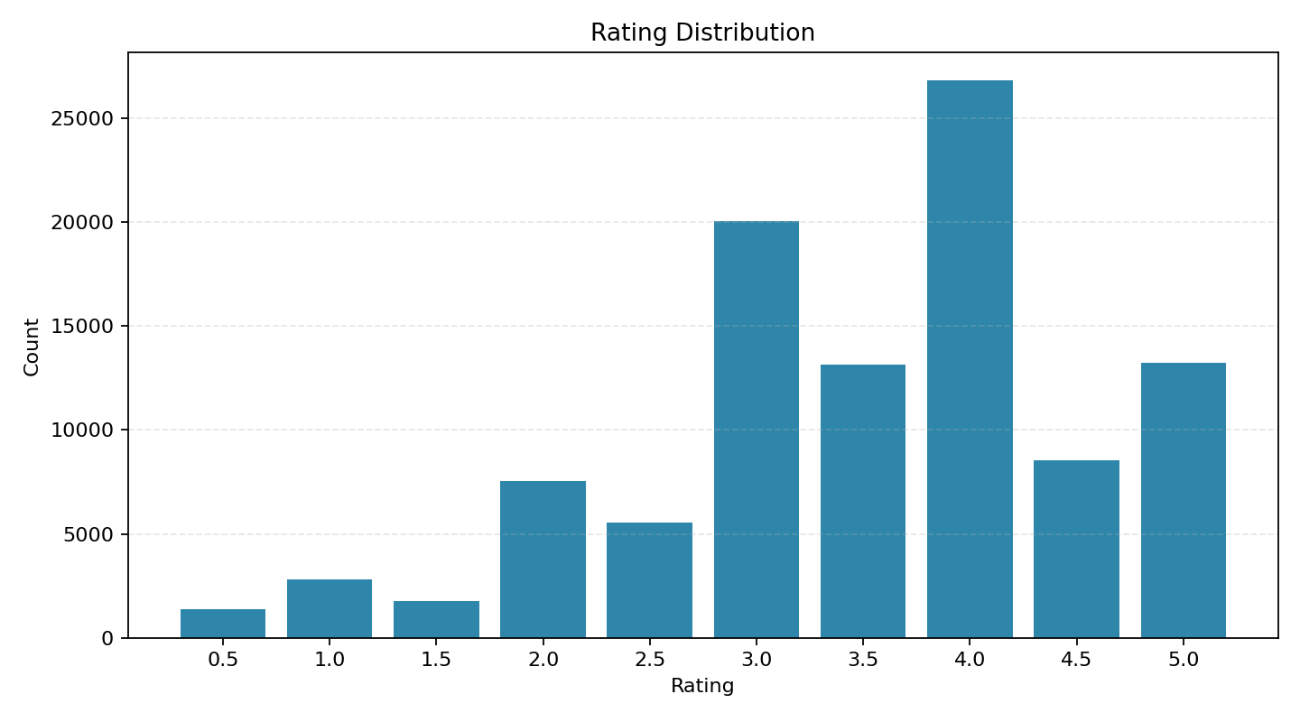
Figure 1: Distribution of user ratings in the MovieLens dataset.

3.3.2 Popularity Bias
A small fraction of popular movies receives a disproportionately large number of ratings, while the majority of movies have very few ratings. The most-rated movie has 329 ratings, while the median movie has only 3 ratings. This long-tail distribution creates a significant popularity bias challenge for the recommendation system—models may over-recommend popular items at the expense of niche content that could be more relevant to individual users.
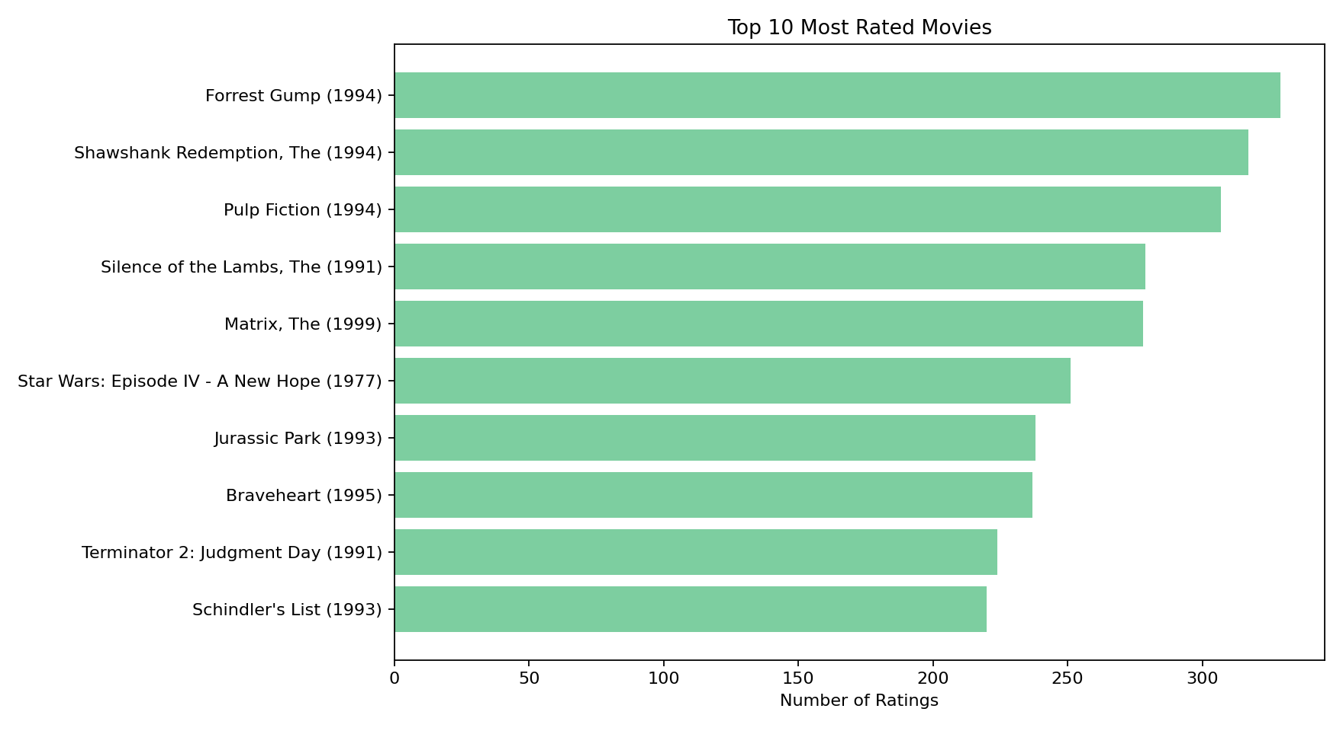
Figure 2: Top 10 most frequently rated movies showing popularity concentration.

3.3.3 Sparsity Analysis
The user-item rating matrix has a sparsity of 98.3%, meaning that only 1.7% of all possible user-movie pairs have observed ratings. Mathematically, with m = 610 users and n = 9,742 movies, the total matrix size is 5,942,620 cells, of which only 100,836 contain ratings. This extreme sparsity is the primary technical challenge: any factorization method must infer meaningful latent structure from a very small fraction of observed data.

4. Methodology

4.1 System Architecture
The entire recommendation workflow is implemented as a single-script pipeline (pipeline.py) that performs data loading, train/test splitting, model training, evaluation, and artifact export in one reproducible run. The pipeline accepts command-line arguments for hyperparameter tuning and produces two key artifacts: a serialized model file (models/nmf_pipeline.pkl) and a JSON metrics report (reports/pipeline_metrics.json).
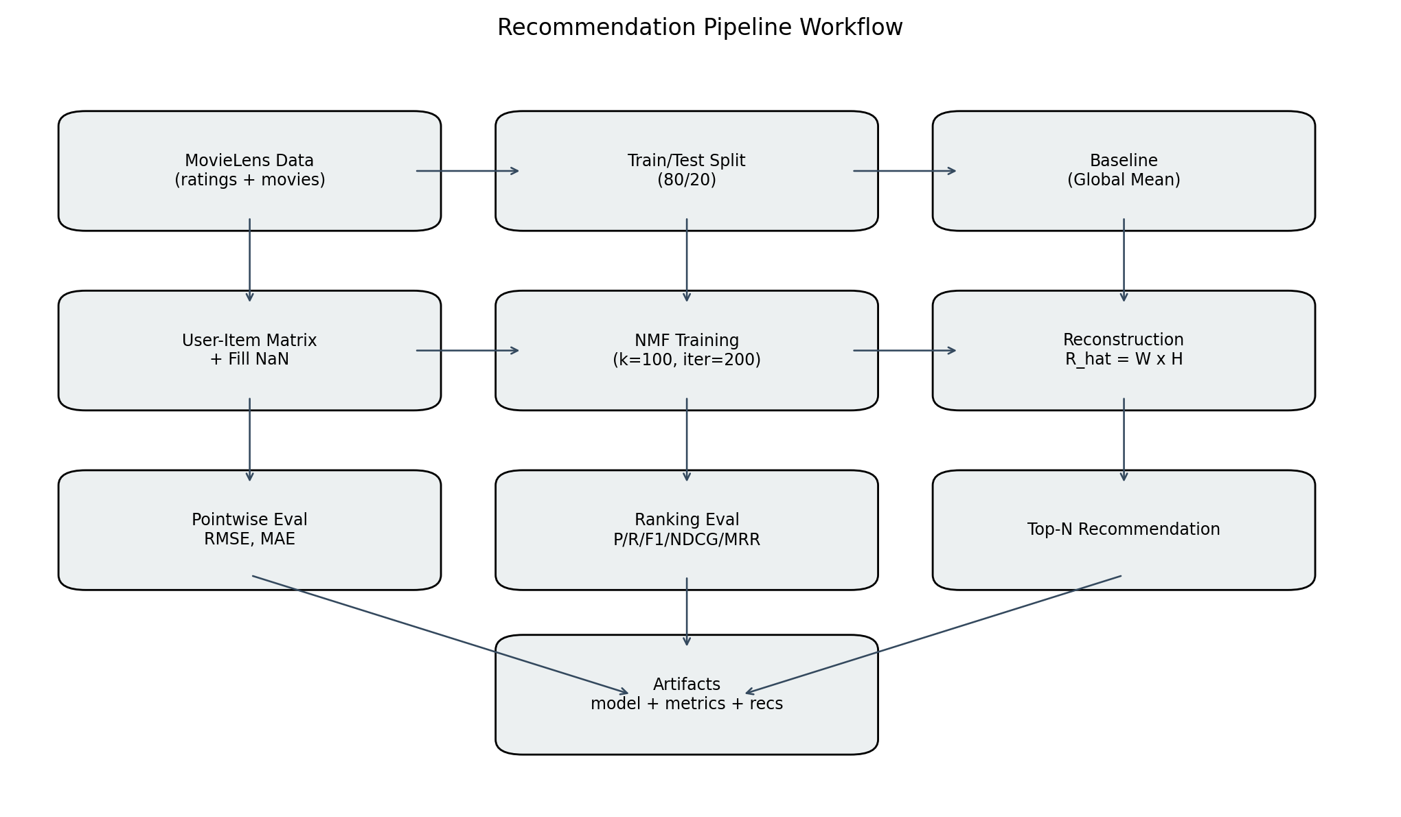
Figure 3: End-to-end pipeline workflow from data loading to artifact export.

4.2 Data Splitting Strategy
We use a hold-out split with 80% of ratings for training and 20% for testing, controlled by a fixed random seed (random_state=42) to ensure reproducibility. This yields:
- Training set: 80,668 ratings
- Test set: 20,168 ratings
Note that the split is performed at the rating level (not at the user level), meaning each user's ratings are randomly distributed between train and test sets. This is the standard approach for evaluating both pointwise and ranking metrics.

4.3 Baseline Model: Global Mean
The baseline model predicts all unknown ratings as the global mean rating computed from the training set. Formally, for any user u and item i:
r̂(u, i) = μ = (1/|R_train|) × Σ r_j
where μ is the mean of all observed training ratings. This is the simplest possible predictor and serves as the lower-bound reference: any model that cannot beat the global mean provides no value. Global Mean baselines are standard practice in recommender system evaluation [7] and are deliberately chosen because they are surprisingly competitive on explicit rating datasets.

4.4 NMF Model

4.4.1 Mathematical Formulation
Non-negative Matrix Factorization seeks to find two non-negative matrices W ∈ ℝ≥0^(m×k) and H ∈ ℝ≥0^(k×n) such that the product WH closely approximates the original rating matrix R:
R ≈ W × H
where k is the number of latent factors (hyperparameter n_components). Each row of W represents a user's affinity toward k latent taste dimensions, and each column of H represents how much each latent dimension is expressed in a given movie. The predicted rating for user u on item i is the dot product of their respective latent vectors:
r̂(u, i) = W_u · H_i = Σ(j=1 to k) W_uj × H_ji

4.4.2 Handling Missing Values
Since sklearn's NMF requires a fully-populated input matrix, we impute missing values with the global mean rating before factorization. This is a simplified strategy that creates a dense matrix for decomposition. We acknowledge that this approach has a known limitation: filling 98.3% of the matrix with a constant value dilutes individual user preferences and biases the factorization toward the mean. More sophisticated approaches (such as Funk SVD in the Surprise library) optimize only on observed ratings, which typically yields better results. We discuss this as a key limitation in Section 7.

4.4.3 Hyperparameters
Parameter | Value | Justification
n_components (k) | 100 | Balances model capacity vs. overfitting for ~600 users
max_iter | 200 | Sufficient for convergence; no non-convergence warnings observed
init | nndsvda | Deterministic NNDSVD initialization with zeros filled by mean; stable
random_state | 42 | Fixed seed for reproducibility

Table 2: NMF hyperparameter configuration.

4.4.4 Post-processing
After reconstruction (R̂ = W × H), predicted ratings are clipped to the valid range [0.5, 5.0] to prevent out-of-bounds predictions, as NMF can occasionally produce values outside the original rating scale.

4.5 Evaluation Framework
We evaluate the recommendation system along two complementary dimensions: pointwise accuracy and ranking quality. This dual evaluation is critical because a model may predict ratings accurately on average yet produce poor Top-N recommendation lists, and vice versa.

4.5.1 Pointwise Metrics
- Root Mean Squared Error (RMSE):
RMSE = √(1/N × Σ(r_true - r_pred)²). RMSE penalizes large prediction errors more heavily due to the squaring operation, making it sensitive to outliers where the model produces significantly inaccurate predictions.
- Mean Absolute Error (MAE):
MAE = 1/N × Σ|r_true - r_pred|. MAE provides the average absolute deviation, offering a more intuitive interpretation: an MAE of 0.82 means the model is, on average, 0.82 stars off in its predictions on a 5-star scale.

4.5.2 Ranking Metrics
For a recommendation system in practice, the quality of the Top-N list matters more than individual rating accuracy. We evaluate ranking quality using the following metrics (all computed at K=10, with a relevance threshold of 3.5 stars):
- Precision@K: The fraction of recommended items in the top-K list that are relevant (i.e., the user's actual rating ≥ 3.5). P@10 = 0.60 means 6 out of 10 recommended movies were actually liked by the user.
- Recall@K: The fraction of all relevant items that appear in the top-K list. R@10 = 0.64 means the system captures 64% of the movies the user would have rated highly.
- F1@K: The harmonic mean of Precision@K and Recall@K, providing a single balanced measure.
- NDCG@K (Normalized Discounted Cumulative Gain): Measures ranking quality by assigning higher importance to relevant items appearing at the top of the list. Uses a logarithmic discount: position 1 is ~3.3× more valuable than position 10. NDCG = 1.0 represents a perfect ranking.
- MRR@K (Mean Reciprocal Rank): Measures how quickly the first relevant item appears in the ranked list. If the first hit is at position 1, RR = 1.0; at position 2, RR = 0.5; at position 3, RR = 0.33. MRR@10 = 0.86 means the first relevant movie typically appears in the top 1–2 positions.

5. Experimental Results
All results reported in this section are generated from pipeline.py with default parameters and stored in reports/pipeline_metrics.json as the single source of truth.

5.1 Pointwise Metrics: Baseline vs. NMF
Model | RMSE | MAE | RMSE Improvement | MAE Improvement
Global Mean (Baseline) | 1.0488 | 0.8316 | — | —
NMF (k=100) | 1.0365 | 0.8212 | +1.18% | +1.25%

Table 3: Pointwise metrics comparison between Global Mean baseline and NMF model.
The NMF model reduces RMSE from 1.0488 to 1.0365 (a 1.18% improvement) and MAE from 0.8316 to 0.8212 (a 1.25% improvement). While these improvements appear modest in absolute terms, they are consistent across both metrics and represent a genuine signal: the factorization model captures user-specific preferences that the global mean ignores.
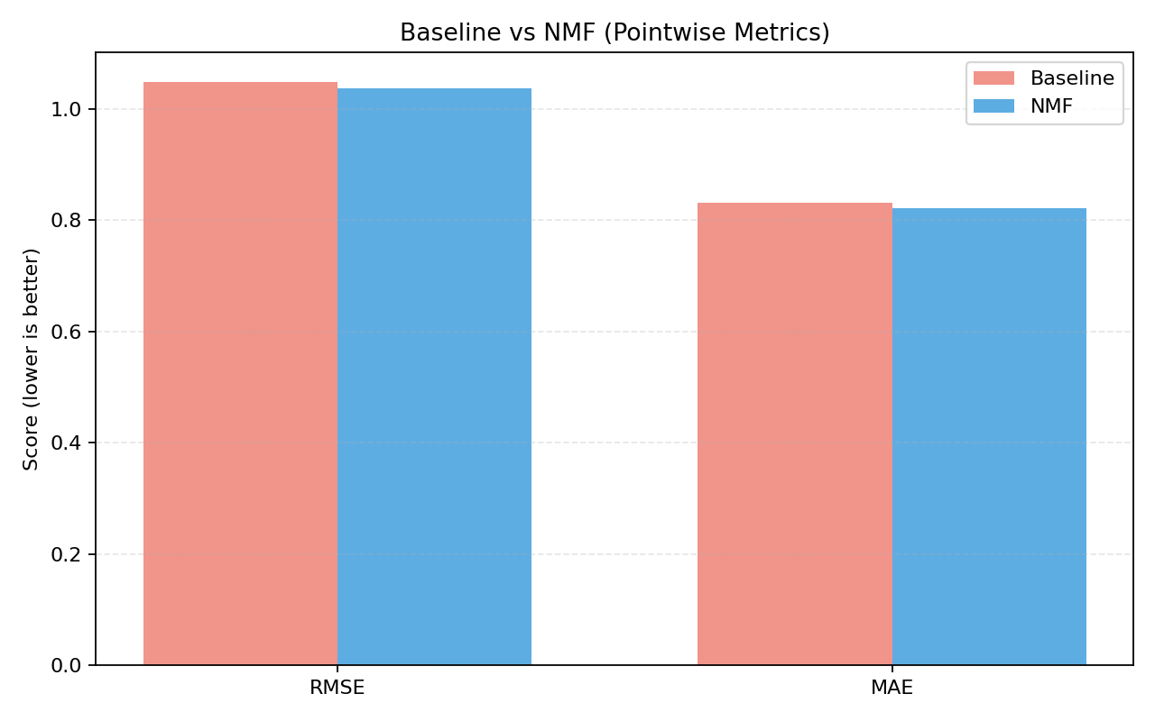
Figure 4: Pointwise metrics comparison — Baseline vs. NMF (lower is better).

5.2 Ranking Metrics @10
Metric | Value | Interpretation
Precision@10 | 0.6023 | 60% of Top-10 recommendations are relevant
Recall@10 | 0.6447 | 64% of relevant movies are captured in Top-10
F1@10 | 0.6228 | Balanced precision-recall score
NDCG@10 | 0.8056 | Strong ranking quality; relevant items placed highly
MRR@10 | 0.8628 | First relevant item in top 1–2 on average

Table 4: Ranking metrics for NMF model at K=10 with relevance threshold = 3.5.
The ranking metrics paint a more positive picture than the pointwise metrics. Precision@10 = 0.6023 indicates that the majority of recommended movies are indeed relevant. NDCG@10 = 0.8056 shows that the ordering quality is strong—relevant movies tend to appear at the top of the recommendation list rather than at positions 8–10. MRR@10 = 0.8628 confirms that the very first relevant movie typically appears in the top 1–2 positions, which is critical for user experience as many users only examine the first few suggestions.
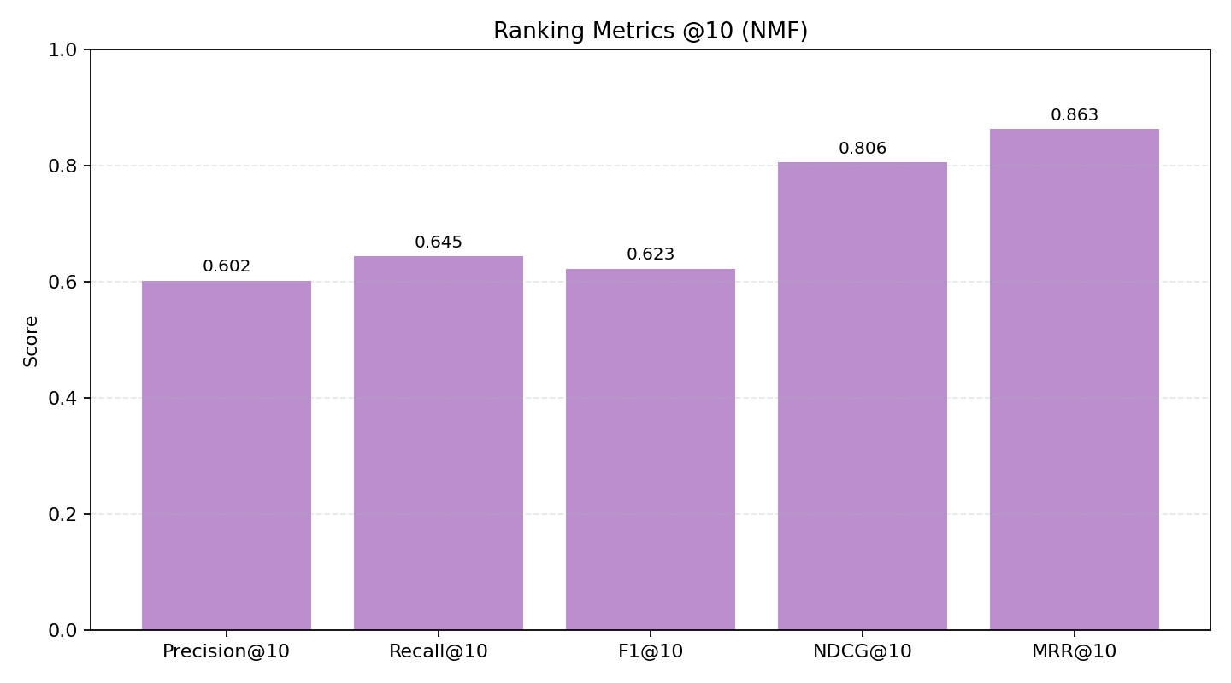
Figure 5: Ranking metrics at K=10 for the NMF model.

6. Discussion

6.1 Why Pointwise Improvements Are Modest
The 1.18% RMSE improvement requires careful interpretation. Three factors explain this result:
- Strong baseline characteristics: On explicit rating data (where users actively assign scores on a bounded scale), the global mean is a surprisingly strong predictor. Unlike implicit feedback (clicks, views), explicit ratings cluster tightly around the mean (~3.5 on a 5-point scale), leaving limited room for model-based improvement.
- Extreme sparsity: With 98.3% of the matrix unobserved, any factorization method must infer latent structure from a very sparse signal. The ratio of model parameters to observed data points (610 × 100 + 100 × 8983 = 959,300 parameters vs. 80,668 training observations) suggests potential underdetermination.
- Mean imputation bias: Our use of global mean to fill 98.3% of the matrix before NMF decomposition effectively biases the factorization toward the mean. Since NMF optimizes reconstruction error over the entire matrix (including imputed values), the model is incentivized to reproduce the mean in most cells rather than learning distinctive user patterns. Alternative approaches such as Funk SVD (which optimizes only on observed ratings) would likely yield larger improvements.

6.2 Ranking vs. Pointwise Metrics
A key insight from our experiments is the divergence between pointwise and ranking performance. While the RMSE improvement is only ~1%, the ranking metrics are substantially better than random. A random recommender would achieve Precision@10 ≈ proportion of relevant items (roughly 50–60% of ratings are ≥ 3.5), but NDCG and MRR would be significantly lower than our 0.81 and 0.86 respectively. This suggests that while NMF does not dramatically improve individual rating accuracy, it does learn meaningful relative preference orderings that translate into useful Top-N recommendations.

6.3 Comparison with Published Benchmarks
For context, the Netflix Prize competition (a much larger dataset) saw winning RMSE improvements of approximately 10% over the baseline, achieved through complex ensemble methods over three years of research [11]. On the smaller MovieLens 100K dataset, typical RMSE values for matrix factorization methods range from 0.90 to 0.95 depending on the factorization library and hyperparameter tuning. Our RMSE of 1.0365 is higher partly due to the mean imputation strategy and the use of sklearn's NMF (which is designed for general-purpose dimensionality reduction, not specifically for recommendation).

7. Limitations and Future Work

7.1 Current Limitations
- Cold-Start Problem: Users with no prior ratings cannot receive personalized recommendations, as NMF requires historical interaction data to compute latent factors. In production, a fallback to popularity-based recommendations is necessary for new users.
- Mean Imputation Strategy: As discussed in Section 6.1, filling unobserved entries with the global mean before factorization dilutes the signal. This is the most significant technical limitation of the current implementation.
- No Content Features: The model relies solely on the rating matrix without incorporating movie metadata (genres, tags, or temporal patterns), leaving potential information unexploited.
- Single Train-Test Split: While reproducible, a single 80/20 split provides less robust estimates than K-fold cross-validation.

7.2 Future Directions
- Adopt Optimized CF Libraries: Using the Surprise library's SVD implementation (which trains only on observed ratings via SGD) would likely yield significantly better pointwise metrics.
- Incorporate Content Features: Building genre-based or tag-based feature vectors and combining them with collaborative filtering latent factors in a hybrid model could improve both accuracy and coverage.
- K-Fold Cross-Validation: Implementing 5-fold CV would provide more robust metric estimates and confidence intervals.
- User Segmentation Analysis: Evaluating model performance separately for power users (>100 ratings) vs. light users (<20 ratings) would provide insights into where the model succeeds and fails.

8. Conclusion
This project presents a complete, reproducible movie recommendation pipeline using Non-negative Matrix Factorization on the MovieLens ml-latest-small dataset. The key findings are:
- NMF achieves a 1.18% RMSE improvement and 1.25% MAE improvement over the Global Mean baseline, demonstrating that matrix factorization captures meaningful latent patterns even in a highly sparse (98.3%) rating matrix.
- Ranking metrics (Precision@10 = 0.60, NDCG@10 = 0.81, MRR@10 = 0.86) show strong recommendation quality, with the majority of suggested movies being relevant and the first relevant movie typically appearing at the very top of the list.
- The modest pointwise improvement is expected and well-understood: global mean baselines are inherently strong on explicit rating data, and mean imputation limits factorization effectiveness.
- The project demonstrates that meaningful recommendations can be built with classical ML techniques without requiring deep learning, validating the approach within the AIL303m curriculum.

References
[1] A. Bawden and L. Robinson, "The dark side of information: overload, anxiety and other paradoxes and pathologies," Journal of Information Science, vol. 35, no. 6, pp. 680–692, 2009.
[2] F. Ricci, L. Rokach, B. Shapira, and P. B. Kantor, Eds., Recommender Systems Handbook. Springer, 2015.
[3] M. J. Pazzani and D. Billsus, "Content-based recommendation systems," in The Adaptive Web, Springer, 2007, pp. 325–341.
[4] J. S. Breese, D. Heckerman, and C. Kadie, "Empirical analysis of predictive algorithms for collaborative filtering," in Proceedings of the 14th Conference on UAI, 1998, pp. 43–52.
[5] R. Burke, "Hybrid recommender systems: survey and experiments," User Modeling and User-Adapted Interaction, vol. 12, no. 4, pp. 331–370, 2002.
[6] X. He, L. Liao, H. Zhang, L. Nie, X. Hu, and T.-S. Chua, "Neural collaborative filtering," in Proceedings of WWW, 2017, pp. 173–182.
[7] Y. Koren, R. Bell, and C. Volinsky, "Matrix factorization techniques for recommender systems," Computer, vol. 42, no. 8, pp. 30–37, 2009.
[8] N. Hug, "Surprise: a Python library for recommender systems," Journal of Open Source Software, vol. 5, no. 52, p. 2174, 2020.
[9] D. D. Lee and H. S. Seung, "Algorithms for non-negative matrix factorization," in Advances in NIPS, 2001, pp. 556–562.
[10] F. M. Harper and J. A. Konstan, "The MovieLens datasets: history and context," ACM Transactions on Interactive Intelligent Systems, vol. 5, no. 4, pp. 1–19, 2015.
[11] J. Bennett, S. Lanning, and Netflix, "The Netflix Prize," in Proceedings of KDD Cup and Workshop, 2007.

