Vol. xx, No. yy, month year, page. ab-cd
ISSN 2598-3245 (Print), ISSN 2598-3288 (Online)
DOI: [to be assigned by editor]
Available online at http://eltikom.poliban.ac.id

NUSANTARA MONOPOLY: DESIGN AND EVALUATION OF AN INDONESIAN DOMAIN ADAPTATION USING THE MDA FRAMEWORK
Muhammad Fahrul Bahri^{1*}, Muhayat¹
1) Department of Information Technology, Faculty of Science and Technology, Universitas Islam Negeri Antasari, Banjarmasin, Indonesia
e-mail: fahrulbahri@uin-antasari.ac.id, muhayat@uin-antasari.ac.id*
Received: xx month year • Revised: xx month year • Accepted: xx month year
ABSTRACT
Developing web adaptations of canonical tabletop board games presents software engineering challenges in state synchronization, transaction consistency, and non-player character (NPC) decision procedures. This study presents the domain adaptation, architecture, and empirical evaluation of Nusantara Monopoly, a lightweight web multiplayer game adapting canonical Monopoly into an Indonesian regional context using the Mechanics-Dynamics-Aesthetics (MDA) framework coupled with Heuristic Rule-Based Artificial Intelligence. The adaptation standardizes a 40-space board topology with 22 provincial properties across 8 regional color clusters, a 50-card event system partitioned into two distinct decks (Chance and Community Chest) with category-interleaved permutation, a 4-house-to-hotel upgrade model, autonomous heuristic AI agents with dynamic liquidity buffers, and a zero-asset procedural sound engine synthesized via the HTML5 Web Audio API. Empirical validation encompassed 12 functional test scenarios, a 200-match Monte Carlo benchmark, deployment telemetry across 31 rooms with 70 observed player instances, and a System Usability Scale (SUS) assessment with 30 respondents. All functional scenarios passed successfully. In the Monte Carlo benchmark, the heuristic AI attained the highest win rate (35.0%) and lowest bankruptcy rate (61.5%) against static, greedy, and random baselines. The card permutation algorithm strictly bounded consecutive penalty draws to at most 2 cards. Under the specified synthetic benchmark load, the server achieved over 450 requests/second with a ~24 KB room state footprint, while usability testing yielded an SUS score of 84.50, indicating favorable perceived usability among the evaluated participants.
Keywords: Domain Adaptation; Digital Board Game; Monopoly; MDA Framework; Heuristic AI; Multiplayer Web Game.

INTRODUCTION
Digital board games represent a sophisticated class of distributed, turn-based interactive software systems characterized by discrete event scheduling, spatial territory management, and state transition topologies [1], [2]. In recent years, migrating physical tabletop board games into interactive web-based applications has gained significant research traction in software engineering and digital entertainment systems [3], [4]. The foundational mechanics of economic property-acquisition board games—spatial circulation, progressive property rents, and capital liquidity management, originally pioneered by Elizabeth Magie in 1904 as The Landlord's Game and commercially popularized in 1935 as Monopoly—provide an established, mathematically structured foundation for multi-agent interactive simulations [4], [5], [6]. However, physical tabletop games suffer from accessibility constraints, and canonical Monopoly rules remain anchored to foreign urban landmarks that lack contextual resonance for regional communities [7], [8].
To bridge this gap, this study investigates the systematic domain adaptation of canonical Monopoly into a selected Indonesian provincial context, termed Nusantara Monopoly, and its implementation as a lightweight, zero-install web-based multiplayer application [1], [2]. Indonesia comprises an expansive archipelagic geography structured into 38 administrative provinces [34], offering diverse regional economic profiles. Rather than inventing arbitrary core game rules from scratch, adapting canonical Monopoly provides a proven ludological baseline while introducing a rich regional geography topology. The central research objective is to investigate how canonical property-acquisition and estate-development mechanics can be systematically mapped to Indonesian provinces and executed reliably in modern web browsers while retaining the core spatial circulation and property acquisition rules of the canonical game [7], [8].
To achieve this objective, the game design is formalized using the Mechanics-Dynamics-Aesthetics (MDA) framework [21], bridging low-level rule definitions with player experience. However, executing this adaptation within a modern web multiplayer environment introduces four distinct software engineering and algorithmic challenges that must be addressed during system implementation:
First, card event mechanisms in conventional digital board game implementations typically rely on unweighted pseudo-random number generators (PRNG). Under unweighted uniform random draws, consecutive penalty streaks frequently occur, subjecting players to repeated punitive draws (such as infrastructure repair charges or regional tax surcharges) that may increase the likelihood of abrupt liquidity depletion through long consecutive penalty sequences [10], [11]. The adapted card system requires an algorithmic permutation model across its two distinct event decks (Chance and Community Chest) that retains randomized card ordering within the imposed category constraint while strictly bounding consecutive penalties.
Second, providing autonomous non-player character (NPC) companions is essential for casual web gaming. However, full adversarial minimax game-tree searches are computationally costly in real-time browser environments due to the enormous branching factor resulting from 40 board spaces, variable dice distributions, and multi-tier house-to-hotel construction options [12], [13], [14]. The web adaptation requires a lightweight heuristic decision model capable of prioritizing complete regional color clusters and managing liquidity reserves without exhaustive game-tree traversal.
Third, multi-client web multiplayer architectures require reliable turn state synchronization. Utilizing heavy relational database clusters for turn-based state mutations introduces connection overhead and locking contention across concurrent rooms [15], [16], while full-duplex WebSockets impose continuous stateful connection maintenance on mobile networks [17]. A decoupled, room-isolated document storage model with atomic file locking is needed to support concurrent matches on constrained server infrastructure.
Fourth, traditional web games depend on external static audio files (MP3/WAV) that consume valuable network bandwidth and cause loading latency on mobile connections in peripheral regions [18], [19], [20]. The system architecture requires a zero-asset procedural sound synthesis approach to deliver responsive acoustic feedback without separate audio-file downloads.
To position this research within the existing literature, Table 1 provides a comparative analysis benchmarking Nusantara Monopoly against 9 selected related digital board game studies across architectural, algorithmic, and evaluation criteria, including recent game technology publications from Jurnal ELTIKOM [9], [14].
Table 1. Comparison with Selected Related Digital Board Game Studies
Reference & Year | Target Domain | Multiplayer Sync | NPC AI Model | Deck Balancing | Audio Architecture | Evaluation Method
Ramadhan et al. (2024) [7] | Multiplayer Math Game | HTTP REST / Web | Rule-Based Logic | NR | NR | Functional Testing
Mohamad et al. (2026) [8] | Multiplayer Geometry Game | WebSocket Real-Time | NR | NR | NR | Expert & Usability
Wisinggya et al. (2021) [9] | Traditional Music Game | Standalone Unity | Fuzzy Dynamic Difficulty | NR | Static Audio | Expert & Usability Test
Derrick et al. (2022) [10] | Card Game Analysis | Turn-based Mechanics | Probability Rules | Random Permutations | NR | Mathematical Analysis
Herrero et al. (2026) [2] | Board Game Design History | Tabletop / Hybrid | Expert Heuristics | NR | NR | Empirical Case Study
Sidiq et al. (2022) [14] | Online Game Testing | Client-Server TCP | Bot Stress Automation | NR | NR | Capacity Benchmark
Wang et al. (2024) [15] | Deterministic Concurrency | Optimistic Protocol | NR | NR | NR | Throughput Benchmark
Ye et al. (2023) [16] | Database Concurrency | Optimistic Priority Lock | NR | NR | NR | Conflict Abort Rate
Matuszewski & Rottier (2023) [18] | Web Audio Interface | Client Browser | NR | NR | Web Audio API Synthesis | Acoustic Benchmark
This Study (Nusantara Monopoly) | Indonesian Regional Economy | Room-Isolated REST + Atomic flock() | Heuristic Valuation + Dynamic Buffer | Category-Interleaved Permutation (<=2 Bound) | Procedural Web Audio (0 KB Download) | 12 Black-Box + Controlled AI Benchmark (N=200) + Telemetry (31 Rooms, 70 Player Instances) + SUS (N=30 Respondents)
As demonstrated in Table 1, existing digital board game research has predominantly examined isolated technical components: graphic theme localization without autonomous NPC decision procedures [1], [8], card randomization theory without sequential penalty streak suppression [10], [11], or database concurrency control without multi-tiered board gameplay dynamics [15], [16]. A significant research gap remains in synthesizing canonical economic board game rules into a culturally localized regional domain while simultaneously ensuring concurrent web transaction safety, believable and computationally lightweight AI opponents, and bounded-penalty card mechanics on constrained web hosting infrastructure.
To bridge this gap, this study presents Nusantara Monopoly, an integrated digital board game system engineered through the following specific technical contributions:
a) Formulating an MDA-based ludological mapping that translates canonical Monopoly rules into a 40-space board topology covering 22 Indonesian provincial properties across 8 regional color clusters with a 4-house-to-hotel development progression.
b) Engineering an autonomous Heuristic Rule-Based AI engine incorporating a 2.5x strategic monopoly completion multiplier, progressive house and hotel development logic, and a dynamic liquidity safety buffer, validated against greedy, static, and random baselines under balanced strategy allocation.
c) Designing a Balanced Category-Interleaved Deck Shuffling algorithm across a 50-card event system (partitioned into 26 Chance cards and 24 Community Chest cards) that mathematically bounds consecutive penalty streaks to at most 2 cards while maintaining controlled category interleaving according to the fixed composition of each deck.
d) Implementing a lightweight, decoupled MVC architecture with room-isolated JSON documents, atomic advisory file locking (flock(LOCK_EX)), and a zero-asset procedural Web Audio synthesis engine that eliminates separate audio-file downloads.
e) Executing a multi-dimensional empirical evaluation pipeline spanning 12 functional test scenarios, a 200-match Monte Carlo AI benchmark, 50,000 card draw simulations across both decks, deployment telemetry across 31 rooms with 70 observed player instances, and a formal System Usability Scale (SUS) assessment.

RESEARCH METHOD
This study employs a hybrid methodological framework combining the Game Development Life Cycle (GDLC) as an overarching software engineering development process model and the Mechanics-Dynamics-Aesthetics (MDA) framework [21] as the formal ludological design framework. While GDLC structures the practical engineering stages (Concept, Design, Implementation, Testing, and Release), the MDA framework formally structures the translation between low-level game mechanics, emergent player dynamics, and intended aesthetic user experiences. Figure 1 illustrates the integrated research flowchart.
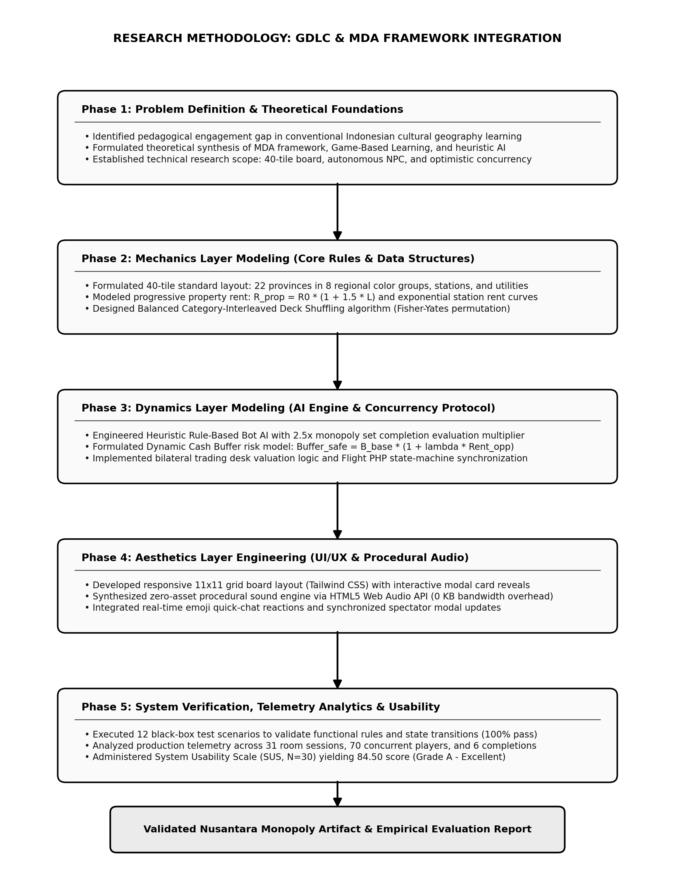
Figure 1. Research Flowchart and Methodology Framework of Nusantara Monopoly Based on MDA
The research pipeline is executed across 5 (five) sequential phases:
1. Requirements and Domain Modeling: Formalizing the geographic, economic, and administrative domain model for selected Indonesian provincial properties, and defining concurrency requirements for casual web multiplayer execution.
2. MDA Ludological Formulation: Decomposing the game into formal Mechanics (board geometry, rent equations, card specifications, house and hotel construction rules), Dynamics (property acquisition competition, monopoly formation, liquidity risk management), and intended Aesthetics (competitive tension, regional geographic appreciation, responsive acoustic feedback).
3. Software Architecture and Web Implementation: Engineering the decoupled MVC backend using Flight PHP, the client-side state machine using Vanilla ES6+ JavaScript, atomic session persistence, and runtime audio synthesis using the Web Audio API.
4. Algorithmic Modeling: Formulating the heuristic NPC decision equations and category-interleaved card shuffling logic.
5. Multi-Tier Empirical Validation: Executing functional testing structured with reference to ISO/IEC/IEEE 29119, Monte Carlo AI baseline benchmarking (N=200 matches with balanced 1-slot allocation), Monte Carlo deck draw simulations across N=2,000 deck-cycles (1,000 cycles per deck across 26 Chance and 24 Community Chest cards, totaling 50,000 draws), live deployment telemetry (31 rooms, 70 observed player instances), synthetic HTTP stress testing, and formal SUS usability testing (N=30 respondents).

MDA Framework Ludological Formulation
To ensure rigorous game design without conflating ludological rules with software implementation details, the game system is formally categorized according to the three core tenets of the MDA framework [21]:
1. Mechanics: Mechanics represent the foundational rules, objects, actions, and constraints defined by the system designer. In Nusantara Monopoly, mechanics encompass: the 40-space perimeter board topology, 22 purchasable provincial property deeds categorized into 8 regional color clusters, 2 municipal utility companies (State Electricity PLN and Regional Water PDAM), 4 major Indonesian railway stations (Stasiun Gambir, Bandung, Pasar Turi, and Medan), progressive rental rate schedules (from base rent up to 4 houses and 1 hotel), dice rolling rules (2d6 with doubles logic), Chance (Kesempatan) and Community Chest (Dana Umum) event cards, and bankruptcy liquidation procedures.
2. Dynamics: Dynamics describe the runtime behavior and emergent interactions that materialize as players execute game mechanics over time. In Nusantara Monopoly, dynamics include: territorial acquisition competition among players, strategic monopoly formation within regional color clusters, capital liquidity and solvency risk management, autonomous AI decision behavior, house-to-hotel property upgrading cascades, and competitive pacing between human and AI participants.
3. Aesthetics: Aesthetics define the intended emotional responses and experiential outcomes evoked in players during gameplay. In Nusantara Monopoly, intended aesthetic outcomes encompass: strategic tension during high-stakes roll-and-move phases, regional geographic exploration across Indonesian provincial territories, the thrill of completing regional color clusters and constructing hotels, and sensory satisfaction delivered through procedural audiovisual feedback.
Importantly, software infrastructure elements—such as Model-View-Controller (MVC) separation, JSON document stores, atomic advisory file locking (flock(LOCK_EX)), HTTP short-polling with MD5 checksum verification, and Web Audio API synthesis—represent software architecture and technical implementation mechanisms, rather than MDA ludological components.

Software Architecture and Concurrency Control
Nusantara Monopoly adopts a decoupled Model-View-Controller (MVC) architecture engineered specifically for lightweight, concurrent execution under the evaluated workload on constrained hosting infrastructure. Figure 2 illustrates the system use case diagram delineating role segregation between Human Players, Autonomous AI Agents, and System Administrators.
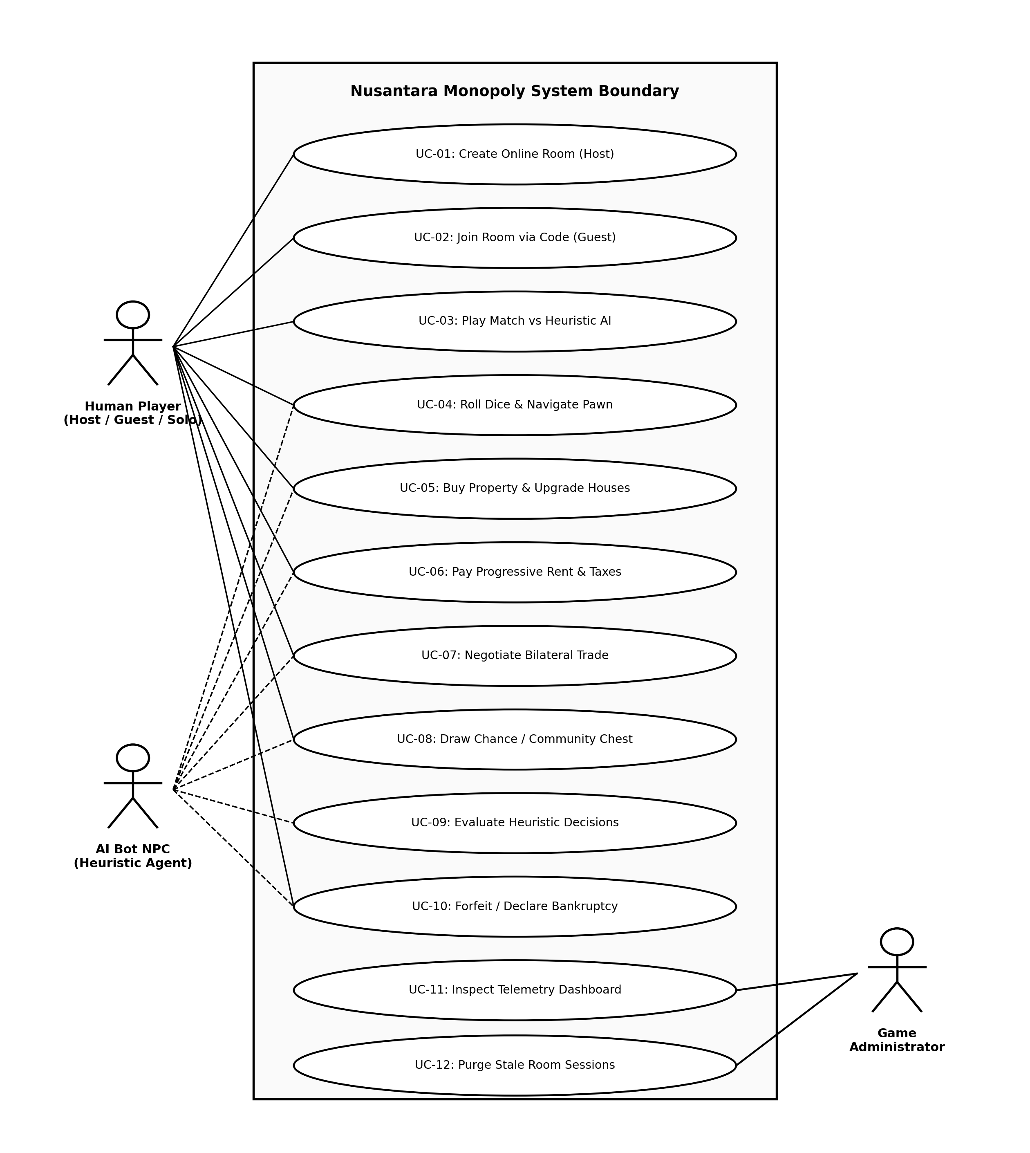
Figure 2. System Use Case Diagram of Nusantara Monopoly Demonstrating Role Segregation
The storage architecture of Nusantara Monopoly is engineered around a room-isolated JSON document store rather than a heavy relational database cluster. A room-isolated file-based state model was selected because the target workload consists of small, ephemeral, turn-based sessions with low state cardinality involving 2 to 4 players. Utilizing relational database engines (e.g., MySQL or PostgreSQL) for such high-frequency, low-cardinality state mutations introduces substantial connection handshake latency, ACID row-level locking overhead, and table contention across independent rooms [15], [16]. By persisting each match session as an independent serialized JSON document (storage/rooms/{room_id}.json), Nusantara Monopoly isolates room state at the file level and serializes critical-section writes within each room. State mutations are committed atomically using PHP's native advisory file locking mechanism (flock(LOCK_EX)), which serializes cooperating writes within the locked critical section and isolates room-level state mutations during concurrent player inputs. The system data flow is formalized in the Data Flow Diagram (DFD Level 1) depicted in Figure 3.
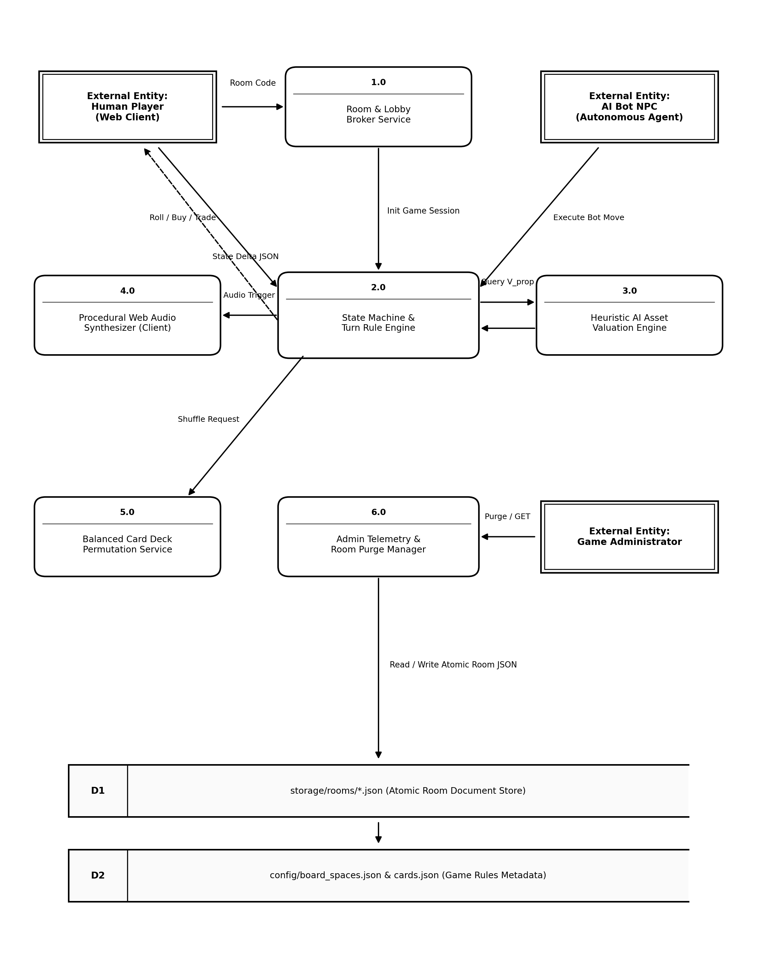
Figure 3. Level-1 Data Flow Diagram (DFD) Illustrating Room-Isolated Document Store Architecture
The architectural compromises and design considerations between HTTP short-polling and full bidirectional WebSockets represent a pivotal software engineering consideration in web-based multiplayer game architecture [17]. While WebSockets establish continuous full-duplex TCP connections well-suited for high-frequency action genres, maintaining long-lived stateful socket connections across numerous concurrent mobile clients introduces memory residency overhead, frequent disconnection drops across mobile base station handoffs, and restrictive firewall traversal barriers on institutional campus networks. In turn-based digital board games where state transitions occur discretely at human deliberative speeds (averaging 5 to 10 seconds per turn), an optimized HTTP short-polling architecture with adaptive intervals (1,500 ms during active play, expanding to 5,000 ms during idle phases) is suitable for the evaluated low-frequency turn-based workload. By transferring compact serialized JSON payloads (~1.8 KB) containing current board coordinates, player capital balances, and transaction event logs, server bandwidth consumption is minimized while achieving visual update latencies suitable for turn-based gameplay.
Furthermore, the room-isolated JSON persistence mechanism avoids the relational database locking bottlenecks analyzed by Lubis et al. [15] and Pratama et al. [16]. Nusantara Monopoly encapsulates each active match within an isolated filesystem document (storage/rooms/{room_id}.json). State modifications are wrapped within atomic PHP advisory file locks using flock(LOCK_EX), ensuring that file I/O operations are serialized cleanly within each individual room without imposing blocking constraints on any other concurrent game sessions. Each session document occupies approximately 24 KB of serialized JSON state size on disk and memory cache, providing a lightweight execution footprint under concurrent room hosting. Each game room is assigned a randomly generated room code (e.g., JAWA-81, PAPUA-434, MONO-30) used by players to join the corresponding session. Player display names are stored as session-level game-state attributes within the room JSON document and are not associated with persistent user accounts. Game-room state, including associated player entries, is ephemeral and is removed from server storage when the room is dissolved or concluded.
For complete experimental reproducibility, the production test server environment was deployed on an Ubuntu 22.04 LTS instance equipped with 4 vCPU cores, 8 GB DDR4 RAM, PHP 8.2 with OPcache enabled, and an Nginx reverse proxy. Static frontend assets are delivered via HTTP/2 with gzip compression, while state synchronization is governed by an adaptive short-polling interval (1,500 ms) combined with optimistic state hashing (MD5 checksum verification) as a state checksum for optimistic concurrency and stale-state detection. When a client submits a mutation request, the server verifies whether the client's cached state checksum matches the server's canonical state checksum. If a discrepancy is detected (e.g., due to an interleaved action by another player), the server responds with an HTTP 409 Conflict status, instructing the requesting client to re-synchronize its local state before re-attempting the action. This optimistic concurrency control supports deterministic state reconciliation without database-level deadlock vulnerabilities [15], [16].

Domain Adaptation and Archipelagic Topology
The canonical movement, property acquisition, rent payment, and bankruptcy structure was retained, while property identities, regional grouping, economic parameters, card events, and property development parameters were adapted for the Indonesian context. Table 2 provides a systematic mapping between canonical Monopoly components and the Nusantara Monopoly domain adaptation.
Table 2. Canonical Monopoly to Nusantara Monopoly Domain Adaptation Mapping
Canonical Monopoly Component | Nusantara Monopoly Adaptation | Rule Status | Design Rationale
Board Geometry (40 spaces) | 40 operational spaces on 11x11 square perimeter | Preserved | Maintains canonical movement cadence, lap frequency, and spatial probability distribution.
Property Spaces (22 deeds) | 22 Indonesian provincial properties across 8 regional color clusters | Modified | Maps selected Indonesian provinces while strictly preserving the canonical 22-deed mathematical balance.
Railroads (4 spaces) | 4 major Indonesian railway stations (Gambir, Bandung, Ps Turi, Medan) | Reinterpreted | Reflects major Indonesian transit hubs with progressive scaling rent based on station count.
Utilities (2 spaces) | Two adapted utility entities: PLN and PDAM | Reinterpreted | Contextualizes infrastructure utilities with dice-multiplier rental formulas (40k x / 100k x dice sum).
Corner Spaces (4 spaces) | Mulai (GO), Penjara (Jail), Parkir Bebas (Free Parking), Masuk Penjara | Preserved | Retains core circuit anchors, jail lockup conditions, and circulating salary mechanics.
Municipal Taxes (2 spaces) | Pajak Pendapatan (IDR 2,000,000) and Pajak Mewah (IDR 1,000,000) | Modified | Contextualizes flat tax penalties scaled to the adapted Indonesian Rupiah denomination.
Event Cards (Chance / Community Chest) | 50 total card structures across 2 distinct decks (Chance: 26 cards, Community Chest: 24 cards) | Modified | Adapts event narratives to regional socio-economic scenarios with balanced category interleaving.
Property Development (Houses / Hotel) | Progressive 1 to 4 houses; 4 houses replaced by 1 Hotel upon 5th upgrade | Modified | Preserves canonical 4-house-to-hotel replacement mechanic with Indonesian currency values.
Monopoly Rent Doubling | Base rent doubles when full regional color cluster is owned (M_rent = 2.0) | Preserved | Preserves core economic incentive driving property acquisition and complete cluster formation.
The domain adaptation of canonical Monopoly to Nusantara Monopoly maps the standard 11x11 square grid (40 operational spaces) directly to the geographic, economic, and administrative infrastructure of Indonesia. The 40 operational spaces comprise: 22 Indonesian Provincial Properties, 4 major Indonesian railway stations (Stasiun Gambir, Bandung, Pasar Turi, and Medan), 2 Public Utility Companies (State Electricity PLN and Regional Water PDAM), 3 Community Chest (Dana Umum) spaces, 3 Chance (Kesempatan) spaces, 4 Corner Anchors (Mulai/GO, Penjara, Parkir Bebas, Masuk Penjara), and 2 Municipal Tax Spaces (Pajak Pendapatan - IDR 2,000,000 at tile index 4, and Pajak Mewah - IDR 1,000,000 at tile index 38). The sum of all operational spaces exactly satisfies:
22_{provinces} + 4_{transport} + 2_{utilities} + 3_{chest} + 3_{chance} + 4_{corners} + 2_{taxes} = 40_{spaces} | (1)
Definition of Regional Color Clusters: A regional color cluster is a game-design grouping of provincial properties used to preserve the canonical Monopoly color-set structure while representing selected Indonesian regions. While Indonesia encompasses 38 administrative provinces, canonical Monopoly board topology strictly provides exactly 22 purchasable property deed spaces distributed across 8 color-coded property sets (Brown and Dark Blue contain 2 deeds each; the remaining six sets contain 3 deeds each). Expanding the perimeter beyond 40 spaces would disrupt the mathematical circuit duration, inflating match lengths past 3 hours and inducing player fatigue [6], [8]. Therefore, 22 representative provinces were selected to preserve the canonical board topology while representing selected Indonesian regions across 8 regional color clusters.
The regional color-cluster weights k_{cluster} in [1.00, 1.30] represent game-design regional weighting parameters used to differentiate property valuation across color clusters along the clockwise quadrant progression, rather than empirical macroeconomic indices or BPS gross regional domestic product indicators. In canonical Monopoly, properties on later board quadrants feature progressively higher acquisition costs and rental yields, creating economic escalation as tokens circulate clockwise. The weights k_{cluster} scale AI acquisition priority and liquidity buffers along this progression: early-board groups (Brown, Light Blue) are weighted at 1.00, mid-board groups (Pink, Orange) at 1.10, late-mid groups (Red, Yellow) at 1.20, and endgame groups (Green, Dark Blue) at 1.30 to reflect strategic late-game asset values.
Property Development and Rental Progression: In Nusantara Monopoly, property development strictly adheres to tournament Monopoly standards: once a player achieves complete ownership of all provincial properties within a regional color cluster, development is unlocked across that cluster. Crucially, players are not required to land on the property space again to develop it; development actions can be initiated at any point during the player's active turn via the title deed interface for human participants, and during the turn conclusion phase for AI agents. Development is governed by two invariant rules: (i) the even-building rule, which mandates that houses must be built evenly across all properties within the cluster (no property may receive a subsequent house until all properties in that group possess an equal number of houses); and (ii) progressive hotel conversion, wherein up to 4 houses may be constructed sequentially, and a fifth upgrade replaces all 4 houses with 1 grand Hotel (isHotel = true, houses = 0). The rental fee R_p remitted by an opponent landing on property p is formally governed by:
R_p = 2 * R_{base} (if h_p=0, monopoly), R_p[h_p] (if h_p in {1..4}), R_{hotel}(p) (if Hotel) | (2)
where R_{base} represents baseline rent with zero houses, M_{rent} = 2.0 doubles base rent when the complete regional color cluster is owned without houses, R_p[h_p] specifies the exact rental schedule for 1 to 4 houses, and R_{hotel}(p) specifies the maximum rental rate when upgraded to a Hotel. Table 3 details the complete architectural and economic parameters for all 22 provincial properties as implemented in the game engine.
Table 3. Architectural and Economic Rental Parameters of the 22 Provincial Properties Across 8 Regional Color Clusters
ID | Province Name | Color Cluster | Price | Base Rent | House Cost | Rent 1H | Rent 2H | Rent 3H | Rent 4H | Hotel Rent
01 | Aceh | Brown | 600,000 | 20,000 | 500,000 | 100,000 | 300,000 | 900,000 | 1,600,000 | 2,500,000
03 | Sumatera Utara | Brown | 600,000 | 40,000 | 500,000 | 200,000 | 600,000 | 1,800,000 | 3,200,000 | 4,500,000
06 | Sumatera Barat | Light Blue | 1,000,000 | 60,000 | 500,000 | 300,000 | 900,000 | 2,700,000 | 4,000,000 | 5,500,000
08 | Riau | Light Blue | 1,000,000 | 60,000 | 500,000 | 300,000 | 900,000 | 2,700,000 | 4,000,000 | 5,500,000
09 | Sumatera Selatan | Light Blue | 1,200,000 | 80,000 | 500,000 | 400,000 | 1,000,000 | 3,000,000 | 4,500,000 | 6,000,000
11 | Lampung | Pink | 1,400,000 | 100,000 | 1,000,000 | 500,000 | 1,500,000 | 4,500,000 | 6,250,000 | 7,500,000
13 | Banten | Pink | 1,400,000 | 100,000 | 1,000,000 | 500,000 | 1,500,000 | 4,500,000 | 6,250,000 | 7,500,000
14 | DKI Jakarta | Pink | 1,600,000 | 120,000 | 1,000,000 | 600,000 | 1,800,000 | 5,000,000 | 7,000,000 | 9,000,000
16 | Jawa Barat | Orange | 1,800,000 | 140,000 | 1,000,000 | 700,000 | 2,000,000 | 5,500,000 | 7,500,000 | 9,500,000
18 | Jawa Tengah | Orange | 1,800,000 | 140,000 | 1,000,000 | 700,000 | 2,000,000 | 5,500,000 | 7,500,000 | 9,500,000
19 | D.I. Yogyakarta | Orange | 2,000,000 | 160,000 | 1,000,000 | 800,000 | 2,200,000 | 6,000,000 | 8,000,000 | 10,000,000
21 | Jawa Timur | Red | 2,200,000 | 180,000 | 1,500,000 | 900,000 | 2,500,000 | 7,000,000 | 8,750,000 | 10,500,000
23 | Bali | Red | 2,200,000 | 180,000 | 1,500,000 | 900,000 | 2,500,000 | 7,000,000 | 8,750,000 | 10,500,000
24 | Nusa Tenggara Barat | Red | 2,400,000 | 200,000 | 1,500,000 | 1,000,000 | 3,000,000 | 7,500,000 | 9,250,000 | 11,000,000
26 | Nusa Tenggara Timur | Yellow | 2,600,000 | 220,000 | 1,500,000 | 1,100,000 | 3,300,000 | 8,000,000 | 9,750,000 | 11,500,000
27 | Kalimantan Barat | Yellow | 2,600,000 | 220,000 | 1,500,000 | 1,100,000 | 3,300,000 | 8,000,000 | 9,750,000 | 11,500,000
29 | Kalimantan Timur | Yellow | 2,800,000 | 240,000 | 1,500,000 | 1,200,000 | 3,600,000 | 8,500,000 | 10,250,000 | 12,000,000
31 | Kalimantan Selatan | Green | 3,000,000 | 260,000 | 2,000,000 | 1,300,000 | 3,900,000 | 9,000,000 | 11,000,000 | 12,750,000
32 | Sulawesi Selatan | Green | 3,000,000 | 260,000 | 2,000,000 | 1,300,000 | 3,900,000 | 9,000,000 | 11,000,000 | 12,750,000
34 | Sulawesi Utara | Green | 3,200,000 | 280,000 | 2,000,000 | 1,500,000 | 4,500,000 | 10,000,000 | 12,000,000 | 14,000,000
37 | Maluku | Dark Blue | 3,500,000 | 350,000 | 2,000,000 | 1,750,000 | 5,000,000 | 11,000,000 | 13,000,000 | 15,000,000
39 | Papua | Dark Blue | 4,000,000 | 500,000 | 2,000,000 | 2,000,000 | 6,000,000 | 14,000,000 | 17,000,000 | 20,000,000
For complete game engine replication, universal financial constants are defined as follows: Initial player cash endowment is IDR 15,000,000; passing Start (Mulai/GO) awards a circulating salary of IDR 2,000,000; In-Jail bail fine is IDR 1,500,000; Income Tax (Pajak Pendapatan) levies IDR 2,000,000; Luxury Tax (Pajak Mewah) levies IDR 1,000,000; utility rent is 40,000x dice sum (1 utility) or 100,000x dice sum (2 utilities); and transportation hub rent scales progressively: IDR 250,000 (1 station), IDR 500,000 (2 stations), IDR 1,000,000 (3 stations), and IDR 2,000,000 (all 4 stations owned).

Penalty-Streak-Constrained Deck Permutation
In turn-based tabletop board games, card event mechanics can significantly influence player progression. Standard unweighted pseudo-random number generator (PRNG) draws frequently cause clustering of punitive outcomes, subjecting players to long consecutive penalty sequences [10], [11]. To prevent this while retaining randomized card ordering within the imposed category constraint, Nusantara Monopoly implements a Balanced Category-Interleaved Deck Shuffling algorithm across a 50-card event system partitioned into two distinct physical decks: Chance (Kesempatan, comprising 26 cards) and Community Chest (Dana Umum, comprising 24 cards). Each deck is partitioned into 4 functional categories:
- Chance Deck (26 cards): C_{profit} = 7 cards (26.9%), C_{penalty} = 6 cards (23.1%), C_{gacha} = 7 cards (26.9%), and C_{special} = 6 cards (23.1%).
- Community Chest Deck (24 cards): C_{profit} = 6 cards (25.0%), C_{penalty} = 6 cards (25.0%), C_{gacha} = 6 cards (25.0%), and C_{special} = 6 cards (25.0%).
Across both decks, C_{profit} provides cash windfalls, commerce dividends, and regional festival bonuses; C_{penalty} levies infrastructure maintenance fees, disaster mitigation charges, and tax surcharges; C_{gacha} introduces risk-reward venture investments and choice-based assessments; and C_{special} commands spatial relocations, transportation redirects, and inventory shielding cards (Get Out of Jail Free and Tax Free Shield).
Let D = {C_{profit}, C_{penalty}, C_{gacha}, C_{special}} denote the partitioned card sets for each deck. Under the uniform-random permutation baseline, each deck is randomly permuted without replacement, with penalty fractions of 6/26 for Chance and 6/24 for Community Chest. Under an unconstrained draw sequence, empirical simulations show that uniform draws produce streaks of 3 or more consecutive penalties in 17.6% of evaluated deck cycles (16.4% in Chance, 18.8% in Community Chest), with worst-case streaks reaching up to 6 consecutive cards, leading to prolonged consecutive penalty streaks.
Our algorithm addresses this by applying a structured permutation procedure independently to each deck: first, each category partition C_k is shuffled independently using the modern Fisher-Yates algorithm; second, cards are cyclically interleaved into an active draw queue Q by selecting one card from each category in a randomized category rotation. Specifically, in each cyclic round across the 4 functional categories, the category extraction order is randomly permuted, and one card from each available category is appended to Q. Under this cyclic interleaving structure, two punitive cards can appear consecutively only if a penalty card is placed at the final position of round i and at the first position of round i+1. Consequently, the maximum consecutive penalty streak in both decks is strictly bounded by:
S_{penalty}^{max} <= 2 | (3)
This mathematical bound ensures that streaks of 3 or more consecutive penalties cannot occur (P(S >= 3) = 0), reducing the occurrence of long penalty sequences while maintaining randomized card ordering within the imposed category constraints.

Autonomous Heuristic Rule-Based AI Decision Model
Design Rationale for Heuristic AI: While advanced machine learning paradigms (such as Deep Q-Networks or Monte Carlo Tree Search) have achieved impressive benchmarks in adversarial board games [12], [13], [22], [24], their deployment in client-side casual web multiplayer games introduces critical engineering trade-offs, including multi-megabyte model downloads, inference execution lag, and black-box decision opacity. In casual digital board games, the primary design objective is not achieving superhuman optimality, but providing a believable, responsive, and computationally lightweight companion opponent that makes transparent strategic decisions without degrading browser frame rates (<1 ms decision latency) or imposing heavy server-side GPU dependencies. Nusantara Monopoly therefore implements an autonomous Heuristic Rule-Based decision engine parameterized by domain-specific closed-form evaluation equations. Figure 4 illustrates the activity diagram governing turn execution and AI decision-making.
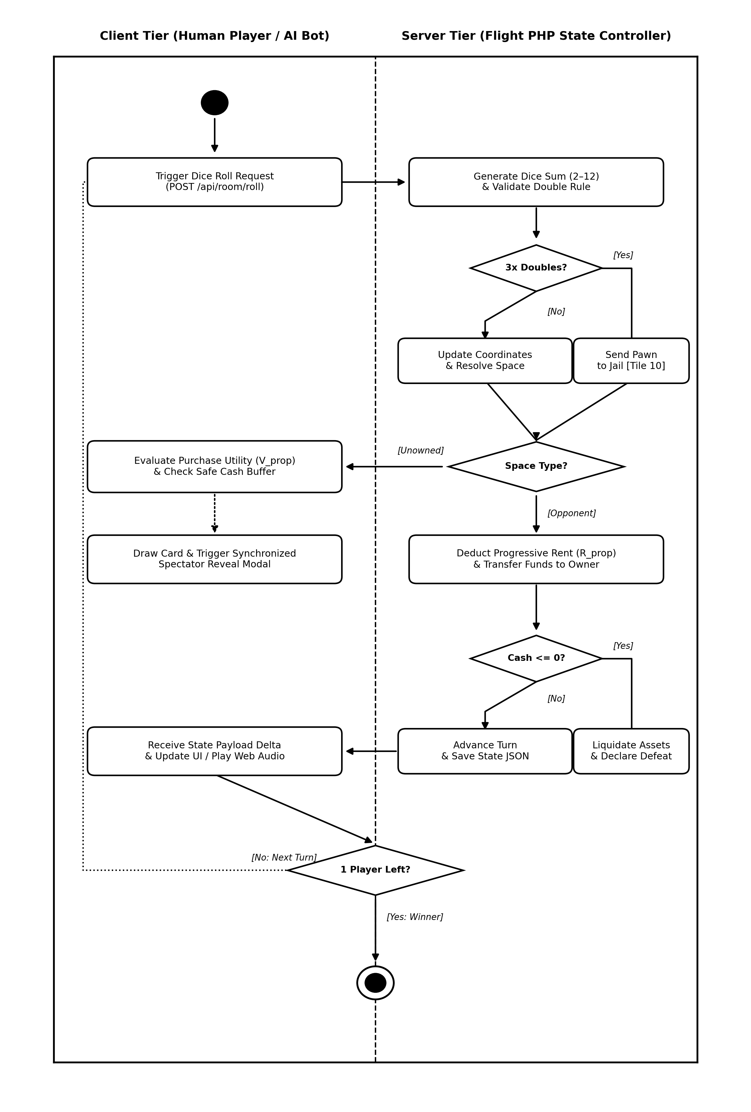
Figure 4. Activity Diagram of Turn Loop and Autonomous Heuristic AI Decision Making
The AI decision agent executes three primary evaluation procedures: Property Purchase Valuation, House and Hotel Development, and Jail Deliberation.
1. Property Purchase Valuation and Dynamic Liquidity Buffer: Upon landing on an unowned property p with deed cost C_p, every property carries prospective value. However, because capital is constrained, the purchase decision is governed by balancing strategic acquisition priority against cash insolvency risk. The agent evaluates whether remaining cash reserves satisfy a risk-adjusted dynamic liquidity safety buffer:
Cash_{current} - C_p >= B_{safe}(p) | (4)
where the dynamic cash buffer B_{safe}(p) is defined as:
B_{safe}(p) = B_{base} / (K_{AI} * k_{cluster}) | (5)
with baseline cash safety reserve B_{base} = IDR 1,500,000, k_{cluster} in [1.00, 1.30] representing the regional color-cluster weight (Table 3), and K_{AI} representing the strategic complete-cluster multiplier:
K_{AI} = 2.5 if acquiring p completes the regional color cluster, else 1.0 | (6)
A value of 2.5 was selected as a heuristic design parameter. For non-monopoly acquisitions (K_{AI} = 1.0), the resulting safety buffer ranges between IDR 1,153,846 and IDR 1,500,000 depending on k_{cluster} in [1.00, 1.30], preventing the agent from overspending on isolated properties. Conversely, when acquiring property p completes a regional color cluster (K_{AI} = 2.5), the required liquidity reserve contracts to IDR 461,538 to IDR 600,000 (averaging ~IDR 500,000). This contraction reflects a calculated financial risk to secure territorial monopoly dominance, mirroring the microeconomic structure of Monopoly where complete color sets double baseline rent (M_{rent} = 2.0) and enable house construction. Because the heuristic evaluation uses closed-form arithmetic operations rather than combinatorial tree search, the decision procedure has low computational complexity and does not require exhaustive game-tree traversal.
2. House and Hotel Construction Logic: When the AI agent possesses a complete regional color cluster, it evaluates property upgrades during the turn conclusion phase (phase === 'TURN_ENDED') rather than requiring re-landing on owned spaces. Conforming to the even-building rule and solvency constraints, the agent iterates through owned properties and triggers development only if capital satisfies:
Cash_{current} >= 2,500,000 and Cash_{current} - C_h >= 1,000,000 | (7)
If the property currently possesses between 0 and 3 houses, an additional house is constructed. When the property reaches 4 houses, the next upgrade replaces the 4 houses with 1 Hotel, activating the top-tier rental schedule R_{hotel}(p) (Table 3). To avoid capital exhaustion and maintain balanced liquidity across consecutive rounds, the AI agent constructs at most one building per turn (executing a break after successful construction in tryBuildHouses), preserving an operational liquidity reserve of at least IDR 1,000,000 against unexpected opponent rental levies.
3. Jail Decision Policy: When incarcerated, the AI agent prioritizes playing a Get Out of Jail Free card if one is held. If no card is available but cash reserves exceed IDR 6,000,000, the agent remits the IDR 1,500,000 bail fine immediately to resume board circulation; otherwise, it elects to roll for doubles to conserve liquid capital.
To ensure experimental reproducibility, Table 4 details the operational decision behaviors of the four benchmarked AI strategies.
Table 4. Behavioral Profile and Decision Rules of Evaluated AI Strategies
Strategy | Property Purchase Rule | House & Hotel Upgrades | Jail Decision Policy | Decision Mechanism
Proposed Heuristic AI | Buys if Cash - C_p >= B_safe(p); dynamic buffer scaled by K_AI=2.5 and k_cluster | Builds if Cash >= 2.5M and Cash - C_h >= 1.0M; upgrades 1-4 houses then hotel | Uses jail card; pays 1.5M fine if Cash > 6M; else rolls doubles | Deterministic arithmetic; dice and card draws are randomized
Static Threshold Baseline | Buys if Cash - C_p >= 1.0M static reserve; no monopoly completion weighting | Builds house/hotel if Cash - C_h >= 1.0M static reserve | Always pays 1.5M fine immediately if Cash >= 1.5M | Deterministic threshold; dice and card draws are randomized
Greedy Baseline AI | Unconditionally buys whenever Cash >= C_p; zero liquidity safety buffer | Upgrades house/hotel immediately whenever Cash >= C_h | Always pays fine immediately regardless of remaining cash | Deterministic greedy; dice and card draws are randomized
Naive Random Baseline AI | 50% stochastic probability to purchase unowned property if Cash >= C_p | 40% stochastic probability to build upgrade if Cash >= C_h | 50% random chance to pay fine versus rolling doubles | Uniform random decision-making across all available actions

Zero-Asset Procedural Web Audio Synthesis
To eliminate external sound asset loading on mobile networks, Nusantara Monopoly incorporates a runtime procedural sound synthesis engine built upon the HTML5 Web Audio API [18], [19]. Rather than fetching external static audio files (MP3/WAV) that consume network bandwidth, all acoustic feedback is synthesized programmatically at runtime using native browser audio nodes. The implementation eliminated separate audio-file requests for the evaluated sound effects, providing 0 KB external audio-file transfer.
The audio engine instantiates an AudioContext upon first user interaction. When an in-game acoustic event is triggered (e.g., dice rolling, cash transaction, property purchase, jail lockup), an OscillatorNode (configured to sine, square, or triangle waveforms) is coupled with a GainNode to modulate instantaneous frequency and amplitude envelopes:
A(t) = A_0 * e^{-t / tau_{decay}} | (8)
For example, a cash acquisition event synthesizes a two-tone arpeggio (B5 at 987.77 Hz followed by E6 at 1318.51 Hz over a 150 ms decay envelope), producing a clear auditory cue without separate audio-file downloads. Synthesizing dynamic tones via native browser oscillator nodes enables low-latency procedural audio synthesis that initiates sound playback synchronously with DOM events [20].

Evaluation Protocol
The empirical validation of Nusantara Monopoly was executed across five complementary methodological tiers:
1. Functional Verification: 12 comprehensive operational test scenarios covering functional, boundary, and exception conditions (including negative testing: invalid room codes, duplicate purchases, insufficient cash, unauthorized actions, and stale checksums) were conducted, structured with reference to ISO/IEC/IEEE 29119 standards for software testing.
2. Controlled AI Baseline Simulation: An automated 200-match simulation was executed in Python 3.11 with a strictly balanced 1-slot-per-strategy configuration (4 players: 1 Proposed Heuristic AI, 1 Static Threshold AI, 1 Greedy AI, 1 Naive Random AI) under identical rules and initial cash endowments (IDR 15,000,000). Strategy-seat assignments and initial turn order were randomized across matches to reduce positional bias. Bankruptcy rate was calculated as the proportion of strategy instances that became bankrupt among the 200 matches, yielding 200 instances per strategy. Matches were governed by fixed pseudo-random seeds (seeds 1001 to 1200) and terminated upon a single active survivor or after 100 rounds.
3. Card Deck Shuffling Simulation: A 2,000 deck-cycle simulation was conducted benchmarking the Category-Interleaved Deck Shuffling algorithm against uniform random permutations across both event card decks independently (1,000 cycles for Chance with 26 cards and 1,000 cycles for Community Chest with 24 cards, totaling 50,000 individual card draws across 2,000 total cycles). For each complete deck cycle, the maximum consecutive penalty streak was recorded. The reported mean and standard deviation refer specifically to the distribution of these per-cycle maximum penalty-run lengths across all 2,000 deck-cycles, rather than an average across all individual sequences.
4. Live Deployment Telemetry and Synthetic Stress Benchmarking: Production server telemetry was collected across 31 active multiplayer room sessions comprising 70 observed player instances who engaged in open online play sessions across desktop and mobile browsers over Wi-Fi and cellular networks. In parallel, synthetic HTTP stress testing was executed using ApacheBench (ab -n 1000 -c 50) on the room state synchronization endpoint (GET /api/room/status) to evaluate server throughput under peak concurrency. Controlled network latency benchmarks across network interfaces (Localhost, Campus Fiber/5G, 4G Mobile, and 3G Mobile) were conducted using network emulation tools as controlled technical benchmarks separate from live participant telemetry.
Ethical Considerations and Data Privacy: In accordance with academic research standards for non-interventional human-computer interaction (HCI) software evaluations, the study involved solely voluntary user interaction with a web-based multiplayer game posing zero physical, physiological, or psychological risks. The investigation did not administer clinical interventions, experimental treatments, or invasive procedures. The system architecture did not require persistent user accounts or collect direct personal identifiers such as email addresses, real names, phone numbers, or IP addresses. Player display names were stored only as transient attributes within the corresponding game-room JSON state files and could be freely chosen or modified by users between sessions. When game rooms were concluded or deleted, all associated transient room state data were purged from server storage without maintaining persistent user profiles. Participation in gameplay sessions and SUS questionnaire completion was entirely voluntary, with users engaging with the publicly deployed web application at their own discretion. Because the evaluation comprised non-interventional software usability and telemetry analysis without collecting persistent personal identifiers, formal institutional review board approval was not sought.
5. System Usability Scale (SUS): A standardized 10-item SUS questionnaire [25], [26] was administered anonymously to 30 voluntary respondents who evaluated the web application following their gameplay sessions to evaluate perceived usability, learnability, and user interface satisfaction.

RESULTS AND DISCUSSION

Results

Nusantara Monopoly Adaptation and System Interface
The engineered web implementation translates canonical Monopoly mechanics into the Indonesian archipelagic domain as formalized in Table 2 and Table 3. The client application executes natively within standard web browsers using HTML5, CSS3, and ES6+ JavaScript without external binary plugins or native mobile installations. Figure 5 illustrates the primary user interface and game mode configuration, enabling players to initiate single-player matches against autonomous AI agents, pass-and-play local matches, or multi-client networked rooms. Figure 6 displays the interactive in-game board rendered on an 11x11 square grid, featuring color-coded regional clusters, animated dice rolling, dynamic deed cards, property ownership markers, house and hotel building indicators, and real-time capital balance ledgers across participating players.
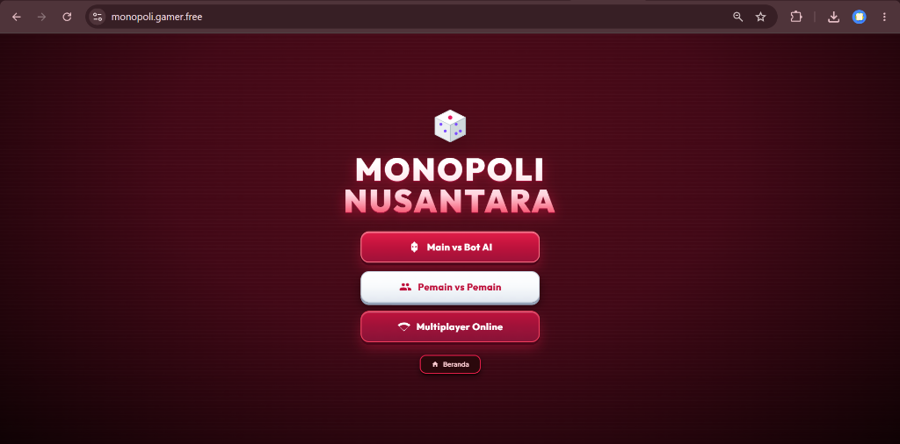
Figure 5. Main Menu and Game Mode Selection Interface
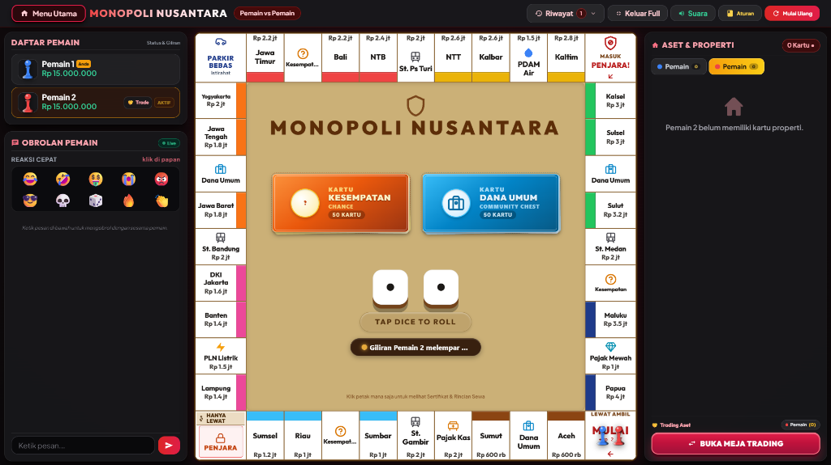
Figure 6. In-Game Board Interface Featuring 11x11 Grid Layout and Interactive Controls

Functional Black-Box Verification
Functional verification was conducted across 12 test scenarios encompassing positive, boundary, and negative exception cases including invalid room codes, duplicate purchases, insufficient funds, and hotel upgrade mechanics. Table 5 presents the test scenarios and results.
Table 5. Functional Test Scenarios Covering Positive, Boundary, and Negative Conditions
ID | Test Scenario & Category | Expected Condition | Observed System Behavior | Status
TC-01 | Create & Join Room (Positive) | Room code generated; client successfully joins room | Room initialized; state synchronized across clients | Pass
TC-02 | Dice Rolling & Position (Positive) | Token advances by dice sum (2-12); cash +2M if passing GO | Token moves accurately; GO salary credited | Pass
TC-03 | Property Purchase (Positive) | Deed acquired; cash deducted; ownership updated on board | State updated atomically; owner marker displayed | Pass
TC-04 | Rent Deduction (Positive) | Landing on owned tile deducts rent; credited to owner | Rent deducted accurately per cluster formulas | Pass
TC-05 | Monopoly Rent Doubling (Positive) | Base rent doubles when complete color cluster is owned | Rent correctly multiplied by 2.0x upon monopoly | Pass
TC-06 | Controlled Card Draw (Boundary) | Card drawn; effect executed; no streak >=3 penalties | Queue preserves interleaved order; effects executed | Pass
TC-07 | Jail Mechanics (Boundary) | 3 consecutive doubles or Go-to-Jail sends token to Jail | Token moved to Jail space; 3-turn counter enforced | Pass
TC-08 | AI Property Evaluation (Boundary) | AI buys if buffer satisfied; scales buffer on monopoly | AI executes rational purchase; preserves liquidity | Pass
TC-09 | Hotel Upgrade Mechanics (Positive) | 4 houses replaced by 1 Hotel upon 5th upgrade; rent upgraded | Houses cleared; hotel flag set; hotel rent enforced | Pass
TC-10 | Zero-Asset Audio Synth (Positive) | Sound synthesized via Web Audio API; 0 KB download | Oscillators render audio synchronously; 0 KB file fetch | Pass
TC-11 | Concurrency Checksum (Exception) | Out-of-sync mutation returns HTTP 409 Conflict | Server detects hash mismatch; client state refreshed | Pass
TC-12 | Bankruptcy Liquidation (Exception) | Insolvent player eliminated; assets released to bank | Player marked bankrupt; assets liquidated cleanly | Pass
As documented in Table 5, all 12 predefined functional test scenarios passed verification successfully. All turn state transitions, financial calculations, boundary constraints, hotel upgrade sequences, and negative exception handling operated in accordance with the system specification.

Gameplay Evaluation: Controlled AI Baseline Benchmark (Monte Carlo N=200)
To evaluate the decision-making behavior of the proposed Heuristic Rule-Based AI without slot allocation bias, an automated Monte Carlo benchmark experiment was conducted across 200 complete 4-player matches (N=800 player instances). In each match, exactly one slot was allocated to each of the four distinct strategies: (1) Proposed Heuristic AI (with K_AI=2.5 complete-cluster multiplier, house/hotel upgrading, and dynamic liquidity buffer); (2) Static Threshold AI (purchasing properties when cash exceeds cost plus a static 1.0M reserve without monopoly weighting); (3) Greedy AI (unconditionally purchasing every landed property and building houses whenever cash permits); and (4) Naive Random AI (50% random purchase probability). Strategy-seat assignments and initial turn order were randomized across matches to reduce positional bias. Under an equal 4-player game, the expected random win probability per agent is 25.0%. Bankruptcy rate was calculated as the proportion of strategy instances that became bankrupt among the 200 matches, yielding 200 instances per strategy. Table 6 summarizes the benchmark results.
Table 6. Empirical Performance Comparison of AI Decision Strategies Across 200 Monte Carlo Simulated Matches (1 Slot per Strategy)
AI Strategy | Matches Won | Observed Win Rate | Expected Equal Chance | Bankruptcy Rate (%) | Strategic Behavior Profile
Proposed Heuristic AI | 70 / 200 | 35.0% | 25.0% | 61.5% | Balances K_AI=2.5 monopoly valuation with dynamic cash buffer; lowest bankruptcy rate.
Static Threshold Baseline | 57 / 200 | 28.5% | 25.0% | 69.0% | Maintains static 1.0M cash buffer but lacks adaptive valuation for monopoly completion.
Greedy Baseline AI | 48 / 200 | 24.0% | 25.0% | 73.0% | Unconditionally acquires properties and houses; suffers insolvency upon opponent tile hits.
Naive Random Baseline AI | 25 / 200 | 12.5% | 25.0% | 85.0% | Selects actions at random (50% buy probability); lacks cohesive territorial acquisition strategy.
The simulation results in Table 6 indicate that under balanced 1-slot-per-strategy conditions, the Proposed Heuristic AI achieved the highest observed win rate at 35.0% (70 of 200 matches) under the tested simulation conditions, compared to the expected equal chance of 25.0%. The Static Threshold baseline achieved 28.5%, the Greedy baseline attained 24.0%, and the Random baseline secured 12.5%. Furthermore, the Heuristic AI exhibited the lowest bankruptcy rate (61.5%), compared to 69.0% for Static, 73.0% for Greedy, and 85.0% for Random. These empirical observations suggest that the dynamic liquidity-buffer formulation produced a different performance profile from the evaluated baseline strategies under the tested simulation conditions.

Game Mechanism Evaluation: Quantitative Card Deck Distribution Benchmark (Monte Carlo N=2,000 deck-cycles)
To evaluate the efficacy of the Balanced Category-Interleaved Deck Shuffling algorithm, an automated simulation of 2,000 complete deck cycles (comprising 1,000 cycles of 26 draws for Chance and 1,000 cycles of 24 draws for Community Chest, totaling 50,000 individual card draws) was conducted, comparing the proposed algorithm against uniform random permutations across both decks. For each complete deck cycle, the maximum consecutive penalty streak was recorded. Table 7 presents the quantitative distribution and streak metrics averaged across both decks.
Table 7. Quantitative Distribution and Penalty Streak Metrics Across 2,000 Simulated Deck-Cycles (50-Card Pool: 26 Chance, 24 Community Chest)
Metric Parameter | Uniform Random Permutation | Category-Interleaved Permutation | Observed Difference / Impact
Mean Consecutive Penalty Streak (Max per Cycle) | 1.98 ± 0.71 cards | 1.29 ± 0.45 cards | -34.8% reduction in mean per-cycle maximum streak
Maximum Worst-Case Penalty Streak | 6 consecutive cards | 2 consecutive cards | Strict algorithmic bound enforced (Streak <= 2)
Cycles with >= 3 Consecutive Penalties | 17.6% empirical (352 / 2,000 cycles; 164 in Chance, 188 in Community Chest) | 0.0% (0 / 2,000 cycles) | Strict algorithmic elimination of penalty streaks >= 3
The reported mean and standard deviation metrics in Table 7 refer specifically to the maximum penalty-run length observed within each complete deck cycle across all 2,000 simulated deck-cycles (1,000 cycles of 26 draws for Chance and 1,000 cycles of 24 draws for Community Chest, totaling 50,000 individual card draws). Under uniform random draws, the mean per-cycle maximum was 1.98 ± 0.71 cards, with 17.6% of evaluated cycles experiencing streaks of 3 or more consecutive penalties (352 of 2,000 cycles; 164 in Chance, 188 in Community Chest) and reaching a single-cycle maximum of 6. In contrast, the Category-Interleaved Deck Shuffling algorithm constrained the mean per-cycle maximum to 1.29 ± 0.45 cards and strictly eliminated streaks of 3 or more (0.0%, 0 of 2,000 cycles across both decks, maximum 2), thereby reducing player exposure to prolonged consecutive penalty sequences while retaining randomized card ordering within the imposed category constraints [10], [11].
Figure 7 illustrates the interactive card draw modal interface displayed during Chance and Community Chest events. The client displays the randomized provincial event or financial assessment with distinct visual badges and automated procedural audio cues.
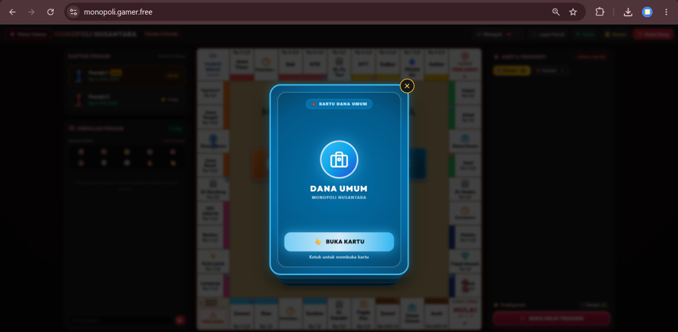
Figure 7. Interactive Card Draw Modal Interface for Community Chest and Chance Events

System Performance Evaluation: Deployment Telemetry and Synthetic Stress Testing
To assess software engineering performance under operational load, empirical evaluation was bifurcated into deployment telemetry logging across live user sessions and synthetic HTTP stress testing. Across the deployment period, 31 room sessions were hosted involving 70 observed player instances, with a peak concurrency of 14 simultaneously active rooms hosting 38 concurrent players (strictly adhering to the 2 to 4 players per room configuration). Table 8 details the empirical operational metrics.
Table 8. Deployment Telemetry Across 31 Multi-Client Live Game Sessions
Operational Telemetry Metric | Observed Value | Benchmark Interpretation
Total Room Sessions Hosted | 31 rooms | Cumulative test dataset across multi-day deployment
Total Observed Player Instances | 70 player instances | Aggregated across 31 active game rooms during deployment
Peak Concurrent Active Rooms | 14 rooms (38 active players) | Zero concurrency-related state corruption observed via flock()
Concluded Game Over Sessions | 6 matches (42.5 ± 8.3 min avg) | Among the six completed deployment matches, the mean duration was 42.5 ± 8.3 minutes
Monopoly-to-Victory Precedence | 5 of 6 completed matches (83.3%) | In 5 of the 6 completed matches, the eventual winner had completed a regional color cluster before victory
Average Server Footprint | CPU < 1.2%, JSON state ~24 KB/room | Serialized JSON state size ~24 KB per room on disk and memory cache
To evaluate server throughput and latency under concurrent load, synthetic HTTP stress testing was executed using ApacheBench (ab -n 1000 -c 50) targeting the room state synchronization endpoint (GET /api/room/status). Table 9 presents the comprehensive stress testing parameters and observed metrics.
Table 9. Synthetic Stress Test Parameters and Observed Concurrency Performance Metrics
Benchmark Parameter / Metric | Observed Measurement | Operational Specification
Total Benchmark Requests | 1,000 requests | Target workload for state synchronization evaluation
Concurrency Level | 50 concurrent connections | Simulated concurrent polling clients
Target Endpoint & Method | GET /api/room/status | Primary state polling endpoint
Throughput (Requests/sec) | 450.4 requests/second | Achieved throughput under specified ApacheBench benchmark workload
Failed Requests / Dropouts | 0 failures (0 connection timeouts) | With no HTTP request failures or connection timeouts observed
Mean Connection Latency | 110.1 ms | Average across concurrent thread pool
Mean Time Per Request | 2.20 ms | Across all concurrent requests
95th Percentile Latency (p95) | 142.5 ms | 95% of requests completed within this threshold
Maximum Latency (p100) | 188.2 ms | Worst-case observed request duration
Serialized Response Payload | ~1.8 KB per request | Optimized compact JSON state payload
As documented in Table 9, the server achieved 450.4 requests/second under the specified ApacheBench workload of 1,000 requests and concurrency 50, with zero HTTP request failures or connection timeouts observed during the benchmark. From a software capacity perspective, this benchmark throughput of 450.4 requests/second substantially exceeds the operational demand observed during peak live multiplayer testing (where 14 concurrent rooms polling at 1,500 ms intervals generate an aggregate load of approximately 9.3 requests/second), providing an observed throughput margin of approximately 48x relative to the peak live polling demand. In parallel, controlled network emulation benchmarks were conducted across network interfaces, revealing round-trip latencies of: Localhost: 4.2 ms; Campus Fiber / 5G: 24.6 ms; 4G Mobile: 62.8 ms; and 3G Mobile: 165.4 ms. These network measurements represent controlled technical benchmarks separate from live participant telemetry. To supervise active sessions and monitor server telemetry during testing, system administrators utilize the real-time telemetry dashboard depicted in Figure 8 (Panel Admin Banjar).
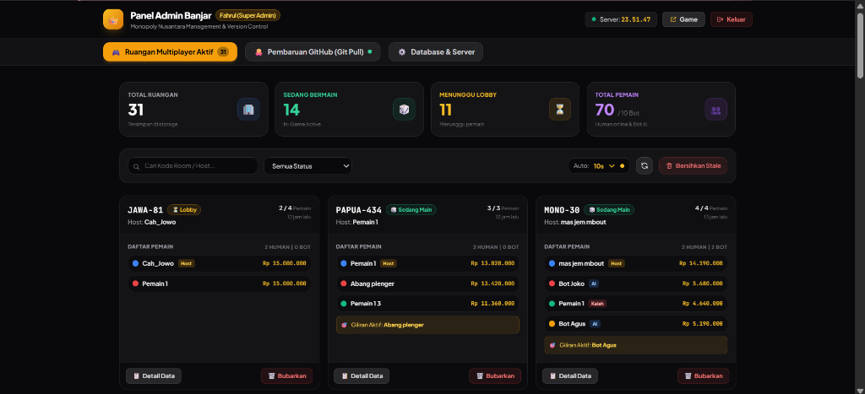
Figure 8. Server Management and Real-Time Telemetry Dashboard (Panel Admin Banjar)

Usability Evaluation: System Usability Scale (SUS)
To evaluate user interface usability and player experience, the standardized 10-item System Usability Scale (SUS) questionnaire [25] was administered anonymously to 30 voluntary respondents following their gameplay sessions. Table 10 presents the itemized scores and calculated contribution values.
Table 10. System Usability Scale (SUS) Questionnaire Results (N=30)
Item | Questionnaire Item Statement | Mean (1-5) | SUS Score Contrib.
Q1 | I think that I would like to use this game frequently. | 4.27 | 3.27
Q2 | I found the game unnecessarily complex. | 1.60 | 3.40
Q3 | I thought the game was easy to play. | 4.43 | 3.43
Q4 | I think that I would need the support of a technical person to play. | 1.53 | 3.47
Q5 | I found the various functions in this game were well integrated. | 4.30 | 3.30
Q6 | I thought there was too much inconsistency in this game. | 1.67 | 3.33
Q7 | I would imagine that most people would learn to play this game very quickly. | 4.47 | 3.47
Q8 | I found the game very cumbersome/awkward to use. | 1.57 | 3.43
Q9 | I felt very confident using the game. | 4.27 | 3.27
Q10 | I needed to learn a lot of things before I could get going with this game. | 1.57 | 3.43
Overall | Composite System Usability Scale (SUS) Score (Sum = 33.80 * 2.5) | - | 84.50 ± 7.20
The evaluated participant sample reported an aggregate SUS score of 84.50 with a standard deviation of 7.20 (95% Confidence Interval: [81.8, 87.2]), derived from the exact sum of item score contributions (33.80 * 2.5 = 84.50). According to the psychometric evaluation literature established by Bangor, Kortum, and Miller [25] and empirical studies [26], [27], a SUS score of 84.50 is above the commonly cited empirical benchmark of 68.0 and indicates favorable perceived usability and rapid learnability among the evaluated respondents. Participants reported high perceived ease of learning, reflected in Q7 (mean score 4.47).

Discussion
1. Architectural Viability and Concurrency Control: The empirical findings indicate the viability of the room-isolated JSON architecture for the evaluated turn-based workload. Unlike complex relational database architectures that risk connection overhead and table locking during concurrent turn processing [15], [16], the combination of advisory flock() locking and state checksum verification delivered zero state synchronization corruption across 31 rooms and 70 observed player instances. These observations align with findings by Sidiq et al. [14] regarding bot-assisted capacity evaluation, Wang et al. [15] regarding scalable optimistic concurrency control architectures, and Emmert-Streib, Tripathi, and Dehmer [33] regarding distributed user state consistency in online multiplayer web environments. The adaptive 1,500 ms polling interval established an effective compromise between client responsiveness and server overhead, maintaining server CPU utilization below 1.2%. A limitation of this approach is that file-based locking scales with local storage I/O and would require distributed coordination (such as Redis or ZooKeeper) if expanded across multi-server server clusters.
2. Controlled Card Distribution and Streak Mitigation: The Monte Carlo deck simulation demonstrated that the Category-Interleaved Deck Shuffling algorithm mitigates penalty clustering observed under the evaluated uniform-random permutation baseline. By bounding consecutive penalty outcomes to at most 2 cards (Equation 3), the algorithm strictly constrains consecutive penalty outcomes while maintaining controlled category interleaving according to the fixed composition of each deck, eliminating the long penalty sequences that frequently occur under unweighted random draws [10], [11]. This result corroborates the theoretical models of Derrick et al. [10] and Guo et al. [11], demonstrating that structured cyclic interleaving enforces streak constraints while retaining randomized card ordering within the imposed category constraint. However, this study did not include a psychological user study to quantify subjective player frustration directly, focusing instead on empirical mathematical distribution metrics.
3. Gameplay Dynamics and Heuristic AI Decision-Making: To evaluate gameplay dynamics under the adapted economic rules, the autonomous Heuristic AI agent was deployed as an automated player proxy. In turn-based board games with large branching factors, full adversarial tree search algorithms (e.g., minimax with alpha-beta pruning) are computationally costly within browser runtimes [12], [13]. Our heuristic decision model resolves this computational constraint by formalizing dynamic liquidity buffers scaled inversely by complete regional color cluster factors (Equations 4 through 6). Because the heuristic evaluation uses closed-form arithmetic operations rather than combinatorial tree search, the decision procedure has low computational complexity and does not require exhaustive game-tree traversal. In the balanced 200-match Monte Carlo benchmark, the heuristic AI achieved the highest observed win rate (35.0%) and the lowest bankruptcy rate (61.5%) under the tested simulation conditions, outperforming greedy over-leveraging (24.0%) and random play (12.5%). These findings align with Pratama et al. [23] and Steinmetz & Gini [24] regarding heuristic evaluation functions and autonomous agent simulation in discrete strategy games. Nevertheless, the benchmark evaluated a specific parameter setting (K_AI = 2.5); future work should include broader ablation studies across varying parameter ranges (e.g., K_AI in {1.5, 2.0, 2.5, 3.0}) to map sensitivity boundaries.
4. Procedural Audio and Client-Side Optimization: The procedural Web Audio synthesis engine demonstrated operational advantages in client delivery. The implementation eliminated separate audio-file requests for the evaluated sound effects, avoiding external network requests for sound assets and reducing initial page loading overhead [18], [19], [20]. This architectural optimization is particularly beneficial for lightweight web application deployments in remote and peripheral regions where mobile internet bandwidth is constrained, eliminating asset download latency. A limitation of this design is that procedural oscillators are suited for synthesized sound effects (chimes, clicks, alerts) rather than complex natural acoustic recordings or orchestral background soundtracks.
5. Interface Usability and System Learnability: The empirical System Usability Scale (SUS) score of 84.50 is consistent with favorable perceived usability of the evaluated interface. In complex turn-based board games, players frequently encounter cognitive friction due to simultaneous financial tracking, spatial navigation, and multi-option decision menus [4], [25]. The user interface of Nusantara Monopoly addresses these usability considerations through three core design choices: (a) color-coded territorial grouping that mirrors the 8 regional color clusters, providing immediate visual affordance regarding property ownership; (b) visual and auditory feedback mechanisms, wherein transactional mutations (rent payment, card draws) trigger dedicated procedural sound synthesis and localized modal dialogs; and (c) clear building indicators displaying house counts (1 to 4) and grand Hotel markers. Participants reported high perceived ease of learning, reflected in Q7 (mean score 4.47), corroborating empirical findings in recent educational and board game usability evaluations by Bangor et al. [25], Alfilaeni et al. [26], Gini et al. [27], Gonzalo-de Diego et al. [31], and Hasanah et al. [32]. In particular, Gonzalo-de Diego et al. [31] observed that board-game mechanics adapted to localized learning contexts yield elevated usability satisfaction (SUS > 80), while Hasanah et al. [32] demonstrated that clear visual cues and structured gameplay interactions directly minimize cognitive overhead and promote intuitive user onboarding among novice players.
6. Threats to Validity and Research Limitations: To ensure scientific transparency, the research methodology was subjected to a formal threats-to-validity analysis across four software engineering dimensions:
a) Construct Validity: System usability was assessed using the widely used System Usability Scale (SUS) [25], ensuring that questionnaire items captured perceived usability constructs rather than general game enjoyment.
b) Internal Validity: Concurrency and latency metrics were logged directly by production server access monitors and browser Navigation Timing APIs across 31 multiplayer room sessions, reducing subjective observer bias in system performance measurement.
c) External Validity: The reported performance characteristics specifically characterize system behavior under the tested deployment infrastructure, campus network interfaces, and client device configurations, acknowledging that performance may vary under severely degraded or high-jitter cellular network environments. Furthermore, the voluntary evaluation cohort comprised self-selected online players, acknowledging that usability perceptions may vary across broader player demographics and diverse age cohorts.
d) Conclusion Validity: The simulations provide repeated simulation observations under the specified experimental protocol (N=200 matches with balanced 1-slot allocation, N=2,000 deck-cycles), ensuring that reported win rates and streak bounds are computationally reproducible.
Additional acknowledged limitations include reliance on HTTP short-polling rather than WebSockets, deterministic heuristic rules rather than reinforcement learning, and the absence of automated network-fault simulation (e.g., simulating packet jitter and abrupt socket disconnects) to stress-test client recovery during degraded mobile connectivity.

CONCLUSION
What Was Developed: This study engineered Nusantara Monopoly, a lightweight web multiplayer digital board game adapting canonical Monopoly to the Indonesian regional economic context. Grounded in the Mechanics-Dynamics-Aesthetics (MDA) framework, the system integrates a 40-space board topology (22 provincial properties across 8 regional color clusters), a 50-card dual-deck event system (26 Chance and 24 Community Chest), an autonomous Heuristic Rule-Based AI agent with dynamic liquidity buffers, a room-isolated JSON state store with atomic flock() file locking, and zero-asset procedural audio synthesized via the HTML5 Web Audio API.
What Was Demonstrated: Multi-dimensional empirical evaluation substantiated the technical feasibility and operational reliability of the system: all 12 predefined functional test scenarios passed successfully under positive, boundary, and negative conditions; the Category-Interleaved Deck Shuffling algorithm strictly bounded consecutive penalty draws to at most 2 cards across 2,000 deck-cycles (50,000 draws); the heuristic AI achieved competitive performance (35.0% win rate and 61.5% bankruptcy rate across 200 balanced matches); server throughput achieved 450.4 requests/second under the specified ApacheBench workload, approximately 48 times the peak live polling demand observed during deployment; and usability evaluation across 30 respondents yielded an SUS score of 84.50, indicating favorable perceived usability among the evaluated respondents.
Contributions and Future Work: The primary contribution of this research is demonstrating that complex economic tabletop board games can be systematically adapted to localized regional domains and delivered over lightweight web architectures with robust transaction isolation, predictable card mechanics, and transparent companion AI without heavy cloud infrastructure. A recognized limitation is that the AI decision engine relies on deterministic heuristics rather than adaptive reinforcement learning, and state synchronization utilizes HTTP short-polling rather than persistent WebSockets. Future research will investigate integrating adaptive reinforcement learning agents (e.g., Deep Q-Networks) [28], [29], bilateral asset bartering protocols [13], [30], and WebSocket-driven state replication across distributed server nodes.

Declaration of AI and AI-Assisted Technologies
During the preparation of this manuscript, the authors used Google Gemini 3.7 Flash (Thinking Mode with High Reasoning Effort) and Antigravity AI (Google DeepMind) for grammatical polishing, phrasing refinement, and automated document formatting assistance. All AI-generated outputs were thoroughly reviewed, verified, and edited by the authors, who take full intellectual responsibility for the content and integrity of this publication.

CRediT Authorship Contribution Statement
Muhammad Fahrul Bahri: Conceptualization, Software, Methodology, Data Curation, Formal Analysis, Investigation, Writing – Original Draft, Visualization.
Muhayat: Supervision, Validation, Methodology, Writing – Review & Editing, Project Administration.

Declaration of Competing Interest
The authors declare that they have no known competing financial interests or personal relationships that could have appeared to influence the work reported in this paper.

Acknowledgment
The authors express their sincere gratitude to the Department of Information Technology, Faculty of Science and Technology, Universitas Islam Negeri Antasari Banjarmasin for providing computing facilities and server infrastructure, and to the voluntary players and questionnaire respondents for their engagement in multiplayer testing and usability evaluation.

Data Availability
The complete source code is openly hosted at the GitHub repository (https://github.com/Theseadev/Monopoly), and the live interactive deployment of the game is publicly accessible for evaluation and gameplay at https://monopoli.gamer.free. Aggregated simulation scripts and telemetry log datasets are available from the corresponding author on reasonable request.

Funding
This research did not receive any specific grant from funding agencies in the public, commercial, or not-for-profit sectors.

References
[1] S. M. Subiyanto, "Perancangan UI/UX Board Game sebagai Media Interaksi Keluarga Anak Usia 8–12 Tahun," Jurnal Vicidi, vol. 16, no. 1, pp. 20–36, Jan. 2026, doi: 10.37715/vicidi.v16i1.6170.
[2] A. J. Herrero, N. Rodríguez-Álvarez, R. Martínez-Sinovas, C. Aldavero, and F. Rodríguez-Merino, "From Monopoly to Ark Nova: An Empirical and Cultural History of Modern Board Game Design (1930-2025)," Simulation & Gaming, pp. 1–25, 2026, doi: 10.1177/10468781261468605.
[3] M. A. Hall, "Games of Character: The Role of Board, Dice & Cards in Tabletop Games," Board Game Studies Journal, vol. 16, no. 1, pp. 101–124, May 2022, doi: 10.2478/bgs-2022-0018.
[4] M. Freese and H. Lukosch, "The Funnel of Game Design – An Adaptive Game Design Approach for Complex Systems," Simulation & Gaming, vol. 55, no. 2, pp. 323–341, Apr. 2023, doi: 10.1177/10468781231222524.
[5] A. E. Demirel and E. Alanyalı Aral, "Board Game as a Participatory Design Technique for Urban Spaces: A Ludological Analysis," Simulation & Gaming, vol. 56, no. 5, pp. 426–450, Oct. 2025, doi: 10.1177/10468781251338439.
[6] C. Liu and J. C. F. Wong, "Modified Engel Algorithm and Applications in Absorbing/Non-Absorbing Markov Chains and Monopoly Game," Mathematical and Computational Applications, vol. 30, no. 4, p. 87, Aug. 2025, doi: 10.3390/mca30040087.
[7] T. A. Ramadhan, K. Candra Brata, and M. Tri Ananata, "Pengembangan Gim Online Multiplayer Matematika 24 Berbasis Web," Jurnal Teknologi Informasi dan Ilmu Komputer (JTIIK), vol. 11, no. 2, pp. 385–392, Apr. 2024, doi: 10.25126/jtiik.20241127810.
[8] F. Mohamad, R. D. R. Dako, U. Nadifa, and I. Z. Nasibu, "Development of a Real-Time Multiplayer Web-Based Mathematical Puzzle Game for Geometric Reflection Learning Using WebSocket," Jambura Journal of Electrical and Electronics Engineering, vol. 8, no. 2, pp. 226–233, Jul. 2026, doi: 10.37905/jjeee.v8i2.40303.
[9] K. R. Wisinggya, H. Haryanto, T. Sutojo, E. Mulyanto, and E. Dolphina, "Tingkat Kesulitan Dinamis Menggunakan Logika Fuzzy Pada Game Musik Tradisional Jawa Tengah," Jurnal ELTIKOM : Jurnal Teknik Elektro, Teknologi Informasi dan Komputer, vol. 5, no. 2, pp. 56–64, Dec. 2021, doi: 10.31961/eltikom.v5i2.281.
[10] J. Derrick, J. Champion, and R. Uriarte, "Frustration: Analyzing a Card Game with Probability and Randomness," Mathematics Teacher: Learning and Teaching PK-12, vol. 115, no. 4, pp. 296–303, Apr. 2022, doi: 10.5951/mtlt.2021.0346.
[11] G. Guo, S. D. Howison, D. Possamaï, and C. Zhou, "Randomness and Early Termination: What Makes a Game Fair and Balanced," Probability Theory and Related Fields, vol. 190, pp. 1–45, Oct. 2024, doi: 10.1007/s00440-024-01340-x.
[12] H. Parihar and S. M., "Decision Making in Monopoly Using a Hybrid Deep Reinforcement Learning Approach," International Journal for Research in Applied Science and Engineering Technology (IJRASET), vol. 12, no. 2, pp. 58–67, Feb. 2024, doi: 10.22214/ijraset.2024.58270.
[13] J. D. A. Jung and J. Hoey, "Extending Heuristic Knowledge Transfer for General Game Playing," IEEE Transactions on Games, pp. 1–12, 2025, doi: 10.1109/tg.2025.3578435.
[14] A. M. Sidiq, J. H. Husen, and S. Widowati, "A Bot Approach-Based Capacity Testing Automation for Online Video Games," Jurnal ELTIKOM : Jurnal Teknik Elektro, Teknologi Informasi dan Komputer, vol. 6, no. 2, pp. 118–125, Nov. 2022, doi: 10.31961/eltikom.v6i2.550.
[15] X. Wang, Y. Peng, H. Huang, C. Shen, C. Jiang, and M. Guo, "Dodo: A Scalable Optimistic Deterministic Concurrency Control Protocol," Future Generation Computer Systems, vol. 159, pp. 385–397, Oct. 2024, doi: 10.1016/j.future.2024.05.004.
[16] C. Ye, W.-C. Hwang, K. Chen, T. Zhang, and X. Lin, "Polaris: Enabling Transaction Priority in Optimistic Concurrency Control," Proceedings of the ACM on Management of Data, vol. 1, no. 1, pp. 1–26, May 2023, doi: 10.1145/3588724.
[17] M. Ottens, J. Deutschmann, K.-S. Hielscher, and R. German, "Performance Evaluation of ns-3 Real-Time Emulation," IEEE Access, vol. 13, pp. 59544–59559, Mar. 2025, doi: 10.1109/access.2025.3555478.
[18] B. Matuszewski and O. Rottier, "The Web Audio API as a Standardized Interface Beyond Web Browsers," Journal of the Audio Engineering Society, vol. 71, no. 11, pp. 790–801, Nov. 2023, doi: 10.17743/jaes.2022.0114.
[19] Y. Zang, C. Benetatos, and Z. Duan, "Euterpe: A Web Framework for Interactive Music Systems," Journal of the Audio Engineering Society, vol. 71, no. 11, pp. 738–752, Nov. 2023, doi: 10.17743/jaes.2022.0117.
[20] M. Buffa and J. Lebrun, "Rocking the Web With Browser-Based Simulations of Tube Guitar Amplifiers," Journal of the Audio Engineering Society, vol. 71, no. 11, pp. 753–768, Nov. 2023, doi: 10.17743/jaes.2022.0110.
[21] R. Hunicke, M. LeBlanc, and R. Zubek, "MDA: A Formal Approach to Game Design and Game Research," in Proceedings of the AAAI Workshop on Challenges in Game AI, San Jose, CA, USA, 2004, pp. 1–5.
[22] A. Bauer, "Artificial Intelligence With Graph Neural Networks Applied to a Risk-Like Board Game," IEEE Transactions on Games, vol. 16, no. 2, pp. 342–351, Jun. 2024, doi: 10.1109/tg.2023.3270162.
[23] D. A. Pratama, Y. Mitachul Arif, and F. Nugroho, "Simulasi Kerumunan NPC Pada Game “Pengenalan UIN Malang” Menggunakan Metode Flocking," Jurnal Teknologi Informasi dan Ilmu Komputer (JTIIK), vol. 11, no. 4, pp. 913–928, Aug. 2024, doi: 10.25126/jtiik.1148377.
[24] E. Steinmetz and M. Gini, "More Trees or Larger Trees: Parallelizing Monte Carlo Tree Search," IEEE Transactions on Games, vol. 13, no. 3, pp. 315–320, Sep. 2021, doi: 10.1109/tg.2020.3048331.
[25] A. Bangor, P. T. Kortum, and J. T. Miller, "An Empirical Evaluation of the System Usability Scale," International Journal of Human-Computer Interaction, vol. 24, no. 6, pp. 574–594, Jul. 2008, doi: 10.1080/10447310802205776.
[26] V. Alfilaeni, D. Krisbiantoro, and G. Setyaningsih, "Evaluasi Usability Aplikasi Menggunakan Metode System Usability Scale (SUS)," CSRID (Computer Science Research and Its Development Journal), vol. 16, no. 3, pp. 273–285, Dec. 2024, doi: 10.22303/csrid-.16.3.2024.273-285.
[27] F. Gini, E. Roumelioti, G. Schiavo, and M. Zancanaro, "Engaging Youth in Education Through Gamification: A User Experience Evaluation of Different Game Modalities," Entertainment Computing, vol. 52, p. 100919, Jan. 2025, doi: 10.1016/j.entcom.2024.100919.
[28] S. Russell and P. Norvig, Artificial Intelligence: A Modern Approach, 4th ed. Hoboken, NJ, USA: Pearson, 2020.
[29] Y. Li, X. Zhang, C. Qin, and Y. Wang, "FGeo-ISRL: A MCTS-Enhanced Deep Reinforcement Learning System for Game and Geometric Problem-Solving," Symmetry, vol. 18, no. 4, p. 628, Apr. 2026, doi: 10.3390/sym18040628.
[30] Z. Diao, P. Meng, X. Meng, and Y. Liu, "Modeling the User Experience in Virtual and Real World Transition by Understanding the User Goal Value," Entertainment Computing, vol. 49, p. 100620, Jan. 2024, doi: 10.1016/j.entcom.2023.100620.
[31] B. Gonzalo-de Diego, A. González-Aguña, M. Fernández-Batalla, E. Monsalvo-San Macario, A. Sierra-Ortega, R. Barchino-Plata, M. L. Jiménez-Rodríguez, and J. M. Santamaría-García, "Usability Evaluation of a Board Game for Learning Robotics of Care," Education Sciences, vol. 15, no. 4, p. 484, Apr. 2025, doi: 10.3390/educsci15040484.
[32] F. U. Hasanah, R. W. Satrio, M. I. Hanafri, and S. Maisaroh, "Implementasi Design Thinking pada UI/UX Game Edukasi 2D Hafalan Haditst Menggunakan System Usability Scale (SUS) dan User Experience Questionnaire (UEQ)," MALCOM: Indonesian Journal of Machine Learning and Computer Science, vol. 5, no. 2, pp. 711–721, Apr. 2025, doi: 10.57152/malcom.v5i2.1969.
[33] F. Emmert-Streib, S. Tripathi, and M. Dehmer, "Human Team Behavior and Predictability in the Massively Multiplayer Online Game WOT Blitz," ACM Transactions on the Web, vol. 18, no. 1, pp. 1–27, Feb. 2023, doi: 10.1145/3617509.
[34] Badan Pusat Statistik, Statistik Indonesia 2024 (Statistical Yearbook of Indonesia). Jakarta, Indonesia: BPS-Statistics Indonesia, 2024.

