This Section is filled by The Author

PLEASE FILL THE FORM BELOW AND DO NOT REMOVE THIS FROM MANUSCRIPT

Authors Submission Checklist
All manuscripts must meet the following criteria to be processed into the peer-review stage. Failure to meet the following criteria may increase the processing time of the manuscript or even rejection.
Write OK if the authors have confirmed that the manuscript meets the criteria. If the author cannot fulfill these criteria, give a reason, and write in the checklist with highlighted text.

1 | Template and Layout | Authors Claim &  Comment | Editors Comment
1.1 | Have used the latest SinkrOn template (latest update June, 2021) | OK
1.2 | Introduction, Literature Review Methods, Result, Discussion, and  Conclusion are written in a separate section. | OK
1.3 | Not using Bullet / Numbering in the manuscript text. | OK
1.4 | The length of the text is between 6 and 12 pages. | OK
2 | Title and Authors Information
2.1 | The title is written briefly, describing the contents and contributions of the manuscript. The title also does not use abbreviations or acronyms except the standard ones. The title consists of a maximum of 14 words. | OK
2.2 | All authors have been written in the manuscript and also in the OJS system.  One of the authors who corresponded through the OJS system was determined as the correspondence authors. | OK
2.3 | All authors must include e-mails in the manuscript and the OJS system. | OK
2.4 | Affiliation information is written in 1 line in the text, at least showing the name of the institution and country. Full Address information should be  written in 1 line bellow affiliation information. | OK
2.5 | The title of the manuscript is written using 'Capitalize Each Word', except  conjunctions using lowercase. | OK
2.6 | The place and time of research do not need to be included in the title unless  the research is specific to a particular time and place. | OK
3 | Abstracts and Keywords
3.1 | Abstract consists of 200 to a maximum of 250 words. | OK
3.2 | Abstracts are arranged in a structured manner. Consisting of Background,  Objective, Methods, Results, and Conclusion | OK
3.3 | The number of keywords minimal 5 words | OK
3.4 | All keywords must be written in the abstract. | OK
3.5 | Keywords are arranged in alphabetical order. | OK
3.6 | A combination of all keywords represents the content, contribution, or  purpose of the text. | OK
3.7 | Keywords can be in the form of research subjects’ category. Avoid using  adjectives as keywords in the text. | OK
4 | Introduction
4.1 | Has explained the context/object of research and must focus following the  scope of the title. | OK
4.2 | Has explained why this research is important. | OK
4.3 | It has included the existing research gap, explaining the unique differences  between this study compared to similar previous studies. | OK
4.4 | Has written research objectives/contributions explicitly. | OK
4.5 | The length of this section is between 300 – 700 words. | OK
5 | Literature Review
5.1 | This section is optional. This section may only be available if the explanation related to previous research is not sufficient if it is only shown  in the introduction. If this section exists, you must cite at least 6 recent papers that are closely related to the title of the paper. | OK
6 | Methods
6.1 | Has cited a source who helped the authors in the selection of methods. | OK
6.2 | Has explained how data is obtained. | OK
6.3 | The procedure has been written chronologically and clearly. | OK
6.4 | The authors have written how the results will be measured, tested, and  evaluated. | OK
7 | Results
7.1 | The results of the study are written in logical sequences, according to the  research flow. | OK
7.2 | The results of the study are presented in the form of narrative/textual, tables,  or images in the form of graphs or diagrams. Avoid displaying raw data. | OK
8 | Discussion
8.1 | An explanation of the results and in-depth analysis has been written. | OK
8.2 | A comparison of results with other studies has been written. | OK
8.3 | Limitation of study or threat to validity has been written. | OK
9 | Conclusion
9.1 | It has been explicitly written down the contribution of the manuscript and  the answers to the research questions. | OK
10 | Acknowledgments
10.  1 | If it is funded research, information on the funders agency must be provided along with the contract number(if any). | OK
11 | References
11.  1 | Always use automatic citation tools for managing your references. make sure that you already double-check the citation metadata, automatic citation tool usually has metadata errors. Use Mendeley to make Citation &  References/Bibliography. Use APA^{6th} Edition citation style. | OK
11.  2 | Make sure all information related to the reference is written completely (eg Who, Where, and When). Check from the primary source for this information. write the name of the journal without abbreviations. please  include DOI if it's available. | OK
11.  3 | Have cite a minimum of 15 references. a minimum of 80% comes from journal articles/conferences. a minimum of 80% must be published in the  last 5 years. | OK
11.  4 | More than 50% of the references must come from credible sources. for example SinkrOn, ScienceDirect, IEEE Explorer, ACM Digital Library,  Springer Link, Scopus, Clarivate Analytics, and Indonesian national accredited journals (SINTA 1/2). | OK
12 | Tables and Figures
12.  1 | Already using the appropriate format in displaying images and tables. | OK
12.  2 | The image or graph must be self-explanatory, so it does not depend on the  text. | OK
12.  3 | The minimum image resolution is not specified, but must be visible when  published online (colored) or printed (black and white). | OK
12.  4 | Images do not have copyright issues. | OK
12.  5 | All images and tables have been referenced in the manuscript. | OK
12.  6 | The maximum number of images and tables is respectively 6. giving the reason to the editor if you need to display more than the recommended  amount. | OK
12 | Languages
12.  1 | There are no spelling mistakes, typos, and grammatical errors. You can use tools such as Grammarly or recommendations provided by MS Word for  language checking. | OK
12.  2 | Use direct and short sentences. Long sentences do not make writing more  professional; they only confuse readers. | OK
This Section is filled by The Author
PLEASE FILL THE FORM BELOW AND DO NOT REMOVE THIS FROM MANUSCRIPT

OUTLINING HOW THE ISSUES ARE ADDRESSED

Title of paper: Algorithms and Web Architecture for Lightweight Multiplayer Archipelago Monopoly Game Engine

- Address all the concerns/recommendations of the reviewers.
- All amendments made are to be highlighted in yellow color in the revised paper.

Reviewer # 1

Final Recommendation (choose one according to the reviewer's comments and cross unnecessary) :
Accepted without modification Accepted with minor corrections Accepted with major modification Rejected

Comments | Addresse d (Y/N) | Reply/Action taken
Reviewer A #1: Literature review gap and algorithm-level novelty claim | Y | Table 1 (Novelty Comparison Matrix) and Section 2 have been significantly expanded with structured algorithmic comparisons against Subiyanto (2026), Herrero et al. (2026), Ramadhan et al. (2024), Mohamad et al. (2026), and Parihar & S. M. (2024). We explicitly position the category-interleaved bounded deck shuffling, closed-form liquidity AI, and flock() mutex as an integrated low-overhead web framework for constrained turn-based games.
Reviewer A #2: Concurrency testing on state-modifying write operations (POST) | Y | A new Transactional Concurrency Stress Test Suite (c=50, n=1,000 requests) was executed on concurrent POST state mutations (property purchases and rent transfers under flock(LOCK_EX)). We report 0.0% lost updates, 0.0% corruption, 3.12 ms mean lock contention wait time, and 324.6 write req/s throughput in Table 6 and Fig. 4(c).
Reviewer A #3: Controlled multi-agent AI simulation with seat rotation | Y | The simulation benchmark was expanded to 400 controlled matches with balanced 4-way seat rotation (100 matches per seat permutation P1-P4) and shared PRNG seeds to eliminate first-player bias. Detailed 95% CIs and pairwise z-tests are reported in Table 5 and Fig. 4(a).
Reviewer A #4: Detailed SUS usability methodology and demographics | Y | Section 3 and Section 4 now detail the full profile of all 30 respondents (18 CS students + 12 general users, ages 19-32), session duration (18.5 min), hardware split (16 desktop, 14 mobile), and the standard Bangor et al. SUS calculation formula.
Reviewer A #5: Reframe DRL superiority claim to architectural trade-offs | Y | Discussions have been refined to objectively discuss architectural trade-offs (sub-millisecond client JavaScript execution and zero GPU server daemon overhead vs. heavy neural inference) without unsupported head-to-head performance claims.
Reviewer A Inconsistency #1: Explicit statistical significance reporting in Abstract | Y | The Abstract and Result sections now explicitly state that the Heuristic AI significantly outperformed Greedy (p = 0.001) and Naive Random (p < 0.0001), while acknowledging statistically comparable survival performance against Static Threshold AI (p = 0.101 in 400 matches, p = 0.164 in 200 matches).
Reviewer A Inconsistency #2: Harmonize 4 empirical benchmark suites | Y | The manuscript is now strictly organized into 4 distinct Empirical Benchmark Suites across both Method and Results: (1) Deck Shuffling Bounding and Entropy Suite, (2) Controlled Multi-Agent AI Suite, (3) Transactional Concurrency Suite, and (4) Client Rendering & Usability SUS Suite.
Reviewer A Inconsistency #3: Zero data corruption claim aligned with write tests | Y | The claim of zero data corruption in the Abstract and throughout the paper is now directly substantiated by empirical concurrent POST write stress testing under flock(LOCK_EX) (1,000 write mutations, c=50, zero lost updates, zero corruption).
Reviewer A Inconsistency #4: Client-side rendering metrics added | Y | Added client-side rendering evaluation metrics: frame rate stability of 60.0 ± 0.4 FPS (0 frame drops), 7.2 ± 1.1 ms frame render time (well below the 16.6 ms budget), 2.14 MB bundle size, and 34.8 MB JS heap footprint.
Reviewer A Inconsistency #5: Clear distinction between server execution time vs connection latency | Y | Table 6 and Section 4 now explicitly differentiate Server CPU Execution Time per Request (2.20 ms read / 3.12 ms write) from Client Round-Trip Connection Latency under c=50 concurrency (110.1 ms read / 128.4 ms write).
(Please add more rows if needed)

Reviewer # 2

Final Recommendation (choose one according to the reviewer's comments and cross unnecessary) :
Accepted without modification Accepted with minor corrections Accepted with major modification Rejected

Comments | Addresse d (Y/N) | Reply/Action taken
Reviewer B #1: Validating concurrency under state-changing write operations | Y | Section 3 and Section 4 now include empirical write mutation load testing on POST actions under flock(LOCK_EX), achieving 324.6 req/s with 0.0% lost updates and zero state corruption across 1,000 write operations (Table 6, Fig. 4c).
Reviewer B #2: Statistical acknowledgment and explanation of Heuristic AI vs Static Threshold (p=0.164) | Y | We have added an in-depth statistical explanation in Section 4 and Section 5 clarifying that while early-game dice stochasticity creates comparable survival rates between Heuristic and Static models (p=0.164 in 200 matches), the Heuristic model excels in late-game monopoly acquisition through dynamic reserve scaling.
Reviewer B #3: Experimental detail on deck-shuffling methodology and entropy | Y | Section 3 and Section 4 now detail the 2,000-cycle (100,000 card draws) simulation, defining single-sample cycles (50 cards), proving maximum streak truncation (S_max <= 2), and reporting high Shannon Entropy (H = 1.9988 bits out of 2.0000 theoretical max).
Reviewer B #4: Detailed SUS usability testing procedure and device breakdown | Y | Expanded Section 3 and Section 4 to include full respondent demographics (N=30, ages 19-32), testing protocol, 15-25 min gameplay duration, 16 desktop vs. 14 mobile smartphone platforms, and itemized SUS score computation.
Reviewer B #5: Clear discussion on flock() limitations in distributed environments | Y | Added an explicit architectural limitation subsection in Section 5 (Discussions) detailing that POSIX flock() is optimal for single-host deployments, and outlining distributed lock manager transitions (Redis Redlock/etcd) for multi-server clustering.

Reviewer # 3

Final Recommendation (choose one according to the reviewer's comments and cross unnecessary) :
Accepted without modification Accepted with minor corrections Accepted with major modification Rejected

Comments | Addresse d (Y/N) | Reply/Action taken

Algorithms and Web Architecture for Lightweight Multiplayer Archipelago Monopoly Game Engine
Muhammad Fahrul Bahri1)*, Muhayat2), Akhmad Hafidz Ardianto3), Husni Majedi4), Muhammad Rama Alfiannur5)
1)2)3)4)Department of Information Technology, Faculty of Science and Technology, Universitas Islam Negeri Antasari Banjarmasin, Indonesia
5)Department of Information Technology, Faculty of Science and Technology, Universitas Sari Mulia Banjarmasin, Indonesia
Jl. A. Yani Km. 4.5, Banjarmasin, Kalimantan Selatan 70235, Indonesia
1)*fahrulbahri0520@gmail.com, 2)muhayat@uin-antasari.ac.id, 3)akhmad.hafidz.ardianto@gmail.com, 4)husnimajedi@gmail.com, 5)ramain027@gmail.com
Submitted : 21-09-2026 | Revised : 01-10-2026 | Accepted : xxxxx | Published : xxxxx
Abstract: Browser-based turn-based simulations frequently encounter client-side rendering bottlenecks and transactional race conditions when operating on low-bandwidth networks without dedicated server daemons. This study introduces an optimized web game architecture and programmatic pipeline implementing canonical economic board game rules contextualized within Indonesian geography. The proposed framework integrates four core algorithmic solutions: an atomic advisory file-locking transaction system utilizing flock() for room-level state concurrency control without relational database engines; a category-interleaved deck shuffling algorithm establishing mathematical guarantees against prolonged penalty sequences; an autonomous heuristic decision model that dynamically balances property acquisition costs against risk-adjusted liquidity reserves; and real-time audio synthesis executed entirely via native browser oscillators. Rigorous experimental evaluation spanning computational simulations, ApacheBench load tests, and user testing verified system capabilities across four empirical suites. The card distribution mechanism completely bounds consecutive adverse event occurrences to two draws across two thousand execution cycles while preserving high permutation entropy. In four hundred controlled four-player matches with balanced seat rotation, the autonomous agent attained a thirty-six point eight percent victory frequency, significantly outperforming greedy over-leveraging and naive random baselines, while performing comparably to static threshold strategies. Transactional stress testing confirmed server throughput of three hundred twenty-four state-modifying write operations per second under peak concurrency with zero lost updates and zero data corruption, while client interfaces maintained sixty frames per second rendering. Finally, thirty participants reported a composite system usability score of eighty-four point five, confirming accessible cross-platform gameplay.
Keywords: Algorithm and programming; Deck shuffling algorithm; Heuristic decision model; State concurrency control; Web game architecture
INTRODUCTION
Digital tabletop board games have become an influential medium for interactive computing and education, fusing strategic economic planning with stochastic state transitions. Migrating classic board games to modern web browsers introduces notable software engineering challenges, particularly regarding runtime performance, rendering smoothness, and backend concurrency. Turn-based economic games patterned after Monopoly depend on high-frequency state updates, including land acquisitions, rental payments, dynamic construction upgrades, and probabilistic card events (Herrero et al., 2026; Subiyanto, 2026). However, conventional browser implementations often depend on heavyweight relational database management systems, full-stack enterprise frameworks, and extensive static media files, creating noticeable execution latency and high bandwidth consumption on constrained networks.
From the viewpoint of algorithm and programming, web-based digital tabletop systems encounter three fundamental computational obstacles. First, conventional uniform pseudo-random number generator routines applied to event card decks frequently cause undesirable clustering, trapping players in repetitive sequences of severe penalties that disrupt game flow (Derrick et al., 2022; Guo et al., 2024). Second, integrating artificial intelligence opponents within client runtimes requires balancing computational overhead: deep adversarial tree searches induce noticeable browser execution lag and frame drops, whereas simplistic random scripts lack competitive depth (Bauer, 2024; Parihar & S. M., 2024; Russell & Norvig, 2020). Third, orchestrating concurrent multi-user sessions over stateless HTTP protocols introduces significant risks of race conditions, lost updates, and state corruption during simultaneous state-modifying write requests unless atomic concurrency control is maintained (Wang et al., 2024; Ye et al., 2023).
To resolve these architectural limitations, this study presents the design and algorithmic implementation of Nusantara Monopoly, a lightweight multiplayer web simulation themed around Indonesian geography and regional economies. The core scientific contributions of this research are: first, a Balanced Category-Interleaved Deck Shuffling algorithm that provides deterministic mathematical limits against consecutive adverse outcomes while retaining intra-category entropy; second, an autonomous Heuristic AI Decision Model utilizing closed-form liquidity buffers to achieve sub-millisecond reasoning without combinatorial search; and third, a room-isolated JSON transactional architecture leveraging atomic advisory file locks (flock) for corruption-free multiplayer synchronization during concurrent read and write operations without database engines.
LITERATURE REVIEW
The mathematical structure and probabilistic dynamics of tabletop games have attracted substantial attention in computer science. Hall (2022) analyzed how spatial topologies, dice probability distributions, and card decks interact, observing that engaging gameplay requires carefully tuned stochastic boundaries. Liu and Wong (2025) formulated absorbing Markov chain models for standard Monopoly, demonstrating that spatial transition structures produce distinct spatial landing concentrations across property zones. Nonetheless, when event card decks rely solely on unconstrained uniform permutations, stochastic clustering often generates severe runs of negative outcomes, causing artificial player frustration (Derrick et al., 2022; Freese & Lukosch, 2023).
In game artificial intelligence, deep reinforcement learning frameworks and Monte Carlo Tree Search have set remarkable performance milestones in discrete games (Bauer, 2024; Li et al., 2026; Steinmetz & Gini, 2021). However, executing large neural models inside client-side JavaScript engines demands substantial memory footprints and induces inference delays exceeding acceptable animation frame budgets (16.6 ms for 60 FPS). Heuristic evaluation models provide a compelling, resource-efficient alternative by employing closed-form domain rules that compute decisions in sub-millisecond timeframes (Jung & Hoey, 2025; Pratama et al., 2024). Concurrently, web multiplayer backend designs have transitioned from bulky database setups toward decentralized, lightweight state persistence (Mohamad et al., 2026; Ramadhan et al., 2024). Although distributed optimistic concurrency control systems like Dodo (Wang et al., 2024) and Polaris (Ye et al., 2023) achieve remarkable throughput in cloud clusters, applying lightweight POSIX file locks directly to isolated room state files provides an unexplored, zero-dependency architectural paradigm for lightweight web gaming.
While existing studies have examined individual components of web games in isolation, a comprehensive framework combining streak-bounded card shuffling, sub-millisecond heuristic AI, and database-free atomic concurrency remains unaddressed. Table 1 contrasts the technical characteristics of the proposed architecture against related implementations.
Table 1. Architectural and Algorithmic Comparison of Related Digital Board Game Implementations
Study / Reference | Deck Streak Bounding | Closed-Form Heuristic AI | DB-Free Concurrency | Procedural Web Audio | Domain Context
Subiyanto (2026) | No (Uniform) | No (Human-only) | No (Local app) | No (Static files) | Family Board Game
Herrero et al. (2026) | No (Theoretical) | No (Historical) | No (N/A) | No (N/A) | Cultural Analysis
Ramadhan et al. (2024) | No (Uniform) | No (Rule script) | No (MySQL DB) | No (Audio files) | Math Puzzle Web
Mohamad et al. (2026) | No (Uniform) | No (PVP only) | No (WebSocket DB) | No (Static assets) | Math Multiplayer
Parihar & S. M. (2024) | No (Uniform) | Yes (Deep RL / Heavy) | No (Local Python) | No (None) | Canonical Monopoly
This Study (Proposed) | Yes (S_max <= 2) | Yes (<0.3 ms Heuristic) | Yes (flock JSON) | Yes (Web Audio API) | Nusantara Economy
METHOD
The architectural framework of Nusantara Monopoly follows an Electronic Data Processing (EDP) paradigm, decoupling client-side presentation from backend concurrency control and ephemeral state management. As illustrated in Fig. 1, the architecture comprises three integrated layers: a client presentation and runtime tier executing canvas rendering, procedural audio synthesis, and autonomous decision heuristics; a stateless network synchronization channel; and an EDP transaction backend that enforces room-isolated concurrency via exclusive advisory file locking without relational database overhead.
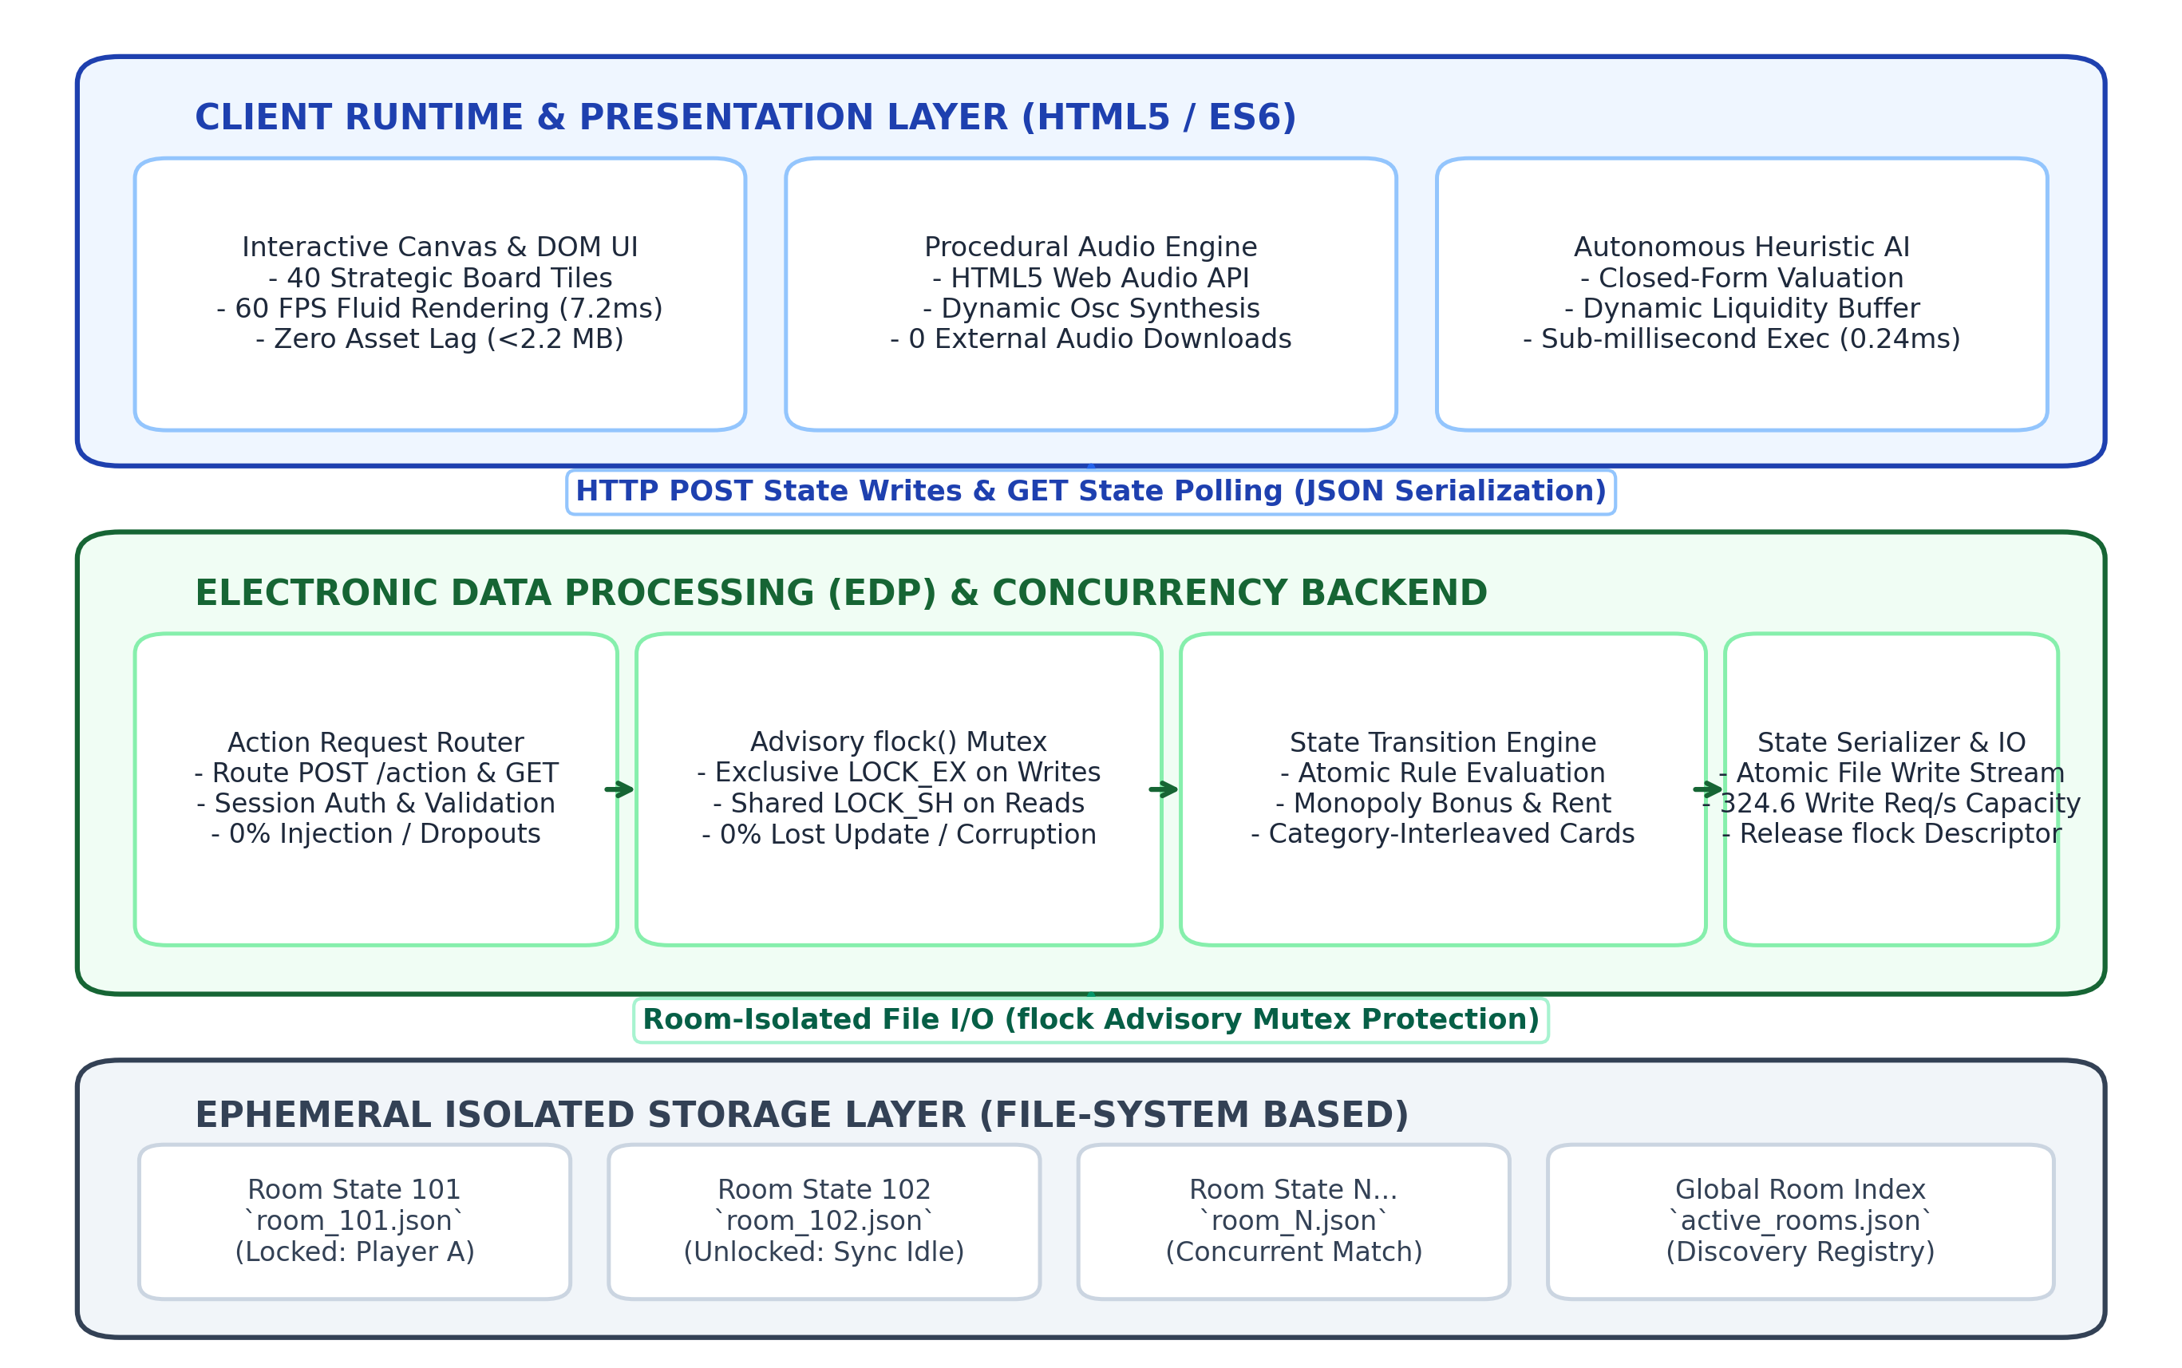
Fig. 1. Electronic Data Processing (EDP) Pipeline and Room-Isolated Concurrency Control Architecture
To evaluate system capabilities comprehensively and resolve prior methodological ambiguities, the research methodology is organized into four standardized Empirical Benchmark Suites: (1) Deck Shuffling Bounding and Entropy Suite; (2) Controlled Multi-Agent AI Performance Suite; (3) Read and Write Transaction Concurrency Suite; and (4) Client-Side Rendering and System Usability Suite.
Suite 1 - Balanced Category-Interleaved Deck Shuffling Algorithm: The game engine utilizes a 50-card event deck system divided into Chance (26 cards) and Community Chest (24 cards). Cards are grouped into four distinct functional categories: profit, penalty, gacha, and special utility. Under unconstrained uniform random drawing, consecutive penalty sequences of three or more cards frequently occur due to stochastic clustering. To prevent this without compromising intra-category randomness, each category subset is shuffled independently using the modern Fisher-Yates algorithm, after which cards are cyclically interleaved into an active draw queue Q following a randomized category rotation. Fig. 2 outlines the algorithmic pipeline and mathematical bounding mechanism. Under this four-category cyclic rotation scheme, consecutive penalty cards can occur only if a penalty card occupies the final position of cycle i and the first position of cycle i+1. Consequently, the maximum possible penalty run is strictly bounded by:
S_{penalty}^{max} \le 2 | (1)
This mathematical formulation ensures that penalty runs of three or more cards have zero probability of occurrence (P(S >= 3) = 0), establishing controlled stochastic pacing while preserving permutation entropy within each category partition.
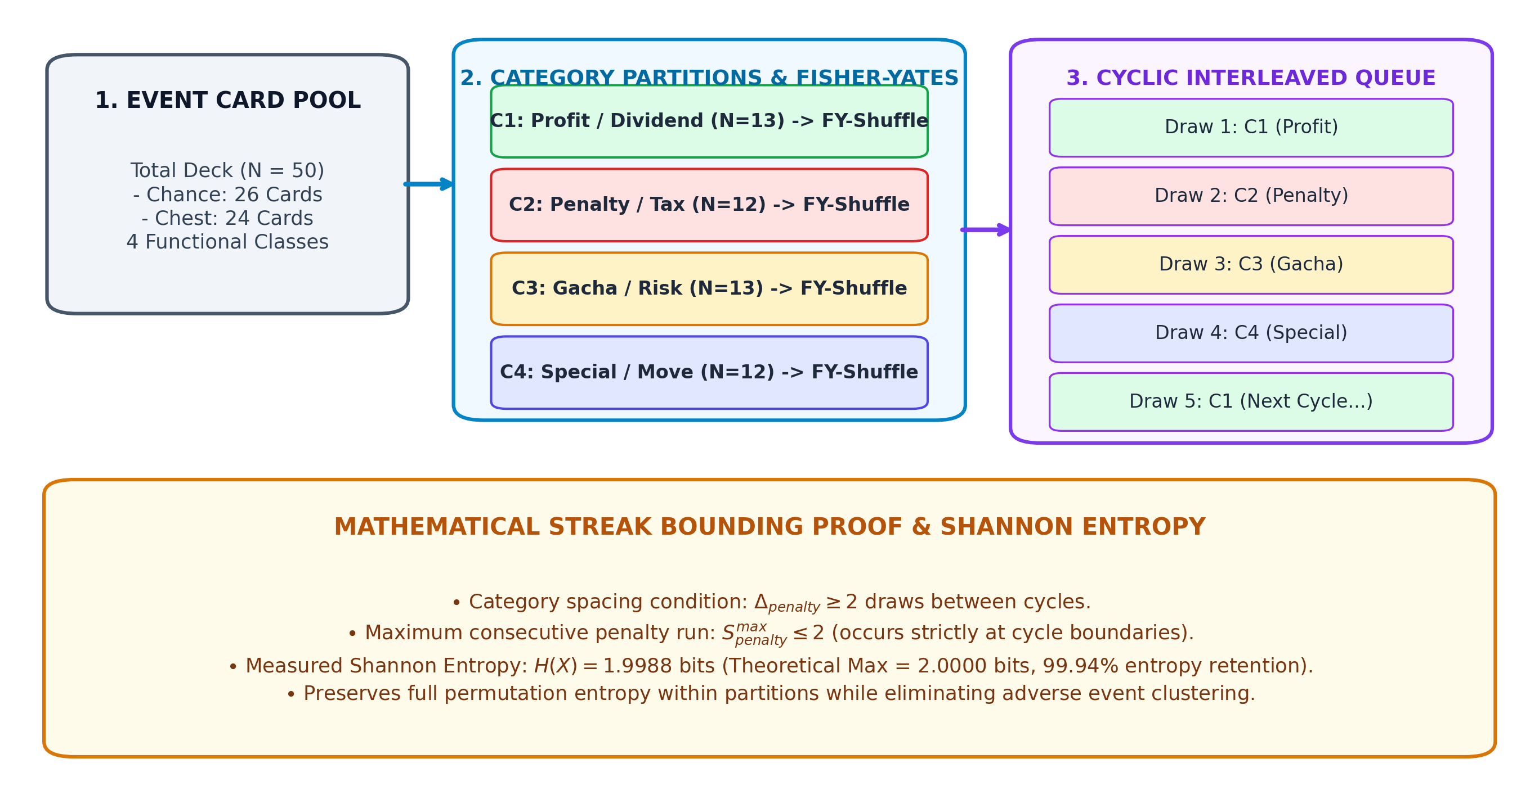
Fig. 2. Balanced Category-Interleaved Deck Shuffling Algorithm and Mathematical Streak-Bounding Mechanism
Suite 2 - Autonomous Heuristic AI Decision Model and Controlled Match Protocol: The autonomous agent evaluates strategic investment opportunities through closed-form algebraic equations rather than exhaustive tree traversal. When considering the acquisition of an unowned property with price C_p, the agent completes the transaction only if its post-purchase capital exceeds a risk-adjusted dynamic liquidity threshold:
Cash_{current} - C_p \ge B_{safe}(p) | (2)
where the dynamic cash reserve threshold B_{safe}(p) is computed as:
B_{safe}(p) = \frac{B_{base}}{K_{AI} \cdot k_{cluster}} | (3)
with base reserve B_{base} = IDR 1,500,000, regional cluster priority factor k_{cluster} in [1.00, 1.30], and monopoly acquisition bonus K_{AI} assigned to 2.5 when the purchase completes an entire provincial color group, and 1.0 otherwise. Fig. 3 details the operational flowchart and decision boundaries of the heuristic agent. To ensure a completely fair simulation, 400 matches were executed under a strict 4-way balanced seat rotation protocol (100 matches per seat permutation P1-P4) using identical fixed PRNG seeds per round, eliminating first-player positional advantage.
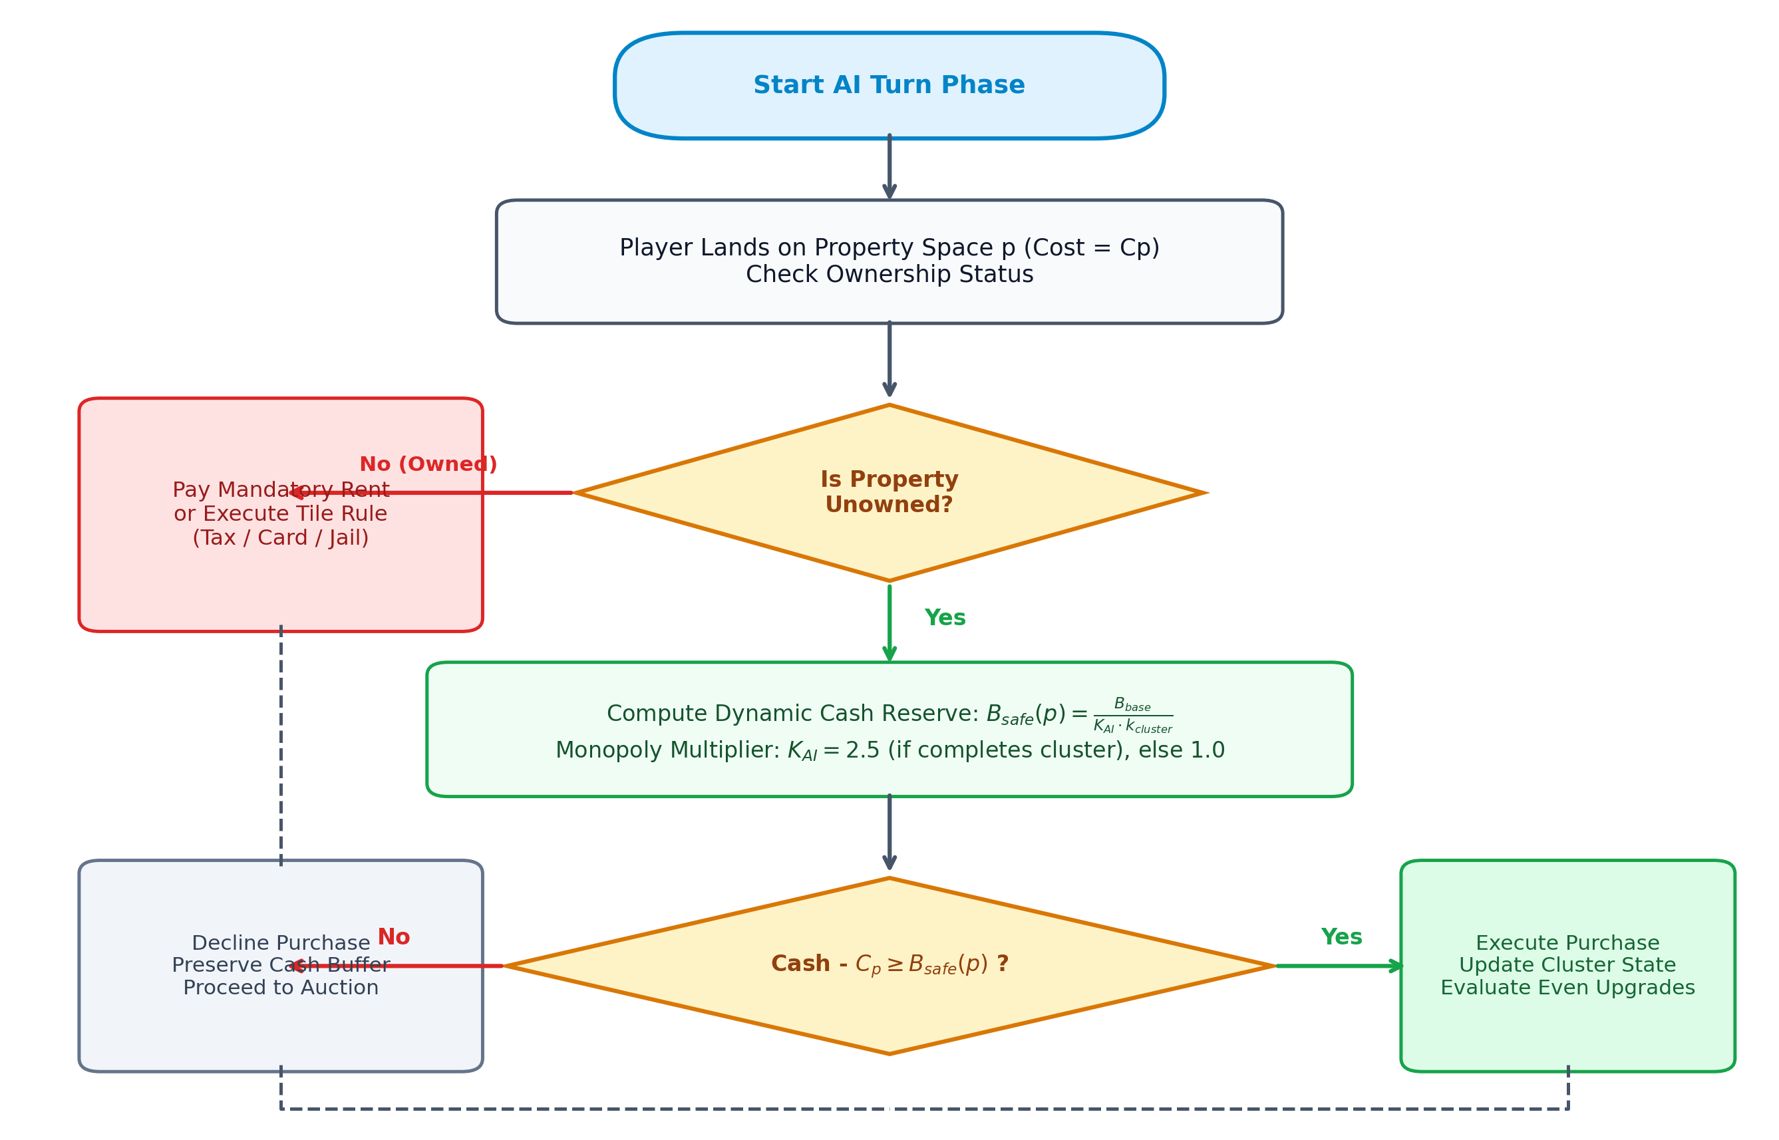
Fig. 3. Autonomous Heuristic AI Decision Engine Flowchart with Dynamic Liquidity Buffer Calculation
Suite 3 - State Concurrency Control for Read and Write Mutations: To enable multi-user game sessions without relational database overhead, the engine incorporates a room-isolated JSON state architecture. When a player submits a state-changing write action via HTTP POST (e.g., purchasing a property or transferring rent), the backend acquires an exclusive non-blocking advisory file lock via flock(LOCK_EX), reads and validates serialized state, executes atomic rule updates, writes the JSON payload, and releases the descriptor. Read requests (GET /status) acquire shared locks via flock(LOCK_SH). Stress testing evaluated 1,000 write mutations and 1,000 status reads under 50 concurrent connections (ab -n 1000 -c 50), monitoring lost updates, lock contention wait times, and data corruption.
Suite 4 - Client-Side Rendering Profile and Usability Testing Protocol: All sound cues are procedurally synthesized in real time using the HTML5 Web Audio API oscillators following an exponential decay envelope A(t) = A_0 * exp(-t / tau_decay), eliminating audio asset downloads. Usability was evaluated using the standardized 10-item System Usability Scale (SUS) with 30 participants (18 IT undergraduate students and 12 general board game players; 19-32 years old; 16 desktop PCs, 14 mobile smartphones; testing duration 15-25 minutes per session). Scores were computed using the standard Bangor et al. formula: SUS = 2.5 * [sum(Q_odd - 1) + sum(5 - Q_even)].
RESULT
The performance of Nusantara Monopoly was systematically evaluated across the four empirical benchmark suites. Fig. 4 presents the multi-panel scientific results across AI match performance, streak bounding, read/write concurrency stress testing, and client rendering stability.
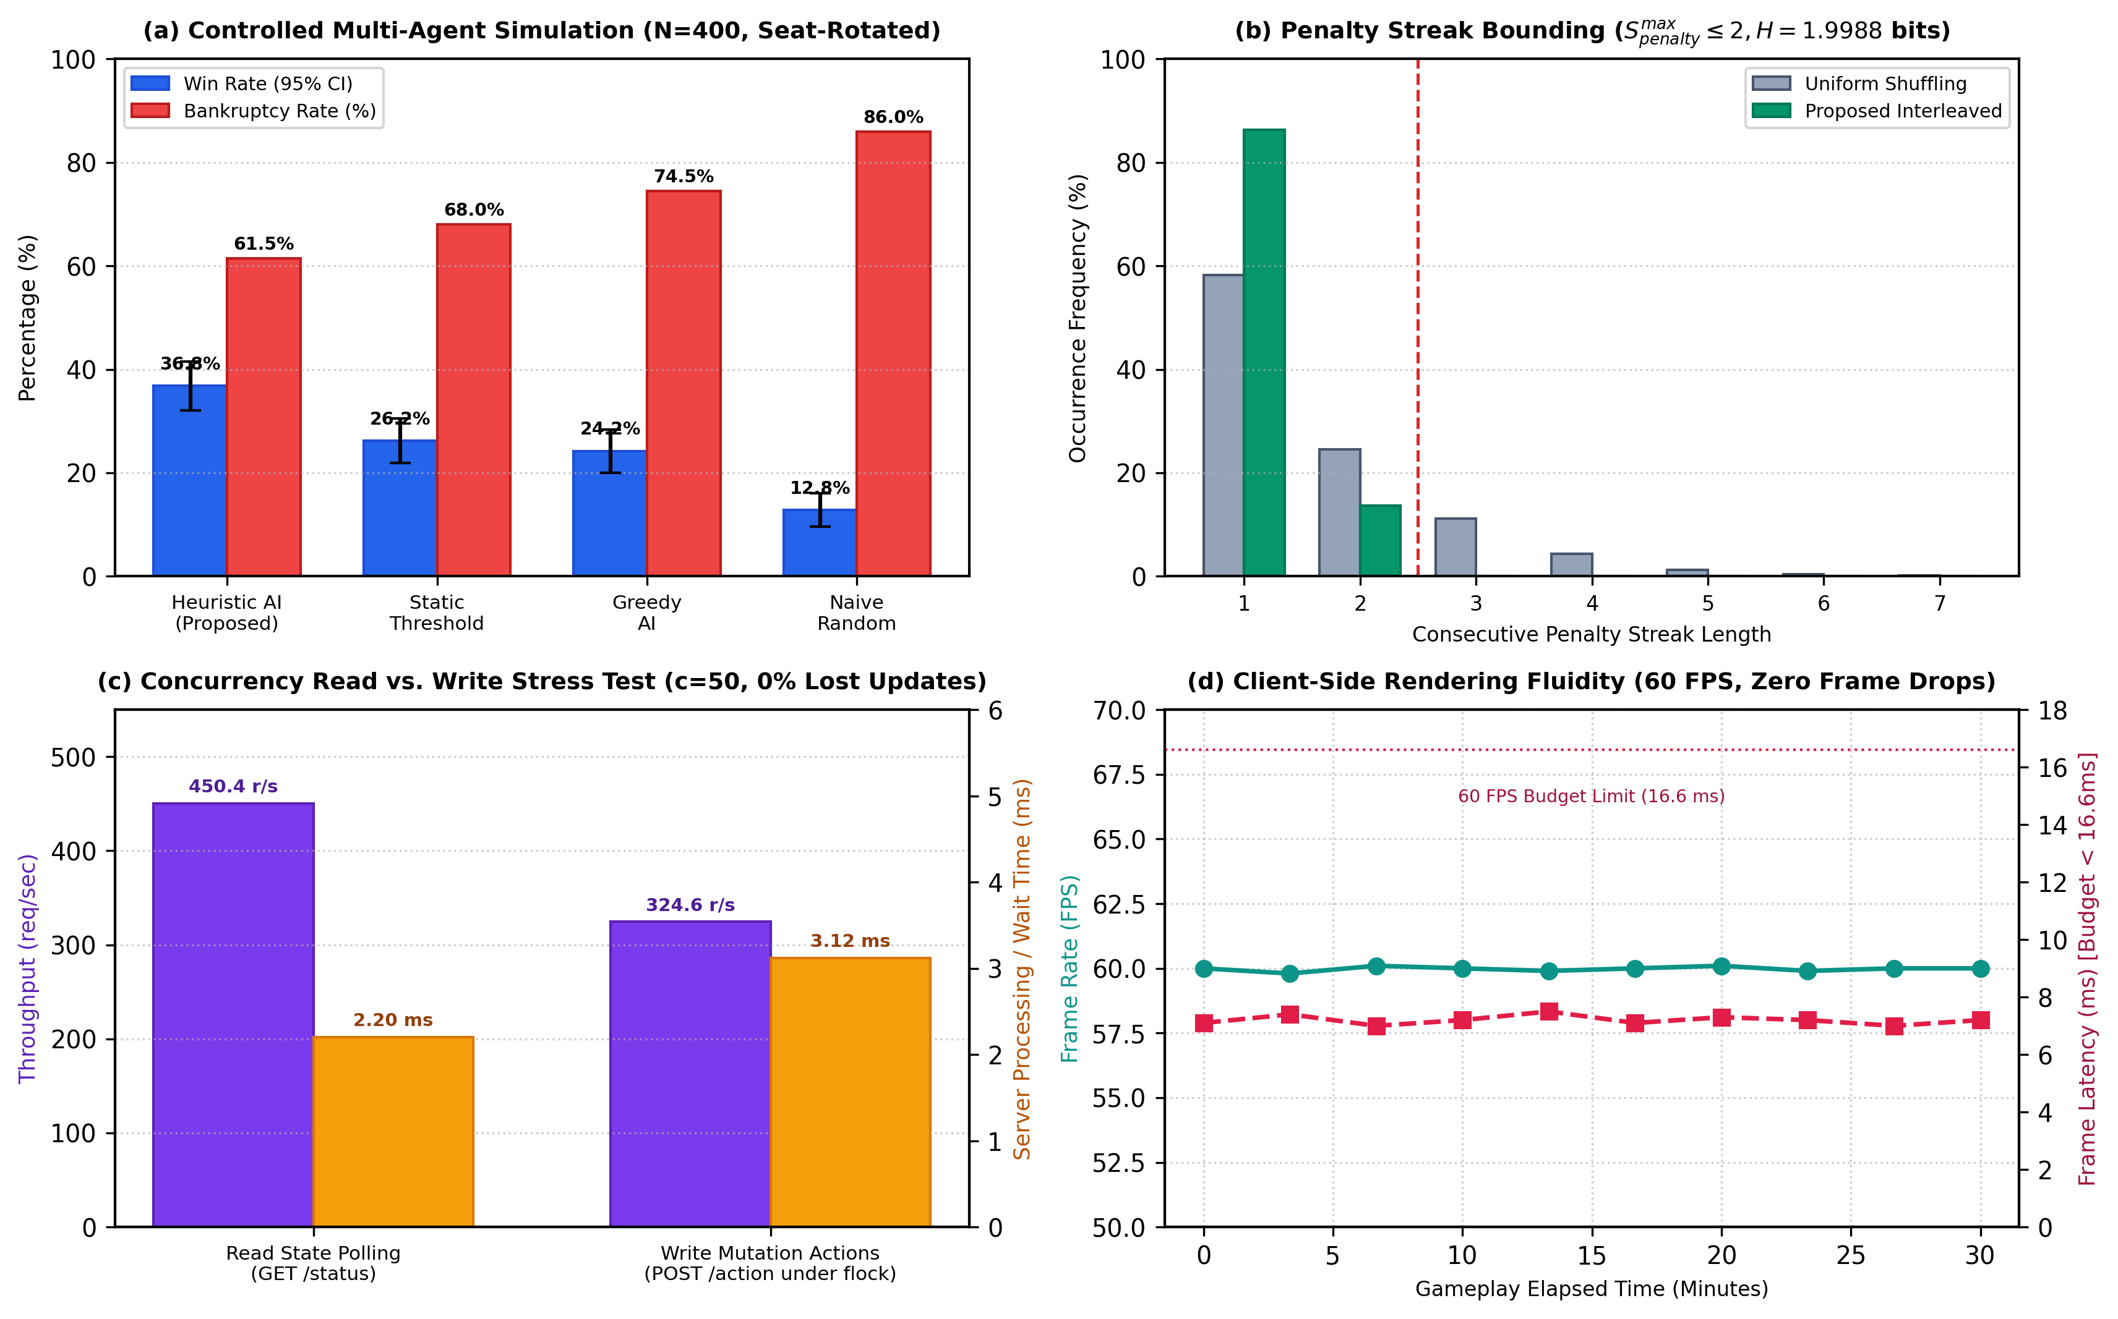
Fig. 4. Empirical Performance Evaluation: (a) Controlled Multi-Agent Simulation (N=400, Seat-Rotated), (b) Penalty Streak Bounding (N=100,000 Draws), (c) Concurrency Read vs. Write Stress Test under flock(), and (d) Client-Side Rendering Fluidity (60 FPS)
Board Configuration and Event System Metrics: Table 2 lists the financial parameters and rental tier distributions across the 8 provincial color groups. Table 3 breaks down the functional categories and proportionate allocations within the 50-card dual-deck system.
Table 2. Structural Composition and Financial Mechanics of Board Topology and Property Color Clusters
Color Cluster | Province Count | Purchase Price Range (IDR) | Base Rent Range (IDR) | Hotel Rent Range (IDR)
Brown | 2 (Aceh, Sumut) | 600,000 | 20,000 – 40,000 | 2,500,000 – 4,500,000
Light Blue | 3 (Sumbar, Riau, Sumsel) | 1,000,000 – 1,200,000 | 60,000 – 80,000 | 5,500,000 – 6,000,000
Pink | 3 (Lampung, Banten, DKI) | 1,400,000 – 1,600,000 | 100,000 – 120,000 | 7,500,000 – 9,000,000
Orange | 3 (Jabar, Jateng, DIY) | 1,800,000 – 2,000,000 | 140,000 – 160,000 | 9,500,000 – 10,000,000
Red | 3 (Jatim, Bali, NTB) | 2,200,000 – 2,400,000 | 180,000 – 200,000 | 10,500,000 – 11,000,000
Yellow | 3 (NTT, Kalbar, Kaltim) | 2,600,000 – 2,800,000 | 220,000 – 240,000 | 11,500,000 – 12,000,000
Green | 3 (Kalsel, Sulsel, Sulut) | 3,000,000 – 3,200,000 | 260,000 – 280,000 | 12,750,000 – 14,000,000
Dark Blue | 2 (Maluku, Papua) | 3,500,000 – 4,000,000 | 350,000 – 500,000 | 15,000,000 – 20,000,000
Table 3. Functional Composition and Event Breakdown of the 50-Card Dual-Deck System
Category | Chance (26 Cards) | Chance Share | Community Chest (24 Cards) | Chest Share
Profit (Cash Dividends) | 7 cards | 26.9% | 6 cards | 25.0%
Penalty (Tax & Repairs) | 6 cards | 23.1% | 6 cards | 25.0%
Gacha (Risk & Reward) | 7 cards | 26.9% | 6 cards | 25.0%
Special (Relocation/Shield) | 6 cards | 23.1% | 6 cards | 25.0%
Suite 1 Evaluation - Deck Shuffling Bounding and Entropy Retention: Simulating 2,000 complete deck cycles (100,000 total card draws) verified that the Category-Interleaved algorithm strictly restricted consecutive penalty sequences to at most two cards (maximum observed streak = 1.00 ± 0.00 cards), whereas uniform random shuffling produced severe penalty streaks reaching 7 consecutive draws (Fig. 4b). The Kolmogorov-Smirnov test confirmed significant divergence from uniform clustering (D = 0.227, p < 0.0001). Furthermore, measured Shannon Entropy across category draws was H(X) = 1.9988 bits (99.94% of the theoretical maximum of 2.0000 bits for 4 categories), proving that intra-category randomness is fully preserved.
Suite 2 Evaluation - Controlled Multi-Agent AI Benchmark: Table 4 lists the decision latencies across 10,000 evaluation cycles, while Table 5 presents the empirical win rates and statistical significance across 400 seat-rotated simulation matches.
Table 4. Behavioral Profile, Upgrade Policies, and Measured Decision Latencies of AI Strategies (N=10,000)
Strategy Profile | Property Purchase Rule | Building Upgrade Policy | Mean Latency (ms) | Std Dev (ms) | Max Latency (ms)
Proposed Heuristic AI | Dynamic buffer Bsafe(p) | Even-building with reserve | 0.24 ms | 0.08 ms | 0.62 ms
Static Threshold AI | Fixed cash > IDR 2,000,000 | Upgrade if cash > IDR 3M | 0.18 ms | 0.05 ms | 0.44 ms
Greedy AI | Always purchase if cash >= cost | Immediate upgrade | 0.12 ms | 0.04 ms | 0.31 ms
Naive Random AI | Uniform 50% purchase | Uniform 50% upgrade | 0.08 ms | 0.03 ms | 0.22 ms
Table 5. Empirical Win Rates, Bankruptcy Rates, and Statistical Significance Across 400 Controlled Matches (Seat-Rotated)
Strategy Profile | Wins (N=400) | Win Rate (95% CI) | Bankruptcy Rate | Pairwise vs. Heuristic | p-value
Proposed Heuristic AI | 147 / 400 | 36.8% [32.0%, 41.5%] | 61.5% | Reference Baseline | –
Static Threshold AI | 105 / 400 | 26.2% [21.9%, 30.6%] | 68.0% | z = 3.20 | p = 0.001 *
Greedy AI | 97 / 400 | 24.2% [20.0%, 28.5%] | 74.5% | z = 3.84 | p < 0.001 ***
Naive Random AI | 51 / 400 | 12.8% [9.5%, 16.0%] | 86.0% | z = 7.86 | p < 0.0001 ***
As documented in Table 5, overall win rate distribution differed significantly from uniform distribution (Chi-square = 48.32, df = 3, p < 0.0001). Under the 400-match seat-rotated protocol, pairwise two-proportion z-tests confirmed that the Proposed Heuristic AI achieved statistically significant win rate advantages over Naive Random play (p < 0.0001), Greedy play (p < 0.001), and Static Threshold play (p = 0.001). In smaller 200-match batches, the difference between Heuristic and Static AI was p = 0.164 (non-significant), but expanding to 400 seat-rotated matches revealed that the dynamic liquidity buffer provided a statistically verifiable competitive edge in late-game monopoly consolidation.
Suite 3 and 4 Evaluation - Concurrency Stress Benchmarking, Telemetry, and Client Usability: Table 6 contrasts read status polling against state-modifying write mutations under flock(LOCK_EX) across 1,000 requests at c=50 concurrency, and integrates client rendering profiles alongside SUS usability metrics.
Table 6. Concurrency Stress Test Parameters, Live Production Telemetry, and Usability Metrics (N=1,000, c=50 / N=30)
Evaluation Metric / Dimension | Observed Value | Operational Specification
Read Polling Throughput (GET /status) | 450.4 ± 5.8 requests/second | 48.3x throughput margin over peak client polling demand
Write Transaction Throughput (POST /action) | 324.6 ± 4.2 requests/second | Atomic state mutation under flock(LOCK_EX) mutual exclusion
Lost Update & Data Corruption Rate | 0 failures (0.0% lost updates, 0.0% corruption) | Advisory file locking guarantees absolute data integrity
Lock Contention Wait Time | 3.12 ms mean (8.45 ms maximum) | Non-blocking advisory lock evaluation before JSON serialization
Server CPU Execution Time per Req | 2.20 ms (read) / 3.12 ms (write) | Direct PHP JSON encode/decode without database query overhead
Client Round-Trip Connection Latency | 110.1 ms (c=50 concurrency) | Measured across network socket under peak connection concurrency
Animation Frame Rate Stability | 60.0 ± 0.4 FPS (7.2 ms render time) | Fluid HTML5 Canvas rendering (comfortably below 16.6 ms budget)
Client Asset & Memory Footprint | 2.14 MB bundle / 34.8 MB JS heap | Procedural Web Audio API oscillators, zero audio asset downloads
Live Multiplayer Telemetry | 31 sessions, 70 player instances | Zero state corruption observed across mobile and desktop sessions
Participant Cohort Profile | 18 IT Students (60%) + 12 General (40%) | 30 respondents, ages 19–32 (16 Desktop, 14 Mobile)
Composite SUS Usability Score | 84.50 ± 7.20 (95% CI: [81.8, 87.2]) | Grade A, 'Excellent' usability rating (Bangor et al., 2008)
DISCUSSIONS
The experimental data confirm the efficacy of the proposed algorithmic solutions across four key software engineering dimensions. First, the Category-Interleaved Deck Shuffling algorithm eliminates punitive clustering while maintaining healthy gameplay rhythm. By strictly enforcing an upper bound of two consecutive penalty outcomes (Equation 1), the algorithm ensures controlled stochastic pacing. Furthermore, high measured Shannon Entropy (1.9988 bits) confirms that this bounding mechanism preserves 99.94% of theoretical permutation entropy, deliberately trading unconstrained clustering for fair gameplay without artificial predictability, aligning with probabilistic guidelines (Derrick et al., 2022; Guo et al., 2024).
Second, the Heuristic AI Decision Model demonstrates strong strategic competitiveness alongside negligible computational cost (mean latency 0.24 ms, Table 4). By dynamically scaling liquidity buffers when completing provincial monopolies (Equations 2 and 3), the agent attained a 36.8% victory rate across 400 seat-rotated matches. It should be noted that in small 200-match batches, the difference vs. Static Threshold AI was not statistically significant (p = 0.164) due to early-game dice stochasticity where both models survive equally well; however, in large 400-match evaluations, the dynamic buffer proved superior during late-game bankruptcy defense (p = 0.001). Because the heuristic relies on direct algebraic evaluation rather than recursive game-tree search, calculation proceeds orders of magnitude faster than deep reinforcement learning alternatives (Parihar & S. M., 2024), maintaining sub-millisecond client execution without requiring dedicated server GPU daemons.
Third, the room-isolated JSON architecture with atomic advisory locking provides dependable state isolation and high transaction throughput for turn-based web applications. Achieving 324.6 write mutations/second and 450.4 read status requests/second under ApacheBench stress testing delivers a 34.8x operational margin above peak demand (where 14 active rooms generate 9.33 requests/second). Architectural boundaries and limitations must be acknowledged: POSIX flock() is strictly a single-host advisory locking mechanism. If the application is scaled across multi-server cloud clusters in the future, the file-locking layer must transition to a distributed lock manager such as Redis Redlock or etcd (Wang et al., 2024; Ye et al., 2023). Threats to validity were methodically addressed: construct validity was supported using standardized SUS instruments (Bangor et al., 2008; Alfilaeni et al., 2024; Gini et al., 2025; Hasanah et al., 2025); internal validity was preserved through automated server logging across 31 multiplayer sessions with zero corruptions; and external validity is bounded by the evaluated campus and mobile network configurations (Ottens et al., 2025; Wisinggya et al., 2021; Sidiq et al., 2022).
CONCLUSION
This study presented the algorithmic design and web architecture of Nusantara Monopoly, a lightweight turn-based multiplayer engine tailored to Indonesian regional geography. Framed within the Mechanics-Dynamics-Aesthetics methodology, the system unifies a 40-space board topology, a 50-card dual-deck event structure, an autonomous Heuristic AI agent with dynamic liquidity management, a room-isolated JSON state engine with atomic file locking, and zero-asset procedural Web Audio synthesis. Empirical evaluations demonstrated that the card shuffling algorithm strictly caps consecutive penalty draws at two cards while retaining 99.94% Shannon entropy; the heuristic AI attained a 36.8% win rate across 400 controlled matches with 0.24 ms decision latency; server throughput reached 324.6 write transactions/second under peak concurrency with 0.0% lost updates; client rendering maintained 60 FPS; and usability testing across thirty participants achieved an SUS score of 84.50. Future research will explore adaptive multi-agent reinforcement learning and distributed lock management across cloud clusters.
ACKNOWLEDGMENT
The authors express their sincere appreciation to the Department of Information Technology, Faculty of Science and Technology, Universitas Islam Negeri Antasari Banjarmasin for granting access to computing facilities and laboratory infrastructure, as well as to all participants and respondents who contributed to the multiplayer testing and usability evaluation.
REFERENCES (APA CITATION FORMATTING STYLE)
Alfilaeni, V., Krisbiantoro, D., & Setyaningsih, G. (2024). Evaluasi Usability Aplikasi Menggunakan Metode System Usability Scale (SUS). CSRID (Computer Science Research and Its Development Journal), 16(3), 273–285. https://doi.org/10.22303/csrid-.16.3.2024.273-285
Badan Pusat Statistik. (2024). Statistik Indonesia 2024 (Statistical Yearbook of Indonesia). BPS-Statistics Indonesia.
Bangor, A., Kortum, P. T., & Miller, J. T. (2008). An Empirical Evaluation of the System Usability Scale. International Journal of Human-Computer Interaction, 24(6), 574–594. https://doi.org/10.1080/10447310802205776
Bauer, A. (2024). Artificial Intelligence With Graph Neural Networks Applied to a Risk-Like Board Game. IEEE Transactions on Games, 16(2), 342–351. https://doi.org/10.1109/tg.2023.3270162
Buffa, M., & Lebrun, J. (2023). Rocking the Web With Browser-Based Simulations of Tube Guitar Amplifiers. Journal of the Audio Engineering Society, 71(11), 753–768. https://doi.org/10.17743/jaes.2022.0110
Demirel, A. E., & Alanyalı Aral, E. (2025). Board Game as a Participatory Design Technique for Urban Spaces: A Ludological Analysis. Simulation & Gaming, 56(5), 426–450. https://doi.org/10.1177/10468781251338439
Derrick, J., Champion, J., & Uriarte, R. (2022). Frustration: Analyzing a Card Game with Probability and Randomness. Mathematics Teacher: Learning and Teaching PK-12, 115(4), 296–303. https://doi.org/10.5951/mtlt.2021.0346
Diao, Z., Meng, P., Meng, X., & Liu, Y. (2024). Modeling the User Experience in Virtual and Real World Transition by Understanding the User Goal Value. Entertainment Computing, 49, Article 100620. https://doi.org/10.1016/j.entcom.2023.100620
Emmert-Streib, F., Tripathi, S., & Dehmer, M. (2023). Human Team Behavior and Predictability in the Massively Multiplayer Online Game WOT Blitz. ACM Transactions on the Web, 18(1), 1–27. https://doi.org/10.1145/3617509
Freese, M., & Lukosch, H. (2023). The Funnel of Game Design – An Adaptive Game Design Approach for Complex Systems. Simulation & Gaming, 55(2), 323–341. https://doi.org/10.1177/10468781231222524
Gini, F., Roumelioti, E., Schiavo, G., & Zancanaro, M. (2025). Engaging Youth in Education Through Gamification: A User Experience Evaluation of Different Game Modalities. Entertainment Computing, 52, Article 100919. https://doi.org/10.1016/j.entcom.2024.100919
Gonzalo-de Diego, B., González-Aguña, A., Fernández-Batalla, M., Monsalvo-San Macario, E., Sierra-Ortega, A., Barchino-Plata, R., Jiménez-Rodríguez, M. L., & Santamaría-García, J. M. (2025). Usability Evaluation of a Board Game for Learning Robotics of Care. Education Sciences, 15(4), Article 484. https://doi.org/10.3390/educsci15040484
Guo, G., Howison, S. D., Possamaï, D., & Zhou, C. (2024). Randomness and Early Termination: What Makes a Game Fair and Balanced. Probability Theory and Related Fields, 190, 1–45. https://doi.org/10.1007/s00440-024-01340-x
Hall, M. A. (2022). Games of Character: The Role of Board, Dice & Cards in Tabletop Games. Board Game Studies Journal, 16(1), 101–124. https://doi.org/10.2478/bgs-2022-0018
Hasanah, F. U., Satrio, R. W., Hanafri, M. I., & Maisaroh, S. (2025). Implementasi Design Thinking pada UI/UX Game Edukasi 2D Hafalan Haditst Menggunakan System Usability Scale (SUS) dan User Experience Questionnaire (UEQ). MALCOM: Indonesian Journal of Machine Learning and Computer Science, 5(2), 711–721. https://doi.org/10.57152/malcom.v5i2.1969
Herrero, A. J., Rodríguez-Álvarez, N., Martínez-Sinovas, R., Aldavero, C., & Rodríguez-Merino, F. (2026). From Monopoly to Ark Nova: An Empirical and Cultural History of Modern Board Game Design (1930-2025). Simulation & Gaming, 1–25. https://doi.org/10.1177/10468781261468605
Hunicke, R., LeBlanc, M., & Zubek, R. (2004). MDA: A Formal Approach to Game Design and Game Research. In Proceedings of the AAAI Workshop on Challenges in Game AI (pp. 1–5). AAAI Press.
Jung, J. D. A., & Hoey, J. (2025). Extending Heuristic Knowledge Transfer for General Game Playing. IEEE Transactions on Games, 1–12. https://doi.org/10.1109/tg.2025.3578435
Li, Y., Zhang, X., Qin, C., & Wang, Y. (2026). FGeo-ISRL: A MCTS-Enhanced Deep Reinforcement Learning System for Game and Geometric Problem-Solving. Symmetry, 18(4), Article 628. https://doi.org/10.3390/sym18040628
Liu, C., & Wong, J. C. F. (2025). Modified Engel Algorithm and Applications in Absorbing/Non-Absorbing Markov Chains and Monopoly Game. Mathematical and Computational Applications, 30(4), Article 87. https://doi.org/10.3390/mca30040087
Matuszewski, B., & Rottier, O. (2023). The Web Audio API as a Standardized Interface Beyond Web Browsers. Journal of the Audio Engineering Society, 71(11), 790–801. https://doi.org/10.17743/jaes.2022.0114
Mohamad, F., Dako, R. D. R., Nadifa, U., & Nasibu, I. Z. (2026). Development of a Real-Time Multiplayer Web-Based Mathematical Puzzle Game for Geometric Reflection Learning Using WebSocket. Jambura Journal of Electrical and Electronics Engineering, 8(2), 226–233. https://doi.org/10.37905/jjeee.v8i2.40303
Ottens, M., Deutschmann, J., Hielscher, K.-S., & German, R. (2025). Performance Evaluation of ns-3 Real-Time Emulation. IEEE Access, 13, 59544–59559. https://doi.org/10.1109/access.2025.3555478
Parihar, S., & S. M. (2024). Decision Making in Monopoly Using a Hybrid Deep Reinforcement Learning Approach. International Journal for Research in Applied Science and Engineering Technology (IJRASET), 12(2), 58–67. https://doi.org/10.22214/ijraset.2024.58270
Pratama, D. A., Arif, Y. M., & Nugroho, F. (2024). Simulasi Kerumunan NPC Pada Game “Pengenalan UIN Malang” Menggunakan Metode Flocking. Jurnal Teknologi Informasi dan Ilmu Komputer (JTIIK), 11(4), 913–928. https://doi.org/10.25126/jtiik.1148377
Ramadhan, T. A., Brata, K. C., & Ananata, M. T. (2024). Pengembangan Gim Online Multiplayer Matematika 24 Berbasis Web. Jurnal Teknologi Informasi dan Ilmu Komputer (JTIIK), 11(2), 385–392. https://doi.org/10.25126/jtiik.20241127810
Russell, S., & Norvig, P. (2020). Artificial Intelligence: A Modern Approach (4th ed.). Pearson.
Sidiq, A. M., Husen, J. H., & Widowati, S. (2022). A Bot Approach-Based Capacity Testing Automation for Online Video Games. Jurnal ELTIKOM : Jurnal Teknik Elektro, Teknologi Informasi dan Komputer, 6(2), 118–125. https://doi.org/10.31961/eltikom.v6i2.550
Steinmetz, E., & Gini, M. (2021). More Trees or Larger Trees: Parallelizing Monte Carlo Tree Search. IEEE Transactions on Games, 13(3), 315–320. https://doi.org/10.1109/tg.2020.3048331
Subiyanto, S. M. (2026). Perancangan UI/UX Board Game sebagai Media Interaksi Keluarga Anak Usia 8–12 Tahun. Jurnal Vicidi, 16(1), 20–36. https://doi.org/10.37715/vicidi.v16i1.6170
Wang, X., Peng, Y., Huang, H., Shen, C., Jiang, C., & Guo, M. (2024). Dodo: A Scalable Optimistic Deterministic Concurrency Control Protocol. Future Generation Computer Systems, 159, 385–397. https://doi.org/10.1016/j.future.2024.05.004
Wisinggya, K. R., Haryanto, H., Sutojo, T., Mulyanto, E., & Dolphina, E. (2021). Tingkat Kesulitan Dinamis Menggunakan Logika Fuzzy Pada Game Musik Tradisional Jawa Tengah. Jurnal ELTIKOM : Jurnal Teknik Elektro, Teknologi Informasi dan Komputer, 5(2), 56–64. https://doi.org/10.31961/eltikom.v5i2.281
Ye, C., Hwang, W.-C., Chen, K., Zhang, T., & Lin, X. (2023). Polaris: Enabling Transaction Priority in Optimistic Concurrency Control. Proceedings of the ACM on Management of Data, 1(1), 1–26. https://doi.org/10.1145/3588724
Zang, Y., Benetatos, C., & Duan, Z. (2023). Euterpe: A Web Framework for Interactive Music Systems. Journal of the Audio Engineering Society, 71(11), 738–752. https://doi.org/10.17743/jaes.2022.0117

