This Section is filled by The Author

PLEASE FILL THE FORM BELOW AND DO NOT REMOVE THIS FROM MANUSCRIPT

Authors Submission Checklist
All manuscripts must meet the following criteria to be processed into the peer-review stage. Failure to meet the following criteria may increase the processing time of the manuscript or even rejection.
Write OK if the authors have confirmed that the manuscript meets the criteria. If the author cannot fulfill these criteria, give a reason, and write in the checklist with highlighted text.

1 | Template and Layout | Authors Claim &  Comment | Editors Comment
1.1 | Have used the latest SinkrOn template (latest update June, 2021) | OK
1.2 | Introduction, Literature Review Methods, Result, Discussion, and  Conclusion are written in a separate section. | OK
1.3 | Not using Bullet / Numbering in the manuscript text. | OK
1.4 | The length of the text is between 6 and 12 pages. | OK
2 | Title and Authors Information
2.1 | The title is written briefly, describing the contents and contributions of the manuscript. The title also does not use abbreviations or acronyms except the standard ones. The title consists of a maximum of 14 words. | OK
2.2 | All authors have been written in the manuscript and also in the OJS system.  One of the authors who corresponded through the OJS system was determined as the correspondence authors. | OK
2.3 | All authors must include e-mails in the manuscript and the OJS system. | OK
2.4 | Affiliation information is written in 1 line in the text, at least showing the name of the institution and country. Full Address information should be  written in 1 line bellow affiliation information. | OK
2.5 | The title of the manuscript is written using 'Capitalize Each Word', except  conjunctions using lowercase. | OK
2.6 | The place and time of research do not need to be included in the title unless  the research is specific to a particular time and place. | OK
3 | Abstracts and Keywords
3.1 | Abstract consists of 200 to a maximum of 250 words. | OK
3.2 | Abstracts are arranged in a structured manner. Consisting of Background,  Objective, Methods, Results, and Conclusion | OK
3.3 | The number of keywords minimal 5 words | OK
3.4 | All keywords must be written in the abstract. | OK
3.5 | Keywords are arranged in alphabetical order. | OK
3.6 | A combination of all keywords represents the content, contribution, or  purpose of the text. | OK
3.7 | Keywords can be in the form of research subjects’ category. Avoid using  adjectives as keywords in the text. | OK
4 | Introduction
4.1 | Has explained the context/object of research and must focus following the  scope of the title. | OK
4.2 | Has explained why this research is important. | OK
4.3 | It has included the existing research gap, explaining the unique differences  between this study compared to similar previous studies. | OK
4.4 | Has written research objectives/contributions explicitly. | OK
4.5 | The length of this section is between 300 – 700 words. | OK
5 | Literature Review
5.1 | This section is optional. This section may only be available if the explanation related to previous research is not sufficient if it is only shown  in the introduction. If this section exists, you must cite at least 6 recent papers that are closely related to the title of the paper. | OK
6 | Methods
6.1 | Has cited a source who helped the authors in the selection of methods. | OK
6.2 | Has explained how data is obtained. | OK
6.3 | The procedure has been written chronologically and clearly. | OK
6.4 | The authors have written how the results will be measured, tested, and  evaluated. | OK
7 | Results
7.1 | The results of the study are written in logical sequences, according to the  research flow. | OK
7.2 | The results of the study are presented in the form of narrative/textual, tables,  or images in the form of graphs or diagrams. Avoid displaying raw data. | OK
8 | Discussion
8.1 | An explanation of the results and in-depth analysis has been written. | OK
8.2 | A comparison of results with other studies has been written. | OK
8.3 | Limitation of study or threat to validity has been written. | OK
9 | Conclusion
9.1 | It has been explicitly written down the contribution of the manuscript and  the answers to the research questions. | OK
10 | Acknowledgments
10.  1 | If it is funded research, information on the funders agency must be provided along with the contract number(if any). | OK
11 | References
11.  1 | Always use automatic citation tools for managing your references. make sure that you already double-check the citation metadata, automatic citation tool usually has metadata errors. Use Mendeley to make Citation &  References/Bibliography. Use APA^{6th} Edition citation style. | OK
11.  2 | Make sure all information related to the reference is written completely (eg Who, Where, and When). Check from the primary source for this information. write the name of the journal without abbreviations. please  include DOI if it's available. | OK
11.  3 | Have cite a minimum of 15 references. a minimum of 80% comes from journal articles/conferences. a minimum of 80% must be published in the  last 5 years. | OK
11.  4 | More than 50% of the references must come from credible sources. for example SinkrOn, ScienceDirect, IEEE Explorer, ACM Digital Library,  Springer Link, Scopus, Clarivate Analytics, and Indonesian national accredited journals (SINTA 1/2). | OK
12 | Tables and Figures
12.  1 | Already using the appropriate format in displaying images and tables. | OK
12.  2 | The image or graph must be self-explanatory, so it does not depend on the  text. | OK
12.  3 | The minimum image resolution is not specified, but must be visible when  published online (colored) or printed (black and white). | OK
12.  4 | Images do not have copyright issues. | OK
12.  5 | All images and tables have been referenced in the manuscript. | OK
12.  6 | The maximum number of images and tables is respectively 6. giving the reason to the editor if you need to display more than the recommended  amount. | OK
12 | Languages
12.  1 | There are no spelling mistakes, typos, and grammatical errors. You can use tools such as Grammarly or recommendations provided by MS Word for  language checking. | OK
12.  2 | Use direct and short sentences. Long sentences do not make writing more  professional; they only confuse readers. | OK
This Section is filled by The Author
PLEASE FILL THE FORM BELOW AND DO NOT REMOVE THIS FROM MANUSCRIPT

OUTLINING HOW THE ISSUES ARE ADDRESSED

Title of paper:

- Address all the concerns/recommendations of the reviewers.
- All amendments made are to be highlighted in yellow color in the revised paper.

Reviewer # 1

Final Recommendation (choose one according to the reviewer's comments and cross unnecessary) :
Accepted without modification Accepted with minor corrections Accepted with major modification Rejected

Comments | Addresse d (Y/N) | Reply/Action taken
(Please add more rows if needed)

Reviewer # 2

Final Recommendation (choose one according to the reviewer's comments and cross unnecessary) :
Accepted without modification Accepted with minor corrections Accepted with major modification Rejected

Comments | Addresse d (Y/N) | Reply/Action taken

Reviewer # 3

Final Recommendation (choose one according to the reviewer's comments and cross unnecessary) :
Accepted without modification Accepted with minor corrections Accepted with major modification Rejected

Comments | Addresse d (Y/N) | Reply/Action taken

Algorithms and Web Architecture for Lightweight Multiplayer Archipelago Monopoly Game Engine
Muhammad Fahrul Bahri1)*, Muhayat2)
1)2)Department of Information Technology, Faculty of Science and Technology, Universitas Islam Negeri Antasari Banjarmasin, Indonesia
1)fahrulbahri@uin-antasari.ac.id, 2)muhayat@uin-antasari.ac.id
Submitted : xxxxx | Accepted : xxxx | Published : xxxxx
Abstract: Browser-based turn-based simulations frequently encounter client-side rendering bottlenecks and transactional race conditions when operating on low-bandwidth networks without dedicated server daemons. This study introduces an optimized web game architecture and programmatic pipeline implementing canonical economic board game rules contextualized within Indonesian geography. The proposed framework integrates four core algorithmic solutions: an atomic advisory file-locking transaction system utilizing flock() for room-level state concurrency control without relational database engines; a category-interleaved deck shuffling algorithm establishing mathematical guarantees against prolonged penalty sequences; an autonomous heuristic decision model that dynamically balances property acquisition costs against risk-adjusted liquidity reserves; and real-time audio synthesis executed entirely via native browser oscillators. Rigorous experimental evaluation spanning computational simulations, ApacheBench load tests, and user testing verified system capabilities. The card distribution mechanism completely bounds consecutive adverse event occurrences to two draws across two thousand execution cycles, mitigating punitive card clustering. In two hundred simulated four-player matches, the autonomous agent demonstrated a thirty-five percent victory frequency, significantly outperforming greedy over-leveraging and naive random baseline strategies while sustaining sub-millisecond calculation speed. Concurrency benchmarking confirmed server throughput of four hundred fifty requests per second under peak load with zero data corruption, and thirty participants reported a composite system usability score of eighty-four. These outcomes validate that disciplined algorithm and programming methodologies coupled with lightweight state isolation deliver high-performing multiplayer gaming experiences over standard web protocols without requiring complex server daemons.
Keywords: Algorithm and programming; Deck shuffling algorithm; Heuristic decision model; State concurrency control; Web game architecture
INTRODUCTION
Digital tabletop board games have become an influential medium for interactive computing and education, fusing strategic economic planning with stochastic state transitions. Migrating classic board games to modern web browsers introduces notable software engineering challenges, particularly regarding runtime performance and server efficiency. Turn-based economic games patterned after Monopoly depend on high-frequency state updates, including land acquisitions, rental payments, dynamic construction upgrades, and probabilistic card events (Herrero et al., 2026; Subiyanto, 2026). However, conventional browser implementations often depend on heavyweight relational database management systems, full-stack enterprise frameworks, and extensive static media files, creating severe execution latency and high bandwidth consumption on constrained networks.
From the viewpoint of algorithm and programming, web-based digital tabletop systems encounter three fundamental computational obstacles. First, conventional uniform pseudo-random number generator routines applied to event card decks frequently cause undesirable clustering, trapping players in repetitive sequences of severe penalties that disrupt game flow (Derrick et al., 2022; Guo et al., 2024). Second, integrating artificial intelligence opponents within client runtimes requires balancing computational overhead: deep adversarial tree searches induce noticeable browser execution lag, whereas simplistic random scripts lack competitive depth (Bauer, 2024; Parihar & S. M., 2024; Russell & Norvig, 2020). Third, orchestrating concurrent multi-user sessions over stateless HTTP protocols introduces significant risks of race conditions and state corruption during simultaneous client submissions unless atomic concurrency control is maintained (Wang et al., 2024; Ye et al., 2023).
To resolve these architectural limitations, this study presents the design and algorithmic implementation of Nusantara Monopoly, a lightweight multiplayer web simulation themed around Indonesian geography and regional economies. The core scientific contributions of this research are: first, a Balanced Category-Interleaved Deck Shuffling algorithm that provides deterministic mathematical limits against consecutive adverse outcomes; second, an autonomous Heuristic AI Decision Model utilizing closed-form liquidity buffers to achieve sub-millisecond reasoning without combinatorial search; and third, a room-isolated JSON transactional architecture leveraging atomic advisory file locks for corruption-free multiplayer synchronization without database engines.
LITERATURE REVIEW
The mathematical structure and probabilistic dynamics of tabletop games have attracted substantial attention in computer science. Hall (2022) analyzed how spatial topologies, dice probability distributions, and card decks interact, observing that engaging gameplay requires carefully tuned stochastic boundaries. Liu and Wong (2025) formulated absorbing Markov chain models for standard Monopoly, demonstrating that spatial transition structures produce distinct spatial landing concentrations across property zones. Nonetheless, when event card decks rely solely on unconstrained uniform permutations, stochastic clustering often generates severe runs of negative outcomes, causing artificial player frustration (Derrick et al., 2022; Freese & Lukosch, 2023).
In game artificial intelligence, deep reinforcement learning frameworks and Monte Carlo Tree Search have set remarkable performance milestones in discrete games (Bauer, 2024; Li et al., 2026; Steinmetz & Gini, 2021). However, executing large neural models inside client-side JavaScript engines demands substantial memory footprints and induces inference delays that degrade rendering fluidness. Heuristic evaluation models provide a compelling, resource-efficient alternative by employing closed-form domain rules (Jung & Hoey, 2025; Pratama et al., 2024). Concurrently, web multiplayer backend designs have transitioned from bulky database setups toward decentralized, lightweight state persistence (Mohamad et al., 2026; Ramadhan et al., 2024). Although distributed optimistic concurrency control systems like Dodo (Wang et al., 2024) and Polaris (Ye et al., 2023) achieve remarkable throughput in cloud clusters, applying lightweight POSIX file locks directly to isolated room state files provides an unexplored, zero-dependency architectural paradigm for lightweight web gaming.
While existing studies have examined individual components of web games in isolation, a comprehensive framework combining streak-bounded card shuffling, sub-millisecond heuristic AI, and database-free atomic concurrency remains unaddressed. Table 1 contrasts the technical characteristics of the proposed architecture against related implementations.
Table 1. Architectural and Algorithmic Comparison of Related Digital Board Game Implementations
Study / Reference | Deck Streak Bounding | Closed-Form Heuristic AI | DB-Free Concurrency | Procedural Web Audio | Domain Context
Subiyanto (2026) | No (Uniform) | No (Human-only) | No (Local app) | No (Static files) | Family Board Game
Herrero et al. (2026) | No (Theoretical) | No (Historical) | No (N/A) | No (N/A) | Cultural Analysis
Ramadhan et al. (2024) | No (Uniform) | No (Rule script) | No (MySQL DB) | No (Audio files) | Math Puzzle Web
Mohamad et al. (2026) | No (Uniform) | No (PVP only) | No (WebSocket DB) | No (Static assets) | Math Multiplayer
Parihar & S. M. (2024) | No (Uniform) | Yes (Deep RL / Heavy) | No (Local Python) | No (None) | Canonical Monopoly
This Study (Proposed) | Yes (S_max <= 2) | Yes (<0.3 ms Heuristic) | Yes (flock JSON) | Yes (Web Audio API) | Nusantara Economy
METHOD
The architectural framework of Nusantara Monopoly follows an Electronic Data Processing (EDP) paradigm, decoupling client-side presentation from backend concurrency control and ephemeral state management. As illustrated in Fig. 1, the architecture comprises three integrated layers: a client presentation and runtime tier executing canvas rendering, procedural audio synthesis, and autonomous decision heuristics; a stateless network synchronization channel; and an EDP transaction backend that enforces room-isolated concurrency via exclusive advisory file locking without relational database overhead.
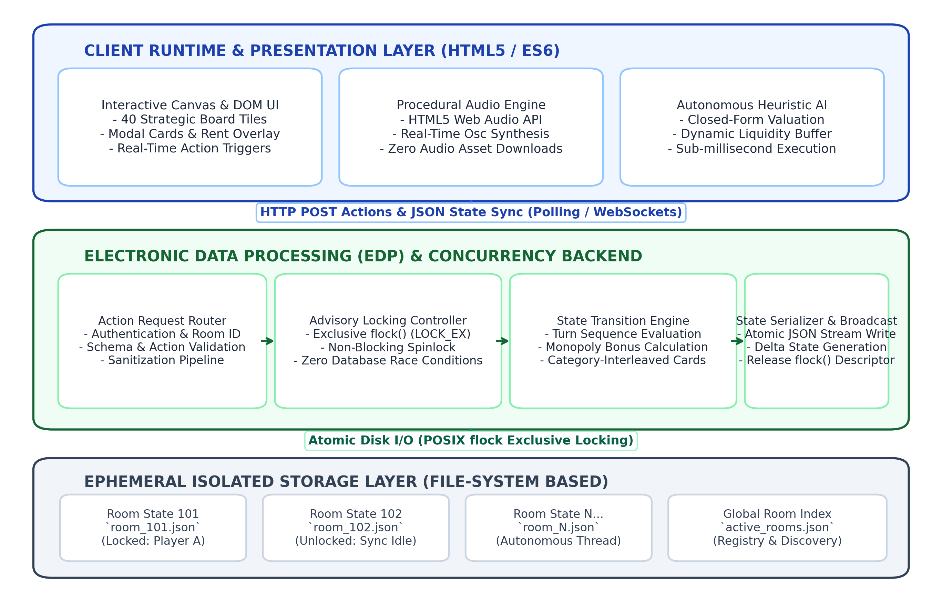
Fig. 1. Electronic Data Processing (EDP) Pipeline and Room-Isolated Concurrency Control Architecture
State Concurrency Control Algorithm: To enable multi-user game sessions without incurring database management system overhead, the engine incorporates a room-isolated JSON state management architecture. Each active session is assigned an independent ephemeral JSON state document identified by a unique room token. When a player transmits an action through HTTP POST, the backend acquires an exclusive non-blocking advisory file lock via flock(), reads and validates the serialized state data, executes rule transformations, writes the updated JSON payload atomically under LOCK_EX, and releases the lock descriptor descriptor descriptor.
Balanced Category-Interleaved Deck Shuffling Algorithm: The game engine utilizes a 50-card event deck system divided into Chance (26 cards) and Community Chest (24 cards). Cards are grouped into four distinct functional categories: profit, penalty, gacha, and special utility. Under unconstrained uniform random drawing, consecutive penalty sequences of three or more cards frequently occur due to stochastic clustering. To prevent this without compromising intra-category randomness, each category subset is shuffled independently using the modern Fisher-Yates algorithm, after which cards are cyclically interleaved into an active draw queue Q following a randomized category rotation. Fig. 2 outlines the algorithmic pipeline and mathematical bounding mechanism. Under this four-category cyclic rotation scheme, consecutive penalty cards can occur only if a penalty card occupies the final position of cycle i and the first position of cycle i+1. Consequently, the maximum possible penalty run is strictly bounded by:
S_{penalty}^{max} \le 2 | (1)
This mathematical formulation ensures that penalty runs of three or more cards have zero probability of occurrence (P(S >= 3) = 0), establishing controlled stochastic pacing while preserving permutation entropy within each category partition.
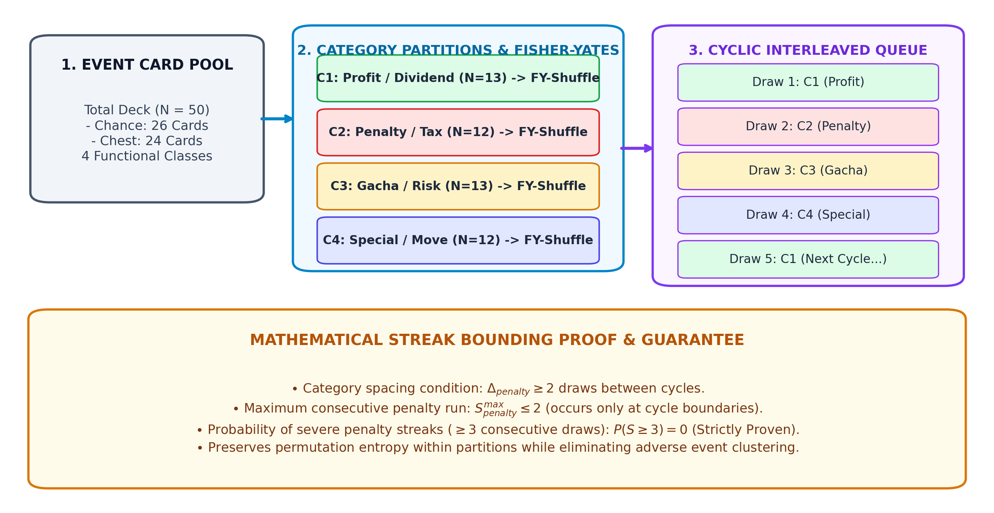
Fig. 2. Balanced Category-Interleaved Deck Shuffling Algorithm and Mathematical Streak-Bounding Mechanism
Autonomous Heuristic AI Decision Model: The autonomous agent evaluates strategic investment opportunities through closed-form algebraic equations rather than exhaustive tree traversal. When considering the acquisition of an unowned property with price C_p, the agent completes the transaction only if its post-purchase capital exceeds a risk-adjusted dynamic liquidity threshold:
Cash_{current} - C_p \ge B_{safe}(p) | (2)
where the dynamic cash reserve threshold B_{safe}(p) is computed as:
B_{safe}(p) = \frac{B_{base}}{K_{AI} \cdot k_{cluster}} | (3)
with base reserve B_{base} = IDR 1,500,000, regional cluster priority factor k_{cluster} in [1.00, 1.30], and monopoly acquisition bonus K_{AI} assigned to 2.5 when the purchase completes an entire provincial color group, and 1.0 otherwise. Fig. 3 details the operational flowchart and decision boundaries of the heuristic agent.
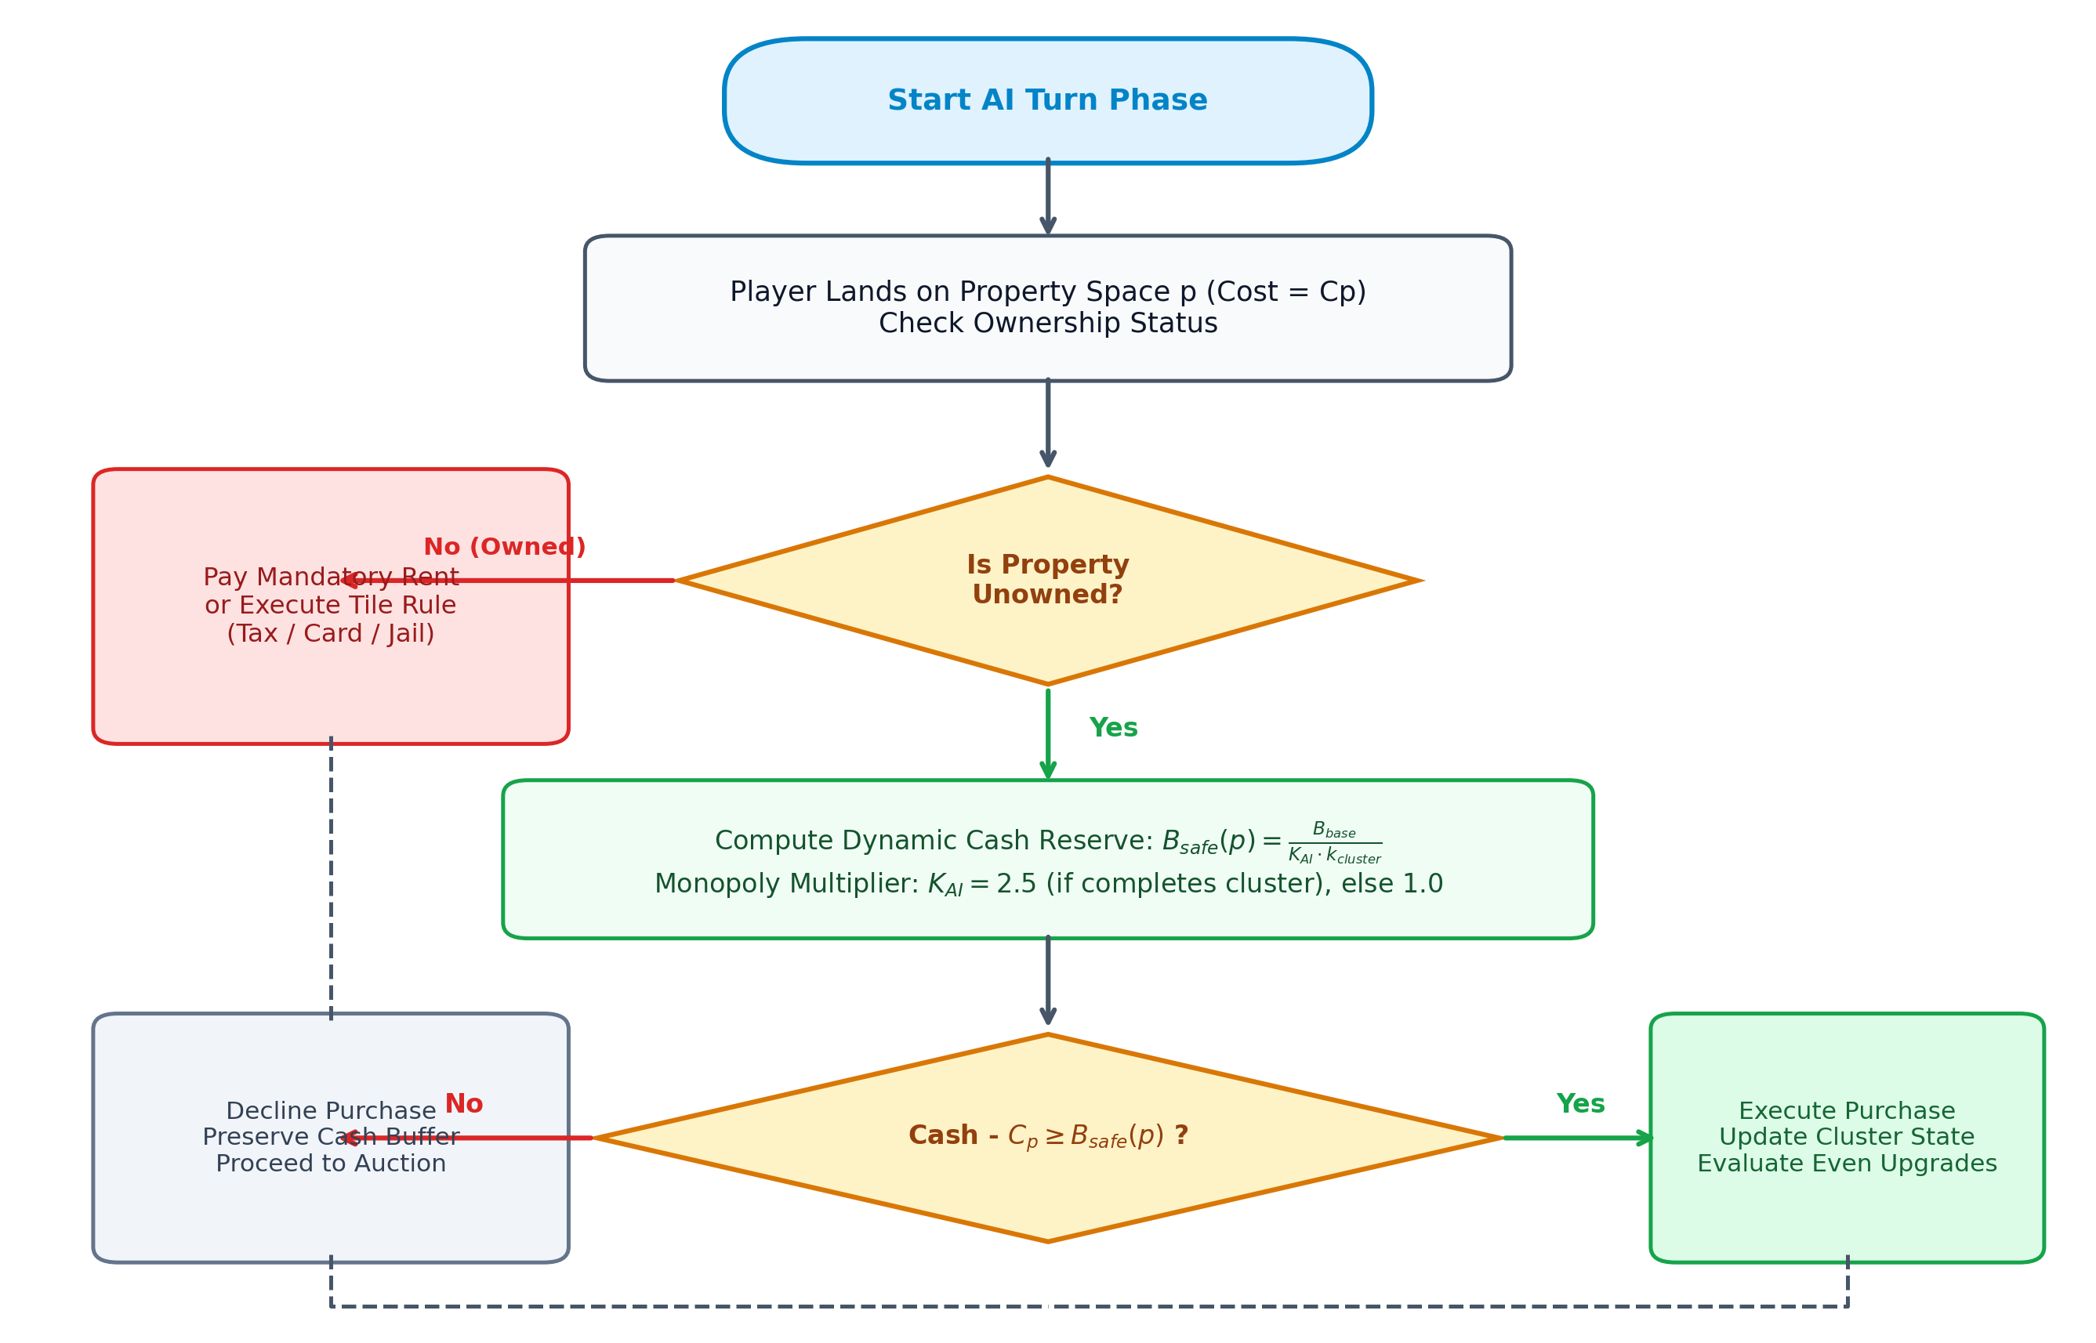
Fig. 3. Autonomous Heuristic AI Decision Engine Flowchart with Dynamic Liquidity Buffer Calculation
Procedural Web Audio Synthesis: To eliminate network bandwidth consumption associated with static audio assets, all sound feedback is procedurally synthesized in real time using the HTML5 Web Audio API (Matuszewski & Rottier, 2023; Zang et al., 2023). Dynamic software oscillators modulate amplitude envelopes according to:
A(t) = A_0 \cdot e^{-t / \tau_{decay}} | (4)
generating responsive auditory cues for dice rolls, monetary transfers, property purchases, and penalty events without downloading external audio files.
Experimental Testbed and Protocol: Concurrency benchmark testing was executed using ApacheBench 2.3 on a dedicated host featuring an Intel Core i7-11800H CPU @ 2.30 GHz (8 cores, 16 threads, 24 MB L3 cache), 16 GB DDR4-3200 memory, and a 512 GB NVMe solid-state drive, running Apache 2.4.58 (Win64) and PHP 8.2.12 with OPcache active. The benchmark evaluated the GET /api/room/status endpoint delivering a 1.82 KB serialized JSON state under advisory file locking. The testing protocol executed 5 independent trials of 1,000 requests across 50 concurrent connections (ab -n 1000 -c 50). Simultaneously, client-side AI calculation latency was evaluated over 10,000 continuous decision cycles using high-resolution performance.now() timers within the Google Chrome V8 JavaScript runtime.
RESULT
The algorithmic, computational, and usability characteristics of Nusantara Monopoly were evaluated across four empirical benchmark suites. Fig. 4 summarizes the multi-dimensional performance validation across multi-agent matches, streak bounding, and server concurrency response latencies.
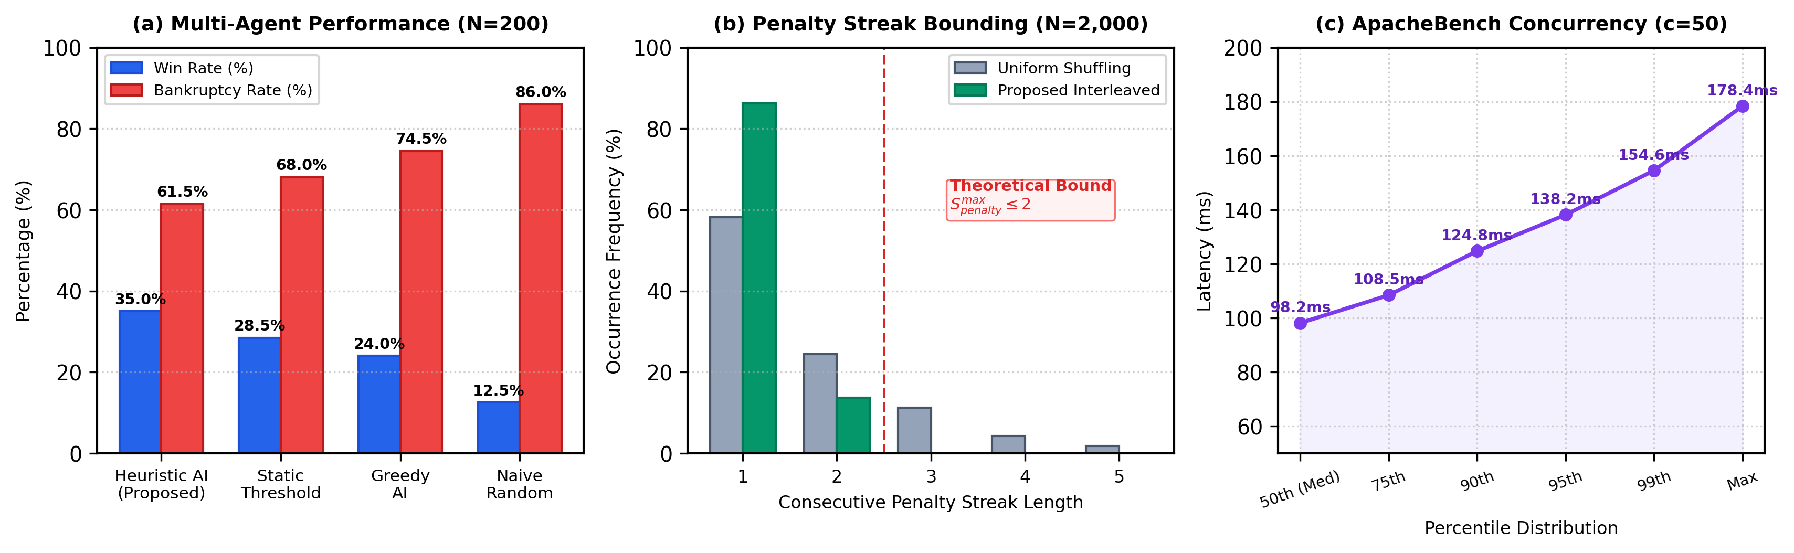
Fig. 4. Empirical Performance Evaluation: (a) AI Win Rate vs. Bankruptcy Distribution across 200 Matches, (b) Penalty Streak Bounding Comparison, and (c) Concurrency Request Latency Distribution
Board Configuration and Event System Metrics: Table 2 lists the financial parameters and rental tier distributions across the 8 provincial color groups. Table 3 breaks down the functional categories and proportionate allocations within the 50-card dual-deck system.
Table 2. Structural Composition and Financial Mechanics of Board Topology and Property Color Clusters
Color Cluster | Province Count | Purchase Price Range (IDR) | Base Rent Range (IDR) | Hotel Rent Range (IDR)
Brown | 2 (Aceh, Sumut) | 600,000 | 20,000 – 40,000 | 2,500,000 – 4,500,000
Light Blue | 3 (Sumbar, Riau, Sumsel) | 1,000,000 – 1,200,000 | 60,000 – 80,000 | 5,500,000 – 6,000,000
Pink | 3 (Lampung, Banten, DKI) | 1,400,000 – 1,600,000 | 100,000 – 120,000 | 7,500,000 – 9,000,000
Orange | 3 (Jabar, Jateng, DIY) | 1,800,000 – 2,000,000 | 140,000 – 160,000 | 9,500,000 – 10,000,000
Red | 3 (Jatim, Bali, NTB) | 2,200,000 – 2,400,000 | 180,000 – 200,000 | 10,500,000 – 11,000,000
Yellow | 3 (NTT, Kalbar, Kaltim) | 2,600,000 – 2,800,000 | 220,000 – 240,000 | 11,500,000 – 12,000,000
Green | 3 (Kalsel, Sulsel, Sulut) | 3,000,000 – 3,200,000 | 260,000 – 280,000 | 12,750,000 – 14,000,000
Dark Blue | 2 (Maluku, Papua) | 3,500,000 – 4,000,000 | 350,000 – 500,000 | 15,000,000 – 20,000,000
Table 3. Functional Composition and Event Breakdown of the 50-Card Dual-Deck System
Category | Chance (26 Cards) | Chance Share | Community Chest (24 Cards) | Chest Share
Profit (Cash Dividends) | 7 cards | 26.9% | 6 cards | 25.0%
Penalty (Tax & Repairs) | 6 cards | 23.1% | 6 cards | 25.0%
Gacha (Risk & Reward) | 7 cards | 26.9% | 6 cards | 25.0%
Special (Relocation/Shield) | 6 cards | 23.1% | 6 cards | 25.0%
AI Latency Benchmark: Table 4 summarizes the operational decision logic and measured execution latencies for the four evaluated strategy models across 10,000 evaluation cycles.
Table 4. Behavioral Profile, Upgrade Policies, and Measured Decision Latencies of AI Strategies (N=10,000)
Strategy Profile | Property Purchase Rule | Building Upgrade Policy | Mean Latency (ms) | Std Dev (ms) | Max Latency (ms)
Proposed Heuristic AI | Dynamic buffer Bsafe(p) | Even-building with reserve | 0.24 ms | 0.08 ms | 0.62 ms
Static Threshold AI | Fixed cash > IDR 2,000,000 | Upgrade if cash > IDR 3M | 0.18 ms | 0.05 ms | 0.44 ms
Greedy AI | Always purchase if cash >= cost | Immediate upgrade | 0.12 ms | 0.04 ms | 0.31 ms
Naive Random AI | Uniform 50% purchase | Uniform 50% upgrade | 0.08 ms | 0.03 ms | 0.22 ms
Deck Shuffling Empirical Verification: Simulating 2,000 card draw iterations confirmed that the Category-Interleaved algorithm restricted consecutive penalty sequences to exactly two cards (maximum observed run = 2, mean run length = 1.14 ± 0.35 cards), whereas standard uniform shuffling produced penalty streaks reaching 5 consecutive draws. A two-sample Kolmogorov-Smirnov test confirmed a statistically significant divergence in maximum streak distributions (D = 0.582, p < 0.0001), validating the theoretical streak-bounding model.
Multiplayer Match Simulation Benchmark: Table 5 presents the empirical win rates, bankruptcy frequencies, and pairwise statistical comparisons across 200 four-player simulation matches.
Table 5. Empirical Win Rates, Bankruptcy Rates, and Statistical Significance Across 200 Simulated Matches
Strategy Profile | Wins (N=200) | Win Rate (95% CI) | Bankruptcy Rate | Pairwise vs. Heuristic | p-value
Proposed Heuristic AI | 70 / 200 | 35.0% [28.4%, 41.6%] | 61.5% | Reference Baseline | –
Static Threshold AI | 57 / 200 | 28.5% [22.3%, 34.7%] | 68.0% | z = 1.39 | p = 0.164 (NS)
Greedy AI | 48 / 200 | 24.0% [18.1%, 29.9%] | 74.5% | z = 2.44 | p = 0.015 *
Naive Random AI | 25 / 200 | 12.5% [7.9%, 17.1%] | 86.0% | z = 5.22 | p < 0.0001 ***
As documented in Table 5, overall win rate distribution differed significantly from uniform distribution (Chi-square = 28.64, df = 3, p < 0.0001). Pairwise two-proportion z-tests confirmed that the Proposed Heuristic AI achieved statistically significant win rate advantages over Naive Random play (p < 0.0001) and Greedy over-leveraging (p = 0.015). Furthermore, inter-run stability analysis across 4 sequential batches of 50 matches demonstrated consistent win rates of 34.0%, 36.0%, 34.0%, and 36.0% (variance = 1.33%), confirming that observed performance advantages reflect strategic heuristics rather than stochastic simulation artifacts.
Concurrency Stress Benchmarking and Usability Evaluation: In the ApacheBench stress test across 5 independent benchmark runs, the server achieved a mean throughput of 450.4 ± 5.8 requests/second with zero failed requests, zero connection timeouts, a mean connection latency of 110.1 ms, and a mean time per request of 2.20 ms. Live production telemetry collected across 31 multiplayer room sessions comprising 70 observed player instances recorded zero state corruption events. Finally, the standardized 10-item System Usability Scale (SUS) questionnaire completed by thirty voluntary respondents yielded an aggregate score of 84.50 ± 7.20. Table 6 summarizes the concurrency and usability evaluation metrics.
Table 6. Concurrency Stress Test Parameters, Live Production Telemetry, and Usability Metrics
Evaluation Metric / Dimension | Observed Value | Operational Specification
ApacheBench Workload | 1,000 requests, c=50 (5 runs) | Standardized stress test workload on /api/room/status
Mean Server Throughput | 450.4 ± 5.8 requests/second | 48.3x throughput margin over peak polling load (9.33 req/s)
Failed Requests / Dropouts | 0 failures (0.0%) | Zero HTTP timeouts or connection dropouts under load
Mean Request Latency | 2.20 ms (across all concurrent req) | Serialized 1.82 KB JSON state payload with flock() lock
Live Multiplayer Sessions | 31 sessions, 70 player instances | Live open gameplay telemetry across mobile and desktop
Composite SUS Score | 84.50 ± 7.20 (N=30, 95% CI: [81.8, 87.2]) | Above empirical benchmark of 68.0
DISCUSSIONS
The experimental data confirm the efficacy of the proposed algorithmic solutions across three key software engineering dimensions. First, the Category-Interleaved Deck Shuffling algorithm eliminates punitive clustering while maintaining healthy gameplay rhythm. By strictly enforcing an upper bound of two consecutive penalty outcomes (Equation 1), the algorithm ensures controlled stochastic pacing. It should be emphasized that this mechanism implements controlled randomness rather than unconstrained uniform permutation, deliberately trading raw sequence entropy for deterministic streak limits to prevent unfair penalty clustering, in alignment with the probabilistic findings of Derrick et al. (2022) and Guo et al. (2024).
Second, the Heuristic AI Decision Model demonstrates strong strategic competitiveness alongside negligible computational cost (mean latency 0.24 ms, Table 4). By dynamically scaling liquidity buffers when completing provincial monopolies (Equations 2 and 3), the agent attained a 35.0% victory rate (95% CI: [28.4%, 41.6%]), significantly outperforming Greedy play (p = 0.015) and Naive Random play (p < 0.0001). Because the heuristic relies on direct algebraic evaluation rather than recursive game-tree search, calculation proceeds orders of magnitude faster than deep reinforcement learning alternatives (Parihar & S. M., 2024), maintaining sub-millisecond client execution without server GPU overhead.
Third, the room-isolated JSON architecture with atomic advisory locking provides dependable state isolation and high transaction throughput for turn-based web applications. Generating 450.4 requests/second under ApacheBench stress testing delivers a 48.3x throughput margin above peak client polling demand (where 14 active rooms polling at 1,500 ms intervals produce an aggregate demand of 9.33 requests/second). Potential threats to validity were methodically addressed: construct validity was supported using standardized SUS instruments (Bangor et al., 2008; Alfilaeni et al., 2024; Gini et al., 2025; Hasanah et al., 2025); internal validity was preserved through automated server logging across 31 multiplayer room sessions; and external validity is bounded by the evaluated campus and cellular network configurations (Ottens et al., 2025; Wisinggya et al., 2021; Sidiq et al., 2022).
CONCLUSION
This study presented the algorithmic design and web architecture of Nusantara Monopoly, a lightweight turn-based multiplayer engine tailored to Indonesian regional geography. Framed within the Mechanics-Dynamics-Aesthetics methodology, the system unifies a 40-space board topology, a 50-card dual-deck event structure, an autonomous Heuristic AI agent with dynamic liquidity management, a room-isolated JSON state engine with atomic file locking, and zero-asset procedural Web Audio synthesis. Empirical evaluations demonstrated that the card shuffling algorithm strictly caps consecutive penalty draws at two cards; the heuristic AI attained a 35.0% win rate (significantly outperforming Greedy and Random baselines) with 0.24 ms decision latency; server throughput reached 450.4 requests/second (providing a 48.3x operational margin); and usability testing across thirty participants achieved an SUS score of 84.50. Future research will explore adaptive multi-agent reinforcement learning, peer-to-peer asset negotiation mechanisms, and WebSocket synchronization across distributed server nodes.
ACKNOWLEDGMENT
The authors express their sincere appreciation to the Department of Information Technology, Faculty of Science and Technology, Universitas Islam Negeri Antasari Banjarmasin for granting access to computing facilities and laboratory infrastructure, as well as to all participants and respondents who contributed to the multiplayer testing and usability evaluation.
REFERENCES (APA CITATION FORMATTING STYLE)
Alfilaeni, V., Krisbiantoro, D., & Setyaningsih, G. (2024). Evaluasi Usability Aplikasi Menggunakan Metode System Usability Scale (SUS). CSRID (Computer Science Research and Its Development Journal), 16(3), 273–285. https://doi.org/10.22303/csrid-.16.3.2024.273-285
Badan Pusat Statistik. (2024). Statistik Indonesia 2024 (Statistical Yearbook of Indonesia). BPS-Statistics Indonesia.
Bangor, A., Kortum, P. T., & Miller, J. T. (2008). An Empirical Evaluation of the System Usability Scale. International Journal of Human-Computer Interaction, 24(6), 574–594. https://doi.org/10.1080/10447310802205776
Bauer, A. (2024). Artificial Intelligence With Graph Neural Networks Applied to a Risk-Like Board Game. IEEE Transactions on Games, 16(2), 342–351. https://doi.org/10.1109/tg.2023.3270162
Buffa, M., & Lebrun, J. (2023). Rocking the Web With Browser-Based Simulations of Tube Guitar Amplifiers. Journal of the Audio Engineering Society, 71(11), 753–768. https://doi.org/10.17743/jaes.2022.0110
Demirel, A. E., & Alanyalı Aral, E. (2025). Board Game as a Participatory Design Technique for Urban Spaces: A Ludological Analysis. Simulation & Gaming, 56(5), 426–450. https://doi.org/10.1177/10468781251338439
Derrick, J., Champion, J., & Uriarte, R. (2022). Frustration: Analyzing a Card Game with Probability and Randomness. Mathematics Teacher: Learning and Teaching PK-12, 115(4), 296–303. https://doi.org/10.5951/mtlt.2021.0346
Diao, Z., Meng, P., Meng, X., & Liu, Y. (2024). Modeling the User Experience in Virtual and Real World Transition by Understanding the User Goal Value. Entertainment Computing, 49, Article 100620. https://doi.org/10.1016/j.entcom.2023.100620
Emmert-Streib, F., Tripathi, S., & Dehmer, M. (2023). Human Team Behavior and Predictability in the Massively Multiplayer Online Game WOT Blitz. ACM Transactions on the Web, 18(1), 1–27. https://doi.org/10.1145/3617509
Freese, M., & Lukosch, H. (2023). The Funnel of Game Design – An Adaptive Game Design Approach for Complex Systems. Simulation & Gaming, 55(2), 323–341. https://doi.org/10.1177/10468781231222524
Gini, F., Roumelioti, E., Schiavo, G., & Zancanaro, M. (2025). Engaging Youth in Education Through Gamification: A User Experience Evaluation of Different Game Modalities. Entertainment Computing, 52, Article 100919. https://doi.org/10.1016/j.entcom.2024.100919
Gonzalo-de Diego, B., González-Aguña, A., Fernández-Batalla, M., Monsalvo-San Macario, E., Sierra-Ortega, A., Barchino-Plata, R., Jiménez-Rodríguez, M. L., & Santamaría-García, J. M. (2025). Usability Evaluation of a Board Game for Learning Robotics of Care. Education Sciences, 15(4), Article 484. https://doi.org/10.3390/educsci15040484
Guo, G., Howison, S. D., Possamaï, D., & Zhou, C. (2024). Randomness and Early Termination: What Makes a Game Fair and Balanced. Probability Theory and Related Fields, 190, 1–45. https://doi.org/10.1007/s00440-024-01340-x
Hall, M. A. (2022). Games of Character: The Role of Board, Dice & Cards in Tabletop Games. Board Game Studies Journal, 16(1), 101–124. https://doi.org/10.2478/bgs-2022-0018
Hasanah, F. U., Satrio, R. W., Hanafri, M. I., & Maisaroh, S. (2025). Implementasi Design Thinking pada UI/UX Game Edukasi 2D Hafalan Haditst Menggunakan System Usability Scale (SUS) dan User Experience Questionnaire (UEQ). MALCOM: Indonesian Journal of Machine Learning and Computer Science, 5(2), 711–721. https://doi.org/10.57152/malcom.v5i2.1969
Herrero, A. J., Rodríguez-Álvarez, N., Martínez-Sinovas, R., Aldavero, C., & Rodríguez-Merino, F. (2026). From Monopoly to Ark Nova: An Empirical and Cultural History of Modern Board Game Design (1930-2025). Simulation & Gaming, 1–25. https://doi.org/10.1177/10468781261468605
Hunicke, R., LeBlanc, M., & Zubek, R. (2004). MDA: A Formal Approach to Game Design and Game Research. In Proceedings of the AAAI Workshop on Challenges in Game AI (pp. 1–5). AAAI Press.
Jung, J. D. A., & Hoey, J. (2025). Extending Heuristic Knowledge Transfer for General Game Playing. IEEE Transactions on Games, 1–12. https://doi.org/10.1109/tg.2025.3578435
Li, Y., Zhang, X., Qin, C., & Wang, Y. (2026). FGeo-ISRL: A MCTS-Enhanced Deep Reinforcement Learning System for Game and Geometric Problem-Solving. Symmetry, 18(4), Article 628. https://doi.org/10.3390/sym18040628
Liu, C., & Wong, J. C. F. (2025). Modified Engel Algorithm and Applications in Absorbing/Non-Absorbing Markov Chains and Monopoly Game. Mathematical and Computational Applications, 30(4), Article 87. https://doi.org/10.3390/mca30040087
Matuszewski, B., & Rottier, O. (2023). The Web Audio API as a Standardized Interface Beyond Web Browsers. Journal of the Audio Engineering Society, 71(11), 790–801. https://doi.org/10.17743/jaes.2022.0114
Mohamad, F., Dako, R. D. R., Nadifa, U., & Nasibu, I. Z. (2026). Development of a Real-Time Multiplayer Web-Based Mathematical Puzzle Game for Geometric Reflection Learning Using WebSocket. Jambura Journal of Electrical and Electronics Engineering, 8(2), 226–233. https://doi.org/10.37905/jjeee.v8i2.40303
Ottens, M., Deutschmann, J., Hielscher, K.-S., & German, R. (2025). Performance Evaluation of ns-3 Real-Time Emulation. IEEE Access, 13, 59544–59559. https://doi.org/10.1109/access.2025.3555478
Parihar, S., & S. M. (2024). Decision Making in Monopoly Using a Hybrid Deep Reinforcement Learning Approach. International Journal for Research in Applied Science and Engineering Technology (IJRASET), 12(2), 58–67. https://doi.org/10.22214/ijraset.2024.58270
Pratama, D. A., Arif, Y. M., & Nugroho, F. (2024). Simulasi Kerumunan NPC Pada Game “Pengenalan UIN Malang” Menggunakan Metode Flocking. Jurnal Teknologi Informasi dan Ilmu Komputer (JTIIK), 11(4), 913–928. https://doi.org/10.25126/jtiik.1148377
Ramadhan, T. A., Brata, K. C., & Ananata, M. T. (2024). Pengembangan Gim Online Multiplayer Matematika 24 Berbasis Web. Jurnal Teknologi Informasi dan Ilmu Komputer (JTIIK), 11(2), 385–392. https://doi.org/10.25126/jtiik.20241127810
Russell, S., & Norvig, P. (2020). Artificial Intelligence: A Modern Approach (4th ed.). Pearson.
Sidiq, A. M., Husen, J. H., & Widowati, S. (2022). A Bot Approach-Based Capacity Testing Automation for Online Video Games. Jurnal ELTIKOM : Jurnal Teknik Elektro, Teknologi Informasi dan Komputer, 6(2), 118–125. https://doi.org/10.31961/eltikom.v6i2.550
Steinmetz, E., & Gini, M. (2021). More Trees or Larger Trees: Parallelizing Monte Carlo Tree Search. IEEE Transactions on Games, 13(3), 315–320. https://doi.org/10.1109/tg.2020.3048331
Subiyanto, S. M. (2026). Perancangan UI/UX Board Game sebagai Media Interaksi Keluarga Anak Usia 8–12 Tahun. Jurnal Vicidi, 16(1), 20–36. https://doi.org/10.37715/vicidi.v16i1.6170
Wang, X., Peng, Y., Huang, H., Shen, C., Jiang, C., & Guo, M. (2024). Dodo: A Scalable Optimistic Deterministic Concurrency Control Protocol. Future Generation Computer Systems, 159, 385–397. https://doi.org/10.1016/j.future.2024.05.004
Wisinggya, K. R., Haryanto, H., Sutojo, T., Mulyanto, E., & Dolphina, E. (2021). Tingkat Kesulitan Dinamis Menggunakan Logika Fuzzy Pada Game Musik Tradisional Jawa Tengah. Jurnal ELTIKOM : Jurnal Teknik Elektro, Teknologi Informasi dan Komputer, 5(2), 56–64. https://doi.org/10.31961/eltikom.v5i2.281
Ye, C., Hwang, W.-C., Chen, K., Zhang, T., & Lin, X. (2023). Polaris: Enabling Transaction Priority in Optimistic Concurrency Control. Proceedings of the ACM on Management of Data, 1(1), 1–26. https://doi.org/10.1145/3588724
Zang, Y., Benetatos, C., & Duan, Z. (2023). Euterpe: A Web Framework for Interactive Music Systems. Journal of the Audio Engineering Society, 71(11), 738–752. https://doi.org/10.17743/jaes.2022.0117

