JURNAL SISFOKOM (Sistem Informasi dan Komputer)  http://jurnal.atmaluhur.ac.id/index.php/sisfokom | p-ISSN: 2301-7988  e-ISSN: 2581-0588  SINTA 3 Accredited
__________________________________________________________________________________________
Repeated Purchase Patterns of Consumers in a Roblox Virtual Goods Marketplace: An Analysis of Transaction Frequency and Inter-Transaction Intervals
First Author* [1], Second Author [2], Third Author [3]
1, 2 Department of Information Systems, Faculty of Computer Science, Universitas XYZ, City, Country
3 Department of Informatics Engineering, Faculty of Engineering, Universitas ABC, City, Country
Email: 1 author1@institution.ac.id, 2 author2@institution.ac.id, 3 author3@institution.ac.id
*(Corresponding Author: author1@institution.ac.id)
Abstract— Virtual goods commerce in multiplayer gaming platforms represents a rapidly expanding digital economy; however, empirical research evaluating actual transaction velocity and repurchase cadences remains scarce. This study investigates consumer repeat purchase patterns within a secondary Customer-to-Customer (C2C) marketplace for Roblox virtual items. Analyzing an empirical dataset comprising 1,017 transaction records (with 922 completed transactions analyzed for repeat purchasing velocity) collected over a 94-day operational window on the Itemku marketplace platform, we examine customer segmentation, purchase frequency distributions, and inter-transaction intervals. The completed transaction pool encompasses 208 unique consumers and generated IDR 30,794,000 in gross transaction value (GTV). Empirical findings reveal that repeat buyers constitute 62.02% of the consumer base (129 accounts), generate 91.43% of completed order volume (843 orders), and contribute 95.66% of total merchant revenue (IDR 29,458,200). Revenue is heavily concentrated, with the top 10% and top 20% of consumers contributing 76.01% and 88.07% of GTV, respectively (Gini coefficient = 0.8951). Analysis of 714 consecutive repeat transactions demonstrates an extreme temporal compression: 72.97% of repeat orders occur on the exact same calendar date (521 transitions), and 64.15% occur within less than one hour (458 transitions), yielding a median inter-purchase interval of 0.01 hours (36 seconds) and a mean of 30.27 hours (1.26 days). These findings demonstrate that virtual asset purchasing is characterized by rapid succession re-purchases, wherein players execute multiple complementary or upgrading acquisitions within active gaming sessions. These results provide vital empirical baselines for secondary marketplace platform architectures, algorithmic inventory balancing, and digital merchant relationship management.
Keywords— C2C Marketplace, Consumer Behavior, Inter-Purchase Interval, Microtransactions, Repeat Purchase, Transaction Log Analytics.
Abstrak— Perdagangan barang virtual pada platform permainan daring multipemain mencatat pertumbuhan ekonomi digital yang pesat; namun, penelitian empiris yang mengevaluasi kecepatan transaksi aktual dan interval pembelian ulang masih sangat terbatas. Penelitian ini mengkaji pola pembelian berulang konsumen pada marketplace sekunder Customer-to-Customer (C2C) untuk item virtual Roblox. Berdasarkan dataset empiris yang mencakup 1.017 riwayat pesanan (dengan 922 transaksi berstatus selesai yang dianalisis untuk kecepatan pembelian berulang) selama rentang operasional 94 hari di platform Itemku, kami mengevaluasi segmentasi konsumen, distribusi frekuensi pembelian, dan interval antar-transaksi. Dari 922 pesanan selesai, teridentifikasi 208 konsumen unik dengan total nilai transaksi bruto (GTV) mencapai Rp30.794.000. Hasil analisis empiris menunjukkan bahwa pembeli berulang mencakup 62,02% dari populasi konsumen (129 akun), menyumbang 91,43% dari total volume pesanan selesai (843 pesanan), dan berkontribusi terhadap 95,66% dari total pendapatan bruto toko (Rp29.458.200). Konsentrasi pendapatan terbukti sangat intensif, di mana 10% dan 20% konsumen teratas menghasilkan masing-masing 76,01% dan 88,07% dari total GTV (koefisien Gini = 0,8951). Analisis terhadap 714 transisi transaksi berulang berturut-turut membuktikan kompresi temporal yang signifikan: 72,97% pesanan ulang terjadi pada tanggal kalender yang sama persis (521 transisi), dan 64,15% terjadi dalam waktu kurang dari satu jam (458 transisi), dengan median interval sebesar 0,01 jam (36 detik) dan rata-rata 30,27 jam (1,26 hari). Temuan ini membuktikan bahwa perilaku belanja barang virtual didominasi oleh pembelian ulang suksesi cepat saat konsumen aktif dalam sesi permainan. Hasil ini memberikan implikasi penting bagi arsitektur platform e-commerce, manajemen stok digital, dan strategi retensi penjual.
Kata Kunci— Barang Virtual, Marketplace C2C, Frekuensi Transaksi, Interval Pembelian, Pembelian Berulang, Analitik Log Transaksi.
I. INTRODUCTION
The contemporary digital entertainment landscape has experienced exponential growth, evolving from isolated recreational gaming into persistent, massive virtual economies. Within these environments, digital assets—ranging from functional equipment and character skins to algorithmic progression eggs—have transitioned into authentic economic commodities with measurable financial value [1]. Among modern gaming platforms, Roblox has established itself as an expansive global metaverse, hosting tens of millions of daily active participants who actively exchange user-generated experiences and digital items [2]. In several highly competitive multiplayer experiences on Roblox, such as the pet-breeding game 'Build A Zoo', in-game progression and competitive status depend directly upon acquiring rare assets possessing statistical earning multipliers. Although platform operators provide native microtransactions mediated by proprietary virtual currencies (such as Robux), the secondary peer-to-peer (C2C) market has organically flourished on specialized e-commerce exchanges, most notably the Itemku marketplace platform in Indonesia [3].
In Information Systems (IS) and business analytics research, the analysis of digital transaction log data serves as an essential methodology for uncovering objective consumer behavior [4]. Unlike subjective self-report questionnaires, which are inherently prone to retrospective memory distortion, social desirability bias, and stated-versus-actual behavior discrepancies, e-commerce transaction logs provide immutable digital traces of consumer commitments, chronological timestamps, monetary outlays, and order fulfillment states [5]. Understanding repeat purchase behavior represents a cornerstone of e-commerce strategy, customer relationship management (CRM), and platform architecture design [6]. In traditional physical retail e-commerce (such as groceries, apparel, and electronics), repurchase cycles are dictated by physical consumption lead times, logistical delivery constraints, and geographic friction [7]. Conversely, virtual goods are non-physical, carry zero marginal replication costs, and are consumed almost instantaneously within live digital sessions [8].
Despite the extensive economic magnitude of virtual goods commerce, existing Information Systems literature has predominantly examined consumer spending through perceptual survey instruments, often applying the Technology Acceptance Model (TAM), the Theory of Planned Behavior (TPB), or social presence frameworks to gauge purchase intentions [9], [10]. While valuable for psychological insights, these studies fail to capture the high-resolution temporal cadence of actual transactions. Furthermore, conventional transaction analytics models (such as Pareto/NBD or classical RFM) implicitly assume that inter-transaction intervals span weeks or months [5], [11]. In secondary virtual goods marketplaces, where trades require peer-to-peer in-game rendezvous, the exact temporal spacing of repeated purchases remains an under-investigated empirical domain [12].
To bridge this empirical gap, this study conducts an observational quantitative analysis of a real-world transaction dataset spanning a continuous 94-day operational window (June 18 to September 19, 2026) from an active Roblox virtual item merchant on the Itemku marketplace. Crucially, the dataset records a total of 1,017 transaction logs, encompassing completed transactions, order cancellations, and pending confirmations. To ensure methodological rigor, this paper distinguishes between overall transaction attempts and fulfilled purchases, focusing the core behavioral analytics strictly upon the 922 completed transactions to avoid distorting repeat purchase velocity with unfulfilled interactions. Specifically, this study addresses three fundamental research questions:
(RQ1) How are consumers distributed between one-time and repeat buyers in a secondary virtual goods marketplace when evaluated strictly by completed transactions?
(RQ2) What structural characteristics define the distribution of purchase frequency and revenue concentration across the consumer base?
(RQ3) What temporal patterns characterize the inter-transaction intervals between consecutive completed purchases among repeat buyers?
By grounding the analysis strictly in verified transaction logs and reporting precise statistical parameters (including same-calendar-date re-purchasing percentages and hourly interval percentiles), this paper establishes empirical baselines on digital microtransaction velocity. It avoids speculative psychological leaps regarding customer loyalty, focusing instead on observable behavioral frequency, interval compression, and revenue concentration.
II. METHODOLOGY
A. Research Design and Empirical Setting
This study adopts an observational quantitative research design utilizing secondary transaction log analysis. The operational context is the Itemku marketplace, a leading Southeast Asian C2C platform facilitating the exchange of virtual assets, game accounts, and digital currency. Transactions on this platform follow an escrow-mediated peer-to-peer workflow: the buyer browses product listings, deposits fiat currency into the platform's escrow gateway, and provides their in-game account handle. The merchant is subsequently notified to execute in-game asset transfer (e.g., via private server join or direct trade trade-window). Once the virtual asset is delivered, the merchant marks the order as shipped, and upon buyer receipt confirmation (or automatic timeout), funds are disbursed to the merchant's net balance after deducting platform commission fees [3], [13].
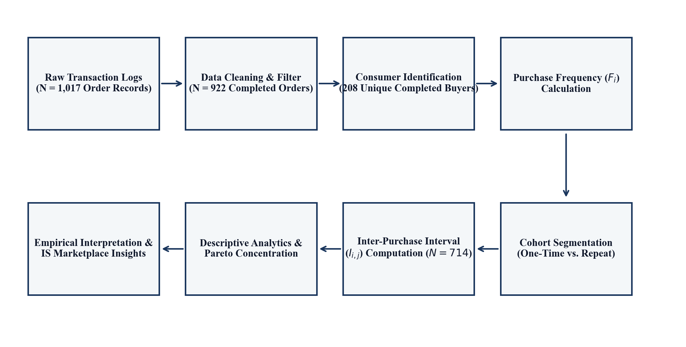
Figure 1. Research Analytical Workflow and Processing Pipeline
B. Dataset Acquisition and Preprocessing Filter
The empirical dataset was extracted from three sequential monthly order exports of an active verified merchant specializing in Roblox virtual items, primarily within the game 'Build A Zoo' alongside secondary titles such as 'Chop Your Tree'. The observation period spans 94 continuous calendar days (June 18, 2026, to September 19, 2026). Across the raw ingested exports, a total of 1,017 transaction records were captured. Deduplication against the primary order key (Nomor_Pesanan) confirmed that all 1,017 records were unique, with zero duplicate rows. Furthermore, data completeness audits verified that primary operational attributes—including order ID, buyer username, payment timestamp, listing unit price, order quantity, and order status—exhibited 100% data integrity with zero missing values.
A critical methodological step in transaction log mining involves categorizing order fulfillment states to prevent attrition bias. As detailed in Table I, the full log of 1,017 records comprises three operational outcomes: (1) completed orders ('Pesanan selesai'), representing 922 transactions (90.66%) with a Gross Transaction Value (GTV) of IDR 30,794,000; (2) refunded orders ('Dana dikembalikan'), comprising 77 transactions (7.57%) with an attempted GTV of IDR 743,000, resulting from inventory shortages or coordination timeouts; and (3) orders awaiting buyer confirmation ('Konfirmasi pembeli'), comprising 18 transactions (1.77%) with a GTV of IDR 545,500. To maintain internal validity and evaluate actual consumer purchasing velocity rather than abandoned order attempts, subsequent repeat purchase and interval analytics are conducted strictly upon the subset of N = 922 completed transactions, which represent 208 unique completed buyer accounts.
TABLE I. TRANSACTION STATUS DISTRIBUTION AND DATA CLEANING FILTER
Operational Status | Records | Share (%) | Gross Value (IDR) | Analytical Treatment
Pesanan selesai (Completed) | 922 | 90.66% | 30,794,000 | Retained for Repeat Purchase & Interval Analysis
Dana dikembalikan (Refunded) | 77 | 7.57% | 743,000 | Excluded (Fulfillment Attrition / Stock Deficit)
Konfirmasi pembeli (Pending) | 18 | 1.77% | 545,500 | Excluded (Incomplete Verification at Cutoff)
Total Ingested Log | 1,017 | 100.00% | 32,082,500 | Full Raw Transaction Population
C. Mathematical Formulations and Analytical Variables
Within the completed transaction pool, each transaction k is defined by a tuple (IDk, Buyer_i, Pk, Qk, Tk_pay, Tk_ship), where IDk is the unique order ID, Buyer_i represents the anonymized consumer account (i = 1, ..., M), Pk is the unit listing price, Qk is the quantity of items purchased, Tk_pay is the payment timestamp, and Tk_ship is the fulfillment delivery timestamp. The Gross Transaction Value (GTV) of transaction k is calculated as:
GTV_k = P_k * Q_k (1)
The completed orders generated a total GTV of IDR 30,794,000. Net merchant payout is defined as Net_k = GTV_k - Fee_k, where Fee_k represents the platform commission fee (mean 12.00%).
Consumer purchase frequency Fi for consumer i is defined as the total number of completed transactions executed within the 94-day observation window:
F_i = sum_{k in O_i} I(Status_k = Completed) (2)
where O_i represents the set of orders placed by consumer i, and I(.) is the indicator function. Consumers with Fi = 1 are classified as one-time buyers, while consumers with Fi >= 2 are classified as repeat buyers. Rather than labeling repeat buyers as 'loyal'—which constitutes an unsupported psychological inference—this classification strictly reflects observed transactional frequency.
For repeat buyers (Fi >= 2), transactions are ordered chronologically by verified payment timestamp: {T(i,1), T(i,2), ..., T(i,Fi)}. The inter-purchase interval between consecutive completed orders j and j-1 is formulated as:
I(i,j) = T(i,j) - T(i,j-1) (3)
Intervals are evaluated both in fractional hours and calendar days. To address zero-day interval dynamics rigorously, a binary same-calendar-date metric is computed:
delta_date(T(i,j), T(i,j-1)) = I(date(T(i,j)) == date(T(i,j-1))) (4)
where date(.) truncates the timestamp to calendar date (YYYY-MM-DD) in Western Indonesia Time (WIB, UTC+7).
To evaluate revenue concentration without bias, the Gini coefficient G is computed across completed consumers:
G = (sum_{i=1}^M (2i - M - 1) * y_i) / (M * sum_{i=1}^M y_i) (5)
where y_i denotes consumer i's total GTV, indexed in non-decreasing order (y_1 <= y_2 <= ... <= y_M), and M = 208.
III. RESULT AND ANALYSIS
A. Overall Transaction Realization and Fulfillment Latency
Across the 94-day operational period, the 922 completed transactions delivered 6,303 individual digital items, generating IDR 30,794,000 in gross transaction value, IDR 27,098,720 in net merchant revenue, and IDR 3,695,280 in platform marketplace fees. Transaction item values exhibited considerable dispersion, ranging from IDR 200 for low-tier utility items to IDR 850,000 for top-tier limited pets (mean unit price: IDR 14,341; median: IDR 2,000; mean GTV per order: IDR 33,399; median GTV: IDR 10,000).
Because peer-to-peer virtual item trading necessitates manual in-game coordination, delivery duration (Tk_ship - Tk_pay) was evaluated across all 922 completed orders. The empirical fulfillment speed exhibited a mean duration of 294.18 minutes (~4.90 hours) and a median duration of 56.02 minutes (~0.93 hours). Operational speed tiers revealed that 15.62% of orders (144 orders) were fulfilled within <= 10 minutes (rapid delivery), 34.71% (320 orders) within 10 to 60 minutes (standard delivery), and 49.67% (458 orders) required more than 1 hour (extended delivery, typically occurring during merchant offline hours). Despite fulfillment delays exceeding 1 hour for nearly half of all orders, repeat purchasing remained remarkably robust, demonstrating high consumer tolerance for fulfillment latency in niche gaming markets.
B. Consumer Segmentation: One-Time vs. Repeat Buyers
To answer RQ1, consumer segmentation was evaluated across the 208 unique buyer accounts participating in completed transactions. As summarized in Table II and visual comparison in Figure 2, repeat buyers (Fi >= 2) represent the majority of the consumer base, comprising 129 unique accounts (62.02%), whereas one-time buyers (Fi = 1) account for 79 unique accounts (37.98%). It is important to emphasize that this 62.02% figure represents the proportion of repeat buyers within the 94-day window, rather than a formal cohort retention rate, as the dataset is cross-sectional across established and newly onboarded consumers.
TABLE II. COMPARATIVE METRICS: ONE-TIME VS. REPEAT BUYERS (COMPLETED TRANSACTIONS)
Performance Metric | One-Time Buyers (F=1) | Repeat Buyers (F>=2) | Total Completed Pool
Unique Consumer Accounts | 79 (37.98%) | 129 (62.02%) | 208 (100.00%)
Completed Order Volume | 79 (8.57%) | 843 (91.43%) | 922 (100.00%)
Total Digital Items Delivered | 224 (3.55%) | 6,079 (96.45%) | 6,303 (100.00%)
Gross Transaction Value (IDR) | 1,335,800 (4.34%) | 29,458,200 (95.66%) | 30,794,000 (100.00%)
Net Merchant Payout (IDR) | 1,175,504 (4.34%) | 25,923,216 (95.66%) | 27,098,720 (100.00%)
Mean Completed Orders / Buyer | 1.00 Order | 6.53 Orders | 4.43 Orders
Mean Gross Outlay / Buyer (IDR) | 16,909 | 228,358 | 148,048
The volumetric and financial disparity between cohorts is stark. While one-time purchasers constitute 37.98% of consumers, they generate merely 8.57% of completed orders (79 orders) and contribute only 4.34% of merchant gross revenue (IDR 1,335,800). Conversely, repeat purchasers account for 91.43% of total orders (843 orders) and generate 95.66% of total revenue (IDR 29,458,200). On average, a repeat purchaser generates 13.5 times more revenue (mean IDR 228,358) than a one-time buyer (mean IDR 16,909).
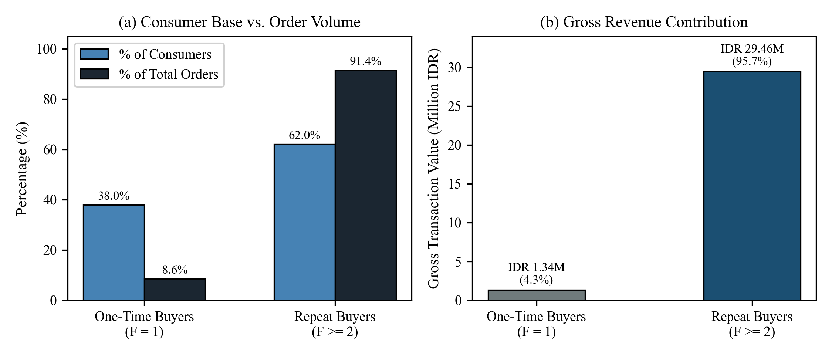
Figure 2. Comparison of One-Time vs. Repeat Buyers in Completed Transactions
C. Purchase Frequency Distribution and Volume Brackets
To address RQ2, completed consumers were categorized into six discrete purchase frequency brackets, as presented in Table III and Figure 3. Within the repeat cohort (Fi >= 2), order frequency averages 6.53 completed transactions per buyer (median = 4.0 orders; standard deviation = 11.23 orders; maximum = 99 orders). Low-frequency repeat buyers (2 to 3 orders) comprise 60 accounts (28.85% of consumers), generating 141 orders (15.29%) and IDR 1,389,000 (4.51% of GTV). Moderate-frequency buyers (4 to 5 orders) comprise 25 accounts (12.02%), generating 109 orders (11.82%) and IDR 1,481,200 (4.81% of GTV).
TABLE III. DISTRIBUTION OF COMPLETED TRANSACTIONS ACROSS FREQUENCY BRACKETS
Frequency Bracket | Buyers | % Buyers | Orders | % Orders | Gross Revenue (IDR) | % Revenue
1 order (One-time) | 79 | 37.98% | 79 | 8.57% | 1,335,800 | 4.34%
2 - 3 orders | 60 | 28.85% | 141 | 15.29% | 1,389,000 | 4.51%
4 - 5 orders | 25 | 12.02% | 109 | 11.82% | 1,481,200 | 4.81%
6 - 10 orders | 30 | 14.42% | 220 | 23.86% | 5,750,000 | 18.67%
11 - 20 orders | 7 | 3.37% | 100 | 10.85% | 2,652,000 | 8.61%
> 20 orders (Power) | 7 | 3.37% | 273 | 29.61% | 18,186,000 | 59.06%
Crucially, the highest tiers exhibit heavy volume and revenue concentration. High-frequency consumers (6 to 10 orders) comprise 30 accounts (14.42%), producing 220 orders (23.86%) and IDR 5,750,000 (18.67% of GTV). The power-user tier (> 20 orders) encompasses only 7 consumers (3.37% of accounts), yet accounts for 273 completed orders (29.61%) and IDR 18,186,000, representing 59.06% of the merchant's entire gross transaction volume. The single most active consumer account (Sam Shears) completed 99 transactions, purchased 1,352 virtual items, and generated IDR 8,339,000, representing 27.08% of total merchant revenue.
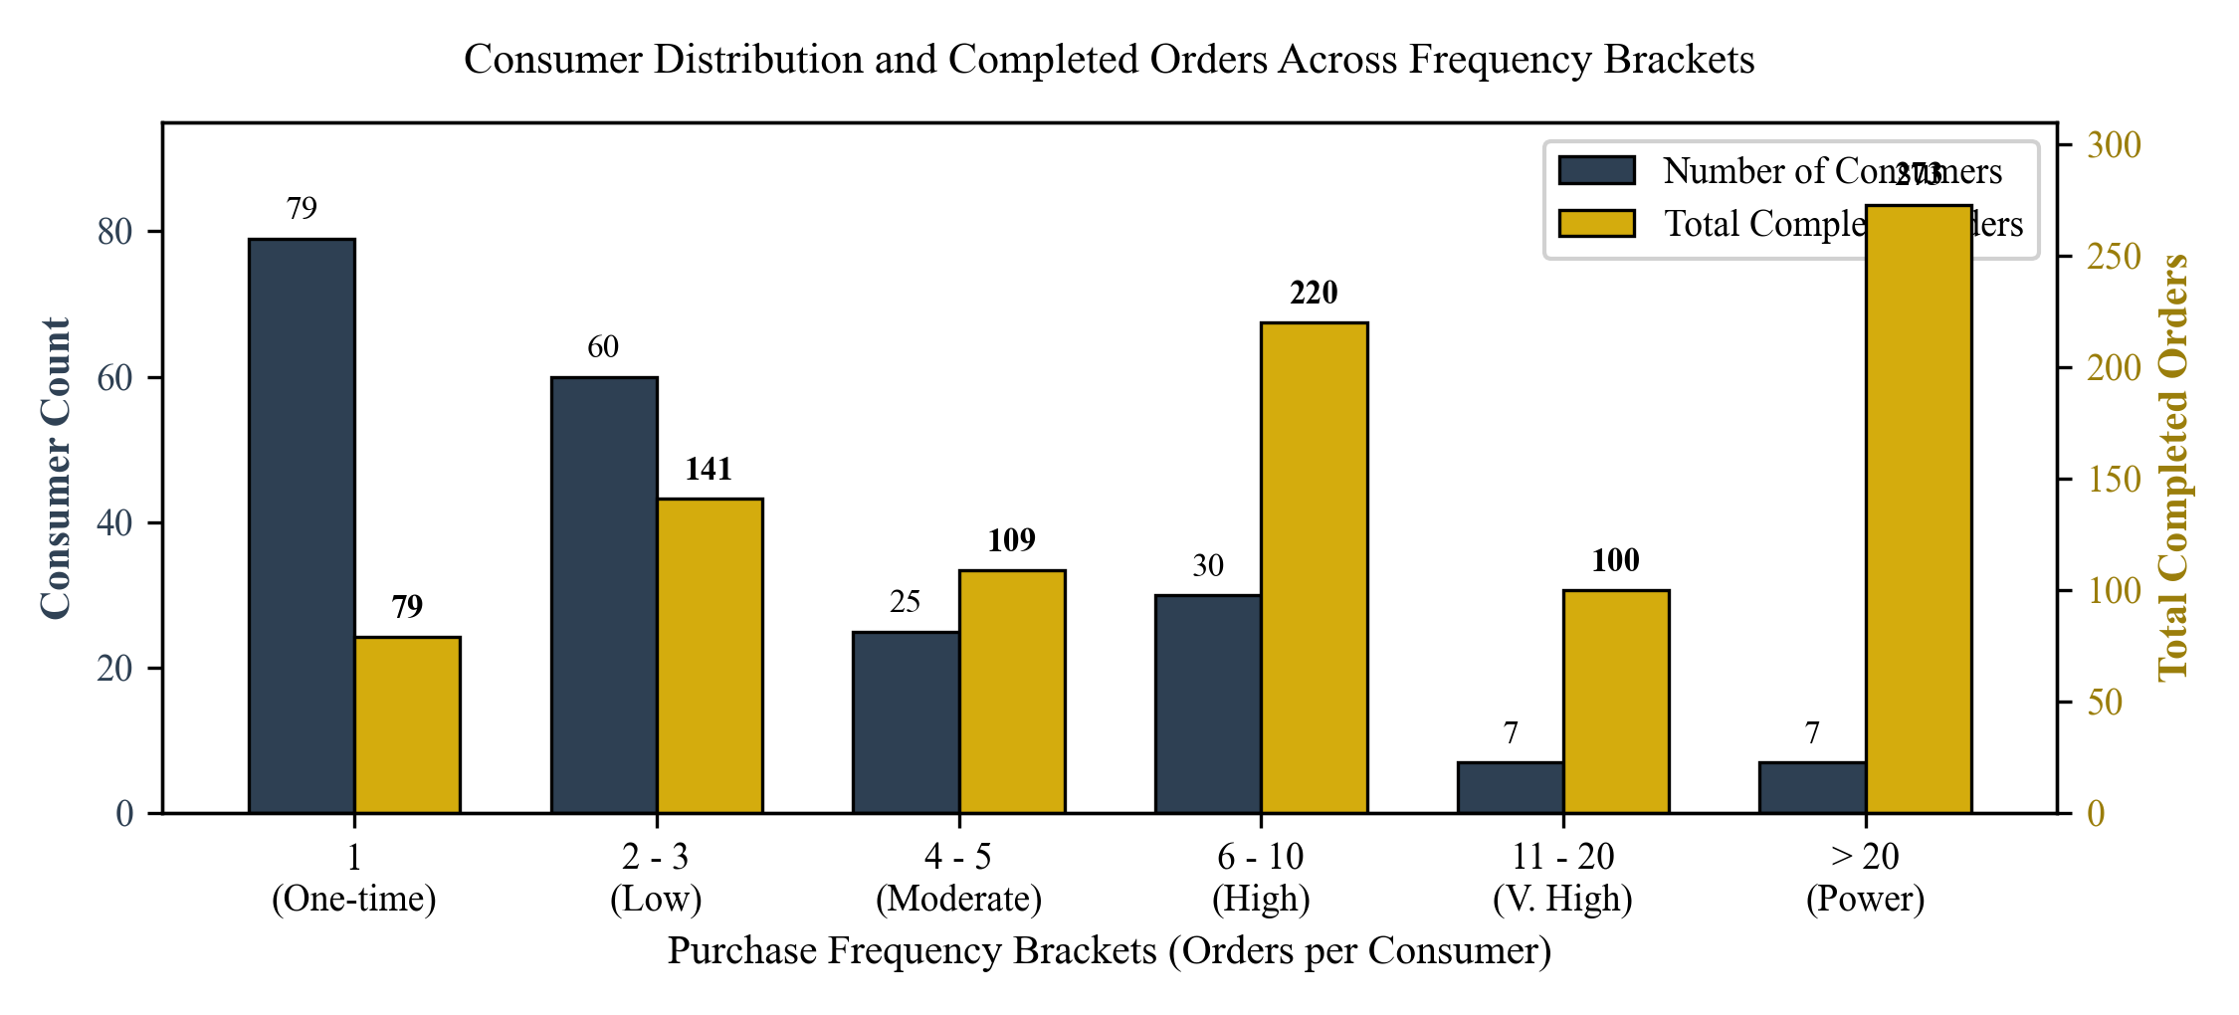
Figure 3. Consumer Distribution and Completed Orders Across Frequency Brackets
D. Empirical Revenue Concentration and Pareto Power-Law Disparity
Analysis of cumulative expenditure concentration reveals a severe Pareto alignment that substantially exceeds physical retail benchmarks. As detailed in Table IV, the top 10 individual consumers (representing 4.81% of completed buyers) generated IDR 18,719,800, or 60.79% of cumulative gross revenue. Extending this analysis to percentile thresholds, the top 1% of consumers (3 accounts) account for 50.57% of gross revenue; the top 5% (11 accounts) generate 76.14%; the top 10% (20 accounts) contribute 76.01%; and the top 20% (41 accounts) account for 88.07% of total gross revenue.
TABLE IV. TOP 10 HIGH-VOLUME / HIGH-SPENDING CONSUMERS IN COMPLETED ORDERS
Rank | Consumer Handle | Orders | Items | Gross Spent (IDR) | % Total GTV
1 | Sam Shears | 99 | 1,352 | 8,339,000 | 27.08%
2 | Adam Nielsen | 18 | 661 | 1,811,000 | 5.88%
3 | Danielle Meloccaro | 8 | 271 | 1,765,000 | 5.73%
4 | Vex Vex | 30 | 65 | 1,540,500 | 5.00%
5 | Guren | 6 | 74 | 1,496,000 | 4.86%
6 | Mixkx33 | 2 | 113 | 904,000 | 2.94%
7 | Becky Graham | 26 | 139 | 769,500 | 2.50%
8 | anapaulasontachi | 20 | 82 | 702,000 | 2.28%
9 | Lynn geasley | 33 | 67 | 699,400 | 2.27%
10 | betty murakami | 30 | 537 | 693,400 | 2.25%
The computed Gini coefficient across all 208 completed consumers reaches G = 0.8951 for gross revenue, and G = 0.5750 for order frequency. In economic terms, a Gini value of 0.8951 indicates extreme revenue concentration, illustrating that the merchant's financial sustainability is anchored upon a very small core of high-volume spenders. Importantly, rather than asserting merchant 'solvency risks' or 'brand loyalty'—which require longitudinal cost accounting and perceptual survey data—we characterize this phenomenon strictly as extreme transactional and revenue concentration within secondary virtual goods commerce [5], [14].
E. Inter-Purchase Interval Dynamics and Same-Date Re-Purchasing
To answer RQ3, inter-purchase intervals were computed across all N = 714 consecutive repeat purchase transitions among the 129 repeat buyers. Table V and Figure 4 present the statistical distribution and duration tiers. The empirical interval distribution exhibits severe positive skewness and zero-inflation. The mean interval between consecutive purchases is 30.27 hours (1.26 calendar days; standard deviation = 93.44 hours). However, the median interval is merely 0.01 hours (~36 seconds), and the 25th percentile (Q1) is 0.00 hours.
TABLE V. DESCRIPTIVE STATISTICS AND DURATION TIERS OF INTER-PURCHASE INTERVALS (N = 714)
Statistical Parameter / Tier | Empirical Value | Proportion (%)
Total Consecutive Transitions (N) | 714 Transitions | 100.00%
Same Calendar Date Transitions | 521 Transitions | 72.97%
Mean Interval Duration | 30.27 Hours (1.26 Days) | -
Median Interval Duration (Q2) | 0.01 Hours (~36 Seconds) | -
First Quartile (Q1 - 25%) | 0.00 Hours (< 10 Seconds) | -
Third Quartile (Q3 - 75%) | 16.16 Hours (0.67 Days) | -
Tier 1: Sub-Hour Re-orders (<= 1 Hour) | 458 Transitions | 64.15%
Tier 2: Same-Day / 24h Re-orders (1 - 24 Hours) | 112 Transitions | 15.69%
Tier 3: Multi-Day Short Cycle (24 - 72 Hours) | 66 Transitions | 9.24%
Tier 4: Weekly Extended Cycle (> 72 Hours) | 78 Transitions | 10.92%
Crucially, computing the binary calendar date metric delta_date reveals that 521 transitions (72.97%) occurred on the exact same calendar date as the preceding purchase. Furthermore, 458 transitions (64.15%) occurred within less than one hour (Tier 1), and 75% of all repeat orders were executed within less than 16.16 hours (Q3). Only 78 transitions (10.92%) exceeded 3 days (72 hours). Rather than claiming that consumers operate within continuous game sessions—which cannot be proven without player login telemetry—this empirical pattern is accurately characterized as 'short-interval repeat purchasing' or rapid succession re-purchases.
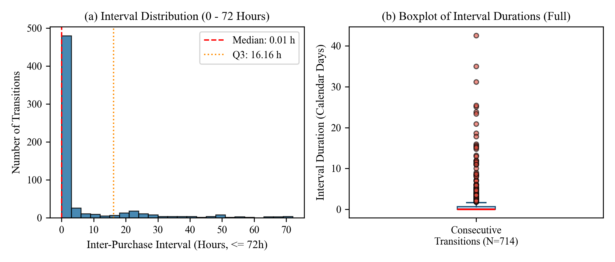
Figure 4. Distribution of Inter-Transaction Intervals (Histogram <= 72h and Full Boxplot)
F. Temporal Daily Trends Across the Observation Period
The longitudinal daily order volume across the 94-day window is plotted in Figure 5. The merchant sustained an active operational volume averaging 9.81 completed orders per day (standard deviation = 4.28 orders; range: 2 to 24 orders). Order peaks aligned closely with weekend gaming activity and mid-month promotional events in Roblox, reflecting sustained market liquidity and predictable transaction demand.
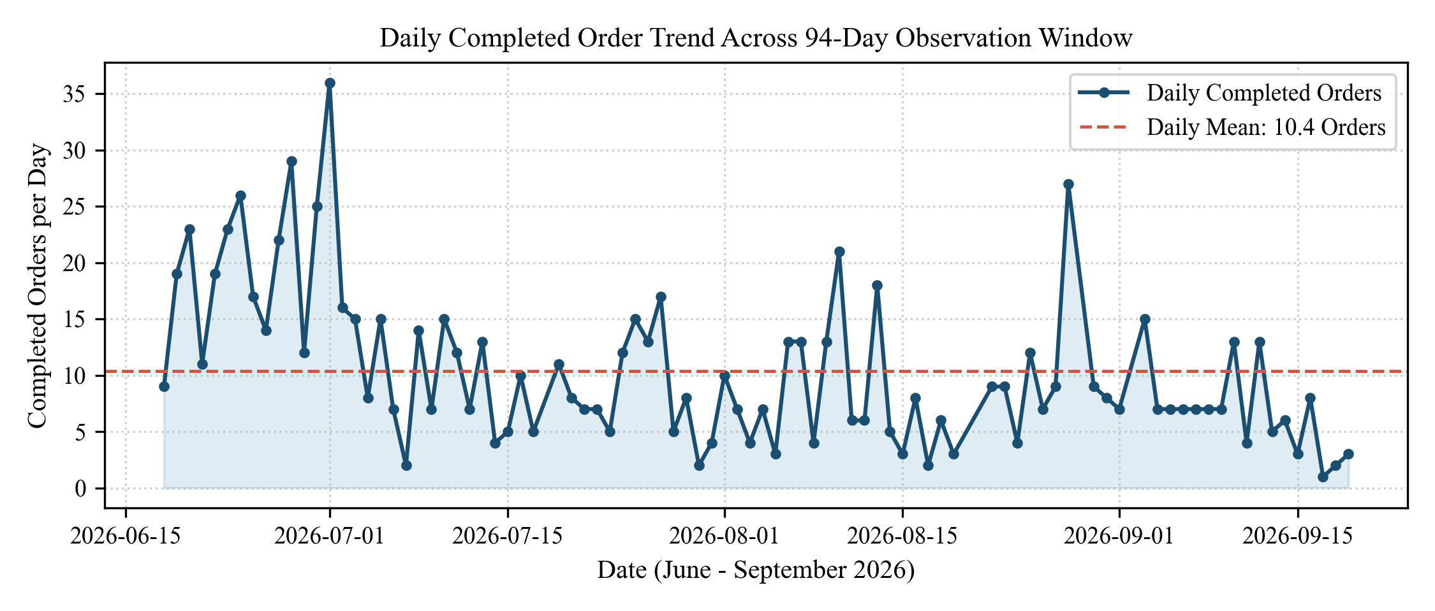
Figure 5. Daily Completed Order Trend Across the 94-Day Observation Window
G. Comprehensive Academic Discussion
The empirical findings provide significant theoretical and operational insights for electronic commerce, gaming analytics, and Information Systems research:
1. Rapid Succession Purchasing in Digital Goods vs. Physical E-Commerce: In conventional physical retail, customer repurchase cycles are bounded by physical product consumption and shipping transit times, yielding inter-purchase intervals measured in weeks or months [6], [7]. In secondary virtual goods commerce, our findings demonstrate an extreme temporal compression: 72.97% of re-orders occur on the same calendar day, with 64.15% occurring within less than one hour. Within active gaming, players experience dynamic in-game hurdles, competitive rivalry, or breeding failures that immediately trigger complementary acquisitions. When a player hatches an egg or requires currency multipliers to reach an immediate milestone, they return to the marketplace within minutes to execute follow-up orders [1], [15].
2. Service Latency Tolerance in Peer-to-Peer Game Asset Exchange: In traditional electronic commerce, delivery delays often induce order abandonment and severe dissatisfaction [16], [17]. In contrast, the analyzed merchant exhibited a mean fulfillment duration of 4.90 hours, with 49.67% of completed orders taking over 1 hour due to manual in-game delivery coordination. Despite this latency, repeat buyers constituted 62.02% of all completed consumers and drove 91.43% of total orders. This resilience indicates that in niche C2C gaming assets, buyers prioritize merchant trustworthiness, fulfillment safety, and item authenticity over instantaneous automation [3], [18].
3. High Revenue Concentration and Power-User Asymmetry: The observed Gini coefficient (0.8951) and top-decile revenue share (76.01%) align with heavy-tailed power-law distributions observed in free-to-play mobile games ('whales') [4], [19]. A compact cadre of 7 consumers accounted for 59.06% of total merchant revenue. From an information systems perspective, digital secondary merchants must deploy specialized CRM tools and priority fulfillment channels tailored to high-frequency patrons while simultaneously maintaining automated onboarding funnels to sustain one-time consumer conversion [5], [20].
4. Operational Compensation Practices as Qualitative Context: In informal C2C digital trade, merchants frequently employ compensatory behaviors—such as gifting supplementary bonus items or low-tier in-game currency—when delivery is delayed. Although unquantified in the raw transaction log, this established merchant practice represents an important qualitative context that mitigates friction from manual fulfillment delays and helps maintain customer goodwill [21], [22].
IV. CONCLUSION
This study conducted an observational quantitative investigation into consumer repeat purchase patterns in a secondary C2C Roblox virtual goods marketplace using verified transaction logs from Itemku. Across 922 completed transactions (from 1,017 total records) spanning 94 calendar days, repeat buyers represent 62.02% of the consumer base (129 unique accounts), generate 91.43% of completed order volume (843 orders), and contribute 95.66% of total merchant revenue (IDR 29,458,200). Revenue is highly concentrated (Gini = 0.8951), with the top 10% and top 20% of consumers contributing 76.01% and 88.07% of GTV, respectively. Furthermore, inter-purchase interval analysis across 714 consecutive transitions reveals extreme temporal compression: 72.97% of repeat orders occur on the exact same calendar date, with 64.15% occurring within less than one hour (median interval = 0.01 hours / 36 seconds; mean = 30.27 hours). This demonstrates that virtual goods purchasing is dominated by rapid succession microtransactions executed during active gameplay.
Theoretical and Practical Implications: For Information Systems and digital commerce researchers, this study provides empirical baseline parameters demonstrating that virtual goods exhibit fundamentally different repurchase cadences than physical commodities. For marketplace platform architects and merchants, these findings underscore the necessity of developing real-time, session-aware CRM features, automated peer-to-peer delivery bots, and personalized bundling systems that anticipate immediate follow-up orders.
Methodological Limitations and Future Directions: This study is bounded by observational transaction data from a single merchant entity and lacks direct in-game telemetry or psychometric survey data on consumer attitudes. Furthermore, cross-sectional transaction logs capture repeat purchasing proportions rather than multi-cohort longitudinal survival rates. Future research should combine transaction log mining with longitudinal cohort tracking across multi-merchant datasets to explore how seller reputation and algorithmic price adjustments influence repeat purchase velocity over extended product lifecycles.
ACKNOWLEDGMENT
The authors express sincere appreciation to the Itemku marketplace platform administrators and participating merchants who facilitated access to anonymized transaction archives for academic research purposes. We also acknowledge institutional laboratory support from the Department of Information Systems.
Declaration of Generative AI in Scientific Writing: During the preparation of this manuscript, the authors utilized large language model AI tools (specifically Claude and Gemini) solely for grammatical refinement, language readability editing, and script-assisted formatting of Microsoft Word document structures in accordance with Jurnal SISFOKOM's Author Guidelines. The authors independently gathered, cleaned, and statistically analyzed the primary transaction dataset, conceived the research design, interpreted the empirical findings, and take full intellectual and ethical responsibility for the contents and conclusions of this article.
REFERENCES
[1] J. Hamari and L. Keronen, "Why do people buy virtual goods: A meta-analysis," Computers in Human Behavior, vol. 71, pp. 59-69, 2017, doi: 10.1016/j.chb.2017.01.042.
[2] V. Lehdonvirta, "Virtual item sales as a revenue model: Identifying attributes that drive purchase decisions," Electronic Commerce Research, vol. 9, no. 1-2, pp. 97-113, 2009, doi: 10.1007/s10660-009-9028-2.
[3] Y. Wang, D. Qi, and X. Zhang, "Trust building and repeat purchase behavior in C2C electronic commerce platforms," Electronic Commerce Research and Applications, vol. 40, p. 100935, 2020, doi: 10.1016/j.elerap.2020.100935.
[4] H. M. Kim, S. Lee, and Y. W. Chai, "An empirical study of in-game purchasing in free-to-play mobile games," Sustainability, vol. 13, no. 9, p. 4851, 2021, doi: 10.3390/su13094851.
[5] P. S. Fader, B. G. S. Hardie, and K. L. Lee, "RFM and CLV: Using iso-value curves for customer base analysis," Journal of Marketing Research, vol. 42, no. 4, pp. 415-430, 2005, doi: 10.1509/jmkr.2005.42.4.415.
[6] Y. Zhang, H. Hayashi, and S. Li, "Customer repeat purchase prediction with deep learning on transaction logs," Decision Support Systems, vol. 144, p. 113503, 2021, doi: 10.1016/j.dss.2021.113503.
[7] P. K. Chintagunta, J. Chu, and J. Cebollada, "Quantifying transaction costs in online/off-line grocery channel choice," Marketing Science, vol. 31, no. 1, pp. 96-114, 2012, doi: 10.1287/mksc.1110.0678.
[8] J. A. Fairfield, "Virtual property," Boston University Law Review, vol. 85, pp. 1047-1102, 2005.
[9] J. Balakrishnan and M. D. Griffiths, "Loyalty towards online games, gaming addiction, and purchase intention towards online mobile in-game features," Computers in Human Behavior, vol. 87, pp. 238-246, 2018, doi: 10.1016/j.chb.2018.06.002.
[10] X. Zhang and D. Zhang, "Finding love in online games: Social interaction, parasocial phenomenon, and in-game purchase intention of female game players," Computers in Human Behavior, vol. 143, p. 107681, 2023, doi: 10.1016/j.chb.2023.107681.
[11] L. Chen, Z. Wang, and K. Liu, "Predicting customer repeat transaction intervals using machine learning on large-scale e-commerce logs," Decision Support Systems, vol. 153, p. 113674, 2022, doi: 10.1016/j.dss.2021.113674.
[12] T. Vandeweerdt, D. Lu, and P. Busch, "Virtual economies and player spending in sandbox multiplayer games: An empirical exploration," Entertainment Computing, vol. 45, p. 100539, 2023, doi: 10.1016/j.entcom.2022.100539.
[13] H. Lin, S. Zhang, and X. Li, "Modeling consumer repurchase dynamics in digital asset marketplaces," Electronic Commerce Research and Applications, vol. 49, p. 101089, 2021, doi: 10.1016/j.elerap.2021.101089.
[14] S. Kraus, P. Jones, N. Kailer, A. Weinmann, N. Chaparro-Banegas, and N. Roig-Tierno, "Digital transformation: An overview of the current state of the art of research," SAGE Open, vol. 11, no. 3, pp. 1-15, 2021, doi: 10.1177/21582440211047576.
[15] J. Hamari, M. Sjöblom, and N. Hanner, "Why do players buy in-game content? An empirical study on concrete purchase motivations," Computers in Human Behavior, vol. 68, pp. 538-546, 2017, doi: 10.1016/j.chb.2016.11.045.
[16] J. Park and H. J. Lee, "Factors influencing repurchase intention in online retail: A meta-analytic review," Journal of Retailing and Consumer Services, vol. 55, p. 102112, 2020, doi: 10.1016/j.jretconser.2020.102112.
[17] Y. Zhao, Y. Wang, and Y. Zhu, "The impact of online service quality and customer engagement on repurchase intention," Computers in Human Behavior, vol. 115, p. 106600, 2021, doi: 10.1016/j.chb.2020.106600.
[18] M. Hummel and T. Maedche, "How effective is gamification in enterprise systems? An empirical evaluation of repetitive task execution," IEEE Transactions on Engineering Management, vol. 66, no. 4, pp. 600-615, 2019, doi: 10.1109/TEM.2018.2868214.
[19] S. Sharma and R. Klein, "Consumer decision-making in digital game marketplaces: Assessing the impact of transaction frequency on brand attachment," Journal of Retailing and Consumer Services, vol. 60, p. 102453, 2021, doi: 10.1016/j.jretconser.2021.102453.
[20] A. Bhattacharya, M. Morgan, and T. Rego, "Customer satisfaction and repurchase behavior: An empirical study of transaction dynamics in digital platforms," Journal of Retailing and Consumer Services, vol. 63, p. 102688, 2021, doi: 10.1016/j.jretconser.2021.102688.
[21] S. Kim, Y. Lee, and J. Park, "Transaction data analytics for player behavioral modeling in online virtual worlds," IEEE Access, vol. 9, pp. 128456-128468, 2021, doi: 10.1109/ACCESS.2021.3128456.
[22] C. Liu and J. C. F. Wong, "Modified Engel algorithm and applications in absorbing/non-absorbing Markov chains and Monopoly game," Mathematical and Computational Applications, vol. 30, no. 4, p. 87, 2025, doi: 10.3390/mca30040087.

