picoCTF

NAWARATHNA.N.P.D.T

IT22117496

1. Obedient Cat

Since the file is in ASCII text format, you can open it like any other text file after downloading the task.

Steps for solve:

1)Download the file which includes on task.

2)Open that file using notepad.

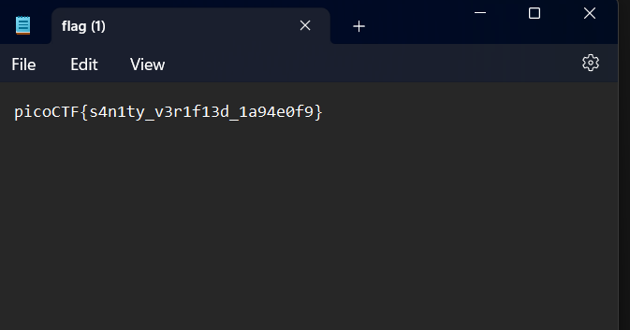

Flag: picoCTF{s4n1ty_v3r1f13d_1a94e0f9}

### 2. Insp3ct0r

In this challenge test knowledge of online application security and code analysis by looking for flaws in the HTML, JavaScript, and CSS components and finding hints that lead to the flag. This flag includes 3 parts.

Steps for solve:

1)Click the link (<https://jupiter.challenges.picoctf.org/problem/41511/>).

2)After clicking that it will show Inspect me interface website.

3)By clicking Ctrl + Shift + I inspect that site.

4)In ‘problem/9670’ folder there are three files.

5)Opening this three files **(index)** , **myjs.js , mycss.css can find three parts of the flag.**

Flag: picoCTF{tru3_d3t3ct1ve_0r_ju5t_lucky?832b0699}

### 3. Scavenger Hunt

### In this challenge include 5 parts of the flag. The capacity to move on and eventually finish the hunt by putting information from several sources together.

Steps for solve:

1. <http://mercury.picoctf.net:5080/> go to this link and inspect the website by using Ctrl + Shift + I .
2. After that go to the HTML file it includes the first part of the flag( <!-- Here's the first part of the flag: picoCTF{t -->).
3. Next accessing the CSS file can find second part of the flag (/* CSS makes the page look nice, and yes, it also has part of the flag. Here's part 2: h4ts_4_l0 */).
4. I also check the JS file as possible find some hint of the next part (/* How can I keep Google from indexing my website? */)
5. By searching from google a part of “indexing my website” it has robots file.I change mtjs.js to robots.txt and find third part of the flag ( part 3: t_0f_p14c) [mercury.picoctf.net:5080/robots.txt](http://mercury.picoctf.net:5080/robots.txt).
6. There is a hint includes this part (I think this is an Apache server... can you Access the next flag?) Apache sever permission manage by .htacess file. [mercury.picoctf.net:5080/.htaccess](http://mercury.picoctf.net:5080/.htaccess) (Part 4: 3s_2_lO0k).
7. Previous part also includes the hint of next part (I love making websites on my Mac, I can Store a lot of information there) In Mac .DS_Store file store the configuration of how desktop look.
8. By changing the .htaccess to DS_Store it shows last part of the flag.

[mercury.picoctf.net:5080/.DS_Store](http://mercury.picoctf.net:5080/.DS_Store) .

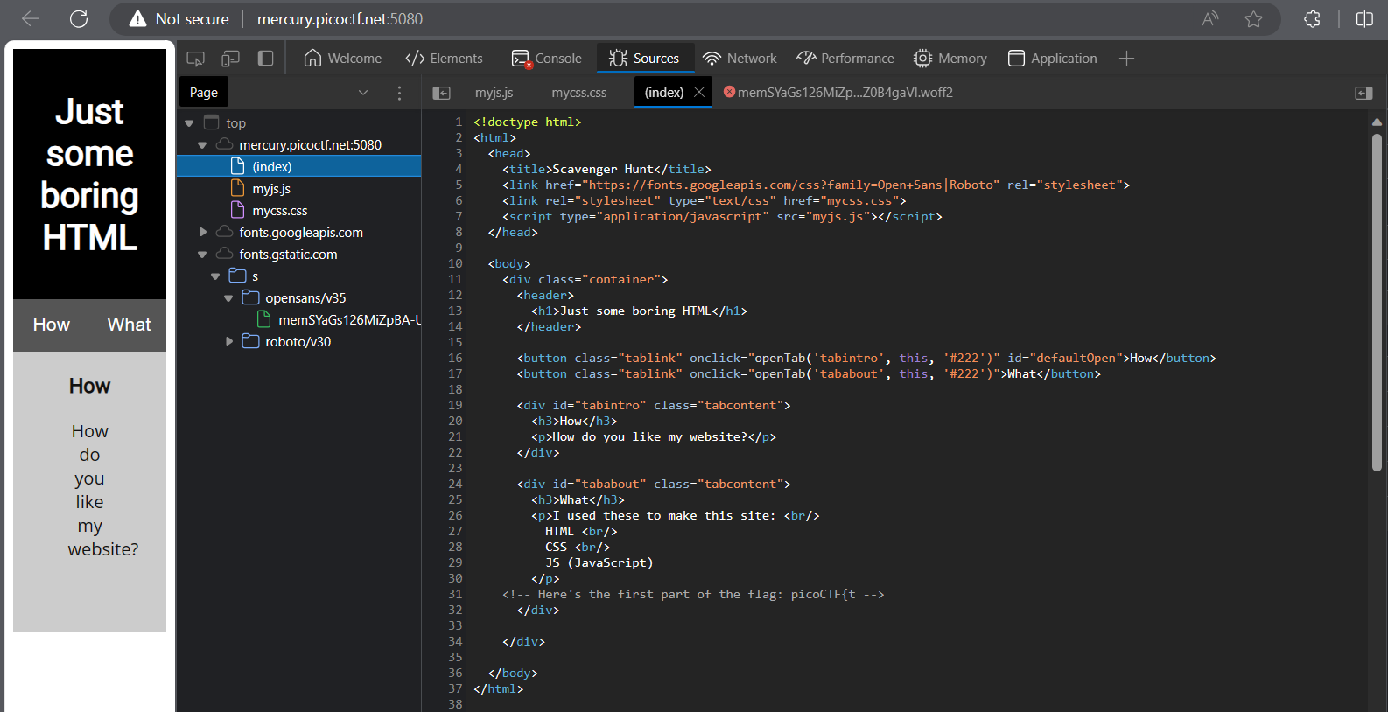

I love making websites on my Ma can Store a lot of information there.

Flag : picoCTF{th4ts_4_l0t_0f_pl4c3s_lo0k_35844447}

### 4) Some Assembly Required 1

### In this level must crack the assembly code, comprehend its reasoning, and locate the buried flag. To solve the enigma contained in the code.

Steps for solve:

1. <http://mercury.picoctf.net:37669/index.html> by clicking this link visited the web page.
2. Inspect that page using Ctrl + Shift + I go to the HTML file.
3. In that file there is JS file ( G82XCw5CX3.js) I just type url and go to the another page.
4. [mercury.picoctf.net:37669/G82XCw5CX3.js](http://mercury.picoctf.net:37669/G82XCw5CX3.js) in this link there is a file called “wasm”

in that file flag include.

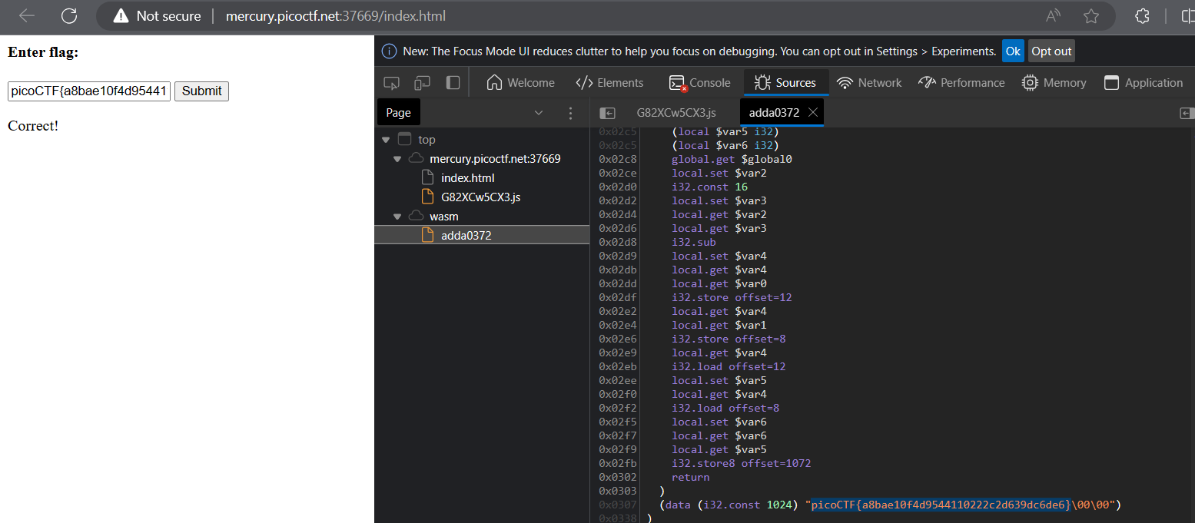

Flag : picoCTF{a8bae10f49544110222c2d639dc6de6}

### where are the robots

### Finding hidden "robots.txt" files on a website is part task. This task  look around the website, examine these files, and find hints that point to the elusive flags.

Steps for solve:

1. https://jupiter.challenges.picoctf.org/problem/36474/ opening that link it go to basic website.
2. In this problem it suggest to look robots.txt
3. After searching that it shows (/477ce.html) [jupiter.challenges.picoctf.org/problem/36474/robots.txt](https://jupiter.challenges.picoctf.org/problem/36474/robots.txt).
4. By searching that url it shows the flag. [Where are the robots (picoctf.org)](https://jupiter.challenges.picoctf.org/problem/36474/477ce.html) .

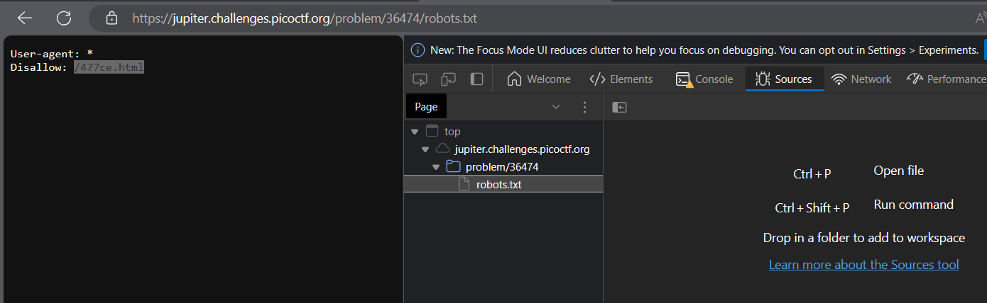

### Flag : picoCTF{ca1cu1at1ng_Mach1n3s_477ce}

### 6)dont-use-client-side

### In this challenge are often given access to a web application that pushes users to carry out specific browser tasks, like editing data or making judgments.

Steps for solve:

### <https://jupiter.challenges.picoctf.org/problem/37821/> by clicking link go to the basic website .

### In that website using Ctrl + Shift + I inspect that.

### After inspect that there is a folder called index under that folder HTML file there.

### In the challenge hint section say “Never trust the client” in order that the flag in HTML file un orderly.

### By making the that properly can get flag.

### 

### Flag : picoCTF{no_clients_plz_1a3c89}

### 7)login

### In this challenge, often challenged with finding ways to compromise a simulated login system in order to access a user's account or discover secret data.

Steps for solve:

### [login.mars.picoctf.net](https://login.mars.picoctf.net/) by clicking that basic website open.

### By inspect that there is js file [login.mars.picoctf.net/index.js](https://login.mars.picoctf.net/index.js) .

### In that file there is a some hidden information.

### It is based64 encoding.

### By using that in linux teminal can found the flag.

### 

### Flag :picoCTF{53rv3r_53rv3r_53rv3r_53rv3r_53rv3r}

### 8)Includes

### In this section complete challenges involving the use of code libraries or "includes" in web development. They are frequently required to manipulate or take advantage of these inclusions in order to find weaknesses or accomplish particular goals.

Steps for solve:

### [website](http://saturn.picoctf.net:50761/)  by clicking that link it go to the basic website.

### Using Ctrl + Shift + I inspect that, after inspect it shows index ,JS and CSS files .

### In that js file and css file includes the flag as a comment.

### 

### Flag : picoCTF{1nclu51v17y_1of2_f7w_2of2_df589022}

### Inspect HTML

### Participants are often given a web page and instructed to use the developer tools in their browsers to look at the HTML structure of the website.

Steps for solve:

### [website](http://saturn.picoctf.net:64200/)  visit that link and it go to the basic website.

### In the hint section it says access to the web inspector.

### By using Ctrl + Shift + I inspect the website , in that there is a index file under that there is a HTML file.

### In that HTML file flag includes as the comment.

### 

### Flag : picoCTF{1n5p3t0r_0f_h7ml_fd5d57bd}

### 10)Local Authority

### In this group frequently encounter difficulties relating to local system permits and authority. They are tasked with using these rights improperly to get privileges or access on a fictitious computer system or network.

Steps for solve:

1. [website](http://saturn.picoctf.net:59126/) go to this link and enter the basic website.
2. In this challenge hint section says “How is the password checked on this website?” .
3. After inspect it shows only CSS file.
4. After that I enter user name and password as the “admin”.
5. After that it shows CSS file and PHP file ,In that PHP file flag includes.

