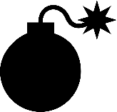

KeepTalking  
and nobody EXPLODES

BOMB DEFUSAL

MANUAL

github.com/Theta-Dev/KeepTalkingBomb

Version 1.0*Welcome to the dangerous and challenging world of bomb defusing.  
Study this manual carefully; you are the expert. In these pages you will find everything you need to know to defuse even the most insidious of bombs.  
And remember — One small oversight and it could all be over!*

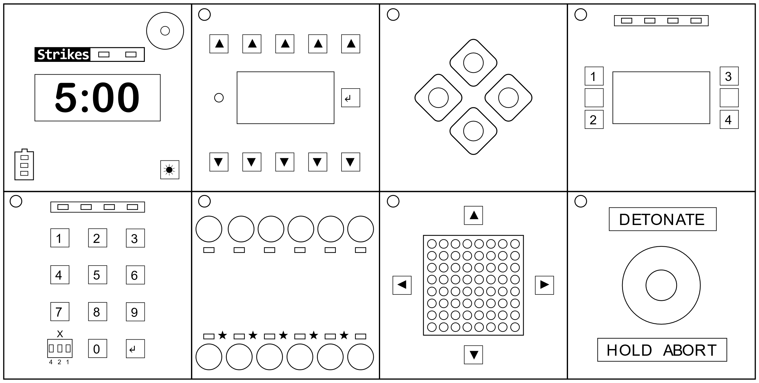

A bomb will explode when its countdown timer reaches 0:00 or when too many strikes have been recorded. The only way to defuse a bomb is to disarm all of its modules before its countdown timer expires.

Modules  
Each bomb consists of several modules. The modules have an indicator LED in the corner. A blue light means that the module is active and needs to be disarmed. Once you have successfully disarmed the module, the LED will turn green.  
Instructions on how to disarm modules can be found on the following pages.

Strikes  
When the Defuser makes a mistake, the bomb will record a strike which will be displayed on the indicator above the countdown timer. Bombs with a strike indicator will explode upon the third strike.  
A blinking strike indicator shows that the bomb is in Hardcore Mode and will explode upon the first strike, leaving no room for error.

Some disarming instructions will require specific information about the bomb. The battery level of the bomb is displayed by the 3 LEDs on the top left module. On the sides of the bomb you will find the serial number and 3 LED indicators.

Bomb types  
When you are in the main menu you can choose between 4 bomb types:

|  |  |
| --- | --- |
| **E**asy | 3 random modules |
| **M**edium | 5 random modules |
| **H**ard | 7 random modules |
| **C**ustom | Custom bomb: press any button on a module to toggle it on/off  **Exceptions:**  Password/Morse/Keypad/Who’s on First/Memory: choose the module using the menu on the display  Wires: plug 1 wire into the wire module / Complicated Wires: plug in 2 or more wires |

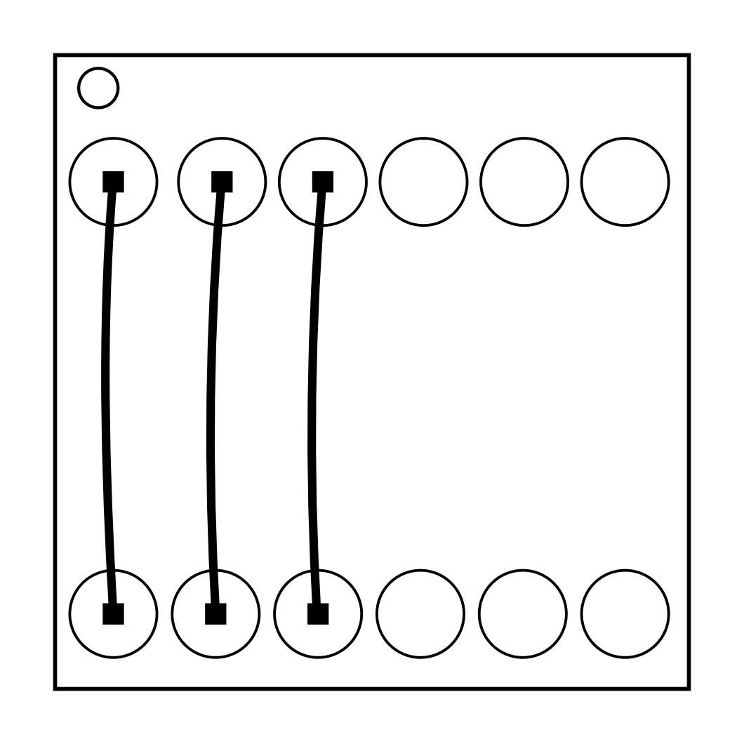On the Subject of Wires  
*Wires are the lifeblood of electronics! Wait, no, electricity is the lifeblood. Wires are more like the arteries. The veins? No matter…*

* A wire module can have 3-6 wires on it.
* Only the one correct wire needs to be cut to disarm the module.
* Wire ordering begins with the first on the left.

|  |  |
| --- | --- |
| 3 wires: If there are no red wires, cut the second wire. Otherwise, if the last wire is white, cut the last wire. Otherwise, if there is more than one blue wire, cut the last blue wire. Otherwise, cut the last wire. | 5 wires: If the last wire is white and the last digit of the serial number is odd, cut the fourth wire. Otherwise, if there is exactly one red wire and there is more than one yellow wire, cut the first wire. Otherwise, if there are no white wires, cut the second wire. Otherwise, cut the first wire. |
| 4 wires: If there is more than one red wire and the last digit of the serial number is odd, cut the last red wire. Otherwise, if the last wire is yellow and there are no red wires, cut the first wire. Otherwise, if there is exactly one blue wire, cut the first wire. Otherwise, if there is more than one yellow wire, cut the last wire. Otherwise, cut the second wire. | 6 wires: If there are no yellow wires and the last digit of the serial number is odd, cut the third wire. Otherwise, if there is exactly one yellow wire and there is more than one white wire, cut the fourth wire. Otherwise, if there are no red wires, cut the last wire. Otherwise, cut the fourth wire. |

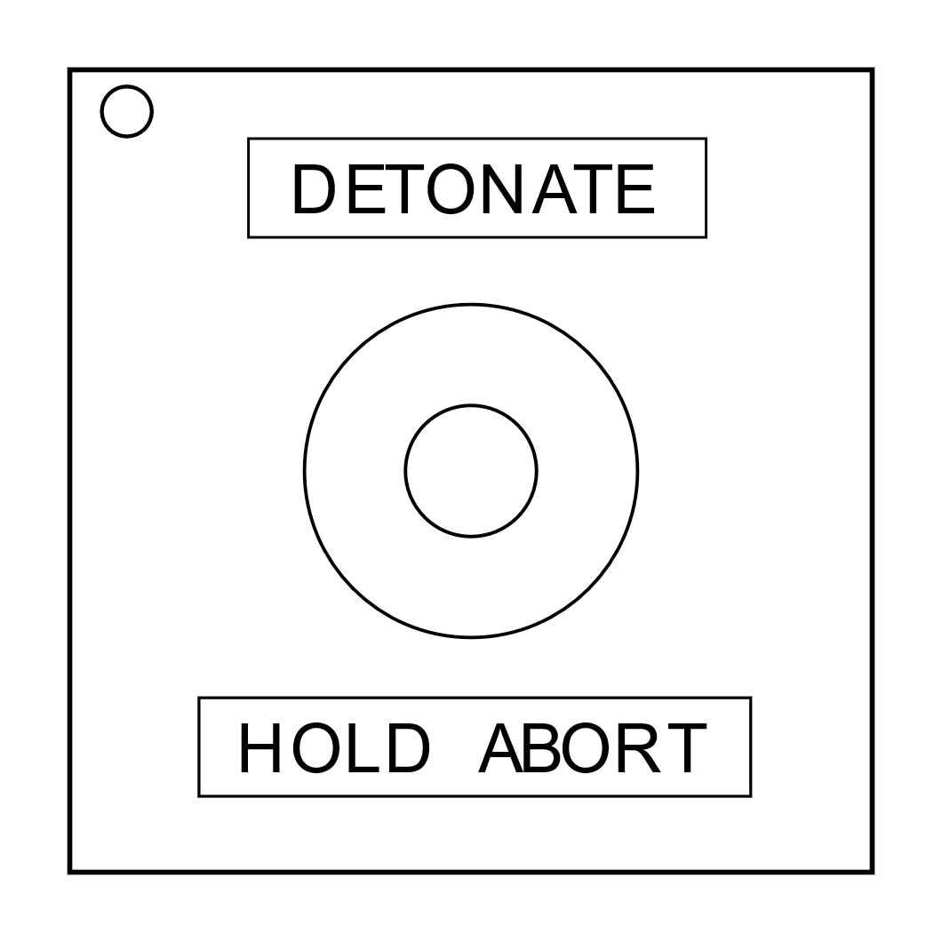On the Subject of The Button

*You might think that a button telling you to press it is pretty straightforward. That’s the kind of thinking that gets people exploded.*

Follow these rules in the order they are listed. Perform the first action that applies:

1. If the button is blue and the button says "Abort", hold the button and refer to "Releasing a Held Button".
2. If the battery level is above 1 and the button says "Detonate", press and immediately release the button.
3. If the button is white and there is a lit indicator with label CAR, hold the button and refer to "Releasing a Held Button".
4. If the battery level is above 2 and there is a lit indicator with label FRK, press and immediately release the button.
5. If the button is yellow, hold the button and refer to "Releasing a Held Button".
6. If the button is red and the button says "Hold", press and immediately release the button.
7. If none of the above apply, hold the button and refer to "Releasing a Held Button".

Releasing a Held Button  
If you start holding the button down, it will change its color. Based on the new color, you must release the button at a specific point in time:

* Blue strip: release when the countdown timer has a 4 in any position.
* White strip: release when the countdown timer has a 1 in any position.
* Yellow strip: release when the countdown timer has a 5 in any position.
* Any other color strip: release when the countdown timer has a 1 in any position.

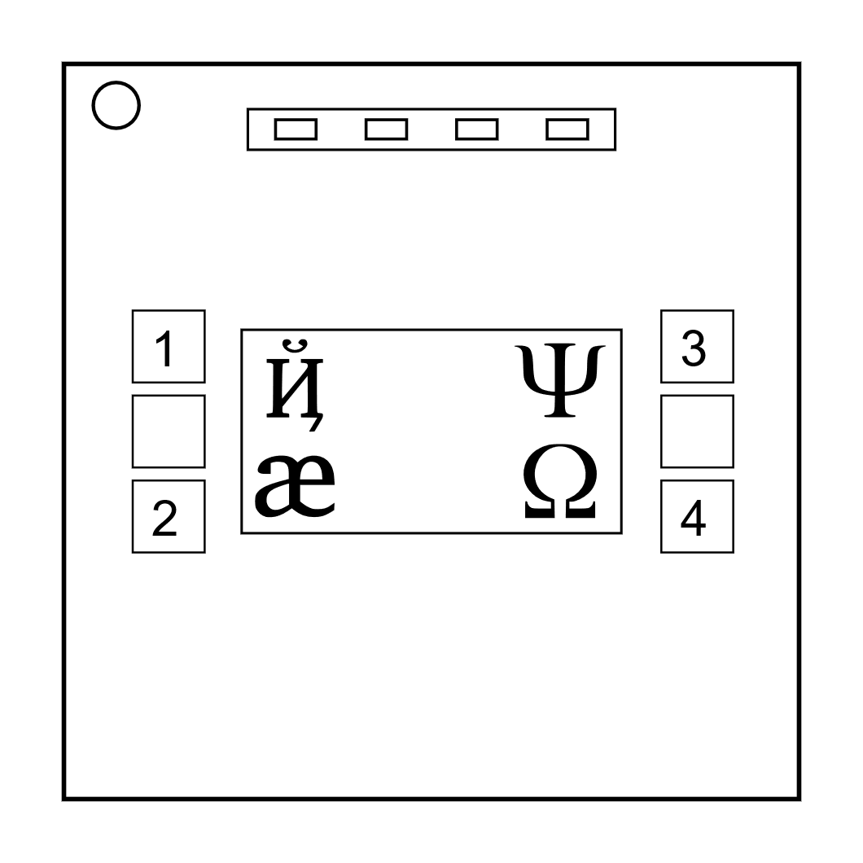On the Subject of Keypads

*I'm not sure what these symbols are, but I suspect they have something to do with occult.*

|  |
| --- |
|  |
|  |
|  |
|  |
|  |
|  |
|  |

* Only one column below has all four of the symbols from the keypad.
* Press the four buttons in the order their symbols appear from top to bottom within that column.

|  |
| --- |
|  |
|  |
|  |
|  |
|  |
|  |
|  |

|  |
| --- |
|  |
|  |
|  |
|  |
|  |
|  |
|  |

|  |
| --- |
|  |
|  |
|  |
|  |
|  |
|  |
|  |

|  |
| --- |
|  |
|  |
|  |
|  |
|  |
|  |
|  |

|  |
| --- |
|  |
|  |
|  |
|  |
|  |
|  |
|  |

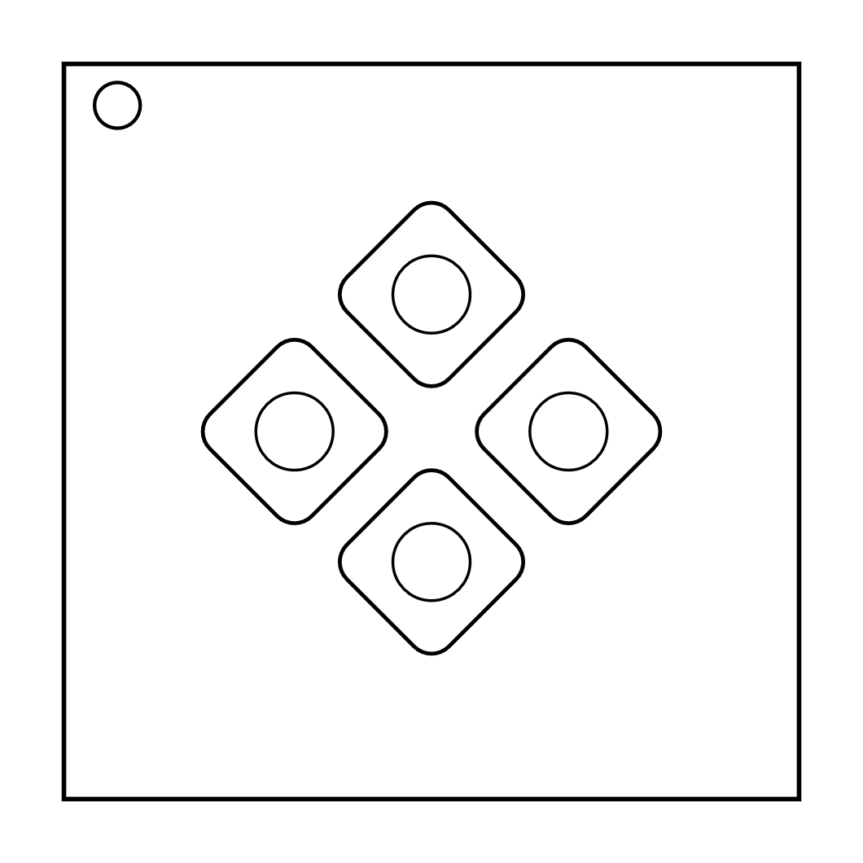On the Subject of Simon Says

*This is like one of those toys you played with as a kid where you have to match the pattern that appears, except this one is a knockoff that was probably purchased at a dollar store.*

1. One of the four colored buttons will flash.
2. Using the correct table below, press the button with the corresponding color.
3. The original button will flash, followed by another. Repeat this sequence in order using the color mapping.
4. The sequence will lengthen by one each time you correctly enter a sequence until the module is disarmed.

If the serial number contains a vowel:

|  |  |  |  |  |  |
| --- | --- | --- | --- | --- | --- |
|  | | Red Flash | Blue Flash | Green Flash | Yellow Flash |
| Button to press: | No Strikes | Blue | Red | Yellow | Green |
| 1 Strike | Yellow | Green | Blue | Red |
| 2 Strikes | Green | Red | Yellow | Blue |

If the serial number does not contain a vowel:

|  |  |  |  |  |  |
| --- | --- | --- | --- | --- | --- |
|  | | Red Flash | Blue Flash | Green Flash | Yellow Flash |
| Button to press: | No Strikes | Blue | Yellow | Green | Red |
| 1 Strike | Red | Blue | Yellow | Green |
| 2 Strikes | Yellow | Green | Blue | Red |

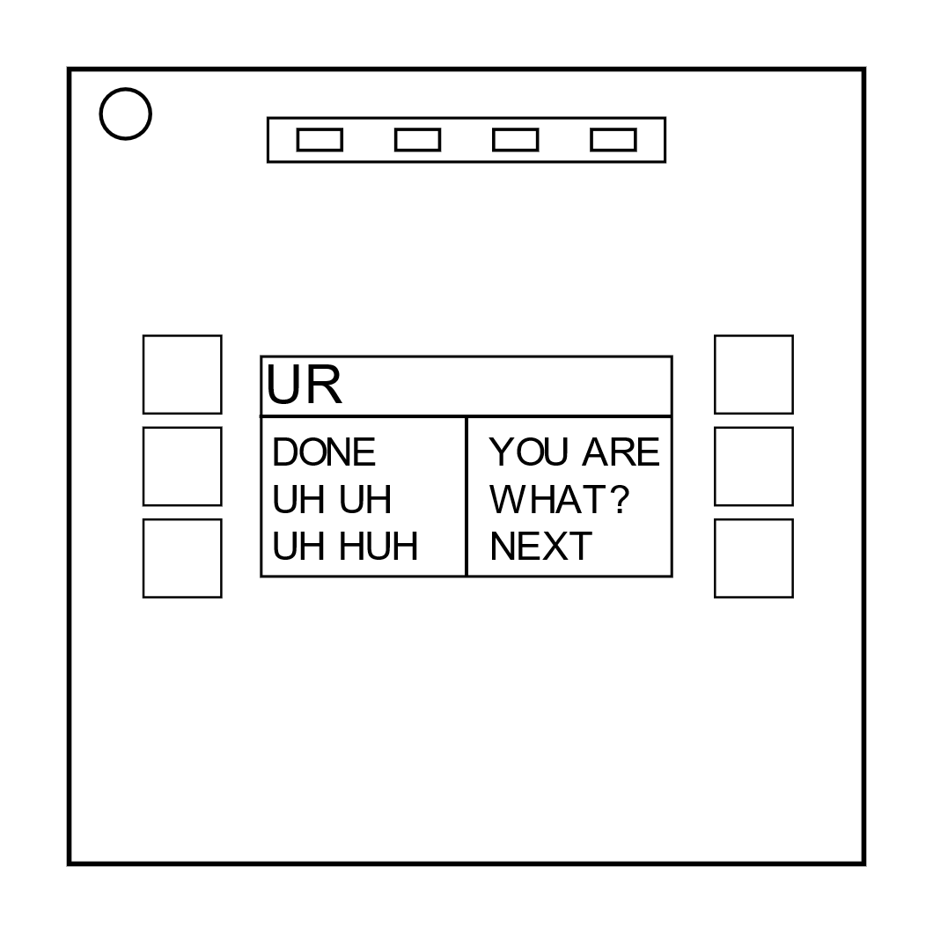On the Subject of Who’s on First

*This contraption is like something out of a sketch comedy routine, which might be funny if it wasn't connected to a bomb. I’ll keep this brief, as words only complicate matters.*

1. Read the display and use step 1 to determine which button label to read.
2. Using this button label, use step 2 determine which button to push.
3. Repeat until the module has been disarmed.

Step 1:  
Based on the display, read the label of a particular button and proceed to step 2:

|  |  |  |  |  |  |  |  |  |  |  |  |  |  |  |  |  |  |  |  |  |  |  |  |  |  |  |  |  |
| --- | --- | --- | --- | --- | --- | --- | --- | --- | --- | --- | --- | --- | --- | --- | --- | --- | --- | --- | --- | --- | --- | --- | --- | --- | --- | --- | --- | --- |
| YES | |  | FIRST | |  | DISPLAY | |  | OKAY | |  | SAYS | |  | NOTHING | |  |  | |  | BLANK | |  | NO | |  | LED | |
|  |  |  |  | Look At |  |  |  | Look At |  |  |  |  |  |  |  |  |  |  |  |  |  |  |
| Look At |  |  |  |  |  |  |  |  |  | Look At |  |  |  |  | Look At |  |  | Look At |  |
|  |  |  |  |  | Look At |  |  |  | Look At |  |  | Look At |  |  |  |  | Look At |  |  |
|  |  |  |  |  |  |  |  |  |  |  |  |  |  |  |  |  |  |  |  |  |  |
| LEAD | |  | READ | | RED | | REED | | LEED | | HOLD ON | | YOU | | YOU ARE | | YOUR | |  | YOU’RE | |
|  |  |  |  |  |  |  |  |  |  |  |  |  |  |  |  |  |  |  |  |  |  |
|  |  |  | Look At |  | Look At |  |  |  |  |  |  |  | Look At |  |  |  | Look At |  | Look At |
|  | Look At |  |  |  |  | Look At |  | Look At |  |  | Look At |  |  |  | Look At |  |  |  |  |
|  |  |  |  |  |  |  |  |  |  |  |  |  |  |  |  |  |  |  |  |  |  |  |  |
| UR | | THERE | | THEY’RE | | THEIR | | THEY ARE | | SEE | | C | | CEE | |  |  |  |  |
| Look At |  |  |  |  |  |  |  |  |  |  |  |  |  |  | Look At |  |  |  |  |  |  |  |
|  |  |  |  |  |  |  | Look At | Look At |  |  |  |  |  |  |  |  |  |  |  |
|  |  |  | Look At | Look At |  |  |  |  |  |  | Look At |  |  |  | Look At |  |  |  |  |

### Step 2: Using the label from step 1, push the first button that appears in its corresponding list:

|  |  |
| --- | --- |
| "READY": | YES, OKAY, WHAT, MIDDLE, LEFT, PRESS, RIGHT, BLANK, READY, NO, FIRST, UHHH, NOTHING, WAIT |
| "FIRST": | LEFT, OKAY, YES, MIDDLE, NO, RIGHT, NOTHING, UHHH, WAIT, READY, BLANK, WHAT, PRESS, FIRST |
| "NO": | BLANK, UHHH, WAIT, FIRST, WHAT, READY, RIGHT, YES, NOTHING, LEFT, PRESS, OKAY, NO, MIDDLE |
| "BLANK": | WAIT, RIGHT, OKAY, MIDDLE, BLANK, PRESS, READY, NOTHING, NO, WHAT, LEFT, UHHH, YES, FIRST |
| "NOTHING": | UHHH, RIGHT, OKAY, MIDDLE, YES, BLANK, NO, PRESS, LEFT, WHAT, WAIT, FIRST, NOTHING, READY |
| "YES": | OKAY, RIGHT, UHHH, MIDDLE, FIRST, WHAT, PRESS, READY, NOTHING, YES, LEFT, BLANK, NO, WAIT |
| "WHAT": | UHHH, WHAT, LEFT, NOTHING, READY, BLANK, MIDDLE, NO, OKAY, FIRST, WAIT, YES, PRESS, RIGHT |
| "UHHH": | READY, NOTHING, LEFT, WHAT, OKAY, YES, RIGHT, NO, PRESS, BLANK, UHHH, MIDDLE, WAIT, FIRST |
| "LEFT": | RIGHT, LEFT, FIRST, NO, MIDDLE, YES, BLANK, WHAT, UHHH, WAIT, PRESS, READY, OKAY, NOTHING |
| "RIGHT": | YES, NOTHING, READY, PRESS, NO, WAIT, WHAT, RIGHT, MIDDLE, LEFT, UHHH, BLANK, OKAY, FIRST |
| "MIDDLE": | BLANK, READY, OKAY, WHAT, NOTHING, PRESS, NO, WAIT, LEFT, MIDDLE, RIGHT, FIRST, UHHH, YES |
| "OKAY": | MIDDLE, NO, FIRST, YES, UHHH, NOTHING, WAIT, OKAY, LEFT, READY, BLANK, PRESS, WHAT, RIGHT |
| "WAIT": | UHHH, NO, BLANK, OKAY, YES, LEFT, FIRST, PRESS, WHAT, WAIT, NOTHING, READY, RIGHT, MIDDLE |
| "PRESS": | RIGHT, MIDDLE, YES, READY, PRESS, OKAY, NOTHING, UHHH, BLANK, LEFT, FIRST, WHAT, NO, WAIT |
| "YOU": | SURE, YOU ARE, YOUR, YOU'RE, NEXT, UH HUH, UR, HOLD, WHAT?, YOU, UH UH, LIKE, DONE, U |
| "YOU ARE": | YOUR, NEXT, LIKE, UH HUH, WHAT?, DONE, UH UH, HOLD, YOU, U, YOU'RE, SURE, UR, YOU ARE |
| "YOUR": | UH UH, YOU ARE, UH HUH, YOUR, NEXT, UR, SURE, U, YOU'RE, YOU, WHAT?, HOLD, LIKE, DONE |
| "YOU'RE": | YOU, YOU'RE, UR, NEXT, UH UH, YOU ARE, U, YOUR, WHAT?, UH HUH, SURE, DONE, LIKE, HOLD |
| "UR": | DONE, U, UR, UH HUH, WHAT?, SURE, YOUR, HOLD, YOU'RE, LIKE, NEXT, UH UH, YOU ARE, YOU |
| "U": | UH HUH, SURE, NEXT, WHAT?, YOU'RE, UR, UH UH, DONE, U, YOU, LIKE, HOLD, YOU ARE, YOUR |
| "UH HUH": | UH HUH, YOUR, YOU ARE, YOU, DONE, HOLD, UH UH, NEXT, SURE, LIKE, YOU'RE, UR, U, WHAT? |
| "UH UH": | UR, U, YOU ARE, YOU'RE, NEXT, UH UH, DONE, YOU, UH HUH, LIKE, YOUR, SURE, HOLD, WHAT? |
| "WHAT?": | YOU, HOLD, YOU'RE, YOUR, U, DONE, UH UH, LIKE, YOU ARE, UH HUH, UR, NEXT, WHAT?, SURE |
| "DONE": | SURE, UH HUH, NEXT, WHAT?, YOUR, UR, YOU'RE, HOLD, LIKE, YOU, U, YOU ARE, UH UH, DONE |
| "NEXT": | WHAT?, UH HUH, UH UH, YOUR, HOLD, SURE, NEXT, LIKE, DONE, YOU ARE, UR, YOU'RE, U, YOU |
| "HOLD": | YOU ARE, U, DONE, UH UH, YOU, UR, SURE, WHAT?, YOU'RE, NEXT, HOLD, UH HUH, YOUR, LIKE |
| "SURE": | YOU ARE, DONE, LIKE, YOU'RE, YOU, HOLD, UH HUH, UR, SURE, U, WHAT?, NEXT, YOUR, UH UH |
| "LIKE": | YOU'RE, NEXT, U, UR, HOLD, DONE, UH UH, WHAT?, UH HUH, YOU, LIKE, SURE, YOU ARE, YOUR |

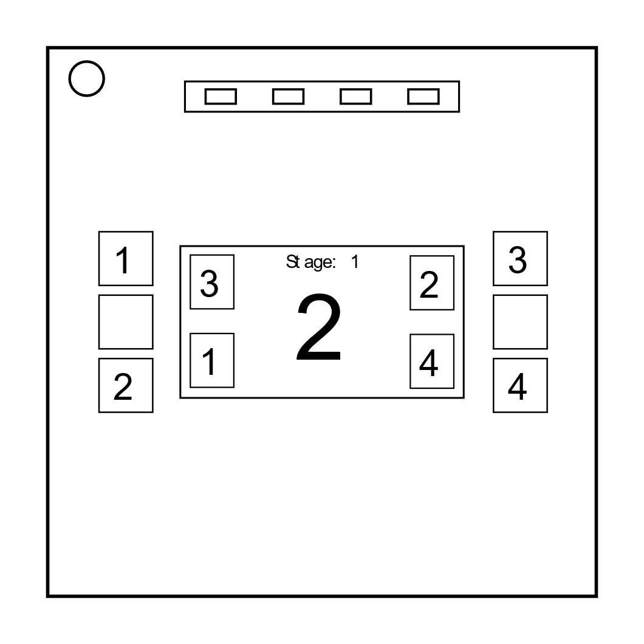On the Subject of Memory  
*Memory is a fragile thing but so is everything else when a bomb goes off, so pay attention!*

* Press the correct button to progress the module to the next stage. Complete all stages to disarm the module.
* Pressing an incorrect button will reset the module back to stage 1.
* Button positions numbers are printed next to the buttons.

Stage 1:  
If the display is 1, press the button in the second position.

If the display is 2, press the button in the second position.

If the display is 3, press the button in the third position.

If the display is 4, press the button in the fourth position.

Stage 3:  
If the display is 1, press the button with the same label you pressed in stage 2.

If the display is 2, press the button with the same label you pressed in stage 1.

If the display is 3, press the button in the third position.

If the display is 4, press the button labeled "4".

Stage 2:

If the display is 1, press the button labeled "4".

If the display is 2, press the button in the same position you pressed in stage 1.

If the display is 3, press the button in the first position.

If the display is 4, press the button in the same position you pressed in stage 1.

Stage 5:  
If the display is 1, press the button with the same label you pressed in stage 1.

If the display is 2, press the button with the same label you pressed in stage 2.

If the display is 3, press the button with the same label you pressed in stage 4.

If the display is 4, press the button with the same label you pressed in stage 3.

Stage 4:

If the display is 1, press the button in the same position you pressed in stage 1.

If the display is 2, press the button in the first position.

If the display is 3, press the button in the same position you pressed in stage 2.

If the display is 4, press the button in the same position you pressed in stage 2.

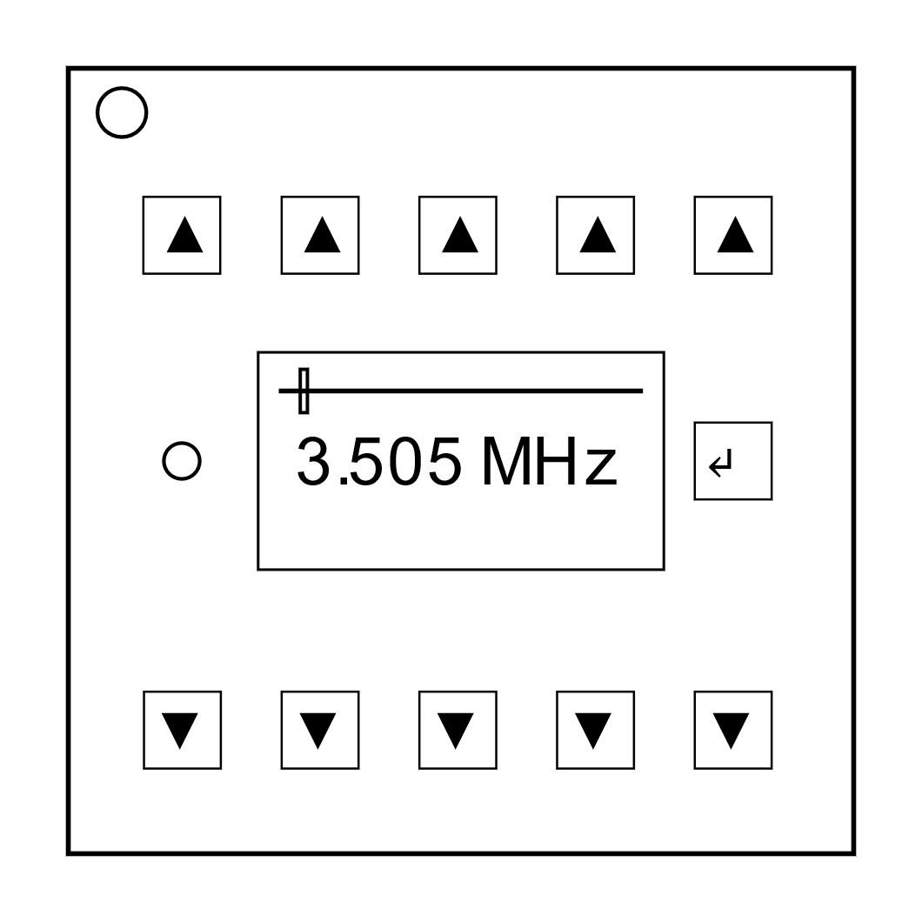On the Subject of Morse Code  
*An antiquated form of naval communication? What next? At least it's genuine Morse Code, so pay attention and you might just learn something.*

* Interpret the signal from the flashing light using the Morse Code chart to spell one of the words in the table.
* The signal will loop, with a long gap between repetitions.
* 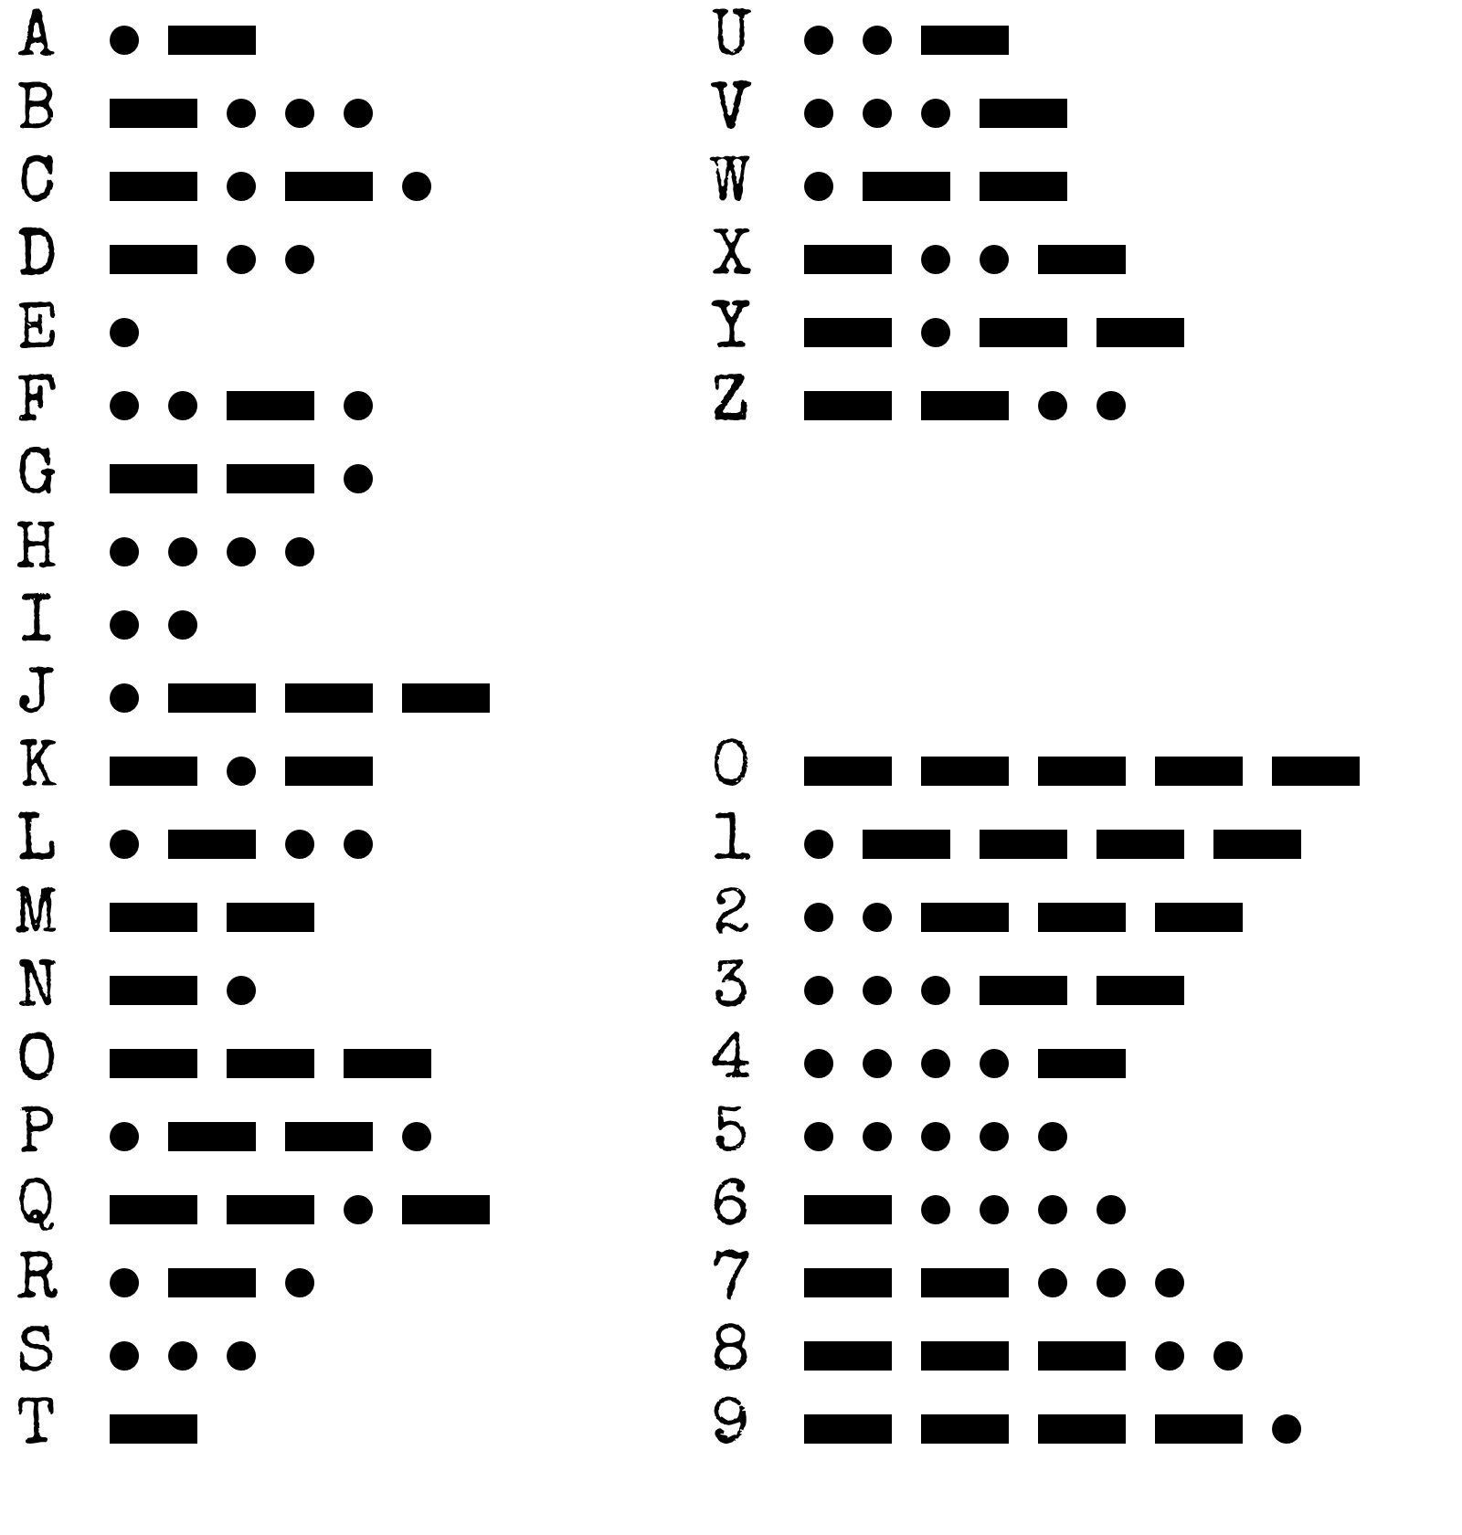Once the word is identified, set the corresponding frequency and press the transmit (TX) button.

|  |  |
| --- | --- |
| Word: | Frequency: |
| shell | 3.505 MHz |
| halls | 3.515 MHz |
| slick | 3.522 MHz |
| trick | 3.532 MHz |
| boxes | 3.535 MHz |
| leaks | 3.542 MHz |
| strobe | 3.545 MHz |
| bistro | 3.552 MHz |
| flick | 3.555 MHz |
| bombs | 3.565 MHz |
| break | 3.572 MHz |
| brick | 3.575 MHz |
| steak | 3.582 MHz |
| sting | 3.592 MHz |
| vector | 3.595 MHz |
| beats | 3.600 MHz |

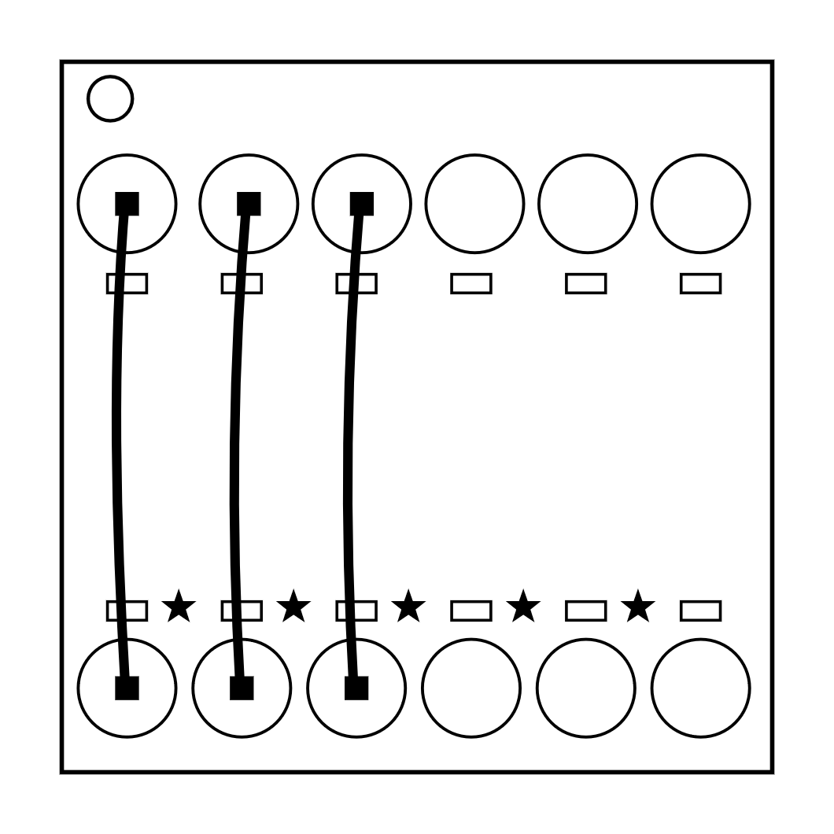On the Subject of Complicated Wires  
*These wires aren't like the others. Some have 2 colors! That makes them completely different. The good news is that we've found a concise set of instructions on what to do about it! Maybe too concise...*

* Look at each wire: there is a blue LED above the wire and a yellow LED marked with a "★" symbol below the wire.
* 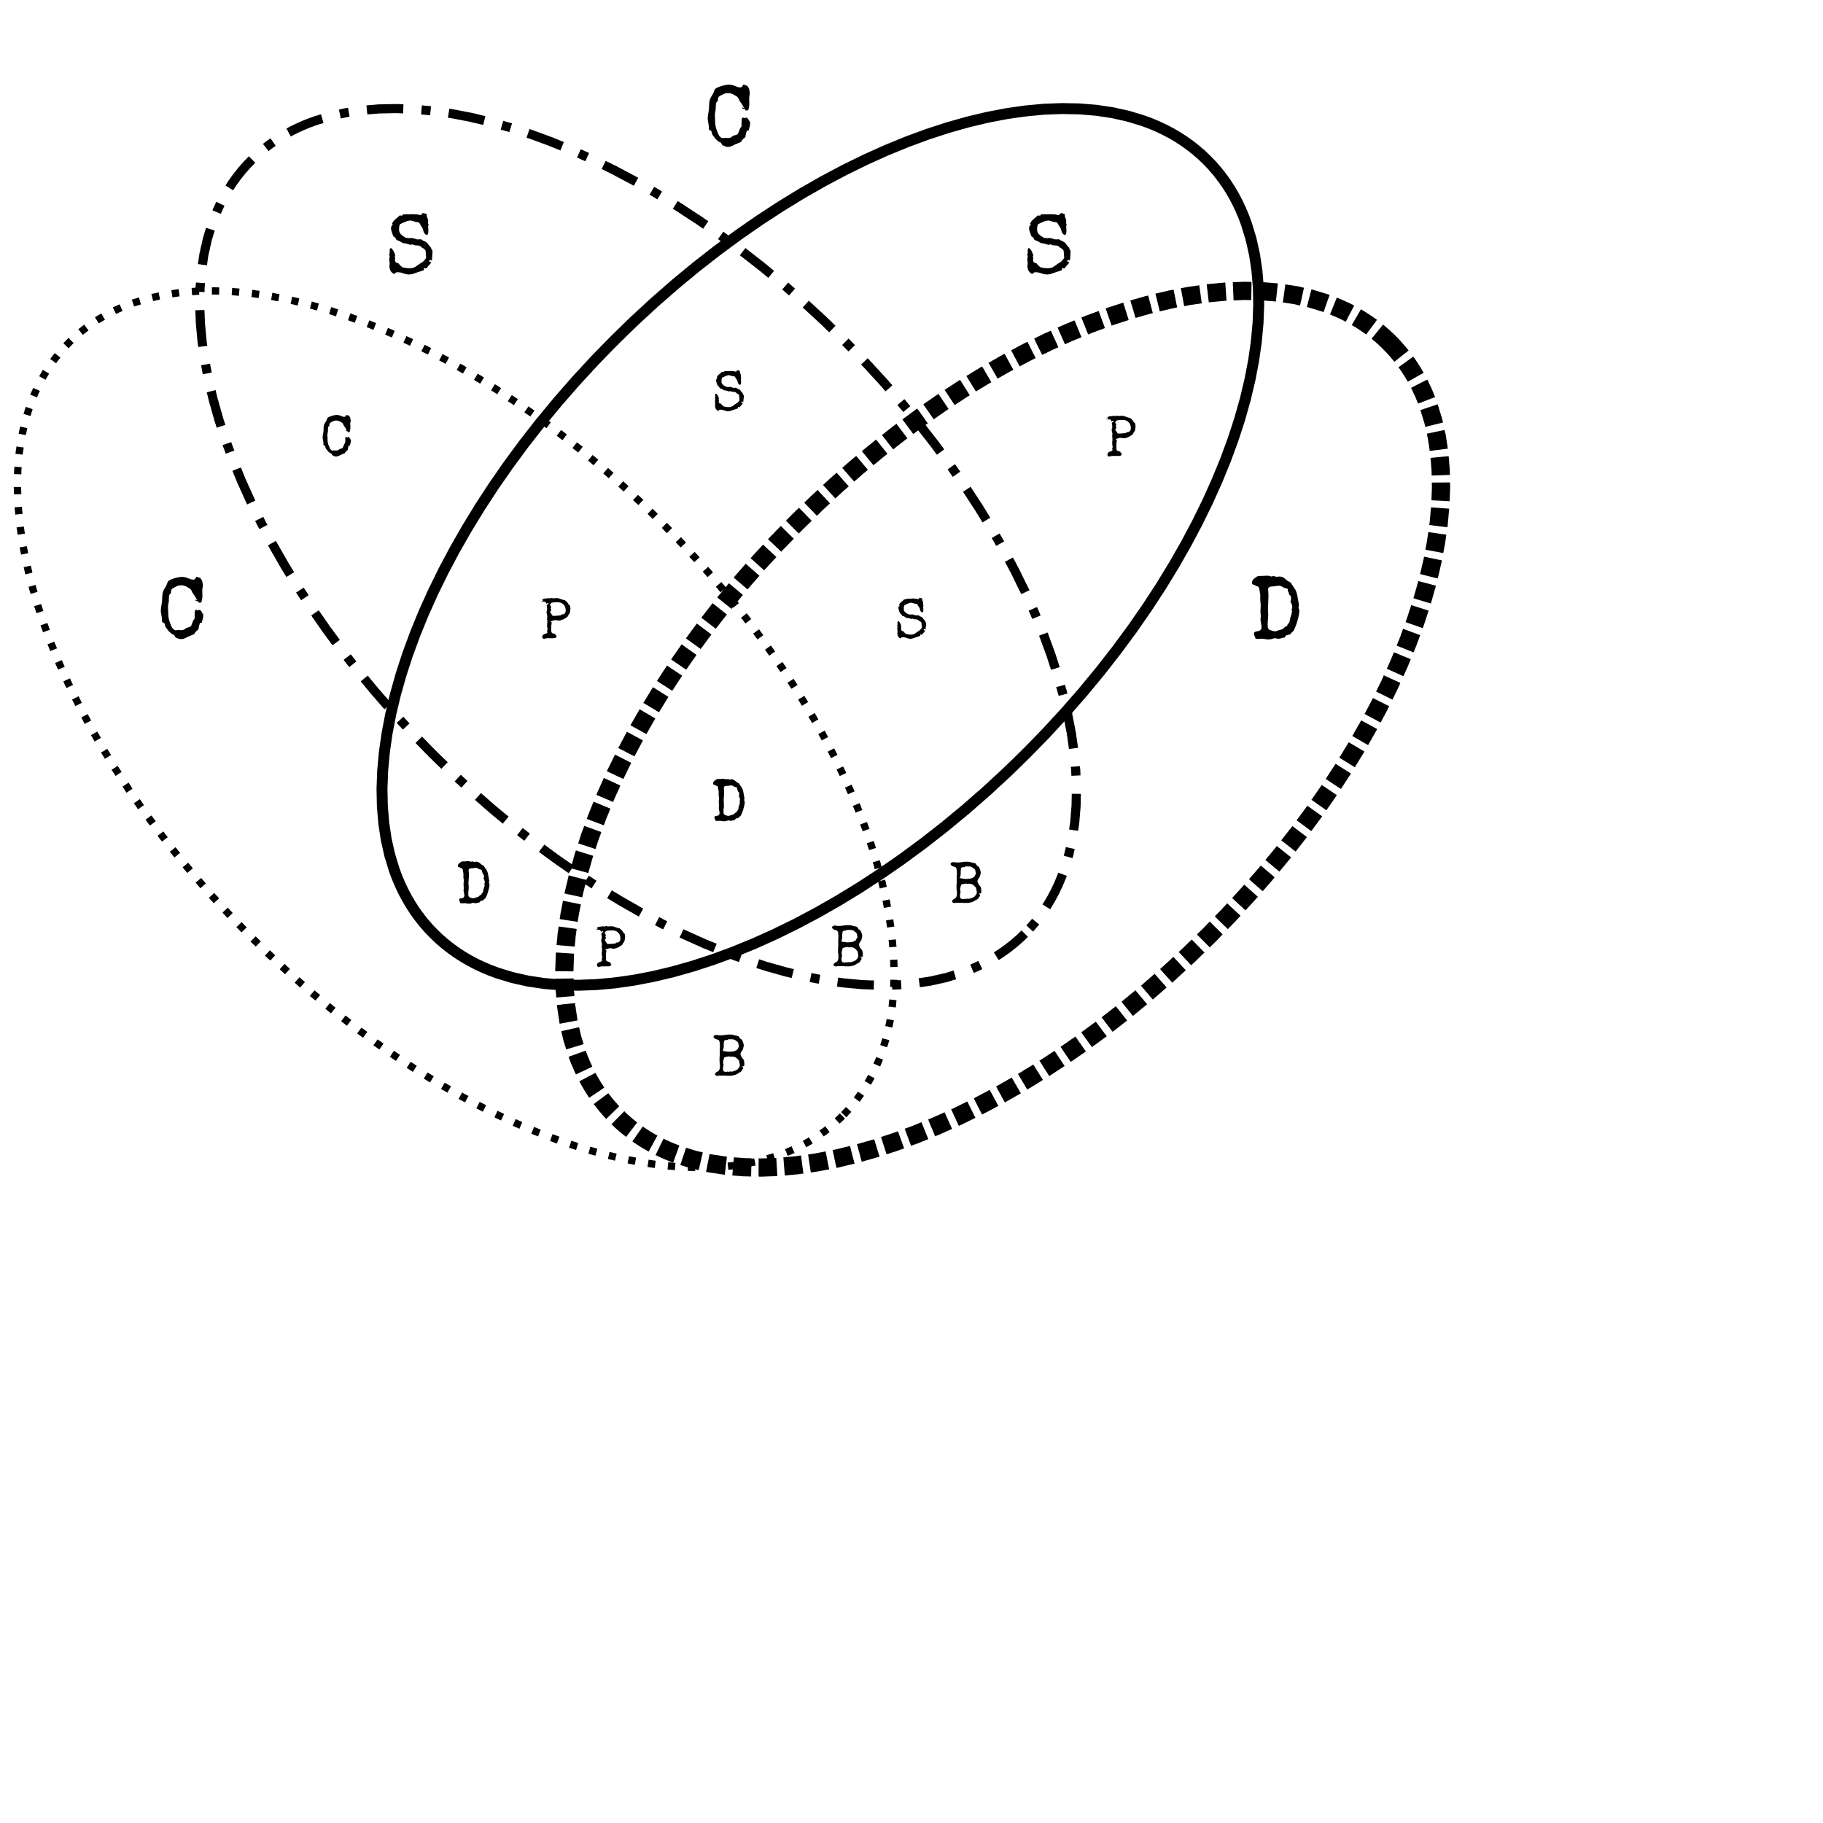For each wire/LED/symbol combination, use the Venn diagram below to decide whether or not to cut the wire.
* Each wire may have with multiple colors.

Purple

|  |  |
| --- | --- |
|  | Red color |
|  | Blue color |
|  | ★ symbol |
|  | LED is on |

|  |  |
| --- | --- |
| Letter | Instruction |
| C | Cut the wire |
| D | Do not cut the wire |
| S | Cut the wire if the last digit of the serial number is even |
| P | Cut the wire if the bomb has a serial port |
| B | Cut the wire if the bomb’s battery level is at least 2 |

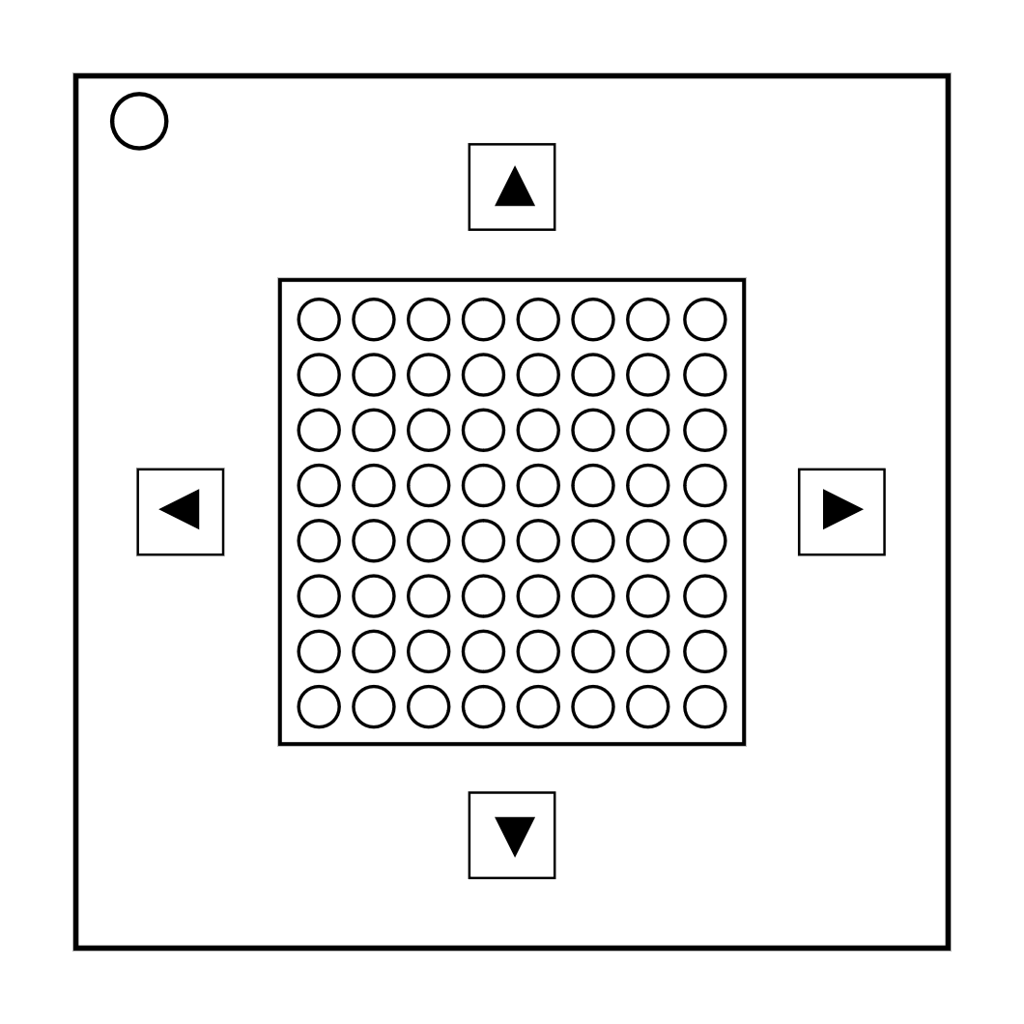On the Subject of Mazes  
*This seems to be some kind of maze, probably stolen off of a restaurant placemat.*

* A maze consists of 6x6 LEDs.
* 2 LEDs are lighting continuously. These should match up with the circular markings on one of the mazes below.
* The defuser must navigate the fast flashing LED to the slowly flashing LED using the arrow buttons.
* **Warning:** Do not cross the lines shown in the maze. These lines are invisible on the bomb.

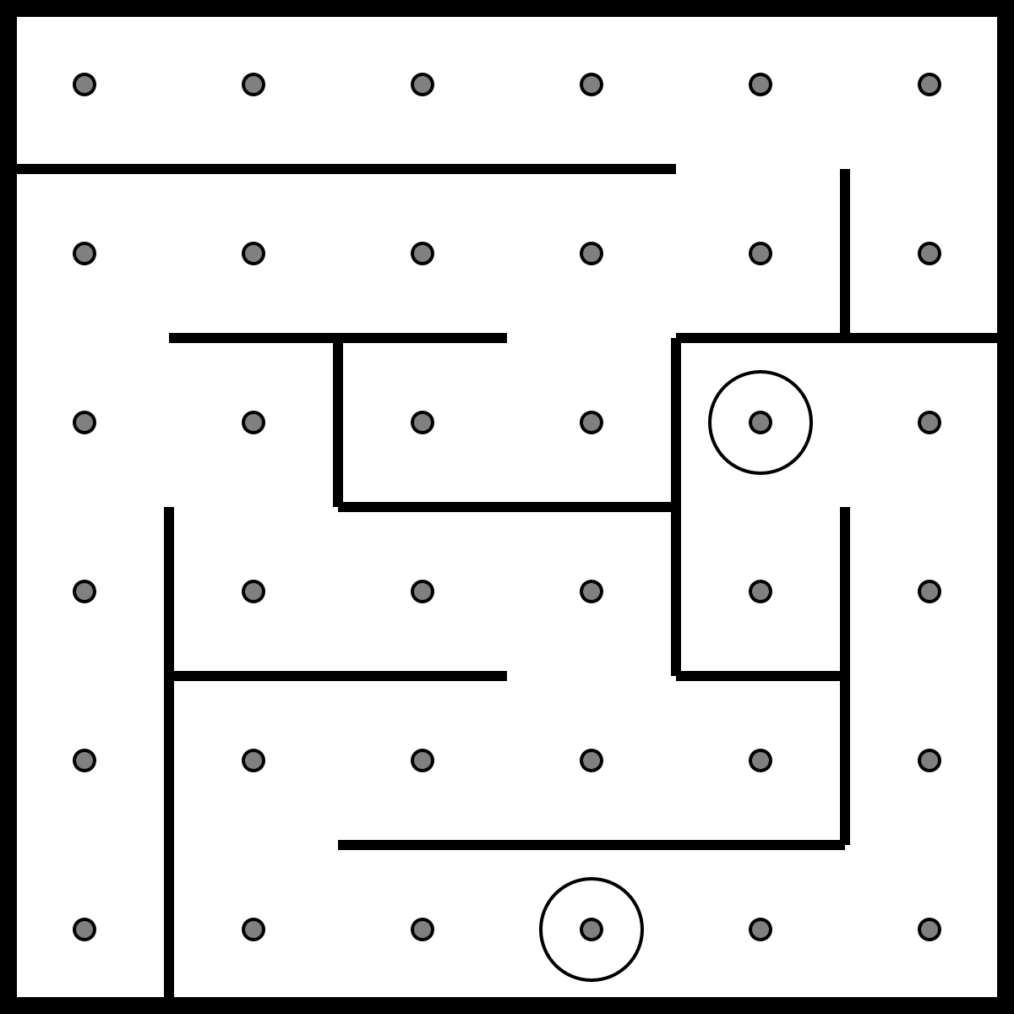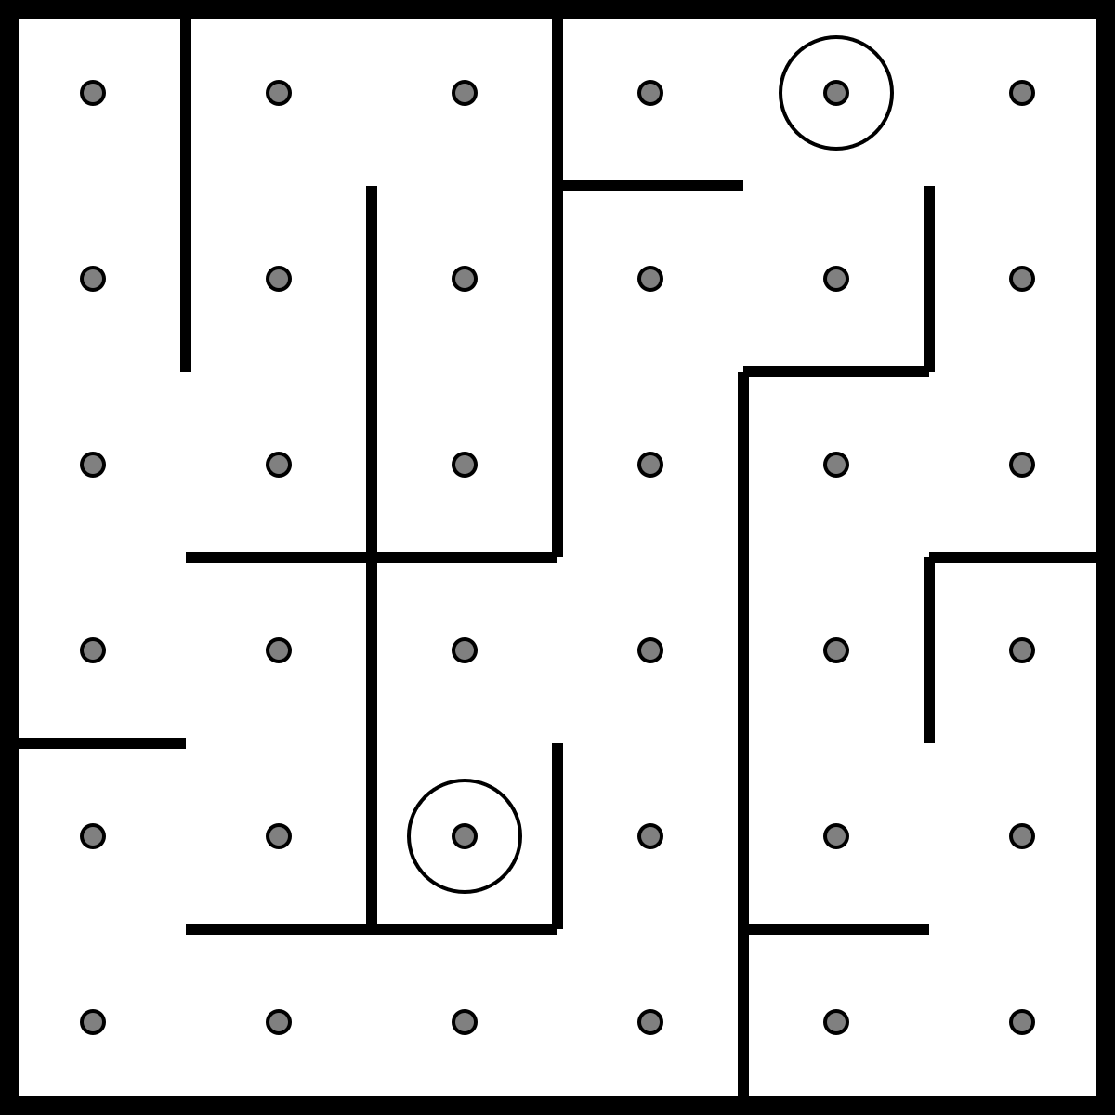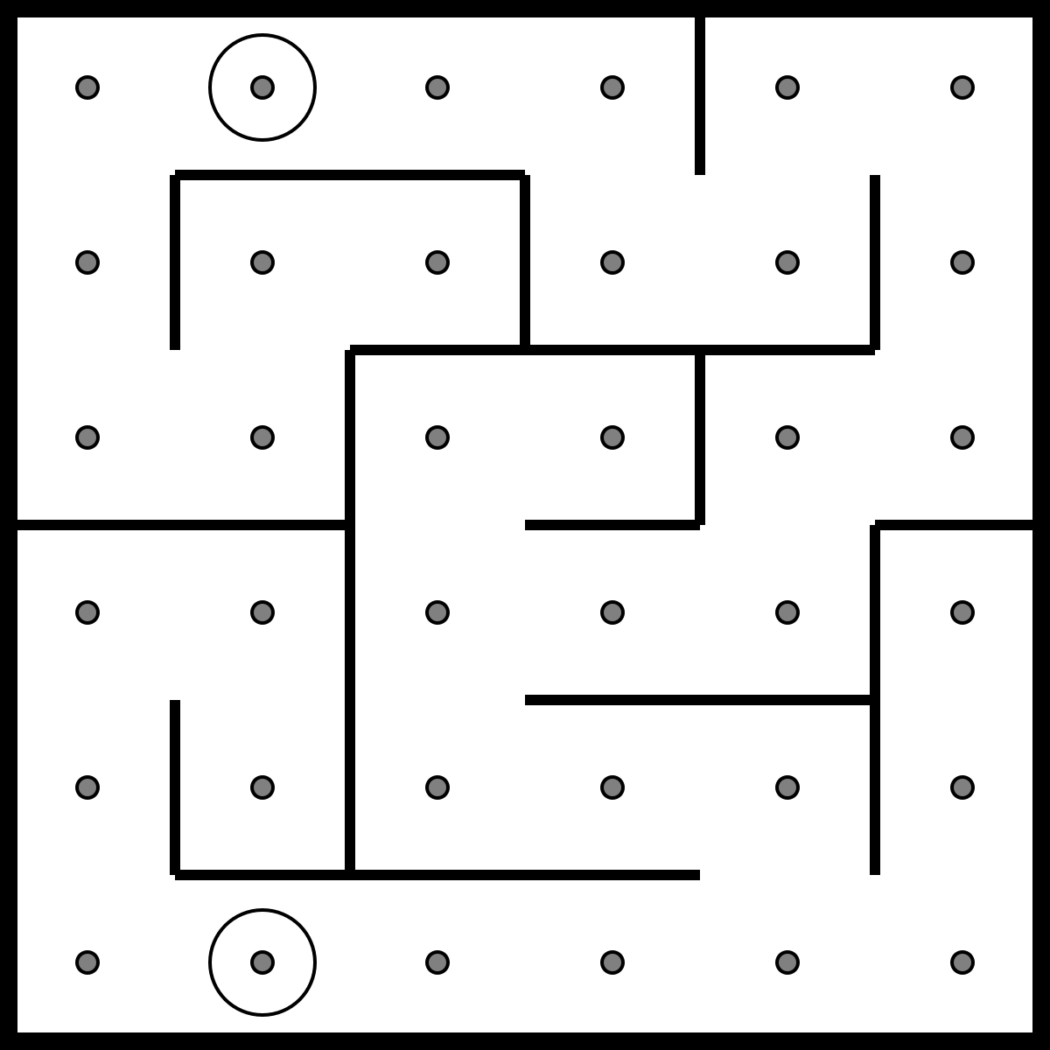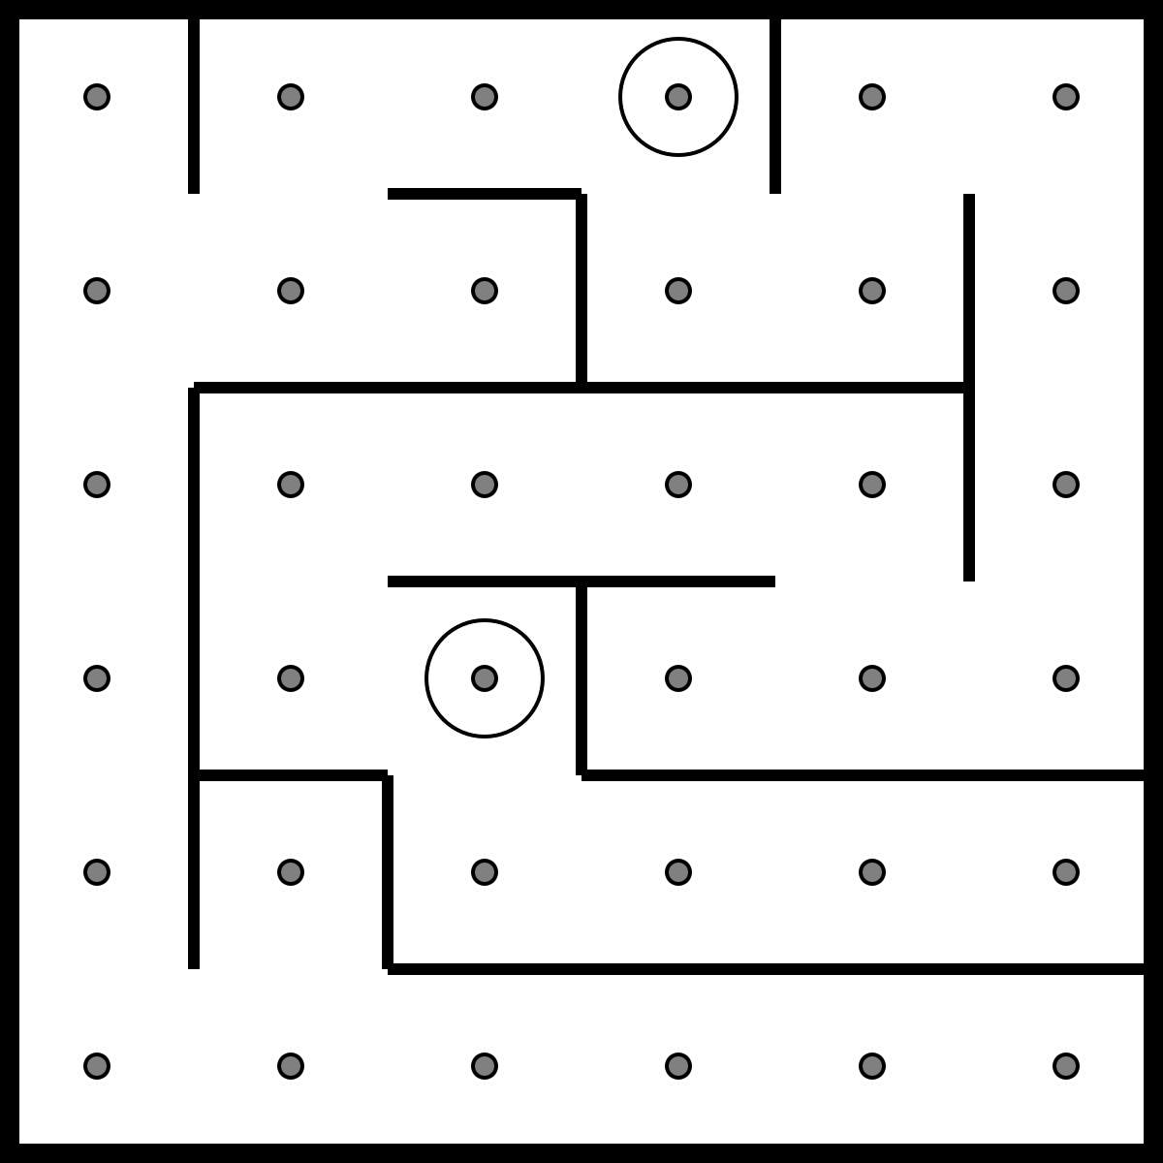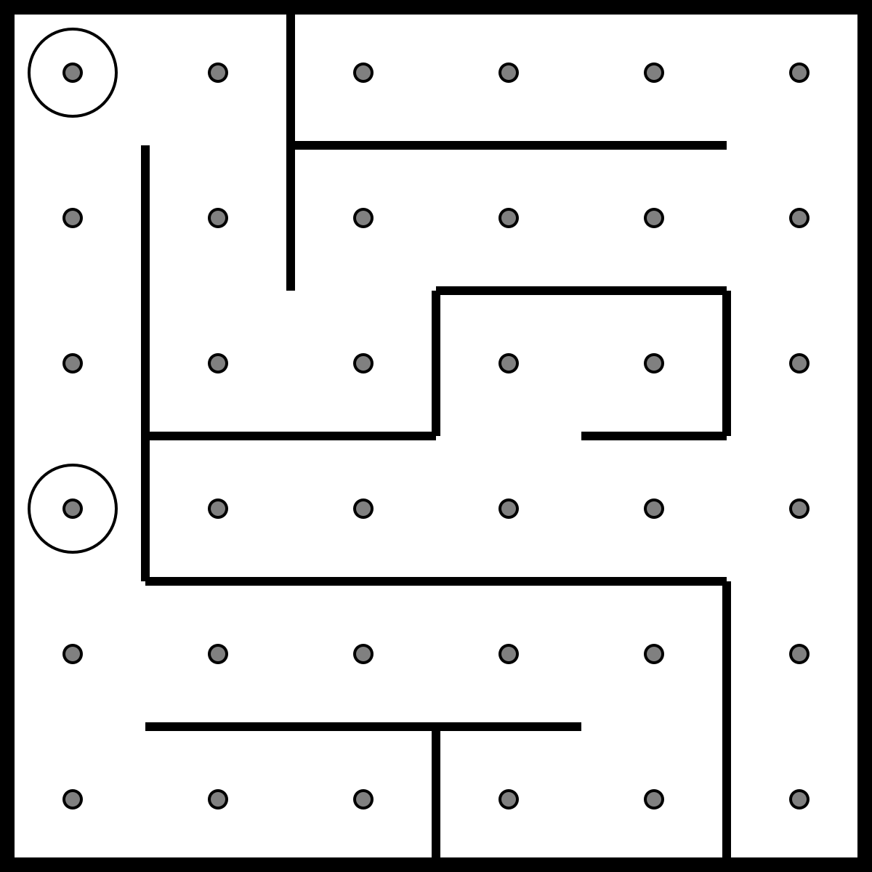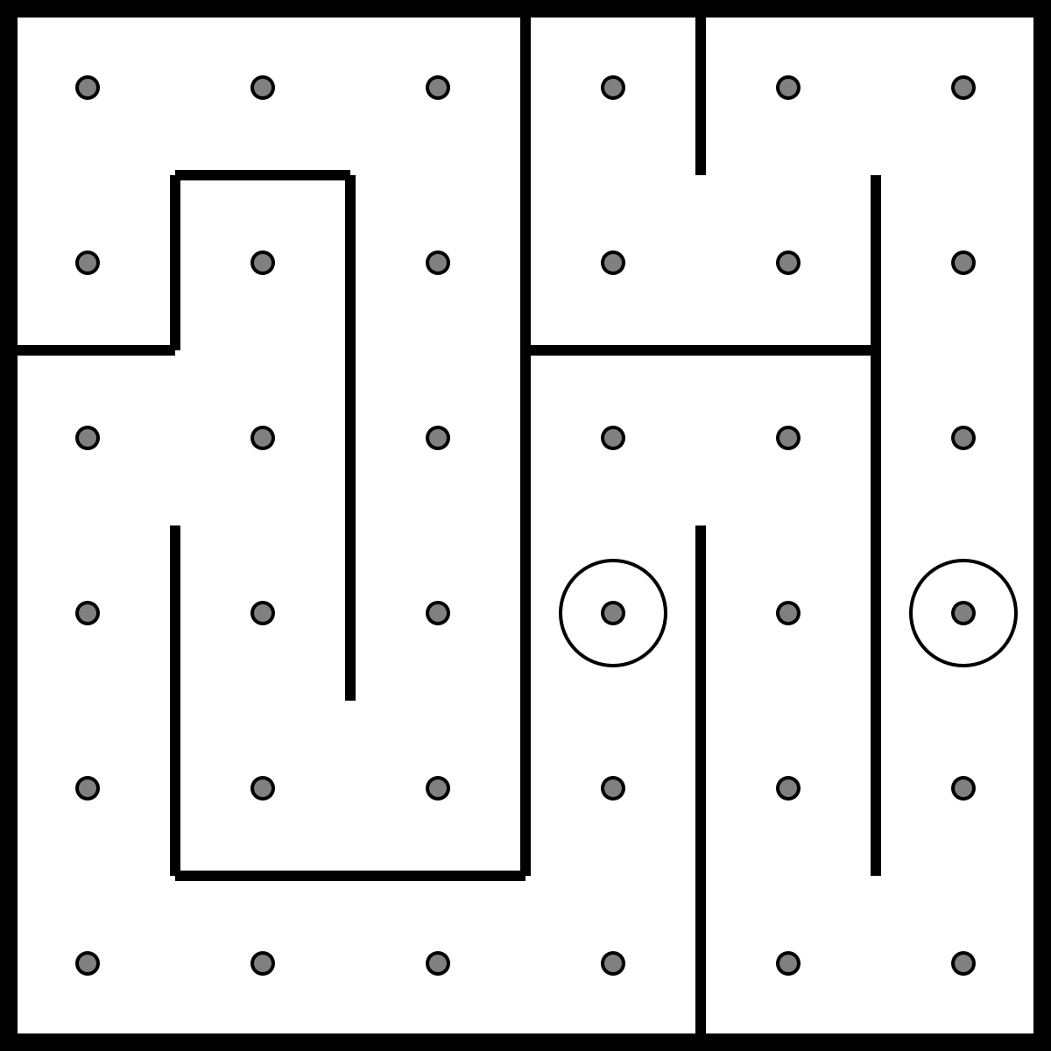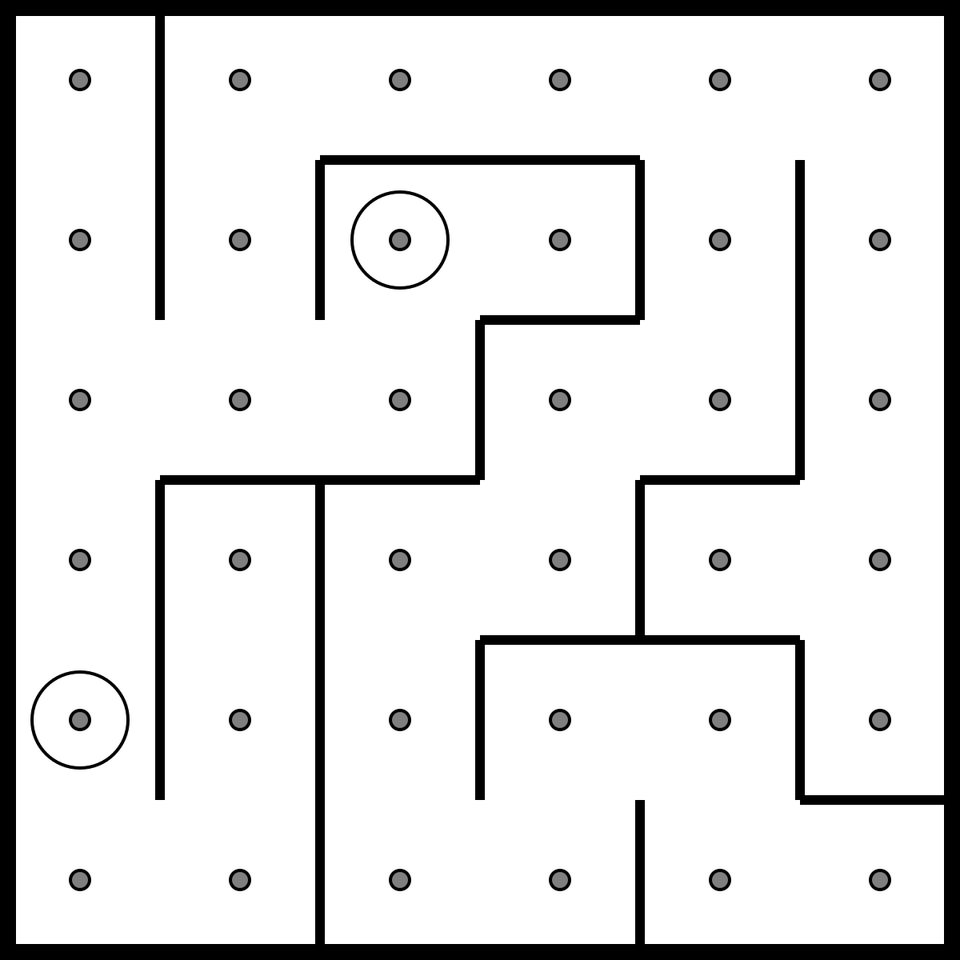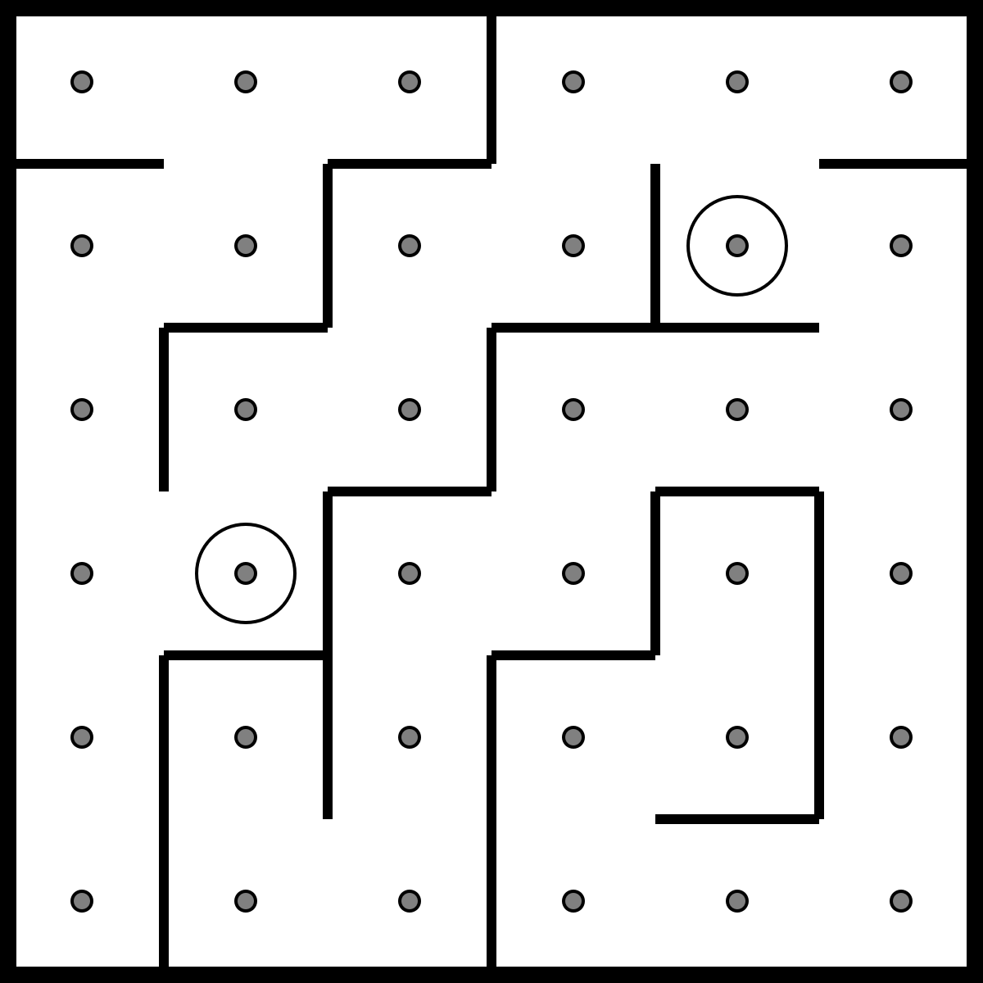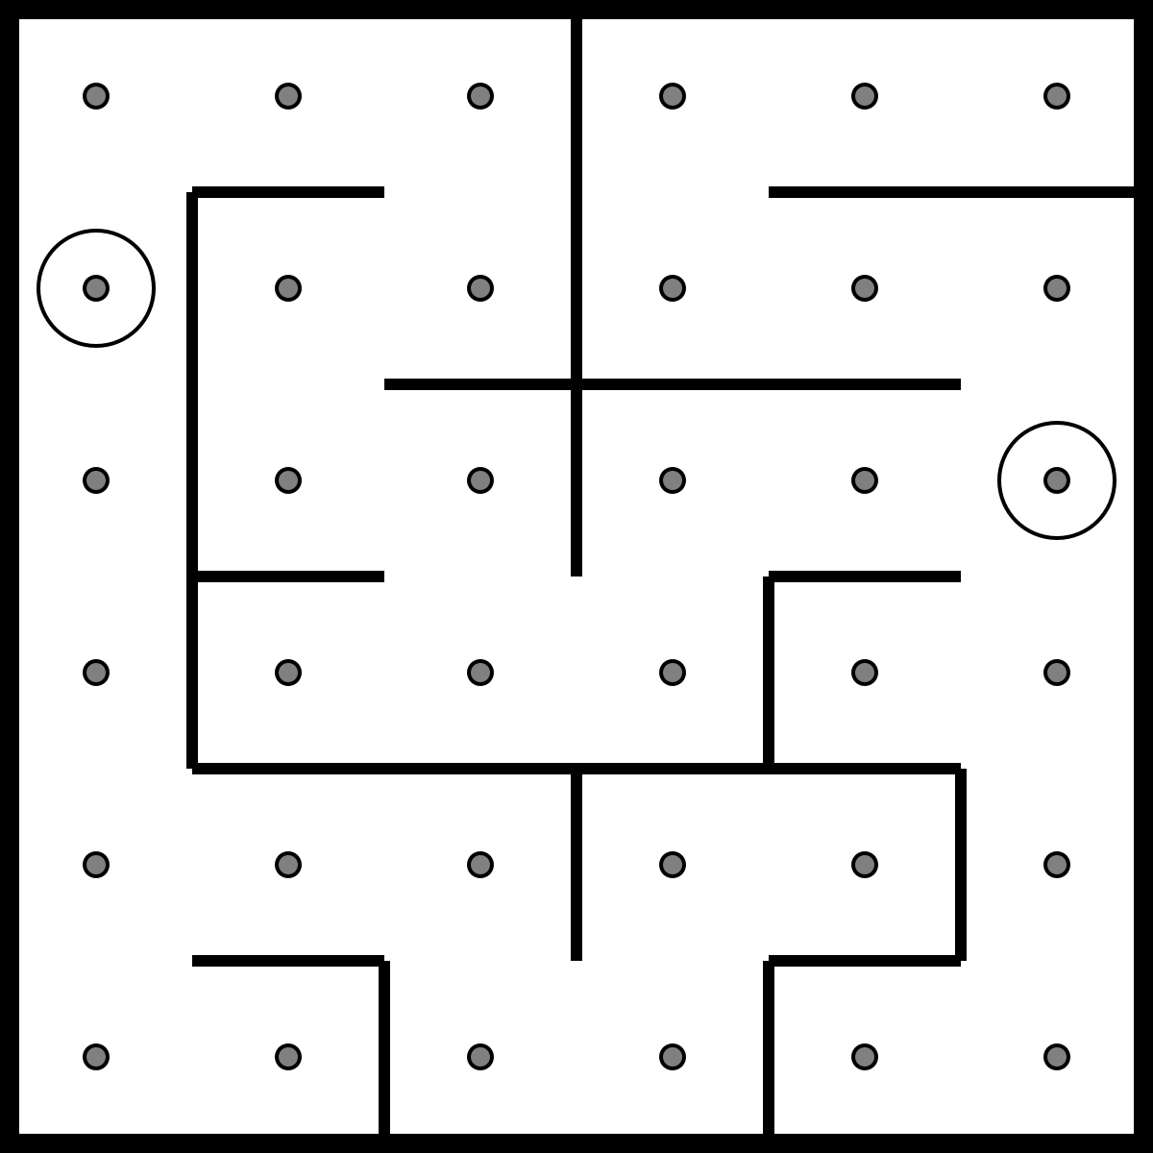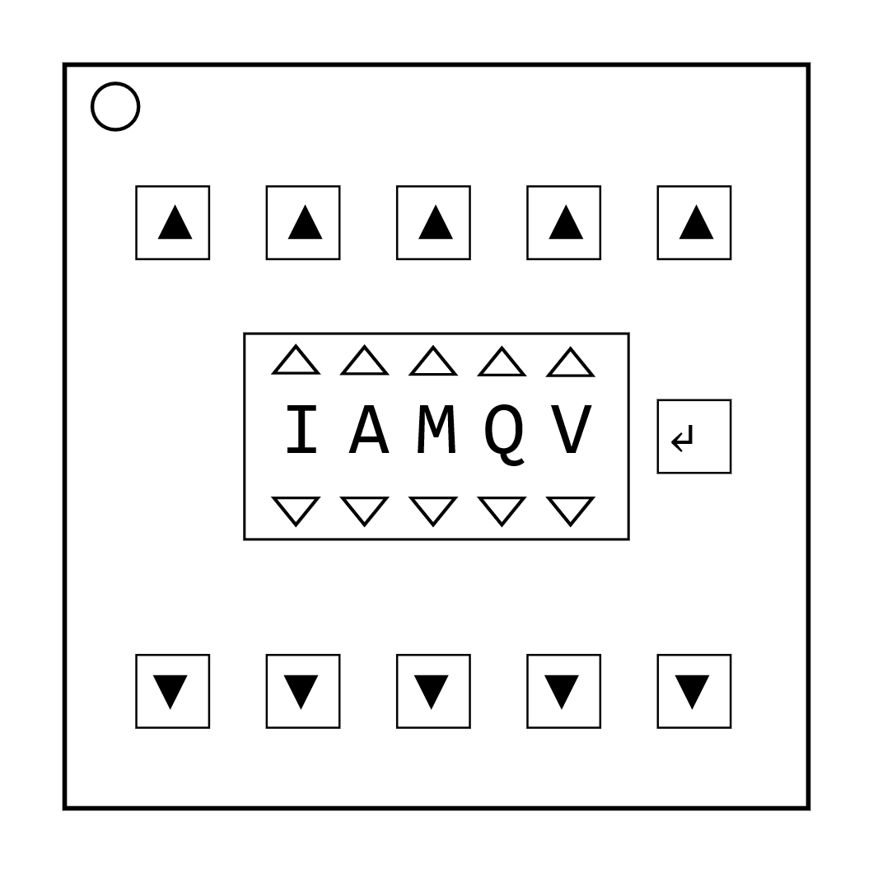On the Subject of Passwords  
*Fortunately this password doesn't seem to meet standard government security requirements: 22 characters, mixed case, numbers in random order without any palindromes above length 3.*

* The buttons above and below each letter will cycle through the possibilities for that position.
* Only one combination of the available letters will match a password below.
* Press the submit button once the correct word has been set.

|  |  |  |  |  |
| --- | --- | --- | --- | --- |
| about | after | again | below | could |
| every | first | found | great | house |
| large | learn | never | other | place |
| plant | point | right | small | sound |
| spell | still | study | their | there |
| these | thing | think | three | water |
| where | which | world | would | write |

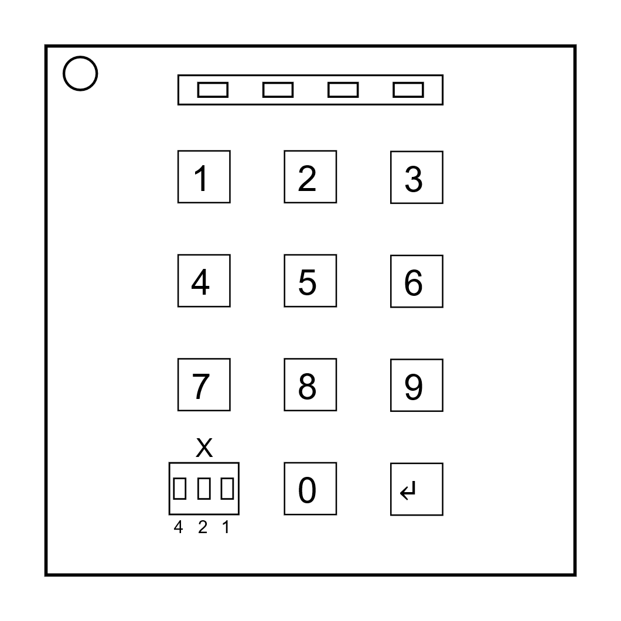On the Subject of PIN codes  
*Four numbers to be entered on a keypad.*

The PIN consists of four digits. Each digit needs to be calculated using these formulas:

If both x and y are even:

Otherwise, if the battery level is above 2 and y is odd:

Otherwise, if the digit sum of the serial number is greater than 12:

Otherwise:

|  |  |  |  |  |  |
| --- | --- | --- | --- | --- | --- |
|  |  | Digit | | | |
|  | y | 1 | 2 | 3 | 4 |
| Value of x | 0 | 91 | 59 | 16 | 3 |
| 1 | 63 | 7 | 88 | 39 |
| 2 | 72 | 51 | 73 | 36 |
| 3 | 71 | 54 | 58 | 25 |
| 4 | 30 | 94 | 14 | 93 |
| 5 | 87 | 35 | 90 | 45 |
| 6 | 56 | 60 | 17 | 67 |
| 7 | 33 | 85 | 64 | 38 |

Variable reference:  
: value of the binary display below the keypad  
: determined by the table on the right  
: nth digit of serial number (from left to right)  
: digit sum of serial number  
: battery level (0-3)  
: state of indicator (On: 1, Off: 0)