# Introduction

In my city we have a couple of international students for which it might be useful to know the main shopping locations near their dormitory and what they can buy from there.

These places should also be grouped by their purpose, like if it's a department store, farmer's market, clothes and shoes' shop, etc.

# Data acquisition and cleaning

For the business problem, stated previously, we can use the data obtained using Foursquare API and the geolocator set on the location of the dormitory.

The data we can obtain is about the location of the shopping places and the category of each, used for clustering.

The first steps are getting the dormitory latitude and longitude and building the URL.

Once the data is retrieved in a JSON format, we extract the columns needed ( location name, address, latitude and longitude, distance from the dorm, and the list of the categories of which the location belongs to; from the list of categories we keep only the first one).

We then check the categories available and group the locations by category.

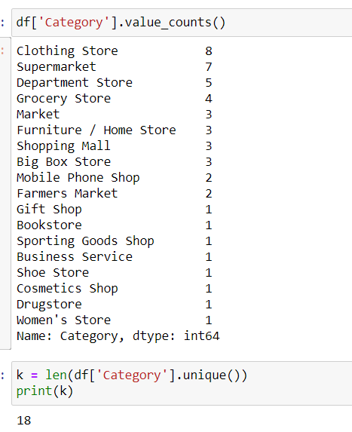

# Clustering algorithm

For clustering I used the K-Means algorithm and I represented the results using a map from the Folium package.

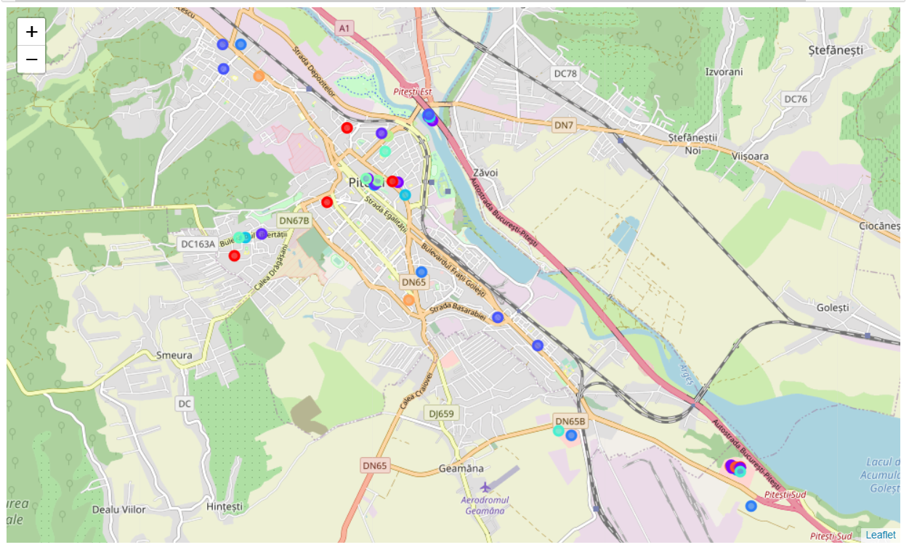

# Conclusion

Using the methods learned during the course I was able to find and analyse a set of location that might be useful for a potential student.

A further step can be sorting the locations of each category by their rating and tips.