# Introduction

The scenario in this project assumes that I plan on opening a line of restaurants across the world, but I need to choose a country as a starting point, or at least a region. For starters I have to analyze the economical and urban development, and also the happiness score of multiple countries. Furthermore, due to the current epidemiological situation I need to be aware of the development of Covid-19 pandemic in the potential candidates countries, as well as the evolution of the vaccination process and what influences it.

# Data acquisition and cleaning

For this analysis I used multiple datasets.

“country_vaccinations.cvs” dataset contains data about the current state of the vaccination in each country. Some of the columns of this data set are country, date, total_vaccinations, people_vaccinated, people_fully_vaccinated, daily_vaccinations_raw, daily_vaccinations, total_vaccinations_per_hundred, people_vaccinated_per_hundred, people_fully_vaccinated_per_hundred, daily_vaccinations_per_milion.

The first processing on this data set was grouping all this data by country summing up the values for each day and then selecting only the column “daily_vaccinations_per million” due to the accuracy of the data, since the rest of the columns contains a bigger amount of NaN values. Also, a StandardScaler was applied on the data in order to standardize it.

Another dataset used in this project is an economic dataset containing economic indicators for each country in the last two years. As previously we grouped the data by country using the mean. Additional processing included renaming of the columns and casting of the data types into more suitable ones.

These two datasets were merged into one for simplicity. The final dataframe looks like this:

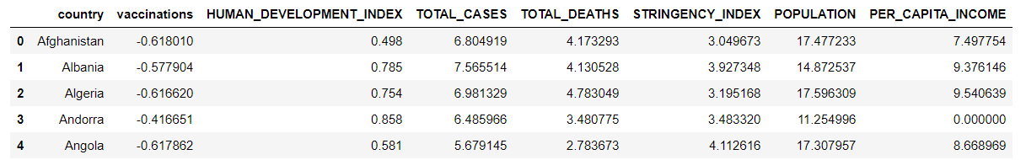

In order to determine the happiness index and the quality of life in each country we used 7 datasets containing data like ladder score and rank, social support, family support, health, freedom and generosity measurements from 2015 to 2021. These datasets were combined using the country and “happiness score” for each each year. The final result is:

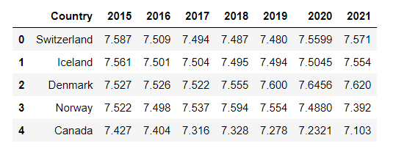

The last dataset used in this project was one regarding the urban development in Finland on with I applied grouping by mean and used only the results from 2000 to 2019.

# Exploratory analysis

## Covid-19 vaccination process analysis

The first exploratory analysis I made was related with the vaccination process across the globe.

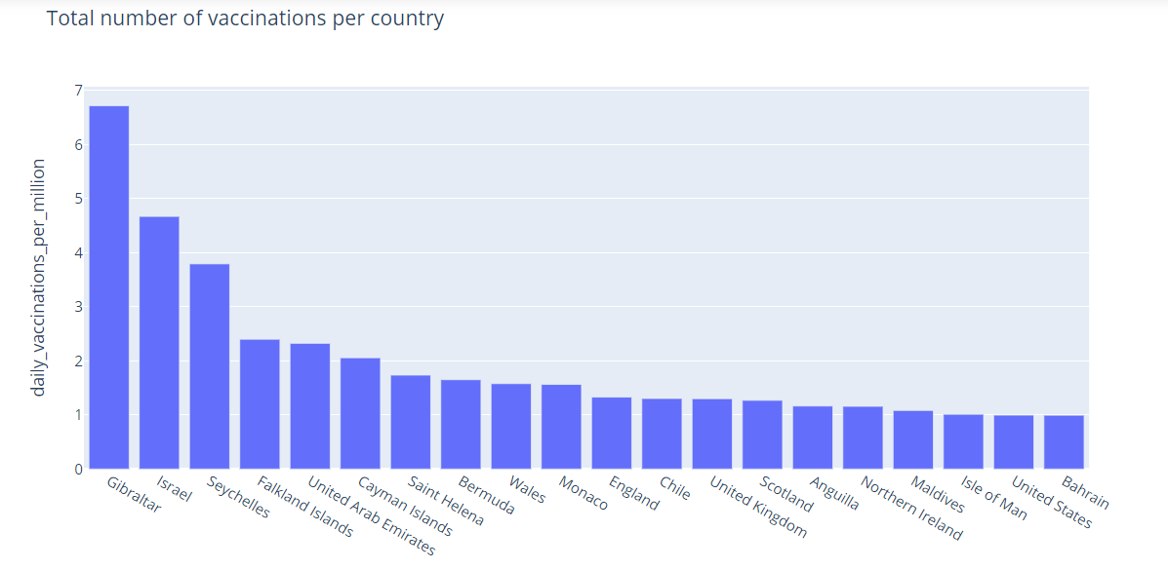

At first, I used a histogram using the standardized data on vaccinations from the first dataset, to check whether or not there are countries with exceptionally different results in the process of vaccination (either very low or very high values). For the same purpose I used a choropleth world map displaying the current state of the vaccination, which I found to be quite even, resulting from both visualization methods.

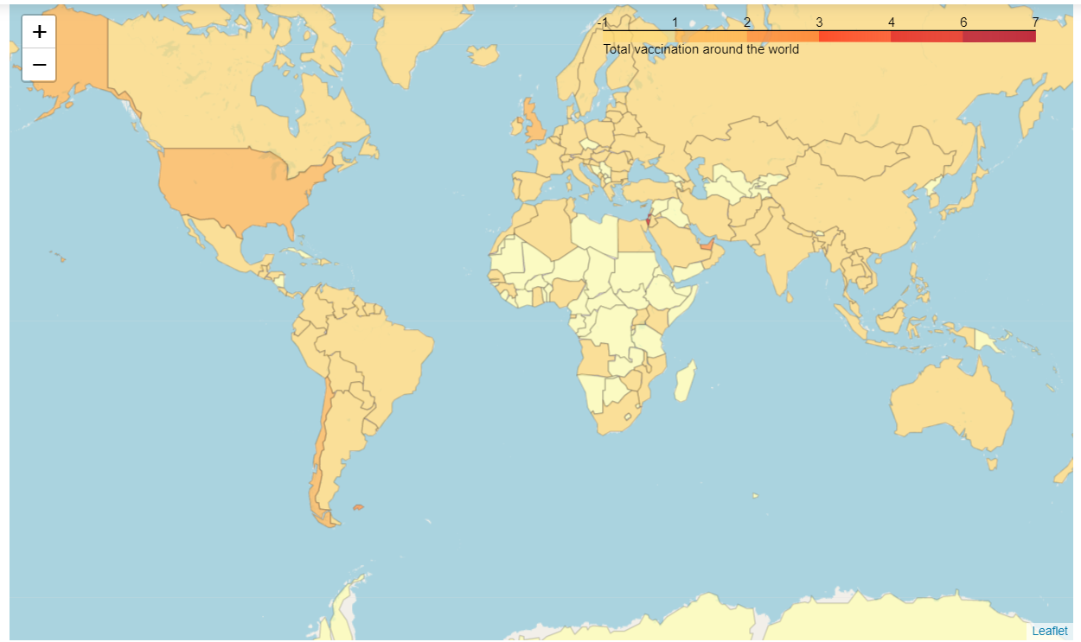

Furthermore, I tried to find out whether or not the economic factors or stringency index influenced one way or another the vaccination process, but again I couldn’t find a clear linear correlation between these factors. What I found is a linear correlation between human development and the per capita income.

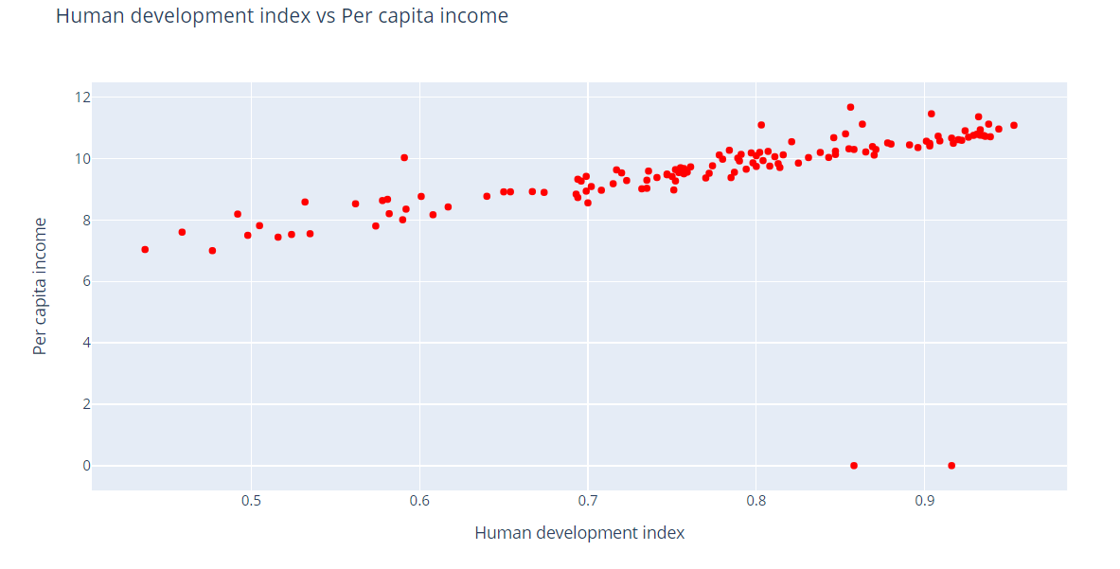

## Economic analysis

The economic analysis in this scenario, proved to be much more revealing. The map below shows a growth in happiness index and quality of life in Canada, Australia and Northern countries of Europe.

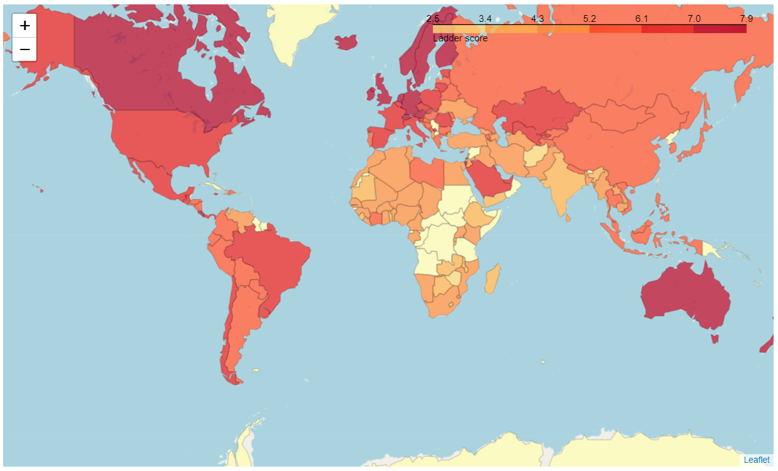

A quick sort of the dataframe puts the Baltic countries on top of the list. And the line chart below shows an exponential growth for Finland.

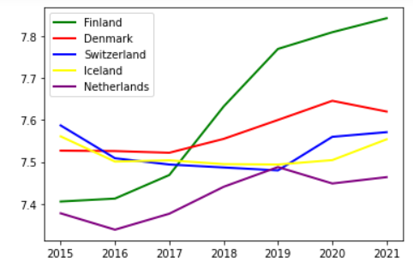

Having this result, the next step was a more in-depth analysis of Finland economy and urban development. In the chart below, we can see a relatively stable economic situation from 2000 until 2010, when the economic crisis appeared, and that outstanding growth since 2015 that we observed in the chart above.

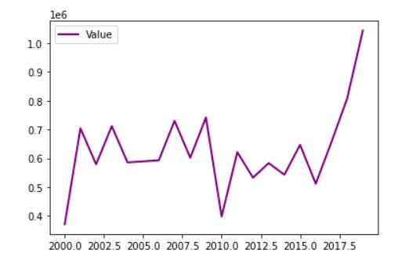

# Results

After this analysis, Finland looks like a good candidate due to its potential growth. Another good option might be Denmark due to its stability regarding the economy.

# Conclusion

A future work can include a more in-depth analysis of the economic and socio-political factors in the Baltic countries, as well as the distribution of different types of restaurants in these countries.