|  |
| --- |
|  |
| Faculty of Computers and Information Technology (FCIT) |
| **Auto-Attendance**  Supervisor: Dr Mohammad Naif Al-Atawi  Students::  Mazen Mohsen Tohari 411003806  Abdulrhman Saeed Alshahrani 411004826  Ahmed Marzuq Alanzy 391002020  Thamer Thib Alanazi 411005223  Abdulmohsen Mohammed Alblawi 371000352  Rayed Eidan Alzahrani 391006401 |
| Submitted in partial fulfilment of the requirements for the Degree of Bachelor of Computer Science |
| Academic Year: 2022/23 |

**Declaration of Originality**

Except as properly recognized, this project is entirely my own original work. No portions or all of it have been taken from any other sources. As a result, all references to previously published material (found in books, journals, magazines, the internet, etc.) have been acknowledged and linked to a reference item in the main report.

I consent to the storage and use of an electronic copy of this report for the purposes of preventing and detecting plagiarism.

I am aware that cheating and plagiarism are violations of university policies and will be dealt with as such.

Signed: Date:

**Office Stamp**

**Copyright**

The copyright of this project and report belongs to the University of Tabuk.

* **Abstract**

It is a smartphone software whose main objective is to facilitate various tasks that used to take both the student and the lecturer a lot of time. And it's easy to use just hold your phone to the NFC Tag and it'll set you attended. The App could used not just for university and students, but it's also could used for any organization with its employees.

**Table of Contents**

**Abstract 3**

**Table of Contents 4**

**Additional Materials on the Accompanying CD 5**

**List of Table 5**

**List of Figures 5**

**List of Abbreviations 5**

**Acknowledgements 5**

1. **Introduction 6**
   1. **Background to the Project 6**
   2. **Project Objectives 6**
   3. **Aims and Objectives 6**

**1.3.1** **Advantage 7**

**1.3.2** **Drawback 7**

1. **Investigation 8**
   1. **Where's my Staff 8**
   2. **TimeCamp 9**
   3. **Bonsai 9**
   4. **Odoo 10**
   5. **Menaitech** **11**
2. **Methodology 12**
   1. **Requirements & Analysis 12**
   2. **Design 14**
      1. **Use Case Diagram 14**
      2. **Sequence Diagram 15**
      3. **Activity Diagram 16**
      4. **Entity Relationship Diagrams 17**
      5. **Data Dictionary Design 18**

**Implementation 19**

**Testing 19**

**Maintenance 19**

**4** **Result 20**

**5 Conclusion 22**

**6 References 22**

|  |  |  |  |
| --- | --- | --- | --- |
| **List of Table** |  | | |
| **TABLE** | **TITLE** | **PAGE** |  |
| Table 1. Comparison with related systems |  |  | 11 |
| Table 2: Ibeacon VS NFC Tag |  |  | 13 |
| Table 3. Attendance |  |  | 17 |
| Table 4. Teacher |  |  | 18 |
| Table 5. Student |  |  | 18 |
| Table 6. Hall |  |  | 18 |
| Table 7. Schedule |  |  | 18 |
| Table 8. Section |  |  | 18 |

**List of Figures**

**FIGURE TITLE PAGE**

Figure 1. Where's my Staff website 8

Figure 2. TimeCamp website 9

Figure 3. Bonsai website 10

Figure 4. Odoo website. 11

Figure 5. Waterfall Mode 12

Figure 6. NFC Tag 13

Figure 7. use case Diagram 14

Figure 8. Sequence Diagram 15

Figure 9. Activity Diagram 16

Figure 10. ER Diagrams 17

**List of Abbreviations**

CS Computer Science

**Acknowledgements**

We would like to express our gratitude to everyone who helped us complete this project successfully. Thank you, Dr. Muhammad Nayef Al-Atwi, our study supervisor, for his incredibly helpful direction, advice, and amazing patience during the course of the research process.

We also want to thank our parents and friends for their love and support, who aided and inspired us

1. **Introduction**

In the beginning, let us review the problems, how much the Lecturer loses time for attending, and sometimes he mistakes another Student, but our project idea can solve it. What about the Students They mistake things that the project can solve, such as what is the proper hall and is that my Course; if the project has rich for the highest compilation, we can use it for things other than the university, such as Cafés, restaurants and touristic places, this project can have many ideas involving (area information and sending it for the user).

* 1. **Background to the Project**

Given the importance of time for the student and the teacher and to take the maximum educational attainment.

Our project focuses on saving time and facilitating many steps.

* 1. **Project Objectives**

• Ease of attendance and absence

• Find out where the halls are

• Knowing where the teachers are

**Problem overview:**

* The college requires a method of tracking students' attendance and absences, and by using the auto-attendance system could save the lecture time.

**1.3 Aims and Objectives**

Therefore, we are working on an application for university students to facilitate the connection and save time for students to find halls and teachers.

Auto-attendance and timer for the duration of the student's lecture attendance.

Our system will save the teacher and student time. Also, the conflict with Student's name will not be an issue.

**1.3.1 Advantages**

• 1- Attendance and absence for all students automatically.

• 2- Temporary for the duration of the student's lecture attendance.

• 3- Hall status, is there a lecture or not.

• 4- Fetching the information of the current hall, for example (the lecturer, the Lecturer start timer)

• 5- Hall Lectures.

• 6- Print the student attendance record for only the lecturer.

**1.3.2 Drawbacks**

• The cost of Ibeacon.

• Does not specify the time if the Ibeacon didn't indicate the student.

• If the student has his phone turned off, then his absent.

• If the student has his phone turned off in the middle of class time, it will show less attendance time in state time.

* 1. **Overview of This Report**

In addition to the current chapter, the report consists of nine other chapters:

* Chapter 2 presents the investigation.
* Chapter 3 presents the methodology.
* Chapter 4 presents the requirements.
* Chapter 5 depicts the analyses of the system.
* Chapter 6 describes the design of the system.
* Chapter 7 presents the implementation.
* Chapter 8 presents the conclusions.

1. **Investigation**

We investigated many of the similar systems available on the web platform. We discovered several systems that offer a similar system 3the web platform—analyzed based on the observation.

* 1. **Where's my Staff.**

Where’s My Staff is a smartphone app developed by Trigging Company to help managers keep track of their employees during working hours. Office spaces and buildings.

* **Advantages**

1. Employee tracking.
2. Know the office locations.

* **Disadvantages**

1. Absence and presence.
2. For managers only.

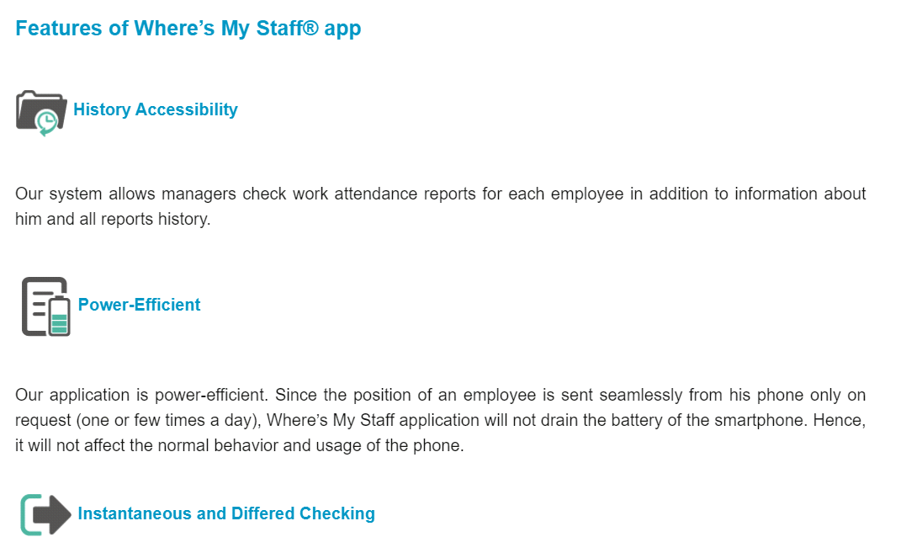

**Figure 1.** Where's my Staff

* 1. **TimeCamp**

TimeCamp is an attendance and absence management application for staff and students.

* **Advantages**

1. Follow up attendance and absence.
2. Attendance stats

* **Disadvantages**

1. Know the locations of halls and offices.
2. Absenteeism and preparation manually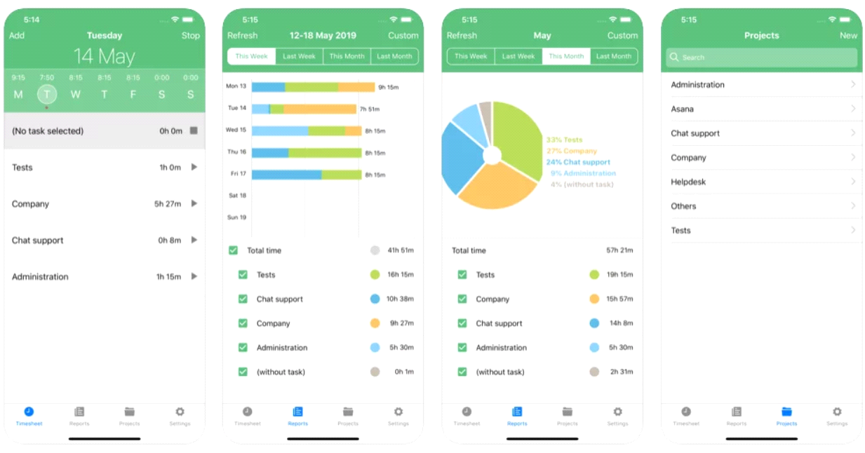.

**Figure 2.** TimeCamp

* 1. **Bonsai**

Bonsai is a tool for employees and company managers to manage and track attendance.

* **Advantages**

1. Easily track attendance.
2. With some customizations can be used as an employee attendance tracker
3. Auto invoice generation
4. Time and attendance tracking capabilities

* **Disadvantages**

1. For companies only.

2. Office places or halls

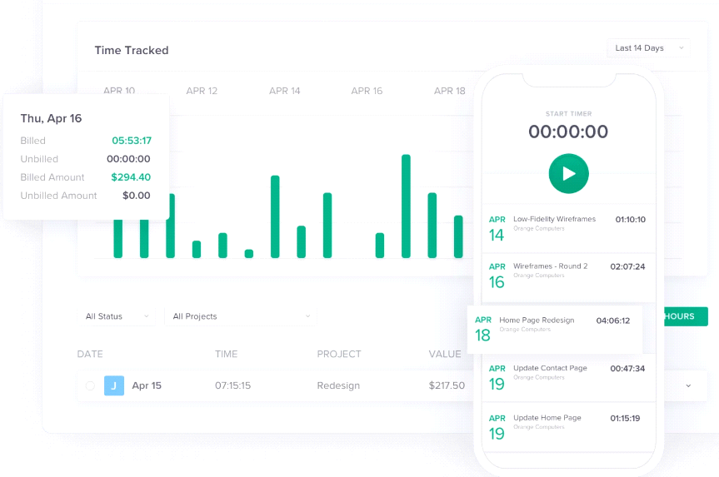

**Figure 3.** Bonsai

* 1. **Odoo**

Attendance management site and attendance statistics for employees and students

* **Advantages**

1. Manage attendance efficiently and simply.
2. Offers ease to manage each & every field force employee attendance.
3. Eliminates the use of paperwork needed for attendance marking and monitoring.
4. Get live field employee attendance details.
5. No need for a heavy system to mark attendance.

* **Disadvantages**

1. staff quarters
2. Hall locations

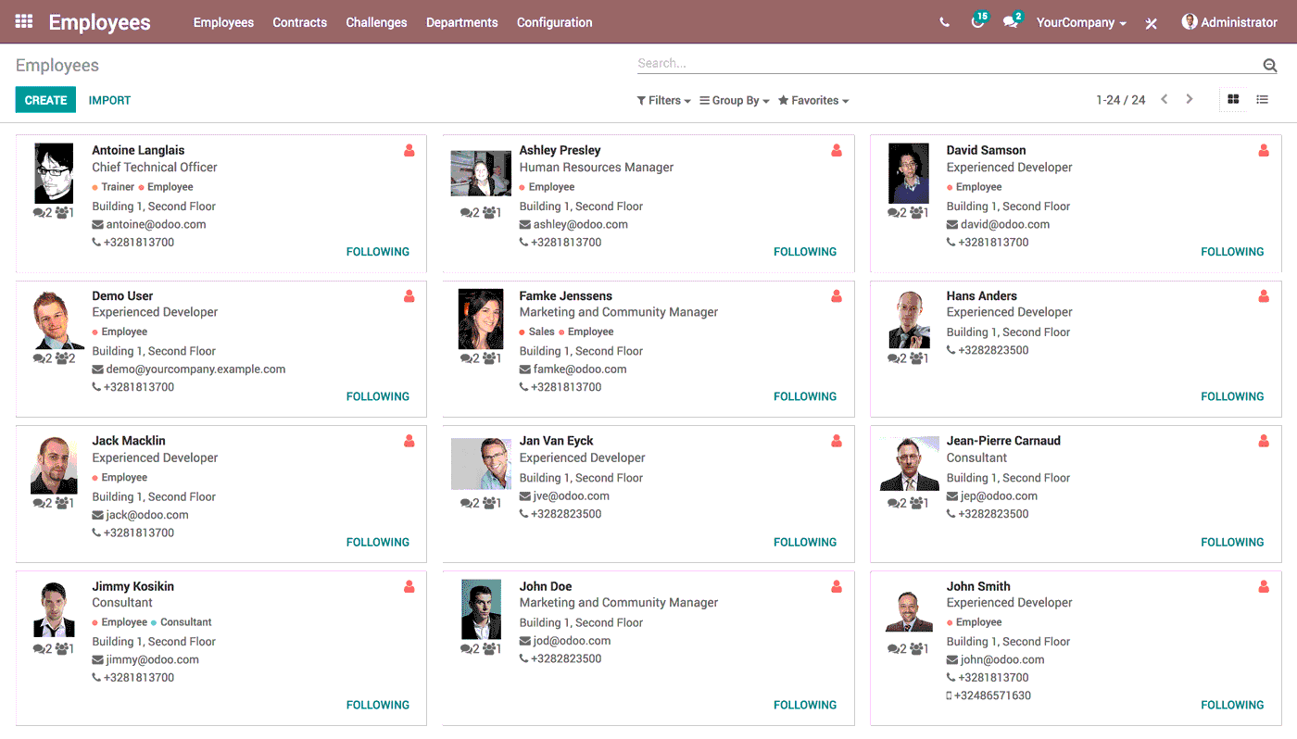

**Figure 4.** Odoo

* 1. **Menaitech**

A site specialized in following up attendance and absence.

* advantages

1. Manage attendance easily and effectively.
2. The Appraisal system is fully featured and covers all needed to evaluate employee performance, merits, and progress.

* disadvantages

1. Adjust attendance times.
2. Office or staff locations.

|  |  |  |  |  |  |
| --- | --- | --- | --- | --- | --- |
| **Features** | **System** | | | | |
| **Where's my Staff** | **TimeCamp** | **Bonsai** | **Odoo** | **Menaitech** |
| **Web platform** | **✅** | **✅** | **✅** | **✅** | **✅** |
| **Free trial** | **❎** | **❎** | **✅** | **✅** | **✅** |
| **stability** | **✅** | **✅** | **✅** | **✅** | **✅** |
| **Arabic language** | **✅** | **❎** | **❎** | **✅** | **✅** |

**Table 1. Comparison with related systems**

1. **Methodology**

Waterfall project management will be used. The waterfall technique is a project management strategy that places a focus on a straight line from the start to the finish of a project. This practice is frequently used by engineers, who are front-loaded to rely on careful planning, thorough documentation, and diligent execution.

The Waterfall process usually includes stages:

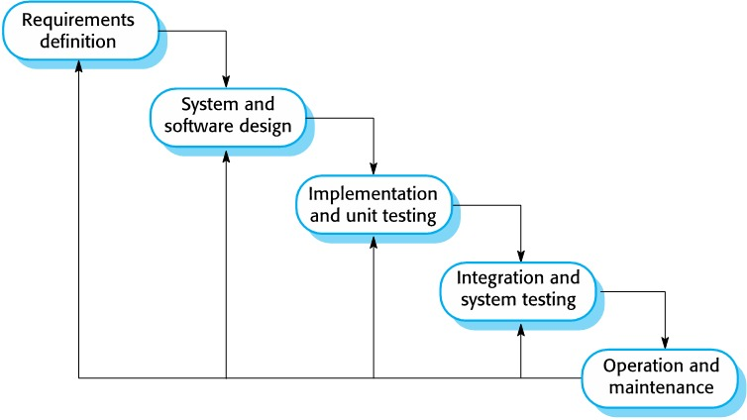

**Figure 5.** Waterfall Model

* 1. **Requirements & Analysis:**

At this stage we think about what we'll need to make the system work, from the hardware to software, at the end we chose to go with Android Studio to build our app, and we have used Java programming language to do it, and for the hardware we choose to go with the beacon technology at first but there was some problem occurs, so we go with NFC Tag.

**ibeacon NFC Tag**

|  |  |  |  |  |
| --- | --- | --- | --- | --- |
| software | hardware | vs | software | hardware |
| for the ibeacon coding it’s only limited to Xcode for IOS users | all the ibeacons devices have their own apps and database |  | the NFC Tag can be run by both android and IOS | The NFC TAG can be bought by anyone and doesn't need special code for it |

**Table2: Ibeacon VS NFC Tag**

**The limitation for convert to NFC Tag:**

1- The students must scan the NFC Tag.

2- The students need to open the app and chose the subject.

3- The phone needs to have NFC enabled.

T**he advantages for converting to NFC Tag:**

1- Can be programed for both IOS and Android.

2- easier connecting to the app.

3- faster reading then Ibeacon.

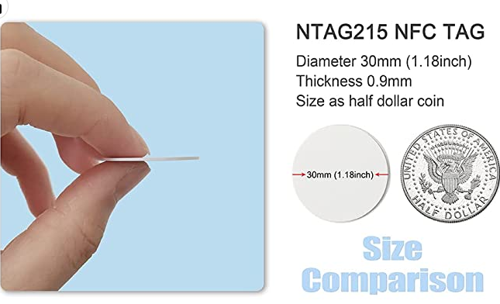

**Figure 6.** NFC Tag

* 1. **Design:**

At this phase, we will use some of the Unified Modeling Languages (UML) in this project because of its great help in the analysis and documentation process. Using the schemes, Sequence Diagram, Activity Diagram.

* + 1. **Use Case Diagram**

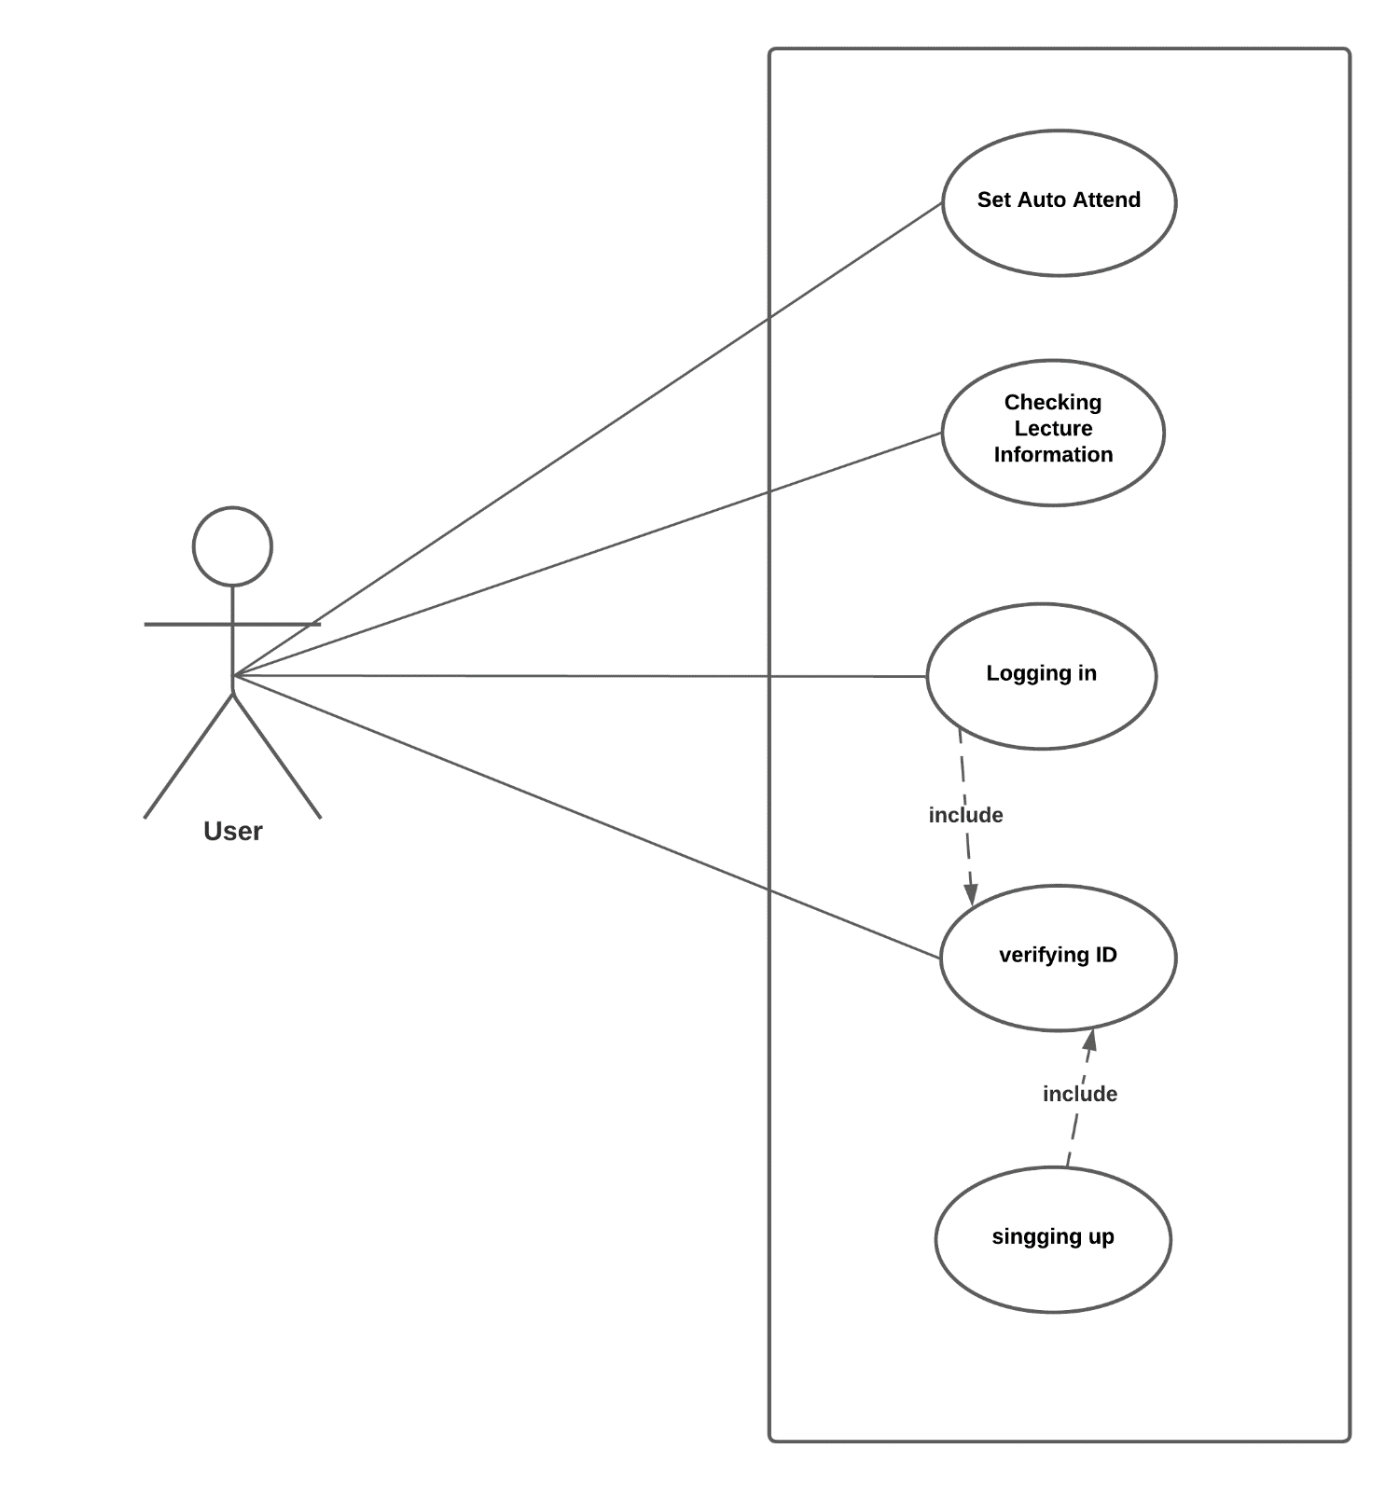

**Figure 7.** use case Diagram.

* + 1. **Sequence Diagram**

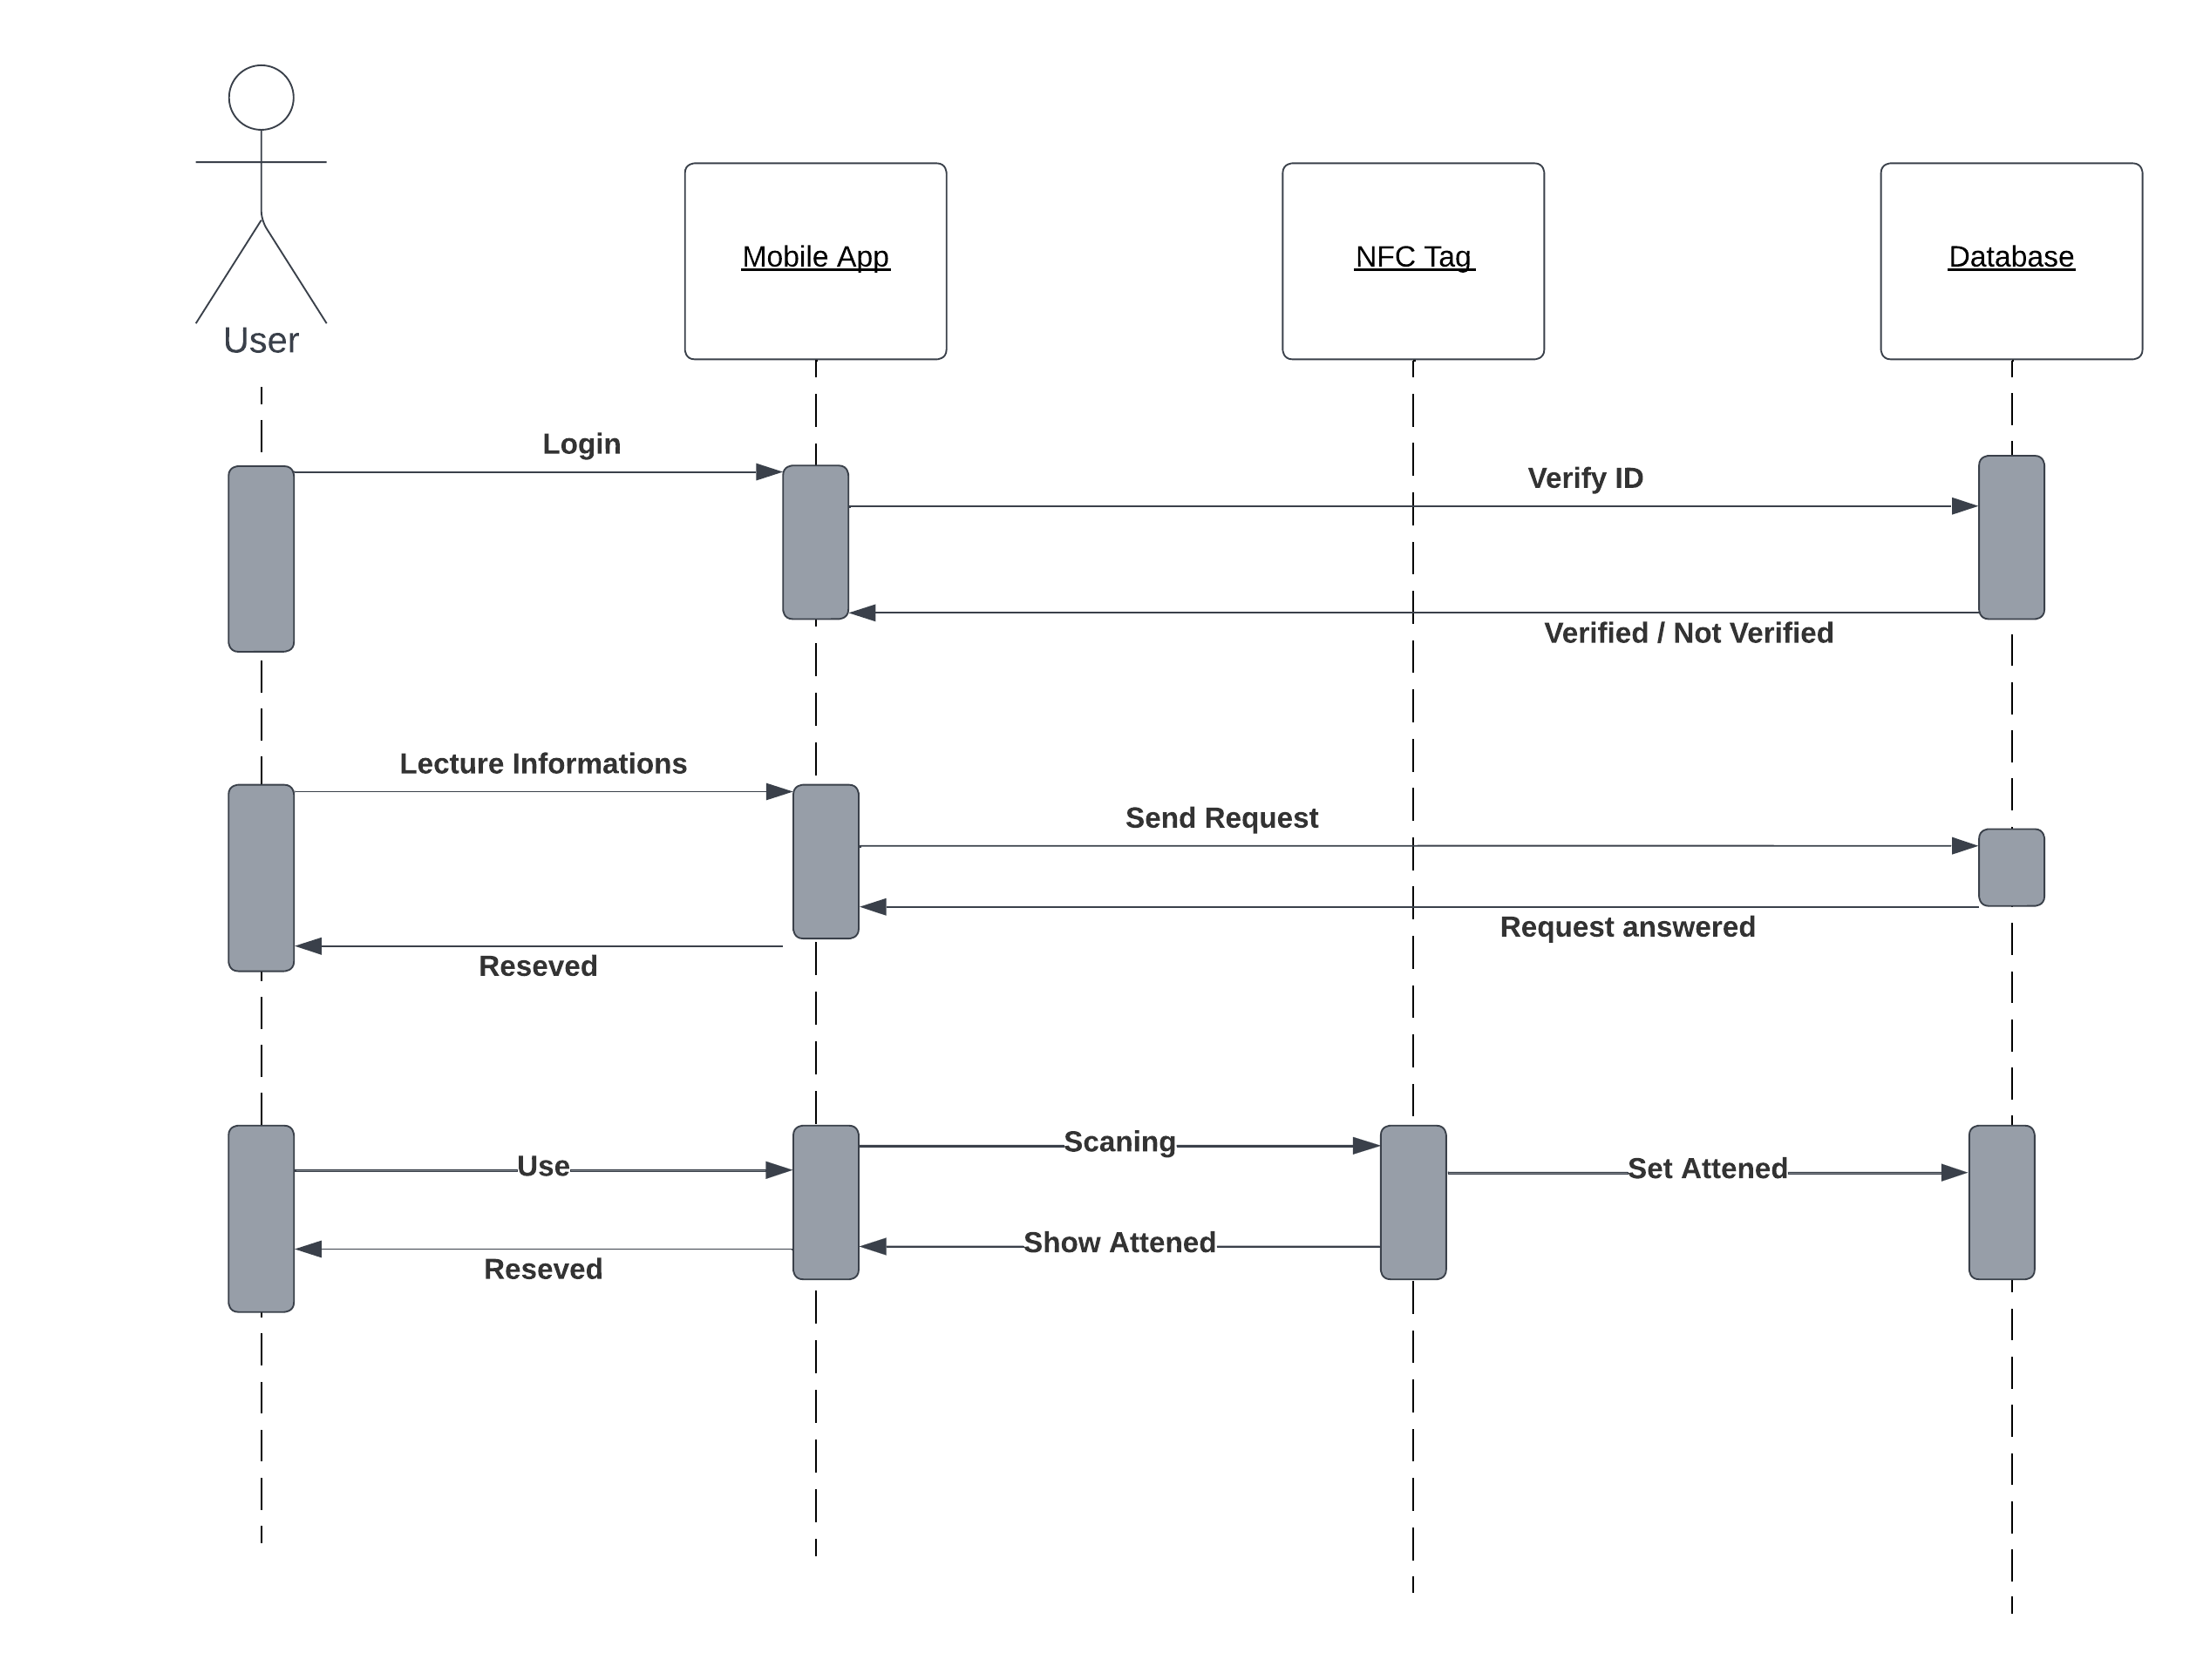

**Figure 8.** Sequence Diagram

* + 1. **Activity Diagram**

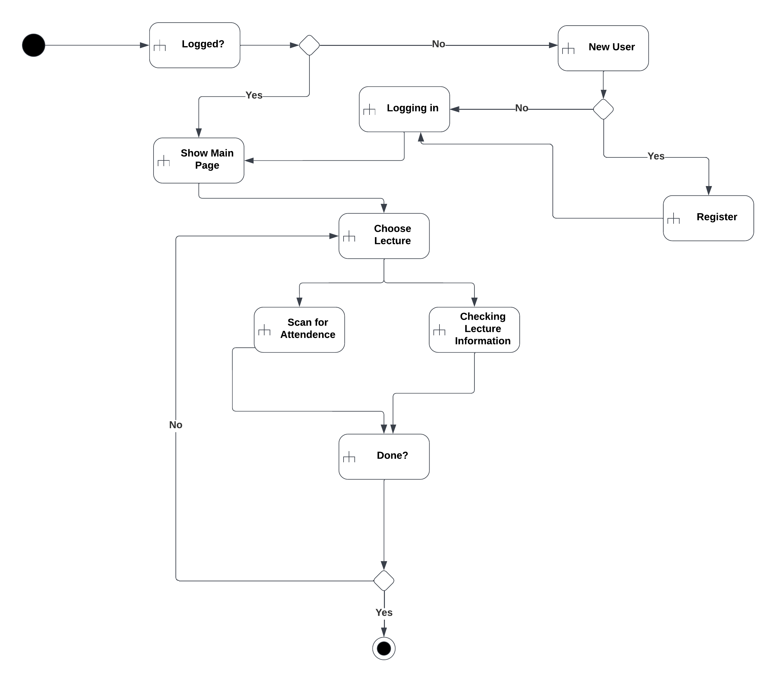

**Figure 9.** Activity Diagram

* + 1. **Entity Relationship Diagrams**

we will present the entire system’s design through a diagram shown in the figure conceptual databases and relationships between objects in the system through the Entity Relationship Diagram (ERD).

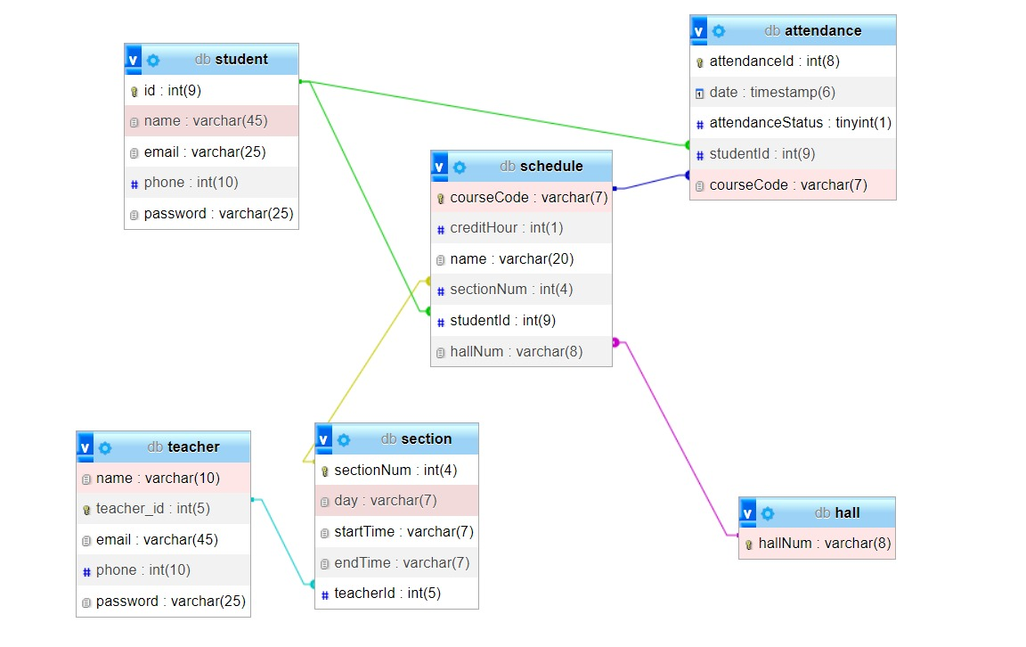

**Figure 10.** ER Diagrams

* + 1. **Data Dictionary Design**

The data dictionary is an inventory of data elements in a database or data model with a detailed description of its format, relationships, meaning, source, and usage [7]. The data dictionary for the project is shown in the tables below.

**Table 3. Attendance**

|  |  |  |
| --- | --- | --- |
| **Attribute** | **Type** | **Key** |
| Attendance_ID | int(8) | PK |
| Date | timestamp |  |
| Attendance_Status | tinyint(1) |  |
| Student_ID | int(9) | FK |
| Course_Code | varchar(7) | FK |

**Table 4. Teacher**

|  |  |  |
| --- | --- | --- |
| **Attribute** | **Type** | **Key** |
| Teacher_ID | Int(5) | PK |
| Name | Varchar(10) |  |
| Email | varchar(45) |  |
| Phone | Int(10) |  |
| Password | Varchar(25) |  |

**Table 5. Student**

|  |  |  |
| --- | --- | --- |
| **Attribute** | **Type** | **Key** |
| Student_ID | Int(9) | PK |
| SName | varchar(45) |  |
| Email | varchar(25) |  |
| Phone_num | Int(10) |  |
| Password | Varcahr(25) |  |

**Table 6. Hall**

|  |  |  |
| --- | --- | --- |
| **Attribute** | **Type** | **Key** |
| Hall_num | Int(5) | PK |

**Table 7. Schedule**

|  |  |  |
| --- | --- | --- |
| **Attribute** | **Type** | **Key** |
| Course_Code | Varchar(7) | PK |
| CreditHour | Int(1) |  |
| Name | varchar(20) |  |
| Section_Num | Int(4) | FK |
| Student_ID | Int(9) | FK |
| Hall_Num | Varchar(8) | FK |

**Table 8. Section**

|  |  |  |
| --- | --- | --- |
| **Attribute** | **Type** | **Key** |
| Section_Num | Int(4) | PK |
| Day | Varchar(7) |  |
| Start_Time | Varchar(7) |  |
| End_Time | Varchar(7) |  |
| Teacher_ID | Int(5) | FK |

**Implementation:**

Now we start to build the system from the database to the app itself. There were some obstacles facing us like, in the database at first, we choose to go with MySQL Workbench, and it's not work with us so we go with Firebase instead, and its work. We start to put a plan and how we'll work, and we divided‏ the team to 3 tasks each have 2 students to handle it.

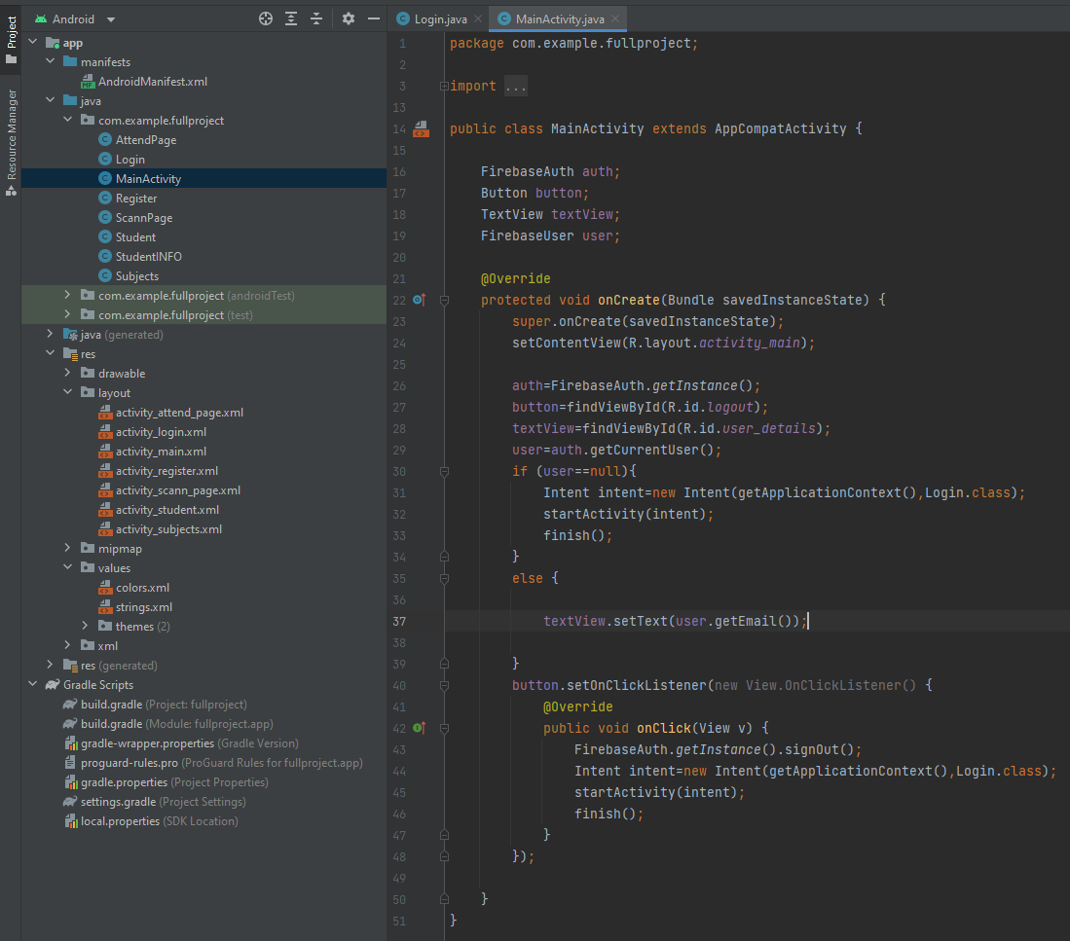

**Figure 5.** someCode we were work on

**Testing:**

We have tested the system to make sure it'll work as expected form it.

**Maintenance:**

The problem that occurs we have tried to fix it.

1. **Result** 
   1. We now can do signing in or logging in to the app as shown:

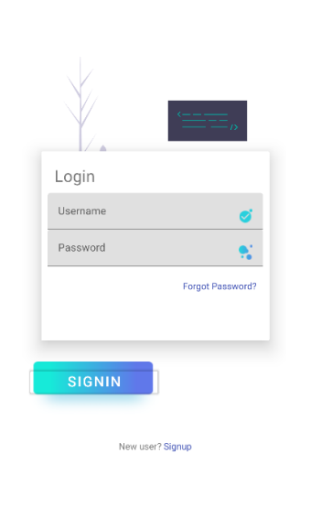

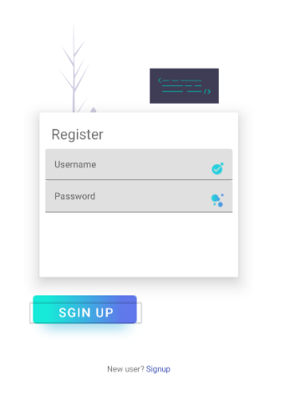

* 1. Also, you can check the subject information as shown:

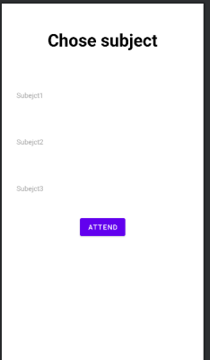

* 1. Here you can attend yourself at this page:

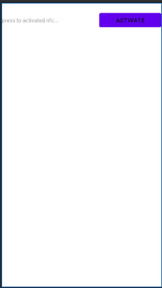 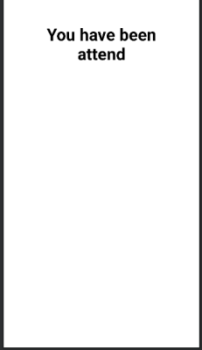

1. **Conclusion**

In conclusion, it's evident that the goal of this project was to enhance the productivity and effectiveness of the teaching and learning process. By developing a system that helps to keep teachers focused on their lectures, it has become easier for them to maximize the time spent on imparting knowledge to students. The implementation of this system has led to an increase in the productivity of both teachers and students.

By freeing up the teacher's time, they can now concentrate solely on their lecture and avoid distractions, leading to a more engaging and productive learning environment. Moreover, the system has provided students with the opportunity to be more productive and proactive in their learning. By eliminating time-consuming and distracting activities, students are now better equipped to absorb knowledge and develop critical thinking skills.

The results of this project demonstrate that by implementing systems that streamline and optimize processes, it's possible to create a more productive and efficient learning environment. This has significant implications for the education sector, and it could serve as a model for other institutions seeking to enhance their teaching and learning processes.

In short, The future looks bright, and we believe that this project will deliver great results and make a significant contribution to the education sector.

1. **References**
2. Where's my staff website 🡪 <https://www.whereismystaff.com/>
3. TimeCamp website 🡪 <https://www.timecamp.com/homepage>
4. Bonsai website 🡪 <https://www.hellobonsai.com>
5. Odoo website 🡪 <https://www.odoo.com/>
6. Adobe Experience Cloud, stages in a Waterfall process.
7. Geekforgeeks website 🡪 <https://www.geeksforgeeks.org/non-functional-requirements-in-software-engineering/>