Christopher McKirgan
Computer A2 Coursework

User Guide

Introduction
Welcome to your custom built chess game user guide! This user guide has been designed for all system users of the Capture King LAN chess system at Bridgwater College’s Chess Club. To help navigate to a specific aspect of the program documentation, please use the table above. Make sure to fully read the documentation before using the program.
Installation and running the program
Capture King does not require installation on the college systems. The program is a portable executable file. This means you can run it without violating the colleges terms and condition sof using their network.
To install first obtain the installation disk entitled “Capture King – a LAN Chess Game (Chess Club BCSU) “ from either the Chess Club President or with Chess Club ID from the ICT officer in the Student Union Office. Please note that the ICT officer is not always present in the office.
Once you have obtained the disk login to your user account on the college system with your login credentials. If you have forgotten your credentials you can obtain your username by simply knowling you own name and date of birth. For example Christopher McKirgan born 19/09/89 would be given the username of MCKIC1909. If you have never logged into the college system your password is “welcome” all in lower casing.
If you have forgotten your password you can obtain a new one by visiting the tech room in room 201 on the second floor of the Derrick Gibson Wing in the central campus building.
Once logged in follow the following steps:
- Insert the CD-ROM shiny side down into the CD/DVD player of the computer
- Navigate to the “start” menu (bottom left of the system) and click it
- Then go to “my computer”
- In my computer right click the CD/DVD ROM drive entitled “Capture King – Chess Club BCSU” and select “explore”
- With this window still open go to “start” and click it
- Select “my documents”; clicking it
- Now going back to the Capture King CD folder
- You will see a folder entitled “Capture King”, drag this into the “My documents” folder.
NOTE: it is important to drag the entire folder whenever moving the program and never move the executable file on its own. Doing so may cease the program to function correctly.
- Installation is complete.
You may now log off the system and return the disk to the BCSU ICT officer, or the Chess Club President.
To then run the program:
- Log into the college system
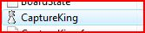
- Click “start””my documents””Capture King”
- Double click “Capture King.exe”
- The program is now running

Where it works


The program is designed to work within the range of a Local area network. Bridgwater College operates under 3 local area networks: loxton campus, central campus and graphics and arts department.
The loxton campus (the new building) is home to beauty theory and philology students, and contains little computer systems, so technicians have placed it on a separate LAN. The graphics ad art department uses a MAC system and has been placed on its own network alongside a MAC technician department. The central campus stretches the entire central buildings, include all three floors of the Derrick Gibson Wing, the Business and Media Block as well as the Hut Build. Both Libraries and freelance computer rooms are also connected to this LAN.

When playing a game in o ne of these LAN zones you will only be matches with players in that zone. To gain the majority of students it would be wise to play with students within the central zone, however, the entire wireless system it broadcast in and around the central building and the signal stretches across other blocks, connecting to this wireless connection will allow you to play with other students in the central zone.
It is important to note the system was designed to be played on the college computer systems and not through the wireless system on laptops. Playing on the wireless system may cause your program to crash or drop-out due to poor connectivity, or because the software has been designed specifically to the college systems.

Welcome Screen

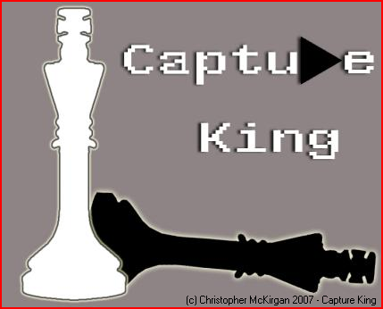
At first you will see a small splash screen which will be present for a few seconds, to skip this simple click it.
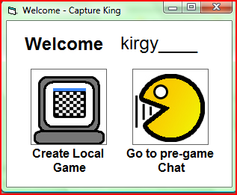
After that the screen below will appear :
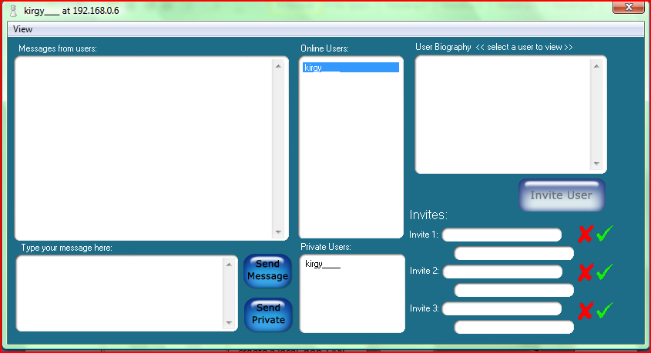
This screen should welcome your username, then you have two options; go to the pre-game chat room, or create a local, non-LAN game for two people playing on the system.
To go to the lobby where other users are chatting and arranging games simply select the “pre-game chat” option by clicking its picture.
You will then be presented with the pregame chat form and the welcome form will disappear. The pre-game chat form (pictured right) is used to commuinicate to other users, send invites and view users stats.
Follow the following sections of this user guide to learn how to operate the features of this form.

Adding/removing private users
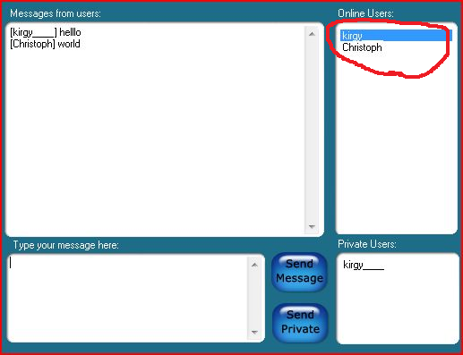
When inside the pre-game chat lobby form it is very easy to select a user to add to the private user list. You simply select the user from the “online user” list – pictures left by double clicking them. Once you have double clicked them they will be added to the private user list shown in the bottom right of the picture to the left.
To remove them from the private user list , again, it is simple. Simply double click the user you wish to remove from the private user list. After which the user will disappear from that list.
Please note, you cannot remove yourself from the private user list.

Sending a message

There are two places which you can send a chat message, either inside the game whilst you play with your opponent, or whilst in the pre-game chat room.
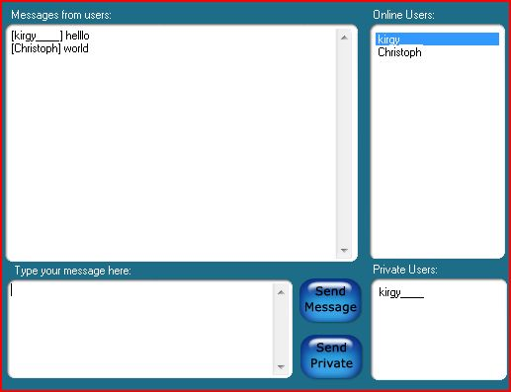
Sending a message in the pre-game chat room
To type a message to send simply type text using your keyboard into the bottom left box pictured to the left, titled “Type your message here:”

Once you have typed your message you can either hit the “enter” key on your keyboard, or select the blue button captioned “Send Message”.
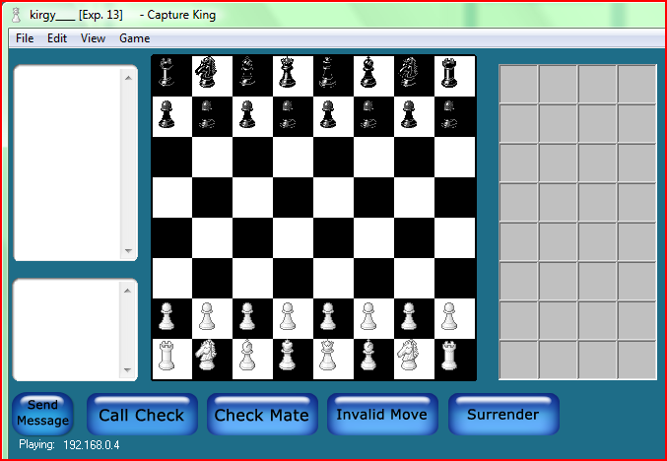
However, if you wish to send a message to only the users in the private list box, you can do so by typing a message in the text box in the bottom left hand corner of the form (and pictured above with the title “type your message here:”) then instead of pressing return you click the button captioned “Send Private”. The users in your private list will be the only ones to receive that message.
To send a message to a player inside a game you type into the lower left text box on the form pictured to the right. You simply type your message into this textbox and either hit “enter” or click the blue button captioned “send message”. The message will then be delivered to the opponent in their game window; you will also see the message appear in the top left hand text box pictured to the right prefixed with your system username.
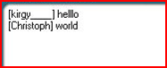
Opponents message will also be prefixed with their username. This is true for both the in-game chat and pre-game chat form chat. The example to the left shows user “kirgy____” chatting with user “christoph”.

Viewing a user’s stats

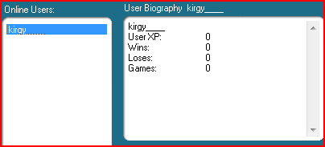
To view another players stats you need to be inside the pre-game chat form. Whilst in the pregame chat form select the username of the user you wish to view the stats of, then click that user’s username in the online user list.
Once the username has been clicked, their stats will appear to the right of that list in the textbox entitled “user biography”. In the pictured example user “kirgy____” is viewing his own stats.

Inviting to a game

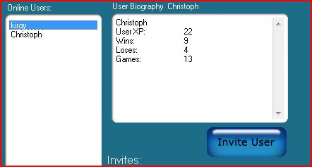
Sending invites
To invite another user to a game you must first navigate yourself to the pre-game chat form. From here you will need to click on their username. Once you’ve click on their username their stats will appear in the “user biography section. As shown on the right. Once you have selected a user, the “invite user” button directly below will light up blue. You may now click the invite user button to send them an invite.
Onc e you have invited a user your invite will appear instaltaniously in their invite list. The other user will either accept or reject the invite. If they do not respond to your invite within 15 seconds it will automaticaly reject. After this time you may have to send another invite.
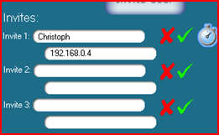
Recieving invites
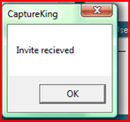
If another user invites you to a game you will receive an invite in you “incoming invites list” pictured to the left. You may receive a maximum of 3 invites at one time. If anyone attempts to send any invites when you invite list is full you will automatically reject that new invite.
When an invite is first received you will be alerted with a message box (pictures right) the invite list will update with the username of that user and IP address. You may also recognise that a “timer” icon has appeared, this indicates that the invite will reject within 15 seconds (invites automatically reject 15 seconds after received to allow room for more invites).
When an invite is in the list, like pictured above, you may either accept the invite or reject it. Rejecting an invite will cause it to be removed from the list. To reject the invite simply click the cross icon next to the invite you wish to reject.
To accept an invite you simply have to click the tick icon next to the invite you wish to accept. Once you have accepted an invite you and your opponent will immediately leave the pre-game chat form and be taken straight into a game. The invitee will be given the role of “white” team, which by convention, takes the first move.

Playing a game
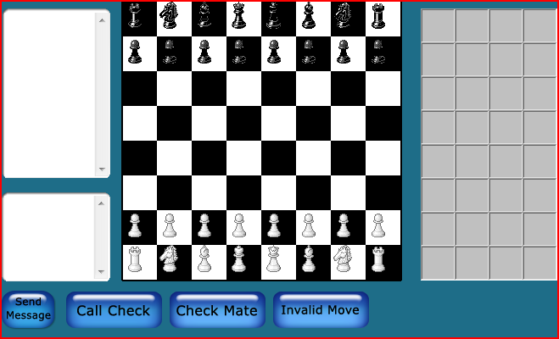
To play a game you must first be invited to a game and accept, or invite someone to a game and they accept. The methods for this are documented in this user guide.
Once you are in a game please notice the in-game chat on the left hand side. You can use this to have casual banter, taunts and jeers or epic final words with your opponent. By convention the white team will go first. By default the white team is assigned to the “invitee” as a gesture of good will.
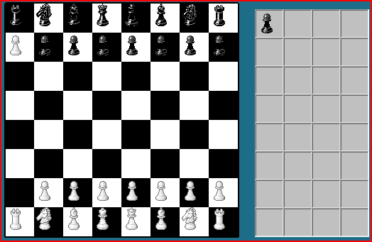
The game is played by simply dragging and dropping pieces on the board to other squares. To take a piece simply drag a piece onto another. Please note: you cannot take you own pieces, any attempts to do so will result in a little warning message and return you piece to its previous position.
Once a piece has been taken you will see that the piece appears in the graveyard to the right of the chess board (pictured right), this is used for visual reference inside the game of pieces taken.
Calling check

All special game requests: Check, check mate and invalid moves are visually recognised by the users playing. If you believe there is a check hit the check button. Your opponent will then receive a message captioned “check has been called”.

Calling checkmate
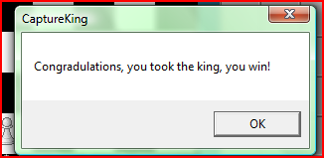
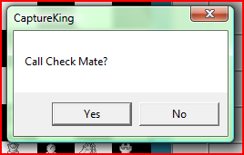
To call checkmate you must first be sure a checkmate is ready to be called. If you are sure simply hit the button captioned “check mate”. Once this button has been hit you will receive the question box pictured to the left asking to confirm. Once confirmed your opponent will receive a similar box asking to confirm. If the opponent confirms you will win the game and receive the message box pictures to the right congratulating this.
If the opponent has not accepted the check mate you should use the in-game chat to commuinicate with them – they may have spotted a move potential that you have not, or maybe though they may have thought a move potential was there but is not.
Calling invalid move

If an invalid move has taken place either by accident from you, or noticably by your opoonent you may call an invalid move. You can do this by clickin the “call invalid move button” located under the game board. Your opponent will then be asked to confirm this, if they confirm any previous move will be undone.

Levelling system

The levelling system was designed to help ensure that you, as a chess player are able to match yourself against someone of equal experience as yourself. You can do this by viewing the stats of a player (clicking their username, see section in this user guide).
The levelling system is an automatic process achieved at the end of a game after checkmate has been called. If you wish to increase you user level, also known as XP; shortened for experience, you must play more games. The below table shows the XP earned for different game ending:
Playing a game to the end | 1 XP
Losing a game | 0 XP
Winning a game | 1 XP

As you can see winning a game will give you a total of 2XP, whereas losing will give you a total of 1XP.

Customising the board

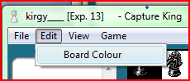
The chess game gives the option to change the colours of the chess board, to do so you first have to be in an active game. To customise the chess board colours follow the following steps:
- On the game form, select “edit” from the drop-down menu at the top
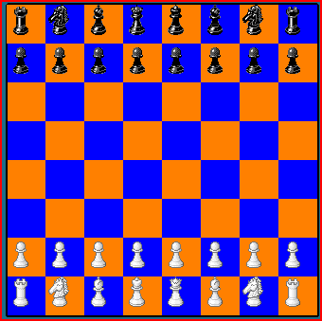
- From there select “board colour“
- You will then see a colour dialogue box (pictures right) select a colour from this box then click “ok”. After you will be asked to select a second colour, select a colour then select “ok” again.
- The board colours will now change to the colours that you have selected. On the example to the right the user has customised the colours to oragne and blue.

Troubleshooting

Here you can find information on problems that may be caused in the system, and solutions for them.
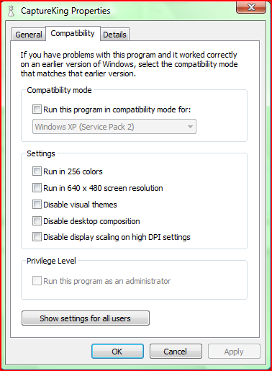
When I run the game on my laptop it doesn’t work
The game was specifically designed for the desktop window XP based system at the college, although most XP systems with the winsock control installed will run the program, it cannot be guaranteed to work on your laptop, however there are some solution’s
If you are running windows vista, before clicking to run the program first right click the program, select “properties” and then select “compatibility tab” (pictured left) you will then need to select the option “run this program in compatibility for windows XP (service pack 2)”.
If the program fails to run still or it fails to run in XP please contact your computer provider or a qualified technician as you may have the “winsock” control missing from your system.
When I run the program on the college system it doesn’t work, i get an error “input past end of file”
You have not installed the program correctly, or you have moved the location of the program from where it was before without moving the whole folder on its own. Please refer to installation for more information.
When I run the program I receive the error “port already in use”
This has occurred because an event of the program is already running, check your windows task bar for a minimized version of the program.
When I try and play with my friends in the college on the game they don’t appear in the online user list
This is because your friends are playing on a different LAN zone. Refer to “where it can be played” at the beginning of the user guide.

