**Muhammad Hadi**

**25244**

**ROBERTA-BASE:-**Parameters: -

    output_dir="test_trainer",

    evaluation_strategy="epoch",

    logging_strategy="epoch",

    save_strategy="epoch",

    num_train_epochs=3,  # Example number of epochs

    per_device_train_batch_size=8,  # Example batch size

    per_device_eval_batch_size=8,  # Example batch size

    logging_dir='./logs',  # Directory for storing logs

    logging_steps=500,  # Log every 500 steps

    save_total_limit=2,  # Example number of checkpoints to save

    load_best_model_at_end=True,  # Load the best model at the end of training

Output :-

Parameters: -

training_args = TrainingArguments(

    output_dir="test_trainer",

    evaluation_strategy="epoch",

    logging_strategy="epoch",

    save_strategy="epoch",

    num_train_epochs=5,  # Example number of epochs

    per_device_train_batch_size=16,  # Example batch size

    per_device_eval_batch_size=16,  # Example batch size

    logging_dir='./logs',  # Directory for storing logs

    logging_steps=500,  # Log every 500 steps

    save_total_limit=2,  # Example number of checkpoints to save

    load_best_model_at_end=True,  # Load the best model at the end of training

)

Output :-

Parameters:-

training_args = TrainingArguments(

    output_dir="test_trainer",

    evaluation_strategy="epoch",

    logging_strategy="epoch",

    save_strategy="epoch",

    num_train_epochs=5,  # Example number of epochs

    per_device_train_batch_size=8,  # Example batch size

    per_device_eval_batch_size=8,  # Example batch size

    logging_dir='./logs',  # Directory for storing logs

    logging_steps=500,  # Log every 500 steps

    save_total_limit=2,  # Example number of checkpoints to save

    load_best_model_at_end=True,  # Load the best model at the end of training

)

Output :-

Parameters :-

training_args = TrainingArguments(

    output_dir="test_trainer",

    evaluation_strategy="epoch",

    logging_strategy="epoch",

    save_strategy="epoch",

    num_train_epochs=7,  # Example number of epochs

    per_device_train_batch_size=8,  # Example batch size

    per_device_eval_batch_size=8,  # Example batch size

    logging_dir='./logs',  # Directory for storing logs

    logging_steps=500,  # Log every 500 steps

    save_total_limit=2,  # Example number of checkpoints to save

    load_best_model_at_end=True,

)

Output :-

**DISTILBERT :-**

Parameters :-

training_args = TrainingArguments(

    output_dir="test_trainer",

    evaluation_strategy="epoch",

    logging_strategy="epoch",

    save_strategy="epoch",

    num_train_epochs=7,  # Example number of epochs

    per_device_train_batch_size=8,  # Example batch size

    per_device_eval_batch_size=8,  # Example batch size

    logging_dir='./logs',  # Directory for storing logs

    logging_steps=500,  # Log every 500 steps

    save_total_limit=2,  # Example number of checkpoints to save

    load_best_model_at_end=True,  # Load the best model at the end of training

)

Output :-

Parameters :-

training_args = TrainingArguments(

    output_dir="test_trainer",

    evaluation_strategy="epoch",

    logging_strategy="epoch",

    save_strategy="epoch",

    num_train_epochs=7,  # Example number of epochs

    per_device_train_batch_size=8,  # Example batch size

    per_device_eval_batch_size=8,  # Example batch size

    logging_dir='./logs',  # Directory for storing logs

    logging_steps=500,  # Log every 500 steps

    save_total_limit=2,  # Example number of checkpoints to save

    load_best_model_at_end=True,  # Load the best model at the end of training

)

Output :-

Parameters :-

training_args = TrainingArguments(

    output_dir="test_trainer",

    evaluation_strategy="epoch",

    logging_strategy="epoch",

    save_strategy="epoch",

    num_train_epochs=7,  # Example number of epochs

    per_device_train_batch_size=8,  # Example batch size

    per_device_eval_batch_size=8,  # Example batch size

    logging_dir='./logs',  # Directory for storing logs

    logging_steps=500,  # Log every 500 steps

    save_total_limit=2,  # Example number of checkpoints to save

    load_best_model_at_end=True,  # Load the best model at the end of training

)

# Trainer

trainer = Trainer(

    model=model,

    args=training_args,

    train_dataset=train_dataset,

    eval_dataset=test_dataset,

    compute_metrics=compute_metrics,

    optimizers=(optimizer, None),

)

Output :-

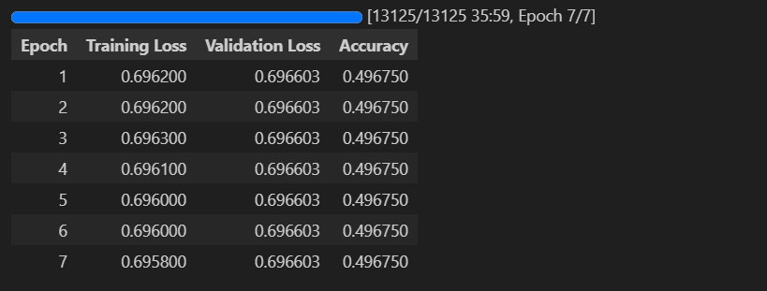

**GPT-2:-** Slowest to train and finetune but the best performance only trained a single epoch in an hour to achieve the accuracy of 0.92.

Parameters:-

training_args = TrainingArguments(

output_dir='./results',

num_train_epochs=1,

per_device_train_batch_size=5,

per_device_eval_batch_size=5,

logging_dir='./logs',

logging_steps=500,

evaluation_strategy="epoch",

save_steps=500,

overwrite_output_dir=True

)

from transformers import Trainer

trainer = Trainer(

model=gpt2_model,

args=training_args,

train_dataset=train_dataset,

eval_dataset=test_dataset,

compute_metrics=compute_metrics

)

Output:- 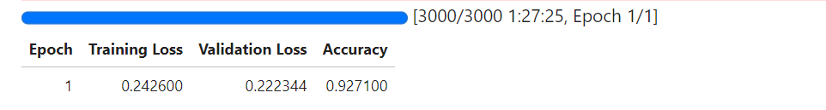

**Took around 15-20 minutes for the training of 3 epochs and batch size of 8. Did not really note the time of rest of the trainings as it was taking too long but can take an idea from the 3-epoch model. I did training simultaneously on both Kaggle and colab and managed to complete it within a day.**