MRIO Analysis

MRIO Analysis for GHG, Land, and Water Indicators
This document provides a step-by-step explanation of how to conduct Multi-Regional Input-Output (MRIO) analysis focused on three key environmental indicators: Greenhouse Gas Emissions (GHG), Land Use, and Water Use. The analysis uses EXIOBASE-style MRIO data stored in Zarr format and restricts attention to 25 food-related sectors across multiple regions.

1. MRIO Data with D matrix results
An MRIO model links producers and consumers across multiple regions and sectors, capturing both economic transactions and environmental impacts. The environmental extension matrix D is a 3D tensor with dimensions:
- Environmental indicators (f)
- Producers (region × sector)
- Consumers (region × sector × product)
For this study, we reshape D into a 6D tensor:
E(r, s, r’, s’, p, f), where:
r = producing region
s = producing sector
r’ = consuming region
s’ = consuming sector
p = product/final demand category
f = environmental indicator

2. Idea: Selection of Indicators
The dataset contains 19 environmental indicators. Since not all are relevant to food system sustainability, we focus on three key categories:
- GHG (climate change impact)
- Land (hectares of land used)
- Water (m³ of water used)
To do this, we identify the indices of the three indicators from the metadata (environmental_indicator array) and extract a smaller sub-matrix containing only these three.

3. Idea: Restricting to Food Sectors
From the 163 sectors available, we select 25 food-related sectors including crop cultivation, livestock farming, fishing, and food processing. Only flows originating in these sectors are considered. Producer indices are constructed as (region × number of sectors + sector index).

4. Idea: Building Food-Specific Dataset
For each selected indicator, we loop over food-sector producers and collect flows to all consuming regions, sectors, and products. The result is a tidy DataFrame with columns:
- Producer region, Producer sector
- Consumer region, Consumer sector, Consumer product
- Indicator (GHG, Land, Water)
- Value (impact magnitude)
This dataset allows filtering, aggregation, and visualization of environmental impacts across producer-consumer relationships.

5. Idea: Aggregation and Insights
Based on D matrix results (Impact: it multiplied T matrix already):
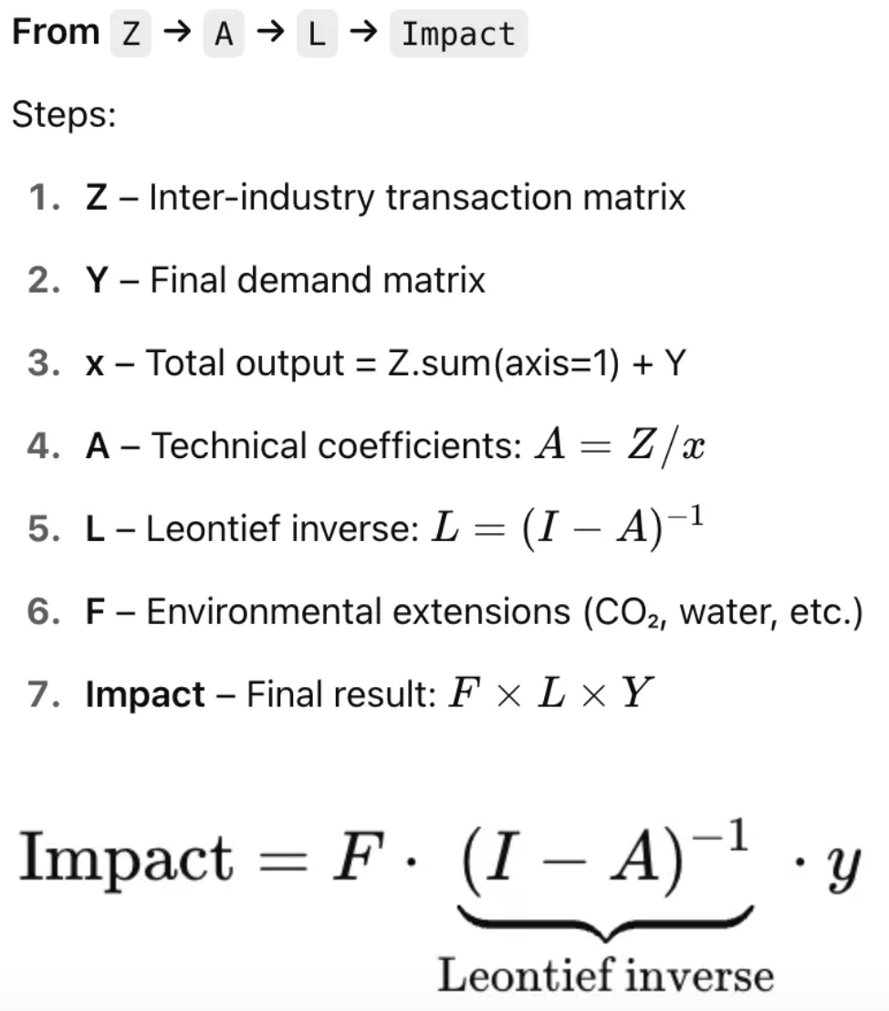
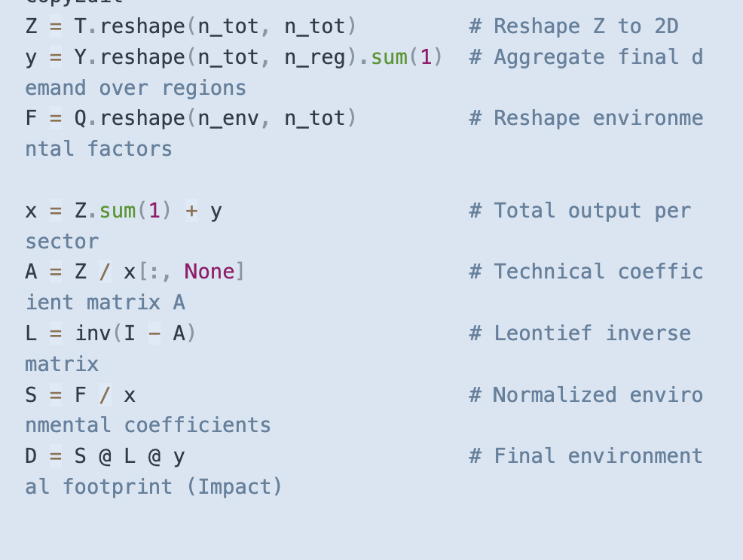
Once the tidy DataFrame is built, impacts can be summarized in several useful ways:
- Total GHG/Land/Water use per food sector.
- Footprint per consuming region.
- Trade-related environmental flows between producer and consumer regions.
These summaries reveal which sectors and regions drive the largest impacts, and how consumption patterns in one region depend on resource use in others.

