**www.tmasolutions.com**

9

**www.tmasolutions.com**

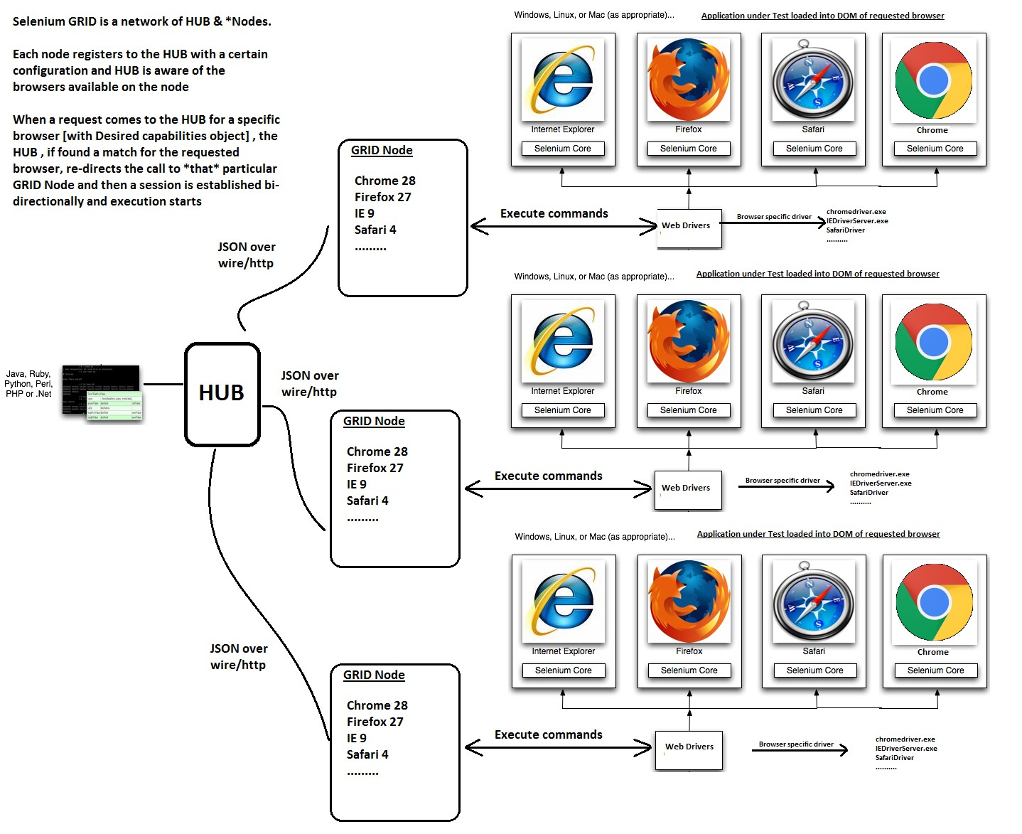

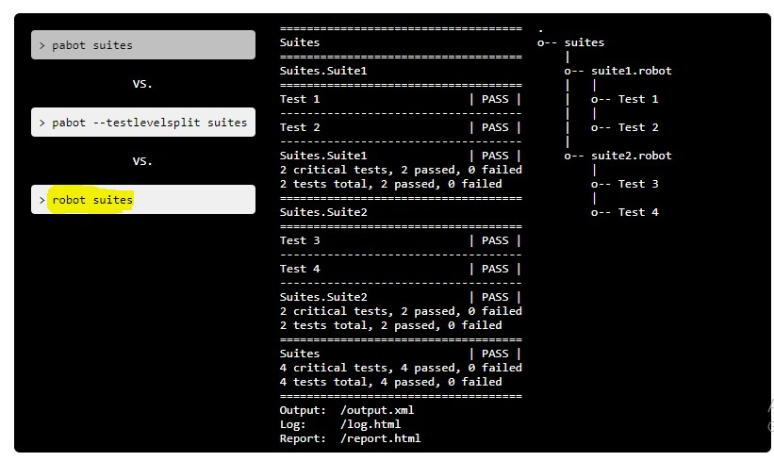

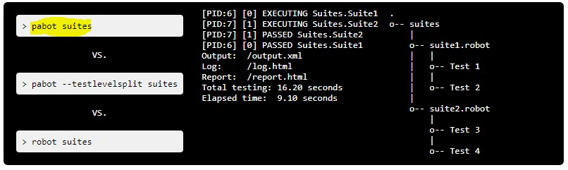

5

8

**Jenkins**

**Robot**

**Framework**

**Selenium**

**grid**

**Jira**

**BitBucket**

**Jenkins**

**X**

**-**

**ray**

**Framework**

**Source Control**

**CI tool**

**Remote Env**

**Tracking tool**

**Slack**

**Notification**

**Developer**

**Web App**

[**.**](https://medium.com/@austin.johnson/triggering-jenkins-from-a-push-to-a-specific-branch-bitbucket-6effecb4b451#:~:text=In%20order%20to%20set%20this,the%20%E2%80%9CBuild%20Triggers%E2%80%9D%20section)

8

**www.tmasolutions.com**

**Jenkins**

**Robot**

**Framework**

**Selenium**

**grid**

**Jira**

**BitBucket**

**Jenkins**

**X**

**-**

**ray**

**Framework**

**Source Control**

**CI tool**

**Remote Env**

**Tracking tool**

**Slack**

**Notification**

**Developer**

**Web App**

7

8

**Jenkins**

**Robot**

**Framework**

**Selenium**

**grid**

**Jira**

**BitBucket**

**Jenkins**

**X**

**-**

**ray**

**Framework**

**Source Control**

**CI tool**

**Remote Env**

**Tracking tool**

**Slack**

**Notification**

**Developer**

**Web App**