MACAO POLYTECHNIC UNIVERSITY
CSAI3121 – Machine Learning and Intelligent Data Analysis
Academic year 2026/2027 · Semester 1

Next-Day Weather Prediction for Macau with Machine Learning
Maximum and minimum temperature and weather condition for the following day

Field | Value
Group | (fill in the group number)
Members | Thiago Honorato Ferreira (P262742-1) · Marcelo Oliveira (P262739-4) · João Vitor Konrad (P262740-2)
Submission date | 11 November 2026

All results are produced by notebooks/weather_prediction_macau.ipynb (Open-Meteo/ERA5 data, random seed 42).

1. Executive Summary
This project builds a machine-learning system that predicts, for Macau, tomorrow's maximum and minimum air temperature and tomorrow's weather condition (clear, partly cloudy, cloudy or rain). The system misses the maximum temperature by 1.22 °C on average and the minimum by 0.99 °C, which is 19% and 11% less error than the simple rule "tomorrow will be like today". Both improvements are statistically significant.
Short-range forecasts guide everyday decisions in schools, energy supply, health services and outdoor events. Because tomorrow's temperature is usually close to today's, a model is only useful if it clearly beats that simple rule, and this is the benchmark used throughout the project.
The Visual Crossing file suggested in the specification turned out to contain only 15 days, and those days were a forecast rather than observed history, so it could not be used. Instead, twelve years of daily data for Macau (2014–2025, 4383 days) were taken from the public Open-Meteo service and converted to the same format. The models learned from 2014–2021, were selected on 2022–2023 and were evaluated once on 2024–2025.
The gain in temperature accuracy is largest in winter, when cold fronts can drop the temperature sharply from one day to the next; there, the error for the maximum falls from 1.91 °C to 1.43 °C. For the weather condition, the system answers the question "will it rain tomorrow?" correctly on four days out of five and provides a rain probability that is 37% more accurate than the historical average. In the four-category prediction, however, its advantage over the simple rule is small and not statistically supported.
The system looks at a single point on the map, so it cannot see typhoons or fronts approaching from elsewhere, and it tends to smooth extreme values. It can support planning but does not replace the official warnings of the Macao Meteorological and Geophysical Bureau (SMG). The main lesson is that the gains came from representing the memory and seasonality of the weather well, rather than from complex algorithms.

2. Problem Definition and Dataset

2.1 Problem description
The project addresses two prediction tasks with a one-day horizon (t+1). In both, only information available at the end of day t may be used, exactly as in a real forecast.
Task | Type | Target | Main metric
1 | Regression | Tomorrow's maximum and minimum temperature (°C), one model each | MAE
2 | Classification | Tomorrow's condition: Clear, Partly Cloudy, Cloudy or Rain | Macro F1

From a machine-learning perspective the problem is interesting because weather combines two structures that tabular models do not capture on their own: memory, since today's state conditions tomorrow's, and cycles, since the seasons repeat every year. The challenge is to turn a time series into features that a supervised model can use without ever seeing the future.
Four objectives were set: to beat persistence ("tomorrow equals today") in both tasks; to use strictly chronological validation with no information leakage; to test whether observed differences are statistically significant and practically relevant; and to deliver reproducible code that runs end to end without manual intervention.

2.2 Dataset
The specification recommends the Visual Crossing Weather Query Builder. The file obtained from it (macao_teacher_data.csv) was audited before any modelling. It contained 15 records, from 11 to 25 October 2026, in US units: the current day followed by 14 future dates. It is the default 15-day forecast shown by the service, not historical data. Since the project requires at least 3000 days of history, the file was used only as a format reference.
Data were instead obtained from the Open-Meteo Historical Weather API, which serves the ERA5 reanalysis of the European Centre for Medium-Range Weather Forecasts free of charge (Hersbach et al., 2020). A reanalysis assimilates observations from stations, satellites and radiosondes into a physical model and produces a continuous, gap-free estimate of the state of the atmosphere. The raw download was stored unchanged in data/macao_openmeteo.csv and then mapped to the Visual Crossing column schema, which makes the code independent of the data source.
Item | Value
Location | Macau (lat 22.20, lon 113.54), time zone Asia/Macau
Period | 1 January 2014 to 31 December 2025, daily and continuous
Records | 4383 days (minimum required: 3000)
Raw variables | 15 numeric + 1 text label (conditions)
Engineered features | 76
Targets | target_tmax, target_tmin (°C) and target_cond (4 classes)

The 15 numeric variables are the maximum, minimum and mean temperature; the maximum and minimum apparent temperature; dew point; relative humidity; precipitation; the share of the day with precipitation; maximum wind speed; maximum gust; wind direction; sea-level pressure; cloud cover; and solar energy.
The specification requires an explicit mapping from the original condition labels to a small set of classes. Because ERA5 has no text label, one was built from physical rules and then mapped with priority given to precipitation, the condition that matters most for practical decisions.
Rule | Class | Days | Share
Precipitation ≥ 1 mm (WMO definition of a rain day) | Rain | 2104 | 48%
No rain; cloud cover between 30% and 70% | Partly Cloudy | 909 | 21%
No rain; cloud cover ≥ 70% | Cloudy | 687 | 16%
No rain; cloud cover < 30% | Clear | 683 | 16%

The 1 mm threshold prevents negligible drizzle from counting as rain, and the cloud thresholds roughly follow the okta scale used in surface observation.

3. Data Preparation, Feature Engineering and EDA

3.1 Data quality
Before modelling, the data were audited with physical rules defined by type of variable rather than with a hand-written range for each column. This is more general and easier to justify: precipitation, wind, cloud cover, pressure, solar energy and humidity cannot be negative; percentages cannot exceed 100%; wind direction cannot exceed 360°; and the daily mean temperature must lie between the minimum and the maximum. Duplicated dates, missing dates and missing values were also counted.
Every rule returned zero violations, so no cleaning step was implemented; a cleaning function that removes nothing would only add complexity. An assertion stops the notebook instead if a problem ever appears, for example with a different data source.
Using a 3×IQR criterion, 324 extreme values were found in precipitation and 23 in wind gusts, and none in temperature or pressure. In meteorology extremes are usually real, so they were investigated rather than removed. The five windiest days coincide with typhoons that hit Macau: Mangkhut (16 September 2018, 173 km/h), Hato (23 August 2017), Ragasa (24 September 2025), Saola (2 September 2023) and Wipha (20 July 2025), each with falling pressure and more than 60 mm of rain. These records were kept: they are legitimate events, tree-based models are robust to them, and in the linear models standardisation and regularisation limit their influence.

3.2 Feature engineering
The guiding principle was the absence of leakage. To predict day t+1, every feature uses only days t, t−1, t−2 and earlier, and the targets are shifted into the future. An automatic test confirms that each row's target equals the next day's temperature in 100% of cases and that no feature reproduces the target (the highest absolute correlation is 0.939).
Group | Examples | Rationale
Today's values (14) | tempmax, humidity, cloudcover | the current state is the best single predictor of tomorrow
Lags (20) | tempmax_lag1, humidity_lag2 | capture whether conditions are warming, cooling, drying or moistening
Differences (5) | tempmax_diff1, pressure_diff3 | short-term tendency; pressure changes accompany fronts and rain systems
Rolling statistics (24) | tempmax_roll7, temp_std7, rain_days7 | smooth daily noise and describe the recent regime
Physical (3) | temp_range, dewpoint_dep, temp_anomaly30 | a small dew-point depression signals saturated air; the anomaly flags an unusual air mass
Seasonality (4) | doy_sin, doy_cos, month_sin, month_cos | cyclical encoding makes 31 December and 1 January neighbours
Wind direction (2) | winddir_sin, winddir_cos | 359° and 1° are almost the same direction
Today's class (4) | today_Rain, today_Clear | persistence of the weather type, one-hot encoded so that no order is imposed

Scale-sensitive models (linear models, KNN and SVM) receive a StandardScaler inside a pipeline, fitted only on the training data of each step; tree-based models are used without scaling. The day of the week was examined and discarded, because the mean maximum temperature varies by less than 0.2 °C across days, which is noise with an obvious physical explanation. Hour of day does not apply to daily data.

3.3 Exploratory data analysis
Four findings from the exploratory analysis shaped the modelling. The first is a strong seasonal cycle: the median maximum temperature rises from about 20 °C in January to 31 °C in July, and rain dominates from May to September, when more than 69% of days are wet (Figure 1). Clear and Partly Cloudy prevail in winter. This justifies the cyclical day-of-year and month features.
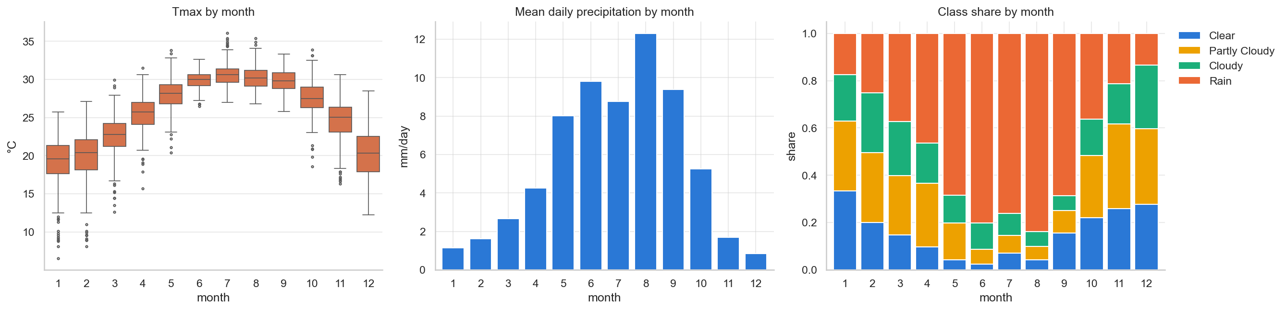
Figure 1 – Maximum temperature by month, mean daily precipitation and class shares by month (2014–2025).
The second is the strong memory of temperature. The correlation between today's and tomorrow's maximum temperature is 0.93 and decays slowly with the lag (Figure 2), so persistence is a demanding benchmark. Rainfall has much weaker autocorrelation, which anticipates that classification will be harder than regression.
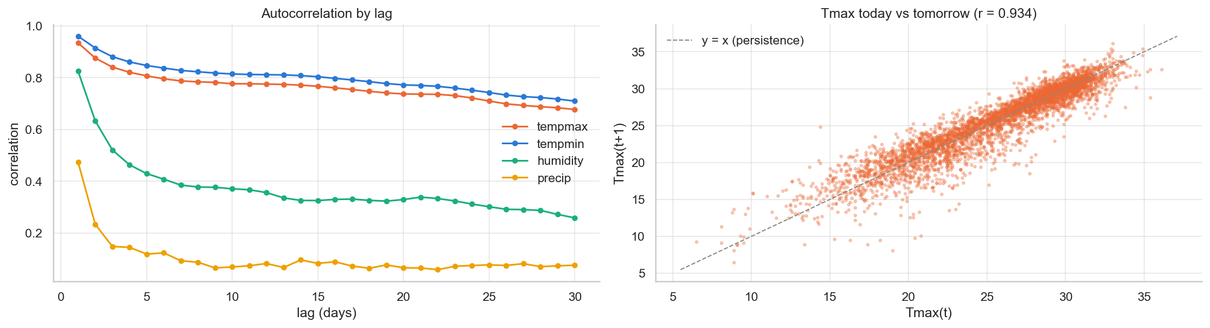
Figure 2 – Autocorrelation by lag (left) and today's maximum temperature against tomorrow's (right).
The third is class imbalance. Rain accounts for 48% of days, and always predicting Rain already yields about 49% accuracy, so accuracy alone is misleading. Macro F1 is therefore the main classification metric, and the models that support it are trained with balanced class weights.
The fourth concerns physical relationships. Today's pressure is negatively correlated with tomorrow's temperature (r = −0.81 for the maximum), reflecting cold, dry winter air masses. Days followed by rain have a mean humidity of 85.5% and a mean pressure of 1009 hPa, against 73% and 1017 hPa for days followed by clear skies. Temperatures, apparent temperatures and dew point are strongly collinear, which calls for regularisation in the linear models.

4. Model Development

4.1 Protocol and baselines
Random splits are unsuitable for time series because they let a model train on the future and be evaluated on the past, which produces optimistic scores. The data were split into chronological blocks defined by the target date, so that no label from a later period is used to fit a model evaluated on an earlier one.
Set | Target period | Rows | Use
Train | 31 Jan 2014 to 31 Dec 2021 | 2892 | model fitting and grid search
Validation | 2022 to 2023 | 730 | model comparison and selection
Test | 2024 to 2025 | 731 | single final evaluation

Validation and test each cover two full years, including all seasons and two typhoon seasons. The training set starts on 31 January 2014 because the first 29 days lack enough history for the 30-day anomaly feature.
For regression, persistence (tomorrow's temperature equals today's) is the official baseline, and climatology (the training mean for the same day of the year, smoothed over 15 days) is an additional reference that measures how much is gained by looking at the current state rather than only at the calendar. For classification, the official baseline is the majority class (always Rain), while persistence of the condition (tomorrow looks like today) is a far more demanding reference.

4.2 Machine learning models
Since it cannot be known in advance which family of algorithms suits these data best, nine regressors and eight classifiers from different families were compared, all with standard initial hyperparameters.
Family | Regression | Classification | Reason for inclusion
Linear | Linear regression, Ridge (L2), Lasso (L1) | Logistic regression | approximately linear relationships; regularisation handles correlated inputs
Neighbours | KNN | KNN | predicts from the past days most similar to today
Kernel | SVR (RBF) | SVC (RBF) | captures smooth non-linear relationships
Probabilistic | – | Gaussian naive Bayes | simple reference that assumes independent features
Bagged trees | Random forest, extra trees | Random forest, extra trees | capture interactions and non-linearity; robust to outliers
Boosting | Gradient boosting, histogram gradient boosting | Gradient boosting, histogram gradient boosting | sequential trees that correct earlier errors; often strongest on tabular data

One regression model was trained per target because the physical drivers differ: the maximum depends more on sunshine and cloud during the following day, the minimum on humidity and the air mass present overnight. For classification, balanced class weights raise the cost of errors on the rarer classes without creating synthetic samples; KNN, naive Bayes and gradient boosting do not offer this option.

4.3 Hyperparameter tuning
The best model of each task on validation was tuned with GridSearchCV, which evaluates every combination of a grid, using cross-validation over five time-ordered folds (TimeSeriesSplit with a one-day gap) on the training set only. In each fold the model trains on the past and is evaluated on the period immediately after it. An ordinary k-fold would shuffle the days and use the future to predict the past, and the one-day gap stops the target of the last training day from appearing as a feature of the first validation day. The grids have at most 27 combinations, small enough to be searched exhaustively. MAE was minimised for regression and macro F1 maximised for classification.
Target | Tuned model | Final settings | Validation: before → after
Tmax | Gradient boosting | 200 trees; learning rate 0.05; max depth 3 | MAE 1.032 → 1.035 °C
Tmin | Histogram gradient boosting | learning rate 0.02; 300 iterations; 15 leaves; min samples per leaf 20 | MAE 0.993 → 0.991 °C
Condition | Extra trees | 400 trees; max depth 10; max features sqrt; min samples per leaf 10 | Macro F1 0.532 → 0.514

Tuning brought no relevant improvement and made the extra trees model worse. The default settings were already adequate, and the configuration that is optimal on the 2014–2021 folds does not necessarily carry over to 2022–2023, a sign of distribution drift over time. For this reason the procedure does not rely on tuning alone and compares the tuned model with an ensemble.

4.4 Ensemble
As an extension, an ensemble combining the tuned model with the second- and third-best models on validation was evaluated: averaged predictions for regression (VotingRegressor) and averaged probabilities, or soft voting, for classification (VotingClassifier). Models from different families tend to make different errors, and averaging cancels part of them. The final model for each task was chosen by a rule fixed before looking at the test set: the better validation score between the tuned model and the ensemble.
Target | Ensemble members | Tuned (validation) | Ensemble (validation) | Final model
Tmax | Tuned gradient boosting, Ridge, linear regression | 1.035 °C | 1.011 °C | Ensemble
Tmin | Tuned histogram gradient boosting, random forest, extra trees | 0.991 °C | 0.988 °C | Ensemble
Condition | Tuned extra trees, random forest, logistic regression | 0.514 | 0.539 | Ensemble

The final model was then refitted on the training and validation data together and evaluated once on the test set.

5. Results and Evaluation
On the 2024–2025 test set, the final model reduced the error relative to persistence by 19% for the maximum temperature and 11% for the minimum, both statistically significant. For the weather condition the gain exists but is not significant.

5.1 Metrics and significance testing
Metric | Task | Justification
MAE (main) | Regression | mean error in °C, interpretable and robust to outliers
RMSE | Regression | penalises large misses such as unforecast cold fronts
R² and Pearson's r | Regression | explained variance and ability to follow rises and falls
Macro F1 (main) | Classification | equal weight for the four classes; not inflated by the majority class
Accuracy and balanced accuracy | Classification | intuitive; balanced accuracy is the mean per-class recall
Precision, recall and confusion matrix | Classification | show which classes are confused
ROC AUC and Brier score | Rain / no rain | assess the quality of the rain probability

To test whether differences are real, a moving block bootstrap with 7-day blocks and 2000 resamples was used (Künsch, 1989). Resampling blocks rather than individual days preserves the autocorrelation of the errors, which an ordinary bootstrap would ignore. A difference is considered significant when its 95% confidence interval excludes zero.

5.2 Regression: validation comparison
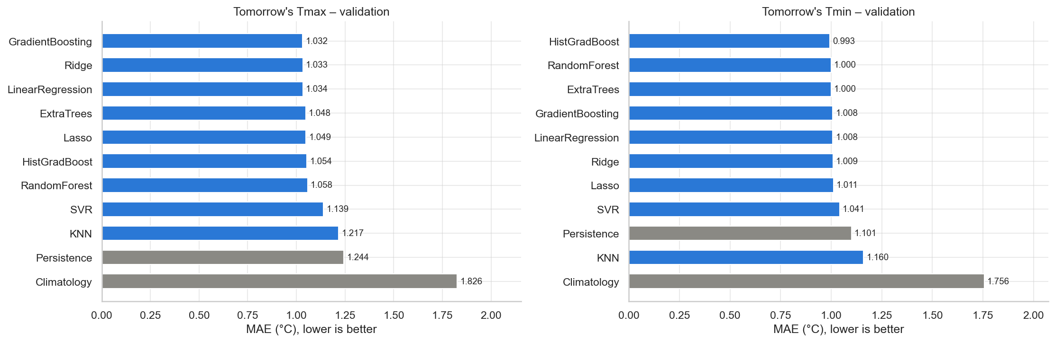
Figure 3 – Validation MAE (2022–2023) of all regression models; references in grey.
Almost every model beats persistence, the exception being KNN for the minimum temperature (Figure 3). Climatology misses by about 1.8 °C, showing that the calendar alone is not enough. The leading models are separated by hundredths of a degree: for the maximum, gradient boosting (1.032 °C), Ridge (1.033 °C) and linear regression (1.034 °C) are practically tied, although Ridge trains in milliseconds and gradient boosting in about six seconds. Once the features are in place, the relationship between today's state and tomorrow's temperature is predominantly linear. KNN and SVR lag behind, as distance-based similarity loses meaning in 76 dimensions.

5.3 Regression: final test evaluation
Target | Model | MAE (°C) | RMSE (°C) | R² | r
Tmax | Persistence | 1.510 | 2.060 | 0.808 | 0.904
Tmax | Climatology | 2.139 | 2.676 | 0.677 | 0.853
Tmax | Ensemble (final) | 1.220 | 1.605 | 0.884 | 0.942
Tmin | Persistence | 1.107 | 1.582 | 0.912 | 0.956
Tmin | Climatology | 1.790 | 2.380 | 0.800 | 0.895
Tmin | Ensemble (final) | 0.987 | 1.382 | 0.933 | 0.967

The 95% confidence interval for the MAE reduction relative to persistence is [0.21, 0.36] °C for the maximum and [0.07, 0.17] °C for the minimum, so both are significant. The test error for the minimum agrees with the validation estimate (0.988 °C), which indicates that model selection did not overfit the validation period.
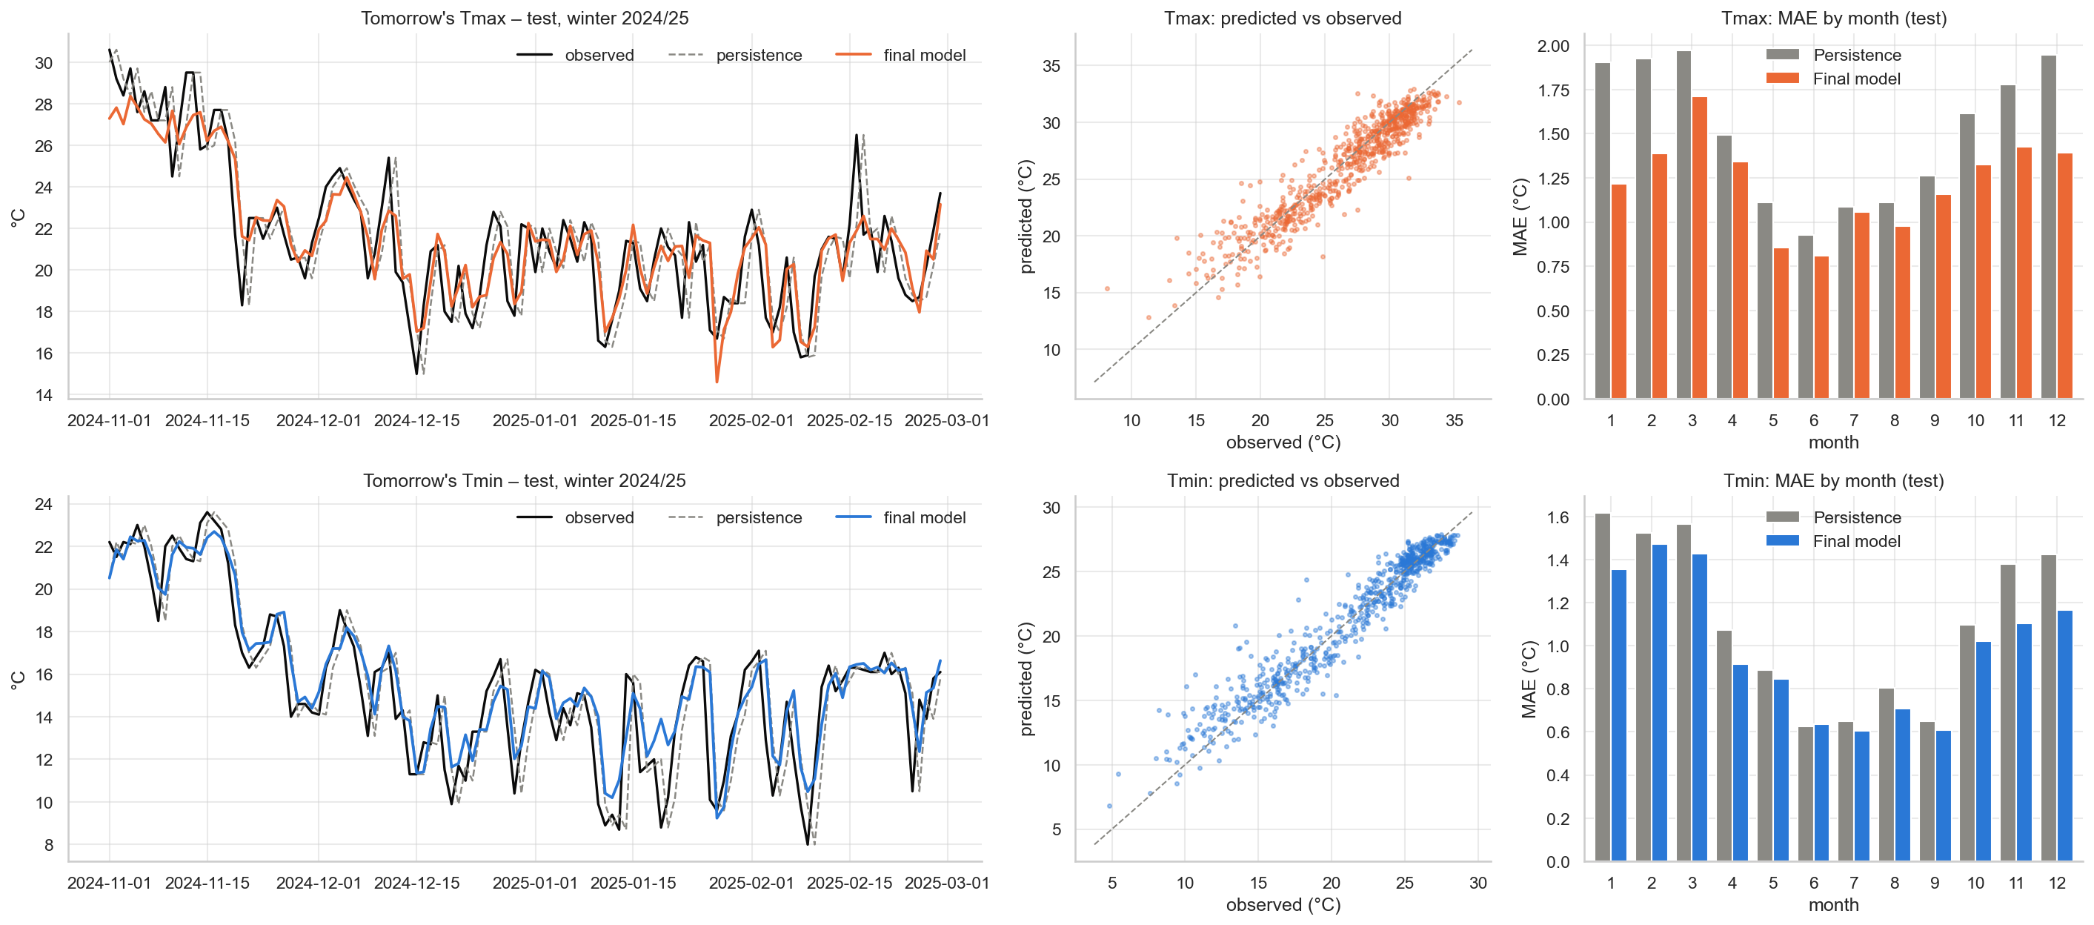
Figure 4 – Test set: predicted and observed series in winter 2024/25, predicted against observed, and MAE by month.
Figure 4 shows where the gain comes from. From November to March, when cold fronts cause sharp drops, the error for the maximum falls from 1.91 to 1.43 °C and for the minimum from 1.50 to 1.31 °C. In the more stable summer, persistence is already good and the gain is smaller (1.10 to 0.97 °C for the maximum). In the winter series, persistence is simply the observed curve shifted by one day; the model anticipates part of each change but still smooths peaks and troughs, a typical consequence of minimising the average error.

5.4 Classification: validation and test
Model | Macro F1 (validation) | Macro F1 (test) | Accuracy (test) | Balanced acc. (test)
Ensemble (final) | 0.539 | 0.501 | 0.606 | 0.515
Extra trees | 0.532 | – | – | –
Random forest | 0.530 | – | – | –
Logistic regression | 0.524 | – | – | –
Persistence | 0.523 | 0.489 | 0.596 | 0.490
SVC | 0.522 | – | – | –
KNN | 0.510 | – | – | –
Gradient boosting | 0.510 | – | – | –
Histogram gradient boosting | 0.498 | – | – | –
Naive Bayes | 0.448 | – | – | –
Majority class | 0.164 | 0.172 | 0.524 | 0.250

Only the final model and the baselines were evaluated on the test set. On validation, only three models beat persistence on macro F1, and by small margins. Naive Bayes performs worst because its assumption of independent features is clearly violated here. The majority class illustrates the problem with accuracy: it is right on half of the days yet has a macro F1 of only 0.16. On the test set the ensemble edges out persistence (0.501 against 0.489), but the confidence interval for the difference, [−0.022, 0.045], includes zero, so the gain is not statistically supported.
Class (test) | Precision | Recall | F1 | Days
Rain | 0.833 | 0.783 | 0.808 | 383
Clear | 0.460 | 0.634 | 0.533 | 101
Cloudy | 0.372 | 0.362 | 0.367 | 116
Partly Cloudy | 0.311 | 0.282 | 0.296 | 131

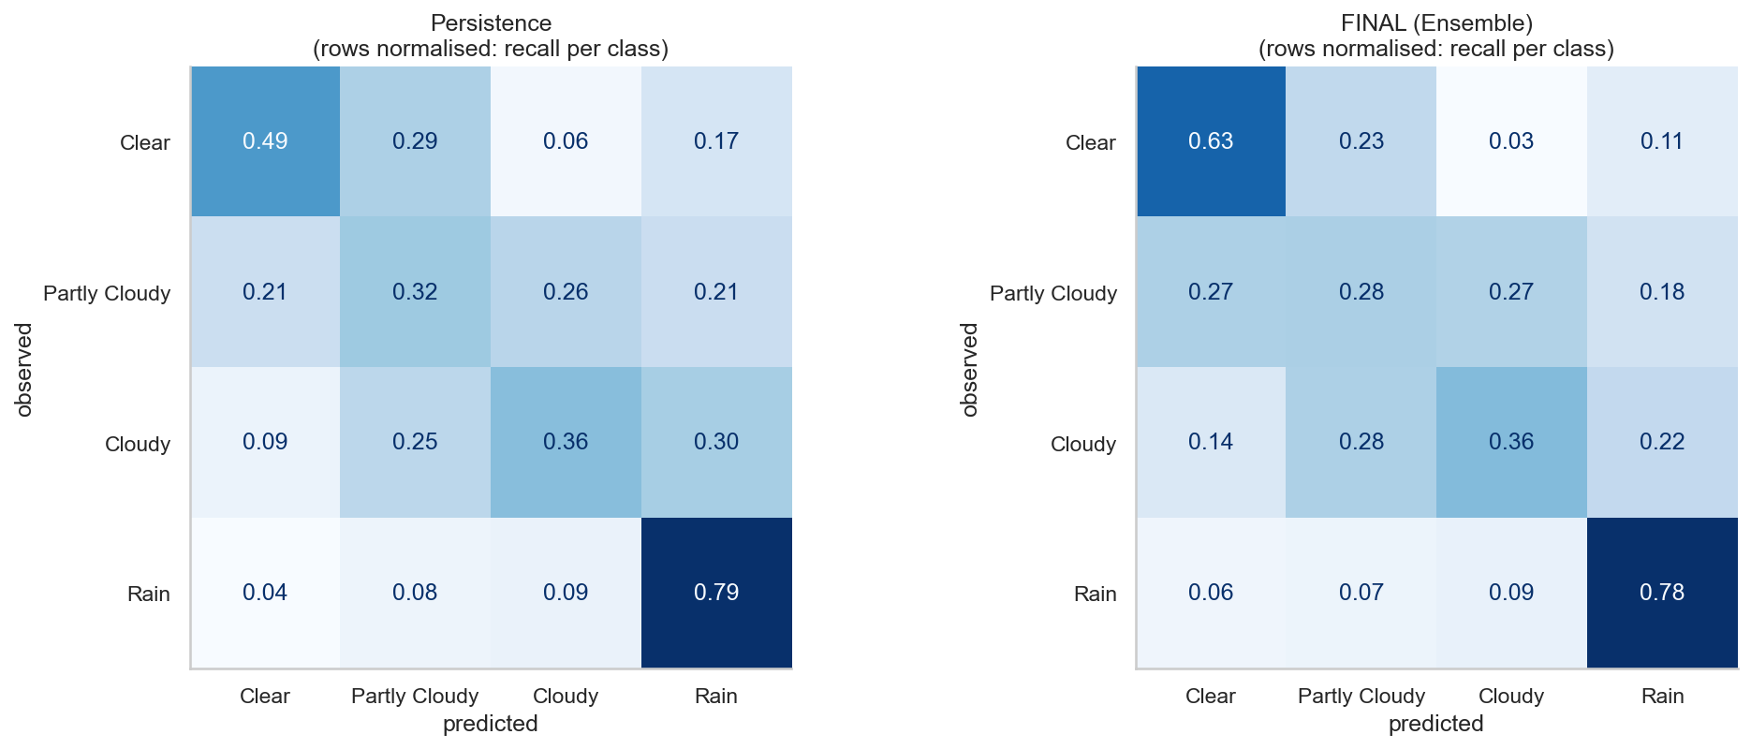
Figure 5 – Test confusion matrices, row-normalised: persistence (left) and final model (right).
Rain is identified well, while Clear, Partly Cloudy and Cloudy are confused with one another (Figure 5). These classes are separated by cloud-cover thresholds, and days close to a threshold are practically indistinguishable. The model clearly improves the recall of Clear, from 0.49 under persistence to 0.63, which is useful for planning outdoor activities.

5.5 Rain or no rain, and probability quality
Model (test) | Accuracy | Precision (rain) | Recall (rain) | F1 (rain)
Majority class | 0.524 | 0.524 | 1.000 | 0.688
Persistence | 0.781 | 0.791 | 0.791 | 0.791
Ensemble (final) | 0.804 | 0.833 | 0.783 | 0.808

As a yes/no forecast the model is slightly better than persistence, but its main value lies in the probability: the ROC AUC is 0.884 and the Brier score is 0.160, against 0.252 for a constant climatological probability, a 37% reduction. Persistence can only answer yes or no, whereas the model can express a forecast such as "80% chance of rain".

5.6 Feature importance
Importance was measured by permutation on the validation set: each feature is shuffled in turn and the resulting loss in performance is recorded. The method is model-agnostic and is computed outside the training data, unlike impurity-based importance in trees. For regression, today's values dominate (mean temperature and minimum apparent temperature for the maximum; minimum temperature for the minimum), followed by 14-day rolling means, seasonal terms and day-to-day differences. Strong wind and a falling minimum temperature also appear as signs of incoming cold air.
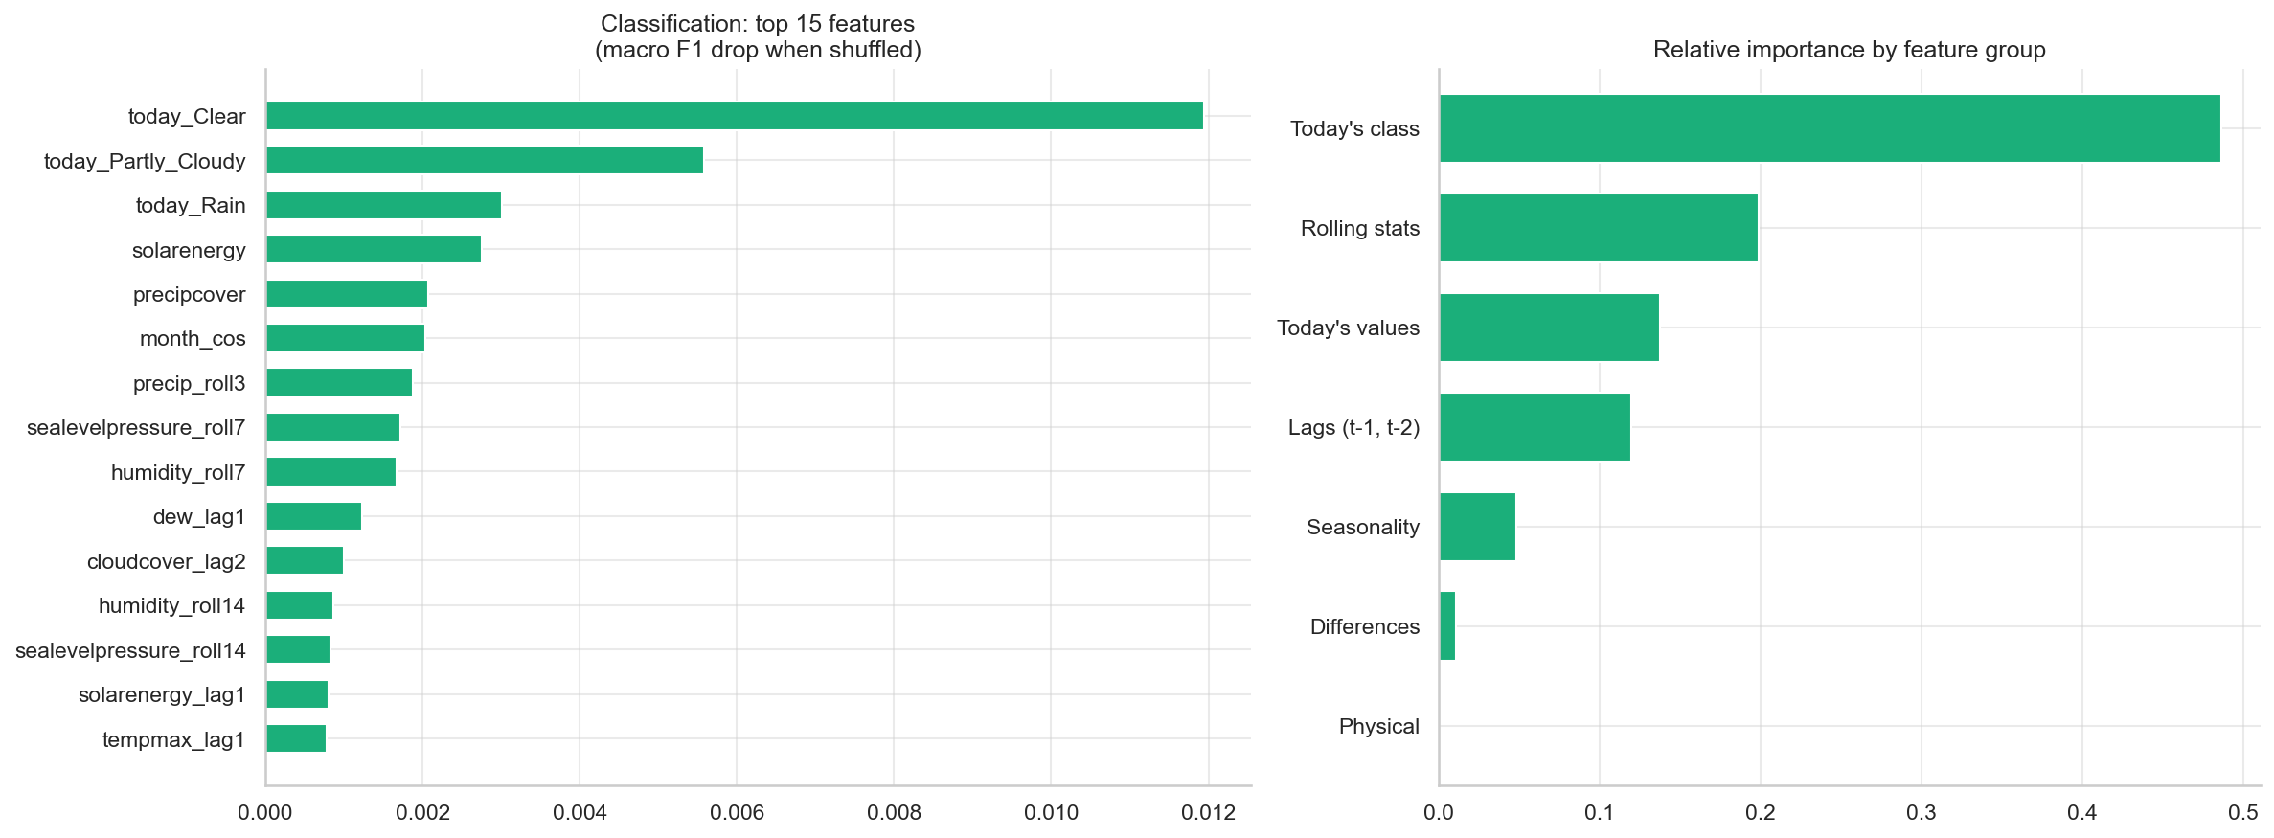
Figure 6 – Permutation importance for classification: top 15 features and importance by feature group.
For classification (Figure 6), today's class is the most important group, with about half of the total, followed by rolling statistics such as rain over the last three days and pressure and humidity over the last week. In effect the model learns that tomorrow's sky resembles today's, adjusted for recent rain, humidity, pressure and season, which explains why it stays close to persistence. Because highly correlated features share importance among themselves, the group totals are more reliable than the individual ranking.

6. Discussion and Limitations

6.1 Discussion
Persistence merely repeats today. The models combine the current state with its tendency (lags and differences), the recent regime (rolling means) and the time of year (cyclical encoding). They can thus learn, for example, that an unusually warm December day tends to be followed by a return towards normal, a form of regression to the mean, and that strong wind with a falling minimum temperature announces a north-east monsoon surge.
The wide comparison of models had the largest effect of any step. Gradient boosting and extra trees, which were not among the three models considered initially, won on validation for the maximum temperature and for classification, and this change lowered the test error for the maximum from 1.27 to 1.22 °C. Ensembling added a consistent gain on validation, particularly when it combined different families, such as boosted trees with linear models for the maximum. Hyperparameter tuning contributed almost nothing. In this problem, the quality of the features and the diversity of models mattered more than fine-tuning.
The temperature improvements are practically relevant: average errors fall by 0.1 to 0.3 °C, are statistically significant, and are concentrated in winter, when cold spells affect health, energy demand and agriculture. For four-class weather prediction there is no proven gain; the practical value lies in the rain probability, which is far better than climatology.
Classification is harder because rainfall depends on synoptic-scale systems such as fronts, troughs and typhoons that cannot be seen from a single point. The intermediate classes are also separated by arbitrary cloud thresholds, which caps performance regardless of the algorithm: the seven best candidates all scored between 0.51 and 0.54 macro F1 on validation.

6.2 Limitations
The data come from a single ERA5 grid point with a resolution of about 25 km, which smooths extremes and overstates drizzle (48% of days reach 1 mm). The classes depend on thresholds chosen by the group (1 mm, 30% and 70%), and the data do not come from the source recommended in the specification, because the available file contained only a 15-day forecast. The models have no spatial information, so a typhoon 500 km away is invisible to them, and no numerical weather prediction input. Rare events are scarce in the training data and extremes are underestimated. The test set covers two years, and El Niño or La Niña years, as well as gradual warming, could change the performance. The models perform worst during intense cold fronts, approaching typhoons and transitional months such as March and October, when the pattern changes quickly.

6.3 Future work
Natural extensions are adding neighbouring stations (Hong Kong, Zhuhai, Guangzhou) to detect approaching systems, together with climate indices such as ENSO; using hourly data to build late-afternoon pressure and humidity tendencies; producing probabilistic temperature forecasts with quantile regression and calibrating the rain probabilities; trying sequence models such as LSTMs or the Temporal Fusion Transformer, and stacking with a meta-model; and evaluating with a walk-forward scheme that retrains every month, as an operational system would.

7. Project Management and Team Reflection
This section should be completed by the group; the allocation below is a proposal.
Member | Main responsibility | Support
Thiago Honorato Ferreira | data collection and audit, feature engineering | report review
Marcelo Oliveira | Task 1: regression, grid search, ensemble and significance testing | slides
João Vitor Konrad | Task 2: classification, rain analysis and feature importance | EDA and figures
All | report, presentation and cross-review of the code | –

Risk | Impact | Mitigation
Suggested data insufficient (15-day forecast) | no training data | prior audit; public alternative converted to the same format
Leakage of future information | optimistic, invalid scores | split by target date; time-ordered folds with a one-day gap; automatic target test
Non-reproducible results | loss of credibility | fixed seed; raw data stored; full notebook re-run after every change
Class imbalance | a model that only predicts Rain | macro F1 as main metric; balanced class weights
Repeated use of the test set | biased selection | test used once, only for the final model and baselines
Model files above 100 MB | failed push to GitHub | model files excluded from version control, since the notebook recreates them

Assertions in the code check target alignment, the absence of quality problems and the absence of features identical to the target. Every refactoring was validated by comparing the result tables before and after, which had to remain identical, and all figures in this report come from the files in results/ produced by the notebook.
Team reflection (to be completed by the group). Suggested points: discovering that the recommended data were insufficient and documenting the alternative source; the surprising strength of persistence; and the decision to report the classification tie honestly.

8. Responsible Impact Assessment and Conclusion

8.1 Impact assessment
Potential benefits include planning electricity demand, health alerts for vulnerable groups during cold spells, organising outdoor events and school activities, and teaching data science on a real problem. Incorrect forecasts carry risks: a false "Clear" on a typhoon day could lead people into danger, and underestimating a 4 °C drop could leave vulnerable people unprotected. Because the model smooths extremes, its largest errors tend to occur in exactly the most dangerous events.
Responsible use therefore requires always communicating uncertainty (a typical error of about ±1 °C, and a probability of rain rather than a yes/no answer), never replacing the official SMG warnings for typhoons and heavy rain, retraining the models periodically as the climate changes, and being transparent about the data: a reanalysis at a single point, with classes defined by thresholds chosen by the group.

8.2 Conclusion
The project set out to predict tomorrow's maximum temperature, minimum temperature and weather condition in Macau. After auditing the suggested data and replacing them with twelve years of ERA5 reanalysis, it built 76 leakage-free temporal features, used a chronological split, compared nine regressors and eight classifiers against persistence baselines, tuned the best models with a grid search over five time-ordered folds, combined the top three models in an ensemble and assessed significance with a block bootstrap.
The ensemble reached a test MAE of 1.22 °C for the maximum and 0.99 °C for the minimum, 19% and 11% better than persistence and statistically significant. For the weather condition it reached a macro F1 of 0.501 against 0.489 for persistence, without significance, but delivered rain probabilities with a ROC AUC of 0.88.
The main lesson is that, for daily weather series, a well-chosen simple baseline is hard to beat. The gains came from representing the memory and seasonality of the weather and from comparing models from different families, not from algorithmic complexity or fine-tuning. Reporting honestly where machine learning did not help is part of a sound analysis.

References
1. Breiman, L. (2001). Random forests. Machine Learning, 45, 5–32.
2. Friedman, J. H. (2001). Greedy function approximation: a gradient boosting machine. Annals of Statistics, 29(5), 1189–1232.
3. Geurts, P., Ernst, D. and Wehenkel, L. (2006). Extremely randomized trees. Machine Learning, 63, 3–42.
4. Hersbach, H. et al. (2020). The ERA5 global reanalysis. Quarterly Journal of the Royal Meteorological Society, 146, 1999–2049.
5. Künsch, H. R. (1989). The jackknife and the bootstrap for general stationary observations. Annals of Statistics, 17(3), 1217–1241.
6. Pedregosa, F. et al. (2011). Scikit-learn: machine learning in Python. Journal of Machine Learning Research, 12, 2825–2830.
7. Open-Meteo Historical Weather API: https://open-meteo.com/en/docs/historical-weather-api
8. Visual Crossing Weather Query Builder: https://www.visualcrossing.com/weather-query-builder/

Appendix: Mapping between Report and Code
Report section | Notebook | Functions in weather_utils.py | Outputs
2.2 Dataset | 2.1–2.4 | check_coverage, download_open_meteo, to_visual_crossing_schema, to_metric | data/macao_openmeteo.csv
3.1 Data quality | 3.1–3.3, 4.1 | quality_report, iqr_outliers, to_class | audit table
3.2 Features | 6.1–6.2 | build_features | data/processed/
3.3 EDA | 5.1–5.8 | – | figures/eda_*.png
4. Models | 7.1, 8.1–8.5, 9.1–9.4 | make_regressors, make_classifiers, tune_model, ensemble, climatology_predict, persistence_class | results/*_validation_results.csv
5. Results | 8.6–8.8, 9.5–9.8, 10.1 | regression_metrics, classification_metrics, rain_metrics, block_bootstrap_diff, feature_group | results/*_test_results.csv, figures/

