MACAO POLYTECHNIC UNIVERSITY
BACHELOR OF ARTIFICIAL INTELLIGENCE
CSAI3121-311/312 Machine Learning and Intelligent Data Analysis
Academic year 2026/2027 | Semester 1

Group Project (update)
Weather Prediction using Machine Learning
Report Submission: 11 Nov
Presentation Class 311: 16 Nov
Class 312: 17 Nov

Build an end-to-end machine-learning system that predicts temperature and weather condition from historical meteorological data. Teams will develop and compare multiple regression and classification models, evaluate their performance using appropriate metrics, and communicate their findings in a technical report, a non-technical summary, and an in-class oral presentation.

Learning Objectives:
- Apply regression and classification techniques to meteorological data;
- Handle real-world datasets with multiple features for effective modeling;
- Design machine-learning solutions for weather forecasting, involving data processing, feature selection, model implementation, training, hyperparameter tuning, and evaluation;
- Communicate technical findings effectively to both technical and non-technical audiences through written and oral presentation;
- Apply basic project planning, risk management, and quality-assurance practices to deliver a reproducible machine-learning solution.

Technical Requirements:
1. Prediction Tasks
In a team of 3-4 students, plan, develop and evaluate machine-learning solutions for the following two prediction tasks:
(1) Next-Day Maximum and Minimum Temperature Prediction (Regression):
Predict the maximum and minimum air temperatures for the next day using historical daily meteorological data available up to the current day.

(2) Next-Day Weather-Condition Prediction (Classification):
Predict the weather condition for the next day (e.g., clear, partly cloudy, cloudy, rain) using daily meteorological data.
Teams must define and document a clear mapping from the original weather-condition labels to a manageable set of prediction classes. For example: Clear, Partly Cloudy, Cloudy, and Rain.

2. Model Comparison
For each prediction task, teams must implement and compare:
- One baseline model: Define and justify a simple reference approach. For example,
- For temperature prediction, an appropriate baseline may be the persistence model: “the minimum temperature of the next-day is equal to the minimum temperature of today’s”.
- For weather-condition prediction, an appropriate baseline may be always predicting the most frequent weather class.
- At least TWO suitable machine-learning algorithms: Select algorithms appropriate to the prediction task and explain the rationale for their selection.
- One final tuned model: Select the best-performing candidate model and improve it through hyperparameter tuning. Report the final hyperparameter settings and explain the tuning method used.

3. Implementation Requirements
All analysis, modelling, and evaluation must be implemented in well-organized and reproducible Jupyter notebook(s). The submitted notebook(s) must run from data loading to final evaluation without manual modification.

3.1 Data Collection
- Use the Visual Crossing Weather Query Builder (https://www.visualcrossing.com/weather-query-builder/) to collect historical weather data.
- Select one location (e.g., Macau) and collect at least 3000 records or 10 years of continuous data.
- Download daily data for both temperature and weather-condition predictions.
- Save the raw data in CSV format and document the location, time period, and variables used.

3.2 Data Processing and Feature Engineering
Teams must perform and document appropriate data-preparation steps, including:
- Handle missing, invalid, or duplicate records
- Create relevant temporal features (hour of day, day of week, month, lagged features such as previous day t-1, previous two-day t-2, rolling averages such as 7-day moving average)
- Encode categorical variables when necessary
- Scale or normalize numerical features when necessary
- Split data chronologically: training, validation, test; ensure that no future information is used to predict past observations

3.3 Exploratory Data Analysis
Teams must conduct exploratory data analysis and present appropriate visualisations. This should include:
- Summary statistics and distributions of key variables
- Analysis of relationships between relevant features and the prediction targets
- Time-series plots showing major trends, seasonal patterns, or unusal observations
- Identify data-quality problems, class imbalance, outliers, etc.

3.4 Model Development
For each task, teams must:
- Define the input features and prediction target clearly.
- Explain and justify the selected features, including lagged and rolling features.
- Implement the baseline model and at least two ML algorithms.
- Document the main hyperparameter settings used for each model.
- Explain why each ML algorithm is suitable for the task.

3.5 Model Evaluation
Teams must select suitable evaluation metrics and justify their choice.
For the regression task, suitable metrics may include:
- Mean Absolute Error (MAE)
- Root Mean Squared Error (RMSE)
- Correlation coefficient
- R² score

For the classification task, suitable metrics may include:
- Accuracy
- Precision, recall, and F1-score
- Confusion matrix

For each prediction task:
- Compare baseline and ML models using tables and appropriate plots.
- Evaluate final model performance only once on the held-out test set.
- Identify the best-performing model using the selected metric(s).
- Discuss whether observed performance differences are practically meaningful.
- Analyze feature importance where supported by the selected algorithm.
- Discuss limitations, sources of error, and situations in which the model may perform poorly.

4. Innovation and Extension
Students are encouraged to explore and justify additional techniques beyond the minimum requirements. Examples include
- additional data sources,
- domain knowledge integration,
- feature engineering/importance,
- ensemble or advanced machine learning methods,
- novel validation strategies,
- model interpretation.

Deliverables:
Teams must submit a zipped file project_groupID_all.zip, containing the following files:
- Jupyter Notebook(s): Well-organized and reproducible code covering data processing, exploratory analysis, feature engineering, model development, hyperparameter tuning, and evaluation. project_codes_groupID.zip
- Dataset: Raw and processed weather data files, and clear instructions for reproducing the data download. project_data_groupID.zip
- Project Report (10-15 pages): A concise report giving a (1) non-technical executive summary, (2) problem definition and dataset (3) data preparation, feature engineering and EDA, (4) model development (5) results and evaluation, (6) discussion and limitations, (7) project management and team reflection, (8) impact, limitations, future improvements, and conclusion. project_report_groupID.pdf
- Self and Peer Assessment: One for each member. This component is not graded but for individual reflection on learning and teamwork. project_selfpeer_groupID _StudentName.pdf
- Presentation (10 min): A presentation of the project results. All team members must participate in the presentation and Q&A. project_slides_groupID.pdf
- Marksheet: Fill in necessary information in the first page. project_marksheet_groupID.docx
- GenAI declaration forms: Complete the form, signed, one for each member. project_GenAI_groupID_ StudentName.pdf

Marking Criteria: Project 80%, Presentation Q&A 20%
Criterion | Weight
Non-technical summary of the work | 5%
Problem definition and dataset description | 2%
Data processing, feature engineering, and exploratory data analysis | 10%
ML methods, model comparison, hyperparameter tuning, and evaluation | 35%
Discussion of results and model interpretation | 15%
Project management and teamwork: task allocation, timeline, risks, mitigation actions, quality checks, and team reflection | 3%
Responsible impact assessment, limitations, future improvements and conclusion | 5%
Report quality: organisation, clarity, figures/tables, and presentation | 5%
Code quality: readability, documentation, organisation, and reproducibility | 5%
Oral presentation organization, clarity, visual quality, and communication | 5%
Demonstrated understanding of the methods, results, limitations, and responses to questions | 10%
Total | 100%

Meteorological Data:
Weather API: https://www.visualcrossing.com/weather-query-builder/
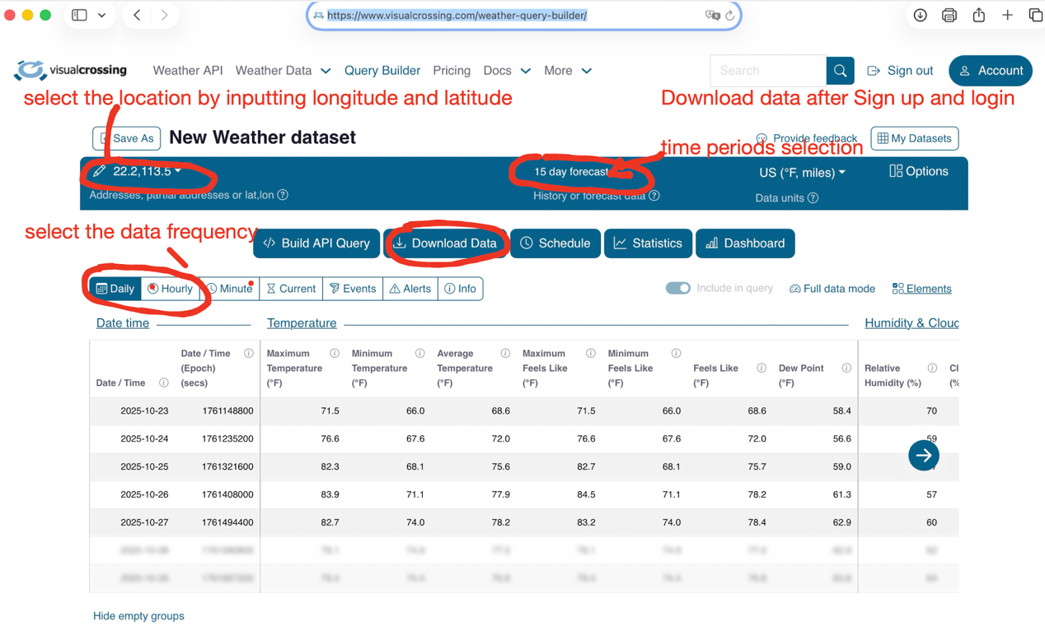

Final reminder:
After you sign up with an email, you can freely download the data, but there are quantity restrictions per day. However, this should be sufficient for your project as long as all members cooperate in downloading. You are free to choose what data to download, how to download it, and how to use it.

For weather prediction, using only basic machine learning models will not yield good results. Since weather data exhibits continuity and periodicity, you should consider how to apply traditional machine learning to time series data. If you try multiple models and combine them using reasonable strategies, you may achieve better results. Please feel free to explore this on your own and as a team.

