Refinery Inflexibility and the Decarbonization of Transport: Implications for Net-Zero Emissions Transitions

1. Introduction
The goal to reach net-zero emissions by mid-century has reshaped the policy landscape across transportation, energy, and industrial sectors. Many countries now impose mandates, standards, or targets that effectively push for the phaseout of internal combustion engine (ICE) vehicles and the adoption of zero-emission alternatives, such as battery electric vehicles (BEVs) and hydrogen fuel cell vehicles (FCEVs). Historically, most of the near-term decarbonization emphasis has focused on light-duty vehicles (LDV), given their high turnover, existing charging infrastructure momentum, and favourable cost trajectories for battery electric vehicles (BEVs) ^{1,2}. In many climate and transport models, electrification of LDVs is treated as a “low-hanging fruit” pathway toward emission reductions, often outpacing efforts in heavy-duty, marine, aviation, or alternative fuels³. However, this emphasis on passenger vehicle strategies often assumes that the fuel and energy supply sector will seamlessly adjust to reduced fuel demand, implicitly expecting that demand for refined petroleum products will simply decline as a result.
The output slate of a refinery depends critically on its configuration (simple vs. complex units, presence of upgrader, cracking, coking, hydrocracking, hydrotreating) and the types of crude oil feedstocks it can accept (e.g. light vs. heavy, sulphur content). Transforming a refinery’s product mix (e.g., cutting gasoline yield sharply while boosting diesel or petrochemical feedstocks) may require costly capital investments, retrofits, or entire unit additions⁴. Even storage, logistics, and blending constraints limit how rapidly or flexibly a refinery can shift its output. As a result, sudden or steep declines in one product may not be easily absorbed without stranded assets or operating inefficiencies.
Most energy-economy models⁵ (including many integrated assessment models, IAMs, and sectoral optimization frameworks) and studies about the impact of vehicle electrification^{6–9} do not incorporate refinery flexibilities or detailed constraints on refined product supply when assessing the environmental and economic impacts of vehicle electrification. These models typically assume that energy supply adjusts smoothly (or is cost-optimally reconfigured) to meet demand changes, without internal frictions or rigidities in downstream refinement. As a result, model projections may understate transition costs, overestimate co-benefits, or misallocate investment signals.
This paper aims to shed light on how refinery inflexibility constrains the pace and cost of transport decarbonization and explore the systemic feedback that emerges when shifting demand from liquid fuels to electricity.

2. Background and Literature Review

2.1. Vehicle Electrification Approaches
The transition to electric vehicles (EVs) has emerged as an important decarbonization strategy to meet net-zero emissions targets. Governments and international organizations have outlined ambitious timelines for phasing out internal combustion engine (ICE) vehicles, particularly in the light-duty vehicle (LDV) segment. For example, the European Union has legislated a ban on new ICE car sales by 2035¹⁰, while jurisdictions like California and Norway have committed to even earlier phaseout timelines¹¹. These policies are typically accompanied by financial incentives, such as purchase subsidies, tax exemptions, and investments in charging infrastructure, aimed at accelerating the market uptake of EVs¹².
Numerous studies have projected significant reductions in greenhouse gas (GHG) emissions, air pollutants, and operating costs through widespread adoption of EVs^{13–17}. However, the electrification of heavy-duty vehicles (HDVs) remains more complex, due to technical challenges such as vehicle weight, range requirements, and charging logistics^{18–25}. As a result, decarbonization strategies often prioritize LDVs first, with HDV transitions occurring more gradually or relying on alternative fuels such as hydrogen or renewable diesel.

2.2. Refinery Operations and Product Slate Inflexibility
WIP

3. Methods
This study employs the Canadian Open Energy Outlook (CANOE) model, an open-source, long-term energy systems optimization framework developed for Canada and based on the Tools for Energy Model Optimization and Analysis (Temoa) platform. CANOE provides a technology-rich representation of Canada’s energy system, allowing for the detailed assessment of policy, technology, and demand-side scenarios that influence national decarbonization pathways. The model operates on a least-cost optimization framework, minimizing total system costs while satisfying energy service demands, resource constraints, and technology performance limits.
Within CANOE, the petroleum refining sector was represented as a set of transformation technologies converting crude oil and auxiliary energy inputs, such as electricity and natural gas, into refined petroleum products, including gasoline, diesel, jet fuel, and other derivatives. This approach enables a direct link between upstream crude oil supply, refining activities, and downstream fuel consumption within the broader energy system. The product mix ratios for (?)each(?) province were fixed according to current regional fuel demand patterns, capturing the existing distribution of refined product outputs.
Two scenarios were developed to explore the effects of flexibility in fuel supply representation. In the completely flexible scenario, refined petroleum products were modelled as exogenously supplied commodities, imported into the system as needed to satisfy provincial fuel demands. This setup assumes full flexibility in the supply chain, where the model determines the least-cost pathway for meeting national energy service requirements without internal refinery constraints.
On the other hand, the completely inflexible scenario endogenized domestic fuel production, incorporating the refinery technologies described earlier. Under this configuration, the model explicitly determined refinery operations and input requirements, linking domestic crude production and energy inputs to the generation of refined fuels.
Comparative analyses between these two configurations were then conducted to assess their impacts on greenhouse gas (GHG) emissions, fuel consumption patterns, electricity generation requirements, and vehicle technology adoption across Canada. By contrasting the flexible and inflexible system representations, this study quantifies how the structure of domestic refining and fuel supply pathways influences Canada’s decarbonization strategies and associated system-level outcomes.

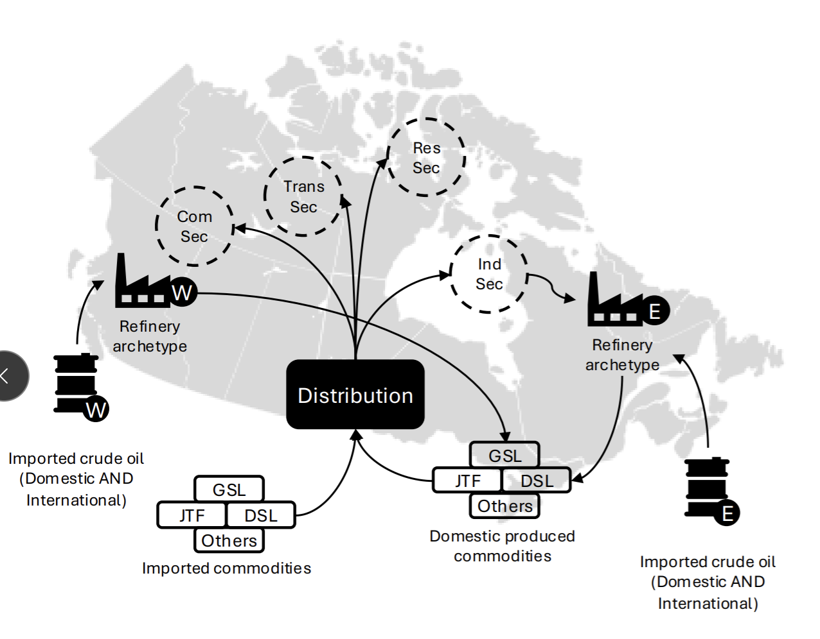
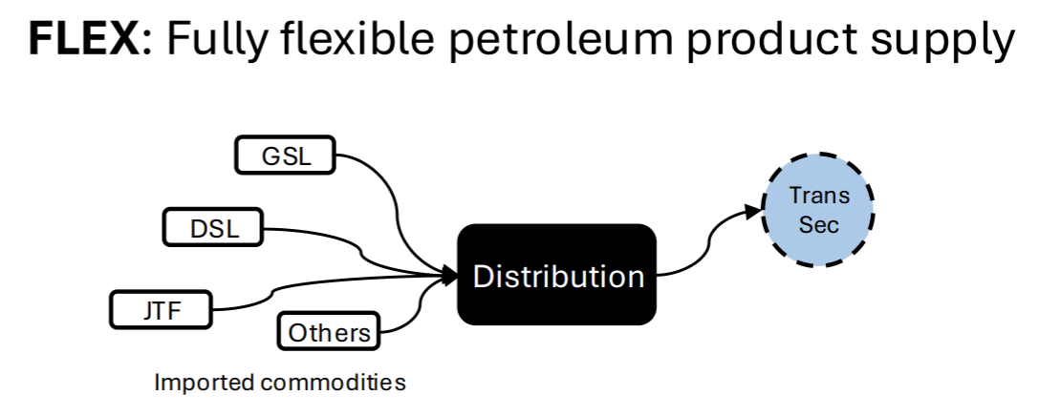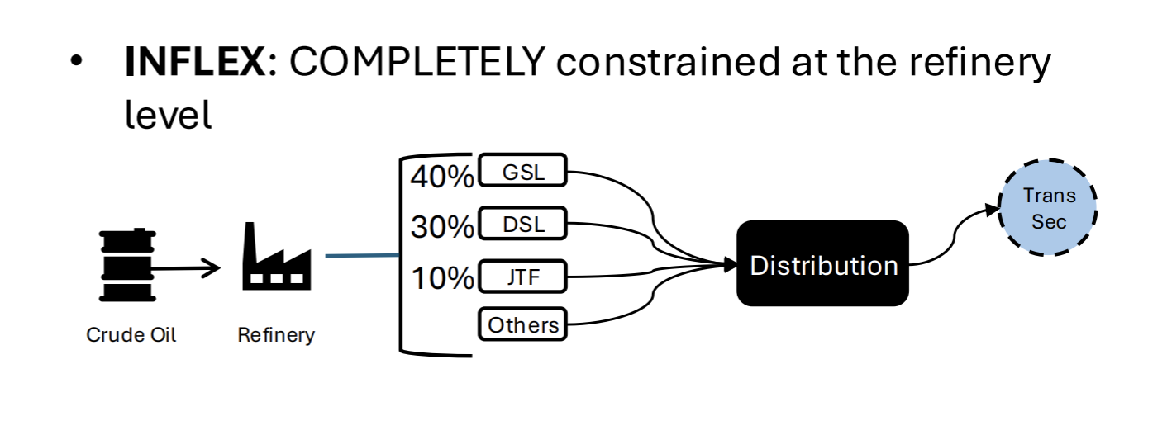

4. Results & Discussion

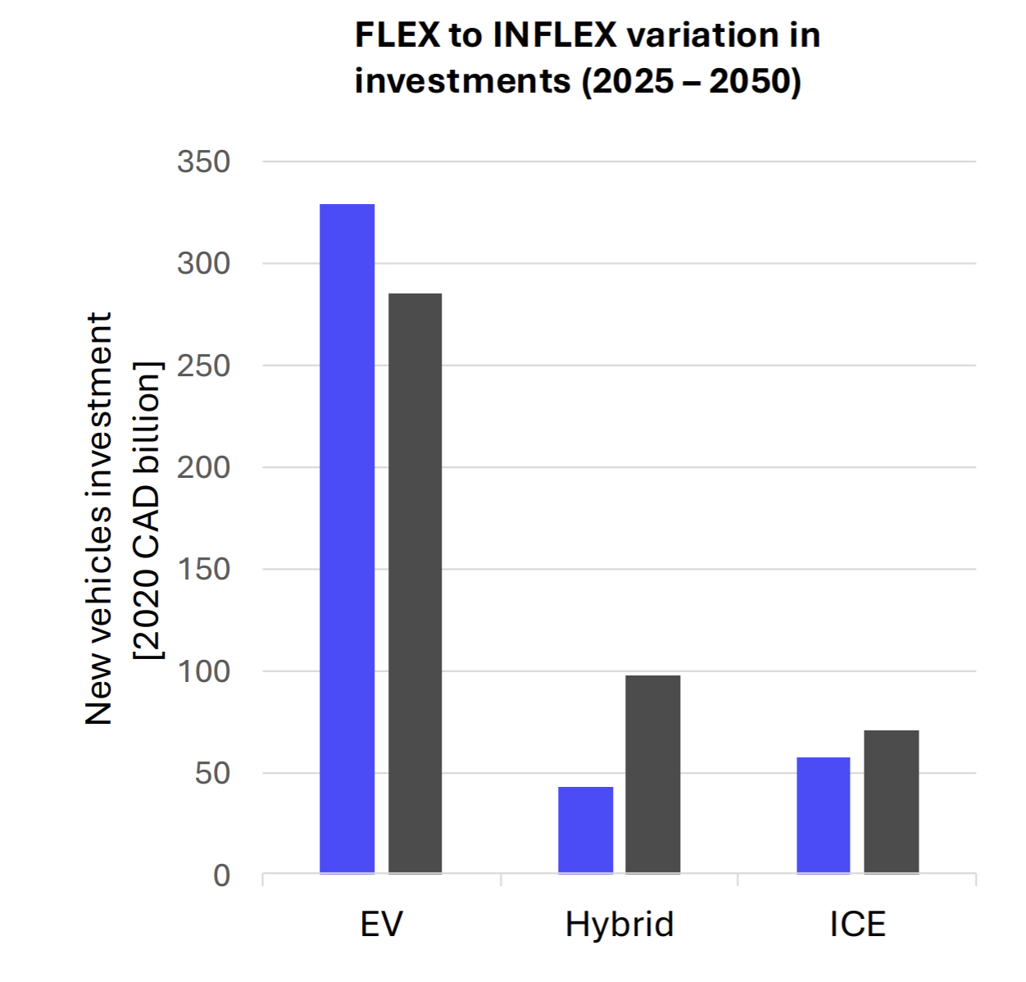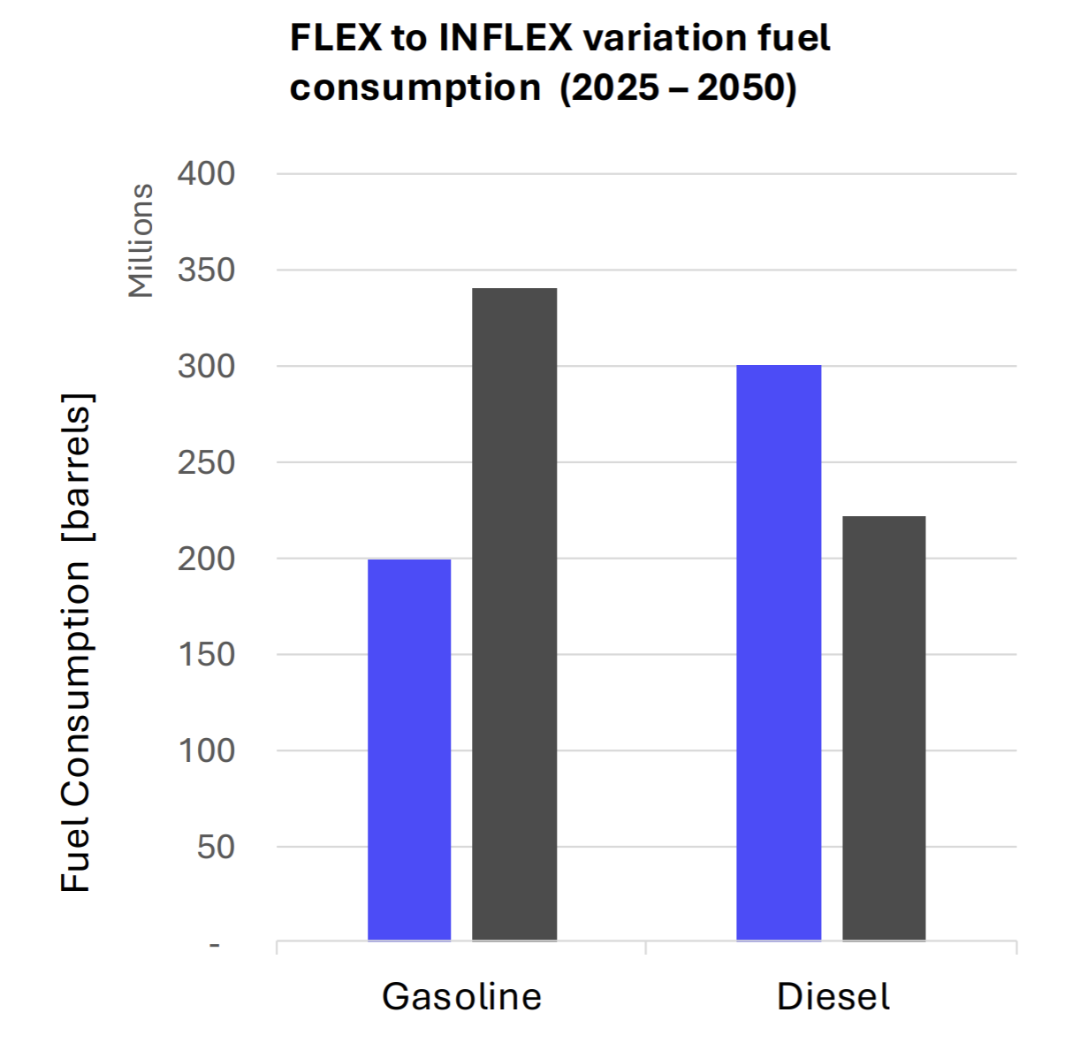

5. Results & Discussion
WIP
References:
1. Clinton, B. C., Knittel, C. R. & Metaxoglou, K. Electrifying Transportation: Issues and Opportunities. MIT Cent. Energy Environ. Policy Res. (2020).
2. Global EV Outlook 2023 – Analysis. IEA https://www.iea.org/reports/global-ev-outlook-2023 (2023).
3. Outlook for emissions reductions – Global EV Outlook 2024 – Analysis. IEA https://www.iea.org/reports/global-ev-outlook-2024/outlook-for-emissions-reductions.
4. Kaiser, M. J., de Klerk, A., Gary, J. H. & Handwerk, G. E. Petroleum Refining: Technology, Economics, and Markets. (CRC Press, 2019).
5. Rhodes, E., Hoyle, A., McPherson, M. & Craig, K. Understanding climate policy projections: A scoping review of energy-economy models in Canada. Renew. Sustain. Energy Rev. 153, 111739 (2022).
6. Bayani, R., Soofi, A. F., Waseem, M. & Manshadi, S. D. Impact of Transportation Electrification on the Electricity Grid—A Review. Vehicles 4, 1042–1079 (2022).
7. Guo, Z., Sun, S., Wang, Y., Ni, J. & Qian, X. Impact of New Energy Vehicle Development on China’s Crude Oil Imports: An Empirical Analysis. World Electr. Veh. J. 14, 46 (2023).
8. Alagoz, E. Electrifying the Transportation Sector: Implications for the Oil and Gas Industry. Int. J. Energy Smart Grid 8, 25–35 (2023).
9. Tamba, M. et al. Economy-wide impacts of road transport electrification in the EU. Technol. Forecast. Soc. Change 182, 121803 (2022).
10. Barnard, M. The EU Finalizes Ban on New Gas and Diesel Cars by 2035, Cementing the EV Transition. Climate Wins https://medium.com/climate-wins/the-eu-finalizes-ban-on-new-gas-and-diesel-cars-by-2035-cementing-the-ev-transition-c149dbf03636 (2025).
11. EV Mandates Will Stay Because Canada is Not The Only Country Planning to Phase Out Internal Combustion Engine Vehicles. Motor Illustrated https://motorillustrated.com/ev-mandates-will-stay-because-canadas-only-one-country-with-targets-for-phasing-out-internal-combustion-engine-vehicles/147106/ (2025).
12. Policies to promote electric vehicle deployment – Global EV Outlook 2021 – Analysis. IEA https://www.iea.org/reports/global-ev-outlook-2021/policies-to-promote-electric-vehicle-deployment.
13. Choma, E. F., Evans, J. S., Hammitt, J. K., Gómez-Ibáñez, J. A. & Spengler, J. D. Assessing the health impacts of electric vehicles through air pollution in the United States. Environ. Int. 144, 106015 (2020).
14. Chen, Z., Carrel, A. L., Gore, C. & Shi, W. Environmental and economic impact of electric vehicle adoption in the U.S. Environ. Res. Lett. 16, 045011 (2021).
15. Skipper, T. N., Lawal, A. S., Hu, Y. & Russell, A. G. Air quality impacts of electric vehicle adoption in California. Atmos. Environ. 294, 119492 (2023).
16. Vega-Perkins, J., Newell, J. P. & Keoleian, G. Mapping electric vehicle impacts: greenhouse gas emissions, fuel costs, and energy justice in the United States. Environ. Res. Lett. 18, 014027 (2023).
17. Afkhami, B., Akbarian, B. & Ansari, E. Adoption of battery electric vehicles for reduction of greenhouse gases and air pollutant emissions: A case study of the United States. Energy Storage 4, e280 (2022).
18. Hasnain, A., Somiruwan Gamwari, A., Resalayyan, R., Farokhi Sadabadi, K. & Khaligh, A. Medium- and Heavy-Duty Vehicle Electrification: Trends and Technologies. IEEE Trans. Transp. Electrification 11, 3602–3616 (2025).
19. Spiller, B., Lohawala, N. & DeAngeli, E. Medium-and heavy-duty vehicle electrification: Challenges, policy solutions, and open research questions. Resour. Future Wash. DC Tech Rep (2023).
20. Alonso-Villar, A., Davíðsdóttir, B., Stefánsson, H., Ásgeirsson, E. I. & Kristjánsson, R. Electrification potential for heavy-duty vehicles in harsh climate conditions: A case study based technical feasibility assessment. J. Clean. Prod. 417, 137997 (2023).
21. Martinez-Boggio, S., Monsalve-Serrano, J., García, A. & Curto-Risso, P. High Degree of Electrification in Heavy-Duty Vehicles. Energies 16, 3565 (2023).
22. Rohith, G., Devika, K. B., Menon, P. P. & Subramanian, S. C. Sustainable Heavy Goods Vehicle Electrification Strategies for Long-Haul Road Freight Transportation. IEEE Access 11, 26459–26470 (2023).
23. Li, S., Djilali, N., Rosen, M. A., Crawford, C. & Sui, P.-C. Transition of heavy-duty trucks from diesel to hydrogen fuel cells: Opportunities, challenges, and recommendations. Int. J. Energy Res. 46, 11718–11729 (2022).
24. Fleming, K. L., Brown, A. L., Fulton, L. & Miller, M. Electrification of Medium- and Heavy-Duty Ground Transportation: Status Report. Curr. Sustain. Energy Rep. 8, 180–188 (2021).
25. Smith, D. et al. Medium- and Heavy-Duty Vehicle Electrification: An Assessment of Technology and Knowledge Gaps. https://www.osti.gov/biblio/1615213 (2020) doi:10.2172/1615213.

