Trello:

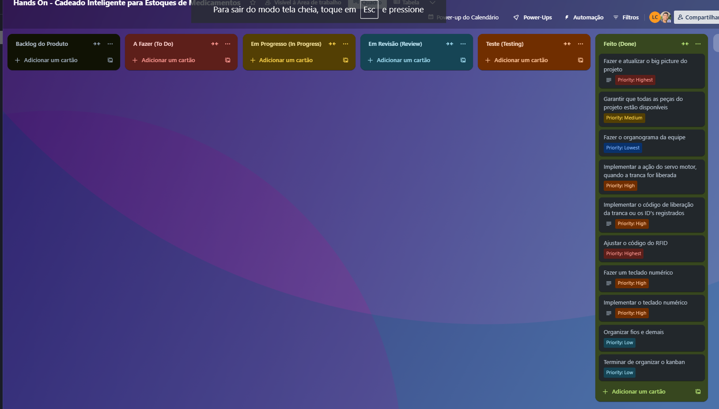
https://trello.com/b/scoCjgim/hands-on-cadeado-inteligente-para-estoques-de-medicamentos

