**AGB report: 2023-8-5**



Under Creative Commons CC-BY-NC-SA 4.0 license. <https://creativecommons.org/licenses/by-nc-sa/4.0/>

Please quote the associated report[1] if reusing this report template or results.

***AGB****: above-ground biomass, counting only trees longer than 1.30 meter and having a DBH (diameter at breast height) thicker than 10 centimeters. Check for the precautions of use in the associated report[2] and GitHub repository[3].*

***QSM****: quantitative structure modelling, tree reconstruction processing by performing for vertical slices randomized Hough transformation (ellipse fitting) to rebuild the tree as a stack of cylinders.*

Location of the starting point: 121.495364ºE, 23.791372ºN

Subplot(s): T2S8

Area of the analyzed region of interest: 30.0 by 30.0 meters (900.0 m2)

Species of tree: *bischofia javanica*

Number of trees within the subplot(s): 13

Number of trees detected by the model after co-registration: 31 (238.0 %)

Number of trees ready for QSM after removal of too small trees: 28 (215.0 %)

Number of trees having successfully passed QSM: 5 (38.0 %)

|  |  |  |  |  |
| --- | --- | --- | --- | --- |
| (by tree) | Estimated DBH (cm) | Measured DBH (cm) | Estimated total height (m) | Measured living height (m) |
| Average | 19.3 | 20.7 | 11.6 | 9.1 |
| Standard deviation | 3.1 | 8.4 | 2.4 | 2.8 |
| Maximum | 23.4 | 35.6 | 16.0 | 14.5 |
| Minimum | 14.2 | 10.7 | 9.0 | 4.2 |

Table 1: Measurements accuracy (DBH, height)

Measured living height is approximated from measured living length using its leaning angle. Note that we compare the estimated total height with the actual living height (≠ actual total height).

|  |  |  |  |
| --- | --- | --- | --- |
| (by tree) | Estimated AGB (kg) | AGB from Brown’s equation[4] (kg) | Estimated AGB, surfaced (kg/m2) |
| TOTAL | 777.2 | 770.6 | 0.9 |
| Average | 155.4 | 154.1 | / |
| Standard deviation | 7.3 | 40.6 | / |
| Maximum | 162.4 | 193.1 | / |
| Minimum | 145.0 | 82.1 | / |

Table 2: AGB estimations

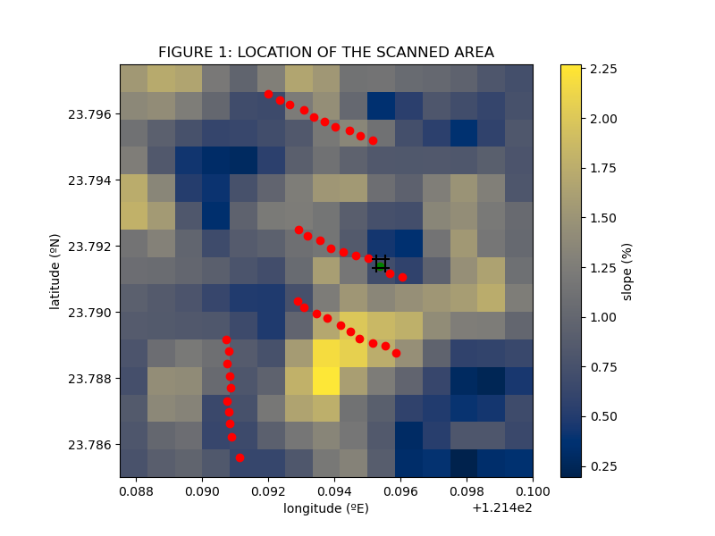

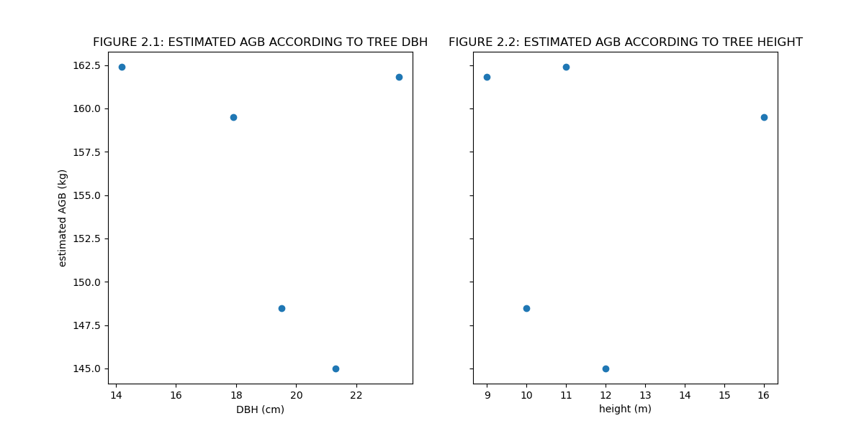

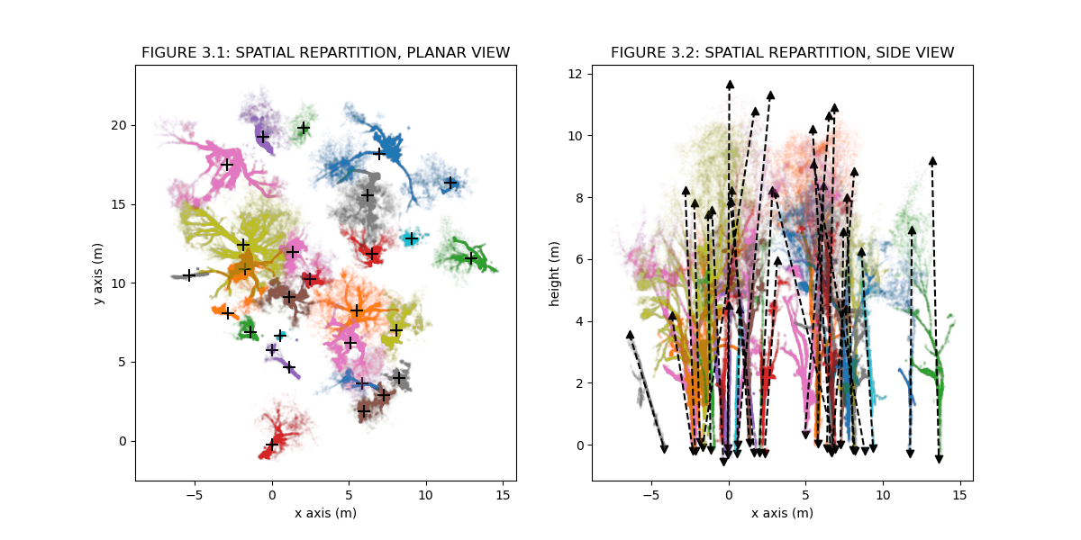

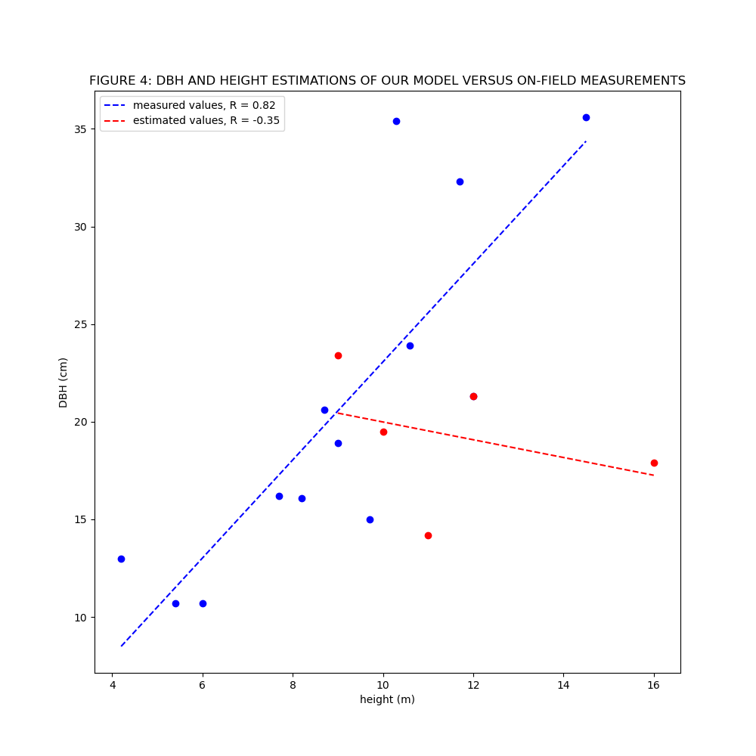

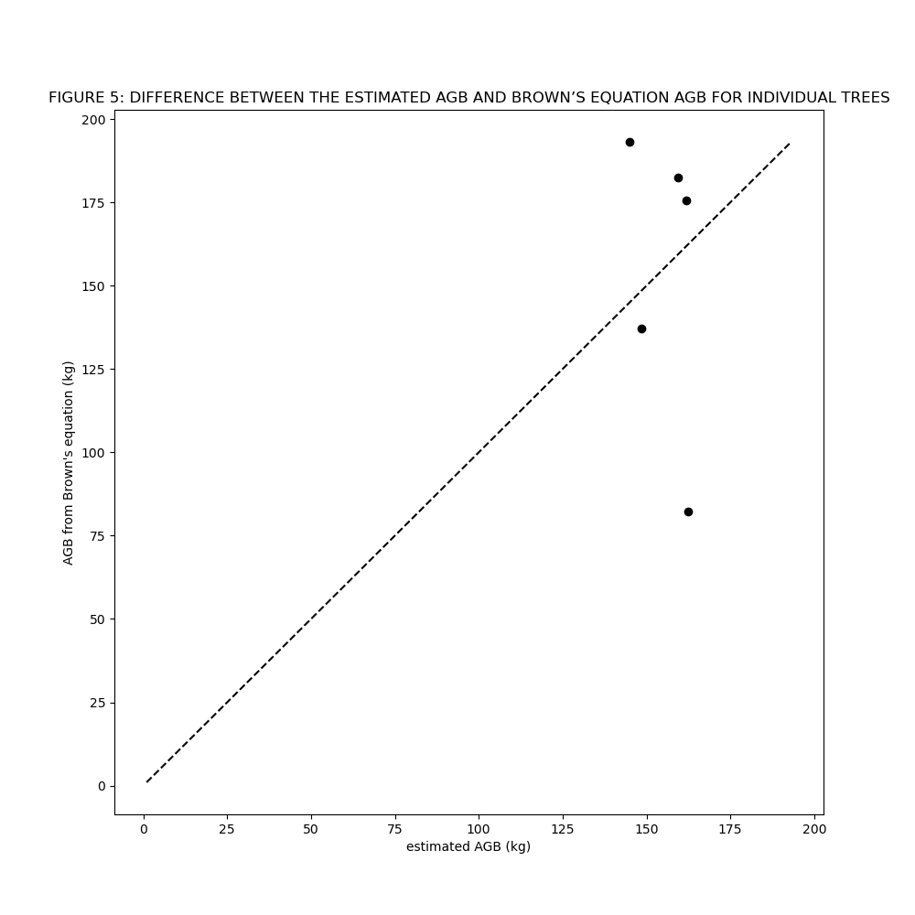

1. Chardon T. (2023). *Semi-automatic estimation of the tree biomass using terrestrial LiDAR data* [internship report]
2. *Ibid.*
3. <https://github.com/Thibalt-C/tree-biomass-estimator/>
4. Brown S., Gillespie A., Lugo A. (1989). “Biomass Estimation Methods for Tropical Forests with Applications to Forest Inventory Data”, *Forest Science*, 35, 881-902.