Deleterious alleles detection

GERP++
The main source of information is a github link!
https://www.biostars.org/p/9563600/

But luckily, there is Github repository:
https://github.com/tvkent/GERPplusplus

GERP
The Genomic Evolutionary Rate Profiling score (GERP) is used to identify and quantify conserved elements in a genome (Davydov et al., 2010). Conserved genomic regions are likely to be functionally important, as they have remained unchanged over long periods of evolutionary time. By aligning the genomic regions of multiple related species in a Multiple Sequence Alignment (MSA), we can calculate a rejected substitution score, difference between the number of observed substitutions and expected substitutions from Hardy-Weinberg equilibrium, and this score is the base of GERP. A high positive score indicates that fewer substitutions occurred than expected by chance, implying that the position is highly conserved and likely under strong selection. This is used to detect important regions in the genome, such as protein-coding exons or critical regulatory sequences. This score has been used to detect deleterious variants across genomes of 490 accessions of seed genebank to detect deleterious mutational changes in 7 germplasms collections (Fu, 2023).
The conda link of gerp is accessible here.
The Rejected Substitution (RS) score for each position describes the degree of conservation by selection pressure on a specific locus. It therefore indicates an important conserved region maintained.
RS score
The Rejected Substitution (RS) score quantifies how strongly evolution has constrained a given nucleotide position in a multiple sequence alignment of orthologous sequences.
The term "rejected substitution" comes from the difference between the number of substitutions expected under neutrality (if the position evolved without constraint) and the number actually observed in the alignment.
- Expected substitutions: This is the number of substitutions that would be expected to occur at the site if it were evolving neutrally (without selection). It depends on the phylogenetic tree and neutral mutation rates.
- Observed substitutions: The actual number of substitutions seen in the alignment.

RS score = Rejected Substitution score for each position.

RS score reflects how many substitutions were "rejected" by purifying selection, that is, how much less variable a site is than you'd expect if it were neutral. Hence the name.
The RS score helps us identify regions of the genome that are under purifying (negative) selection, places where mutations are being "rejected" by evolution because they would break something important.
Compare observed substitutions with expected neutral substitution rate in an Multiple Sequence Alignment (MSA) of orthologous genomic sequences.

RS=Expected Substitutions−Observed Substitutions

Positive RS Score (e.g., > 2 or 3) | Indicates evolutionary constraint, meaning the position is highly conserved and likely functionally important.  It means that expected substitutions > observed substitutions. There are less substitutions than expected, therefore selection pressure keeps this loci unchanged in a conserved region.
RS ≈ 0 | Suggests the position evolves neutrally, meaning no strong selection pressure.  The expected substitutions = observed substitutions. There is no selection pressure, the amount of substitution being not below or above the expected level of substitutions in a neutral evolution region.
Negative RS Score | Suggests accelerated evolution, possibly due to positive selection or relaxed constraint.  Expected substitutions < observed substitutions.  There are more substitutions than expected, which means this site was under selection pressure, but it has disappeared over time. Mutation is more tolerated than before.  It’s called “relaxed” because the strength of constraint (selection against mutation) is lower, not necessarily gone entirely.

Gerpcol (per-site RS score)
Compute RS scores for every position of each alignment.
Gerpcol requires an evolutionary tree and at least one multiple alignment file (in mfa format) to be processed. The output shows two columns: the substitution rate expected under the neutral model, and the observed substitution score. Per-site RS score is calculated with: RS = Neutral_Rate - Observed_Rate.

Gerpelem (Element score = per-segment RS score)
Given a rates file as output by gerpcol, gerpelem will find and report a list of elements that appear constrained beyond what is likely to occur by chance. But as repetitive elements fit that description, statistics are used to remove them.
The README.txt file of GERPplusplus is the main documentation on the software.
On Github, the documentation is here:
https://github.com/XDcat/GerpHelper/blob/master/gerp%2B%2BKRT_patch/README.md
The output file shows the Rejected Substitution (RS) score representing the total number of substitutions that would have been expected to occur in each segment following the neutral model minus the number of substitutions actually observed. RS score shows the “excess conservation” for each element.
The results of gerpcol are noisy and statistically not significant as a per-site value. Identifying conserved elements as a whole is statistically more robust.

GERP use in literature

Population genetic models of GERP scores suggest pervasive turnover of constrained sites across mammalian evolution (Huber et al., 2020)
Purpose:
The article uses population genetic models on vertebrate datasets to assess if the Genomic Evolutionary Profiling Rate (GERP) can be used to assess the strength of selection (N_{e}s), particularly to strength of purifying selection.
Findings suggest that for genes that have high turnover rate (genes that change rapidly), adding species does not change the statistical power of the analysis.
Method:
The specimens were 35 mammals data set aligned on the human reference genome (p.28/26).
The GERP score load for each specimen is the average GERP score across all derived variants for an individual.
Method used in comparative genomics to characterize sites under purifying selection.
Search sequences conserved across distantly related species, it is at its core a measure of conservation. It is the reduction of the number of substitutions in the MSA compared to neutral expectation. A score of 4 at a site shows that 4 more substitutions were expected using the neutral model than what is observed.
This article model pops under purifying selection to assess performance of GERP at detecting purifying selection under different scenarios.
- At individual coding mutations
- With different sequence turnover rates at noncoding sites
- Portion of the human genome under purifying selection (ca, on s’en balance sur des baits).
Results:
Deleterious mutations tend to have a more positive GERP score. The strength of the purifying selection (N_{e}s=strength of selection) is a function of the GERP score.
In the PNG data, there is no other way than comparative genomics, with GERP, to estimate N_{e}s. This article is important as it will allow us to use GERP score as a proxy for N_{e}s.
What is more intriguing is the rapid turnover at noncoding constrained sites.
Furthermore, it is directly stated that there are limitations of using comparative genomics for detecting deleterious mutations. It might be our angle of approach: staking different methods (ROH, HyPhy, GERP, and the SIFT mutation prediction) to identify potential deleterious alleles.

Prehistoric genomes reveal the genetic foundation and cost of horse domestication (Schubert et al., 2014).
Purpose:
For the part that interests me: they found association between inbreeding and excess of deleterious mutations.
However, I don’t understand for the moment what is the relation between GERP score (purifying selection) and inbreeding.
Method:
They give the GERP method and use p.8/9 of the publication. But a lot of information is given in the Results part (p.6/9). They seem to estimate mutation load with GERP score, which is strange. Let’s have a look in Appendix section S3 to understand.
Document is here /home/thibauld/Documents/Bioinformatics/Deleterious_alleles_pipeline/Deleterious_alleles_PNG/Litterature

S3 is p.61/121. They check that all the GERP sites are exons. I suppose we can check if the baits are matching exon during the blast?
Later they use the ancestral state using donkey data. Can we do the same using Hillebrandias data?
For them: measure of genetic load in an individual = GERP at each site * number of derived alleles carried by the individual at this site.
Taking the average of all these measures per individual, and it provides an estimated score of genetic load.
In a sense, it is making sense. On highly-conserved sites, alternate allele is probably deleterious. So checking the presence of one or two alternate allele at these sites and making a metrix of it is a good idea.

.

It seems that they operate with a methodology in three steps:
- Detecting high-GERP score sites. GERP > 4 strongly constrained site.
- Checking the genotype at the site: if heterozygous lightly deleterious, if homozygous highly deleterious.

They limit the analysis to polymorphic sites only. They put a threshold of -2 GERP score to be considered as under selection.
Results:
For GERP, in the paragraph ‘’Genetic Load as the Cost of Domestication’’ (p.6/9).

Detection deleterious alleles with GERP and prediction mutations with (Henn et al., 2016).
Relation between domestication, inbreeding, bottleneck, and GERP. (Marsden et al., 2016)

Identifying conserved regions with phylogenetic evolutionary rates (HyPhy)
Baseml is a tool of the Phylogenetic Analysis by Maximum Likelihood (PAML) package (Yang, 2007). It is used to estimate the evolutionary rates at different sites or along different branches of a phylogenetic tree based on a multiple sequence alignment. It provides estimates of the substitution rates at each site, which can vary depending on the evolutionary model used. May help to identify different parts of the genome under positive selection.
Polymorphism in these ancestral alleles is indicative of a possible deleterious mutation with high-effect, and might therefore be responsible for genetic load (Long et al., 2023).

Baseml is a bit outdated, and an alternative, Hyphy, is described p. 453 of (Salemi et al., 2009).
We can estimate the evolutionary rate of nonsynonymous/synonymous rate ratio ($ω=d_{N}/d_{S})$ with Hyphy, a package that detects part of the genome under positive selection.

Intersection conserved regions and sites under selection
The highly conserved sites maintained by selection are detected using the Rejected
Hyphy meme takes as input:
- MSA loci alignment rifles (.fna)
- A species tree file

Filtering the results by Minor Allele Frequencies
The conserved regions selected with intersection of GERP and baseml score are highly conserved, a variation in these sites is potentially highly deleterious. A method to ensure that the allele selected has a low occurrence and likely to be deleterious is to consider a very large set of haplotypes and select loci with a low Minor Allele Frequency (MAF). This method has been used to detect deleterious alleles in Cassava using a specific set of data called the Cassava HapMap. This data set included 241 Cassava accessions gathered in order to build an haplotype map (Long et al., 2023). This project has isolated 28 millions variants and gives access to a large range of different alleles across populations, and only the sites with a MAF lower than 20% were selected as potential deleterious alleles (Ramu et al., 2016).

Estimate the quantitative impact of deleterious mutations
The first step to understand the impact of potential deleterious mutations is to annotate the genomes at selected sites with tools such as Ensembl-Variant Effect Predictor (McLaren, 2016), which can even detect variants associated with loss of function (LOF).
To estimate the impact of each non-synonymous mutation in the sites identified as potentially deleterious, we can use the Sorting Intolerant from Tolerant (SIFT) algorithm to predict the effect of coding variants on protein function (Sim et al., 2012). RandomForest prediction model: A machine learning technique used for classification and regression that can handle complex interactions between variables. With the previous methods, we were using methods to tell if sites were deleterious or not. With the RandomForest model, we try to quantify the impact of each nonsynonymous mutation on phenotype (Long et al., 2023). We take conserved sites by baseml filtering. They use a RandomForest model to help determine which nonsynonymous mutations are functionally significant. We take the SIFT score from each of these sites to predict deleterious effects. UniRep deep learning technique can predict change in protein structure.

Genomic variant annotations and functional effect prediction
SnpEff and SnpSift
https://pcingola.github.io/SnpEff/

Installation of the tool: https://pcingola.github.io/SnpEff/download/
Annotation of the genome: https://pcingola.github.io/SnpEff/snpeff/introduction/#building-from-source

Two pre-existing databases: Cucumis mela, Cucumis sativus

Reads alignment and phylogenetic reconstruction methodology
We have not mapped the reads directly on B. masoniana genome, although we will use the annotations of this later, as we wished to construct a phylogeny using CAPTUS to build the MSA and filter out paralogous sequences.

- Baits pipeline
We use msa alignments and phylogenetic trees (from CAPTUS) to discover maintained loci under purifying selection on the Begonia baits.
- Get the evolutionary rate ($ω=d_{N}/d_{S})$ to detect loci under selection/purifying selection.
- Run the HyPhy pipeline to get the all_loci.csv output.
  - Run script_prunning_trees.sh to output gene_trees/${locus}_pruned.treefile
  - Run script_prunning_msa.sh to output cleaned_msa/${locus}_NOSTOP_prunned.fna
  - Run script_sync_msa_tree.sh to have the same number of taxa in msa and gene tree, and get the outputs in synced_msa and synced_trees.
  - Run script_hyphy.sh to output output_meme/${locus}.json
  - run script_extractMEMEcsv.sh to make the output dataframes in ./csv_extracted_MEME.
2. Get the GERP score/Rejected Substitution score (RS) to identify the conserved loci in the target genome.
- In the /GERP/GERP_PNG_ASTRAL folder, run the GERP pipeline (script_1_GERP_prepare.sh, script_2_GERP_array.sh, script_3_GERP_merge.sh) to get the regions under selection in the Begonia baits.
Input:
mfa_dir/*.mfa
Output:
all.mfa.rates.elems

II. Genome pipeline
We call variants on the B. masoniana genome (ROH pipeline) and annotate them with SIFT to predict mutation effects.

- Produce the VCF file for target samples and genome.
- Run my ROH pipeline with sequencing reads and the most complete genome possible (for which you have annotations for further steps). We get the all.vcf output. I added scripts to run the PNG data in an array to make the BAM files and individual VCF files.
- Run SIFT annotations software (snpEff) to annotate the variants with predicted effect of the mutations.
- In the /SIFT directory, run the script_build_database.sh script in the snpEff directory on the target genome annotations to generate a library of gene expressions.
- In the /SIFT directory, run the script_SIFT.sh in the SIFT directory to generate the VCF annotations from the all.vcf file and the library generated at the previous step. The output is the all_annotated.vcf file in the SIFT directory..
- Filter variants that are conserved sequences in the target group.
- Run the script_extract_variants_genregions.sh script to rename the headers of the VCF file and extract the variants contained in the intersection file, giving the bait_variants.vcf output.

III. Blast pipeline
We blast the baits on the B. masoniana genome, and keep unique results to calculate the exact location of the baits on this genome.

- Produce the list of matches with baits as query and B. masoniana genome as subject.
In the folder /blast_masoniana run the script_blast.sh to blast the Begonia baits on B. masoniana genome, results are then filtered in the second output.
Input:
/home/tmichel/projects/rbge/tmichel/reference_genomes/Bmas.fa
Intersected_baits.fasta
Output:
results_blast.csv
Results_filtered.csv
- In /Deleterious_alleles_github/baits_sequences we run the script script_baits_seq.sh to get the length of each Begonia bait in BED format. It will be useful in the IV. step.
Input:
Hannah_Begonia_baits_edited.fasta
Output:
baits_coordinates.csv
- Still in the /blast_masoniana directory, on a local computer, run the filtering_overlaping_blasts.ipynb to filter further the results of the blast, and to filter the unique location of the baits on the genome.
Input:
results_blast.csv
Output:
results_blast_best_per_cluster_Only_one_match.csv

IV. Merge pipeline
We calculate the location of the bait SNPs on the B.masoniana genome.
- In the folder /intersection_GERP_HyPhy_ASTRAL we run the intersection_GERP_HyPhy.ipynb script to calculate the location of conserved sequences on the baits from the results of Hyphy and GERP.
input:
/Hyphy/csv_extracted_MEME/all_loci.csv (step I.)
/GERP/GERP_PNG_ASTRAL/All.mfa.rates.elems (step I.)
/Deleterious_alleles_github/baits_sequences/baits_coordinates.csv (step III)
output:
intersection_GERP_HyPhy.bed
- In folder /Merge_pipeline, we use the script merge_pipeline.ipynb to map the conserved regions from the baits to the chromosomes of B. masoniana genome.
input:
intersection_GERP_HyPhy.bed (step IV.)
results_blast_best_per_cluster_Only_one_match.csv (step III.)
output:
Scaffold_conserved_loci.bed
- In the folder /conserved_SNPs we use the script script_conserved_SNPs.sh to discriminate which are the SNPs that are in conserved regions.
input:
/SIFT/all_annotated.vcf (step II.)
/Merge_pipeline/Scaffold_conserved_loci.bed (step IV.)
output:
filtered_in_regions.vcf

V. Data extraction pipeline
We now have the list of variants that are within conserved regions of the genome, maintained by purifying selection. We will extract the VCF and annotations info. We will try to isolate the samples having deleterious alleles “ON” and to quantify the high-SIFT/GERP number (I think I saw an article on the subject: search the notes and find it!!!).

Using Papua New Guinea data set model
This analysis can be quite robust as there are many samples (191 individuals and 60 species) which is important for the indices related to phylogenetic analysis.

For memory:
GERP detects conserved positions across species (deep evolutionary timescale).
HyPhy detects purifying selection at the codon level based on within-species or closely related species variation (shallower timescale).

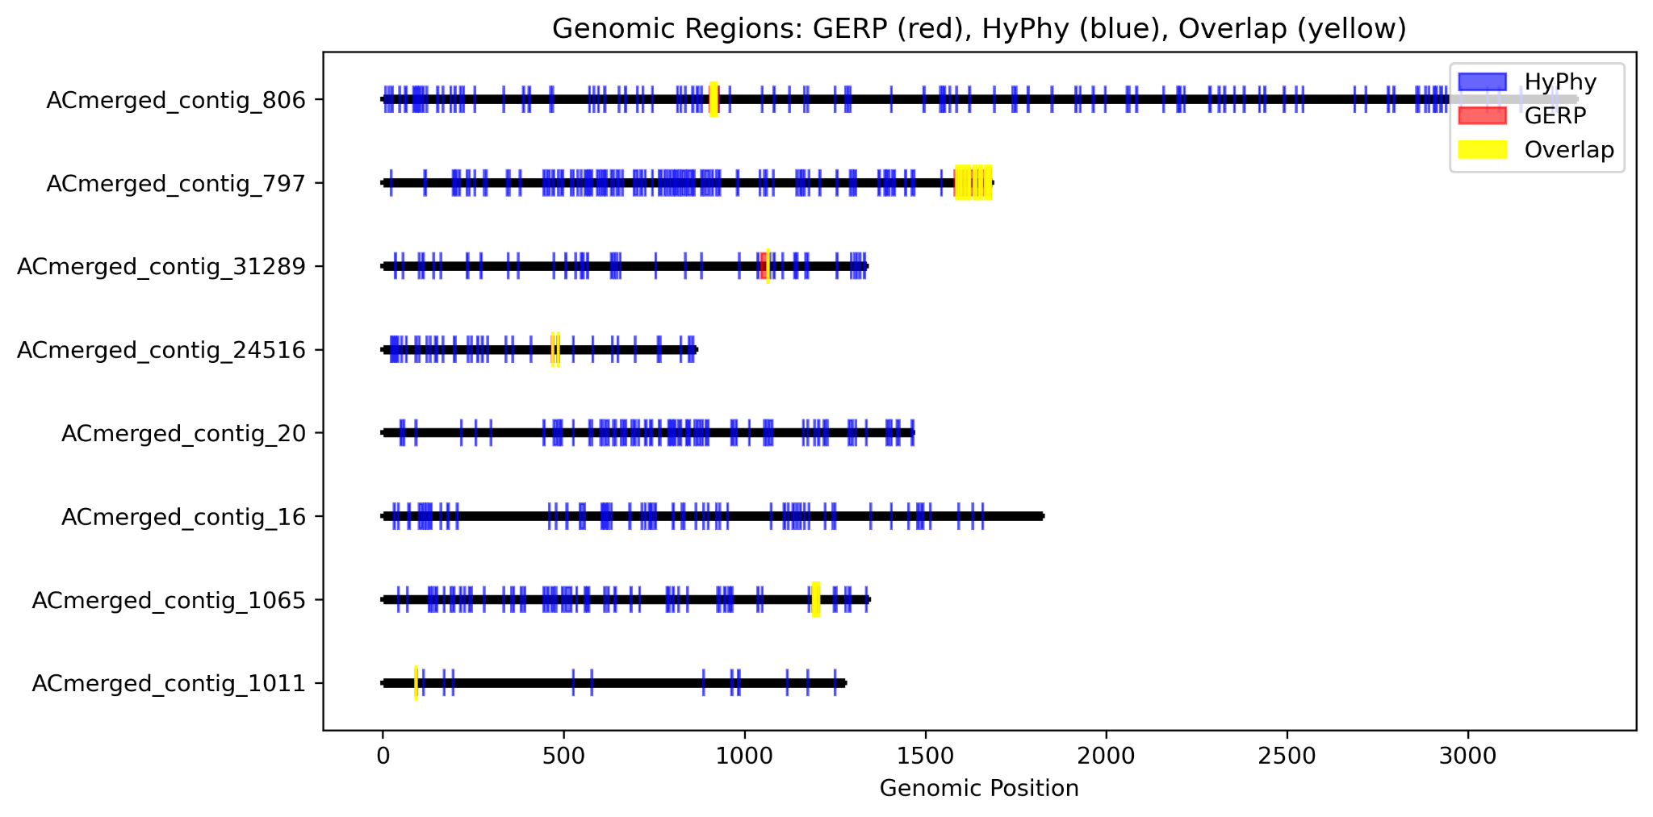
Fig. 1: GERP and Hyphy intersection with gene tree and species tree generated with ML method (Iqtree).

The PNG data set has 191 specimens. It provides sufficient power to Hyphy analysis (hyphy meme), as there will be a high number of segregating sites, with effective estimation of the evolutionary rate $ω=d_{N}/d_{S}$ (non-synonymous/synonymous substitutions), giving accurate detection of purifying selection.

A | 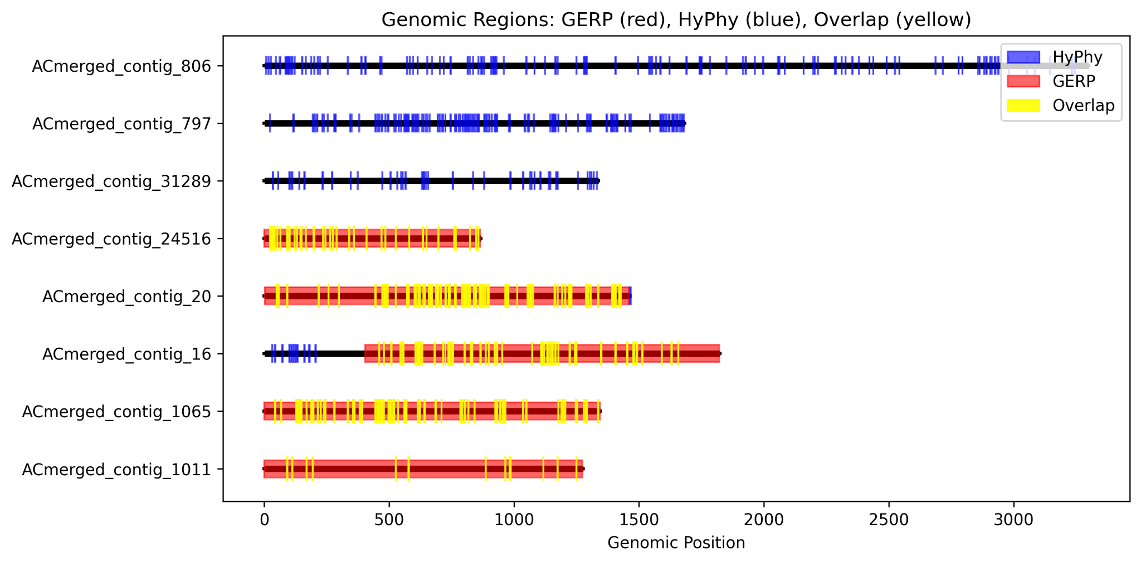
B | 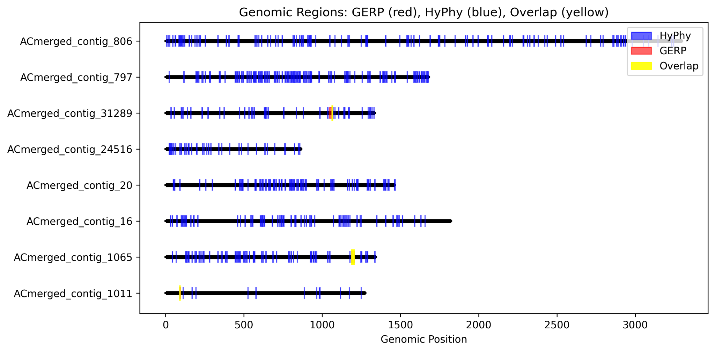
 | Fig. 2: GERP and Hyphy intersection with gene tree and species tree generated with ML-MSC methods (respectively FastTree-CAPTUS). (a) GERP sections are incorrect, as the ASTRAL tree was still in coalescent units, and not in substitutions. (b) GERP detected conserved loci comparable with Iqtree reconstructed phylogeny, using rescaled ML-MSC species tree.

Present advances of the project
A test has been made with a ML phylogenetic reconstruction (IQtree (species tree)). Results are shown on the figure above (Fig. 1).
The present stage of the project is to use a ML-MSC reconstructed phylogeny similar to the tree that Hannah WIlson has built (FastTree(gene trees)-ASTRAL(species tree)). Unfortunately, we must re-calibrate it with the ML method (Iqtree3) to replace the coalescent units of the MSC tree with a substitution rate for GERP computation to be significant (Fig. 2).

SnpEff and SnpSift
The reference website is here: https://pcingola.github.io/SnpEff/.

SnpEff is used to annotate a VCF file with the genes function and variants expression.
Using SnpEff requires a database. Unfortunately, Begonia and Hillebrandia databases do not exist yet.
https://pcingola.github.io/SnpEff/snpeff/build_db/
One alternative would be to use the database of Cucumis sativus, which is available.
Cucumis_sativus [https://snpeff.odsp.astrazeneca.com/databases/v5_3/snpEff_v5_3_Cucumis_sativus.zip, https://snpeff.odsp.astrazeneca.com/databases/v5_2/snpEff_v5_2_Cucumis_sativus.zip, https://snpeff.odsp.astrazeneca.com/databases/v5_1/snpEff_v5_1_Cucumis_sativus.zip, https://snpeff.odsp.astrazeneca.com/databases/v5_0/snpEff_v5_0_Cucumis_sativus.zip]

To make the database, we have a GFF file available in this directory:
~/projects/rbge/tmichel/reference_genomes directory
With these files here:
Bmas.pep Bmas.gff Bmas.fa Bmas.cds
In Step2, Option 3: Building a database from GFF files => NOT advised!
But we can use gffread to convert GFF in GTF.
# Via conda:
conda install -c bioconda gffread

# Convert GFF to GTF
gffread Bmas.gff -T -o Bmas.gtf

LOF mutations in Begonia quoted in literature
I would need one document of the paper "Genomic divergence and mutation load in the Begonia masoniana complex from limestone karsts" (Chen, 2024).

p.6 It is mentioned that a list of LOF mutations are given Fig. 4f (Venn chart) and Table S10.
p.6 it is mentioned that the phenotype association of LOF genes are Figs. S8, S9 and Tables S11 and S12.

The supplementary material is here:
https://www.sciencedirect.com/science/article/pii/S2468265924000507?via%3Dihub#appsec1

“Moreover, the results indicated that these LOF mutation genes were significantly associated with phosphate metabolism and DNA repair in the four species (Figs. S8 and S9; Tables S11 and S12).”

Using B. fluvialis and B. sublobata
With only 3 specimens, it is not possible to estimate the variation of dN and dS reliably, detection power of 0 for evolutionary rate (ω) . However, GERP seems independent of sample size if the samples are from different species.
GERP being the most informative index we have, the analysis of B. fluvialis and B. subobata seems possible.

—-------------------------------------------------------------------------------------------------

I am reaching out with a question regarding the genome annotations required to build a snpEff database.

As I understand it, the database must be based on the same reference genome used to generate the VCF/BED file submitted to snpEff. In my case, as with Jiaxi, this means I need to create a custom database.
The challenge is that I aligned my reads to the Begonia bait set, and I unsure wether it is possible to annotate this set without a broader genomic context, ideally entire chromosomes.

Do we have anything equivalent to a GFF file for the bait set? If not, my idea is to use an already well-anotated genome, blast the baits against it, and transfer annotations based on the hits.

I was hoping to use the B. masoniana genome from Li et al. (2022) as a reference, since it would allow me to compare the deleterious alleles I have identified with the ones reported in the Chen et al. (2024) article about the B. masoniana complex from limesto karsts. However, the genome available at CNGB does not seem to have been annotated (https://db.cngb.org/search/assembly/CNA0013975/).

Would you know which is currently our best-annotated Begonia genome?
##############################################################

Hi Thibauld,
All the baits are CDS, so a gff would cover each one.

Why not just use the B. masoniana genome and its annotation, mapping the captures directly to it. There is no need to extract the bait mapping regions separately – just work with the genome coverage you have

The B. masoniana gff is here:

~/projects/rbge/Begonia_genomes/Reference_Annotations/Bmas.gff
##############################################################
Thanks for the annotation file! Unfortunately, I used the baits reference sequences for my analysis, thinking it would be quicker to process and better suited to the target capture PNG data set.

Previously, I have identified potentially conserved sites under selection by intersecting two measures. The evolutionary rate (ω) from HyPhy to identify sites under purifying selection and the Genomic Evolutionary Rate Profiling score (GERP) from GERP++ to identify conserved regions are likely to be functionally important.

It tooks me two months to get the script working and obtain the results, since both Hyphy and GERP++ require all MSAs and gene trees. Now that I finally have the potential candidate sites (picture attached), I am a bit reluctant to start over if there is a quicker alternative.

But if my Blast solution is not working, I will bite the bullet and start from scratch with the B. masoniana genome.

##############################################################
Hi again Catherine,
The protocol I described below is designed to identify conserved sequences under selection in the Papua New Guinea dataset along with the Hillebrandia sample, and potentially to detect loss of function (LOF) mutations. I thought it would be a practical way to assess possible inbreeding in target capture datasets where we have only one sample per population and cannot rely on frequency-based tools (F-stats, D-stats, pop structure analysis, etc...).

I would also like to try this approach to B. fluvialis and B. sublobata. If we have BRAKER3 annotations for any of the genomes, as mentioned in Jiaxi research plan, I can still compare the LOF mutations identified by Chen in the Masoniana complex. I do not expect B. fluvialis or B. sublobata to have lost many essential genes, but they could be compared to Hillebrandia, where I expect a lot of losses.

I think the scope of this study is sufficiently distinct from the intended purpose of the data set (adaptation to riverine environment) so my project would not overlap with others. Let me know what you think of this, and whether this overlaps with anyone else's research.

Hi Thibauld,
This is interesting. There seem to be regions of purifying selection on all the genes in the bait set! I did not expect that. Does it report by chromosome – meaning it finds the best evidenced regions on each bait? Can you rank the baits by which they have the strongest signal?
Jiaxi did annotations for flu and sub and they are on cropdiversity in the reference_annotations folder.
Why do you expect Hillebrandia to have lost many essential genes? It does still function!
I think it’s the flexibility which it has lost in the bottle necks.
Will have another look at the ROH plots – lovely contrast between eh species there and I’m very happy for you to study this further.
Cheers
Catherine

##############################################################

Hi Catherine,
In the plot I sent to you, the yellow-highlighted intersections do not represent the region with the strongest signal for each bait, but rather the positions of the chromosomes where we have strong evidence for conserved regions likely under purifying selection.

To be more accurate:
- GERP (in red) indicates all the positions with fewer substitutions than expected under neutrality. I selected Rejected Substitution (RS) score threshold >2.5 , which may indicate evolutionary constraint).
- HyPhy (in blue) indicate codons under purifying selection based on the ratio of nonsynonymous on synonymous substitutions. I selected regions with a selection pressure ratio ω < 1.

I will get back to you soon with the list of the baits showing the strongest signal.

As you mentioned I think Hillebrandia may have lost adaptative potential due to fixed loci that are not necessarily deleterious alleles.
I think this pipeline could detect adaptative alleles still present in B. fluvialis and B. sublobata but no longer found in Hillebrandia. So, we might find loss of adaptative alleles, adaptative load, by comparison with these other species.
Nonetheless, I do not rule out the possibility of finding alleles that reduce fitness, deleterious alleles, that would not kill the plant but impair its performance.

Thank you for your support, I am looking forward to what we will find with the full genome analysis!

Comparison deleterious alleles with Beonia masoniana complex from limestone karsts

General question:
- Is the list of deleterious alleles available?

Related to demographic history:
- Could we reconstruct the demographic history of PNG Begonia?
- Is it possible as well for B.fluvialis and B.sublobata?
- Do we have enough markers with Begonia baits sets, or does it require WGS?

Reconstruction of demographic history with pairwise sequential Makovian coalescent (PSMC) model. Check with dadi using site frequency spectrum (SFS), with a group of 10 individuals min.
62 specimens in the article.

PSMC model

PSMC models the coalescent times between the two haplotypes in a diploid genome

Pairwise=to haplotypes. The PSMC model coalescent process between pairs of sequences.
Sequentially=model work along the genome with a sliding window.
Markovian: Markov property=state at given position depends only of the state at previous position. PSMC assumes the coalescent time process along the genome can be approximated by a Hidden Markov Model (HMM).
Coalescent=This refers to the coalescent theory, a mathematical model used in population genetics to trace genealogies backward in time. The coalescent process models how two lineages merge (coalesce) going back in time, which helps estimate past population sizes.

PSMC | - More related to population genomics than phylogenetics  - Ideally WGS  - Diploid seq or phased (based on heterozygous sites)  - High quality ref genome  - Use density and distribution of heterozygous sites across the genome, but no alleles frequencies. So, no need for several individuals.  - Coverage20-30x  - Masking repetitive regions  - Can it work with target capture? NO, too many gaps.
Site Frequency Spectrum (SFS)-based methods (Dadi)

!!!!! Multiple Sequentially Markovian Coalescent (MSMC) is the same method for several individuals!!!

Whole-genome methods:
Other whole-genome methods you might consider:

1. MSMC / MSMC2 (Multiple Sequentially Markovian Coalescent)
- Extends PSMC to multiple haplotypes (from multiple individuals).
- Can infer population size changes and split times.
- Still requires phased genomes and relatively high-quality whole-genome data.
- Works better with more samples but can provide insights beyond PSMC.

2. SMC++
- Like PSMC/MSMC but can use unphased data and multiple samples.
- Infers population size history from whole-genome sequences.
- More flexible with sample size, can incorporate multiple individuals without phasing.
- Can also estimate recent demography better than PSMC.

3. ROH-based methods
- Detects runs of homozygosity to quantify inbreeding and recent population size changes.
- Works on single or multiple genomes.
- Can be done with tools like PLINK, BCFtools roh, or ROHan (which also detects ROH and estimates heterozygosity).

4. Heterozygosity-based summaries
- Simple measures like genome-wide heterozygosity or local diversity can hint at population decline or inbreeding.
- Not as detailed as PSMC but informative for comparative purposes.

5. PSMC’ (PSMC prime) or diCal
- Variants/extensions of PSMC that can model more complex demographic scenarios.
- Require high-quality genome data.

Summary Table:
Method | Data needed | What it infers | Notes
PSMC | 1 diploid genome, WGS | Long-term population size history | Good for single samples
MSMC / MSMC2 | Multiple phased genomes | Population size + split times | Needs more samples, phasing
SMC++ | Multiple genomes, unphased | Population size history | Flexible, works better with samples
ROH detection | Single or multiple genomes | Inbreeding, recent decline | Detects homozygous stretches
Heterozygosity | Single genome | Simple diversity/inbreeding proxy | Easy to compute

Other methods cited in literature:
This article has been sent by Catherine to use our method in order to detect climate change-related demography changes. It quotes several articles using deleterious alleles detection. Check on them to get other methods, potentially non-alleles frequency methods.
(Rowan D. H. Barrett, 2025)

Litterature
Henn, B. M., Botigué, L. R., Peischl, S., Dupanloup, I., Lipatov, M., Maples, B. K., Martin, A. R., Musharoff, S., Cann, H., Snyder, M. P., Excoffier, L., Kidd, J. M., & Bustamante, C. D. (2016). Distance from sub-Saharan Africa predicts mutational load in diverse human genomes. Proceedings of the National Academy of Sciences, 113(4), E440–E449. https://doi.org/10.1073/pnas.1510805112
Huber, C. D., Kim, B. Y., & Lohmueller, K. E. (2020). Population genetic models of GERP scores suggest pervasive turnover of constrained sites across mammalian evolution. PLOS Genetics, 16(5), e1008827. https://doi.org/10.1371/journal.pgen.1008827
Long, E. M., Romay, M. C., Ramstein, G., Buckler, E. S., & Robbins, K. R. (2023). Utilizing evolutionary conservation to detect deleterious mutations and improve genomic prediction in cassava. Frontiers in Plant Science, 13, 1041925. https://doi.org/10.3389/fpls.2022.1041925
Marsden, C. D., Ortega-Del Vecchyo, D., O’Brien, D. P., Taylor, J. F., Ramirez, O., Vilà, C., Marques-Bonet, T., Schnabel, R. D., Wayne, R. K., & Lohmueller, K. E. (2016). Bottlenecks and selective sweeps during domestication have increased deleterious genetic variation in dogs. Proceedings of the National Academy of Sciences, 113(1), 152–157. https://doi.org/10.1073/pnas.1512501113
McLaren, W. (2016). The Ensembl Variant Effect Predictor.
Ramu, P., Esuma, W., Kawuki, R., Rabbi, I. Y., Egesi, C., Bredeson, J. V., Bart, R. S., Verma, J., Buckler, E. S., & Lu, F. (2016). Cassava HapMap: Masking deleterious mutations in a clonal crop species. https://doi.org/10.1101/077123
Rowan D. H. Barrett. (2025). Using herbarium collections to study genetic responses to global change. New Phytologist.
Salemi, M., Vandamme, A.-M., & Lemey, P. (Eds). (2009). The phylogenetic handbook: A practical approach to phylogenetic analysis and hypothesis testing (2nd ed). Cambridge University Press. https://doi.org/10.1017/CBO9780511819049
Schubert, M., Jónsson, H., Chang, D., Der Sarkissian, C., Ermini, L., Ginolhac, A., Albrechtsen, A., Dupanloup, I., Foucal, A., Petersen, B., Fumagalli, M., Raghavan, M., Seguin-Orlando, A., Korneliussen, T. S., Velazquez, A. M. V., Stenderup, J., Hoover, C. A., Rubin, C.-J., Alfarhan, A. H., … Orlando, L. (2014). Prehistoric genomes reveal the genetic foundation and cost of horse domestication. Proceedings of the National Academy of Sciences, 111(52), E5661–E5669. https://doi.org/10.1073/pnas.1416991111
Sim, N.-L., Kumar, P., Hu, J., Henikoff, S., Schneider, G., & Ng, P. C. (2012). SIFT web server: Predicting effects of amino acid substitutions on proteins. Nucleic Acids Research, 40(W1), W452–W457. https://doi.org/10.1093/nar/gks539
Yang, Z. (2007). PAML 4: Phylogenetic analysis by maximum likelihood. Molecular Biology and Evolution, 24(8), 1586–1591. https://doi.org/10.1093/molbev/msm088

