Begonia fluvialis deleterious alleles

Constrains

- No popgen as no alleles frequency, beside ROH
- Too few genomes for a pangenomic method. It’s more a draft graph for comparative purposes, not a full species-wide pangenome.
- HyPhy ω-ratio tests may be underpowered with so few sequences.
- With 8 samples, genotype–environment association is unlikely to have meaningful power.
- Having only Begoniaceae restrict the phylogenetic depth available for computing GERP conservation scores
- This set of data is usable to do what the proposal of Jiaxi was mentioning: calling structural variants, and comparing gene adaptation. We might as well capture deleterious alleles, but it would be overstepping in Catherine’s project (and I have still not heard about Jiaxi’s results). Better to focus on the PNG data set for the moment, and have a talk with Catherine later if I can help on B. fluvialis.

General scientific summary
Begonia fluvialis and Begonia sublobata are two closely related species endemic to Sumatra that exhibit distinct ecological preferences: B. fluvialis is specialized for riverine habitats, whereas B. sublobata occupies terrestrial environments. Previous studies have explored the genomic basis of riverine adaptation in B. fluvialis through comparative analyses with its sister species. Building on this foundation, the present research seeks to reconstruct the demographic history of the group and to identify both putatively deleterious variants and adaptive alleles that may have arisen as a consequence of the riverine specialization of B. fluvialis.
Furthermore, species from the Begonia masoniana karst complex exhibit loss-of-function (LOF) and other deleterious mutations (Chen et al., 2024). Comparing these patterns with those found in B. fluvialis and B. sublobata would be particularly informative, as these species may also have been shaped by demographic changes associated with their ecological adaptations.
Purpose

Significance
We are aware of the limitations of detecting deleterious or adaptive alleles without allele frequency data and population genetic tools. To mitigate this, we will treat each individual as an independent haplotype and incorporate geographical context, while recognizing that this cannot fully substitute for population-level analyses. In some cases, homozygosity for rare alleles at conserved functional sites may provide suggestive evidence of drift or reduced genetic diversity, though such inferences will be interpreted cautiously.
Another limitation is that using only Begoniaceae may restrict the phylogenetic depth available for computing GERP conservation scores, which are more powerful with broader evolutionary sampling. To address this, we will include data from Cucurbitaceae and other outgroups, thereby increasing the detection power of conserved sites.
Background
Previous works have investigated the genomic basis of speciation between the closely related Begonia species B. fluvialis and B. sublobata, which differ in leaf morphology and ecological adaptations in Sumatran habitats. Using PacBio, Illumina, and Nanopore sequencing data, the project has annotated and compared their genomes to identify gene family expansions, structural variants, SNPs, and indels that may underlie adaptation to riverine versus drier environments. Analyses had included synteny mapping, orthogroup comparisons, and mutation impact assessment, alongside intra-species variation studies to distinguish species-specific from shared polymorphisms. Functional enrichment tests have linked candidate genes to leaf development and water-related adaptations. Expected outputs include identifying genetic differences shaping ecological divergence and providing insights with both evolutionary and horticultural applications.

Research question and preliminary results
The samples have been sequenced with a whole genome sequencing (WGS) strategy, and include 3 samples of B. fluvialis, 2 samples of B. sublobata, 2 samples that are South American outgroups (B. plebeja and B. parviflora), and 1 genus outgroup, Hillebrandia sandwicensis.
Sample Average_depth_of_sequencing
Bflu_A39 22.3127
Bflu_A44 21.4643
Bflu_A47 20.084
Bsub_A49 19.9022
Bsub_A51 20.1521
B_parviflora 7.58966
B_pleb 6.49907
Hillebrandia 18.4525

With only 8 specimens available in this analysis, it is very limiting for robust inference of evolutionary rate (ω). There is no access to allele frequencies, nor to demographic reconstruction (no SFS method, dadi, MSMC2, SMC++).

However, GERP seems independent of sample size if the samples are from different species. GERP being the most informative index we have, the analysis of B. fluvialis and B. subobata seems possible.
But GERP works best with broad phylogenetic depth, low power for constraint detection with Begonia + Cucurbitaceae.
GERP works best with broad phylogenetic depth.
→ Using only Begonia + Cucurbitaceae helps, but if alignments are shallow, you’ll get low power for constraint detection.
→ Reviewers may want reassurance that the multiple sequence alignments are long enough and deep enough for reliable GERP scores.

Our central goal is:
- Detects signals of positive selection in some lineages and evidence of relaxed selection in others.
- Identify the accumulation of putative deleterious alleles and what are their potential phenotypical effects.
- Compare the deleterious alleles in this species compared to B. masoniana.

The article "Genomic divergence and mutation load in the Begonia masoniana
complex from limestone karsts" Chen, 2024 does mention a list of deleterious alleles, but the actual list itself is not in the main text. Instead, it is contained in the supplementary materials.

The authors identified loss-of-function (LOF) mutations and genes carrying homozygous deleterious mutations in the four Begonia species studied.
Specifically, they report that 435 genes in B. liuyanii, 467 in B. longgangensis, 668 in B. masoniana, and 96 in B. variegata were found with homozygous LOF mutations. Among these, B. masoniana had 533 unique LOF mutant genes.
These gene lists are provided in the Supplementary Tables (Table S10, and related functional annotations in Tables S11 and S12).

Supplementary data online at Plant Diversity https://doi.org/10.1016/j.pld.2024.04.001.

Previous work has revealed the Runs of Homozygosity (ROH) in these genomes, and will give some clues about what loci are homozygous and about the demographic history of the populations (Fig. 1).
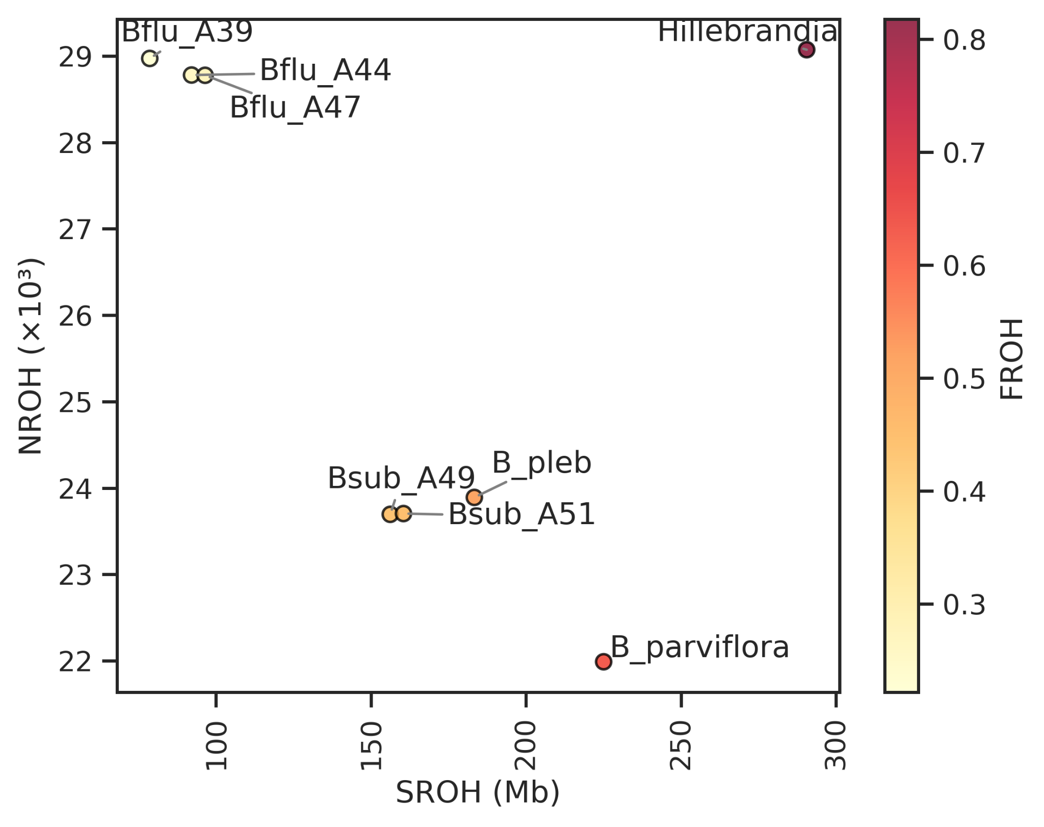
Fig. 1. ROH in the genome of WGS Begonia

Work plan
- Aligning the data
Reads will be aligned to the genome of B. masoniana to produce BAM file alignments (BWA) and variants will be called (GATK).
In parallel, the reads will be aligned in MSA (MAFFT), then each alignment will be separated by genes, and we will infer genes trees and species trees (IQTree).

- Detect positive and purifying selection
To identify lineages and genes that may have experienced adaptive evolution, we will test for signals of positive selection at multiple phylogenetic levels using codon-based models in HyPhy, and cross-validate key findings with codeml in PAML to reduce false positives.
In parallel, we will detect loci under purifying selection, which indicate functionally constrained regions. By intersecting these results with GERP conservation scores, we can highlight conserved genes where substitutions are likely to be functionally important. We will further assess these substitutions using in-silico predictors such as SIFT, which estimate the probability that an amino acid change is deleterious.
  - Branch-level: aBSREL tests whether particular branches experienced episodic diversifying selection. We will correlate results with phylogenetic placement and biogeographic patterns (e.g. lineages colonizing new environments).
  - Gene / gene-wide: BUSTED tests for evidence of positive selection across entire genes, pointing to loci that may have undergone adaptive shifts.
  - Site-level: MEME tests for individual sites under episodic positive selection, complementing site-based tests for pervasive selection (FEL/FUBAR). These site-level results can be cross-referenced with GERP scores to highlight variants of functional importance.
- Detecting relaxed selection
Genes experiencing reduced selective constraint may be more permissive to deleterious substitutions. Using HyPhy RELAX, we will test for relaxation or intensification of selection across specified branches, defined by phylogenetic or biogeographic hypotheses.

- Identifying deleterious alleles
Highly conserved sites are likely essential and under purifying selection. Non-synonymous substitutions at these positions are therefore strong candidates for functionally deleterious alleles. GERP scores identify sites with fewer substitutions than expected under neutrality, highlighting regions of evolutionary constraint. Because our current phylogeny includes only Begonia, conservation depth may be limited; to increase robustness, we will intersect GERP-identified sites with regions under purifying selection (MEME/FEL), thereby focusing on the most likely functionally constrained positions.
- Variants predictors
To assess the potential phenotypic impact of substitutions, we will apply in-silico predictors:
- SIFT (based on sequence conservation) to evaluate whether amino-acid changes are likely deleterious.
- PROVEAN (well-suited for non-model species when homologs are available) to complement SIFT predictions.
Mutations occurring at conserved sites with both a high GERP score and damaging predictions from SIFT/PROVEAN will provide strong evidence of functional impact.

Postdoctoral significance for the project.
References

Questions
What is the genetic load of every population studied?
What is the genetic divergence between populations? As the mutations accumulate, the population can become reproductively isolated (sometimes subpopulation parapatric speciation)? Are there cases of incoming allopatric speciation? (Chen et al., 2024)

Deleterious alleles frequencies
The concept of dominance is intrinsically related to genetic load and to the frequency of deleterious variants (Henn et al., 2015). A consequence of this impact is the inverse relationship between dominance and severity of mutations (Agrawal & Whitlock, 2011). The severity of the deleterious mutation is inversely proportional to h. Why? Deleterious variants with large-effects on phenotype have been purged by purifying selection, and are found in low frequency.

Identifying conserved regions with substitution rates
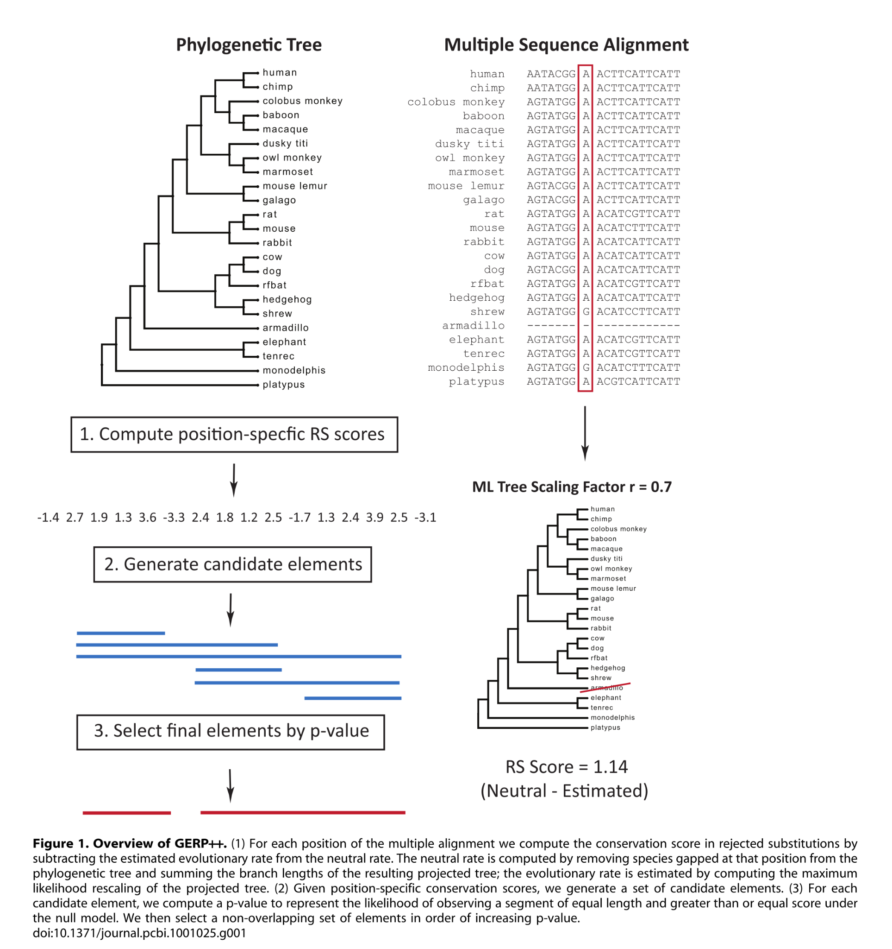
The Genomic Evolutionary Rate Profiling score (GERP) is used to identify and quantify conserved elements in a genome (Davydov et al., 2010). Conserved genomic regions are likely to be functionally important, as they have remained unchanged over long periods of evolutionary time. By aligning the genomic regions of multiple related species in a Multiple Sequence Alignment (MSA), we can calculate a rejected substitution score, difference between the number of observed substitutions and expected substitutions from Hardy-Weinberg equilibrium, and this score is the base of GERP. A high positive score indicates that fewer substitutions occurred than expected by chance, implying that the position is highly conserved and likely under strong selection. This is used to detect important regions in the genome, such as protein-coding exons or critical regulatory sequences. This score has been used to detect deleterious variants across genomes of 490 accessions of seed genebank to detect deleterious mutational changes in 7 germplasms collections (Fu, 2023).
The conda link of gerp is accessible here.
The Rejected Substitution (RS) score for each position describes the degree of conservation by selection pressure on a specific locus. It therefore indicates an important conserved region maintained.

Identifying conserved regions with phylogenetic evolutionary rates
Baseml is a tool of the Phylogenetic Analysis by Maximum Likelihood (PAML) package (Yang, 2007). It is used to estimate the evolutionary rates at different sites or along different branches of a phylogenetic tree based on a multiple sequence alignment. It provides estimates of the substitution rates at each site, which can vary depending on the evolutionary model used. May help to identify different parts of the genome under positive selection.
Polymorphism in these ancestral alleles is indicative of a possible deleterious mutation with high-effect, and might therefore be responsible for genetic load (Long et al., 2023).

Baseml is a bit outdated, and an alternative, Hyphy, is described p. 453 of (Salemi et al., 2009).
We can estimate the evolutionary rate of nonsynonymous/synonymous rate ratio ($ω=d_{N}/d_{S})$ with Hyphy, a package that detects part of the genome under positive selection.

Intersection conserved regions and sites under selection
The highly conserved sites maintained by selection are detected using the Rejected

Filtering the results by Minor Allele Frequencies

The conserved regions selected with intersection of GERP and baseml score are highly conserved, a variation in these sites is potentially highly deleterious. A method to ensure that the allele selected has a low occurrence and likely to be deleterious is to consider a very large set of haplotypes and select loci with a low Minor Allele Frequency (MAF). This method has been used to detect deleterious alleles in Cassava using a specific set of data called the Cassava HapMap. This data set included 241 Cassava accessions gathered in order to build an haplotype map (Long et al., 2023). This project has isolated 28 millions variants and gives access to a large range of different alleles across populations, and only the sites with a MAF lower than 20% were selected as potential deleterious alleles (Ramu et al., 2016).

Estimate the quantitative impact of deleterious mutations
The first step to understand the impact of potential deleterious mutations is to annotate the genomes at selected sites with tools such as Ensembl-Variant Effect Predictor (McLaren, 2016), which can even detect variants associated with loss of function (LOF).
To estimate the impact of each non-synonymous mutation in the sites identified as potentially deleterious, we can use the Sorting Intolerant from Tolerant (SIFT) algorithm to predict the effect of coding variants on protein function (Sim et al., 2012). RandomForest prediction model: A machine learning technique used for classification and regression that can handle complex interactions between variables. With the previous methods, we were using methods to tell if sites were deleterious or not. With the RandomForest model, we try to quantify the impact of each nonsynonymous mutation on phenotype (Long et al., 2023). We take conserved sites by baseml filtering. They use a RandomForest model to help determine which nonsynonymous mutations are functionally significant. We take the SIFT score from each of these sites to predict deleterious effects. UniRep deep learning technique can predict change in protein structure.

Genomic variant annotations and functional effect prediction
SnpEff and SnpSift
https://pcingola.github.io/SnpEff/

Installation of the tool: https://pcingola.github.io/SnpEff/download/
Annotation of the genome: https://pcingola.github.io/SnpEff/snpeff/introduction/#building-from-source

Two pre-existing databases: Cucumis mela, Cucumis sativus

Pipelines
- Run the HyPhy pipeline to get the all_loci.csv output.
Run the GERP pipeline to get the all.mfa.rates.elems output.
Run my ROH pipeline to get the all.vcf output.
- Run the intersec_GERP_hyphy.ipynb script to get the intersection between HyPhy and GERP in the intersection_GERP_HyPhy.bed file. A plot Genomic_Regions_all_intersections.png is generated as well.
- Run the script_extract_variants_genregions.sh script to rename the headers of the VCF file and extract the variants contained in the intersection file, giving the bait_variants.vcf output.

I am reaching out with a question regarding the genome annotations required to build a snpEff database.

As I understand it, the database must be based on the same reference genome used to generate the VCF/BED file submitted to snpEff. In my case, as with Jiaxi, this means I need to creaate a custom database.
The challenge is that I aligned my reads to the Begonia bait set, and I unsure wether it is possible to annotate this set without a broader genomic context, ideally entire chromosomes.

Do we have anything equivalent to a GFF file for the bait set? If not, my idea is to use an already well-anotated genome, blast the baits against it, and transfer annotations based on the hits.

I was hoping to use the B. masoniana genome from Li et al. (2022) as a reference, since it would allow me to compare the deleterious alleles I have identified with the ones reported in the Chen et al. (2024) article about the B. masoniana complex from limesto karsts. However, the genome available at CNGB does not seem to have been annotated (https://db.cngb.org/search/assembly/CNA0013975/).

Would you know which is currently our best-annotated Begonia genome?
##############################################################

Hi Thibauld,
All the baits are CDS, so a gff would cover each one.

Why not just use the B. masoniana genome and its annotation, mapping the captures directly to it. There is no need to extract the bait mapping regions separately – just work with the genome coverage you have

The B. masoniana gff is here:

~/projects/rbge/Begonia_genomes/Reference_Annotations/Bmas.gff
##############################################################
Thanks for the annotation file! Unfortunately, I used the baits reference sequences for my analysis, thinking it would be quicker to process and better suited to the target capture PNG data set.

Previously, I have identified potentially conserved sites under selection by intersecting two measures. The evolutionary rate (ω) from HyPhy to identify sites under purifying selection and the Genomic Evolutionary Rate Profiling score (GERP) from GERP++ to identify conserved regions are likely to be functionally important.

It tooks me two months to get the script working and obtain the results, since both Hyphy and GERP++ require all MSAs and gene trees. Now that I finally have the potential candidate sites (picture attached), I am a bit reluctant to start over if there is a quicker alternative.

But if my Blast solution is not working, I will bite the bullet and start from scratch with the B. masoniana genome.

##############################################################
Hi again Catherine,
The protocol I described below is designed to identify conserved sequences under selection in the Papua New Guinea dataset along with the Hillebrandia sample, and potentially to detect loss of function (LOF) mutations. I thought it would be a practical way to assess possible inbreeding in target capture datasets where we have only one sample per population and cannot rely on frequency-based tools (F-stats, D-stats, pop structure analysis, etc...).

I would also like to try this approach to B. fluvialis and B. sublobata. If we have BRAKER3 annotations for any of the genomes, as mentioned in Jiaxi research plan, I can still compare the LOF mutations identified by Chen in the Masoniana complex. I do not expect B. fluvialis or B. sublobata to have lost many essential genes, but they could be compared to Hillebrandia, where I expect a lot of losses.

I think the scope of this study is sufficiently distinct from the intended purpose of the data set (adaptation to riverine environment) so my project would not overlap with others. Let me know what you think of this, and whether this overlaps with anyone else's research.

Hi Thibauld,
This is interesting. There seem to be regions of purifying selection on all the genes in the bait set! I did not expect that. Does it report by chromosome – meaning it finds the best evidenced regions on each bait? Can you rank the baits by which they have the strongest signal?
Jiaxi did annotations for flu and sub and they are on cropdiversity in the reference_annotations folder.
Why do you expect Hillebrandia to have lost many essential genes? It does still function!
I think it’s the flexibility which it has lost in the bottle necks.
Will have another look at the ROH plots – lovely contrast between eh species there and I’m very happy for you to study this further.
Cheers
Catherine

##############################################################

Hi Catherine,
In the plot I sent to you, the yellow-highlighted intersections do not represent the region with the strongest signal for each bait, but rather the positions of the chromosomes where we have strong evidence for conserved regions likely under purifying selection.

To be more accurate:
- GERP (in red) indicates all the positions with fewer substitutions than expected under neutrality. I selected Rejected Substitution (RS) score threshold >2.5 , which may indicate evolutionary constraint).
- HyPhy (in blue) indicate codons under purifying selection based on the ratio of nonsynonymous on synonymous substitutions. I selected regions with a selection pressure ratio ω < 1.

I will get back to you soon with the list of the baits showing the strongest signal.

As you mentioned I think Hillebrandia may have lost adaptative potential due to fixed loci that are not necessarily deleterious alleles.
I think this pipeline could detect adaptative alleles still present in B. fluvialis and B. sublobata but no longer found in Hillebrandia. So, we might find loss of adaptative alleles, adaptative load, by comparison with these other species.
Nonetheless, I do not rule out the possibility of finding alleles that reduce fitness, deleterious alleles, that would not kill the plant but impair its performance.

Thank you for your support, I am looking forward to what we will find with the full genome analysis!

Comparison deleterious alleles with Beonia masoniana complex from limestone karsts

General question:
- Is the list of deleterious alleles available?

Related to demographic history:
- Could we reconstruct the demographic history of PNG Begonia?
- Is it possible as well for B.fluvialis and B.sublobata?
- Do we have enough markers with Begonia baits sets, or does it require WGS?

Reconstruction of demographic history with pairwise sequential Makovian coalescent (PSMC) model. Check with dadi using site frequency spectrum (SFS), with a group of 10 individuals min.
62 specimens in the article.

PSMC model

PSMC models the coalescent times between the two haplotypes in a diploid genome

Pairwise=to haplotypes. The PSMC model coalescent process between pairs of sequences.
Sequentially=model work along the genome with a sliding window.
Markovian: Markov property=state at given position depends only of the state at previous position. PSMC assumes the coalescent time process along the genome can be approximated by a Hidden Markov Model (HMM).
Coalescent=This refers to the coalescent theory, a mathematical model used in population genetics to trace genealogies backward in time. The coalescent process models how two lineages merge (coalesce) going back in time, which helps estimate past population sizes.

PSMC | - More related to population genomics than phylogenetics  - Ideally WGS  - Diploid seq or phased (based on heterozygous sites)  - High quality ref genome  - Use density and distribution of heterozygous sites across the genome, but no alleles frequencies. So, no need for several individuals.  - Coverage20-30x  - Masking repetitive regions  - Can it work with target capture? NO, too many gaps.
Site Frequency Spectrum (SFS)-based methods (Dadi)

!!!!! Multiple Sequentially Markovian Coalescent (MSMC) is the same method for several individuals!!!

Whole-genome methods:
Other whole-genome methods you might consider:

1. MSMC / MSMC2 (Multiple Sequentially Markovian Coalescent)
- Extends PSMC to multiple haplotypes (from multiple individuals).
- Can infer population size changes and split times.
- Still requires phased genomes and relatively high-quality whole-genome data.
- Works better with more samples but can provide insights beyond PSMC.

2. SMC++
- Like PSMC/MSMC but can use unphased data and multiple samples.
- Infers population size history from whole-genome sequences.
- More flexible with sample size, can incorporate multiple individuals without phasing.
- Can also estimate recent demography better than PSMC.

3. ROH-based methods
- Detects runs of homozygosity to quantify inbreeding and recent population size changes.
- Works on single or multiple genomes.
- Can be done with tools like PLINK, BCFtools roh, or ROHan (which also detects ROH and estimates heterozygosity).

4. Heterozygosity-based summaries
- Simple measures like genome-wide heterozygosity or local diversity can hint at population decline or inbreeding.
- Not as detailed as PSMC but informative for comparative purposes.

5. PSMC’ (PSMC prime) or diCal
- Variants/extensions of PSMC that can model more complex demographic scenarios.
- Require high-quality genome data.

Summary Table:
Method | Data needed | What it infers | Notes
PSMC | 1 diploid genome, WGS | Long-term population size history | Good for single samples
MSMC / MSMC2 | Multiple phased genomes | Population size + split times | Needs more samples, phasing
SMC++ | Multiple genomes, unphased | Population size history | Flexible, works better with samples
ROH detection | Single or multiple genomes | Inbreeding, recent decline | Detects homozygous stretches
Heterozygosity | Single genome | Simple diversity/inbreeding proxy | Easy to compute

Other methods cited in literature:
This article has been sent by Catherine to use our method in order to detect climate change-related demography changes. It quotes several articles using deleterious alleles detection. Check on them to get other methods, potentially non-alleles frequency methods.
(Rowan D. H. Barrett, 2025)

Litterature

Agrawal, A. F., & Whitlock, M. C. (2011). Inferences about the distribution of dominance drawn from yeast gene knockout data. Genetics, 187(2), 553–566. https://doi.org/10.1534/genetics.110.124560
Chen, Y., Dong, L., Yi, H., Kidner, C., & Kang, M. (2024). Genomic divergence and mutation load in the Begonia masoniana complex from limestone karsts. Plant Diversity, S2468265924000507. https://doi.org/10.1016/j.pld.2024.04.001
Davydov, E. V., Goode, D. L., Sirota, M., Cooper, G. M., Sidow, A., & Batzoglou, S. (2010). Identifying a high fraction of the human genome to be under selective constraint using GERP++. PLoS Computational Biology, 6(12), e1001025. https://doi.org/10.1371/journal.pcbi.1001025
Fu, Y.-B. (2023). Deleterious and Adaptive Mutations in Plant Germplasm Conserved Ex Situ.
Henn, B. M., Botigué, L. R., Bustamante, C. D., Clark, A. G., & Gravel, S. (2015). Estimating the mutation load in human genomes. Nature Reviews Genetics, 16(6), 333–343. https://doi.org/10.1038/nrg3931
Long, E. M., Romay, M. C., Ramstein, G., Buckler, E. S., & Robbins, K. R. (2023). Utilizing evolutionary conservation to detect deleterious mutations and improve genomic prediction in cassava. Frontiers in Plant Science, 13, 1041925. https://doi.org/10.3389/fpls.2022.1041925
McLaren, W. (2016). The Ensembl Variant Effect Predictor.
Ramu, P., Esuma, W., Kawuki, R., Rabbi, I. Y., Egesi, C., Bredeson, J. V., Bart, R. S., Verma, J., Buckler, E. S., & Lu, F. (2016). Cassava HapMap: Masking deleterious mutations in a clonal crop species. https://doi.org/10.1101/077123
Rowan D. H. Barrett. (2025). Using herbarium collections to study genetic responses to global change. New Phytologist.
Salemi, M., Vandamme, A.-M., & Lemey, P. (Eds). (2009). The phylogenetic handbook: A practical approach to phylogenetic analysis and hypothesis testing (2nd ed). Cambridge University Press. https://doi.org/10.1017/CBO9780511819049
Sim, N.-L., Kumar, P., Hu, J., Henikoff, S., Schneider, G., & Ng, P. C. (2012). SIFT web server: Predicting effects of amino acid substitutions on proteins. Nucleic Acids Research, 40(W1), W452–W457. https://doi.org/10.1093/nar/gks539
Yang, Z. (2007). PAML 4: Phylogenetic analysis by maximum likelihood. Molecular Biology and Evolution, 24(8), 1586–1591. https://doi.org/10.1093/molbev/msm088

