Convolutional Neural Network for Apple-spotting: App-lying EfficientNet for Enhancing Surface Quality Detection in Color Space

Gillard Thibault   
2022

Massey University, Palmerston North, New Zealand

Abstract

The agri-food industry has to comply with ever stricter standards regarding the safety of fruit production. In addition, the correct classification of rotten and unrotten fruit has a significant economic impact. Generally, damaged apples produce ethylene, which can lead to mold on the surrounding fruit. Efficient classification is therefore of direct economic and ecological benefit and helps to meet the standards

“Keywords : “CNN, deep learning, apple, classification“

1. Introduction

The agri-food industry has to comply with ever stricter standards regarding the safety of fruit production. In addition, the correct classification of rotten and unrotten fruit has a significant economic impact. Generally, damaged apples produce ethylene, which can lead to mold on the surrounding fruit. Efficient classification is therefore of direct economic and ecological benefit and helps to meet the standards.

The classic non-invasive solution for apple inspection is usually to use human vision. One of the main problems with sorting apples manually is the inconsistency of human inspection:  human inspectors are subjective and susceptible to fatigue, moreover, their efficiency depends on their personal capacity and experience. This means that accuracy is strongly variable when sorting apples manually. In addition, sorting apples manually is a very time-consuming process, which can lead to increased production costs.

Studies have been conducted to investigate the feasibility of automating the process of sorting apples in order to address this issue. The number of studies seeking to automate sorting apples with computer vision has increased in recent years, as the demand for safe and consistent food inspection has increased. However, the proposed solutions are effective for size, shape, and color, but they could be more practical for the detection of minor, non-obvious defects, which still require a second manual inspection. Distinguishing between the stem, the calyx, and a defect requires a more sophisticated approach to reach satisfying results.

This article has taken the direction of machine learning in order to address these issues. The use of machine learning algorithms for apple classification is a promising area of research that has the potential to improve the efficiency and accuracy of fruit inspection.

Convolutional Neural Networks (CNN) is the most popular form of computer vision. Convolution layers are employed to reduce the computational overhead when extracting patterns from an image, which can then be analyzed by fully connected layers for the purpose of classification.

New CNNs with adaptive architecture can now scale up to achieve higher performance than classic CNNs. Based on this improvement, the neural network EfficientNet has the ability to optimize its neural architecture on all three dimensions: depth, width, and resolution by using a compound coefficient. EfficientNet has been designed to optimize the network’s accuracy while using fewer parameters, thereby allowing for improved performance using fewer resources.

The article presents the outcomes of a model constructed using this architecture on 4 apple varieties. This was accompanied by tuning of hyperparameters and augmenting the training data to reduce the overfitting of the model and expand the base dataset.

2. Related Works:

3. Dataset :

Origin of the dataset

This paper builds on the 2011 study by Michael Caulton at Massey University, which sought to evaluate the efficacy of the Sobel filter and islanding routine in detecting regions of interest on apple skin. The aim was to classify the images into four distinct categories: stems, calyxes, default, and nothing. This research entailed laborious efforts to build an extensive database of images to be classified into the aforementioned categories for four apple varieties.

DataSet description

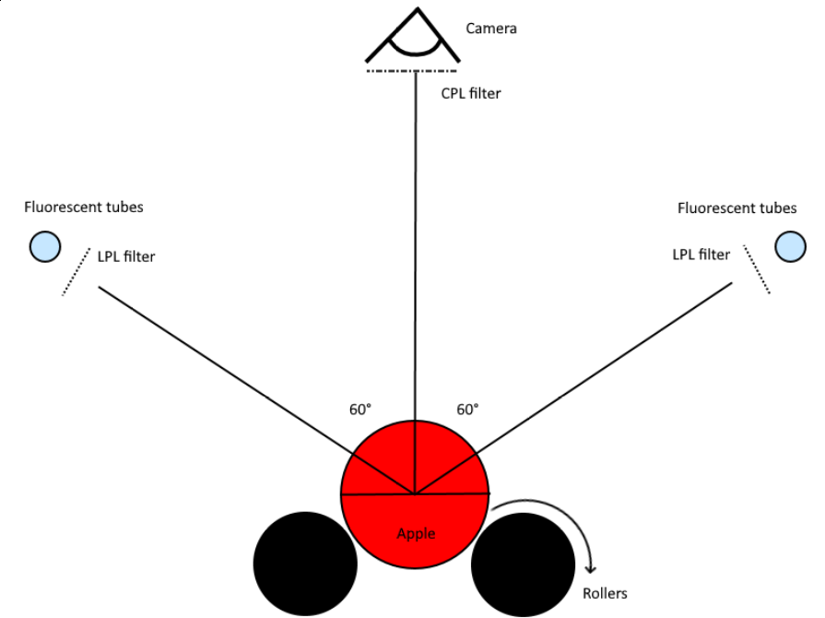

Figure 1 Capture disposition

-Light Source

Two Philips TLD 36W/865 fluorescent lights were positioned at a 60-degree angle to the horizontal axis to maximize the illumination of the apples. Linear polarising filters were added to the light sources to minimize specular reflections caused by the industrial waxing of the apples. Images were taken in a completely dark room to eliminate any interference from external light sources.

- Camera

Images were captured with a Logitech Quickcam 9000 Pro at a resolution of 960x720 pixels. Additionally, a Marumi 28 mm circular polarizing filter was applied to reduce specular reflections.

-Setting up

The apple is placed on 65mm diameter rollers, which are rotated for 2 seconds. This duration ensures that a medium-sized apple makes a complete revolution. During this time, the 15 frames per second camera is able to capture 30 pictures of the apple. This roller system is analogous to those used in the food industry. In a practical context, three cameras, each positioned at an angle of 60° relative to the apple's centre, would be required to capture the entire surface of the apple. Nonetheless, this study focuses on the classification of the apple images rather than on the apple itself and the classification model created is theoretically applicable to the three cameras.

This device enabled the creation of a library of 20,880 images that were derived from 696 apples of 4 distinct varieties.

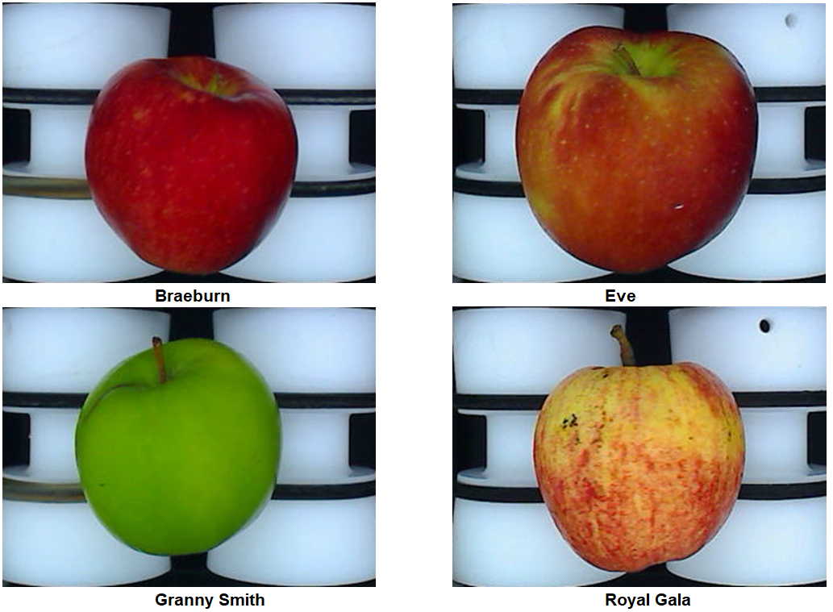

Number of images

|  |  |  |  |  |  |
| --- | --- | --- | --- | --- | --- |
|  | Braeburn | Eve | Granny Smith | Royal Gala | Total |
| Number of Apples | 154 | 198 | 190 | 154 | 696 |
| Number of images | 4,620 | 5,940 | 7,700 | 4,620 | 20,880 |

Studying a circular region was desirable for surface analysis due to the reduced amount of overlap when three cameras were utilized, ultimately conserving computing resources. Additionally, this methodology accounted for the fact that light intensity varies on a spherical object in a radial fashion, which is something that convolutional neural networks (CNNs) are not as sensitive to.

For the same reasons and to leverage the effort spent on manually classifying the 20,880 images, the region of the apple to be analysed and classified will be limited to a length that is equivalent to 50% of the fruit's diameter. This study will differ from the previous one in that the analyzed area is a square. The use of convolution filter requires the use of rectangular areas, but this should not have an effect on the CNN's performance, as there is no indication that radial variations of light intensity have any influence.

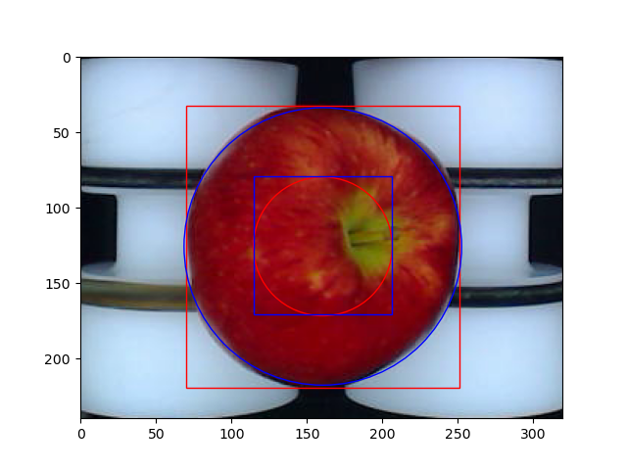

The analysis area was increased by 27.3% by utilizing a square as the area to be analysed. This necessitates a re-evaluation of the classification of the images due to the potential new elements in the additional area, and thus, the angles. Therefore, modifications have been made to the dataset such as the removal of blurred images, favoring quality over size.

|  |  |  |  |  |  |
| --- | --- | --- | --- | --- | --- |
| Number of images | Nothing | Stem | Calyx | Defect | Total |
| Braeburn | 3355 | 726 | 652 | 575 | 5308 |
| Eve | 2618 | 442 | 521 | 570 | 4151 |
| Granny Smith | 2599 | 750 | 515 | 919 | 4783 |
| Royal Gala | 2984 | 590 | 541 | 474 | 4589 |
|  |  |  |  |  | 18831 |

1. Prise de recul
2. Conclusion

**Remerciements**

**Table des illustrations**

Figure 1 Consommation d'énergie totale et la production d'électricité en 2020 1

Figure 2 Production d'électricité en France 1

Figure 3 Schéma d’un barrage 2

Figure 4 Schémas du barrage de Gignac 2

Figure 5 Conversion d’énergie 2

Figure 6 Multiplicateur-Générateur 3

Figure 7 Turbine Kaplan 3

Figure 8 abaque 3

Figure 9 Barrage de Gignac 2007 4

Figure 10 Hauteur de l'eau en 2020 4

Figure 11 Hauteur d'eau moyenne mensuelle en 2020 4

Figure 12 Débit et Puissance mensuels moyens en 2020 4

Figure 13 Puissance mensuelle moyenne en 2020 5