Functional Requirement Specification

# Abstract

## Project context

The objective of this project is to develop an application in JAVA language. The purpose of the project is an IRC chat with requirements dictated by a customer.

## Aim of the document

The FRS is a document aim of which is to list all the requirements specified by the customer in the form of atomic functionality. That is the functionality can’t be more specific.

# Reference Documents and Convention

## 2.1) Reference documents

A Project Management Plan, document in which is described the management of the project (Project description, planning, tasks …).

A Design Input Review to present the principal technic functionalities and the organization of the project. And from this presentation agree on the technic choices to realize the project.

A Software Design Description to explain how the application technically works.

A Validation Test Preview which list all the tests to do.

A Validation Test Report which described the results of the tests.

A Project Tracking Report to keep a written record of the progress of the project.

A coding convention

## 2.2) Convention

See Coding Convention

# Terminology

## 3.1) Definitions

## 3.2) Acronyms

DIR: Design Input Review

FRS: Functional Requirement Specification

PMP: Project Management Plan

PTR: Project Tracking Report

SDD: Software Design Description

VTP: Validation Test Preview

VTR: Validation Test Report

JMS: Java Messaging Service

# Overview

## 4.1) Use Cases

Two types of users, a classic user (User) and an administrator (Main_Admin). List of the functionalities which do by an actor.

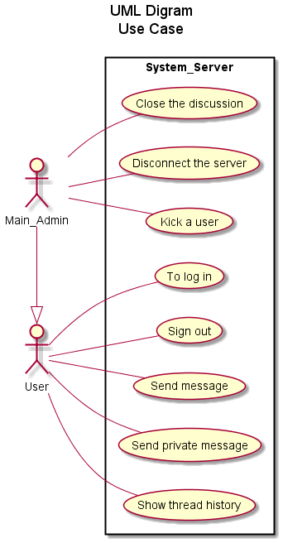

## 4.2) Solution breakdown

|  |  |
| --- | --- |
| Team Member | Role in the team |
| SARROBERT Thibault | Project Manager |
| ROMAN Olivier | Architect |
| ORTEGA Pablo | Developer |
| MOREAU Maxime | Tester Validator |

# Functional Requirements

See requirements document in which there is a list of the requirements with their domain, their ID and their status (optional or mandatory).

# Validation

20% of the source code should be tested automatically. Then the source code should be manually tested in its entirety.

We authorized ourselves 5% non-functionality on the application.

There is two documents for the validation, the VTP and VTR.

# Packaging and deliverables

The application will be shipped in the form a jar executable which launching with bat script. This seems the best way to launch the application with it configurable files.

So you have to run the bat script to launch the application.

# Installation software requirements

The customer has just need the jar executable and the bat script to lunch the application.

# Installation and deployment requirements

The customer must Windows 10 system, version 32 or 64 bits with 500Mo of RAM minimum. And the server will run under Ubuntu 16.

# Operational and Maintenance requirements

## 10.1) Scalability

## 10.2) High Availability and backup

There are two server available to users, and they can send messages on one of the servers. The JMS is used like a stack in which will be saved the historic of the discussion (the last 10 messages). The both servers having access to the JMS, so the users connected on a different server can send messages between us.  
If one of the two server crashes, the client tries to reconnect to the both servers alternatively every 5 seconds for 2 minutes. Once reconnected, the client has the historic of the conversion and he can continue to use the application normally.

If the reconnection failed, the client is disconnected from there servers.

When the server that has fallen is restarted, it must load the data from the JMS.

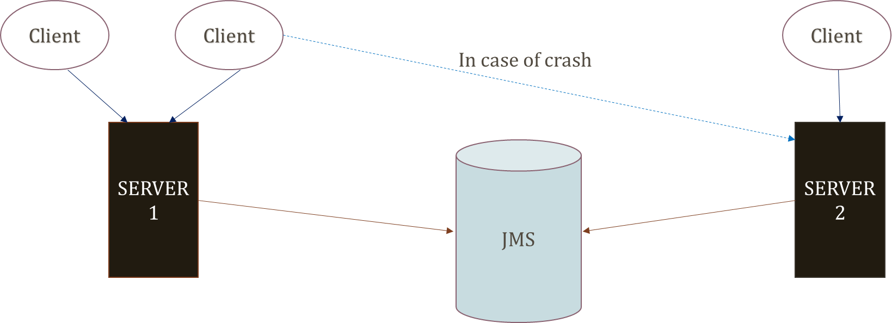

## 10.3) Supportability

# Security Requirements

# Documentation