User manual

# Launch of the application

## Element of deliverable

The deliverable is delivered in a form of a zip that must to be unpacked. This zip contains the folders bin, lib, src, Test, User, a jar file, a bat script.

The jar contains the application, and the bat script must allow launching the application.

## Launching of the application

For launch the application, you have to execute the bat script by double clicking on it or command line. Once time the application launched, a login windows appears on the screen.

# Connection

## Connection as customer

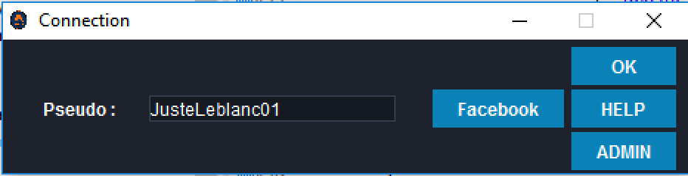

You just have to key-in a pseudonym which contains between 3 and 15 characters and press on OK button or press enter key to be connected as a user.

Click on the HELP button if you wish to have some information.

## Connection as administrator

Like as customer, you key-in a pseudonym which contains between 3 and 15 characters, and click on the ADMIN button. Then a window asking to key-in a password in the text field appears. One time the text field is full, you can click on OK button or press enter key to be connected as an administrator.

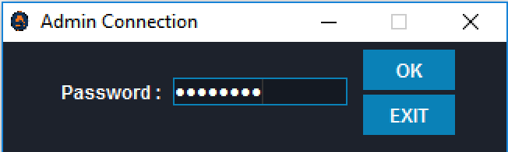

If you key-in a wrong password, a window appears on screen and report to you the password is not correct.

You can click on the EXIT button to come back at the login window.

# Chat Window

## Composition

Tool Bar

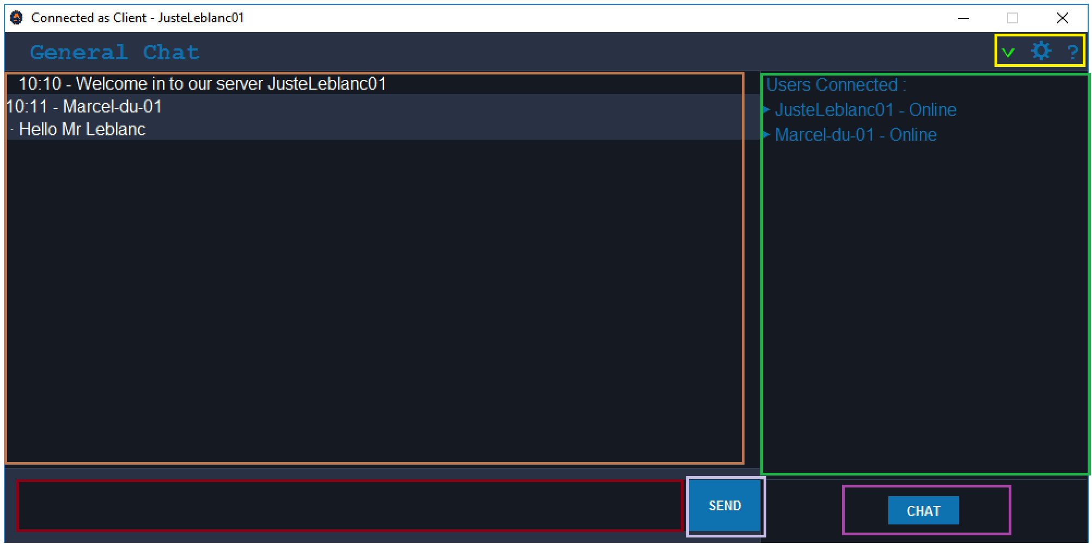

Text area 1 where messages are printed

Text area 2 where the user enters a message

Button to send a message

Button to start a private conversation

List of users connected

## Write and send a message

To write a message you must enter your message in the Text area 2 and press on CHAT button or press enter key to send the message.

## Disconnection

To disconnect of the server, click on Disconnect in the tab Parameter of the tool bar. 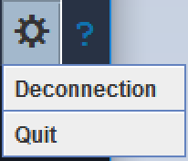

Then a pop up ask you if you really want to disconnect of the server. 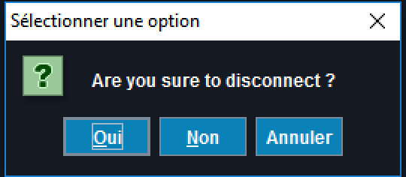

One time the client is disconnected, the login window appears on the screen.

To quit the application, click on Quit in the tab Parameter of the tool bar.

## Change the status

To change status, click on the triangle and choose the desired status between *Connected*, A*bsent* and *Busy*.

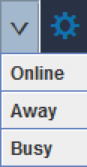

## Start a Private conversation

To start a private conversation you need to press the “Chat” button, then choose from the list the person with whom you wish to chat.



