Week 2 Synthesis — Representation Learning (teaching the model what to look at)
Thibaut Faucheux (CESI) · Host lab: KMUTNB, Bangkok · Supervisor: Dr. Rattanakorn Phadungthin
26 June 2026

1. This week in one paragraph
Week 2 was about representation learning — teaching the model to summarise each oil sample into a few numbers, and, crucially, to make those numbers capture the fault type (which fault), not just the severity (how much gas). I trained and tuned the autoencoder, compared a variational autoencoder (VAE), and ran the key experiment of the project: separating “how much” from “the mix”.
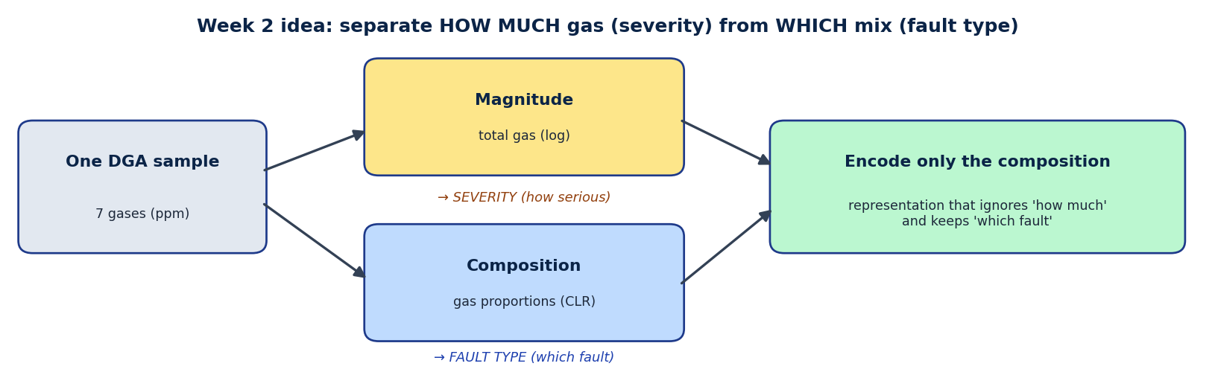
Week 2 idea: split each sample into magnitude (severity) and composition (fault type), and encode only the composition.

2. The problem from Week 1
The plain autoencoder mostly learned severity — the overall amount of gas — not the fault type. The plot below shows it: the representation predicts total gas almost perfectly (R2 = 0.61). That is useful for “how serious”, but it cannot tell partial discharge from thermal from arcing. The fix (already in the plan): fault type lives in the proportions of the gases — exactly what the Duval rule uses — so the model should look at proportions, not raw amounts.
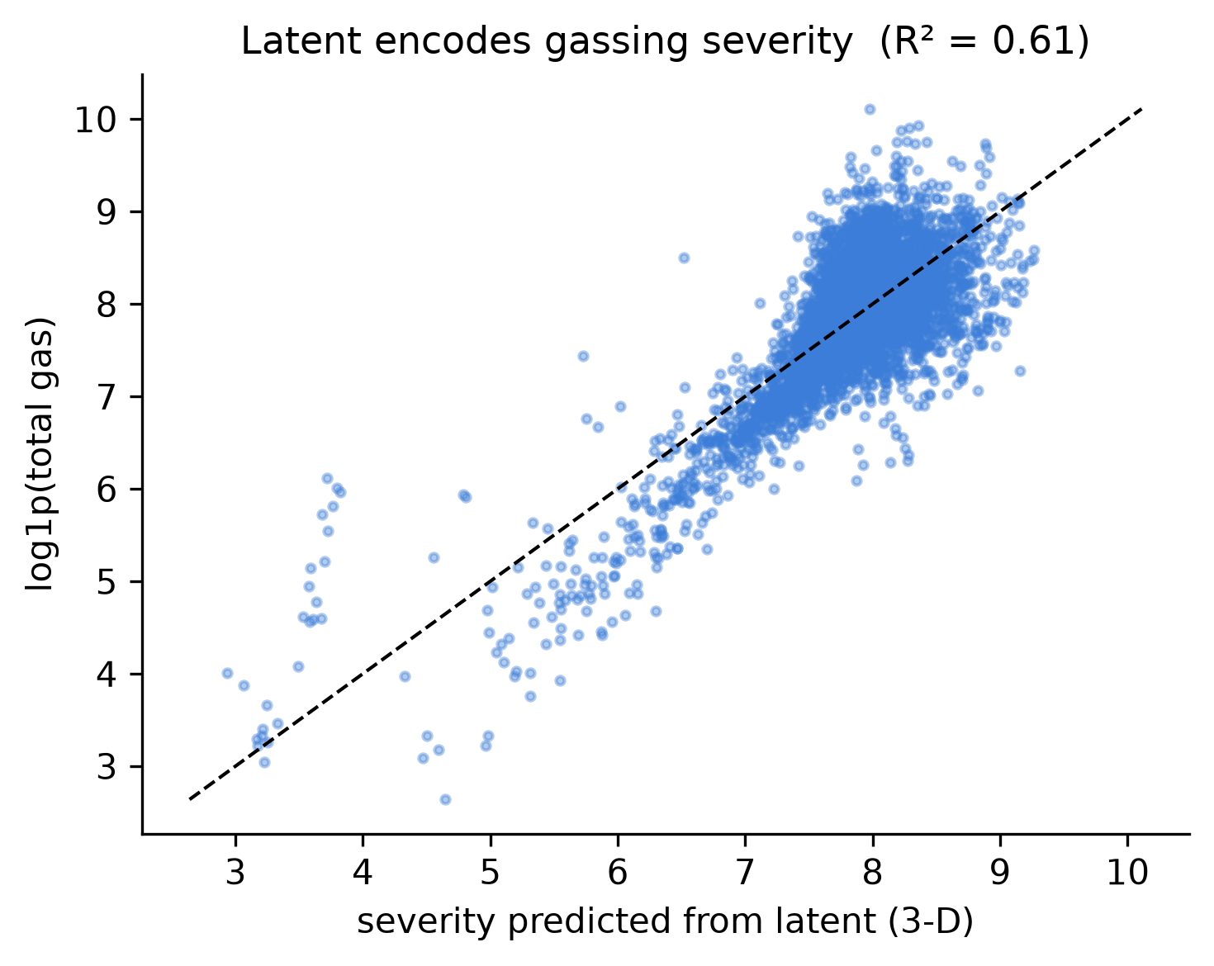
The plain representation encodes severity: it predicts total gas almost perfectly (R2 = 0.61), so it captures “how much”, not “which fault”.

3. What I did (Week 2)
- Trained and tuned the autoencoder (different sizes and numbers of summary dimensions); checked training curves and reconstruction quality.
- Implemented and compared a VAE (a probabilistic autoencoder). The simpler compositional autoencoder gave the clearer, more interpretable separation, so I selected it.
- Key experiment — separate magnitude from composition. I described each sample by its gas proportions (a standard transform, CLR) and encoded only those — removing “how much” and keeping “which mix”.
- Result: agreement with the Duval fault types more than tripled — from ARI 0.14 (raw amounts) to 0.47 (proportions), averaged over 5 runs — and severity stopped leaking into the representation (R2 0.63 -> 0.27).
- Honest check (negative result): I also tried an “adversarial” trick to force type and severity apart. It did not help, so the gain comes from the proportions idea itself, not the trick — reported as such.
- Froze the chosen representation and drafted the method section.
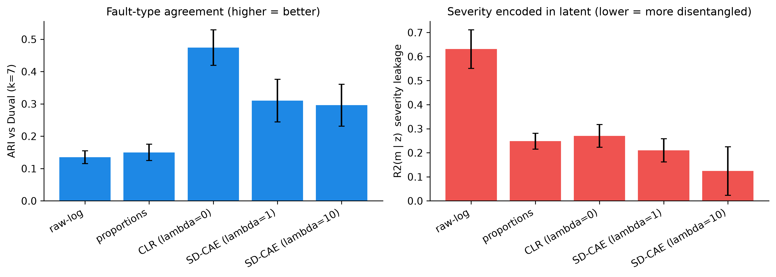
Agreement with Duval fault type (left, higher is better) more than triples with the compositional representation; severity leakage (right, lower is better) drops sharply.
The chosen representation now shows real fault-type structure — discharge (blue), thermal (green/red) and partial-discharge (yellow) samples fall in different regions:
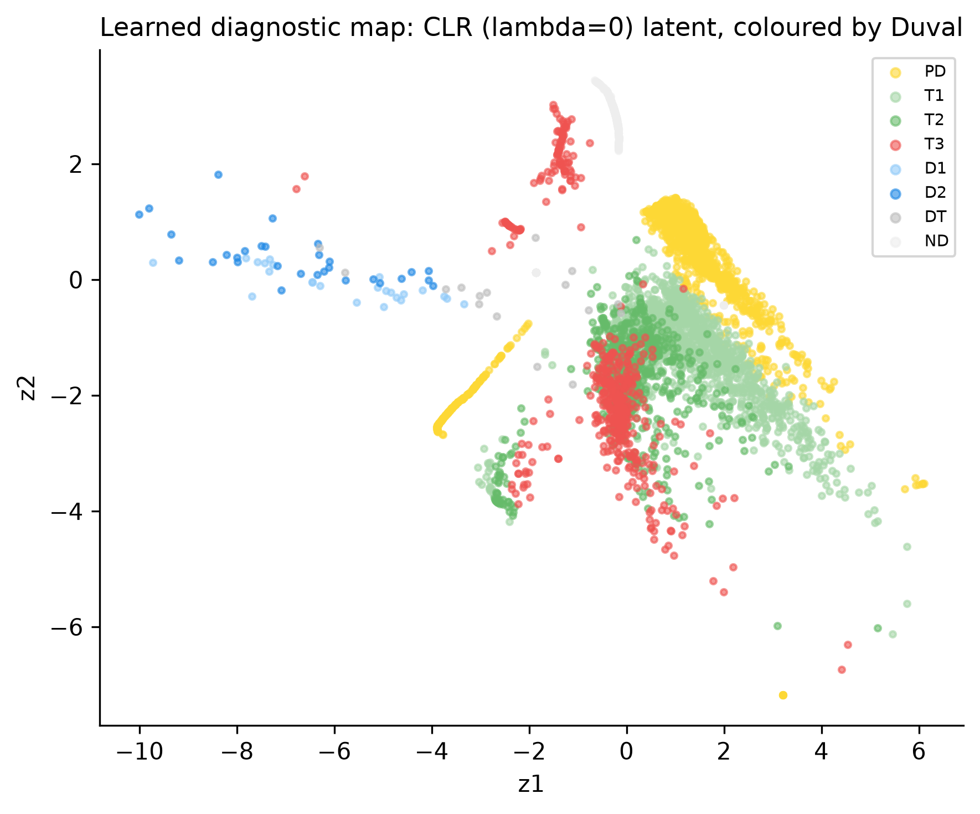
The compositional representation, coloured by Duval type: discharge, thermal and partial-discharge samples separate into different regions.
On credibility: ARI measures agreement with an expert rule (Duval), not accuracy against a true label — we have none. The honest claim is the large relative gain (x3.4) and the removal of severity leakage, not a perfect score. Rare fault classes (D1/D2) stay hard, as expected.

4. What I plan to do (Week 3)
Following the plan: take this representation into clustering (group the fleet into fault families) and anomaly detection (flag unusual samples), and evaluate both quantitatively — internal cluster quality, agreement with Duval, and checking flagged anomalies against the real field-event notes.
The initial plan focused on temporal representation learning, but upon closer inspection, I discovered that the temporal signal—or apparent risk—is actually a sampling artifact: operators resample the units they monitor, so a simple sample count predicts 'faults' better than gas chemistry does. Pursuing RUL analysis would have yielded confounded results rather than physical insights. So, I pivoted to two solid, honest, label-free contributions: (1) SD-CAE, which cleanly separates type and severity and recovers the Duval structure without labels; and (2) a methodological caveat—DGA risk labels are biased by monitoring practices, a point that seemingly hasn't been raised before in the context of DGA."

