Week 1 Synthesis / Label-Free Health Ranking of Power Transformers from DGA
Thibaut Faucheux (CESI) · Host lab: KMUTNB, Bangkok · Supervisor: Dr. Rattanakorn Phadungthin
19 June 2026

1. The project in one paragraph
Power transformers are expensive, critical machines. Dissolved Gas Analysis (DGA) is like a blood test of the insulating oil: when a transformer has an early fault, it produces specific gases. Today engineers read these gases with fixed rules (Duval, IEC, Rogers). These rules need an expert, sometimes give “no answer”, and do not scale to a whole fleet. My project ranks a whole fleet of transformers by risk, without any fault labels / the computer learns the patterns by itself (self-supervised) and uses the history of each unit over time (temporal). I then compare this ranking with the conventional methods.
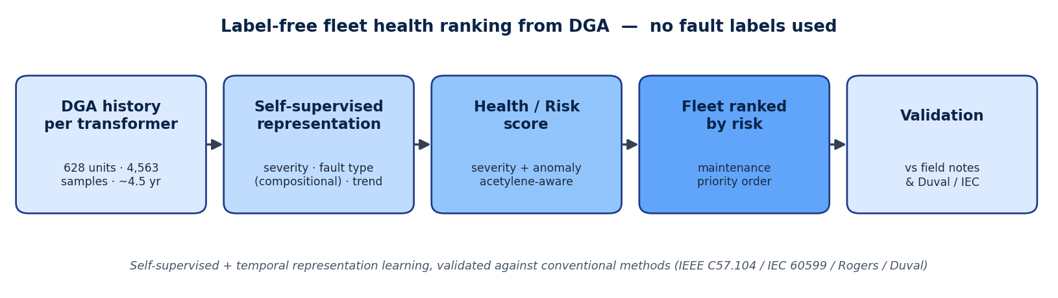
The pipeline: from each transformer’s DGA history to a risk-ranked fleet, with no fault labels.

2. What I understood
- The data has no labels and is longitudinal. 628 transformers, 4,563 oil samples, ~4.5 years, ~7 samples per unit. We do not know the “true” fault, so supervised learning is not realistic / the right goal is to rank units by risk.
- Each gas has a meaning. Hydrogen = partial discharge; methane/ethane = low-temperature heating; ethylene = high-temperature heating; acetylene = arcing = the most dangerous; CO/CO₂ = paper damage.
- Conventional methods are a baseline, not the truth. Running Duval on the fleet gives mostly partial-discharge and thermal faults, with a strong class imbalance and some “not determined” cases.
- The key question: can a model rank the riskiest units / and does it capture the fault type, or only the overall severity (how much gas)?
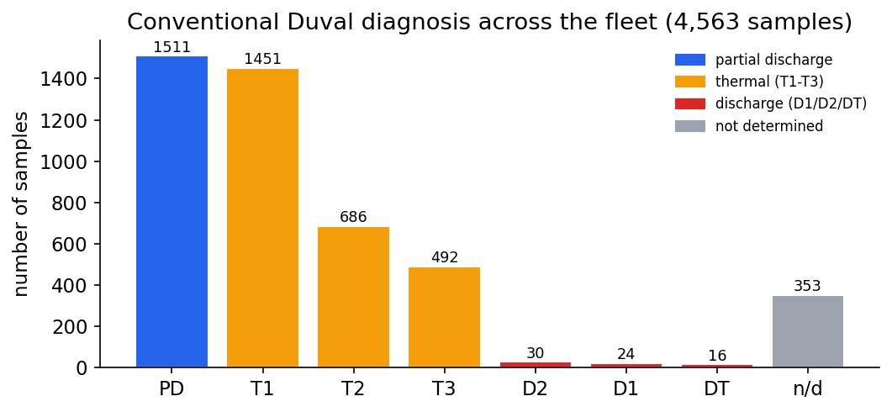
What the conventional Duval rule says about the fleet / a baseline to compare against, with clear class imbalance.

3. What I did (Week 1)
- Built the full project and pipeline (data cleaning → preprocessing → conventional baselines → autoencoder → clustering → anomaly detection → evaluation). It runs end-to-end and is reproducible.
- Read the documentations and organised the references.
- Got two main results:
Finding 1 / the model can separate fault type from severity. A plain autoencoder mostly captures how much gas there is (severity), not which fault it is. Using the gas composition (proportions) instead makes the model agree far better with Duval fault types: agreement score ARI 0.14 → 0.47.
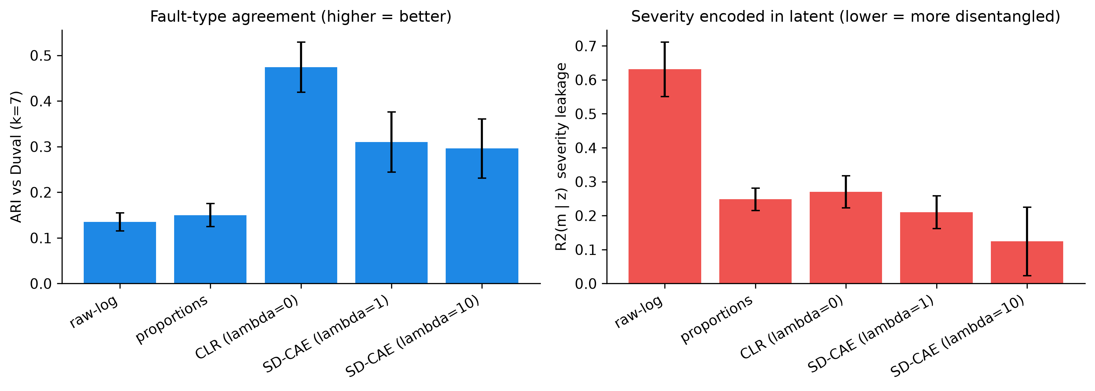
Left: agreement with Duval fault type (higher is better) jumps with the compositional representation. Right: a plain model mostly encodes severity.
Finding 2 / the label-free risk ranking works. I built a risk score (severity + anomaly + acetylene weighting + time trend) and ranked the fleet. The 10% riskiest units have ~30% real fault-events, versus the 11.3% fleet average and only ~2–3% for the safest units. Overall AUC = 0.74 (a simple TCG-only baseline = 0.52).
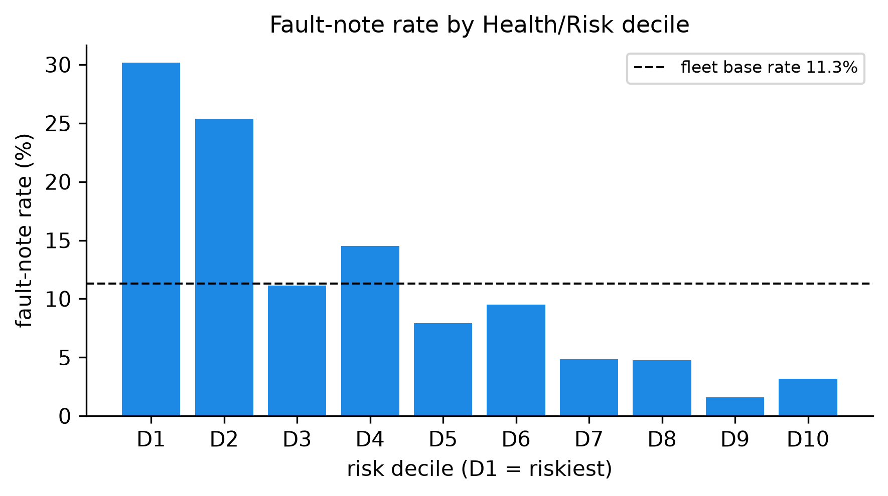
Riskiest units (left, D1) carry many more real field faults than safe units (right, D10) / the ranking is meaningful.

4. What I plan to do (Weeks 2–5)
- Weeks 2–3: finish the per-unit temporal features and the full health/risk index; add a stronger anomaly method (Deep SVDD).
- Week 4: systematic comparison of my ranking against C57.104 / IEC / Rogers / Duval; show the units the rules miss; freeze the results and figures.
- Week 5: write the IEEE paper and prepare the defense.
- Open question to settle: how much the temporal (time-trend) information improves the ranking / early result is a small but positive gain.

