Label-Free Health Ranking of Power Transformers from Dissolved Gas Analysis
Thibaut Faucheux (CESI, FISA4 INFO) · Research Initiation at KMUTNB, Bangkok · Supervisor: Dr. Rattanakorn Phadungthin
End-of-project report — Weeks 1 to 5 — 17 July 2026
Executive summary. Power transformers fail expensively, and Dissolved Gas Analysis (DGA) is the standard way to catch faults early. Conventional interpretation (Duval, IEC, Rogers) is rule-based, needs an expert, and does not scale to a whole fleet without labels. This project developed a label-free, self-supervised framework that ranks a fleet of transformers by incipient-fault risk from their DGA history, and explains each rank by separating fault type from severity. On a real longitudinal fleet (628 units, 4,563 samples, ~4.5 years), the label-free risk ranking reaches AUC 0.74 against recorded field events (vs 0.52 for a total-gas baseline), and the compositional representation triples the agreement with expert fault types (ARI 0.14 to 0.47).

1. Context and motivation
Power transformers are among the most critical and expensive assets of an electrical grid; an in-service failure means outages, safety risk and costly, slow replacement. Dissolved Gas Analysis (DGA) detects incipient faults early: internal thermal or electrical stress decomposes the oil and paper insulation and releases characteristic gases (hydrogen, methane, ethylene, acetylene, carbon oxides) measured in ppm. Conventional interpretation methods — IEC 60599 ratios, Rogers ratios and the Duval Triangle — are rule-based, require expert judgement, sometimes return “not determined”, and implicitly assume a per-sample fault label that utilities rarely have at scale. In practice an operator must prioritise maintenance across an entire fleet — rank units by risk — without labels. That is the gap this project addresses.

2. Objective, research question and dataset
Research question. Can we rank transformers across a fleet by incipient-fault risk, label-free, by learning a self-supervised, temporal representation of each unit’s DGA history and scoring severity and deviation (acetylene-aware) — and how does this compare with conventional DGA interpretation?
Dataset. 628 transformers, 4,563 main-tank oil samples, 42 manufacturers, 115–525 kV, spanning a median ~4.5 years at ~6-month sampling intervals (a genuinely longitudinal fleet). 391 samples carry a real field-event note (Buchholz trip, bushing failure, high power factor…), used as weak validation labels — sparse and imperfect, so results are read as indicative, not absolute.

3. Approach
The pipeline turns each unit’s raw DGA history into a single risk rank, with no fault labels used at any stage, and is benchmarked against the conventional methods.
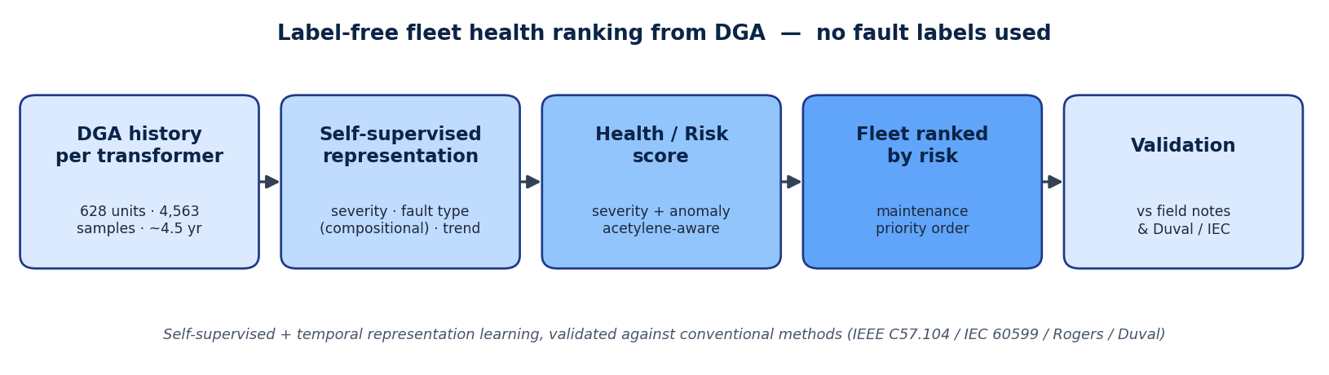
Pipeline: from each transformer’s DGA history to a risk-ranked fleet, with no fault labels.

4. Week-by-week progress
Week | Dates | Theme | Main outcome
1 | 15–19 Jun | Foundations | Clean data + EDA, conventional baselines, literature (16 refs + notes), problem statement
2 | 22–26 Jun | Representation learning | AE + VAE; compositional representation separating fault type from severity (ARI 0.14 to 0.47)
3 | 29 Jun–3 Jul | Clustering + anomaly detection | Fault-family clusters + anomaly scoring, validated against field-event notes
4 | 6–10 Jul | Health/risk index + evaluation | Label-free fleet ranking, AUC 0.74; systematic comparison vs conventional methods
5 | 13–17 Jul | Writing + dissemination | IEEE paper draft, frozen figures/tables, reproducible repository, defense slides
Week 1 — Foundations. Built and verified the full pipeline end-to-end on the real data: cleaning (gas values stored as text, missing markers, field notes), exploratory analysis, and the conventional baselines (Duval / IEC / Rogers) reproduced as the reference to compare against. The literature review produced 16 references with per-paper reading notes. The fleet is dominated by partial-discharge and thermal diagnoses, with a strong class imbalance to keep in mind for evaluation.
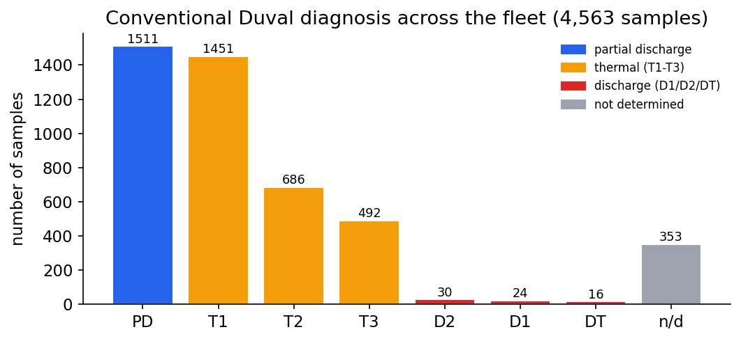
Conventional Duval diagnosis across the fleet — the baseline to compare against, with clear class imbalance.
Week 2 — Representation learning. Trained and tuned an autoencoder and compared a variational autoencoder. The key experiment separated magnitude (total gas = severity) from composition (gas proportions = fault type). Encoding only the composition (a CLR transform) raised agreement with Duval fault types from ARI 0.14 to 0.47 (about ×3.4, over 5 seeds) and removed severity leakage (R² 0.63 to 0.27). An adversarial variant did not help — a negative result reported honestly.
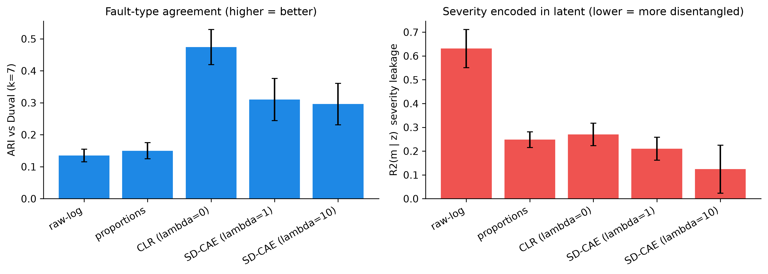
Left: agreement with Duval fault type jumps with the compositional representation. Right: the plain model mostly encodes severity.
The chosen representation shows real fault-type structure — discharge, thermal and partial-discharge samples fall in different regions:
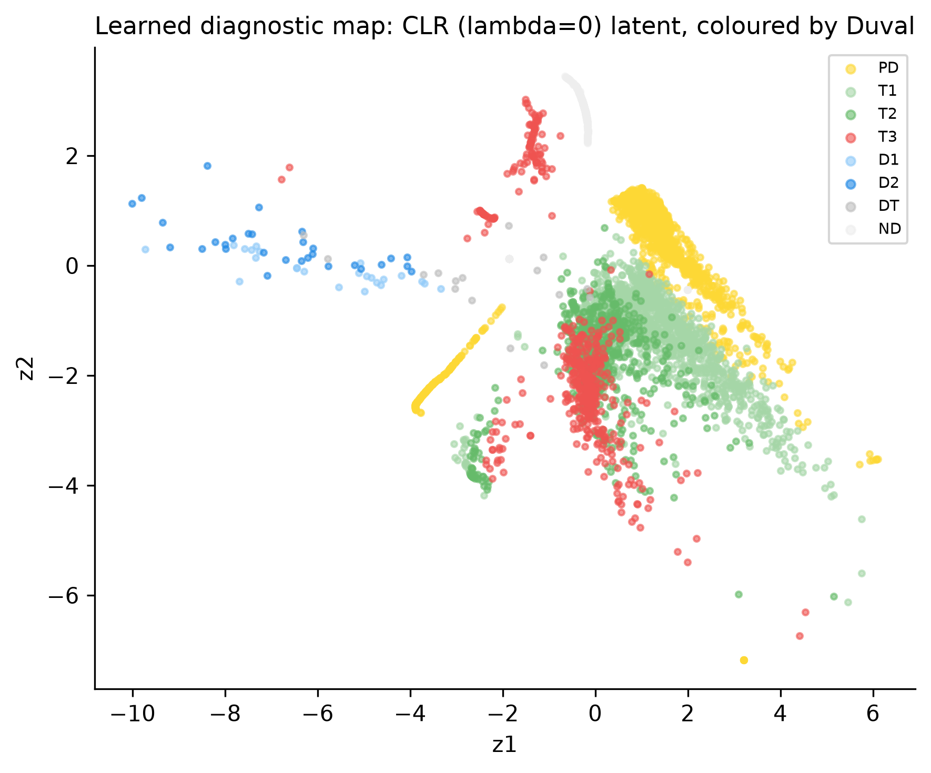
The compositional representation, coloured by Duval type: fault families separate into different regions.
Week 3 — Clustering and anomaly detection. Clustered the representation (KMeans / GMM / HDBSCAN, model selection by silhouette) and interpreted each cluster physically against the Duval mix. Added anomaly scoring by autoencoder reconstruction error and Isolation Forest, and validated flagged anomalies against the field-event notes (precision/recall reported as indicative given weak labels).
Week 4 — Health/risk index and evaluation. Combined severity, an acetylene weighting (acetylene = arcing = the most dangerous fault), a temporal gas-growth-rate feature, and the anomaly score into a single label-free Health/Risk Index, then ranked the fleet. Each component adds measurable value, and the full index reaches AUC 0.74 against field events, far above a total-gas baseline (0.52).
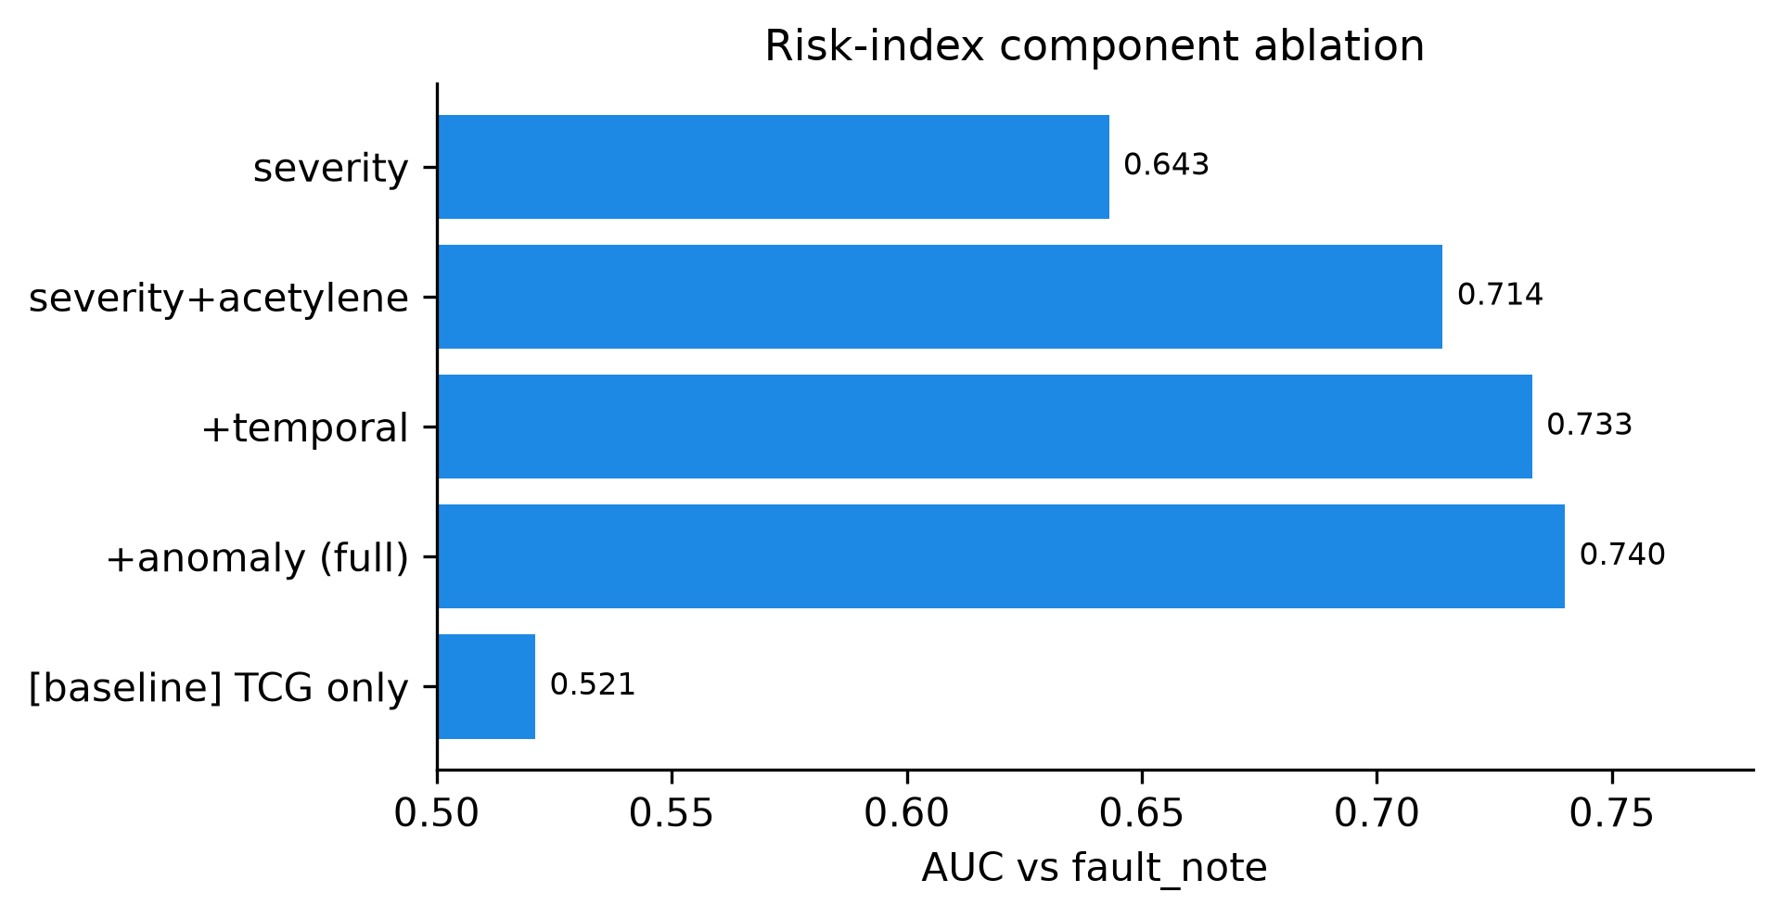
Each component of the risk index adds value: severity 0.64, then +acetylene 0.71, +temporal 0.73, +anomaly 0.74 (vs 0.52 for a total-gas baseline).
Week 5 — Writing and dissemination. Drafted the IEEE paper (all sections), froze the figures and tables under results/, finalised the reproducible repository, and prepared the defense slides.

5. Key results
The ranking is meaningful: the 10% riskiest units carry far more real field faults (~30%) than the fleet average (~11%) and than the safest units (~2–3%), with a monotonic trend across deciles.
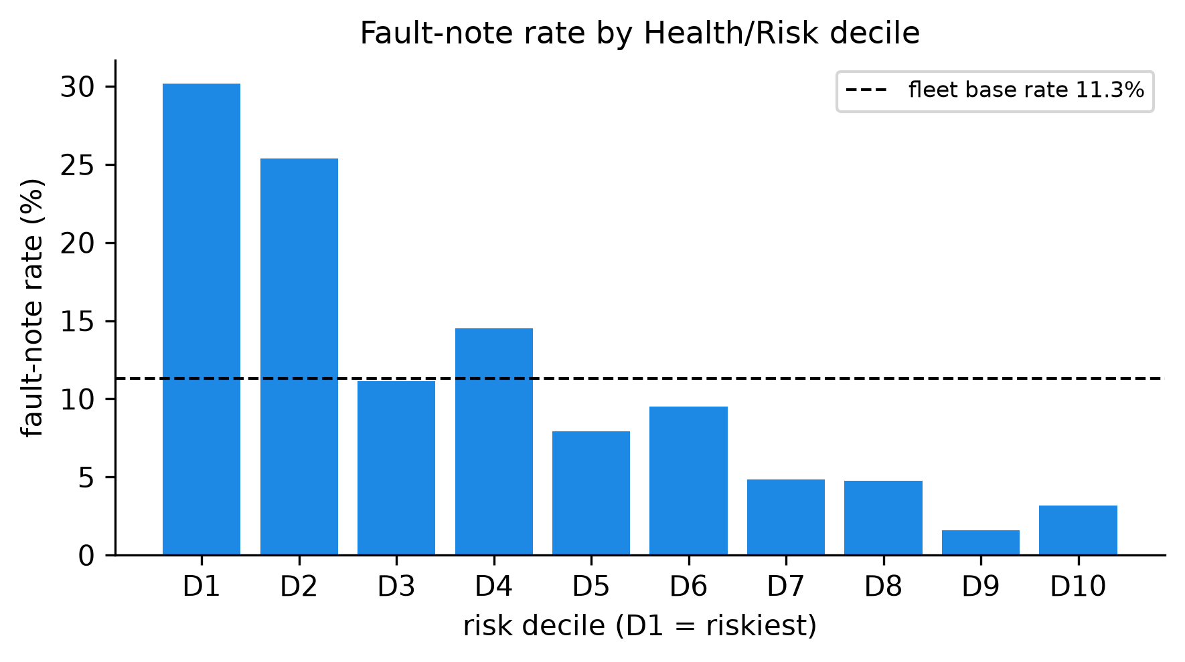
Riskiest units (left, D1) carry many more real field faults than safe units (right, D10) — the ranking is meaningful.
- Representation: fault-type agreement tripled (ARI 0.14 to 0.47); severity leakage removed.
- Risk ranking: AUC 0.74 vs 0.52 baseline; monotonic risk deciles; top-decile lift up to ×2.7.
- Component value: severity 0.64 to +acetylene 0.71 to +temporal 0.73 to +anomaly 0.74.
- Vs conventional: the label-free ranking recovers the units the conventional severity ordering flags, and surfaces some the rules miss — while needing no labels and no expert thresholds.

6. Conclusion
The project delivered a label-free, self-supervised framework that ranks a real fleet of transformers by incipient-fault risk, and explains each rank by separating fault type (a compositional representation) from severity (an acetylene-aware risk score). Three contributions stand out: (1) the label-free fleet health-ranking pipeline, validated on a longitudinal fleet; (2) a compositional representation that recovers fault type and provides the interpretable “why” behind a rank; (3) a systematic comparison with the conventional IEC / Duval / Rogers methods. Because no ground-truth health label exists, the ranking is validated indirectly (field-event notes + agreement with C57.104 severity), and the framework is positioned as decision support, not a claim to beat supervised classifiers (a different setting). In short, it turns DGA from a per-sample rule lookup into a fleet-level, label-free maintenance-prioritisation tool.

7. Limitations and next steps
- Weak, sparse labels (391 field-event notes) → validation is indicative; we report note-rate by decile and precision@k rather than a single accuracy number.
- Temporal features are engineered (gas-growth rates); a deep sequence model over each unit’s trajectory is the natural next step.
- Confound control: the index deliberately uses physical-gas features only (not sampling frequency, which correlates with faults only because faulted units get re-sampled).
- Highest-leverage improvement: a better label — translating the Thai field notes or obtaining the utility’s failure records — would strengthen every risk claim.
- Forward direction (consistent with the 2026 review literature): deep temporal models, Deep SVDD anomaly detection, digital-twin remaining-useful-life prognostics, and privacy-preserving federated learning across utilities.

Reproducible: every figure and number is produced by code under results/. This is a research initiation (5 weeks, one student); results are early and honestly hedged.

