  L1 FA24BL5

Q1:

Software Requirements Specification

for

FU Library Management System

**Version 1.0 approved**

**Prepared by**

**Nguyen Van A - HE**

**FPT University Ha Noi**

**Ha Noi, 18 November 2024**

Q2: use case diagram

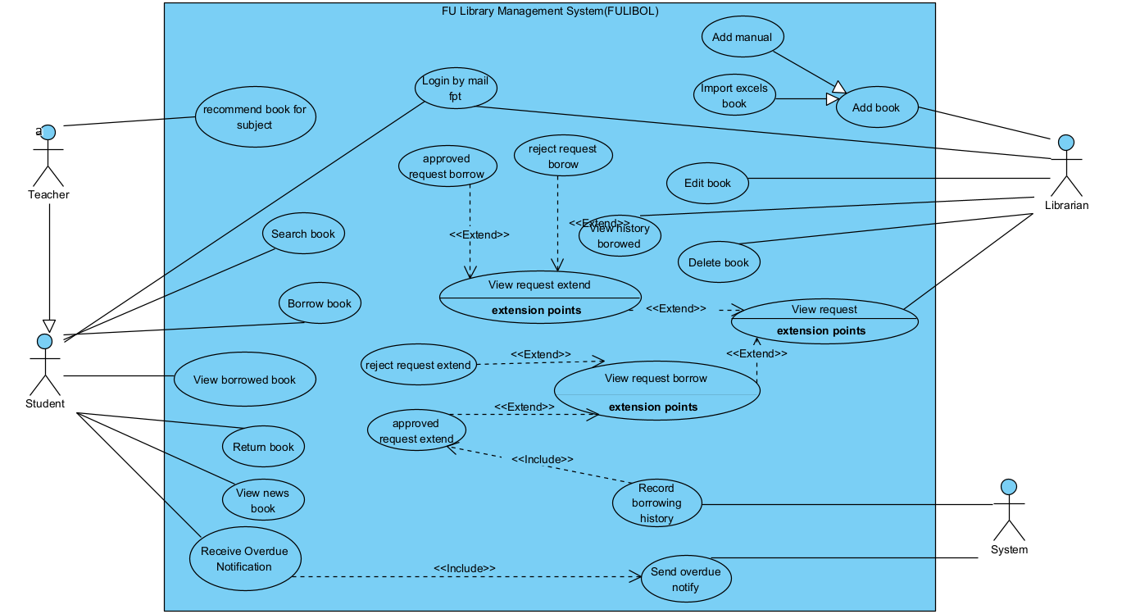

1. In this exam paper, the name of rectangle is: **FU Library Management System**

2. In this exam paper have 4 actors: **System, Librarian, Teacher, Student**

3. 5 use cases:

* **Login**
* **Add Book**
* **Search book**
* **Borrow book**
* **Return book**
* **Send overdue notify**

4. The Actors are **outside** the rectangle.

5. The Ovals represent use cases are **inside** the rectangle

6. Primary actor of the use case **Add Book** is: **Librarian**

7. Secondary actor of use case **Add Book** is: **none.**  
8.

a. Name 2 use cases have extend relationship is: **View request** and **View request extend**

b. The name of base use case is: **View request**

c. The name of extend use case is: **View request extend**

d the dashed line with an arrow that point to **View request**

9.

a. Name 2 use cases have include relationship is: **Send overdue notify** and **Receive Overdue Notification**

b. The name of base use case is: **Receive Overdue Notification**

c. The name of include use case is:**Send overdue notify**

d the dashed line with an arrow that point to **Send overdue notify**

Q3:

< Student must replace this line, answer of Q3 by filling the content into the below table that reflects this exam paper. NOTE: Student must remove the guideline in and after the (….).>

| UC ID and Name: | UC – 1: Add Book | | |
| --- | --- | --- | --- |
| Created By: | Nguyen Van A | Date Created: | 16/12/2024 |
| Primary Actor: | Librarian | Secondary Actors: | System |
| Trigger: | The Librarian selects the “Add Book” option from the system menu. | | |
| Description: | This use case allows the Librarian to add a new book to the system either manually or by importing from an Excel file. | | |
| Preconditions: | 1..The Librarian must be logged into the system. | | |
| Postconditions: | 1. Book added successful to system | | |
| Normal Flow: | 1.The Librarian logs into the system using their credentials.  2.The Librarian selects the **"Add Book"** option from the system menu.  3.The system displays the book input form with options:  **-Manual Input**  **-Import Books from Excel File**  4.The Librarian chooses one of the following options:  **Option 1: Add Book Manually** a. The Librarian enters the following details:  -Title  -Author  -ISBN  -Publisher  -Quantity b. The system validates the entered data. c. If the data is valid, the book is added to the system.  **Option 2: Import Books from Excel File** a. The Librarian uploads an Excel file containing book information. b. The system validates the file format and content. c. If valid, the system imports all books from the Excel file.  5.The system updates the book list and database.  6.The system displays a confirmation message: **"Books have been successfully added."** | | |
| Alternative Flows: | **AF-1: Invalid Book Information**  **1:** The librarian enters incomplete or incorrect book details.  **2:** The system highlights the fields with errors.  **3:** The system displays an error message: **"Please correct the highlighted fields."**  **4:** The librarian corrects the errors.  **5:** The librarian resubmits the form.  **6:** The system validates the data and adds the book successfully. | | |
| Exceptions: | **E-1: System Failure**  **1:** The librarian submits the book details or Excel file.  **2:** A system error occurs while saving the data.  **3:** The system displays an error message: **"Unable to save data. Please try again later."**  **4:** The librarian retries the process once the system is operational. | | |
| Priority: | High | | |
| Frequency of Use: | Daily | | |
| Business Rules: | Book titles and ISBN must be unique.  Excel files must follow the system-defined template for importing books. | | |
| Other Information: | N/A | | |
| Assumptions: | The Librarian has all necessary book details ready.  The system is online and functioning properly during the operation. | | |

**Q4: Non-Functional Requirements**

**a. Performance**

The FU Library Management System must respond to any user action (e.g., searching for books, adding books, or logging in) within 2 seconds under normal conditions.

The system must support at least 500 concurrent users accessing different functions without performance degradation.

A performance test will be conducted to simulate 500 users performing actions such as login, book search, and data updates. If the system response time exceeds 2 seconds, the test will fail.

#### b. Security

1. Only authorized users can access specific functions in the system:
   * **Librarian**: Add, edit, and delete books.
   * **Student**: Search, borrow, and return books.
   * **Teacher**: Recommend books and view borrowed books.
2. User passwords and sensitive data must be encrypted to keep them secure.
3. Unauthorized users trying to access the system will be denied and logged for review.