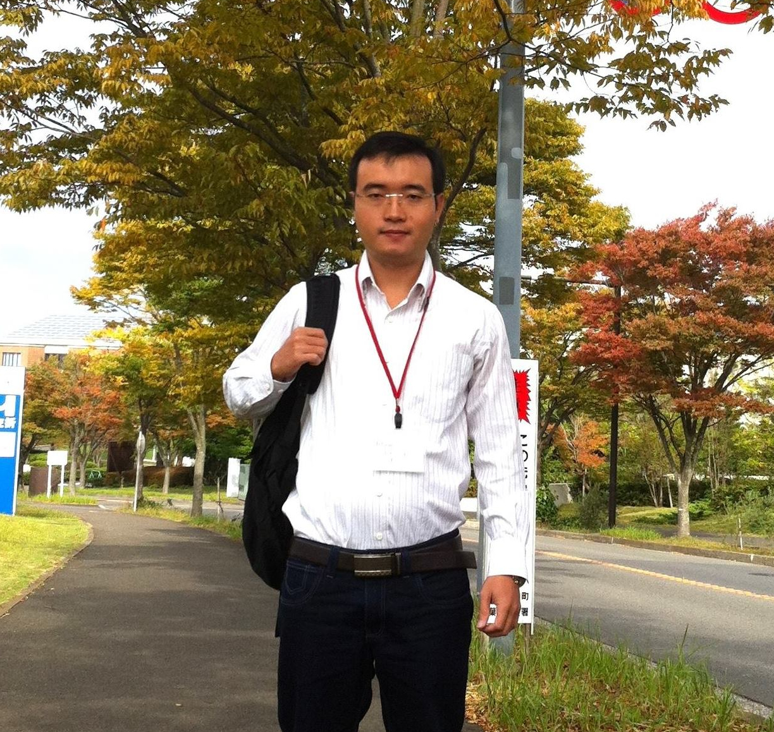

Phan Xuan Thien

Former bachelor and master student - HCMUT (2005-2012)

Former intern - NII (2013-2014)

PhD candidate - NII (Dept. of Informatics – SOKENDAI, 2014-Now)

- - - - - - - - - - - - - - - - - - - - - - -

“Welcome to NII and SOKENDAI!

Study in our institute and university is a great opportunity to develop our scientific and technological career. NII/SOKENDAI always gives international students including Vietnamese students the best support to learn new knowledge and to work with the most reputed professors in Japan in a variety of study fields to achieve our future goal. It is also a good chance to discover beautiful Japanese nature and culture through various social activities held by the institute and the university.

Let us join NII/SOKENDAI and have a great work and enjoyable life during our study in Japan!“

- - - - - - - - - - - - - - - - - - - - - - -