PHAN XUAN THIEN
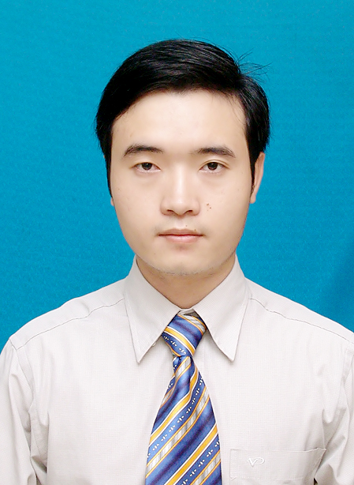
PERSONAL INFORMATION
Full name: Phan Xuan Thien
Date of birth: March 03,1987
Gender: Male
Mobile Phone: (+81) 80 95773387
Email: xuanthiencs@gmail.com

PROFESSIONAL SUMMARY
A motivated and responsible engineer, who has genuine interest in engineering and R&D in IT, with experiences working oversea (Switzerland and Japan) via some engineering and R&D projects, and good English skills. I have strong skill in research and development for innovated systems/applications, and am the author of some scientific publications in international conferences and journal in computer science. I’m hardworking, eager to learn and has special interest in financial applications development.

EDUCATION
- 2002 – 2005: High School Diploma (Gifted High School Program - Mathematics), Hue University of Science, Hue city, Vietnam. Graduate grade: Very good.
- 2005 – 2010: Bachelor of Engineering (Computer Science and Engineering), Ho Chi Minh City University of Technology, Ho Chi Minh city, Vietnam (Top 2 universities in Technology in Vietnam). Graduate grade: Good. Average score: 7.52/10.
- Sep. 2010 – Apr. 2013: Master of Engineering (Computer Science), Ho Chi Minh City University of Technology, Ho Chi Minh city, Vietnam. Graduate grade: Very good. Average score: 8.24/10 (Rank 5%)

SKILLS

- Fluent in C/C++, Java, Python
- MySQL database
- OS: Linux/Unix, Mac OSX, Window
- Tools: Git/GitHub, Eclipse IDE, Netbean, Latex, Virtual Paradigm (UML), Linux/Unix tools
- Good design (OOP/UML) and implementation capabilities
- Solid understanding of software development lifecycle and methods

- Knowledge of Linux/Unix kernel programming
- Knowledge and experience in distributed systems, computer networking/communication
- Experience in application/system performance experimental methods
- Knowledge in Agile/Scrum methodology
- Strong skills in researching, problem analyzing and solving

LANGUAGUES & SOFT SKILLS
- English: Business level.
4 years working oversea (Switzerland and Japan), frequently communicating and discussing with partners, colleagues/researchers in English. Wrote various scientific publications and technical/scientific reports. Did several presentations in international conferences in English.
- Japanese: Basic level (in learning progress to improve the level)
- Good kills in communication and organizing professional seminars/collaborations

WORK HISTORY
- Jun. 2009 – Aug. 2009: Internship Engineer, FPT Software Co. Ltd, Ho Chi Minh city, Vietnam.
  - Learned about SAP, ABAP programming language
  - Programmed some software modules on a real SAP system
- Aug. 2010 – Dec. 2010: worked for Bachelor project, Faculty of Computer Science and Engineering, Ho Chi Minh City University of Technology, Vietnam.
  - Developed a tool to support POP-C++ object file management and execution in a grid computing environment
  - Analyzed software requirements
  - Wrote UML designs
  - Implemented designed tool as an Eclipse plug-in using Java, C/C++
- Sep. 2011 – Feb. 2012: Worked for a R&D project, Faculty of Computer Science and Engineering, Ho Chi Minh City University of Technology, Vietnam.
  - Researched and developed a software system for routing in multi-domain SDN/OpenFlow networks.
  - Designed and implemented a network protocol for communication among SDN controllers/operators
  - Designed and implemented software modules for routing among SDN controllers in a distributed network environment
  - Programming language used: Java
- Feb. 2012 – Aug. 2012: Internship R&D Engineer, Prof. Pierre Kuonen Laboratory, University of Applied Science of Western Switzerland, in Fribourg, Switzerland (continue of the above mentioned project).
- Apr. 2013 to Aug. 2013: Software Engineer at KMS-Technology Co. Ltd., Vietnam.
  - Worked on HMS system for managing expense data of medical employees (doctors, nurses, …) and services for a customer in USA.
  - Programmed to process received data from customers, and some modules (Java) in the system with project teammates
- Sep. 2013 – Mar. 2014: Internship Researcher, National Institute of Informatics (NII), Tokyo, Japan.
R&D project: Wireless/Ad-hoc/Access networks for disaster recovery (an emerging research topic in NII and Japan); Researched and proposed a solution that extends WiFi-Direct for spreading Internet connection via multi-hops for disaster recovery.
- Apr. 2014 – Apr. 2015: Lecturer, University of Information Technology, Vietnam National University, Ho Chi Minh City, Vietnam.
- Oct. 2014 – now: Research Assistant at National Institute of Informatics (Tokyo, Japan) and PhD Candidate at SOKENDAI (The Graduate University for Advanced Studies, Japan).
  - Project: Research and development for a fine-grained and distributed platform for traffic monitoring and analysis in Software-Defined Network (SDN).
  - Monitored network traffic using tools like Tcpdump, Wireshark
  - Wrote Python programs to analyze network traffic
  - Researched, proposed, and developed new monitoring platform for SDN that provides: easy-to-use monitoring APIs for network operators; better performance and scalability; support for fine-grained traffic monitoring for various network managing applications (e.g. anomaly detection, network visualization,...); support for monitoring in distributed network environments.
  - Researched existing solutions, proposed a new architectural solution
  - Wrote UML design (using Virtual Paradigm UML) and implemented the proposed system
  - Did various experiments to evaluate performance and effectiveness of developed platform, which showed 58% growth of monitoring performance
  - Wrote applications on top on the developed platform (anomaly detection app, top-talkers app) to show its applicability
  - Programming languages used: C/C++, Python
  - Wrote several scientific papers, which were published by international conferences and journal

INTEREST
- Travel, football, swimming, reading favorite books, watching BBC/CNN news.
- Joining group activities and social activities.

