PHAN XUAN THIEN

1. PERSONAL DETAILS
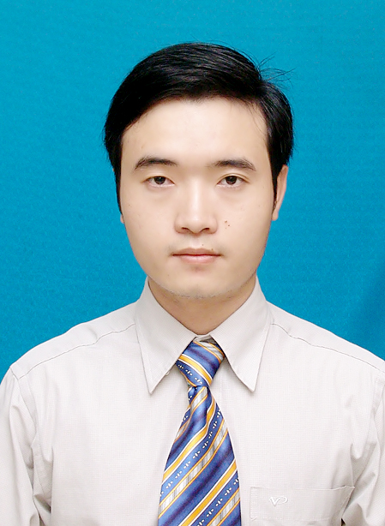
Full name: Phan Xuan Thien
Date of birth: March 03,1987
Gender: Male
Mobile Phone: (+81) 80 95773387
Email: xuanthiencs@gmail.com

2. PERSONAL PROFILE
A motivated and responsible engineer, who has genuine interest in engineering and R&D in Information Technology. I hold Bachelor degree and Master degree (with very good grade, ranked at top 5% of the course) in Computer Science and Engineering. I’m hard working, eager to learn, and have strong skills in communication, professional presentation. I have good skills in English and experiences working oversea (Switzerland and Japan) via some engineering and R&D projects. I’m the author of various scientific publications in international conferences and journal in computer science.

3. EDUCATION
- 2002 – 2005: High School Diploma (Gifted High School Program - Mathematics), conferred by Hue University of Science, Hue city, Vietnam. Graduate grade: Very good.
- 2005 – 2010: Bachelor of Engineering (Computer Science and Engineering), conferred by the Faculty of Computer Science & Engineering, Ho Chi Minh City University of Technology, Ho Chi Minh city, Vietnam (Top 2 universities in Technology in Vietnam). Graduate grade: Good. Average score: 7.52/10.
- Sep. 2010 – Apr. 2013: Master of Engineering (Computer Science), conferred by the Faculty of Computer Science & Engineering, Ho Chi Minh City University of Technology, Ho Chi Minh city, Vietnam. Graduate grade: Very good. Average score: 8.24/10 (Rank 5%).

4. RESEARCH & DEVELOPMENT SKILLS
- Scientific research skills: Had over 3 years R&D experience in a research institute (National Institute of Informatics, Tokyo, Japan). Had various scientific publications in international conferences and journal. Good at problem analyzing and solving, mathematics, logical inference.
- Can program well with programming languages: C/C++, Java, Python, SQL.
- Have good knowledge in computer networking, Hadoop and distributed systems.
- Can program with Ruby, Java Script, HTML.
- Have good knowledge and skill in Object Oriented Programming design and UML.
- Database systems: can work with database management systems like MySQL and Oracle.
- Tools: can work proficiently with Git/GitHub, Latex, Eclipse IDE/ Netbean for programming, Virtual Paradigm for UML for modeling software and systems.
- Operating Systems: can work well with Unix/Linux (used frequently for real scientific deployments and experiments for over 3 years), Mac OSX, Window.
- Other technical skills: have experience in building plug-in for Eclipse IDE.

5. LANGUAGUES & SOFT SKILLS
- English: Business level.
4 years working oversea (Switzerland and Japan), frequently communicating and discussing with partners, colleagues/researchers in English. Excellent at reading English technical/scientific documents in computer science and engineering, report writing, communication and presentation in English. Have written various professional documents in English including my scientific publications, technical/scientific reports. Had various presentations in international conferences in English.
- Japanese: Basic level.
- Good at communication, presentation, problems analyzing and solving, group working.
- Have experience in organizing professional/academic events and seminars. Have organized various seminars and activities for a research community in National Institute of Informatics (Tokyo, Japan) over the past 3 years.

6. WORK EXPERIENCE
- Jun. 2009 – Aug. 2009: Internship Engineer at FPT Software Company Limited, Ho Chi Minh city, Vietnam.
- Aug. 2010 – Dec. 2010: Work for an engineering project at Faculty of Computer Science and Engineering, Ho Chi Minh City University of Technology, Vietnam.
Project detail: “Developing a tool for POP-C++ object file management and execution”.
Used programming language: Java, C/C++.
- Sep. 2011 – Feb. 2012: Work for a research project at Faculty of Computer Science and Engineering, Ho Chi Minh City University of Technology, Vietnam. Project detail: Research and develop a solution for routing in multi-domain SDN/OpenFlow networks.
- Feb. 2012 – Aug. 2012: Internship Researcher at Prof. Pierre Kuonen Laboratory, University of Applied Science of Western Switzerland (in Fribourg, Switzerland).
- Apr. 2013 to Aug. 2013: Software Engineer at KMS-Technology Co. Ltd., Vietnam.
Project Detail: Building the HMS System for managing Expense Data of medical employees (doctors, nurses, …) and services for a customer in USA. Using Technologies: Java, Maven, Oracle Database, Spring framework, Spring Data JPA, Hibernate, Drop Wizards, RESTful Web Service, Ext JS.
- Sep. 2013 – Mar. 2014: Internship Researcher at National Institute of Informatics (NII), Tokyo, Japan. Research project: Wireless/Ad-hoc/Access networks for disaster recovery (an emerging research topic in NII and Japan).
- Apr. 2014 – Apr. 2015: Lecturer at the University of Information Technology, Vietnam National University, Ho Chi Minh City, Vietnam.
- Oct. 2014 – now: Research Assistant at National Institute of Informatics (Tokyo, Japan) and PhD Candidate at SOKENDAI (The Graduate University for Advanced Studies, Japan).
Research field: Network traffic monitoring and analysis, Software-Defined Network (SDN).
Project: Research and development for a fine-grained and distributed platform for traffic monitoring and analysis in Software-Defined Network. As a main member, I worked on researching and developing ....
..........(viet tiep doan nay)

7. PUBLICATION
- Xuan Thien Phan, and Kensuke Fukuda, “SDN-Mon: Fine-grained traffic monitoring framework in Software-Defined Networks”, Journal of Information Processing (JIP), Information Processing Society of Japan, vol. 25, pp.182–190, 2017.
- Xuan Thien Phan, and Kensuke Fukuda. Toward a flexible and scalable monitoring framework in Software-Defined Networks. In Network Monitoring and Management Workshops, IEEE International Conference on Advanced Information Networking and Applications (AINA), 2017, pp. 403–408, Taipei, Taiwan, March 2017.
- Xuan Thien Phan, Quang Tran Minh, Kien Nguyen, Toan Nguyen, Hoang Tran Viet, and Shigeki Yamada, “A devices-association mechanism for Wi-Fi Direct - based Internet connection establishment”, IEICE Technical Committee on Mobile Network and Applications (MoNA), Jan. 24, 2014, Matsuyama, Japan, Jan. 2014.
- Xuan Thien Phan, Quang Tran Minh, Kien Nguyen, Nam Thoai, Shigeki Yamada GICS: Group-based Internet Connection Spreading Architecture for Disaster Recovery, Proc. of IEEE 29th International Conference on Information Networking and Applications Workshops (WAINA), 2015, Gwangju, Korea 478-483 Mar 2015.
- Xuan Thien Phan, Nam Thoai, Pierre Kuonen, “A collaborative model for routing in multi-domains OpenFlow networks”. In IEEE International Conference on Computing, Management and Telecommunications, pages 278-283, Ho Chi Minh city, Vietnam, January 2013.

8. INTEREST
- Travel, football, swimming, reading favorite books, watching BBC/CNN news.
- Joining group activities and social activities.

