PHAN XUAN THIEN

1. PERSONAL DETAILS
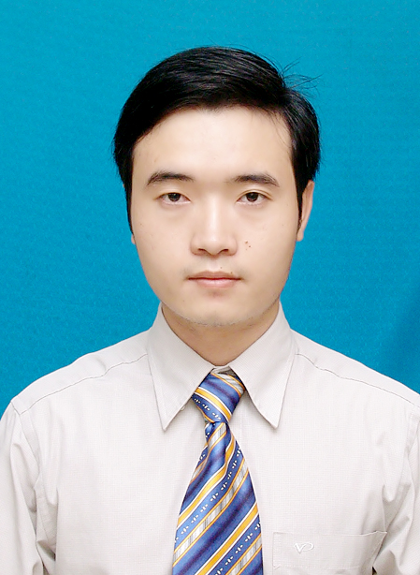
Full name: Phan Xuan Thien
Date of birth: March 03,1987
Gender: Male
Mobile Phone: (+81) 80 95773387
Email: xuanthiencs@gmail.com

2. PERSONAL PROFILE
A motivated and responsible engineer, who is interested in engineering and R&D in Information Technology. I hold Bachelor degree and Master degree (with very good grade, ranked at top 5% of the course) in Computer Science and Engineering. I have 4 years experience working oversea (Switzerland and Japan) via various engineering and R&D projects and activities, with excellent skills in English, and various scientific publications in computer science. I’m hard working, eager to learn, have genuine interest in engineering and researching works in information technology. I also have strong skills in communication, professional presentation, connecting people and colleagues in the working field.

3. EDUCATION
- 2002 – 2005: High School Diploma (Gifted High School Program - Mathematics), conferred by Hue University of Science, Hue city, Vietnam. Graduate grade: Very good.
- 2005 – 2010: Bachelor of Engineering (Computer Science and Engineering), conferred by the Faculty of Computer Science & Engineering, Ho Chi Minh City University of Technology, Ho Chi Minh city, Vietnam (Top 2 universities in Technology in Vietnam). Graduate grade: Good. Average score: 7.52/10.
- Sep. 2010 – Apr. 2013: Master of Engineering (Computer Science), conferred by the Faculty of Computer Science & Engineering, Ho Chi Minh City University of Technology, Ho Chi Minh city, Vietnam. Graduate grade: Very good. Average score: 8.24/10 (Rank 5%).

4. RESEARCH & DEVELOPMENT SKILLS
- Scientific research skills: Had over 3 years R&D experience in a research institute (National Institute of Informatics, Tokyo, Japan). Had various scientific publications in international conferences and journal. Good at problem analyzing and solving, mathematics, logical inference.
- Can program well with programming languages: C/C++, Java, Python, SQL.
- Have good knowledge in computer networking, Hadoop and distributed systems.
- Can program with Ruby, Java Script, HTML.
- Have good knowledge and skill in Object Oriented Programming design and UML.
- Database systems: can work with database management systems like MySQL and Oracle.
- Tools: can work proficiently with Git/GitHub, Latex, Eclipse IDE/ Netbean for programming, Virtual Paradigm for UML for modeling software and systems.
- Operating Systems: can work well with Unix/Linux (used frequently for real scientific deployments and experiments for over 3 years), Mac OSX, Window.
- Other technical skills: have experience in building plug-in for Eclipse IDE.

5. LANGUAGUES & SOFT SKILLS
- English: Business level.
4 years working oversea (Switzerland and Japan), frequently communicating and discussing with partners, colleagues/researchers in English. Excellent at reading English technical/scientific documents in computer science and engineering, report writing, communication and presentation in English. Have written various professional documents in English including my scientific publications, technical/scientific reports. Had various presentations in international conferences in English.
- Japanese: Basic level.
- Good at communication, presentation, problems analyzing and solving, group working.
- Have experience in organizing professional/academic events and seminars. Have organized various seminars and activities for a research community in National Institute of Informatics (Tokyo, Japan) over the past 3 years.

6. WORK EXPERIENCE
- Jun. 2009 – Aug. 2009: Internship Engineer at FPT Software Company Limited, Ho Chi Minh city, Vietnam.
- Aug. 2010 – Dec. 2010: Work for an engineering project at Faculty of Computer Science and Engineering, Ho Chi Minh City University of Technology, Vietnam.
Project detail: “Developing a tool for POP-C++ object file management and execution”.
Used programming language: Java, C/C++.
- Sep. 2011 – Feb. 2012: Work for a research project at Faculty of Computer Science and Engineering, Ho Chi Minh City University of Technology, Vietnam. Project detail: Research and develop a solution for routing in multi-domain SDN/OpenFlow networks.
- Feb. 2012 – Aug. 2012: Internship Researcher at Prof. Pierre Kuonen Laboratory, University of Applied Science of Western Switzerland (in Fribourg, Switzerland).
- Apr. 2013 to Aug. 2013: Software Engineer at KMS-Technology Co. Ltd., Vietnam.
Project Detail: Building the HMS System for managing Expense Data of medical employees (doctors, nurses, …) and services for a customer in USA. Using Technologies: Java, Maven, Oracle Database, Spring framework, Spring Data JPA, Hibernate, Drop Wizards, RESTful Web Service, Ext JS.
- Sep. 2013 – Mar. 2014: Internship Researcher at National Institute of Informatics (NII), Tokyo, Japan. Research project: Wireless/Ad-hoc/Access networks for disaster recovery (an emerging research topic in NII and Japan).
- Apr. 2014 – Apr. 2015: Lecturer at the University of Information Technology, Vietnam National University, Ho Chi Minh City, Vietnam.
- Oct. 2014 – now: Research Assistant at National Institute of Informatics (Tokyo, Japan) and PhD Candidate at SOKENDAI (The Graduate University for Advanced Studies, Japan).
Research field: Network traffic monitoring and analysis, Software-Defined Network (SDN).
Project: Research and development for a fine-grained and distributed platform for traffic monitoring and analysis in Software-Defined Network. As a main member, I worked on researching and developing ....
..........(viet tiep doan nay)

7. PUBLICATION
- Xuan Thien Phan, and Kensuke Fukuda, “SDN-Mon: Fine-grained traffic monitoring framework in Software-Defined Networks”, Journal of Information Processing (JIP), Information Processing Society of Japan, vol. 25, pp.182–190, 2017.
- Xuan Thien Phan, and Kensuke Fukuda. Toward a flexible and scalable monitoring framework in Software-Defined Networks. In Network Monitoring and Management Workshops, IEEE International Conference on Advanced Information Networking and Applications (AINA), 2017, pp. 403–408, Taipei, Taiwan, March 2017.
- Xuan Thien Phan, Quang Tran Minh, Kien Nguyen, Toan Nguyen, Hoang Tran Viet, and Shigeki Yamada, “A devices-association mechanism for Wi-Fi Direct - based Internet connection establishment”, IEICE Technical Committee on Mobile Network and Applications (MoNA), Jan. 24, 2014, Matsuyama, Japan, Jan. 2014.
- Xuan Thien Phan, Quang Tran Minh, Kien Nguyen, Nam Thoai, Shigeki Yamada GICS: Group-based Internet Connection Spreading Architecture for Disaster Recovery, Proc. of IEEE 29th International Conference on Information Networking and Applications Workshops (WAINA), 2015, Gwangju, Korea 478-483 Mar 2015.
- Xuan Thien Phan, Nam Thoai, Pierre Kuonen, “A collaborative model for routing in multi-domains OpenFlow networks”. In IEEE International Conference on Computing, Management and Telecommunications, pages 278-283, Ho Chi Minh city, Vietnam, January 2013.

8. INTEREST
- Travel, football, swimming, reading favorite books, watching BBC/CNN news.
- Joining group activities and social activities.

