PHAN XUAN THIEN

1. PERSONAL DETAILS
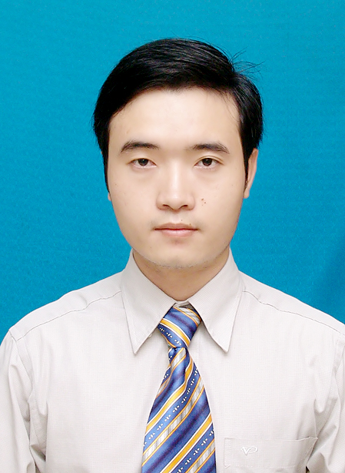
Full name: Phan Xuan Thien.
Date of birth: March 03,1987.
Gender: Male.
Nationality: Vietnamese.
Mobile Phone: (+84) 933993387.
Email: thien@nii.ac.jp Skype: xuanthien.phan
Address: 6/13 Han Mac Tu Street, Vi Da Ward, Hue City, Vietnam.

2. PERSONAL PROFILE
A motivated and responsible PhD student at the Graduate University for Advanced Studies (SOKENDAI). I have been doing research in the area of Computer Networks, Wireless Networks, Software-Defined Networks for about two years, and also have scientific publications in IEEE ComManTel 2013 international conference and IWDENS’ 2015 international workshop. I have a clear, logical mind with a practical approach to problem analysing and solving. I’m hardworking, eager to learn and have a genuine interest in doing research. Moreover, I have good English ability and really self-confidence in communication in English since I had 6 months working in Switzerland during my Master Internship Program, 6 months working as a research internship student and 9 months working as a PhD student in the National Institute of Informatics in Japan.

3. EDUCATION
- From 2002 – 2005: study Gifted High School Program at Hue University of Science (class of Mathematics), Hue city, Vietnam. Graduate grade: Very good.
- From 2005 – 2010: study Bachelor of Engineering at the Faculty of Computer Science & Engineering, Ho Chi Minh City University of Technology, Ho Chi Minh city, Vietnam. Graduate grade: Good. Average score: 7.52/10.
- From September 2010 – April 2013: study Master of Computer Science at Faculty of Computer Science & Engineering, Ho Chi Minh City University of Technology, Ho Chi Minh city, Vietnam. Graduate grade: Very good. Average score: 8.24/10 (Rank 5%).
- From October 2014 until now: study Doctor program at School of Multidisciplinary Science, The Graduate University for Advanced Studies (SOKENDAI).

4. ACADEMIC DEGREE & CERTIFICATE
- Bachelor of Engineering – Computer Science & Engineering (confered by Ho Chi Minh City University of Technology in 2010).
- Master of Engineering – Computer Science (conferred by Ho Chi Minh City University of Technology in April 2013).
- Certificate of successfully completing the Master Internship Program (conferred by University of Applied Sciences of Western Switzerland in August 2012, Switzerland).
- Certificate of successfully completing the International Internship Program in Tokyo, Japan (conferred by National Institute of Informatics in March 2014, Japan).
- English certificate: IELTS 5.5 (taken in November 2011).

5. COMPUTER & RESEARCH SKILL
- Very good at Java (having experiences in this programming language by frequently use through some past projects).
- Work well with technologies: Maven, Spring Framework, Spring Data JPA, Hibernate, Drop Wizards, RESTful Web Service, Ext JS, JUnit.
- Can program well with C++, SQL, HTML, Prolog, Lisp, SmallTalk and Assembly.
- Have strong knowledge and skill in Object Oriented Programming design and UML.
- Database systems: can work with database management systems like MySQL and Oracle.
- Tools: can proficiently work with Eclipse IDE, Netbean for programming, and Virtual Paradigm for UML 10.0 for modeling software and systems.
- Operating Systems: can work well with Mac OSX, Window, Unix/Linux.
- Other technical skills: experienced in building plug-ins for Eclipse IDE.
- Research skills: good at mathematics, problem analyzing and solving, logical inference. Having about one and a half year experience in doing research in Computer Networks, Wireless Networks, Ad Hoc Networks. Having one publication in an international conference (IEEE ComManTel 2013) and one publication in an international workshop (IWDENS 2015).
6. SOFT SKILL
- Fluent in English (Good at reading English technical documents, academic documents in computer science and engineering, good at report writing and especially self-confident in English communication and presentation).
- Good at communication skill, presentation skill, problems analysing and solving, group working skill.

7. WORK EXPERIENCE
- From June 2009 – August 2009: work in the Internship Program in FPT Software Company Limited, Ho Chi Minh city, Vietnam.
- From April 2013 to August 2013: work as a Java Software Engineer in KMS-Technology Co. Ltd., Vietnam.

8. PROJECT EXPERIENCE
- August 2010 – December 2010: Work in the project “Building a tool for supporting POP-C++ object file management and execution”.
Project detail: Developing a plug-in for Eclipse that support users manage POP-C++ object files which are placed distributively among computers in a Grid environment. This tool supports processing management tasks such as migrating, tracking, executing POP-C++ object files,… in the grid environment. The processing management tasks become simpler and easier by using visual appearances provided by the proposed tool. This plug-in was developed based on Java technology. This project was managed by me and Dr. Tran Van Hoai in the Faculty of Computer Science and Engineering-HCMC University of Technology. I was the main developer and was responsible for almost all of works in the project. The purpose of this project was to support for the research in the area of Grid Computing led by Dr. Hoai and it was also my Bachelor thesis project.
- From April 2013 to August 2013: Work in the project: HMS – Master Data Management (in KMS-Tech ology Co. Ltd).
Project Detail: Building the HMS System for managing Expense Data of medical employees (doctors, nurses, …) and services for a customer in USA. Using Technologies: Maven, Oracle Database, Spring framework, Spring Data JPA, Hibernate, Drop Wizards, RESTful Web Service, Ext JS.

9. RESEARCH ACTIVITY AND INTERNSHIP
- From September 2011 – February 2012: do research in the area of Computer Networks (focus on Software-Defined Network and OpenFlow) in the Faculty of Computer Science and Engineering, Ho Chi Minh City University of Technology, Vietnam.
- From February 2012 – August 2012: obtain a scholarship to go to Switzerland in a Master Internship program and do research in the area of Computer Networks (Software-Defined Networks and OpenFlow) in the University of Applied Science of Western Switzerland (in Fribourg, Switzerland).
- From September 2013 – March 2014: obtain a scholarship of the International Internship program to do research in the area of Computer Networks (focus on Wireless Networks and Access Networks) in the National Institute of Informatics (in Tokyo, Japan).
- From October 2014 until now: obtain the Japanese Government Scholarship (MEXT scholarship) to study Doctor Program in The Graduate University for Advanced Studies (SOKENDAI).

10. PUBLICATION
- Xuan Thien Phan, Nam Thoai, Pierre Kuonen, “A collaborative model for routing in multi-domains OpenFlow networks”. In IEEE International Conference on Computing, Management and Telecommunications, pages 278-283, Ho Chi Minh city, Vietnam, January 2013.
- Xuan Thien Phan, Quang Tran Minh, Kien Nguyen, Shigeki Yamada, “GICS: Group-based Internet connection spreading architecture for disaster recovery”. In The 7th International Workshop on Disaster and Emergency Information Network Systems (IWDENS 2015), Gwangju, Korea, March 2015.

11. SOCIAL ACTIVITY
- From June 28, 2006 – July 28, 2006: participate in Green Summer volunteer campaign – the annual volunteer campaign organized by Ho Chi Minh City University of Technology. My team was assigned to build a small bridge (about 20 meters long) and renovate some roads in a small village in Tra Vinh province, Vietnam. We worked and lived with the local inhabitant for about one month. The campaign was concluded when we completed building the new bridge and renovating the roads, and handed them to the local inhabitant. We received a Certificate of Merit from the committee of Youth Union of my university for completing the assigned works well.
12. INTEREST
- Travel, football, swimming, listening to BBC radio.
- Joining group activities and social activities.

