PROJECT OF INTERNET OF THINGS
- Group: 4 – SE1912
- Topic Name: Gas leak warning
- Member
No. | Roll Number | Fullname | Contribution percentage
1 | CE201286 | Phạm Kiên Quốc | 16.67%
2 | CE200652 | Nguyễn Thiện An | 16.67%
3 | CE190488 | Huỳnh Gia Hưng | 16.67%
4 | CE200063 | Nguyễn Lâm Khang | 16.67%
5 | CE180990 | Nguyễn Huỳnh Tài | 16.67%
6 | CE190439 | Hà Văn Tình | 16.67%

I. Objectives - Motivations
1. Objectives
Early Detection of Gas Leakage
- Monitor gas concentration (LPG, methane, propane, etc.) in real time.
- Trigger immediate alerts when the gas level exceeds the safety threshold.
Timely and Remote Alerting
- Send notifications via mobile phone or application.
- Integrate on-site alarms such as buzzers and warning lights.
Enhancing Safety for People and Property
- Reduce the risk of fire, explosion, and gas suffocation.
- Protect households, factories, and industrial kitchens.
Data Storage and Analysis
- Record historical gas concentration data for monitoring and analysis.
Low-Cost and Easy-to-Deploy System
- Utilize common gas sensors (MQ-2) and microcontrollers (ESP8266).
- Easy to expand and maintain.
2. Motivations
Increasing Incidents of Gas Leakage Accidents
- Many fires, explosions, and gas poisoning incidents occur due to late detection or the absence of early warning systems.
Limitations of Continuous Human Monitoring
- Humans cannot constantly check gas leaks manually or rely on smelling gas.
- An automated system operating 24/7 is required.
Rapid Development of IoT Technology
- The Internet of Things enables real-time and remote monitoring.
- Hardware costs are becoming increasingly affordable and accessible for students and households.
Growing Safety Requirements in Smart Homes and Industry
- Smart homes require reliable safety alert systems.
- Factories and industrial kitchens demand strict gas leakage monitoring.

II. Project Implementation
1. Hardwares
ESP8266 | 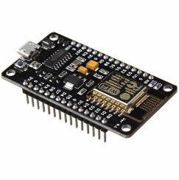
GAS MQ2 | 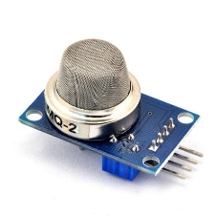
JACK DC 5.5 | 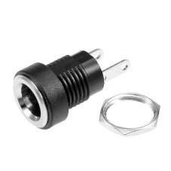
LED RGB | 
DHT11 SENSOR | 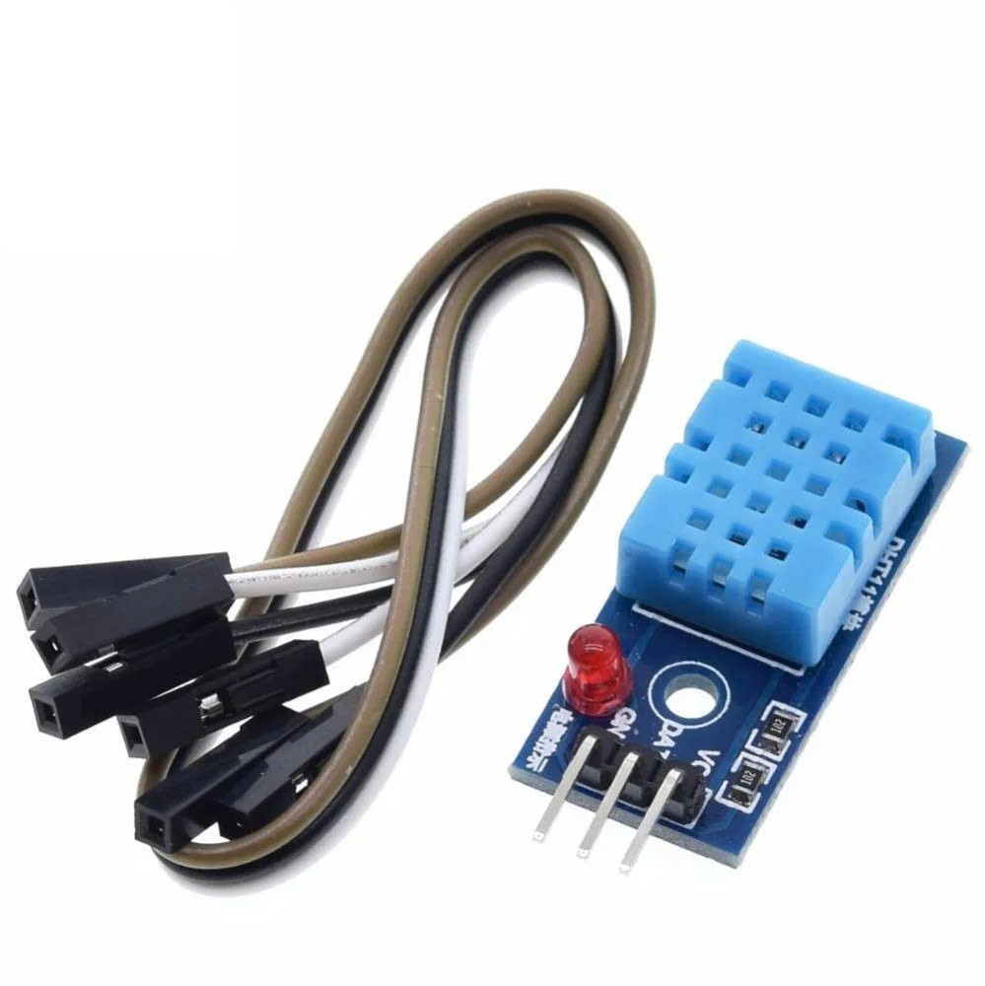
BUZZER 3V | 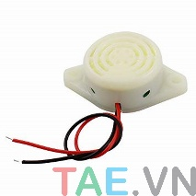
EXHAUST FAN 5 V | 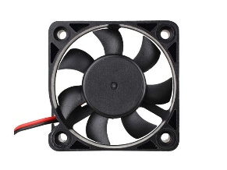
RESISTOR 100 Ω | 
CAMERA
ADAPTER SOURCE DC 5V 1A | 
CW 025 RELAY | 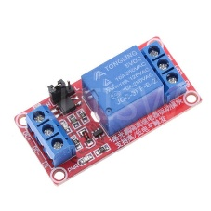

  - Block Diagrams
  - Flowchart
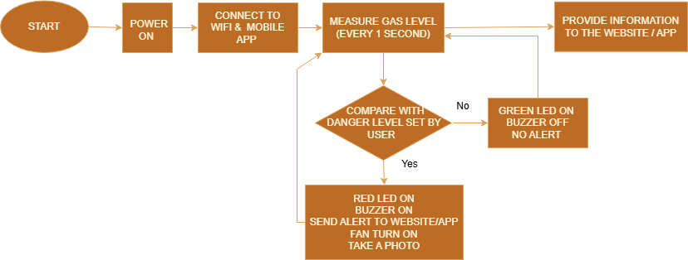
  - Simulation Circuit

III. Results - Conclusion
- Results
LED & Buzzer Alert: When gas leakage was detected, the LED changed from green to red and the buzzer was activated to alert nearby users.
Gas & Temperature Data Transmission: The system successfully transmitted real-time gas concentration and temperature data to the web/application.
Web/App Warning Notification: Warning notifications were displayed on the web/application when gas levels exceeded the safety threshold.
Image Transmission on Alert: Images were automatically captured and sent to the web/application when gas levels exceeded the threshold.
Email Alert Notification: Alert emails were automatically sent when the gas concentration exceeded the safety limit.
Automatic Fan Activation: The ventilation fan was automatically activated to reduce gas concentration during leakage detection.
Manual Fan Control: Users were able to manually turn the fan on or off via the web/application.

- Conclusion
The IoT-based gas leakage monitoring system was successfully designed and implemented, meeting all the defined objectives. The system is capable of real-time gas leakage detection and provides timely local and remote alerts via web, application, and email. Furthermore, the integration of a camera module and both automatic and manual ventilation fan control enhances incident response and user safety. With its low cost, ease of deployment, and scalability, the system is suitable for practical applications in households, factories, and gas-using environments.

IV. Appendix
- Link simulation
- Link Demo
- Reference
- Code

