FPT UNIVERSITY

─────────────────────────────────────────

(DBI202) Project: High School Student Management System

Group 5

Lecture: Lê Thị Phương Dung

Members group | Student code
Nguyễn Thiện An | CE200652
Lâm Tấn Đạt | CE160435
Đỗ Hoài Phong | CE181199
Nguyễn Trường Thịnh | CE202010
Huỳnh Thị Bảo Trân | CS170607

Table of Contents
Table of Contents 1
I. Project Introduction 2
1. Product Background 3
2. Business (Operational) Opportunity 3
3. Software Product Vision 3
4. Project Scope & Limitations 3
II. Software Design Description1. System Design 3
1.1 System Architecture (ERD) 4
1.2 Package Diagram 4
2. Database Design 5
III. SQL Queries 7
Q1: Display student information along with class and academic year. 7
Q2: Display the detailed report card of the student by subject and semester. 8
Q3: Calculate the student's average grade for the semester. 9
Q4: List of 12th grade students for the 2025-2026 school year 10
Q5: Display the homeroom teacher of each class. 11
Q6: Top 10 students with the highest Chemistry scores. 12
Q7: List teachers teaching each class by subject and academic year. 12
Q8: Count the number of students in each class. 13
Q9: Trigger to validate that scores must be between 0 and 10. 14
Q10: : Update a student's phone number. 14
Q11: Find the student with the highest average score in the class. 15
15

I. Project Introduction

1. Product Background
Managing a high school manually is time-consuming and prone to errors. Common challenges include:
Manual Processes: Tracking student information, class assignments, grades, and schedules by hand leads to errors and inefficiency.
Lack of Centralized Data: Student academic records, teacher assignments, and semester results are stored separately, making reporting difficult.
Difficulty in Academic Tracking: Computing weighted averages across multiple score types (oral, 15-min tests, 1-period tests, final exams) is error-prone.
The HighSchoolStudentManagement system is designed to centralize all academic data for students in Grades 10-12, providing reliable data access and query capabilities.

2. Business (Operational) Opportunity
Improve Administrative Efficiency: Provide a single database for managing students, teachers, classes, subjects, and results, reducing redundancy.
Enhance Academic Tracking: Allow staff to easily query student performance across semesters and subjects.
Support Data-Driven Decisions: Enable quick reporting on class rankings, top performers, homeroom teacher assignments, and more.

3. Software Product Vision
Vision: To be a reliable and comprehensive database system for high school academic management, helping schools optimize operations and improve record accuracy.
Objectives:
- Efficiency: Automate student record management, grade tracking, and class assignments.
- Accuracy: Ensure correct grade calculations using weighted formulas.
- Reporting: Provide flexible queries for academic performance and teacher management.
- Scalability: Design a database that accommodates multiple academic years and class expansions.

4. Project Scope & Limitations
Scope: The project focuses on database design to manage core academic entities:
- AcademicYear, Teacher, Class, Subject, Semester, Student, Result, Teaching

Limitations:
- This is a database project (DBI202), focusing on schema design (ERD, Tables) and SQL queries.
- It does not include a front-end application (UI/UX).
- It does not integrate with other school systems (e.g., finance, HR, e-learning platforms).
- Query screenshots are placeholders — to be replaced with actual execution results.

II. Software Design Description
1. System Design
ERD (Entity Relationship Diagram): A diagram describing the entities and relationships for the high school management system, including entities such as Student, Teacher, Class, Subject, Semester, Result, and Teaching.

Entity Description: The system includes the following main entities:
- AcademicYear: Stores academic year information (e.g., 2024-2025).
- Teacher: Manages teacher information and phone number.
- Class: Manages classes by grade level with assigned homeroom teacher (GVCN) and academic year.
- Subject: Stores subject information and total periods.
- Semester: Manages semester periods within an academic year.
- Student: Stores student personal information and class assignment.
- Result: Stores all score types for each student per subject per semester.
- Teaching: Records which teacher teaches which subject to which class in each academic year.

1.1 System Architecture (ERD)

1.2 Package Diagram

2. Database Design

No. | Table / Object | Column / Description | Description
1 | AcademicYear | AcademicYearID | Primary key, unique identifier for each academic year.
 |  | YearName | Name of the year (e.g., '2024-2025').
 |  | StartYear | Start year (integer).
 |  | EndYear | End year (integer).
2 | Teacher | TeacherID | Primary key, unique identifier for each teacher.
 |  | FullName | Full name of the teacher (not null).
 |  | PhoneNumber | Phone number of the teacher.
3 | Class | ClassID | Primary key, unique identifier for each class.
 |  | ClassName | Class name (e.g., '10A1').
 |  | Grade | Grade level: 10, 11, or 12.
 |  | TeacherID | Foreign key to Teacher (homeroom teacher - GVCN).
 |  | AcademicYearID | Foreign key to AcademicYear.
4 | Subject | SubjectID | Primary key, unique identifier for each subject.
 |  | SubjectName | Name of the subject (e.g., Mathematics, Chemistry).
 |  | TotalPeriods | Total number of periods for the subject.
5 | Semester | SemesterID | Primary key, unique identifier for each semester.
 |  | SemesterName | Semester name (e.g., 'Semester 1').
 |  | StartDate | Start date of the semester.
 |  | EndDate | End date of the semester.
 |  | AcademicYearID | Foreign key to AcademicYear.
6 | Student | StudentID | Primary key, unique identifier for each student.
 |  | Name | Full name of the student (not null).
 |  | DateOfBirth | Date of birth.
 |  | Gender | Gender (Male/Female).
 |  | Address | Home address.
 |  | PhoneNumber | Phone number.
 |  | ClassID | Foreign key to Class.
7 | Result | StudentID | Foreign key to Student (part of composite PK).
 |  | SubjectID | Foreign key to Subject (part of composite PK).
 |  | SemesterID | Foreign key to Semester (part of composite PK).
 |  | OralScore | Oral examination score (DECIMAL 4,2).
 |  | Score15Minutes | 15-minute test score (DECIMAL 4,2).
 |  | Score1Period | 1-period test score (DECIMAL 4,2).
 |  | FinalExamScore | Final exam score (DECIMAL 4,2).
8 | Teaching | ClassID | Foreign key to Class (part of composite PK).
 |  | TeacherID | Foreign key to Teacher (part of composite PK).
 |  | SubjectID | Foreign key to Subject (part of composite PK).
 |  | AcademicYearID | Foreign key to AcademicYear (part of composite PK).

III. SQL Queries

Q1: Display student information along with class and academic year.
Display student information along with their class and academic year by joining Student, Class, and AcademicYear tables.

SELECT
s.StudentID,
s.Name AS StudentName,
c.ClassName,
c.Grade,
ay.YearName AS AcademicYear
FROM Student s
JOIN Class c ON s.ClassID = c.ClassID
JOIN AcademicYear ay ON c.AcademicYearID = ay.AcademicYearID;

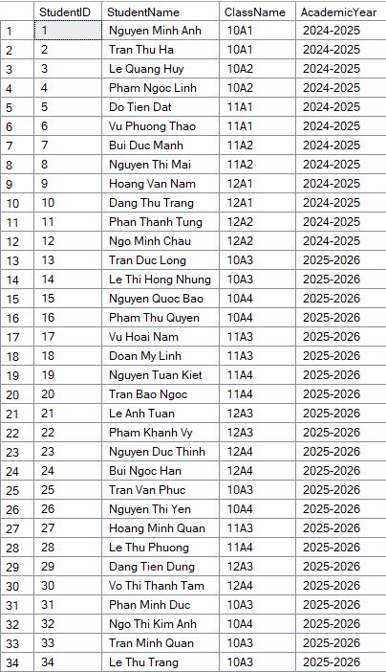

Q2: Display the detailed report card of the student by subject and semester.
Display the detailed score table for each student, including subject and semester information.

SELECT
s.Name AS StudentName,
sub.SubjectName,
se.SemesterName,
r.OralScore,
r.Score15Minutes,
r.Score1Period,
r.FinalExamScore
FROM Result r
JOIN Student s ON r.StudentID = s.StudentID
JOIN Subject sub ON r.SubjectID = sub.SubjectID
JOIN Semester se ON r.SemesterID = se.SemesterID;

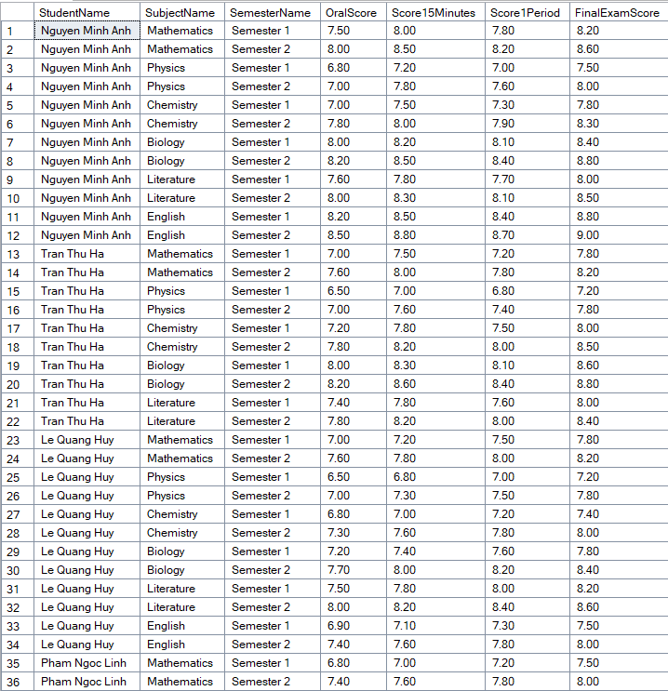

Q3: Calculate the student's average grade for the semester.
Calculate the weighted average score per subject per semester for each student. Formula: OralScore*0.1 + Score15Minutes*0.2 + Score1Period*0.3 + FinalExamScore*0.4

SELECT
s.Name AS StudentName,
sub.SubjectName,
se.SemesterName,
ROUND(
r.OralScore * 0.1 +
r.Score15Minutes * 0.2 +
r.Score1Period * 0.3 +
r.FinalExamScore * 0.4
, 2) AS AverageScore
FROM Result r
JOIN Student s ON r.StudentID = s.StudentID
JOIN Subject sub ON r.SubjectID = sub.SubjectID
JOIN Semester se ON r.SemesterID = se.SemesterID;

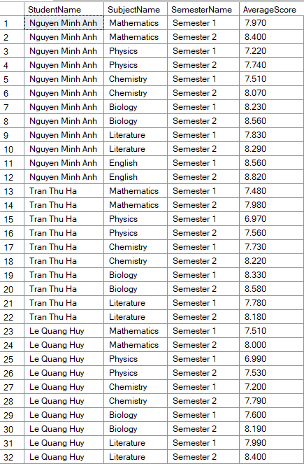

Q4: List of 12th grade students for the 2025-2026 school year
Retrieve the list of Grade 12 students for the academic year 2025-2026.

SELECT
s.StudentID,
s.Name,
c.ClassName,
ay.YearName
FROM Student s
JOIN Class c ON s.ClassID = c.ClassID
JOIN AcademicYear ay ON c.AcademicYearID = ay.AcademicYearID
WHERE c.Grade = 12
AND ay.YearName = '2025-2026';

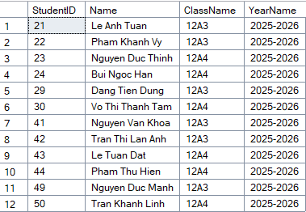

Q5: Display the homeroom teacher of each class.
Display the homeroom teacher for each class, ordered by academic year and class name.

SELECT
c.ClassName,
ay.YearName,
t.FullName AS HomeroomTeacher
FROM Class c
JOIN Teacher t ON c.TeacherID = t.TeacherID
JOIN AcademicYear ay ON c.AcademicYearID = ay.AcademicYearID
ORDER BY ay.YearName, c.ClassName;

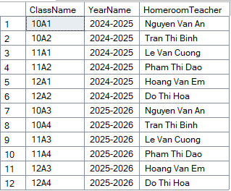

Q6: Top 10 students with the highest Chemistry scores.
Find the top 10 students with the highest average score in Chemistry, sorted descending.

SELECT TOP 10
s.StudentID,
s.Name,
c.ClassName,
ROUND(
r.OralScore * 0.1 +
r.Score15Minutes * 0.2 +
r.Score1Period * 0.3 +
r.FinalExamScore * 0.4
, 2) AS AverageScore
FROM Result r
JOIN Student s ON r.StudentID = s.StudentID
JOIN Class c ON s.ClassID = c.ClassID
JOIN Subject sub ON r.SubjectID = sub.SubjectID
WHERE sub.SubjectName = 'Chemistry'
ORDER BY AverageScore DESC;

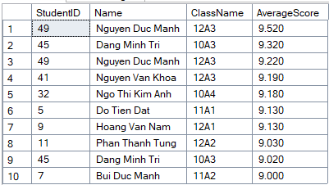

Q7: List teachers teaching each class by subject and academic year.
List all teachers assigned to each class by subject and academic year using the Teaching table.

SELECT
c.ClassName,
t.FullName AS TeacherName,
sub.SubjectName,
ay.YearName
FROM Teaching teach
JOIN Class c ON teach.ClassID = c.ClassID
JOIN Teacher t ON teach.TeacherID = t.TeacherID
JOIN Subject sub ON teach.SubjectID = sub.SubjectID
JOIN AcademicYear ay ON teach.AcademicYearID = ay.AcademicYearID
ORDER BY ay.YearName, c.ClassName, sub.SubjectName;

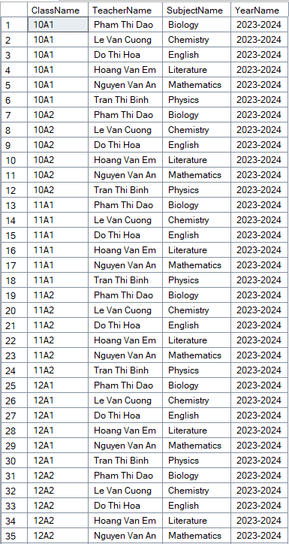

Q8: Count the number of students in each class.
Count the number of students in each class.

SELECT
c.ClassName,
c.Grade,
ay.YearName,
COUNT(s.StudentID) AS TotalStudents
FROM Class c
LEFT JOIN Student s ON c.ClassID = s.ClassID
JOIN AcademicYear ay ON c.AcademicYearID = ay.AcademicYearID
GROUP BY c.ClassID, c.ClassName, c.Grade, ay.YearName
ORDER BY ay.YearName, c.Grade, c.ClassName;

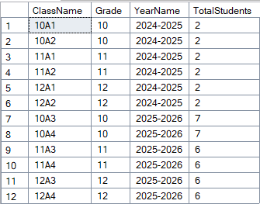

Q9: Trigger to validate that scores must be between 0 and 10.
Trigger checks valid points (0 – 10)
CREATE TRIGGER trg_CheckScore
ON Result
FOR INSERT, UPDATE
AS
BEGIN
IF EXISTS (
SELECT *
FROM inserted
WHERE Score1 < 0 OR Score1 > 10
OR Score2 < 0 OR Score2 > 10
OR Score3 < 0 OR Score3 > 10
OR ScoreFinal < 0 OR ScoreFinal > 10
)
BEGIN
PRINT N'Diem phai nam trong khoan 0 den 10'
ROLLBACK TRANSACTION
END
END

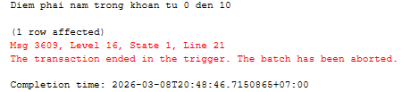

Q10: : Update a student's phone number.
Update the phone number of a specific student (example: StudentID = 1).

-- Update phone number of student with StudentID = 1
UPDATE Student
SET PhoneNumber = '0999999999'
WHERE StudentID = 1;

-- Verify the update
SELECT StudentID, Name, PhoneNumber
FROM Student
WHERE StudentID = 1;

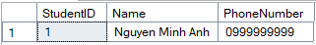
Q11: Find the student with the highest average score in the class.
CREATE PROCEDURE sp_TopStudentInClass
@ClassID INT
AS
BEGIN
SELECT TOP 1 s.StudentID, s.Name,
AVG((OralScore + Score15Minutes + Score1Period + FinalExamScore)/4.0) AS AvgScore
FROM Student s
JOIN Result r ON s.StudentID = r.StudentID
WHERE s.ClassID = @ClassID
GROUP BY s.StudentID, s.Name
ORDER BY AvgScore DESC
END

EXEC sp_TopStudentInClass 1;

Q12: Function calculates the average grade for all subjects for a student.
CREATE FUNCTION fn_AvgStudentScore
(
@StudentID INT
)
RETURNS DECIMAL(4,2)
AS
BEGIN
DECLARE @AvgScore DECIMAL(4,2)

SELECT @AvgScore = AVG((OralScore + Score15Minutes + Score1Period + FinalExamScore)/4.0)
FROM Result
WHERE StudentID = @StudentID

RETURN @AvgScore
END

