

**Event Management at FPTU**

**Software Design Document**

**Table of Contents**

I. Overview 3

1. Code Packages 3

2. Use Case 4

3. Database Schema 5

II. Code Designs 6

1. Create Event 6

a. Class Diagram 6

b. Sequence Diagram(s) 6

c. Database queries 6

2. Register Event 7

a. Class Diagram 7

b. Sequence Diagram(s) 7

c. Database queries 7

3. Search Event 7

a. Class Diagram 8

b. Sequence Diagram(s) 8

c. Database queries 8

III. Database Tables 9

1. tblCategories. 9

2. tblClubDetails 9

3. tblEventRegisters 9

4. tblEventStatuses 9

5. tblFeedbacks 9

6. tblFollowed 9

7. tblFUEvents 10

8. tblLiked 10

9. tblLocations 10

10. tblPayments 10

11. tblRoles 11

12. tblUsers 11

13. tblUserStatuses 5

# **I. Overview**

## **1. Code Packages/Namespaces**

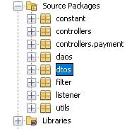

***Package descriptions & package class naming conventions***

| **No** | **Package** | **Description** |
| --- | --- | --- |
| *01* | *.constant* | *The collection of routers* |
| *02* | *.controller* | *The collection of servlets* |
| *03* | *.controller.payment* | *The collection of servlets that specifically used for actions with Payment by User* |
| *04* | *.daos* | *The collection of data access object classes* |
| *05* | *.dtos* | *The collection of data transfer object classes* |
| *06* | *.filter* | *The collection of filters* |
| *07* | *.listener* | *Supporting component of filters* |
| *08* | *.utils* | *The collection of underlying tool that help DAO interact with Database or between components* |
| *09* | *.library* | *The collection of sunderlying tool that help with data formatting and more* |

## **2. Usecase**

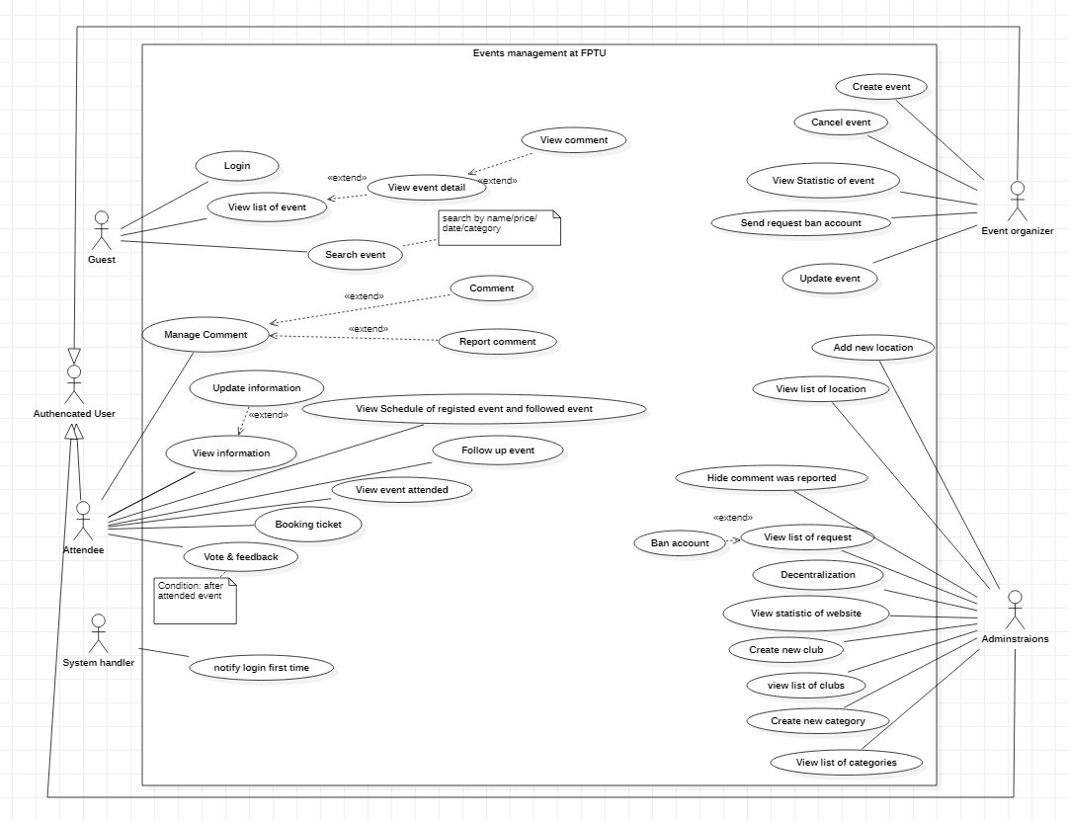

## **3. Database Schema**

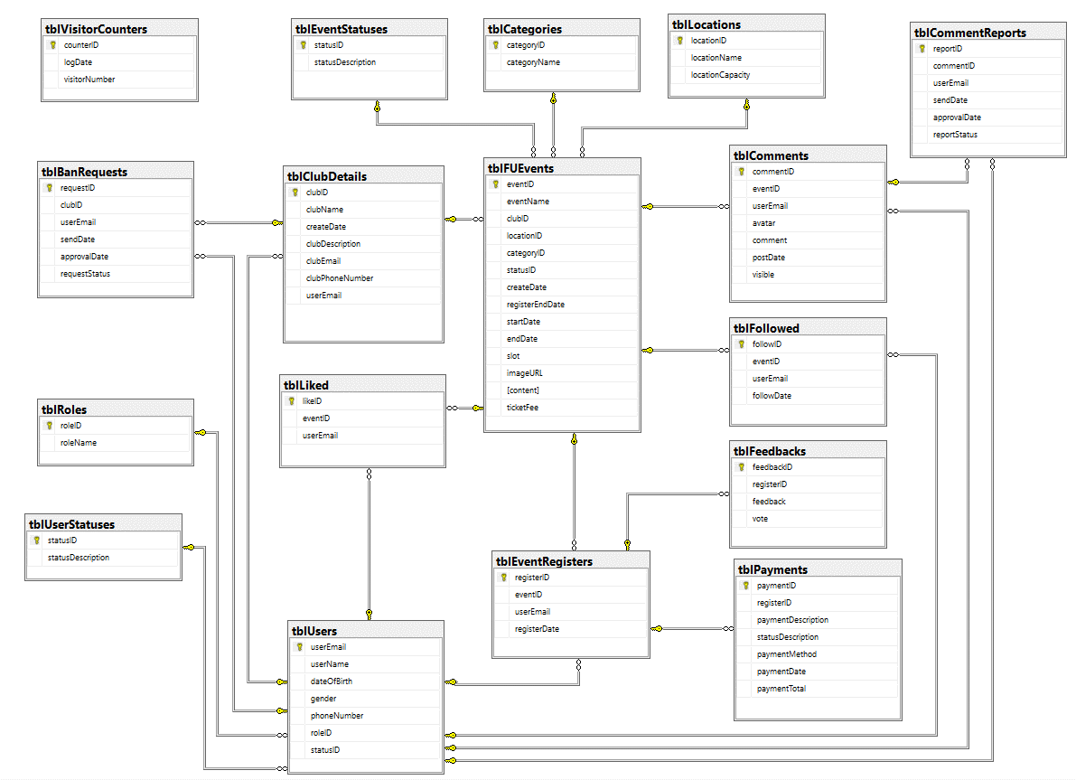

***Table descriptions & package class naming conventions are as below***

| **No** | **Table** | **Description** |
| --- | --- | --- |
| *01* | *tblCategories* | *- Primary keys: categoryID* |
| *02* | *tblCLubDetails* | *-Primary keys: clubID*  *-Foreign key: userEmail* |
| *03* | *tblEventRegister* | *-Primary keys: registerID*  *-Foreign keys: eventID, userEmail* |
| *04* | *tblEventStatus* | *-Primary keys: statusID* |
| *05* | *tblFeebacks* | *-Primary keys: feedbackID*  *-Foreign keys: registerID* |
| *06* | *tblFollowed* | *-Primary keys: followID*  *-Foreign keys: eventID, userEmail* |
| *07* | *tblFUEvents* | *-Primary keys: eventID*  *-Foreign keys: clubID, location,ID categoryID, statusID* |
| *08* | *tblLiked* | *-Primary keys: likeID*  *-Foreign keys: eventID, userEmail* |
| *09* | *tblLocation* | *-Primary keys: locationID* |
| *10* | *tblPayments* | *-Primary keys: paymentID*  *-Foreign keys: registerID* |
| *11* | *tblRoles* | *-Primary keys: roleID* |
| *12* | *tblUsers* | *-Primary keys: userEmail*  *-Foreign keys: roleID, statusID* |
| *13* | *tblUserStatuses* | *-Primary keys: statusID:* |

# **II. Code Designs**

## **1. Create Event**

### **Class Diagram**

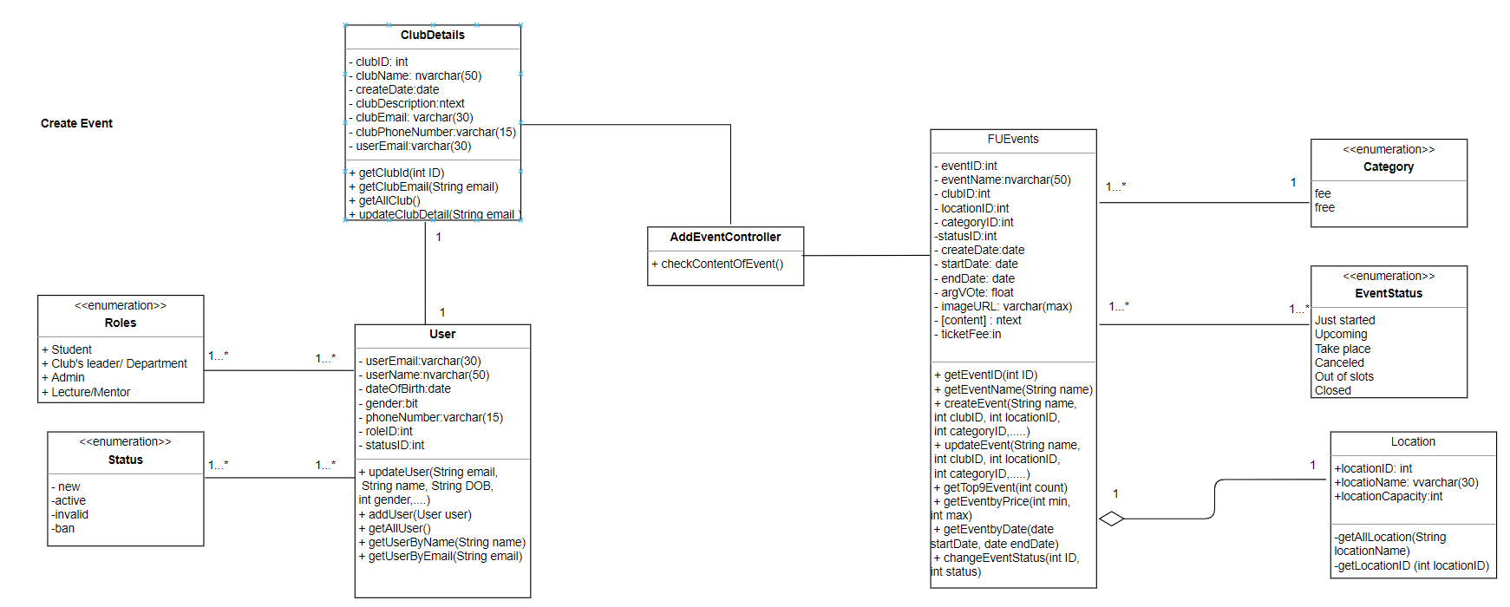

### **Sequence Diagram(s)**

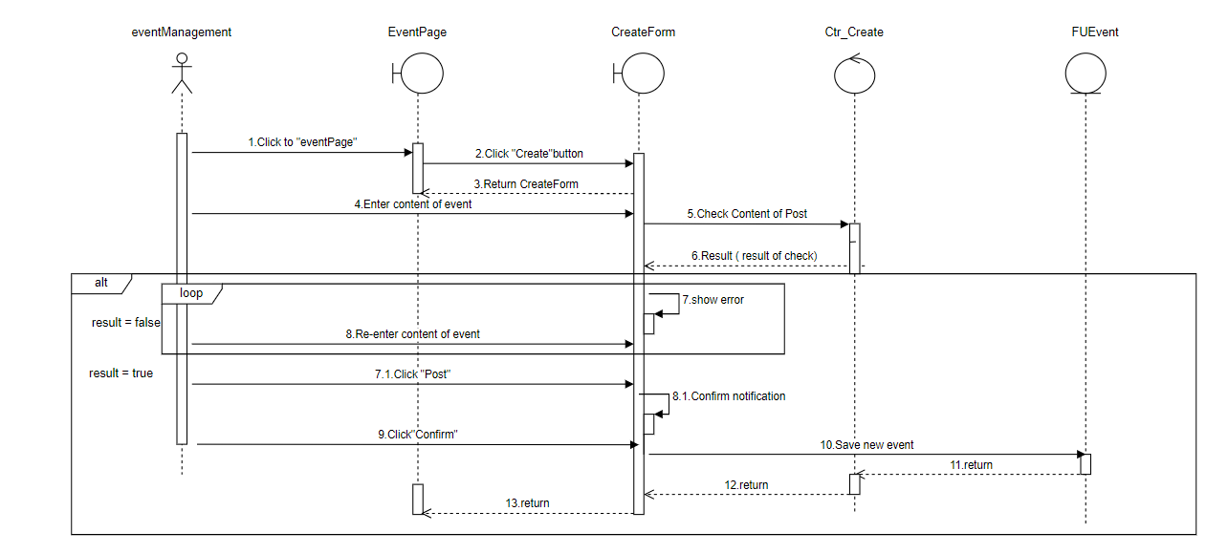

### **d. Database queries**

"INSERT INTO tblFUEvents (eventName, clubID, locationID, categoryID, statusID,"

+ " createDate, startDate, endDate, registerEndDate, slot, imageURL, content, ticketFee)"

+ " VALUES (?,?,?,?,?,?,?,?,?,?,?,?,?)";

## **2. Register Event**

### **Class Diagram**

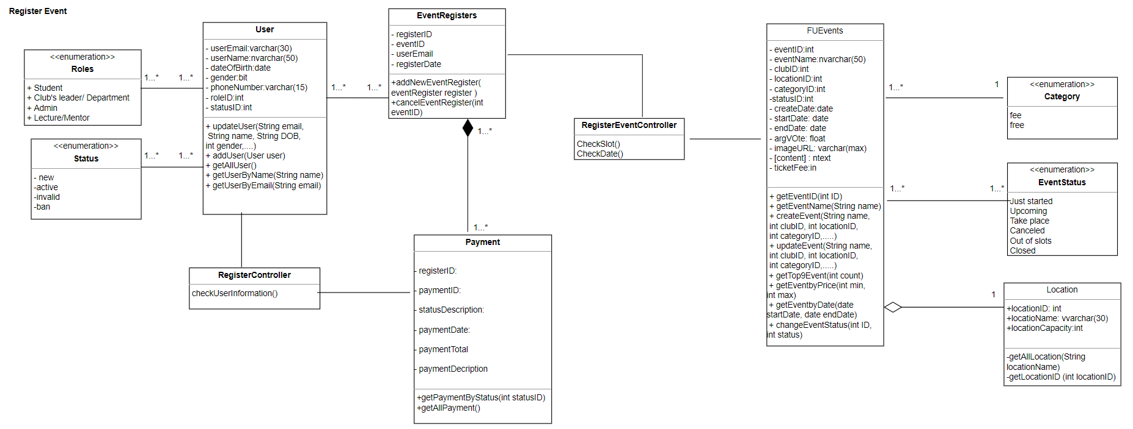

### **Sequence Diagram(s)**

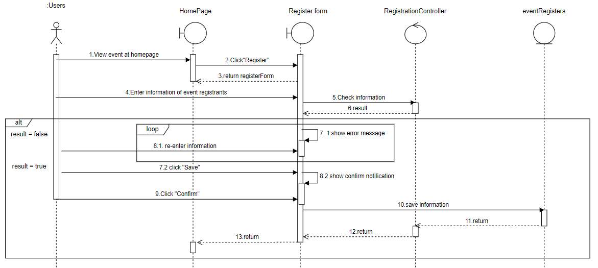

### **c. Database queries**

INSERT INTO tblEventRegisters (eventID, userEmail, registerDate) VALUES (?,?,?)

## **3. Search Event**

### **Class Diagram**

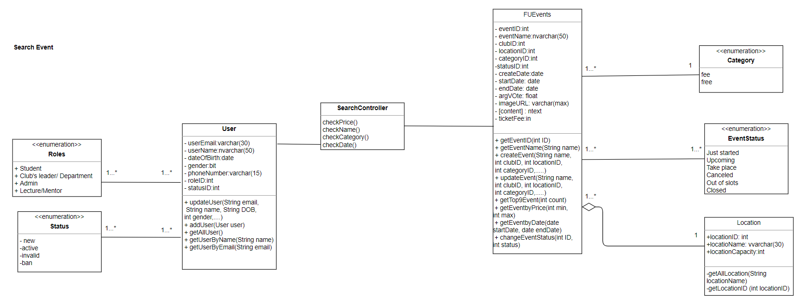

### **Sequence Diagram(s)**

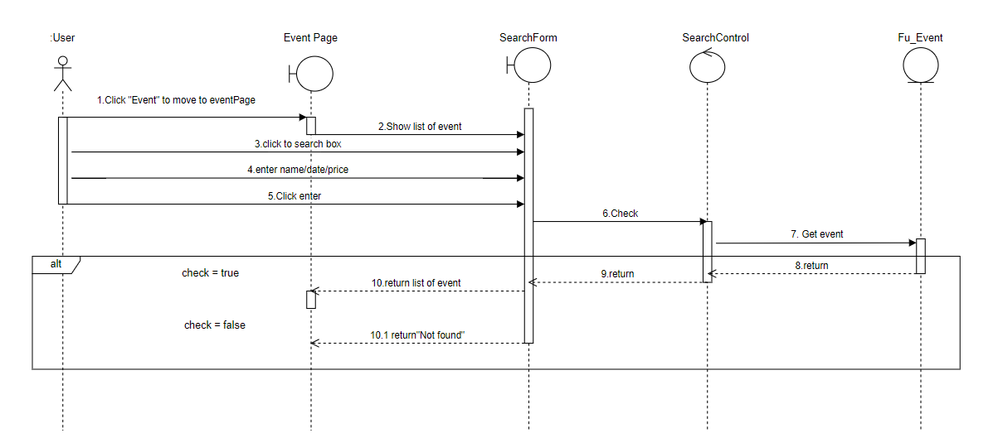

### **c. Database queries**

**By category**

String sql = "SELECT *"

+ " FROM tblFUEvents"

+ " WHERE categoryID = ? AND statusID NOT IN (400)"

+ " ORDER BY statusID"

+ " OFFSET (?-1)*9 ROWS FETCH NEXT 9 ROWS ONLY";

**By price**

"SELECT *"

+ " FROM tblFUEvents"

+ " WHERE (ticketFee >= ? AND ticketFee <= ?) AND statusID NOT IN (400)"

+ " ORDER BY statusID"

+ " OFFSET (?-1)*9 ROWS FETCH NEXT 9 ROWS ONLY";

# **III. Database Tables**

## **1. tblCategories**

| **#** | **Field name** | **Type** | **Size** | **Unique** | **Not Null** | **PK/FK** | **Notes** |
| --- | --- | --- | --- | --- | --- | --- | --- |
| 1 | categoryID | int |  | X | X | PK |  |
| 2 | categoryName | nvarchar(30) | 30 |  | X |  |  |

## **2. tblClubDetails**

| **#** | **Field name** | **Type** | **Size** | **Unique** | **Not Null** | **PK/FK** | **Notes** |
| --- | --- | --- | --- | --- | --- | --- | --- |
| 1 | clubID | Int |  | X | X | PK |  |
| 2 | clubName | nvarchar(50) | 50 |  | X |  |  |
| 3 | createDate | date |  |  | X |  |  |
| 4 | clubDescription | ntext |  |  | X |  |  |
| 5 | clubEmail | varchar(30) | 30 |  |  |  |  |
| 6 | clubPhoneNumber | varchar(15) | 15 |  |  |  |  |
| 7 | userEmail | Varchar(30) |  |  |  | FK |  |

## **3. tblEventRegister**

| **#** | **Field name** | **Type** | **Size** | **Unique** | **Not Null** | **PK/FK** | **Notes** |
| --- | --- | --- | --- | --- | --- | --- | --- |
| 1 | registerID | int |  | X | X | PK |  |
| 2 | eventID | int |  |  |  | FK |  |
| 3 | userEmail | varchar(30) |  |  |  | FK |  |
| 4 | registerDate | date |  |  | X |  |  |

## **4. tblEventStatuses**

| **#** | **Field name** | **Type** | **Size** | **Unique** | **Not Null** | **PK/FK** | **Notes** |
| --- | --- | --- | --- | --- | --- | --- | --- |
| 1 | statusID | int |  | X | X | PK |  |
| 2 | statusDescription | nvarchar(30) | 30 |  | X |  |  |

## **5. tblEventStatuses**

| **#** | **Field name** | **Type** | **Size** | **Unique** | **Not Null** | **PK/FK** | **Notes** |
| --- | --- | --- | --- | --- | --- | --- | --- |
| 1 | feedbackID | Int |  | X | X | PK |  |
| 2 | registerID | Int |  |  |  | FK |  |
| 3 | feedback | ntext |  |  | X |  |  |
| 4 | vote | float |  |  | X |  |  |

## **6. tblFollowed**

| **#** | **Field name** | **Type** | **Size** | **Unique** | **Not Null** | **PK/FK** | **Notes** |
| --- | --- | --- | --- | --- | --- | --- | --- |
| 1 | followID | int |  | X | X | PK |  |
| 2 | eventID | int |  |  |  | FK |  |
| 3 | userEmail | varchar(30) | 30 |  | X | FK |  |

## **7. tblFUEvents**

| **#** | **Field name** | **Type** | **Size** | **Unique** | **Not Null** | **PK/FK** | **Notes** |
| --- | --- | --- | --- | --- | --- | --- | --- |
| 1 | eventID | int |  | X | X | PK |  |
| 2 | eventName | nvarchar(50) | 50 |  | X |  |  |
| 3 | clubID | int |  |  |  | FK |  |
| 4 | locationID | int |  |  |  | FK |  |
| 5 | categoryID | int |  |  |  | FK |  |
| 6 | statusID | int |  |  |  | FK |  |
| 7 | createDate | date |  |  | X |  |  |
| 8 | startDate | date |  |  | X |  |  |
| 9 | endDate | date |  |  | X |  |  |
| 10 | avgVote | float |  |  | X |  |  |
| 11 | imageURL | varchar(max) | Max |  |  |  |  |
| 12 | content | ntext |  |  | X |  |  |
| 13 | ticketFee | int |  |  | X |  |  |

## **8. tblLiked**

| **#** | **Field name** | **Type** | **Size** | **Unique** | **Not Null** | **PK/FK** | **Notes** |
| --- | --- | --- | --- | --- | --- | --- | --- |
| 1 | likeID | int |  | X | X | PK |  |
| 2 | eventID | Int |  |  |  | FK |  |
| 3 | userEmail | varchar(30) | 30 |  |  | FK |  |

## **9. tblLocations**

| **#** | **Field name** | **Type** | **Size** | **Unique** | **Not Null** | **PK/FK** | **Notes** |
| --- | --- | --- | --- | --- | --- | --- | --- |
| 1 | locationID | int |  | X | X | PK |  |
| 2 | locationName | nvarchar(30) | 30 |  | X |  |  |
| 3 | locationCapacity | int |  |  | X |  |  |

## **10. tblPayments**

| **#** | **Field name** | **Type** | **Size** | **Unique** | **Not Null** | **PK/FK** | **Notes** |
| --- | --- | --- | --- | --- | --- | --- | --- |
| 1 | paymentID | int |  | X | X | PK |  |
| 2 | registerID | int |  |  |  | FK |  |
| 3 | statusDesciption | varchar(30) | 30 |  | X |  |  |
| 4 | paymentDate | date |  |  | X |  |  |
| 5 | paymentToTal | int |  |  | X |  |  |

## **11. tblRoles**

| **#** | **Field name** | **Type** | **Size** | **Unique** | **Not Null** | **PK/FK** | **Notes** |
| --- | --- | --- | --- | --- | --- | --- | --- |
| 1 | roleID | int |  | X | X | PK |  |
| 2 | roleName | nvarchar(30) | 30 |  | X |  |  |

## **12. tblUsers**

| **#** | **Field name** | **Type** | **Size** | **Unique** | **Not Null** | **PK/FK** | **Notes** |
| --- | --- | --- | --- | --- | --- | --- | --- |
| 1 | userEmail | Varchar(30 |  | X | X | PK |  |
| 2 | userName | nvarchar(50) | 50 |  | X |  |  |
| 3 | dateOfBirth | Date |  |  |  |  |  |
| 4 | Gender | Bit |  |  |  |  |  |
| 5 | phoneNumber | Varchar(15) | 15 |  |  |  |  |
| 6 | roleID | Int |  |  |  | FK |  |
| 7 | statusID | Int |  |  |  | FK |  |

## **13. tblUserStatuses**

| **#** | **Field name** | **Type** | **Size** | **Unique** | **Not Null** | **PK/FK** | **Notes** |
| --- | --- | --- | --- | --- | --- | --- | --- |
| 1 | statusID | int |  | X | X | PK |  |
| 2 | statusDescription | nvarchar(30) | 30 |  | X |  |  |