Candidate Number:

ISSU0053 Data Science and Big Data Analytics

AM GROUP

UCL International Summer School for Undergraduates 2019

**Assessment II Computer Practical under examination conditions (50%)**

**Timing Friday 9th August 10am – 12:30pm**

**Examination conditions:**

* **The session is open book, so you can consult your notes, textbooks and programming websites as you work.**
* **You must work on the UCL desktop.**
* **All work submitted must be your own. All forms of communication and messaging with other students is strictly prohibited, and violations will be dealt with in accordance with UCL policy.**
* **At the end of the assessment you will have a short time to collate the files you have produced and upload them for marking.**

**Notes:**

Marks for questions are indicative, and a grading curve may be applied to generate a final grade.

All code used to complete the tasks must be submitted in R script files or R notebook files in Rmd format. Partial marks will be awarded for code sections that have been completed but are non-functional.

You should work in one file per section, so at the end of the exam upload either e.g.

sectionA.R, sectionB.R, sectionC.R sectionD.R, sectionE.R

or sectionA.Rmd, sectionB.Rmd, sectionC.Rmd, sectionD.Rmd, sectionE.Rmd

It is recommended you use comments / notes in your files to indicate which part of the question you are attempting, e.g.

# A1

plot(…)

# A2

summary(boston)

**Section (A)**

*Start a new R file for your answer to this question.*

The file sales.csv contains data on the sales of items in a university campus cafe that opens on Mondays to Fridays and is closed at the weekend.

Write R code to:

A1. Load the contents of the file into a data frame.

(1 mark)

A2. Display the names of the columns that have been loaded.

(1 mark)

A3. Edit the data frame so that column windspeed is renamed to wind

(1 mark)

A4. How many rows are in the data frame?

(1 mark)

A5. Drop all rows with NA values and calculate the number of rows removed.

(2 marks)

A6. Edit the data frame to remove the date column.

(1 mark)

A7. The column staff records who was the person working in the shop using the following mapping:

|  |  |  |  |
| --- | --- | --- | --- |
| 1 | 2 | 3 | 4 |
| Harry | Sara | Tom | Kate |

Adjust the data frame so that staff uses the names as given above in a factor type column.

(3 marks)

A8. Add a column food that totals the number of pizza, pasta, and wrap sales each day.

(2 marks)

(12 marks)

**Section (B)**

*Start a new R file for your answer to this question.*

Load the RDA file section_b.Rda into R.

This contains the data frame: sales. This contains the modified version of the data frame you worked on in Section (A) without the food column.

Write R code to find:

B1. The total number of soda sales made over all days recorded in the dataset.

(1 mark)

B2. The highest number of wraps sold in a single day.

(1 mark)

B3. The average value of total_sales on the days when Harry was staffing the shop .

(1 mark)

B4. The average value of total_sales on the days when Sara was staffing the shop .

(1 mark)

B5. Perform a t-test to test the hypothesis that the average total_sales achieved is different on the days Harry works in the shop, compared to the days Sara works in the shop.

(1 mark)

You should see the following result.

Welch Two Sample t-test

data: ...

t = -1.9694, df = 24.574, p-value = 0.06028

alternative hypothesis: ...

95 percent confidence interval:

-56.170716 1.281428

sample estimates:

mean of x mean of y

135.8846 163.3293

B6. Interpret the result against the hypothesis based on a significance level of 0.05.

(1 mark)

B7. Write R code to examine the dataset and display the maximum and minimum humility levels over the recorded period.

(1 mark)

B8. Make the following fits:

model 1. predict sales of coffee using temperature

model 2. predict sales of coffee using humidity

model 3. predict sales of coffee using wind speed

(2 marks)

B9. Display the fits using screenreg.

(1 mark)

============================================

Model 1 Model 2 Model 3

--------------------------------------------

(Intercept) 45.77 *** -1.66 28.63 ***

(3.76) (5.55) (5.36)

temp -0.59 ***

(0.09)

humidity 0.40 ***

(0.09)

wind -0.39

(0.31)

--------------------------------------------

R^2 0.51 0.32 0.04

Adj. R^2 0.50 0.31 0.01

Num. obs. 43 43 43

RMSE 7.46 8.80 10.50

============================================

*** p < 0.001, ** p < 0.01, * p < 0.05

B10. Explain (with reference to the p-values) how we can interpret the value and significance of the coefficients associated with temperature, humidity and windspeed.

(3 marks)

B11. Use the fit of model 2 to predict of the number of coffees sold when:

i) the humidity level is 30 ii) the humidity level is 80.

(2 marks)

(15 marks)

**Section (C)**

*Start a new R file for your answer to this question.*

In this question we will try to predict pizza sales based on the other column values.

Load the RDA file section_b.Rda into R (same as in Section B)

C1. Write code to display the frequency table for daily pizza sales.

(1 mark)

C2. Build a linear regression model to predict pizza sales from the other columns using forward stepwise selection until an optimal model is reached.

(3 marks)

If you are unable to complete this question. You can generate the resulting fit using the code below (also found in the code_example.R file):

lm_step = lm(pizza ~ weekday + humidity + staff + dessert + total_sales + soda, data = sales)

C3. Examine the diagnostic plots associated with this model.

Why is row 18 highlighted in the final plot?

(1 mark)

C4. Write an R command that displays the data associated with this row.

(1 mark)

C5. Do you feel this row should be considered an outlier to the rest of the dataset?

Explain your answer.

(1 mark)

C6. Write R code that uses the fitted residuals to calculate the RSS value for the fit.

(You should find this to be 81.712).

(1 mark)

C7. Calculate the estimated RMSE of the fit using

(1 mark)

C8. The number 43 in the formula above refers to the number of rows.

What does the other number refer to?

(1 mark)

C9. Which of the terms MSE, RMSE, TSS and RSS is of most use to someone considering the accuracy of a prediction produced by the model?

(1 mark)

C10. Use R to build a simple model that predicts pizza sales using weekday as a single predictor.

(1 mark)

This should generate a table of coefficients like:

Coefficients:

Estimate Std. Error t value Pr(>|t|)

(Intercept) 2.1667 0.8058 2.689 0.01058 *

weekdayMonday 1.3889 1.0402 1.335 0.18977

weekdayThursday 3.7083 1.0659 3.479 0.00128 **

weekdayTuesday 4.5333 1.0192 4.448 7.32e-05 ***

weekdayWednesday 2.8333 1.0192 2.780 0.00841 **

C11. Examine the coefficents. How can we interpret the meaning of these values?

(2 marks)

C12. Use R to compare the performance of this model with the larger model from stepwise selection using an ANOVA test.

(1 mark)

This should produce the following table:

Analysis of Variance Table

Model 1: pizza ~ weekday

Model 2: pizza ~ weekday + humidity + staff + dessert

+ total_sales + soda

Res.Df RSS Df Sum of Sq F Pr(>F)

1 38 148.031

2 32 81.712 6 66.318 4.3286 0.002635 **

---

Signif. codes: 0 ‘***’ 0.001 ‘**’ 0.01 ‘*’ 0.05 ‘.’ 0.1 ‘ ’ 1

C13. Interpret the result of the ANOVA test with reference to the coefficients of the additional predictors included in the larger model.

(1 mark)

C14. Explain why even through the performance of the larger model is better it is of no practical purpose in predicting pizza sales.

(1 mark)

C15. Why do we use cross validation methods to compare models when we already have estimates like R2, Adjusted-R2, and estimated RMSE to measure performance?

(2 marks)

C16. When performing k-fold validation using trainControl we can provide an argument “repeats”.

Explain what this argument does, and why it is useful to make use of it.

(2 marks)

C17. When performing k-fold on this data set what is the maximum number of folds we could use?

(1 mark)

C18. Perform k-fold validation on the following models with repeats=100 and 10 folds. Include a suitable command to ensure that your analysis is reproducible.

(4 marks)

model 1. predict number of pizza sales based on weekday

model 2. predict number of pizza sales based on weekday, temperature, humidity and windspeed

You should expect to obtain results that are similar (but not identical) to:

|  |  |  |
| --- | --- | --- |
| **Predictors** | **Residual standard error:** | **Adj R²** |
| day | 1.974 | 0.3434 |
| day and weather columns | 1.855 | 0.4197 |

C19. Which of these models is best to use in this case? Explain your reasoning.

(1 mark)

(27 marks)

**Section (D)**

*Start a new R file for your answer to this question.*

Load the RDA file section_d.Rda into R. It contains the diabetes data set medical_data

D1. Make two histogram plots showing the distributions of the entries in columns glucagon, and log_glucagon

(2 marks)

D2. Based on these plots would glucagon or log_glucagon be better to use as a predictor in a logistic regression/LDA classification analysis? Explain your answer.

(2 marks)

D3. Write the R command that could be used to create column log_glucagon based on the values in the glucagon column.

(1 mark)

D4. Use the data in medical_data to create a plot similar to the one shown below:

(6 marks)

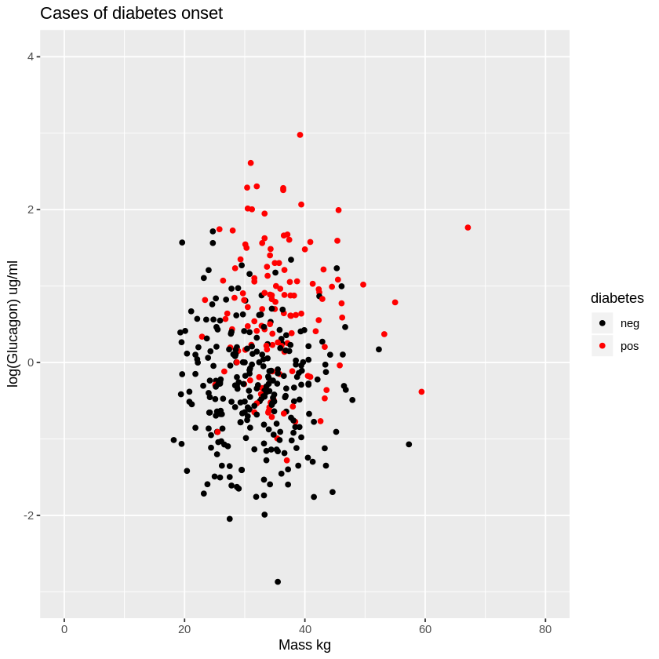

allocation of marks for:

1 mark – displaying the correct data

1 mark – matching x and y axis limits

1 mark – matching x and y axis labels

1 mark – matching title

1 mark – matching legend

1 mark – colouring points according (black for negative, red for positive)

***PLEASE CHECK RESOURCE FOLDER FOR COLOUR VERSION OF PLOT IF NEEDED!***

D5. Look at the plot. Do you think it will be possible to use log_glucagon level and mass to predict whether a person will be in the positive group, i.e. developed diabetes? Explain your answer.

(2 marks)

In order to run logistic regression, K-nearest neighbours and Naive Bayes methods we will create columns that store rescaled predictors for log_glucagon and mass.

This can be done by applying the scale function:

medical_data$log_glucagon_rs <- scale(medical_data$log_glucagon)

medical_data$mass_rs <- scale(medical_data$mass)

D6 . Write R code that displays the mean and standard deviation of the rescaled columns, and comment on how the columns are now scaled.

(2 marks)

To run our analysis we will create a dataframes train_data containing a random sample containing 60% of the full dataset. The rest of the data will be used as a test set and stored in data frame test_data.

D7. Write R commands that shows how to create these data frames from medical_data.

(3 marks)

(18 marks)

**Section (E)**

*Start a new R file for your answer to this question.*

In order to ensure consistency load in the train_data and test_data data frames that have been generated for you by loading section_e.Rda into R. It contains 3 data frames. You can extract them individually by providing the index to the get() function:

train_data = get(section_e[2])

E1. Perform a logistic regression to predict the diabetes class based on the log_glucagon_rs and mass_rs values.

(2 marks)

E2. Use the resulting model to make predictions for the test data set, predicting diabetes if the model predicts more than a 50% or 0.5 probability for a positive diagnosis.

(2 marks)

E3. Create a confusion matrix in the following format. You should find the following result:

(2 marks)

actual

predicted neg pos

neg 97 24

pos 6 30

E4. How many total cases of positive diabetes onset were there in the test dataset?

(1 mark)

E5. How many of these cases of diabetes onset were correctly predicted by the model?

(1 mark)

E6. Hence determine the true positive rate TPR:

(1 mark)

E7. Make a new set of predictions, placing people in the positive category if they are predicted to have more than a 30% or 0.3 probability of being in the group of people developing diabetes.

(1 mark)

actual

predicted neg pos

neg 78 9

pos 25 45

E8. Show that this increases the true positive rate (TPR).

(1 mark)

E9. Suggest a reason why this could be advantageous.

(1 mark)

E10. In what respect has making this change decreased our measured performance?

(1 mark)

We will now try to classify the cases using k-nearest neighbours method.

E11. Apply the method of KNN to predict the class of the test data set using the same predictors as above log_glucagon_rs and mass_rs (don’t use any trainControl or tuneGrid)

(3 marks)

E12: What optimal k was selected (number of neighbours)? (1 mark)

E13. Calculate the misclassification rate of your model.

(1 mark)

E14. The following code creates a sequence of 30 numbers running from 2 to 200:

K_values = c( seq(2,12,2), seq(15,55,5), seq(60,200,10) )

Write code to test the KNN method using these values for K (don’t use traincontrol), and plot the resulting accuracy against K. Include a suitable command to ensure that your analysis is reproducible using values 123.

(4 marks)

E15. What optimal k was selected for the model above? (1 mark)

E16. Code a method to repeat the KNN analysis resampling the data into train and test groups keeping the 0.6 split with 20 repeats in order to generate a measure of averaged performance (keep the K_values for k). Include a suitable command to ensure that your analysis is reproducible using values 123.

Plot the resulting accuracy vs K

(4 marks)

(27Marks)

We will now try to classify the cases using Naive Bayes.

E17. Apply the method of NB to predict the class of the test data set using the same predictors as above log_glucagon_rs and mass_rs. (dont use trainControl). Include a suitable command to ensure that your analysis is reproducible using values 123.

(1 mark)

E18. All classifiers performed more or less the same (around 80% accuracy). It’s unlikely that trying any more algorithms will significantly increase accuracy. Assume you get a lot more data (accuracy of all applied models stays at 80%). Discuss some ways on how you could try to increase the accuracy of your models.

(4 marks)

(5 Marks)

104 marks