**Ruscello White Gloss 60x60 Tiles:**

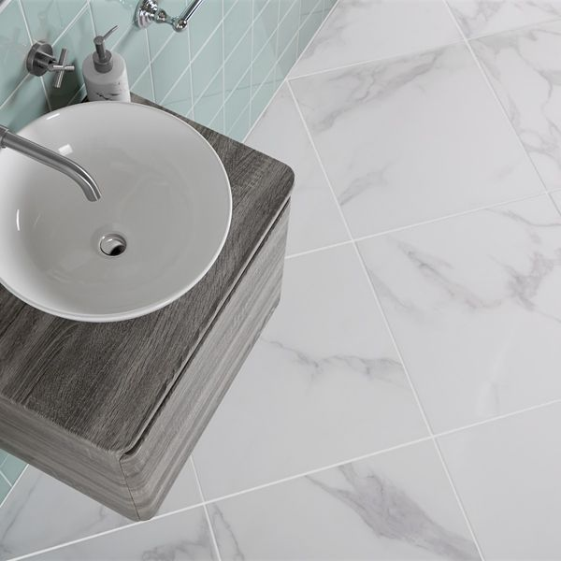

## **Product Description**

These Ruscello Marble Effect Tiles are perfect for creating a natural, opulent look in your home. Inspired by Italy’s famous Calacatta Marble Tiles, they have a stunning marble effect design with delicate grey veins. Made from durable porcelain, they have a shimmering gloss finish that reflects the light for a space-enhancing look.

**What's special about these tiles?**

> Luxurious marble effect design  
> Shimmering gloss finish  
> Organic veining for soft, elegant style  
> Durable, hardwearing porcelain body  
> Perfect for an opulent feel on flooring or walls

## **Product Info**

* Product ID: 44900
* Tiles Per SQM: 2.7777777777778
* Sale by: Per SQM
* Size: 600x600x9.5mm
* Weight: 6.73 KG
* Material Type: Porcelain
* Finish: Gloss
* Colour: White
* Suitability: Floors, Walls
* Grade: 4
* Rectified Edge: No
* Underfloor Heating: Yes
* Thickness (mm): 9.5

**Rustic Blue Reclaimed Wood Effect Tiles:**



## **Product Description**

Piece together a striking, eye-catching display in your interiors with the introduction of these Rustic Blue Wood Plank Tiles. They consist of a reclaimed, aged, weathered wood effect design; some of which with a faded painted appearance. The designs vary from one tile to the next; allowing you to piece together a heavily varied floor display or a stunning feature wall in a bathroom, kitchen, hallway, living room, or bedroom. There are 8 different designs supplied on a random basis.

**What's special about these tiles?**

> They perfectly capture the popular reclaimed look

> They have a mix of different colours for a characterful blend

> Made from porcelain, so durable and hard-wearing

> Unlike natural wood, they don't require treatment and maintenance

> They're more scratch and stain resistant than real wood

> Suitable for use with underfloor heating

## **Product Info**

* Product ID: 14935
* Tiles Per SQM: 11.111111111111
* Sale by: Per SQM
* Size: 150x600x9mm
* Weight: 1.98 KG
* Material Type: Porcelain
* Finish: Matt
* Colour: Brown
* Suitability: Floors, Walls
* Grade: 4
* Rectified Edge: No
* Underfloor Heating: Yes
* Document: [View Layout & Variations](https://m2.wallsandfloors.co.uk/media/amasty/amfile/attach/Walls-and-Floors-rustic-blue-design-recommendations.pdf)
* Thickness (mm): 9

**Lounge Polished Ivory Tiles:**

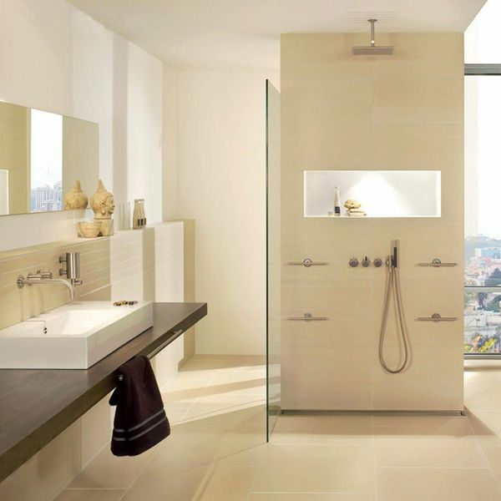

## **Product Description**

Create a stunning natural look in your home with the introduction of these Polished Ivory Floor Tiles. They belong to our selection of Lounge Tiles and have a durable porcelain body - ideal for use throughout the home, and even in areas with high footfall, such as the hallway. Their polished finish shimmers under the light - giving your floor areas an eye-catching appeal. Their ivory stone effect design is ideal for welcoming the sought after natural look into an interior setting. Why is the natural look such a popular interior design trend? Because it enables us to feel closer to nature in our homes - and therefore more at ease.

Due to the natural properties of polished porcelain tiles, we recommend using [LTP MPG](https://www.wallsandfloors.co.uk/catrangetiles/tile-preparation/ltp-cleaning-tile-protecting-tiles/ltp-mpg-sealer-1ltr-sealer-tiles/17683/) colourless impregnating sealer, which is specially formulated to protect and seal polished porcelain tiles.

To prevent staining, we highly recommend sealing these tiles with an [LTP MPG Sealer](https://www.wallsandfloors.co.uk/ltp-cleaning-protecting-ltp-mpg-tile-sealer-11270), both before and after grouting. This can be applied as per the manufacturer’s instructions using an [LTP Buffing Cloth](https://ww2.wallsandfloors.co.uk/ltp-maintenance-tools-blue-buffing-cloth-2-pack). For everyday cleaning, we only recommend [LTP Waxwash](https://www.wallsandfloors.co.uk/ltp-cleaning-protecting-ltp-waxwash-tile-maintenance). Please refer to this [downloadable maintenance PDF](https://www.wallsandfloors.co.uk/media/catalog/product/polished-porcelain-maintenance-cleaning.pdf).

## **Product Info**

* Product ID 11202
* Tiles Per SQM 2.7777777777778
* Sale by Per SQM
* Size 600x600x9mm
* Weight 8.63 KG
* Material Type Porcelain
* Finish Polished
* Colour Beige/Ivory
* Suitability Floors, Walls
* Grade 5
* Rectified Edge No
* Underfloor Heating Yes
* Document [Sealing and Maintenance Guide](https://m2.wallsandfloors.co.uk/media/amasty/amfile/attach/polished-porcelain-maintenance-cleaning.pdf),[Sealing and Maintence Guide](https://m2.wallsandfloors.co.uk/media/amasty/amfile/attach/ltp_polished_porcelain_data_sheet.pdf)
* Thickness (mm) 9

**Scultura Grigio Stone Effect Tiles:**

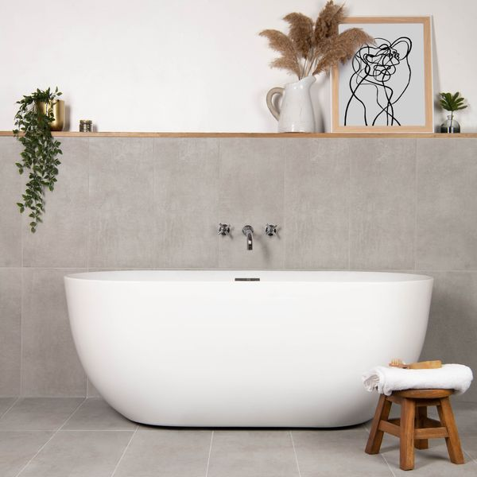

## **Product Description**

Create a calm, natural look in your home with our Scultura Grigio Stone Effect Tiles. Designed in a soft light grey hue, these tiles feature a riven surface with a windswept look that adds depth and movement to the interiors of your home. Made from durable, hardwearing porcelain, they have an anti-slip surface with a natural matt finish.

**What’s special about these tiles?**

> Soft, natural look

> Durable, hardwearing porcelain body

> Riven surface design

> Easy to clean and maintain

## **Product Info**

* Product ID: 45704
* Tiles Per SQM: 5.6115463177033
* Sale by: Per SQM
* Size: 298x598x8mm
* Weight: 3.30 KG
* Material Type: Porcelain
* Finish: Matt
* Colour: Grey
* Suitability: Floors, Walls
* Area Of Usage: Internal
* Grade: 4
* Rectified Edge: No
* Underfloor Heating: Yes
* Anti Slip Grade: R10 / 19-27 Degrees
* Thickness (mm): 8

**Samphire Matt Grey Tiles:**

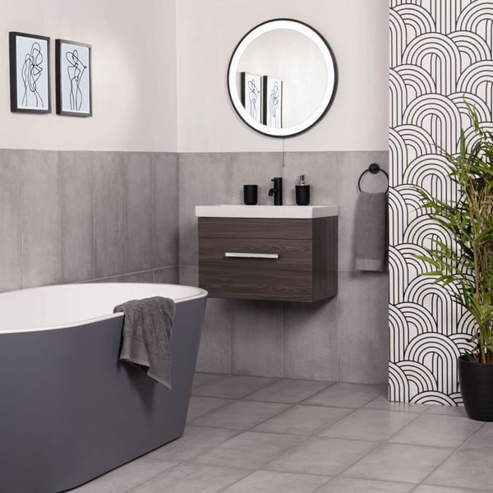

## **Product Description**

With a classic design that’s perfectly suited to any indoor space, our Samphire Dark Grey Stone Effect Porcelain Tiles are the perfect choice for your home. Made from durable porcelain, they feature a mottled stone effect design that embodies the modern, yet rustic feel that’s so popular in interior design. The tiles’ textured surface and natural matt finish are reminiscent of natural stone, forming a simple, elegant look in your home that’s made to last.

**What’s special about these tiles?**

> Dark grey hue

> Naturalistic textured surface

> Durable and hardwearing

> Long lasting and easy to clean

## **Product Info**

* Product ID 45696
* Tiles Per SQM 5.6115463177033
* Sale by Per SQM
* Size 298x598x8mm
* Weight 3.30 KG
* Material Type Porcelain
* Finish Matt
* Colour Grey
* Suitability Floors, Walls
* Area Of Usage Internal, External
* Grade 4
* Rectified Edge No
* Underfloor Heating Yes
* Thickness (mm) 8

**Samphire Matt Beige Tiles:**

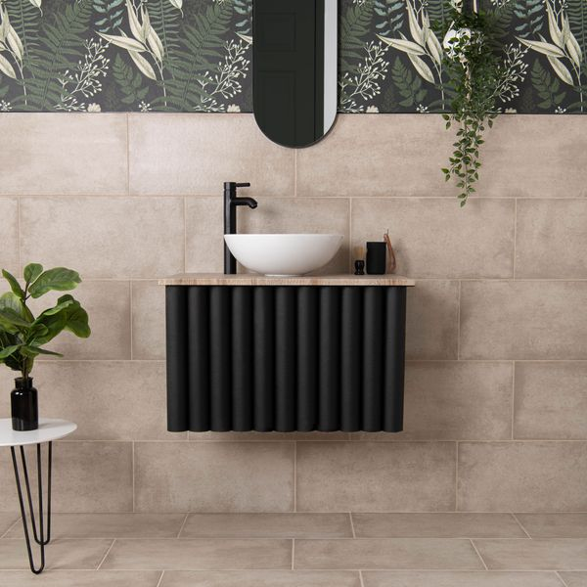

## **Product Description**

**Gorgeous stone effect style**

Create a natural interior space with our Samphire Beige Stone Effect Porcelain Tiles. Made from durable porcelain, they feature a mottled stone effect design that embodies the modern, yet rustic feel that’s so popular in interior design. The tiles’ textured surface and natural matt finish are reminiscent of natural stone, forming a simple, elegant look in your home that’s made to last.

**What’s special about these tiles?**

> Soft beige hue  
> Naturalistic textured surface  
> Durable and hardwearing   
> Long lasting and easy to clean

## **Product Info**

* Product ID 45697
* Tiles Per SQM 5.6115463177033
* Sale by Per SQM
* Size 298x598x8mm
* Weight 3.30 KG
* Material Type Porcelain
* Finish Matt
* Colour Beige/Ivory
* Suitability Floors, Walls
* Area Of Usage Internal
* Grade 4
* Rectified Edge No
* Underfloor Heating Yes
* Thickness (mm) 8