**Memoir Encaustic Penzance Pattern Tiles:**

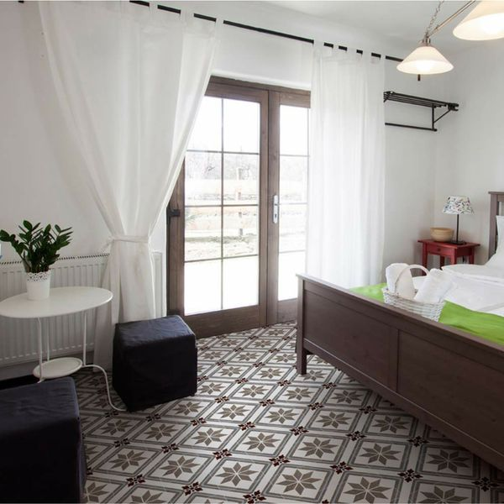

## **Product Description**

Create a charming period look in your home with our Penzance Scored Tiles. They have an ornate vintage pattern, and are perfect for creating a statement floor in a bathroom, kitchen or living area. You can even use them to create a striking first impression on guests, by introducing them into the hallway. They are made from ceramic and have a matt finish. They belong to our collection of Memoir Encaustic Effect Tiles and are named after a charming Cornish fishing town, strife with charming Victorian homes. This tile has a scored design, which you grout; each tile then gives the illusion of four separate tiles.

## **Product Info**

* Product ID: 15384
* Tiles Per SQM: 4.9382716049383
* Sale by: Per SQM
* Size: 450x450x10mm
* Weight: 4.06 KG
* Material Type: Ceramic
* Finish: Matt
* Colour: Multicolour
* Suitability: Floors
* Grade: 4
* Rectified Edge: No
* Underfloor Heating: Yes
* Thickness (mm): 10

**Caramel Varnish Chevron Wood Tiles:**

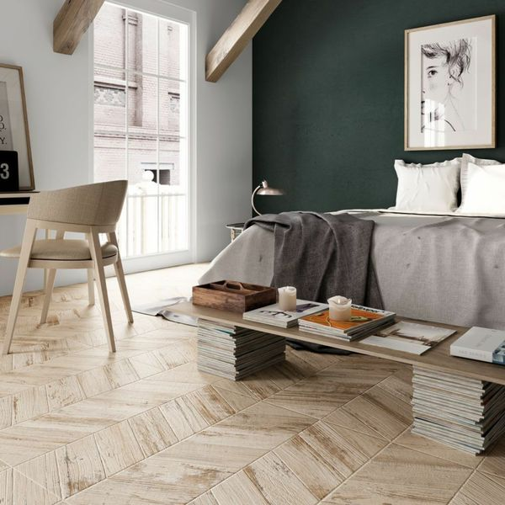

## **Product Description**

Create a striking statement floor or feature wall in your home this season with the introduction of these Caramel Varnished Chevron Wood Tiles. They have an eye-catching chevron layout. Made from porcelain, these wood effect tiles have an aged, faded painted effect; ideal for injecting character into a kitchen, bathroom or living area floor or wall space. They have a matt finish. Want to get the full effect? Order a sample.

## **Product Info**

* Product ID: 15658
* Tiles Per SQM: 2.4691358024691
* Sale by: Per SQM
* Size: 450x900x9mm
* Weight: 9.98 KG
* Material Type: Porcelain
* Finish: Matt
* Colour: Beige/Ivory, Brown
* Suitability: Floors, Walls
* Grade: 4
* Rectified Edge: No
* Underfloor Heating: Yes
* Thickness (mm): 9

**Antoinette Parquet Whiteleaf Jewel Wood Tiles:**

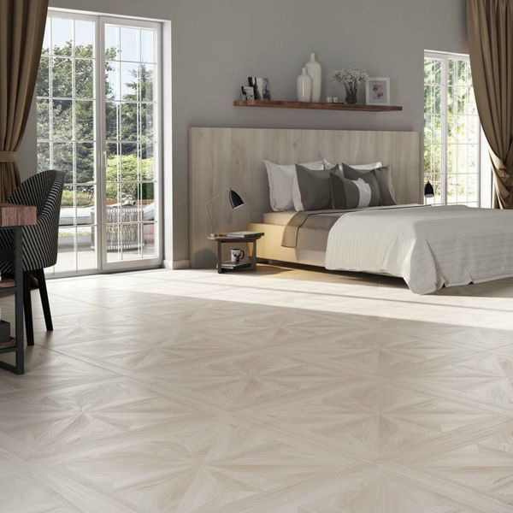

## **Product Description**

Create a luxurious look in your interior spaces with these gorgeous Antoinette Parquet Whiteleaf Jewel Wood Tiles. Made from porcelain, they're durable and long-lasting. They have a naturalistic matt finish with a decorative parquet effect pattern; giving the illusion of an expensive, lovingly carpentered wooden floor.

**What's special about these tiles?**

> Decorative parquet effect pattern  
> Realistic wood effect design  
> Ideal for creating a luxury vintage look  
> Naturalistic matt finish  
> Made from durable, long-lasting porcelain  
> Suitable for use with underfloor heating

**Try before you buy**

If you'd like to take a closer look, why not order a sample tile? Samples are a great way to get a feel for a tile's true colour and texture, and you can see how it looks in your chosen room!

## **Product Info**

* Product ID: 38478
* Tiles Per SQM: 1.5625
* Sale by: Per SQM
* Size: 800x800mm
* Weight: 14.08 KG
* Material Type: Porcelain
* Finish: Matt
* Colour: White
* Suitability: Floors
* Grade: 4
* Rectified Edge: Yes
* Underfloor Heating: Yes
* Anti Slip Grade: R10 / 10-19 Degrees
* Thickness (mm): 10

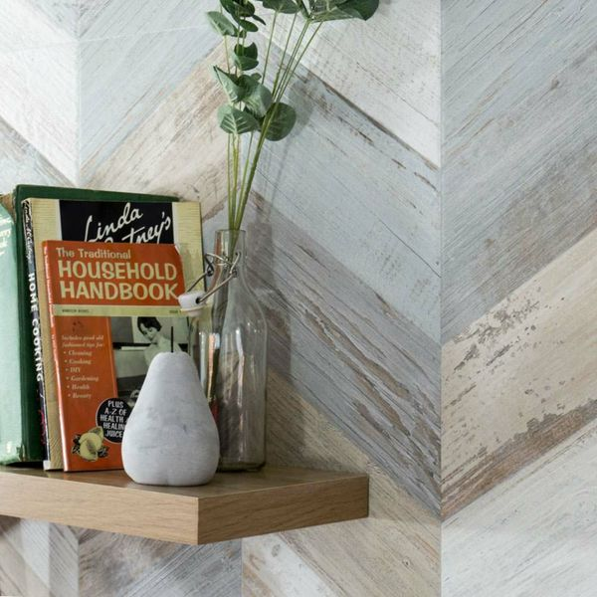**BoCoCa Urban Mix Chevron**

**Wood Tiles:**

## **Product Description**

If your bathroom, kitchen or living area is in desperate need of a refresh, create a characterful statement floor with these Urban Mix Chevron Wood Tiles. They have a striking chevron design, with a mix of white, grey and brown hues. These floor tiles have a wood effect design with an aged, faded painted effect; perfect for introducing character into any room throughout the house. They're made from durable porcelain and have a matt finish. For a closer look, order a sample.

## **Product Info**

* Product ID: 15659
* Tiles Per SQM: 2.4691358024691
* Sale by: Per SQM
* Size: 450x900x9mm
* Weight: 9.98 KG
* Material Type: Porcelain
* Finish: Matt
* Colour: Brown
* Suitability: Floors, Walls
* Grade: 4
* Rectified Edge: No
* Underfloor Heating: Yes
* Thickness (mm): 9

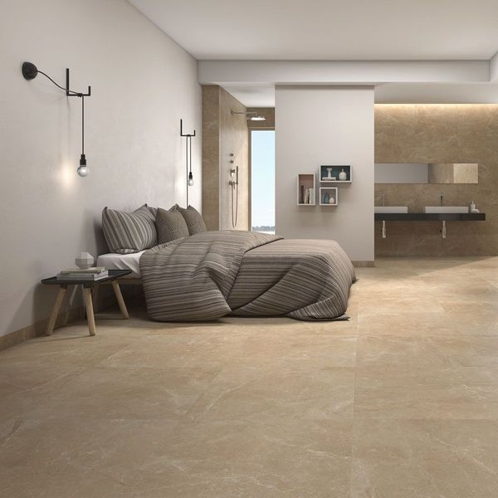**Pecan Brown Polished 59x59 Tiles:**

## **Product Description**

If your interior spaces are looking a little dated, refresh them by introducing the natural look! These Pecan Brown Polished 59x59 Tiles have a stunning marble effect design. Marble is one of the most sought after natural stone types, but it's expensive and requires treatment and maintenance, so these realistic porcelain floor tiles are a fabulous alternative! They have a brown hue and a shimmering polished finish. Order yourself a sample tile.

To prevent staining, we highly recommend sealing these tiles with [LTP MPG sealer](https://www.wallsandfloors.co.uk/ltp-cleaning-protecting-ltp-mpg-tile-sealer-11270), both before and after grouting. This can be applied as per the manufacturer’s instructions using a [LTP Buffing Cloth](https://www.wallsandfloors.co.uk/ltp-maintenance-tools-blue-buffing-cloth-2-pack). For everyday cleaning, we only recommend [LTP Waxwash](https://www.wallsandfloors.co.uk/ltp-cleaning-protecting-ltp-waxwash-tile-maintenance). Please refer to this [downloadable maintenance PDF](https://www.wallsandfloors.co.uk/media/catalog/product/polished-porcelain-maintenance-cleaning.pdf).

## **Product Info**

* Product ID: 15589
* Tiles Per SQM: 2.8727377190463
* Sale by: Per SQM
* Size: 590x590x10mm
* Weight: 7.86 KG
* Material Type: Porcelain
* Finish: Polished
* Colour: Brown
* Suitability: Floors
* Grade: 4
* Rectified Edge: Yes
* Underfloor Heating; Yes
* Thickness (mm): 10