**Karlon Ash Grey Tiles:**

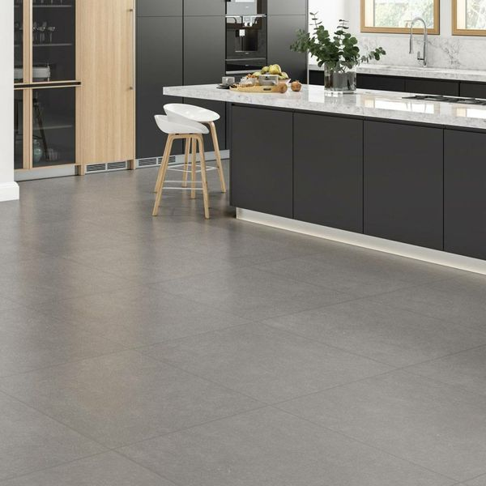

## **Product DESCRIPTION**

Karlon Ash Grey Tiles have a beautifully authentic stone effect design with fossil-like detail, inspired by the famous Belgium Bluestone. Suitable for any floor space in the home with its durable matt anti-slip R11 finish, perfect for wet areas and wetrooms.

**What's special about these tiles?**

> Realistic stone effect design  
> Perfect for a calming natural scheme  
> Made from durable porcelain   
> Durable matt anti-slip R11 finish

## **Product Info**

* Product ID: 43784
* Tiles Per SQM: 2.7320538214603
* Sale by: Per SQM
* Size: 605x605x7mm
* Weight: 5.87 KG
* Material Type: Porcelain
* Finish: Matt
* Colour: Grey
* Suitability: Floors
* Grade: 4
* Rectified Edge: No
* Underfloor Heating: Yes
* Anti Slip Grade: R11 / 12 Degrees
* Thickness (mm): 7

**Voronoi White Marble Effect Hexagon Tiles:**

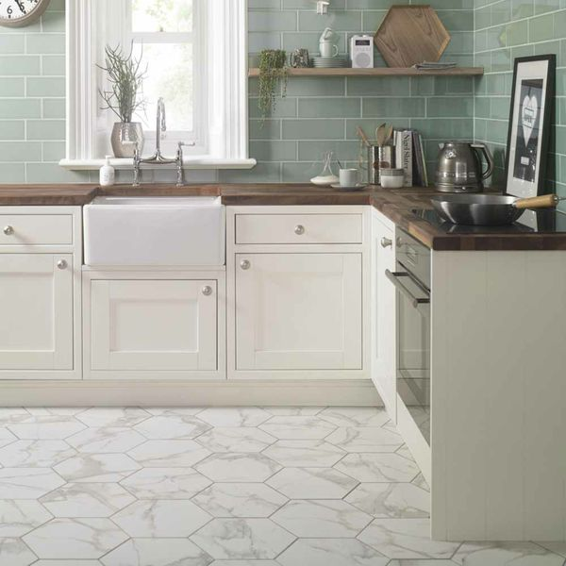

## **Product DESCRIPTION**

Welcome the hexagonal trend into your home this season with these gorgeous Voronoi White Hexagon Tiles. They have a realistic Carrara marble effect design; alive with grey and brown veining draped across a white backdrop. They allow you to create a natural look in a bathroom, kitchen or living room, whilst also introducing some modern, six-sided style. Made from porcelain, they can be used on both walls and floors, and they have a satin sheen and are also suitable for underfloor heating.

**What's special about these tiles?**

> Modern hexagon shape

> Natural marble effect design

> Hardwearing porcelain

> Shimmering gloss finish

**Try before you buy**

Want to take a closer look at these tiles before placing a full order? Order a sample tile! Samples come full size and with Free Delivery, and they're a great way to get a feel for a tile's size, colour and texture. You can even see how it looks on the wall or floor in your chosen space.

## **Product Info**

* Product ID: 15201
* Tiles Per SQM: 14.310684840116
* Sale by: Per SQM
* Size: 330x285x9mm
* Weight: 1.45 KG
* Material Type: Porcelain
* Finish: Satin
* Colour: White
* Suitability: Floors, Walls
* Grade: 4
* Rectified Edge: No
* Underfloor Heating: Yes
* Thickness (mm): 9

**Stonemood White Tiles:**

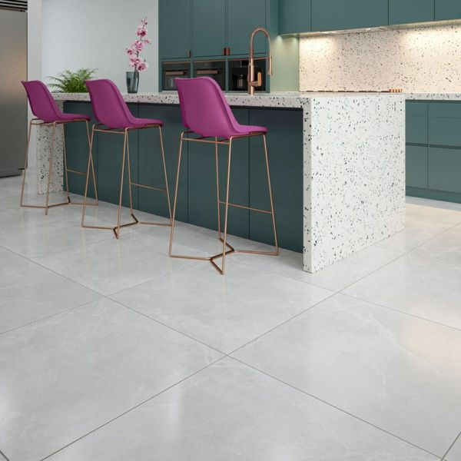

## **Product DESCRIPTION**

Stonemood is an extra-large format range inspired by natural stone, it has a gentle veining to give character and movement, with a soft matt finish, perfect for creating the concept of seamless living. Available in two subtle neutral colourways creating a calm tranquil space. Made in a thinner 8mm porcelain composition whilst still maintaining its hard wearing and durable characteristics of a 10mm porcelain with the same breaking strength. The advantage of the 8mm is a lighter option for handling.

What's special about these tiles?

> They are a stunning white stone effect.

> Their large size is ideal for open-plan living spaces to create a seamless effect.

> Their 8mm thickness reduces their weight and also makes them suitable for underfloor heating.

> Their ceramic body is practical and hard-wearing, yet beautiful.

## **Product Info**

* Product ID: 44339
* Tiles Per SQM: 1.5742849991105
* Sale by: Per SQM
* Size: 797x797x8mm
* Weight: 7.64 KG
* Material Type: Porcelain
* Finish: Matt
* Colour: Grey
* Suitability: Floors
* Grade: 4
* Rectified Edge: Yes
* Underfloor Heating: Yes
* Thickness (mm): 8

**Almond Rustic Metro Tiles:**

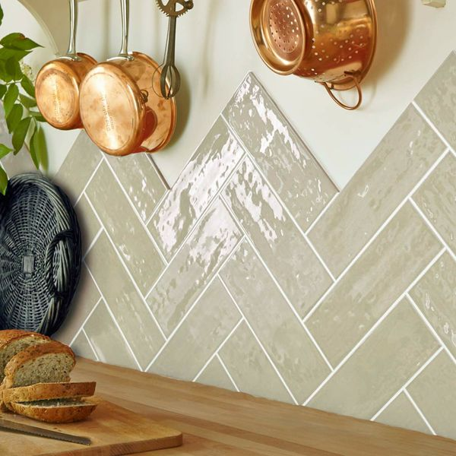

## **Product DESCRIPTION**

Welcome the charming country look into your bathroom or kitchen this season with the introduction of these stylish Almond Gloss Tiles. They have a bumpy rustic surface, and are perfect for creating a kitchen splashback or a feature wall in a bathroom. They're made from ceramic, have a gloss finish, and belong to our range of Rustic Metro 30x10 Tiles. Their rustic design makes them ideal for injecting the traditional farmhouse look into your interior spaces. For an eye-catching finish, adopt a Herringbone layout. Want a closer look? Order a sample tile.

## **Product Info**

* Product ID: 15082
* Tiles Per SQM: 33.333333333333
* Sale by: Per SQM
* Size: 100x300x7mm
* Weight: 0.44 KG
* Material Type: Ceramic
* Finish: Gloss
* Colour: Beige/Ivory
* Suitability: Walls
* Grade: No
* Rectified Edge: No
* Underfloor Heating: No
* Thickness (mm): 7

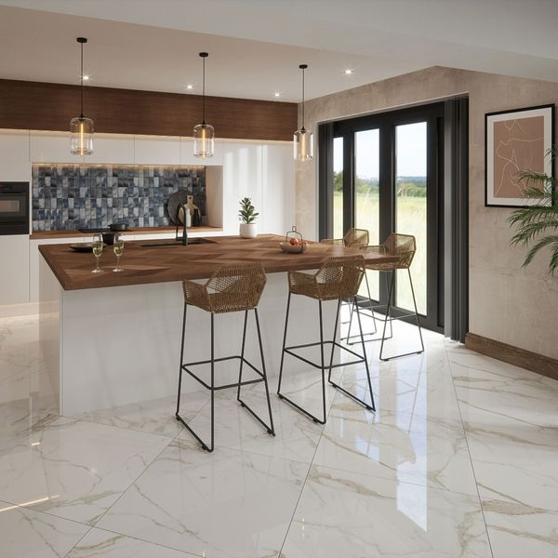

**Ruscello Gold Gloss Marble Effect Tiles:**

## **Product DESCRIPTION**

Introduce a luxurious look into your home with our Ruscello Gold Marble Effect Gloss Tiles. Made from durable porcelain, they feature a stunning marble effect design with delicate gold veining, inspired by Italy’s famous Calacatta marble. These tiles create a lavish yet natural feel to any room they’re in, with a shimmering gloss finish that reflects light around the room for a space-enhancing effect.

**What's special about these tiles?**

> Luxurious marble effect design  
> Shimmering gloss finish  
> Organic veining for soft, elegant style  
> Durable, hardwearing porcelain body  
> Perfect for an opulent feel on flooring or walls

## **Product Info**

* Product ID: 44904
* Tiles Per SQM: 2.7777777777778
* Sale by: Per SQM
* Size: 600x600x9.5mm
* Weight: 7.20 KG
* Material Type: Porcelain
* Finish: Gloss
* Colour: White
* Suitability: Floors, Walls
* Grade: 4
* Rectified Edge: No
* Underfloor Heating: Yes
* Thickness (mm): 9.5

**Pistachio Pick n’ Mix Gloss Tiles:**

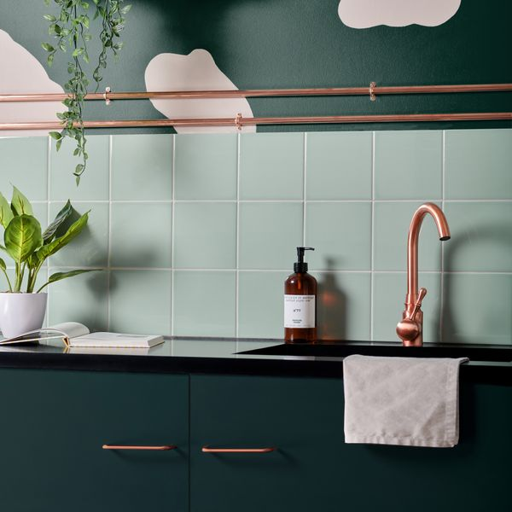

## **Product DESCRIPTION**

Soothing and serene, our Pistachio Pick n’ Mix Gloss Tiles are designed in an uplifting shade of green, with a shimmering gloss finish that catches the light for a space-enhancing look. Made from durable ceramic, these square-shaped tiles are a great base shade for any interior design scheme, as they effortlessly match a range of different colours, patterns and styles.

**What’s special about these tiles?**

> Soothing shade of green

> Durable ceramic

> Shimmering gloss finish

> Effortlessly versatile

## **Product Info**

* Product ID: 45087
* Tiles Per SQM: 44.444444444444
* Sale by: Per SQM
* Size: 150x150x8mm
* Weight: 0.28 KG
* Material Type: Ceramic
* Finish: Gloss
* Colour: Green
* Suitability: Walls
* Rectified Edge: No
* Underfloor Heating: Yes
* Thickness (mm): 8