**Parlor Fallow Walnut Wood Effect Tiles:**

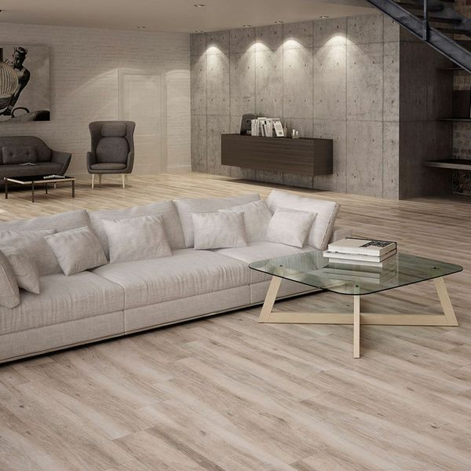

## **Product Description**

Want to welcome that warming, soothing, natural look into your home this season? These Fallow Walnut Tiles are exactly what the doctor ordered. These plank shaped tiles have a realistic wood effect design; complete with knots and woodgrain. They're made from durable porcelain tiles and can be used on floor spaces throughout your home. They belong to our selection of Parlor Wood Effect Tiles. For an attractive floor display, try creating a Herringbone parquet style pattern.

## **Product INFO**

* Product ID 14698
* Tiles Per SQM 3.5765379113019
* Sale by Per SQM
* Size 233x1200x10mm
* Weight 6.24 KG
* Material Type Porcelain
* Finish Matt
* Colour Beige/Ivory
* Suitability Floors
* Grade 4
* Rectified Edge No
* Underfloor Heating Yes
* Document [View Layout Designs](https://m2.wallsandfloors.co.uk/media/amasty/amfile/attach/fallow-walnut-tiles-parlor-wood-effect-tiles-.pdf)
* Thickness (mm) 10

**Aragon Flat Red Quarry Tiles:**

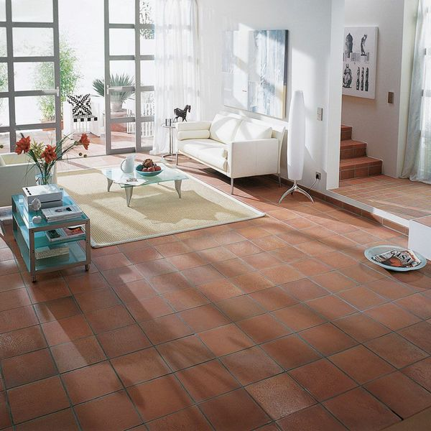

## **Product Description**

Create a rich, natural look in your home with these fantastic Aragon Flat Red Quarry Tiles. Their burnt, red colour will add depth and character to any kitchen, bathroom, hallway or lounge.

Due to the natural nature of these quarry tiles, tile thickness can vary 1-2mm.

**What's special about these tiles?**

> Natural clay

> Subtle matt finish

> Suitable for internal and external use

> Rustic, square shape

**Sealing, cleaning and maintenance**

For a matt finish:

**Sealer**: We recommend sealing these tiles with [LTP Mattstone Tile Sealer](https://www.wallsandfloors.co.uk/ltp-cleaning-protecting-ltp-mattstone-tile-sealer-11256) or LTP Mattstone H20 Tile Sealer. Both sealers fill the open pores on the surface, leaving the tile in its natural appearance.

**Cleaning and aftercare:** To keep these tiles clean, we recommend [LTP Waxwash](https://www.wallsandfloors.co.uk/ltp-cleaning-protecting-ltp-waxwash-tile-maintenance). It contains a trace of linseed oil which will help to repair and maintain the sealer without altering the finish.

For a satin to gloss finish:

**Sealer:** We recommend sealing these tiles with [LTP Glaze Protector](https://www.wallsandfloors.co.uk/ltp-cleaning-protecting-ltp-tile-glaze-protector). The glossiness slightly increases with every application, depending on the desired appearance and can be applied up to a maximum of 6 coats. It's for dry areas and internal use only.

**Cleaning and aftercare**: Regularly use [LTP Floorshine](https://www.wallsandfloors.co.uk/ltp-cleaning-protecting-ltp-floorshine-tile-maintenance) to increase the sheen and repair old worn sealer.

## **Product INFO**

* Product ID 11509
* Tiles Per SQM 44.444444444444
* Sale by Per SQM
* Size 150x150x12mm
* Weight 0.61 KG
* Material Type Clay
* Finish Matt
* Colour Terracotta
* Suitability Floors
* Grade 5
* Rectified Edge No
* Underfloor Heating Yes
* Thickness (mm) 12

**Vintage Wood Rovere Floor Tiles:**

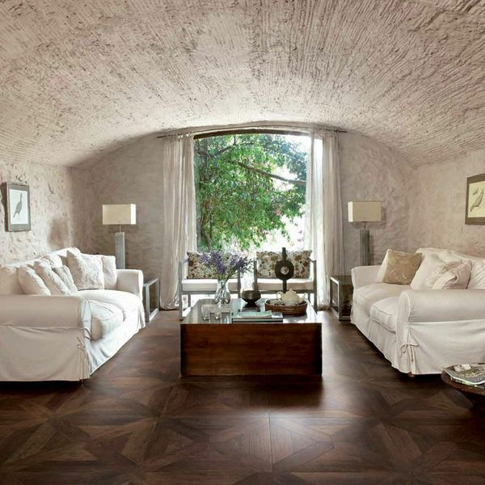

## **Product Description**

This stunning, dark Rovere Floor Tile will add a luxury feel to your home. They're made from glazed porcelain, but the wood effect is incredibly realistic; with variating grains and knots. The parquet-effect joints look fantastic. You have to look very closely before you realise it isn't real varnished wood.

**What's special about these tiles?**

> Realistic wood effect design

> Luxurious parquet style

> Made from durable long-lasting porcelain

**Take a closer look**

Want to take a closer look at these tiles before placing a full order? Why not order a full-size sample tile? We send samples out with Free Delivery! They're the perfect way to see what a tile looks like in position in your home.

## **Product INFO**

* Product ID 12026
* Tiles Per SQM 4.3766740778348
* Sale by Per SQM
* Size 478x478x8mm
* Weight 4.33 KG
* Material Type Porcelain
* Finish Matt
* Colour Brown
* Suitability Floors
* Grade 5
* Rectified Edge No
* Underfloor Heating Yes
* Thickness (mm) 8

**Madagascan Ipil Oak Wood:**

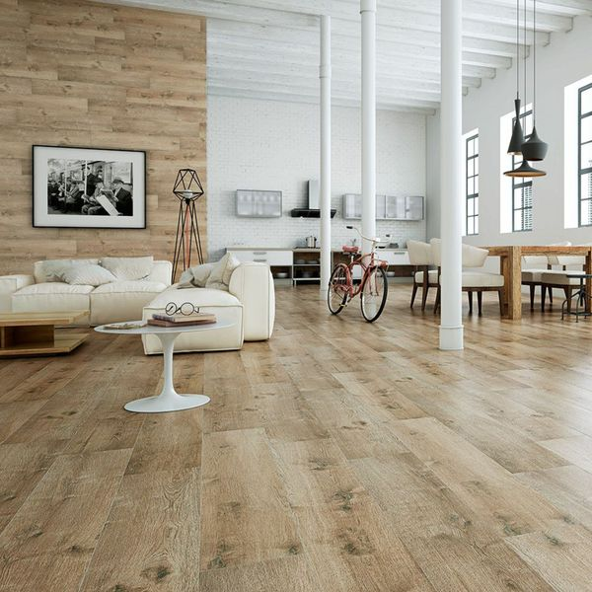

## **Product Description**

A gorgeous light brown in colour, these Oak Tiles are perfect for adding a natural look to your home this season. Create the illusion of a wooden floor throughout your home. Made from porcelain, they can be used in any room in the house; be it a bathroom, a kitchen, a hallway or a bathroom. They belong to our range of Madagascan Ipil Tree Tiles. For an attractive floor display, try creating a herringbone parquet style pattern.

## **Product INFO**

* Product ID 14685
* Tiles Per SQM 3.6231884057971
* Sale by Per SQM
* Size 230x1200x10mm
* Weight 6.22 KG
* Material Type Porcelain
* Finish Matt
* Colour Brown
* Suitability Floors, Walls
* Grade 5
* Rectified Edge No
* Underfloor Heating Yes
* Document [View Layout Designs](https://m2.wallsandfloors.co.uk/media/amasty/amfile/attach/oak-wood-effect-tiles-madagascan-ipil-tree-tiles-.pdf)
* Thickness (mm) 10

**Tangier Antiqua Decor Pattern Floor Tiles:**

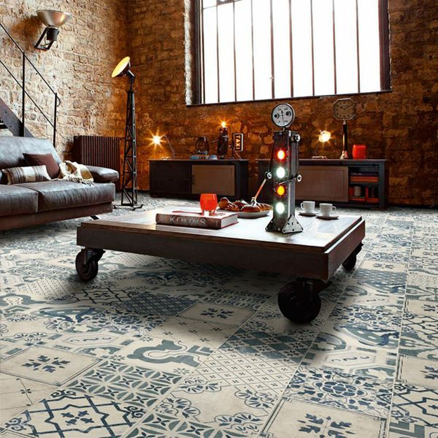

## **Product Description**

With a stunning mix of antique patterns, these Antiqua Decor Floor Tiles are perfect for bringing charm and character to your floor spaces. They have a rustic, antique finish, and consist of a variety of different designs ([See here](https://www.wallsandfloors.co.uk/media/uploads/DocumentTangier%20Floor%20Tile%20PDF1403867567.pdf)); ranging from efflorescent displays through to captivating geometric patterns. You'll receive a random mix of the various designs. To take a closer look at one of the pieces, order a full-size sample tile. These stunning floor tiles have a matt design.

## **Product INFO**

* Product ID: 13606
* Tiles Per SQM: 25
* Sale by: Per SQM
* Size: 200x200x9mm
* Weight: 0.80 KG
* Material Type: Ceramic
* Finish: Matt
* Colour: Blue
* Suitability: Floors, Walls
* Grade: 3
* Rectified Edge: No
* Underfloor Heating: Yes
* Document: [View All Designs](https://m2.wallsandfloors.co.uk/media/amasty/amfile/attach/DocumentTangier%20Floor%20Tile%20PDF1403867567.pdf)
* Thickness (mm): 9

**Comillas Patchwork Floor Tiles:**

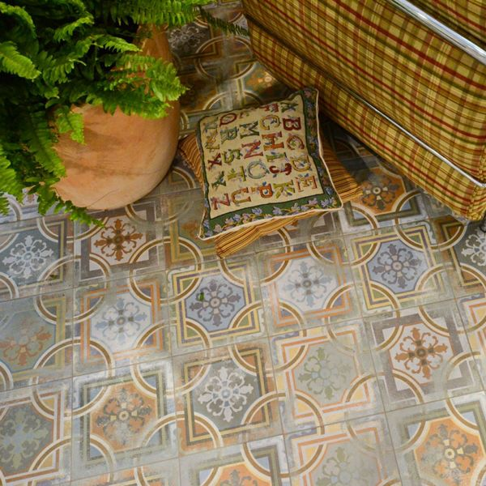

## **Product Description**

For an aged, vintage look that will never go out of style, our Comillas Patchwork Floor tiles are the tile you're looking for! They feature a multitude of muted colours, from blue through orange, to complement your interior design choices and create a feature floor inspired by classic design.

**What's special about these tiles?**

> Aged, muted colourway

> Characterful pattern design

> Crafted from durable ceramic

> Matt finish

**Try before you buy**

If you'd like to take a closer look, why not order a sample tile? Samples are a great way to get a feel for a tile's true colour and texture, and you can see how it looks in your chosen room!

## **Product INFO**

* Product ID: 44853
* Tiles Per SQM: 25
* Sale by: Per SQM
* Size: 200x200x9mm
* Weight: 0.74 KG
* Material Type: Ceramic
* Finish: Matt
* Colour: Sage Green
* Suitability: Floors, Walls
* Rectified Edge: No
* Underfloor Heating: Yes
* Thickness (mm): 9