**Icaria Plus Beige Porcelain Paving Slabs:**

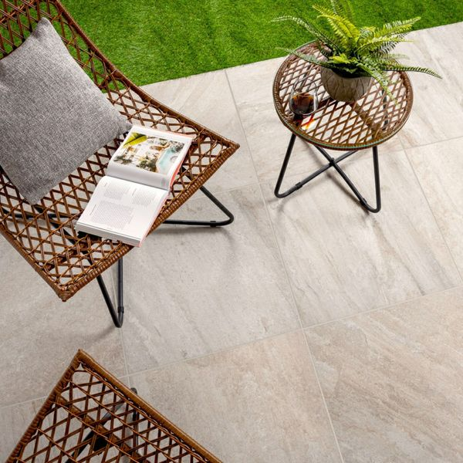

## **Product Description**

High time your garden had a stylish new makeover? For a functional and durable patio base, look no further than these gorgeous Icaria Plus Beige 59x59 20mm Tiles. Made from 20mm thick porcelain, these tiles have a quartzite effect design with directional veining, which adds a characterful textural appearance.

**What's special about these tiles?**

> Quartzite stone effect design

> 20mm thick durable porcelain

> Perfect for a stylish naturalistic patio space

> R11 anti-slip surface

> Long lasting and frostproof

**The perfect finishing touch**

For that perfect finish around your patio space, line the edges with our stylish new [20mm Paving Slab Trims!](https://www.wallsandfloors.co.uk/20mm-paving-slab-trims) Choose the colour that best matches your style!

**Spring Savers product**

This is one of our Spring Savers products! Our Spring Savers products represent fantastic everyday low value and are already discounted to our lowest possible price - therefore, discount codes can not be applied to Spring Savers products.

## **Product INFO**

* Product ID: 44088
* Tiles Per SQM: 2.8246592754749
* Sale by: Per SQM
* Size: 595x595x20mm
* Weight: 13.55 KG
* Material Type: Porcelain
* Finish: Matt
* Colour: Beige/Ivory
* Suitability: Floors
* Area Of Usage: External
* Grade: 4
* Rectified Edge: Yes
* Underfloor Heating: Yes
* Anti Slip Grade: R11 / 12 Degrees
* Document: [20mm Installation Guide](https://m2.wallsandfloors.co.uk/media/amasty/amfile/attach/20mm-installation-guide_4.pdf),[Cleaning and Protection Guide](https://m2.wallsandfloors.co.uk/media/amasty/amfile/attach/ltp_-_walls_floors_-_external_porcelain_-_cleaning_and_protection_guide_-_april_2020.pdf)
* Thickness (mm): 20

**Churchill Snow & Midnight Chequer Mosaic Tiles:**

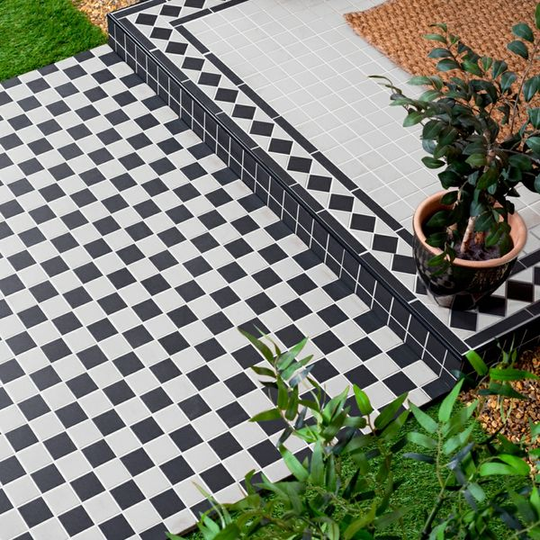

## **Product Description**

Black and white chequered floor tiles are the original decorative statement. Use these Churchill Snow & Midnight Chequer Mosaic Tiles to create a room-stealing period feature floor in your bathroom, hallway, lounge or kitchen! Because they're made from durable porcelain, they can even be used in the garden to create a patio space.

**What's special about these tiles?**

> Sought after Victorian style

> Made from sturdy porcelain

> Grippy R11 finish

> Perfect for use inside and outside

**The measure-up**

The individual tiles measure 45x45mm. There are 36 tiles per sheet and 11.82 sheets per sqm.

**Top tip: Seal before grouting**

Once the tiles are laid we recommend using the [LTP Porcelain Tile Protector](https://www.wallsandfloors.co.uk/ltp-porcelain-tile-protector) before grouting for the best finish.

## **Product Info**

* Product ID: 41056
* Tiles Per SQM: 11.80902445649
* Sale by: Per Sheet
* Size: 291x291x6mm
* Weight: 1.00 KG
* Material Type: Porcelain
* Finish: Matt
* Colour: Black and White
* Suitability: Floors, Walls
* Area Of Usage: External
* Grade: 5
* Rectified Edge: No
* Underfloor Heating: Yes
* Anti Slip Grade: R11 / 12 Degrees
* Thickness (mm): 6

**Witton Noir Porcelain Paving Slabs:**

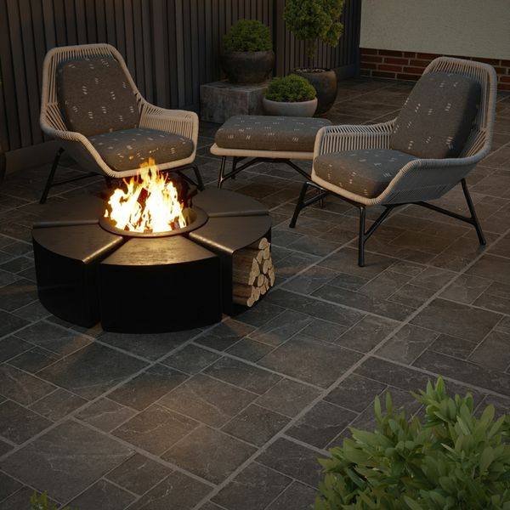

## **Product Description**

Featuring all the characteristics of a natural stone modular pattern in a durable porcelain body, Witton Noir 20mm Porcelain Slab Tiles encapsulate a traditional multi-size pattern within the tile surface, giving an easy option for creating, what is traditionally achieved by mixing several different sized individual tiles together. Witton retains the antiqued rustic charm that's so renowned in old traditional stone floors.

Have you tried our [20mm Paving Slab Trims](https://www.wallsandfloors.co.uk/20mm-paving-slab-trims)?

**What's special about these tiles?**

> Cool, charcoal tone

> Weathered edge for aged charm

> On-trend stone effect modular design

> Ultra durable, weather-resistant 20mm porcelain body

> Strong R11 anti-slip surface, perfect for outdoor spaces

**Try before you buy**

If you'd like to take a closer look, why not order a sample tile? Samples are a great way to get a feel for a tile's true colour and texture, and you can see how it looks in your chosen room!

**Have you seen our selection of**[**Norcros Rock-Tite products**](https://www.wallsandfloors.co.uk/rock-tite-outdoor-installation)**? They're perfect for fixing and completing outdoor projects!**

## **Product INFO**

* Product ID: 44827
* Tiles Per SQM: 2.8246592754749
* Sale by: Per SQM
* Size: 595x595x20mm
* Weight: 13.80 KG
* Material Type: Porcelain
* Finish: Matt
* Colour: Grey
* Suitability: Floors
* Area Of Usage: External
* Grade: 4
* Rectified Edge: Yes
* Underfloor Heating: Yes
* Anti Slip Grade: R11 / 35 Degrees
* Document: [20mm Installation Guide](https://m2.wallsandfloors.co.uk/media/amasty/amfile/attach/20mm-installation-guide_4.pdf),[Cleaning and Protection Guide](https://m2.wallsandfloors.co.uk/media/amasty/amfile/attach/ltp_-_walls_floors_-_external_porcelain_-_cleaning_and_protection_guide_-_april_2020.pdf)
* Thickness (mm): 20

**Icaria XL Blanco Porcelain Paving Slabs:**

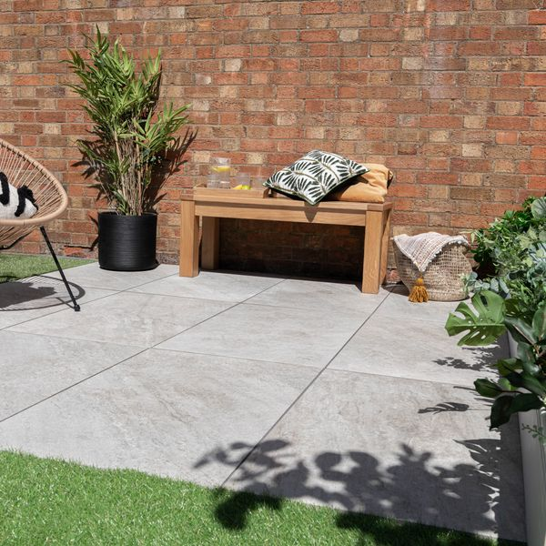

## **Product Description**

Looking for a stylish, yet a functional paving option for your outside space? Our Icaria Plus Blanco Porcelain Paving Slabs feature a quartzite effect design with textured directional veining and a pale ivory hue. Durable, hardwearing and easy to clean, these natural-looking tiles are perfectly suited for the outdoors with a 20mm thick porcelain construction and a matt, anti-slip finish.

**What’s special about these tiles?**

> Quartzite effect design

> Durable and hardwearing

> Anti-slip surface

> Long lasting and frost-proof

**The perfect finishing touch**

For that perfect finish around your patio space, line the edges with our stylish new [20mm Paving Slab Trims!](https://www.wallsandfloors.co.uk/20mm-paving-slab-trims) Choose the colour that best matches your style!

## **Product INFO**

* Product ID: 801480
* Tiles Per SQM: 1.8518518518519
* Sale by: Per SQM
* Size: 600x900x20mm
* Weight: 21.43 KG
* Material Type: Porcelain
* Finish: Matt
* Colour: White
* Suitability: Floors, Walls
* Area Of Usage: External
* Grade: 4
* Rectified Edge: Yes
* Underfloor Heating: No
* Anti Slip Grade: R11 / 35 Degrees
* Document: [Cleaning & Protection Guide](https://m2.wallsandfloors.co.uk/media/amasty/amfile/attach/v6zDQ2bNO72eOYbIuSFeTd6kQ5FyNJtj.pdf),[20mm Installation Guide](https://m2.wallsandfloors.co.uk/media/amasty/amfile/attach/20mm-installation-guide_4.pdf)
* Thickness (mm): 20

**Clifton Grey 60x60 20mm Porcelain Paving Slabs:**

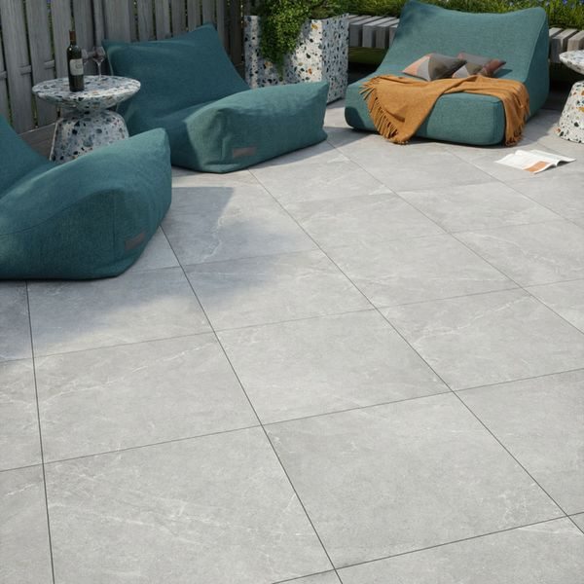

## **Product Description**

Make your outdoor space one of gorgeous design with these Clifton Grey 60x60 20mm Slab Tiles. They feature a realistic stone effect design but are crafted from durable porcelain for quality tiles that are bound to last. Create that patio space you've always dreamed of!

**What's special about these tiles?**

> Authentic, textured design

> Realistic stone effect look

> 20mm thick porcelain for weather resistance and durability

> Anti-slip, matt finish

> Perfect for seamless living

**The perfect finishing touch**

For that perfect finish around your patio space, line the edges with our stylish new [20mm Paving Slab Trims!](https://www.wallsandfloors.co.uk/20mm-paving-slab-trims) Choose the colour that best matches your style!

## **Product INFO**

* Product ID: 44824
* Tiles Per SQM: 2.8246592754749
* Sale by: Per SQM
* Size: 595x595x20mm
* Weight: 13.70 KG
* Material Type: Porcelain
* Finish: Matt
* Colour: Grey
* Suitability: Floors
* Area Of Usage: External
* Grade: 4
* Rectified Edge: Yes
* Underfloor Heating: Yes
* Anti Slip Grade: R11 / 35 Degrees
* Document: [20mm Installation Guide](https://m2.wallsandfloors.co.uk/media/amasty/amfile/attach/20mm-installation-guide_4.pdf),[Cleaning and Protection Guide](https://m2.wallsandfloors.co.uk/media/amasty/amfile/attach/ltp_-_walls_floors_-_external_porcelain_-_cleaning_and_protection_guide_-_april_2020.pdf)
* Thickness (mm): 20

**Trail Quartzita 20x20 Matt Slab Tiles: https:**

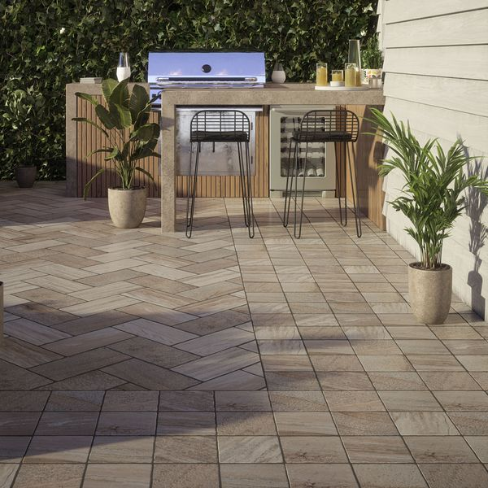

## **Product Description**

With a natural, timeworn appearance and a durable, easy to clean porcelain format, our Trail Quartzita collection offers the perfect look for your outdoor space. Inspired by Italian roads and pathways, our Trail Quartzita Porcelain Paving Slabs feature a realistic quartzite effect design in variegated shades of light brown and beige, perfect for emulating the rustic look of a natural cobblestone design. Designed in a small square format with a natural matt finish and an anti-slip surface, these multifunctional slabs can be used to create multiple unique patterns for a beautiful pathway or larger outdoor spaces.

Have you tried our [2](https://www.wallsandfloors.co.uk/20mm-paving-slab-trims)[0mm Paving Slab Trims?](https://www.wallsandfloors.co.uk/20mm-paving-slab-trims)

**What’s special about these tiles?**

> Inspired by Italian stone pathways

> Natural timeworn appearance

> Light brown and beige hues

> Rustic cobblestone effect design

> Opportunity for multiple layouts

## **Product INFO**

* Product ID: 44967
* Tiles Per SQM: 25
* Sale by: Per SQM
* Size: 200x200x18mm
* Weight: 1.25 KG
* Material Type: Porcelain
* Finish: Matt
* Colour: Grey
* Suitability: Floors
* Area Of Usage: Internal, External
* Rectified Edge: No
* Underfloor Heating: Yes
* Anti Slip Grade: R11 / 12 Degrees
* Document: [Cleaning & Protection Guide](https://m2.wallsandfloors.co.uk/media/amasty/amfile/attach/v6zDQ2bNO72eOYbIuSFeTd6kQ5FyNJtj.pdf),[20mm Installation Guide](https://m2.wallsandfloors.co.uk/media/amasty/amfile/attach/20mm-installation-guide_4.pdf)
* Thickness (mm): 18